1. ***Data Analytical Question Formulation***

1. ***Data Discovery***

*Note:* The above image shows the data analysis of 2024 from (City of Vancouver, n.d) portal.

1. ***Data Storage Design***

*Storage Information*

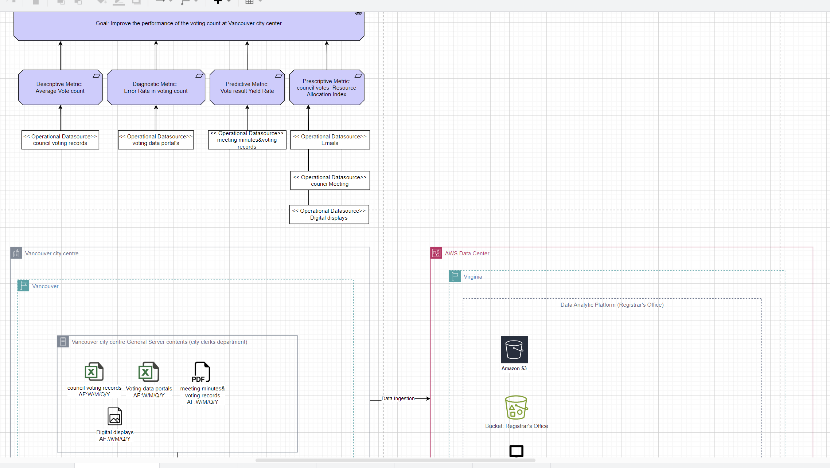

*Note:* The above image shows the data storage option of Council Voting Records.

1. ***Data Ingestion***

*Storage S3 Information-1*

1. ***Data Pipeline Design***

*Pipeline Information*

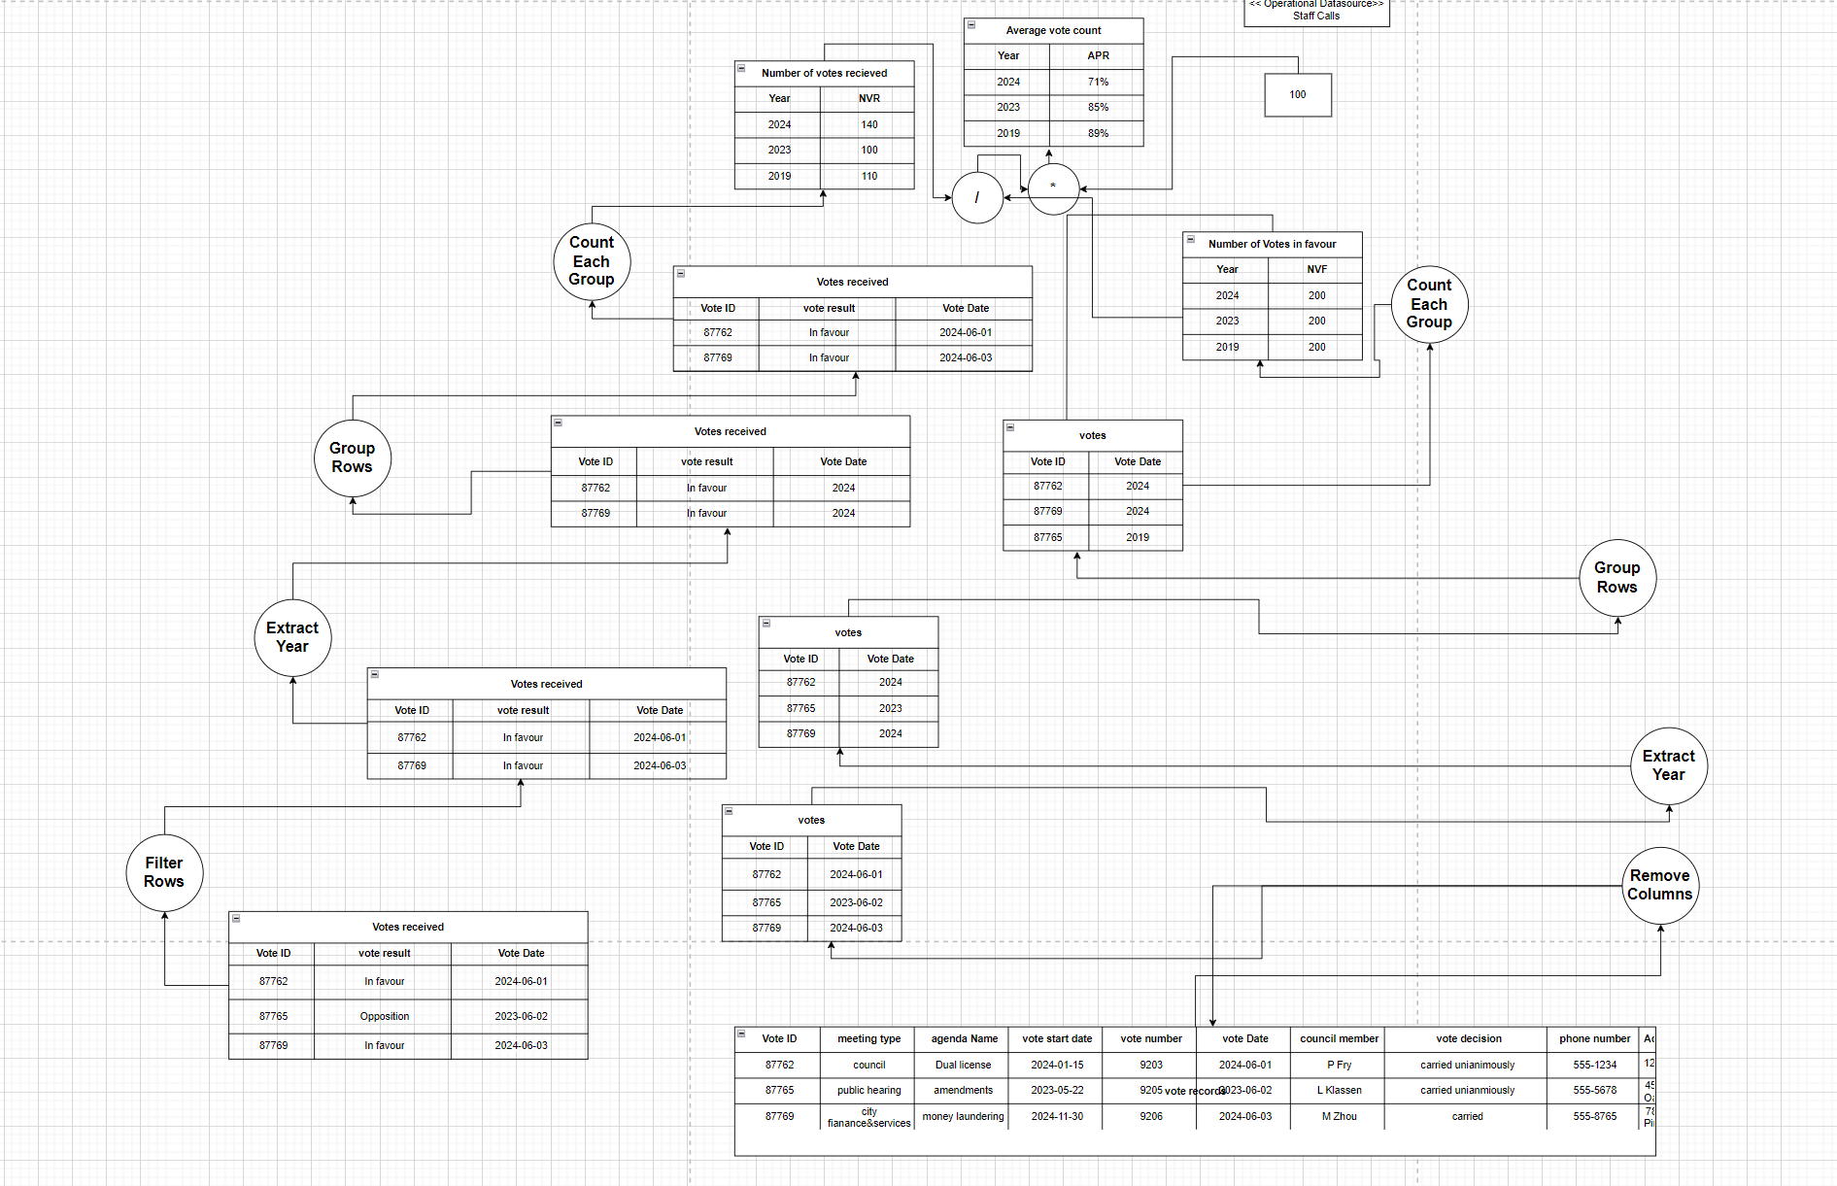

1. ***Data Cleaning & Structuring***

*Cleaning & Structuring Information*

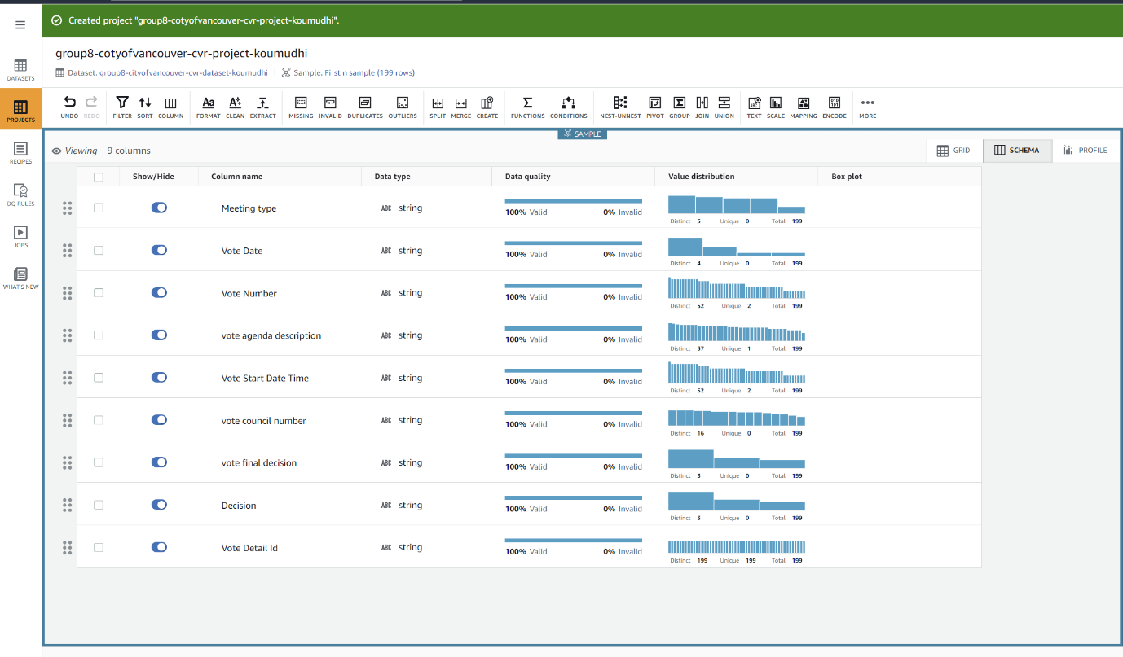

*Cleaning & Structuring Information*

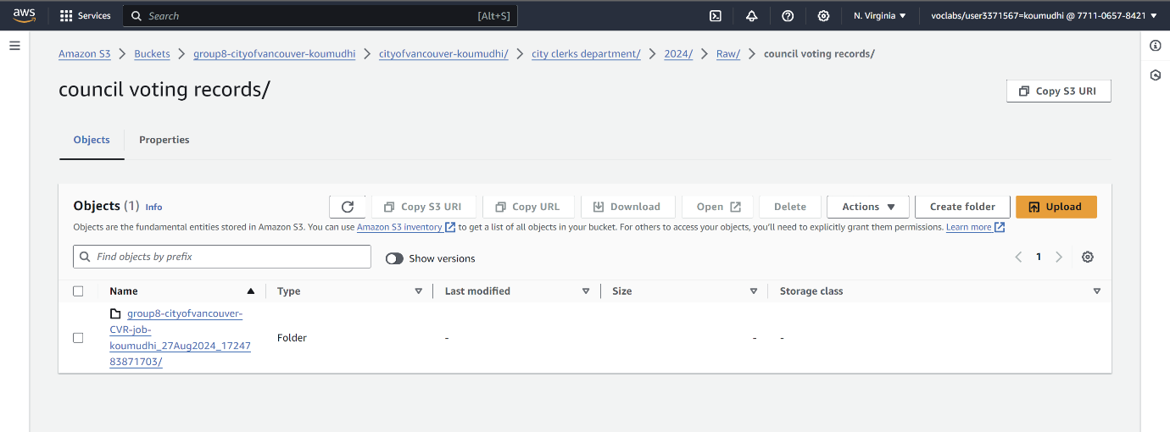

*Cleaning & Structuring Information*

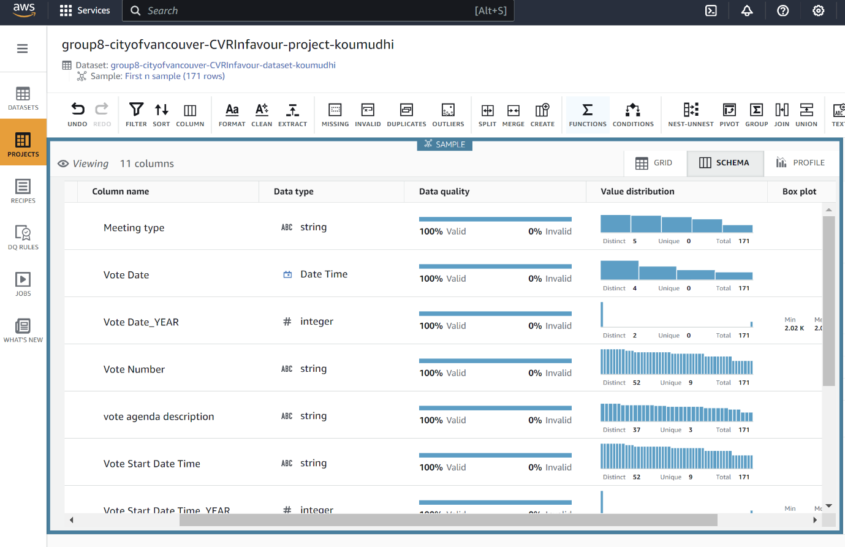

*Cleaning & Structuring Information*

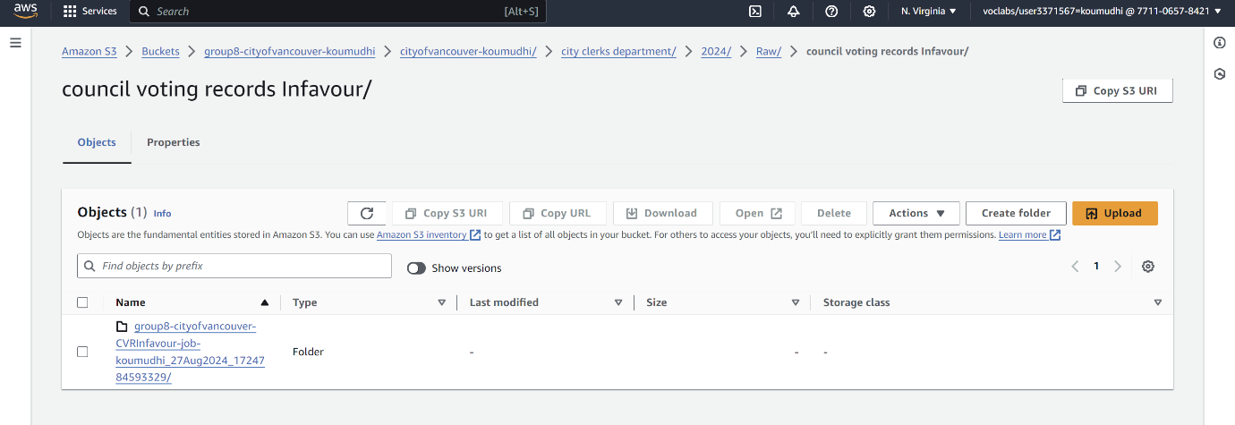

*Cleaning & Structuring Job Information*

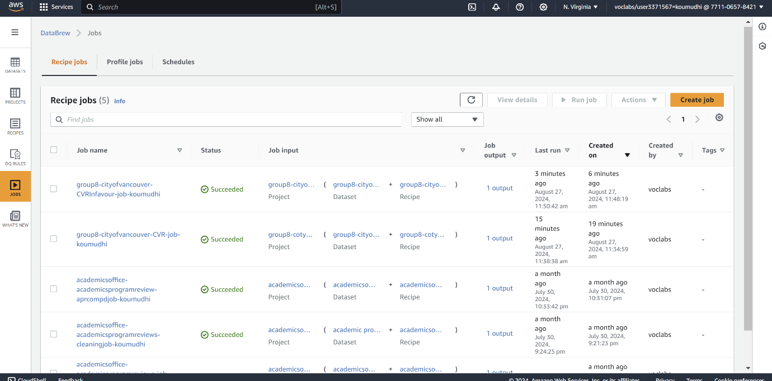

*Pipeline Information-1*

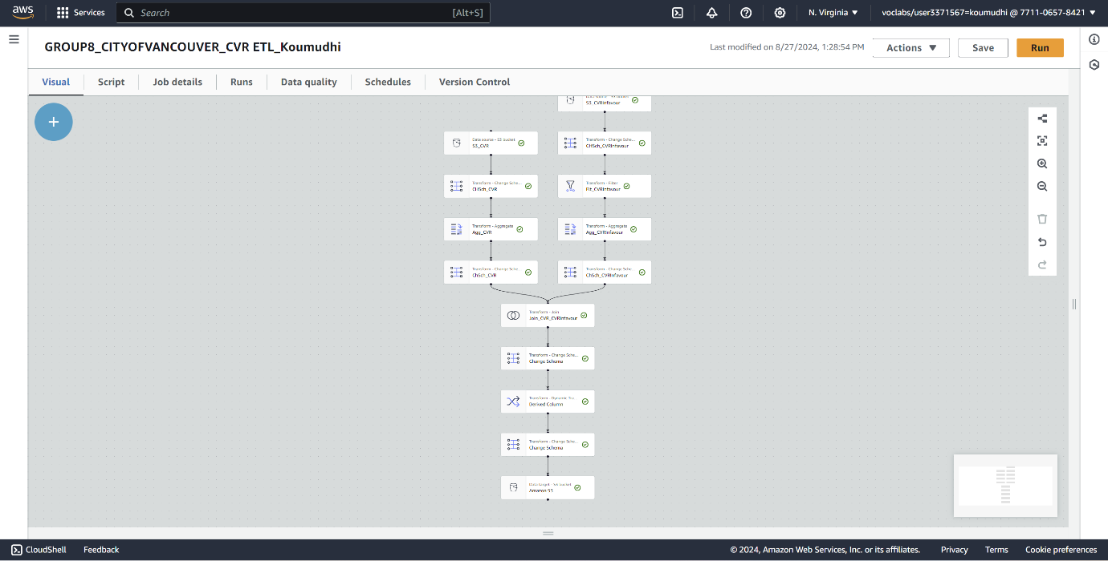

*Pipeline Job Information-1*

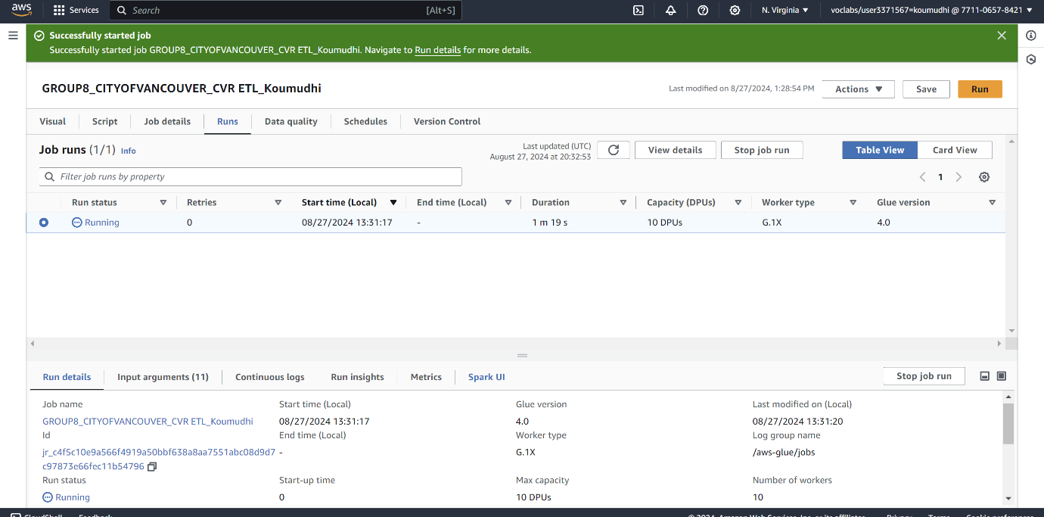

*2 Pipeline Job Information-1*

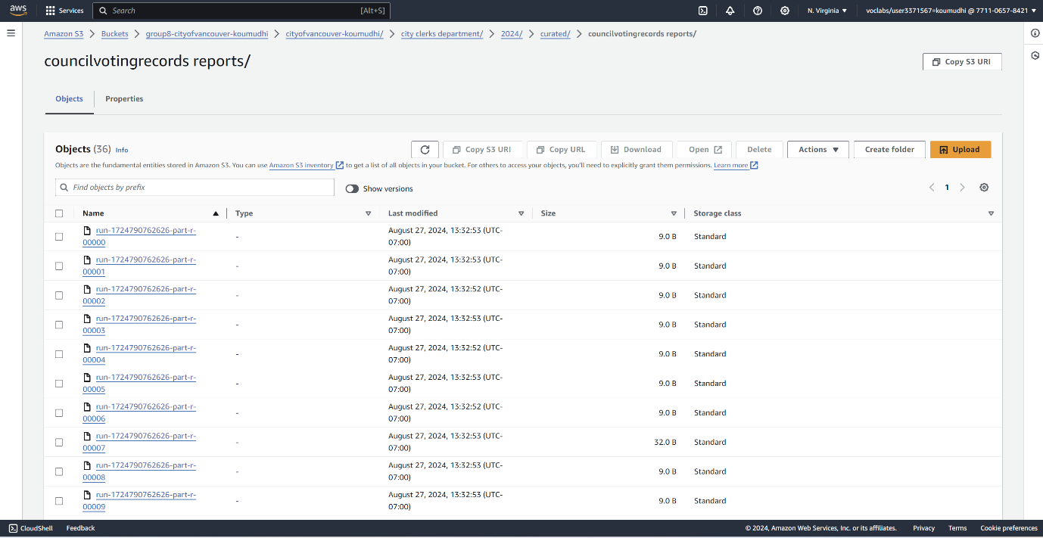

1. ***Data Analysis***

*Analysis Information-1*

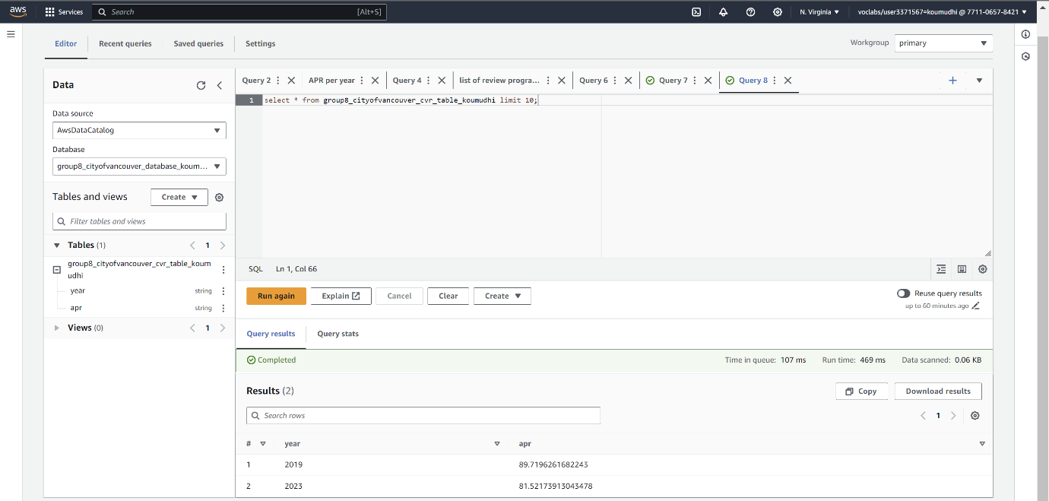

*Dataset 2 Visualization Information-1*

