Visit our website at [https://web.learncodeonline.in](https://web.learncodeonline.in/) for more exciting courses.

**Course**: MySQL

**Difficulty:** Intense

**Instruction**: Import the given **lco_car_rentals.sql** file in phpmyadmin and then answer the following questions with mySQL queries.

**Q1)** Insert the details of new customer:-

First name : Nancy

Last Name: Perry

Dob : 1988-05-16

License Number: K59042656E

Email : [nancy@gmail.com](mailto:nancy@gmail.com)

Ans:- INSERT INTO CUSTOER

(

first_name, last_name, dob, driver_license_number, email

)

VALUES(

‘Nancy’, ‘Perry’, ‘1988-05-16’, ‘K59042656E’, ‘nancy@gmail.com’

);

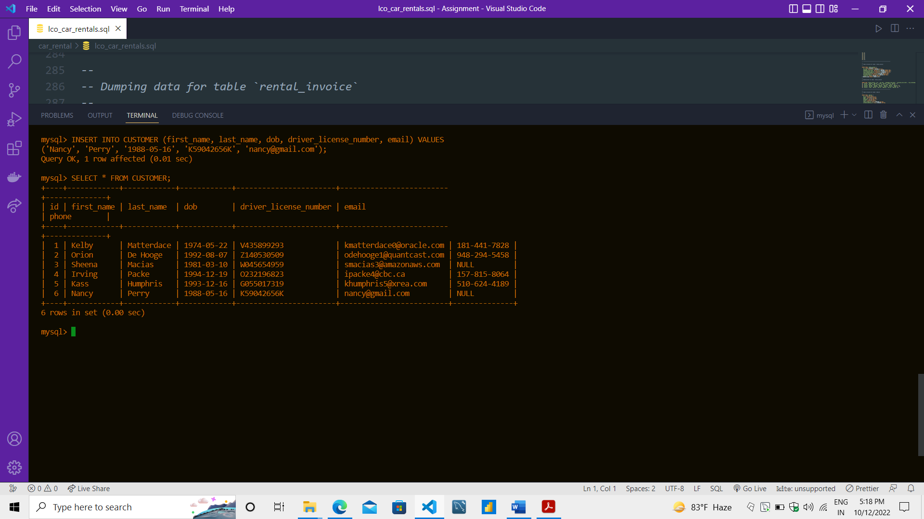

**Q2)** The new customer (inserted above) wants to rent a car from 2020-08-25 to 2020-08-30. More details are as follows:

Vehicle Type : Economy SUV

Fuel Option : Market

Pick Up location: 5150 W 55th St , Chicago, IL, zip- 60638

Drop Location: 9217 Airport Blvd, Los Angeles, CA, zip – 90045

**ANS:- INSERT INTO rental(start_date,end_date,customer_id,vehicle_type_id,fuel_option_id,pickup_location_id,drop_off_location_id)**

**values('2020-08-25', '2020-08-30',**

**(SELECT customer.id FROM customer WHERE customer.driver_license_number="K59042656K"),**

**(SELECT vehicle_type.id from vehicle_type WHERE vehicle_type.name="Economy SUV"),**

**(SELECT fuel_option.id from fuel_option WHERE fuel_option.name="Market"),**

**(SELECT location.id from location WHERE location.zipcode="60638"),**

**(SELECT location.id from location WHERE location.zipcode="90045")**

**);**

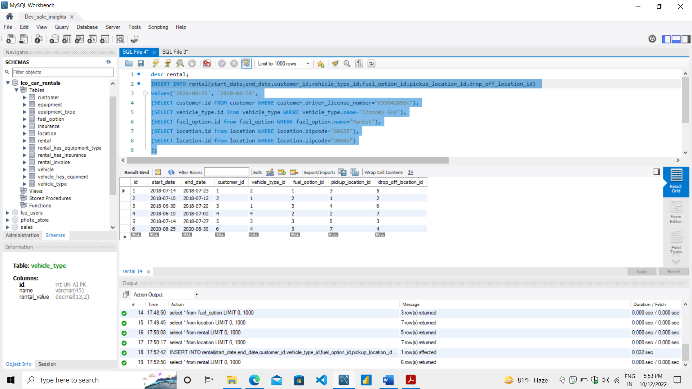

**Q3)** The customer with the driving license W045654959 changed his/her drop off location to 1001 Henderson St, Fort Worth, TX, zip - 76102 and wants to extend the rental upto 4 more days. Update the record.

**Ans:-**

**Q4)** Fetch all rental details with their equipment type.

**Q5)** Fetch all details of vehicles.

**Q6)** Get driving license of the customer with most rental insurances.

**Q7)** Insert a new equipment type with following details.

Name : Mini TV

Rental Value : 8.99

**Q8)** Insert a new equipment with following details:

Name : Garmin Mini TV

Equipment type : Mini TV

Current Location zip code : 60638

**Q9)** Fetch rental invoice for customer (email: smacias3@amazonaws.com).

**Q10)** Insert the invoice for customer (driving license: ) with following details:-

Car Rent : 785.4

Equipment Rent : 114.65

Insurance Cost : 688.2

Tax : 26.2

Total: 1614.45

Discount : 213.25

Net Amount: 1401.2

**Q11)** Which rental has the most number of equipment.

**Q12)** Get driving license of a customer with least number of rental licenses.

**Q13)** Insert new location with following details.

Street address : 1460 Thomas Street

City : Burr Ridge , State : IL, Zip - 61257

**Q14)** Add the new vehicle with following details:-

Brand: Tata

Model: Nexon

Model Year : 2020

Mileage: 17000

Color: Blue

Vehicle Type: Economy SUV

Current Location Zip: 20011

**Q15)** Insert new vehicle type Hatchback and rental value: 33.88.

**Q16)** Add new fuel option Pre-paid (refunded).

**Q17)** Assign the insurance : Cover My Belongings (PEP), Cover The Car (LDW) to the rental started on 25-08-2020 (created in Q2) by customer (Driving License:K59042656E).

**Q18)** Remove equipment_type :Satellite Radio from rental started on 2018-07-14 and ended on 2018-07-23.

**Q19)** Update phone to 510-624-4188 of customer (Driving License: K59042656E).

**Q20) I**ncrease the insurance cost of Cover The Car (LDW) by 5.65.

**Q21)** Increase the rental value of all equipment types by 11.25.

**Q22)** Increase the cost of all rental insurances except Cover The Car (LDW) by twice the current cost.

**Q23)** Fetch the maximum net amount of invoice generated.

**Q24)** Update the dob of customer with driving license V435899293 to 1977-06-22.

**Q25)** Insert new location with following details.

Street address : 468 Jett Lane

City : Gardena , State : CA, Zip - 90248

**Q26)** The new customer (Driving license: W045654959) wants to rent a car from 2020-09-15 to 2020-10-02. More details are as follows:

Vehicle Type : Hatchback

Fuel Option : Pre-paid (refunded)

Pick Up location: 468 Jett Lane , Gardena , CA, zip- 90248

Drop Location: 5911 Blair Rd NW, Washington, DC, zip - 20011

**Q27)** Replace the driving license of the customer (Driving License: G055017319) with new one K16046265.

**Q28)** Calculated the total sum of all insurance costs of all rentals.

**Q29)** How much discount we gave to customers in total in the rental invoice?

**Q30)** The Nissan Versa has been repainted to black. Update the record.