**TASK-1**

* Demonstrate minimum 15 basic Git command with explanation and screenshot.

1. **Git config**

This command is used when we using git first time in your system. This will confirm your name and email. Suppose if you are working in a project so if any one made any change in repo and code. Then you easily know that this person made change in that particular line of code.

**Command:-** git config -–global user.name ”Your name”

Git config –-global user.email “your email”

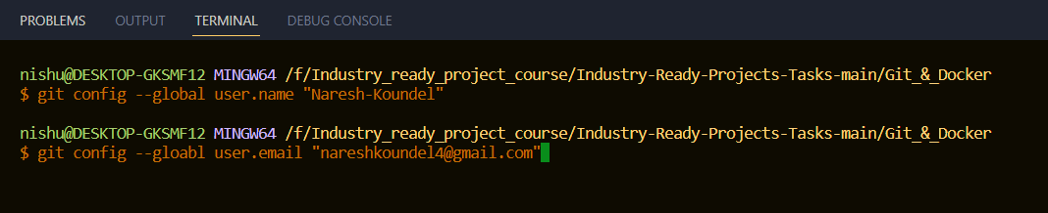

1. **Git init**

This command is used to create a new repository

**Command:-** git init

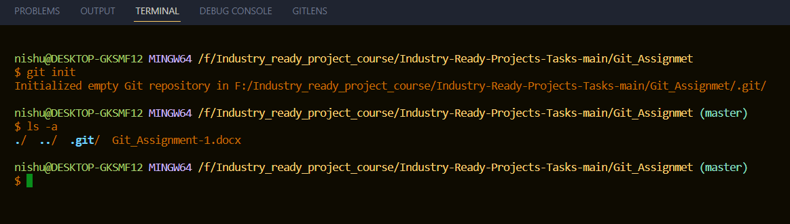

1. **Git add**

This command will add a file to staging area. Staging area is a basically where we hold the code before commit the code.

**Command:-**

For add single file

git add

For add all file in one go

git add *

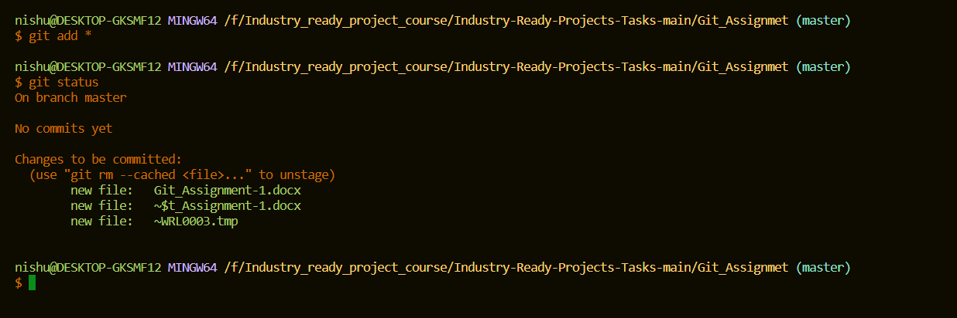

1. **Git status**

This command will list all the files that need to be commit.

**Command:-** git status

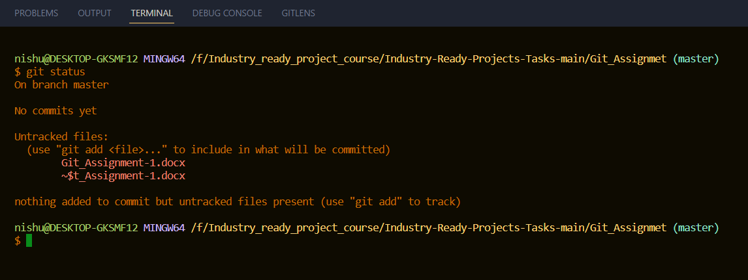

1. Git commit

This command is used to save all the change permanently.

Command:- git commit -m “Type any message”

1. Git push
2. Git branch
3. Git checkout
4. Git clone
5. Git pull
6. Git merge
7. Git log
8. Git branch
9. Git stash
10. Git show