Triton International college

Tinkune, Kathmandu





Lab Report (JavaScript and Php)

|  |  |
| --- | --- |
| Submitted By | Submitted To |
| Name: Bikram Shrestha  Roll no: 13  Class 12 | Department of computer  Submission Date:  2079/11/15 |

### 1. WAP to print Hello World in JavaScript

<html>

<head>

<title>Program</title>

<head>

<body>

<script type="text/javascript">

alert("Hello, World");

document.write("Hello, World");

</script>

</body>

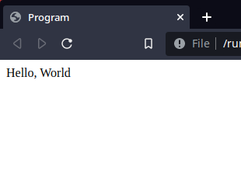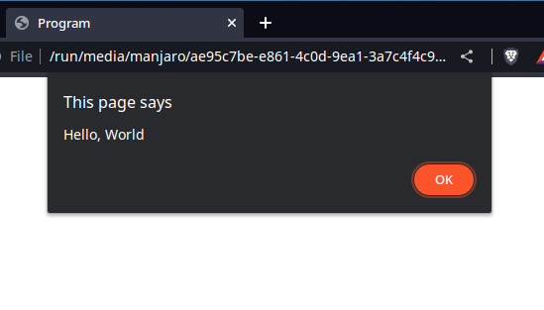</html>

### 2. WAP to calculate cube of Number

<html>

<head>

<title>Program</title>

<head>

<body>

<script type="text/javascript">

var num = parseInt(prompt());

var cube = num*num*num;

var square = num*num;

alert("The Square of " + num + " is "+square);

alert("The Cube of " + num + " is "+cube);

</script>

</body>

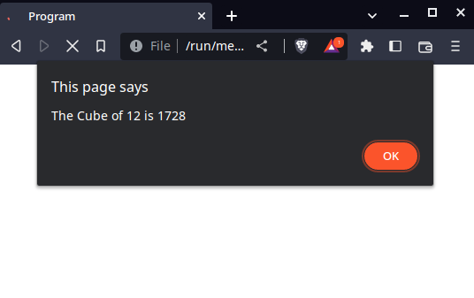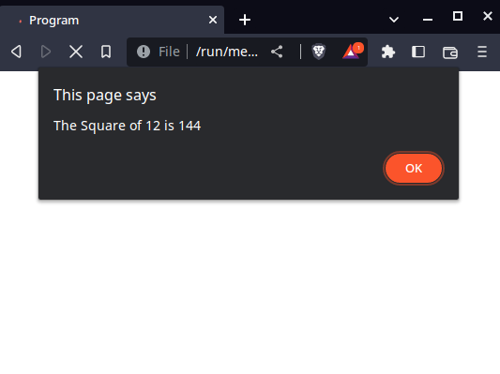</html>

### 3. WAP to find cube and square using function

<html>

<head>

<title>Program</title>

<head>

<body>

<script type="text/javascript">

var a=parseInt(prompt("enter a no"));

cu(a);

var c=sq(a);

document.write(c);

function cu(a)

{

var c=a*a*a;

document.write("cube="+c+"<br>");

}

function sq(a)

{

var c=a*a;

return(c);

}

</script>

</body>

</html>

### 9. WAP to check even or odd

<!DOCTYPE html>

<html lang="en">

<head>

<meta charset="UTF-8">

<meta http-equiv="X-UA-Compatible" content="IE=edge">

<meta name="viewport" content="width=device-width, initial-scale=1.0">

<title>Document</title>

</head>

<body>

<script type="text/javascript">

var num1 = parseInt(prompt("Enter a number"));

alert((num1%2==0)?"Even":"Odd");

</script>

</body>

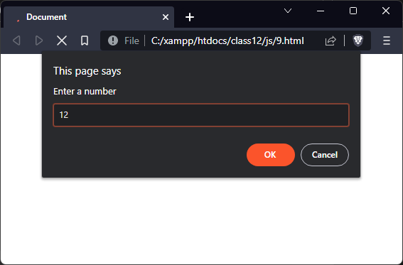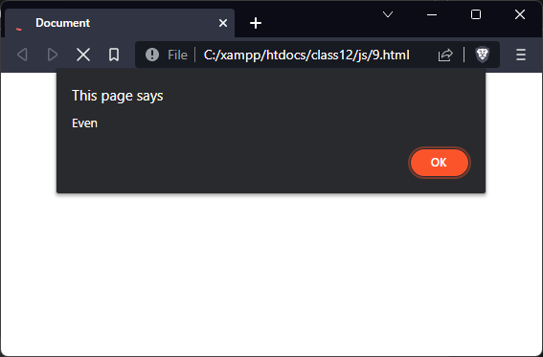</html>

### 10. WAP TO check Odd or even using function

<html>

<head>

<title>Program</title>

</head>

<body>

<script type="text/javascript">

var num1 = parseInt(prompt("Enter a number"));

alert(check(num1));

function check(num) {

if(num1%2==0) {

return "Even";

} else {

return "Odd";

}

}

</script>

</body>

</html>

### 11. WAP to display biggest number among three number

<html>

<head>

<title>Program</title>

<head>

<body>

<script type="text/javascript">

// Basic variables

var num1 = parseInt(prompt());

var num2 = parseInt(prompt());

var num3 = parseInt(prompt());

// calling function

smallest(num1, num2, num3);

// function defination

function smallest(num1, num2, num3) {

if(num1>num2 && num1>num3) {

alert(num1 + " is the biggest number");

} else if(num2>num3) {

alert(num2 + " is the biggest number");

} else {

alert(num3 + " is the biggest nimver")

}

}

</script>

</body>

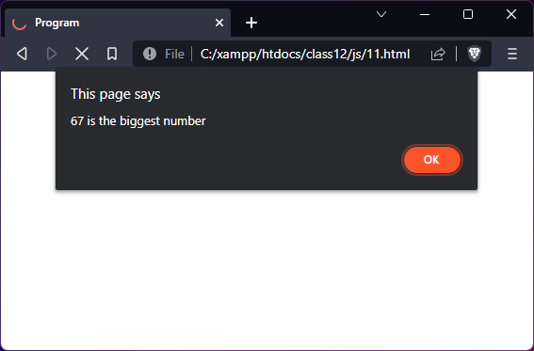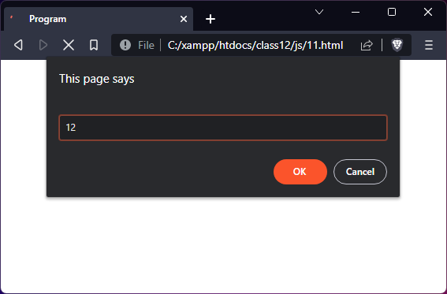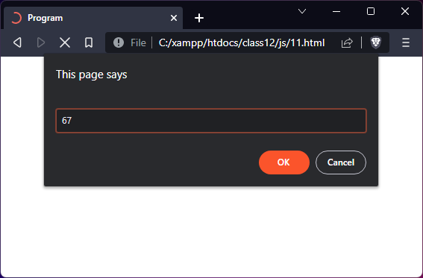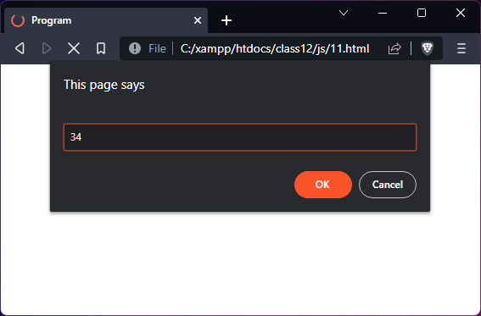</html>

### 12. WAP to display smallest number among three numbers

<html>

<head>

<title>Program</title>

<head>

<body>

<script type="text/javascript">

// Basic variables

var num1 = parseInt(prompt());

var num2 = parseInt(prompt());

var num3 = parseInt(prompt());

// calling function

smallest(num1, num2, num3);

// function defination

function smallest(num1, num2, num3) {

if(num1<num2 && num1<num3) {

alert(num1 + " is the smallest number");

} else if(num2<num3) {

alert(num2 + " is the smallest number");

} else {

alert(num3 + " is the smallest nimver")

}

}

</script>

</body>

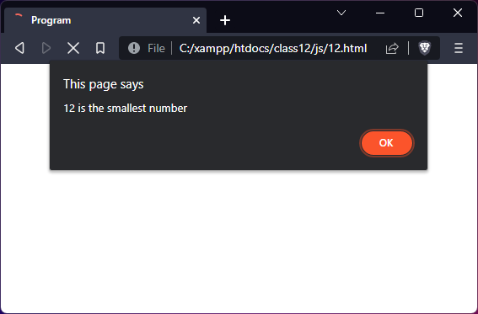</html>

### 13. WAP to prints days of week according to user choice using switch

<html>

<head>

<title>Program</title>

<head>

<body>

<script type="text/javascript">

var number = parseInt(prompt("Enter a number (1..7)"));

switch(number) {

case 1:

document.write("<h3>Sunday</h3>");

break;

case 2:

document.write("<h3>Monday</h3>");

break;

case 3:

document.write("<h3>Tuesday</h3>");

break;

case 4:

document.write("<h3>Wednesday</h3>");

break;

case 5:

document.write("<h3>Thusday</h3>");

break;

case 6:

document.write("<h3>Friday</h3>");

break;

case 7:

document.write("<h3>Saturday</h3>");

break;

default:

document.write("Error: range must be 1 to 7");

}

</script>

</body>

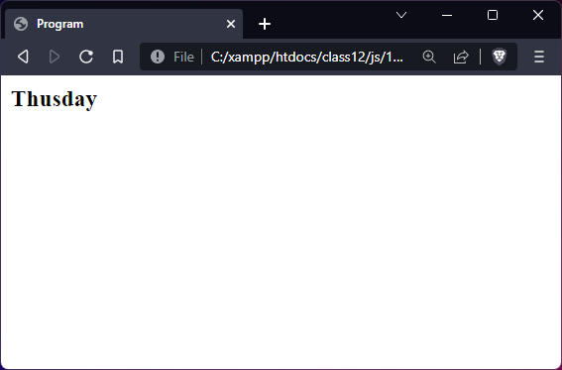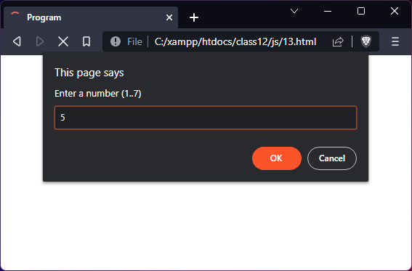</html>

### 15. WAP print 1, 2, 3, 4, 5 using do..while loop

<html>

<head>

<title>Program</title>

<head>

<body>

<script type="text/javascript">

var i=1;

do {

document.write(i + ", ");

i++;

} while(i<=5);

</script>

</body>

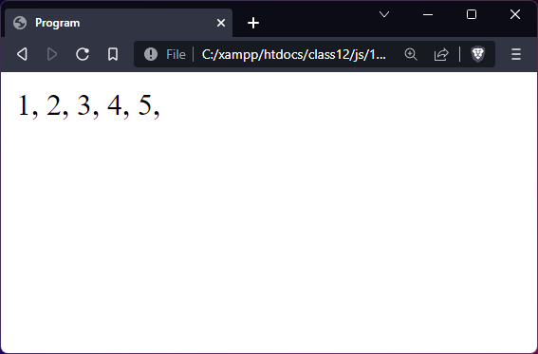</html>

### 16. WAP print 1, 2, 3, 4, 5 using do..while loop and user defined function

<html>

<head>

<title>Program</title>

<head>

<body>

<script type="text/javascript">

function numbers() {

var i=1;

do {

document.write(i + ", ");

i++;

} while(i<=5);

}

// calling function

numbers();

</script>

</body>

</html>

### 17. WAP find sum of first 100 even numbers

<html>

<head>

<title>Program</title>

<head>

<body>

<script type="text/javascript">

var index=0, number=0, sum=0;

do {

if(number%2==0) {

sum += number;

index++;

}

number++;

} while(index<=100);

document.write("Sum of first 100 even number is " + sum);

</script>

</body>

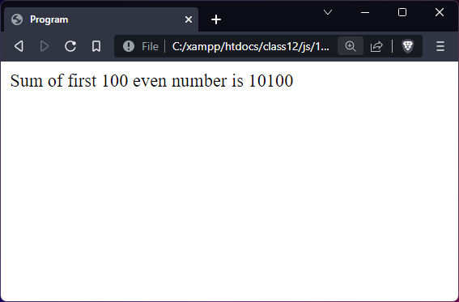</html>

### 19. WAP find the sum of first 67th odd number using function

<html>

<head>

<title>Program</title>

<head>

<body>

<script type="text/javascript">

function sum(num) {

var i=0, sum=0, index=0;

for(i=0;index<num;i++) {

if(i%2 != 0) {

sum += i;

index++;

}

}

}

// calling function

sum(67); // Since we need sum od 67 number so

document.write("Sum of first 67th odd number is " + sum);

</script>

</body>

</html>

### 20. WAP to print multiplication number

<html>

<head>

<title>Program</title>

<head>

<body>

<script type="text/javascript">

var num = parseInt(prompt("Enter a number"));

var num = 1

for(var i=1;i<=10;i++) {

document.write(num + " x "+i+" = "+num*i);

document.write("<br>")

}

</script>

</body>

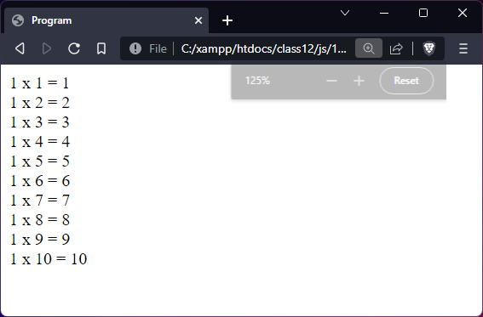</html>

### 21. WAP to print product of first natural number

<html>

<head>

<title>Program</title>

<head>

<body>

<script type="text/javascript">

var num = parseInt(prompt()), mulll=1;

for(var i=1;i<=num;i++) {

mulll *= i;

}

document.write("Multiplication of first natural number is " + mulll);

</script>

</body>

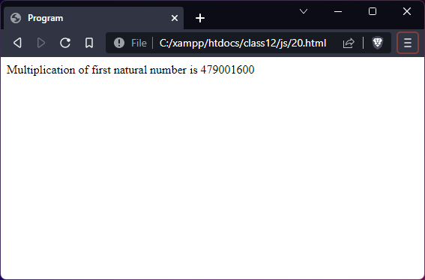</html>

### 22. WAP print factorial of 5

<html>

<head>

<title>Program</title>

<head>

<body>

<script type="text/javascript">

var fact=1;

for(var i=1;i<=5;i++) {

fact *= i;

}

document.write("Factorial of 5 is " + fact);

</script>

</body>

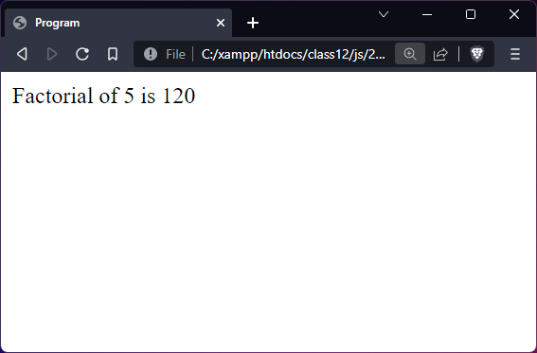</html>

### 23. WAP to print the factorial of given number

<html>

<head>

<title>Program</title>

<head>

<body>

<script type="text/javascript">

var num = parseInt(prompt());

var fact=1;

for(var i=1;i<=num;i++) {

fact *= i;

}

document.write("Factorial of" + num + " is " + fact);

</script>

</body>

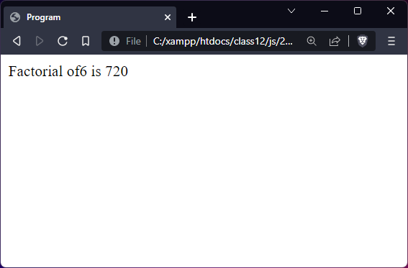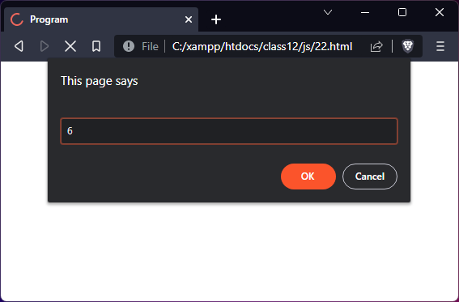</html>

### 24. WAP to print the factorial of number using function

<html>

<head>

<title>Program</title>

<head>

<body>

<script type="text/javascript">

var num = parseInt(prompt());

function factorial(num) {

var fact=1;

for(var i=1;i<=num;i++) {

fact *= i;

}

return fact;

}

document.write("Factorial of" + num + " is " + factorial(num));

</script>

</body>

</html>

### 25. WAP to check prime or composite

<html>

<head>

<title>Program</title>

<head>

<body>

<script type="text/javascript">

var num = parseInt(prompt());

var flag=0;

for(var i=2;i<=(num/2); i++) {

if(num%i==0) {

flag++;

}

}

if(flag>0) {

document.write("The number is composite numer");

} else {

document.write("The number is Prime numer");

}

</script>

</body>

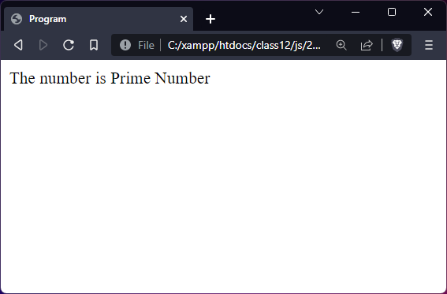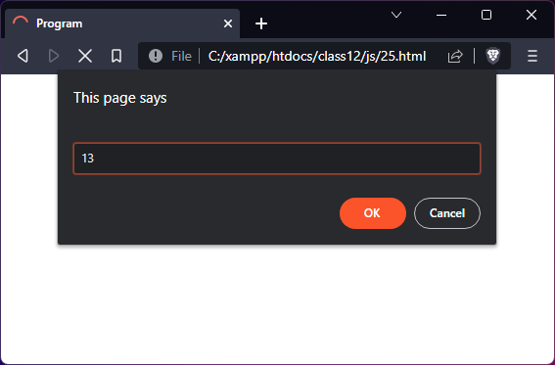</html>

### 26. WAP to check prime or composite using function

<html>

<head>

<title>Program</title>

<head>

<body>

<script type="text/javascript">

var num = parseInt(prompt());

function Check(num) {

var flag=0;

for(var i=2;i<=(num/2); i++) {

if(num%i==0) {

flag++;

}

}

if(flag>0) {

return "Composite"

} else {

return "Prime"

}

}

document.write("The number is "+ Check(num) +" Number");

</script>

</body>

</html>

### 27. WAP to listern click in js

<html>

<head>

<title>Program</title>

<head>

<body>

<button onclick="myFun()"> Click Me </button>

<script type="text/javascript">

/**

* Program to listern click in JS

*/

function myFun() {

alert("You cliked the Button");

}

</script>

</body>

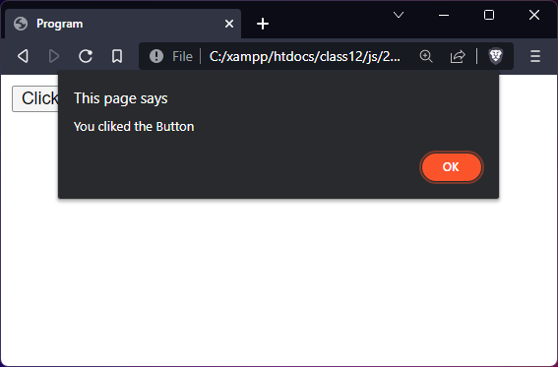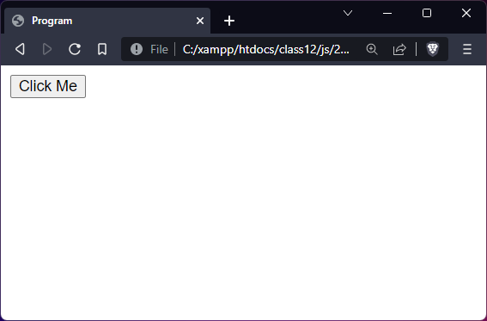</html>

### 29. WAP to reverse a string in javascript

<html>

<head>

<title>Program</title>

<head>

<body>

<script type="text/javascript">

function revString(string) {

var temp = "";

for(var i= string.length -1;i>=0;i++) {

temp += string[i];

}

return temp;

}

var str = prompt("Enter a sting");

document.write("The reverse of " + str + " is -> " + revString(str));

</script>

</body>

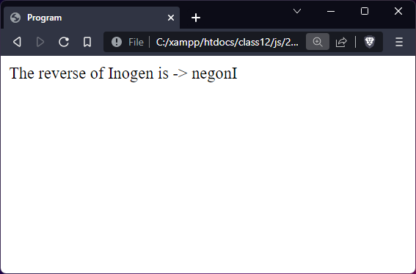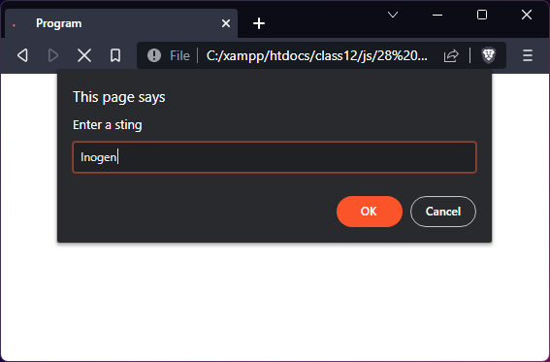</html>

### 35. WAP to create basic object in javascript

<html>

<head>

<title>Program</title>

<head>

<body>

<script type="text/javascript">

var student={

name: "Zero Two",

class:"XII",

roll: 18,

dob: "27/12/2004"

};

document.write(student.name+"<br>"+student.class+"<br>"+student.roll+"<br>"+student.dob);

</script>

</body>

</html>

### 36. WAP so object in javascript

<html>

<head>

<title>Program</title>

<head>

<body>

<script type="text/javascript">

/**

* Objects in JS

*/

var myObjs = {

name: prompt("Enter you Name"),

class: parseInt(prompt("Enter your class")),

roll: parseInt(prompt("Enter your Roll")),

DOB: prompt("Enter your DOB")

}

document.write("Name: " + myObjs.name);

document.write("Class: " + myObjs.class);

document.write("ROll: " + myObjs.roll);

document.write("DOB: " + myObjs.DOB);

</script>

</body>

</html>

### 

### 40. WAP to add image using javascript

<html>

<head>

<title>Program</title>

<head>

<body>

<button onclick="myFun()">Click Me</button>

<script type="text/javascript">

/**

* Program to add image

*/

function myFun() {

var myImage = document.createElement("img");

myImage.src = "myImage.png";

document.appendChild(myImage);

}

</script>

</body>

</html>

(PHP)

1) Program to Print Hello World

<html>

<head>

<title>Document</title>

</head>

<body>

<?php

echo "Hello, world";

?>

</body>

</html>

Output

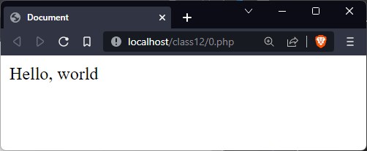

2) Program to print 1 to 10

<html>

<head>

<title>Document</title>

</head>

<body>

<?php

for($x=1; $x<=10; $x++)

{

echo (x < 10)?"$x, ":"$x"."\n";

}

?>

</body>

</html>

Output

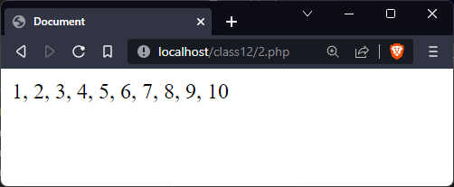

3) Program to connect to database in php

<?php

$servername = "localhost";

$usename = "root";

$password = "";

$dbCon = new mysqli($servername, $usename, $password);

// Checking if Connected or not

if($dbCon->connect_error) {

die( "Error: " . $dbCon->connect_error);

}

echo "Database sucesssfully Connected";

?>

Output

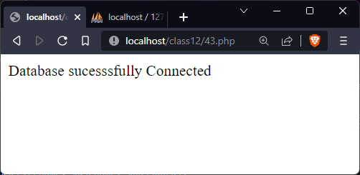

4) Creating Table using php

<?php

$servername = "localhost";

$usename = "root";

$password = "";

$db = "ino";

$dbCon = new mysqli($servername, $usename, $password, $db);

// Checking if Connected or not

if($dbCon->connect_error) {

die( "Error: " . $dbCon->connect_error);

}

echo "Database sucesssfully Connected<br>";

$sqlquery = "create table student(name varchar(20), rollno int, section varchar(5))";

echo "Table created";

$dbCon->query($sqlquery);

?>

Output



5) Program to display data from database

<?php

$servername = "localhost";

$usename = "root";

$password = "";

$db = "ino";

$dbCon = new mysqli($servername, $usename, $password, $db);

// Checking if Connected or not

if($dbCon->connect_error) {

die( "Error: " . $dbCon->connect_error);

}

// If database is connected

echo "Database sucesssfully Connected";

// Sql query

$sqlquery = "create table student(name varchar(20), rollno int, section varchar(5))";

$dbCon->query($sqlquery);

echo "<br>Table created successfull";

$sqlinsertquery = "insert into student values(\"Nabi\",1,\"p2\");";

$dbCon->query($sqlinsertquery);

echo "<br>Data added created successfull<br>";

// Fetching data

$you = $dbCon->query("SELECT * FROM student;");

// Printing

while($rec = $you->fetch_assoc()) {

echo "Name: ".$rec["name"]." Roll no: ".$rec["rollno"]." Section: ".$rec["section"]."<br>";

}

?>

Output

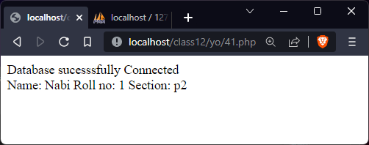

6) Program to display data from database in table

<?php

$servername = "localhost";

$usename = "root";

$password = "";

$db = "ino";

$dbCon = new mysqli($servername, $usename, $password, $db);

// Checking if Connected or not

if($dbCon->connect_error) {

die( "Error: " . $dbCon->connect_error);

}

// If database is connected

echo "Database sucesssfully Connected";

// Sql query

$sqlquery = "create table student(name varchar(20), rollno int, section varchar(5))";

$dbCon->query($sqlquery);

$sqlinsertquery = "insert into student values(\"Nabi\",1,\"p2\");";

$dbCon->query($sqlinsertquery);

// Fetching data

$yos = $dbCon->query("select * from student");

// Printing

echo "<table border=2>";

while($rec = $yos->fetch_assoc()) {

echo "<tr>";

echo "<td>".$rec["name"]." </td>";

echo "<td> ".$rec["rollno"]." </td>";

echo "<td> ".$rec["section"]."</td>";

echo "</tr>";

}

echo "</table>";

?>

Output

