**953323 Software Construction, Testing and Maintenance**

**Wat Phra Singh website**

**By**

**Aslan team**

**Ms.Chonticha Chang 552115014**

**Mr.Punjasin Punya 5521150**

**Ms.Phinthip Samutloiwon 552115050**

**Mr.Visava**

**Department of Software Engineering**

**College of Arts, Media, and Technology**

**Chiang Mai University**

Table of contents

User Requirement Specification and System Requirement Specification 2

Use case diagram 9

Use case description 10

Class diagram 44

Class description 48

Sequence diagram 63

Traceability matrix 74

1. **User Requirement Specification and System Requirement Specification**

**URS-01: Visitor, Member, and Admin can view the home page of the website.**

**SRS-01**: System shall connect to the database.   
**SRS-02:** System shall provide a menu bar that contain homepage link, activity announcement page link, temple’s history page link, gallery page link, contact page link, Q & A page link, map page link, and Facebook fan page link in every pages.  
**SRS-03:** System shall provide the user interface to display the home page.   
**SRS-04**: System shall provide a slide show image to display the temple’s area.

**URS-02: Visitor can register to be a member of the Wat Pra Singh web site.**

**SRS-05:** System shall provide register link for visitor on the home page.  
**SRS-06**: System shall provide register page that contain username textbox, password text box, re-password text box, email text box, submit button and cancel button.  
**SRS-01**: System shall connect to the database.   
**SRS-07**: System shall verify the input username format that allow only a-z, A-Z.  
**SRS-08**: System shall verify the input username length which allow between 5 -10 characters.  
**SRS-09**: System shall verify existing the input username with the database.  
**SRS-10**: System shall hide character in the password field.  
**SRS-11**: System shall verify the input password format that allow only a-z, A-Z, 0-9.  
**SRS-12:** System shall verify the input password length that allow between 6-12 characters.  
**SRS-13:** System shall verify password and re-password matched.  
**SRS-14:** System shall verify the input email format that allow email format (e.g.[xxx@abcmail.com](mailto:xxx@abcmail.com)).  
**SRS-15:** System shall verify existing the input email with the database.  
**SRS-16:** System shall record all information in the register page into the database.  
**SRS-17:** System shall redirect visitor to the homepage after register complete.  
**SRS-18:** System shall provide a success message “Register is succeeded”.  
**SRS-19**: System shall provide an error message “Username is required. Please input username”.   
**SRS-20**: System shall provide an error message “Password is required. Please input password”.   
**SRS-21**: System shall provide an error message “Re-password is required. Please input Re-password”.   
**SRS-22**: System shall provide an error message “Email is required. Please input Email”.   
**SRS-23**: System shall provide an error message “Username is invalid. Please use only a-z, A-Z”.   
**SRS-24**: System shall provide an error message “Username should be between 5-10 characters”.   
**SRS-25**: System shall provide an error message “Username exists”.   
**SRS-26**: System shall provide an error message “Password is invalid. Please use only a-z, A-Z, 0-9”.   
**SRS-27**: System shall provide an error message “Password should be between 6-12 characters”.   
**SRS-28**: System shall provide an error message “Password and re-password are not matched. Please try again”.   
**SRS-29**: System shall provide an error message “Email is in wrong format. Please try again”. **SRS-30**: System shall provide an error message “Email exists”.

**URS-03: Visitor, Member, and Admin can switch website language between Thai and English language.**

**SRS-01**: System shall connect to the database.   
**SRS-31**: System shall provide language button on every page to switch the language of the website between Thai and English.  
**SRS-32:** System shall change the web language to the language that user selected.

**URS-04: Visitor, Member, and Admin can view the activities announcement page.**

**SRS-01**: System shall connect to the database.   
**SRS-02:** System shall provide a menu bar that contain homepage link, activity announcement page link, temple’s history page link, gallery page link, contact page link, Q & A page link, map page link, and Facebook fan page link in every pages.  
**SRS-33**: System shall provide the user interface to display the activities announcement page.  
**SRS-34**: System shall separate each activity into the form of a list.  
**SRS-35**: System shall provide a link of each activity named by activity topic that arranged by date of activities for ten latest topic.

**URS-05: Visitor, Member, and Admin can view the detail of selected activity.**

**SRS-02:** System shall provide a menu bar that contain homepage link, activity announcement page link, temple’s history page link, gallery page link, contact page link, Q & A page link, map page link, and Facebook fan page link in every pages.  
**SRS-36**: System shall provide the user interface to display the activities detail page.  
**SRS-37**: System shall provide activity detail page that contain the name of activity, picture, activity date, and activity information.

**URS-06: Visitor, Member and Admin can view the Q&A page.**

**SRS-01**: System shall connect to the database.  
**SRS-02:** System shall provide a menu bar that contain homepage link, activity announcement page link, temple’s history page link, gallery page link, contact page link, Q & A page link, map page link, and Facebook fan page link in every pages.   
**SRS-38**: System shall provide the user interface to display Q&A page.  
**SRS-39**: System shall separate each Dharma question with an answer into the form of post arrange by the latest answer date.

**URS-07: Visitor, Member, and Admin can view the temple’s history page.**

**SRS-01**: System shall connect to the database.  
**SRS-02:** System shall provide a menu bar that contain homepage link, activity announcement page link, temple’s history page link, gallery page link, contact page link, Q & A page link, map page link, and Facebook fan page link in every pages.   
 **SRS-40**: System shall provide the user interface to display the history page.  
**SRS-41**: System shall provide temple's history information.

**URS-08: Visitor, Member, and Admin can view the gallery page.**

**SRS-01**: System shall connect to the database.  
**SRS-02:** System shall provide a menu bar that contain homepage link, activity announcement page link, temple’s history page link, gallery page link, contact page link, Q & A page link, map page link, and Facebook fan page link in every pages.  
**SRS-42**: System shall provide the user interface to display the gallery page.  
**SRS-43**: System shall separate each album into a list of picture's album link.  
**SRS-44**: System shall provide the thumbnail and the album’s name.

**URS-09: Visitor, Member, and Admin can view pictures of selected album.**

**SRS-02:** System shall provide a menu bar which contains homepage link, activity announcement page link, temple’s history page link, gallery page link, contact page link, Q & A page link, map page link, and Facebook fan page link in every pages.  
**SRS-45**: System shall provide user interface to display all pictures in the selected album.

**URS-10: Visitor, Member, and Admin can view the larger size of selected picture.**

**SRS-46**: System shall provide user interface to display the larger size of chosen picture in the album.

**URS-11: Visitor, Member, and Admin can view the contact page.**

**SRS-01**: System shall connect to the database.  
**SRS-02:** System shall provide a menu bar that contain homepage link, activity announcement page link, temple’s history page link, gallery page link, contact page link, Q & A page link, map page link, and Facebook fan page link in every pages.  
**SRS-47**: System shall provide the user interface to display the contact page.  
**SRS-48**: System shall provide the contact information that contains temple’s address, and phone number.

**USR-12: Visitor, Member, and Admin can view the map page.**

**SRS-02:** System shall provide a menu bar that contain homepage link, activity announcement page link, temple’s history page link, gallery page link, contact page link, Q & A page link, map page link, and Facebook fan page link in every pages.  
**SRS-49**: System shall provide the user interface to display the map page.  
**SRS-50**: System shall provide a map interface from Google map.  
**SRS-51**: System shall retrieve the location of the temple.  
**SRS-52**: System shall pinpoint the temple location.

**URS-13: Visitor, Member, and Admin can redirect to the temple’s Facebook fan page.**

**SRS-02:** System shall provide a menu bar that contain homepage link, activity announcement page link, temple’s history page link, gallery page link, contact page link, Q & A page link, map page link, and Facebook fan page link in every pages.  
**SRS-53**: System shall redirect to the Facebook fan page.

**URS-14: Member and Admin can login to the Wat Pra Singh web site.**

**SRS-54:** System shall provide the login button on the homepage.  
**SRS-55:** System shall provide a login interface that contain username textbox, password text box, submit button and cancel button.  
**SRS-01**: System shall connect to the database.  
**SRS-56**: System shall receive username and password from the user.  
**SRS-57**: System shall verify username and password.  
**SRS-58**: System shall provide a success message “login success”.  
**SRS-59**: System shall provide user’s feature as the different role (Member and Admin).  
**SRS-60**: System shall redirect to the home page.  
**SRS-61**: System shall display the error message “Username or password are not correct”.

**URS-15: Member and Admin can log out from the Wat Pra Singh web site.**

**SRS-62:** System shall provide the logout link on the menu bar after login complete.  
**SRS-63**: System shall disable user’s feature as the different role (Member and Admin) after log out complete.  
**SRS-60**: System shall redirect to the home page.

**URS-16: Member can send the Dharma question.**

**SRS03:** System shall connect to the database.   
**SRS-64**: System shall provide user interface to display the question form that contains question text box, and submit button.   
**SRS-65**: System shall insert the Dharma question into the database.   
**SRS-66**: System shall provide success message “Your question was sent”.  
**SRS-67**: System shall provide error message “Please fill in the Question”.

**URS-17: Member can receive the activity news from the temple via the registered email.**

**SRS-68:** System shall send the activity announcement to user’s email.

**URS-18: Admin can add the temple’s activities in the update activities page.**

**SRS-69:** System shall provide add button on activity announcement page.  
**SRS-70:** System shall provide user interface to display update activity page that contain the topic title text box, date, time, place of the activity, language radio button, submit button, and cancel button.  
**SRS-71:** System shall record new activity into the database. **SRS-68:** System shall send the activity announcement to user’s email.  
**SRS-72:** System shall display the success message “Add success”.  
**SRS-73:** System shall redirect to the activity announcement page.

**URS-19: Admin can edit the temple’s activities in the update activities page.**

**SRS-74:** System shall provide edit button after the activity title on the activity announcement page.  
**SRS-70:** System shall provide user interface to display update activity page that contain the topic title text box, date, time, place of the activity, language radio button, submit button, and cancel button.  
**SRS-75:** System shall retrieve the activity information from the database.  
**SRS-76:** System shall display the topic title, date, time, and place on the text box.  
**SRS-77:** System shall update the information in the database.  
**SRS-78:** System shall display the success message “Edit success”.  
**SRS-73:** System shall redirect to the activity announcement page.

**URS-20: Admin can delete the temple’s activities in the update activities page.**

**SRS-79:** System shall provide delete button after the activity title on the activity announcement page.  
**SRS-80:** System shall provide confirmation user interface “Are you sure to delete this activity? ”.  
**SRS-81:** System shall delete the activity in the database.  
**SRS-82:** System shall display the success message “Delete success”.  
**SRS-73:** System shall redirect to activity announcement page.

**URS-21: Admins can view unanswered Dharma question.**

**SRS-01:** System shall connect to the database.  
**SRS-02:** System shall provide a menu bar that contain homepage link, activity announcement page link, temple’s history page link, gallery page link, contact page link, Q & A page link, map page link, and Facebook fan page link in every pages.  
**SRS-36**: System shall provide the user interface to display unanswered Dharma question. **SRS-83**: System shall separate each Unanswered Dharma question into the form of post arrange by the latest question date.

**URS-22: Admin can answer the Dharma question in the Question page.**

**SRS-84:** System shall provide the answer button next to the question.  
**SRS-85:** System shall provide user interface to display the answer form that contain textbox, submit button, and cancel button.  
**SRS-86:** System shall add answer into the database.   
**SRS-87:** System shall display success message “Answer success”.  
**SRS-88:** System shall redirect to Q&A page.

**URS-23: Admin can delete the Dharma question in the Question page.**

**SRS-89:** System shall provide the delete button next to the question.  
**SRS-90:** System shall display confirmation user interface “Are you sure to delete this question.”   
**SRS-91:** System shall delete the question in the database.   
**SRS-82:** System shall display success message “Delete success”.  
**SRS-88:** System shall redirect to Q&A page.

**URS-24: Admin can edit the temple’s history page.**

**SRS-92:** System shall provide edit button on the temple’s history page.  
**SRS-93:** System shall provide text field, update button, and cancel button.  
**SRS-94:** System shall retrieve the temple’s history from the database.  
**SRS-95:** System shall display the temple’s history in the text field.  
**SRS-77:** System shall update the information in the database.  
**SRS-78:** System shall display the success message “Edit success”.  
**SRS-99:** System shall redirect to the temple’s history page.

1. **Use case diagram**

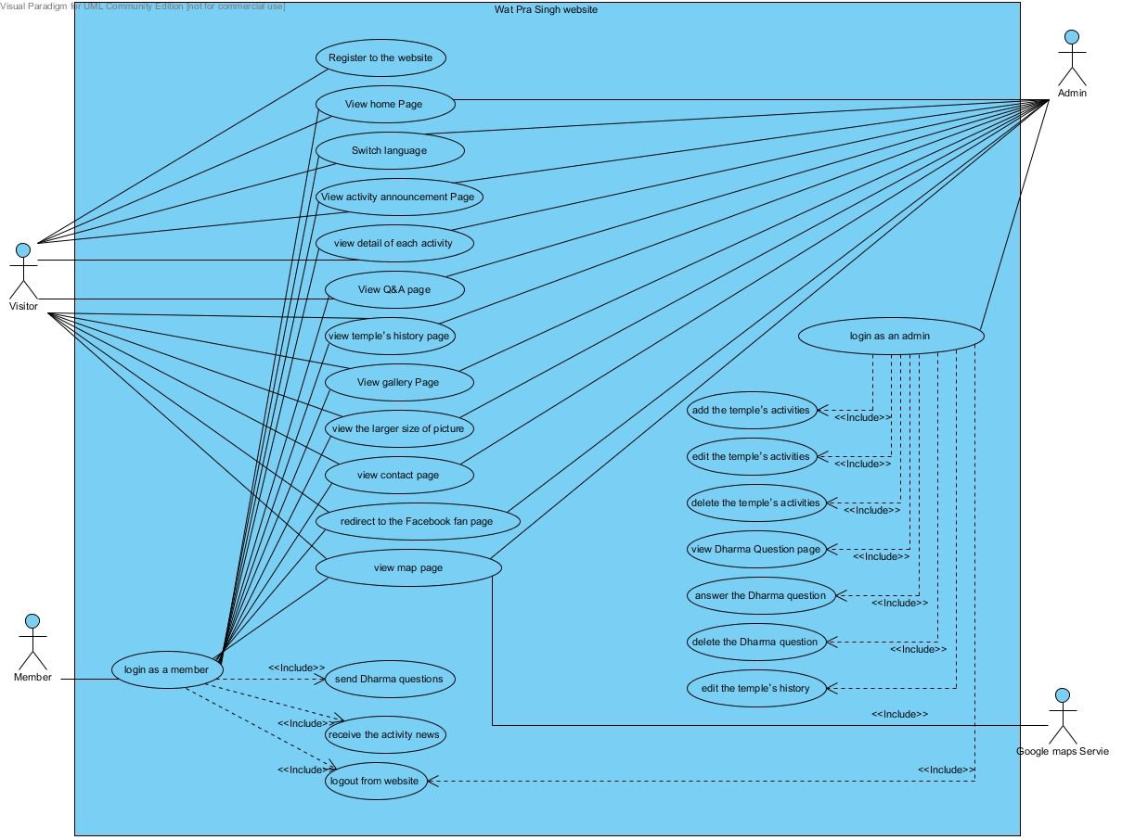

1. **Use Case Description**

**URS-01: Visitor, Member, and Admin can view the home page of the website.**

|  |  |
| --- | --- |
| **Use case ID** | UC-01 |
| **Use case name** | View home page. |
| **Description** | User as a visitor, a member or an admin can view the homepage that contain menu bar, login, a register link, and a slide show of temple’s area. |
| **Actor(s)** | Visitor, Member, Admin. |
| **Precondition** | - |
| **Post condition** | - User is on the homepage. |
| **Include(s)** | - |
| **Normal flow** | 1. User enters to the website. 2. System shall provide the user interface to display the home page with the menu bar. 3. System shall provide slide show image to display the temple’s area. |
| **Alternative flow** | Alternative flow A: User is already on any page of the website.  A.1 User selects ‘Wat Phra Singh’ link on the menu bar.  A.2 Go to Normal flow 2. |
| **Exception** | - |

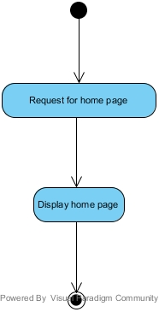

**AD-01: View home page.**

**URS-02: Visitor can register to be a member of the Wat Phra Singh website.**

|  |  |
| --- | --- |
| **Use case ID** | UC-02 |
| **Use case name** | Register. |
| **Description** | User as a visitor can register to the website for receive news and use Q&A. |
| **Actor(s)** | Visitor. |
| **Precondition** | - User is on the homepage. |
| **Post condition** | - User becomes member of the website. |
| **Include(s)** | UC-01 |
| **Normal flow** | 1. System shall provide register link to link to register page. 2. User selects register link. 3. System shall provide register page which include username textbox, password text box, re-password text box, email text box, and submit button. 4. User input information in every box and click submit. 5. System shall provide a success message “Register is succeeded”. |
| **Alternative flow** | - |
| **Exception** | In the step 4 of Normal flow, If username was not input,   1. System shall provide an error message “Username is required. Please input username”. 2. Go to 4 in Normal flow.   In the step 4 of Normal flow, If password was not input,   1. System shall provide an error message “Password is required. Please input password”. 2. Go to 4 in Normal flow.   In the step 4 of Normal flow, If Re-password was not input,   1. System shall provide an error message “Re-password is required. Please input Re-password”. 2. Go to 4 in Normal flow.   In the step 4 of Normal flow, If E-mail was not input,   1. System shall provide an error message “Email is required. Please input Email”. 2. Go to 4 in Normal flow.   In the step 4 of Normal flow, If Username was contain other character except a-z, A-Z,   1. System shall provide an error message “Username is invalid. Please use only a-z, A-Z”. 2. Go to 4 in Normal flow.   In the step 4 of Normal flow, If Username’s length was not between 5-10 characters,   1. System shall provide an error message “Username should be between 5-10 characters”. 2. Go to 4 in Normal flow.   In the step 4 of Normal flow, If Username was exist in Database,   1. System shall provide an error message “Username is existed”. 2. Go to 4 in Normal flow.   In the step 4 of Normal flow, If Password was contain other character except a-z, A-Z, 0-9,   1. System shall provide an error message “Password is invalid. Please use only a-z, A-Z, 0-9”. 2. Go to 4 in Normal flow.   In the step 4 of Normal flow, If Password’s length was not between 6-12,   1. System shall provide an error message “Password should be between 6-12 characters”. 2. Go to 4 in Normal flow.   In the step 4 of Normal flow, If Password and Re-password was not match,   1. System shall provide an error message “Password and re-password is not matched. Please try again”. 2. Go to 4 in Normal flow.   In the step 4 of Normal flow, If Email was not in format,   1. System shall provide an error message “Email is in wrong format. Please try again”. 2. Go to 4 in Normal flow.   In the step 4 of Normal flow, If Email was exist in Database,   1. System shall provide an error message “Email is existed”. 2. Go to 4 in Normal flow.   In the step 4 of Normal flow, if user select cancel button,  1. System shall redirect to home page. |

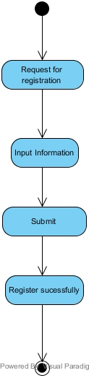

**AD-02: Register.**

**URS-03: Visitor, Member, and Admin can switch website language between Thai and English language.**

|  |  |
| --- | --- |
| **Use case ID** | UC-03 |
| **Use case name** | Switch Language |
| **Description** | User as a visitor, a member or an admin can switch website language between Thai and English language. |
| **Actor(s)** | Visitor, Member, Admin. |
| **Precondition** | - User is on any page of the website. |
| **Post condition** | - User views web site in selected language. |
| **Include(s)** | UC-01 |
| **Normal flow** | 1. System shall provide language button in every pages to switch the language of website between Thai and English. 2. User selects a language in the top right of the web page. 3. User see language changed. |
| **Alternative flow** | - |
| **Exception** | - |

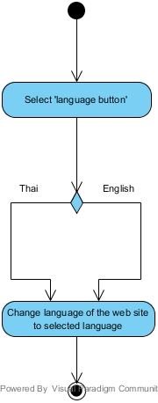

**AD-03: Switch Language**

**URS-04: Visitor, Member, and Admin can view the activities announcement page.**

|  |  |
| --- | --- |
| **Use case ID** | UC-04 |
| **Use case name** | View activities list |
| **Description** | User as a visitor, a member or an admin can view all activities in the activities announcement page. |
| **Actor(s)** | Visitor, Member, Admin. |
| **Precondition** | - User is on any page of the website. |
| **Post condition** | - User is on activities announcement page. |
| **Include(s)** | - |
| **Normal flow** | 1. User select activity on the menu bar. 2. System shall provide the user interface to display the activities announcement page which contain menu bar. 3. System shall separate each activity into the form of list. 4. System shall provide link of each activity named by activity topic that arranged by date of activities for 10 latest topic. |
| **Alternative flow** | - |
| **Exception** | - |

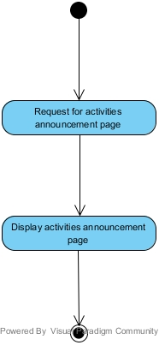

**AD-04: View activities list**

**URS-05: Visitor, Member, and Admin can view detail of selected activity.**

|  |  |
| --- | --- |
| **Use case ID** | UC-05 |
| **Use case name** | View detail of an activity |
| **Description** | User as a visitor, a member or an admin can view detail of each activity. |
| **Actor(s)** | Visitor, Member, Admin. |
| **Precondition** | - User is on activities announcement page. |
| **Post condition** | - User gets the detail of the temple activities. |
| **Include(s)** | UC-04 |
| **Normal flow** | 1. User selects activity in the list. 2. System shall provide the user interface to display the activities detail page with the menu bar. 3. System shall provide activity detail page which contain name of activity, activity date, and activity information. 4. User view detail of activity. |
| **Alternative flow** | - |
| **Exception** | - |

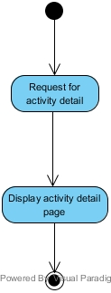

**AD-05:** View detail of an activity

**URS-06: Visitor, Member and Admin can view the Q&A page.**

|  |  |
| --- | --- |
| **Use case ID** | UC-06 |
| **Use case name** | View Q&A |
| **Description** | User as a visitor, a member or an admin can view the Dharma question and answer by go to Q&A page. . |
| **Actor(s)** | Visitor, Member. |
| **Precondition** | - User is on any page of the website. |
| **Post condition** | - User is on Q&A page. |
| **Include(s)** |  |
| **Normal flow** | 1. User selects Q&A on the menu bar. 2. System shall provide the user interface to display Q&A page which contain the menu bar. 3. System shall separate each Dharma question with an answer into form of post arrange by the latest answer date. 4. User sees the Dharma questions & answers. |
| **Alternative flow** | - |
| **Exception** | - |

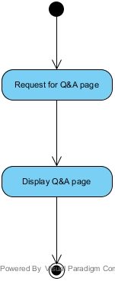

**AD-06: View Q&A**

**URS-07: Visitor, Member, and Admin can view the temple’s history page.**

|  |  |
| --- | --- |
| **Use case ID** | UC-07 |
| **Use case name** | View temple’s history |
| **Description** | User as a visitor, a member or an admin can view temple’s history by go to history page. |
| **Actor(s)** | Visitor, Member, Admin. |
| **Precondition** | - User is on any page of the web site. |
| **Post condition** | - User is on the temple’s history page. |
| **Include(s)** | - |
| **Normal flow** | 1. User selects history on menu bar. 2. System shall provide the user interface to display the history page with the menu bar. 3. System shall provide temple's history information. 4. User views temple’s history. |
| **Alternative flow** | - |
| **Exception** | - |

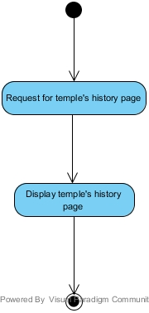

**AD-07: View temple’s history**

**URS-08: Visitor, Member, and Admin can view the gallery page.**

|  |  |
| --- | --- |
| **Use case ID** | UC-08 |
| **Use case name** | View gallery |
| **Description** | User as a visitor, a member or an admin can view all temple activity’s album by go to the gallery page. . |
| **Actor(s)** | Visitor, Member, Admin. |
| **Precondition** | - User is on any page of the web site. |
| **Post condition** | - User is on the gallery page. |
| **Include(s)** | - |
| **Normal flow** | 1. User selects gallery on the menu bar. 2. System shall provide the user interface to display the gallery page which contains the menu bar. 3. System shall provide the thumbnail and the album’s name. |
| **Alternative flow** | - |
| **Exception** | - |

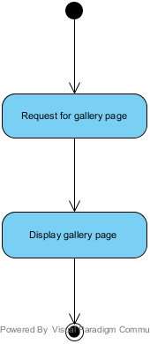

**AD-08: View gallery**

**URS-09: Visitor, Member, and Admin can view pictures of selected album.**

|  |  |
| --- | --- |
| **Use case ID** | UC-09 |
| **Use case name** | View pictures in selected album |
| **Description** | User as a visitor, a member or an admin can view pictures of selected album. . |
| **Actor(s)** | Visitor, Member, Admin. |
| **Precondition** | - User is on the gallery page. |
| **Post condition** | - User view pictures of selected album. |
| **Include(s)** | - UC-08 |
| **Normal flow** | 1. User selects album. 2. System shall provide user interface to display all pictures of the selected album. 3. User views all pictures of the album. |
| **Alternative flow** | - |
| **Exception** | - |

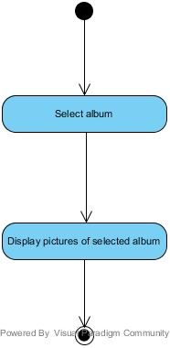

**AD-09: View pictures in selected album**

**URS-10: Visitor, Member, and Admin can view the larger size of selected picture.**

|  |  |
| --- | --- |
| **Use case ID** | UC-10 |
| **Use case name** | View the larger size of selected picture |
| **Description** | User as a visitor, a member or an admin can view the larger size of each activity picture by click on picture that user want to see it. . |
| **Actor(s)** | Visitor, Member, Admin. |
| **Precondition** | - User views pictures of each album. |
| **Post condition** | - User sees larger size of picture. |
| **Include(s)** | UC-08, UC-09 |
| **Normal flow** | 1. User select picture in the album. 2. System shall provide user interface to display the larger size of selected picture in the album. |
| **Alternative flow** | - |
| **Exception** | - |

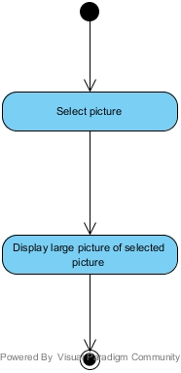

**AD-10: View the larger size of selected picture**

**URS-11: Visitor, Member, and Admin can view the contact page.**

|  |  |
| --- | --- |
| **Use case ID** | UC-11 |
| **Use case name** | View contact information |
| **Description** | User as a visitor, a member or an admin can view contact’s information by goes to contact page. . |
| **Actor(s)** | Visitor, Member, Admin. |
| **Precondition** | - User is on any page of the web site. |
| **Post condition** | - User is on the contact page. |
| **Include(s)** |  |
| **Normal flow** | 1. User select contact on menu bar. 2. System shall provide the user interface to display the contact page with the menu bar. 3. System shall provide the contact information which contains temple’s address, and phone number. |
| **Alternative flow** | - |
| **Exception** | - |

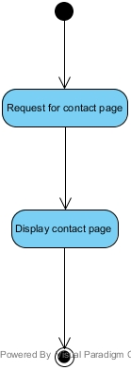

**AD-11: View contact information**

**USR-12: Visitor, Member, and Admin can view the map page.**

|  |  |
| --- | --- |
| **Use case ID** | UC-12 |
| **Use case name** | View map |
| **Description** | User as a visitor, a member or an admin can view map by go to map page. . |
| **Actor(s)** | Visitor, Member or Admin. |
| **Precondition** | - User is on any page of the web site. |
| **Post condition** | - User is on map page. |
| **Include(s)** |  |
| **Normal flow** | 1. User select map on menu bar. 2. System shall provide the user interface to display the map page with the menu bar. 3. System shall pin point the temple location. |
| **Alternative flow** | - |
| **Exception** | - |

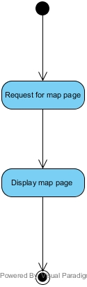

**AD-12: View map**

**URS-13: Visitor, Member, and Admin can redirect to the temple’s Facebook fan page.**

|  |  |
| --- | --- |
| **Use case ID** | UC-13 |
| **Use case name** | View Facebook fan page |
| **Description** | User as a visitor, a member or an admin can view temple’s Facebook fan page by selected Facebook on menu bar. |
| **Actor(s)** | Visitor, Member, Admin. |
| **Precondition** | - User is on any page of the web site. |
| **Post condition** | - User is redirected Facebook fan page. |
| **Include(s)** | - |
| **Normal flow** | 1. User selects Facebook on menu bar. 2. System shall redirect to the Facebook fan page. |
| **Alternative flow** | - |
| **Exception** | - |

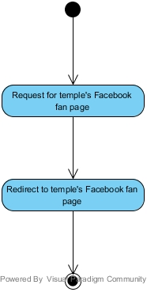

**AD-13: View Facebook fan page**

**URS-14: Member and Admin can login to the Wat Phra Singh website.**

|  |  |
| --- | --- |
| **Use case ID** | UC-14 |
| **Use case name** | Login |
| **Description** | User can login to the Wat Phra Singh website. There are two types of user after login, admin and member. Each type has different features. |
| **Actor(s)** | Member, Admin |
| **Precondition** | - User already has an account to access to the system.  - User is on the homepage. |
| **Post condition** | - User’s status will be changed to be admin or member.  - User can use more features in the system. |
| **Include(s)** | UC-01 |
| **Normal flow** | 1. User selects login button. 2. System shall provide a login interface which contain username textbox, password text box, and submit button. 3. User input information on the boxes and selects submit button. 4. System shall provide a success message “login success”. 5. System shall provide the member or admin feature to user. 6. System shall redirect to the home page after login complete. |
| **Alternative flow** | - |
| **Exception** | In the 3 step of Normal flow, If user input invalid username and password   1. System shall display error message “Username or password are not correct”. 2. Go to 3 in Normal flow.   In the 3 step of Normal flow, If user select cancel button   1. System shall redirect to home page. |

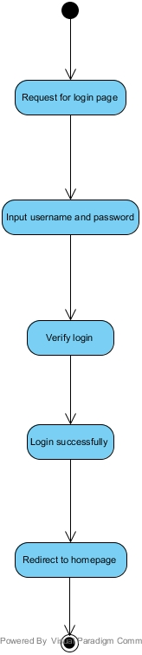

**AD-14: Login**

**URS-15: Member and Admin can logout from the Wat Phra Singh website.**

|  |  |
| --- | --- |
| **Use case ID** | UC-15 |
| **Use case name** | Logout |
| **Description** | User as a member or an admin cans logout from the Wat Phra Singh website. |
| **Actor(s)** | Member, Admin. |
| **Precondition** | - User is login to the website. |
| **Post condition** | - All features for admin or member will be disabled. |
| **Include(s)** | UC-14 |
| **Normal flow** | 1. User selects logout button on the menu bar. 2. System shall redirect to the home page. 3. User sees home page. |
| **Alternative flow** | - |
| **Exception** | - |

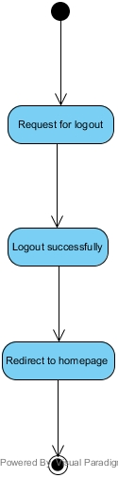

**AD-15: Logout**

**URS-16: Member can send the Dharma question.**

|  |  |
| --- | --- |
| **Use case ID** | UC-16 |
| **Use case name** | Send the Dharma question |
| **Description** | User as a member can send the Dharma question. |
| **Actor(s)** | Member |
| **Precondition** | - User login to the web site as a member.  - User is on the Q&A page. |
| **Post condition** | - User sent the Dharma question to admin. |
| **Include(s)** | UC-06, UC-14 |
| **Normal flow** | 1. System shall provide user interface to display the question form which contains question text box, and submit button. 2. User input information in the boxes and selects submit. 3. System shall provide success message “Your question was sent”. |
| **Alternative flow** | - |
| **Exception** | In the 2 step of Normal flow, if user not input question,  1. System shall provide error message “Please fill in the Question”.  2. Go to 2 Normal flow. |

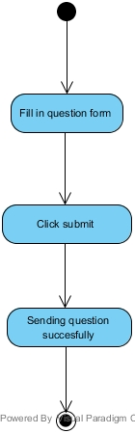

**AD-16: Send the Dharma question**

**URS-17: Member can receive the activity news from the temple via the registered email.**

|  |  |
| --- | --- |
| **Use case ID** | UC-17 |
| **Use case name** | Subscribe via email |
| **Description** | User as a member can receive the activity news from temple via the registered email**.** |
| **Actor(s)** | Member. |
| **Precondition** | - Admin adds new activity to activities announcement page. |
| **Post condition** | - Member receives the activity news via email. |
| **Include(s)** |  |
| **Normal flow** | 1. System shall able to send the activity announcement to user’s email. 2. User receives an email. |
| **Alternative flow** | - |
| **Exception** | - |

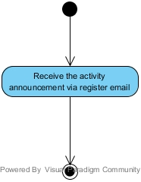

**AD-17: Subscribe via email**

**URS-18: Admin can add the temple’s activities in the update activities page.**

|  |  |
| --- | --- |
| **Use case ID** | UC-18 |
| **Use case name** | Add activity |
| **Description** | User as an admin can add the temple’s activities in the update activities page. |
| **Actor(s)** | Admin |
| **Precondition** | - User is login to the web site as an admin   - User is on activities announcement page. |
| **Post condition** | - New activity has been post to the website |
| **Include(s)** | UC-04, UC-14 |
| **Normal flow** | 1. System shall provide add button on activity announcement page. 2. User selects add button. 3. System shall provide user interface to display update activity page which contain the topic title textbox, date, time, place of the activity, submit button, and cancel button. 4. User input information of activity and selects submit button. 5. System shall display the success message “Add success”. 6. System shall redirect to the activity announcement page. |
| **Alternative flow** | - |
| **Exception** | In the step 4 of Normal flow, If user selects cancel button  1. Go to 6 in Normal flow. |

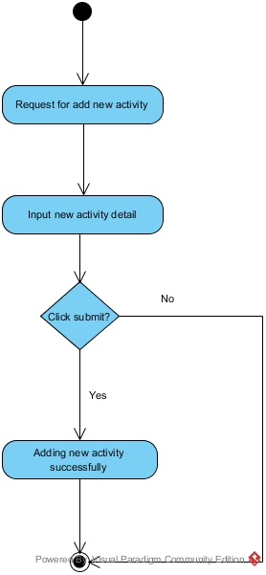

**AD-18: Add activity**

**URS-19: Admin can edit the temple’s activities in the update activities page.**

|  |  |
| --- | --- |
| **Use case ID** | UC-19 |
| **Use case name** | Edit activity. |
| **Description** | User as an admin can edit the temple’s activities in the update activities page. |
| **Actor(s)** | Admin |
| **Precondition** | - User Login as admin.  - User is on the activities announcement page. |
| **Post condition** | - The selected activity has been edited |
| **Include(s)** | UC-04 , UC 14 |
| **Normal flow** | 1. System shall provide edit button after the activity title on the activity announcement page. 2. User selects edit button. 3. System shall provide user interface to display update activity page which contain the topic title textbox, date, time, place of the activity, submit button, and cancel button. 4. System shall display the topic title, date, time, and place on the text box. 5. User edits information of activity in the boxes. 6. System shall display the success message “Edit success”. 7. System shall redirect to the activity announcement page. |
| **Alternative flow** | - |
| **Exception** | In the step 4 of Normal flow, If user selects cancel button  1. Go to 7 in Normal flow. |

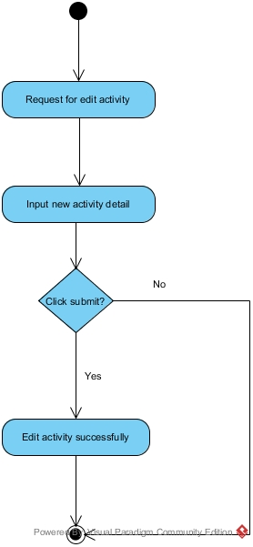

**AD-19: Edit activity**

**URS-20: Admin can delete the temple’s activities in the update activities page.**

|  |  |
| --- | --- |
| **Use case ID** | UC-20 |
| **Use case name** | Delete activity. |
| **Description** | User as an admin can delete the temple’s activities in the update activities page. |
| **Actor(s)** | Admin |
| **Precondition** | - User Login as admin.  - User is on the activities announcement page. |
| **Post condition** | - The selected activity has been delete |
| **Include(s)** | UC-04 , UC-14 |
| **Normal flow** | 1. System shall provide delete button after the activity title on the activity announcement page. 2. User select delete button. 3. System shall provide confirm user interface “Are you sure to delete this activity?” 4. User select confirm button. 5. System shall display the success message “Delete success”. 6. System shall redirect to activity announcement page. |
| **Alternative flow** | - |
| **Exception** | In the step 4 of Normal flow, If user selects cancel button  1. Go to 6 in Normal flow. |

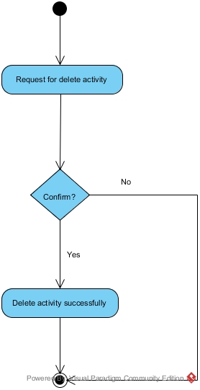

**AD-20: Delete activity**

**URS-21: Admins can view unanswered Dharma question.**

|  |  |
| --- | --- |
| **Use case ID** | UC-21 |
| **Use case name** | View unanswered Dharma question. |
| **Description** | User as an admin can view unanswered Dharma question on Dharma Question page. |
| **Actor(s)** | Admin |
| **Precondition** | - User login as admin.  - User is on any page. |
| **Post condition** | - User is on Q&A page. |
| **Include(s)** | UC-06 , UC-14 |
| **Normal flow** | 1. User selects Q&A on the menu bar. 2. System shall provide the user interface to display Q&A page which contain the menu bar. 3. System shall separate each Unanswered Dharma question into form of post arrange by the latest question date. |
| **Alternative flow** | - |
| **Exception** | - |

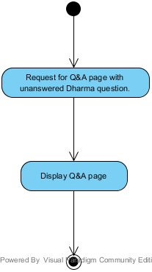

**AD-21: View unanswered Dharma question.**

**URS-22: Admin can answer the Dharma question in the Question page.**

|  |  |
| --- | --- |
| **Use case ID** | UC-22 |
| **Use case name** | Answer question. |
| **Description** | User as an admin can answer the Dharma question in the Dharma Question page. |
| **Actor(s)** | Admin |
| **Precondition** | - User login as admin.  - User is on Q&A page. |
| **Post condition** | - The selected question has been post with answer. |
| **Include(s)** | UC-06 , UC-14 |
| **Normal flow** | 1. System shall provide the answer button next to the question. 2. User selects answer button. 3. System shall provide user interface to display the answer form which contain textbox, submit button, and cancel button. 4. User input an answer and select submit button. 5. System shall display success message “Answer success”. 6. System shall redirect to Q&A page. |
| **Alternative flow** | - |
| **Exception** | In the step 4 of Normal flow, If user selects cancel button  1. Go to 6 in Normal flow. |

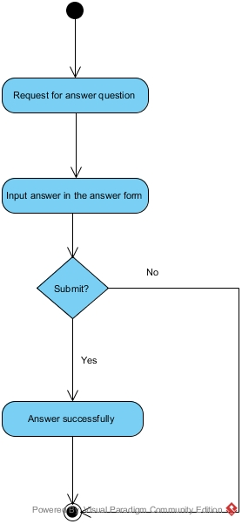

**AD-22: Answer question**

**URS-23: Admin can delete the Dharma question in the Question page.**

|  |  |
| --- | --- |
| **Use case ID** | UC-23 |
| **Use case name** | Delete question. |
| **Description** | User as an admin can delete the Dharma question in the Dharma Question page. |
| **Actor(s)** | Admin |
| **Precondition** | - User log in as admin.  - User is on the Q&A page. |
| **Post condition** | - The selected question has been deleted. |
| **Include(s)** |  |
| **Normal flow** | 1. System shall provide the delete button next to the question. 2. User selects delete button. 3. System shall display confirm user interface “Are you sure to delete this question” 4. User select confirm button. 5. System shall display success message “Delete success”. 6. System shall redirect to Q&A page. |
| **Alternative flow** | - |
| **Exception** | In the step 4 of Normal flow, If user selects cancel button  1. Go to 6 in Normal flow. |

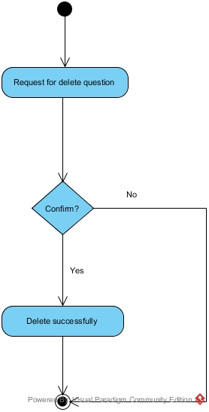

**AD-23: Delete question**

**URS-24: Admin can edit the temple’s history page.**

|  |  |
| --- | --- |
| **Use case ID** | UC-24 |
| **Use case name** | Edit the temple’s history |
| **Description** | User as an admin can edit the temple’s history. |
| **Actor(s)** | Admin |
| **Precondition** | - User log in as admin.  - User is on the temple’s history page. |
| **Post condition** | -The temple’s history page has been edit. |
| **Include(s)** | UC-04 , UC-14 |
| **Normal flow** | 1. System shall provide edit button on the temple’s history page. 2. User selects edit button. 3. System shall provide text field, update button, and cancel button. 4. System shall display the temple’s history on the text field. 5. User edits information and selects update button. 6. System shall display the success message “Edit success”. 7. System shall redirect to the temple’s history page. |
| **Alternative flow** | - |
| **Exception** | In the step 4 of Normal flow, If user selects cancel button  1. Go to 7 in Normal flow. |

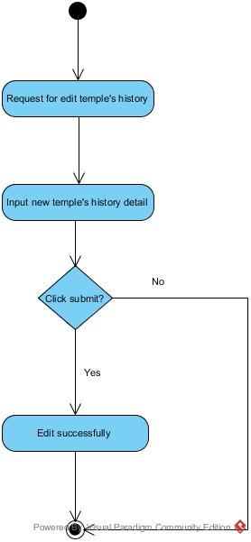

**AD-24: Edit the temple’s history**

1. **Class diagram**

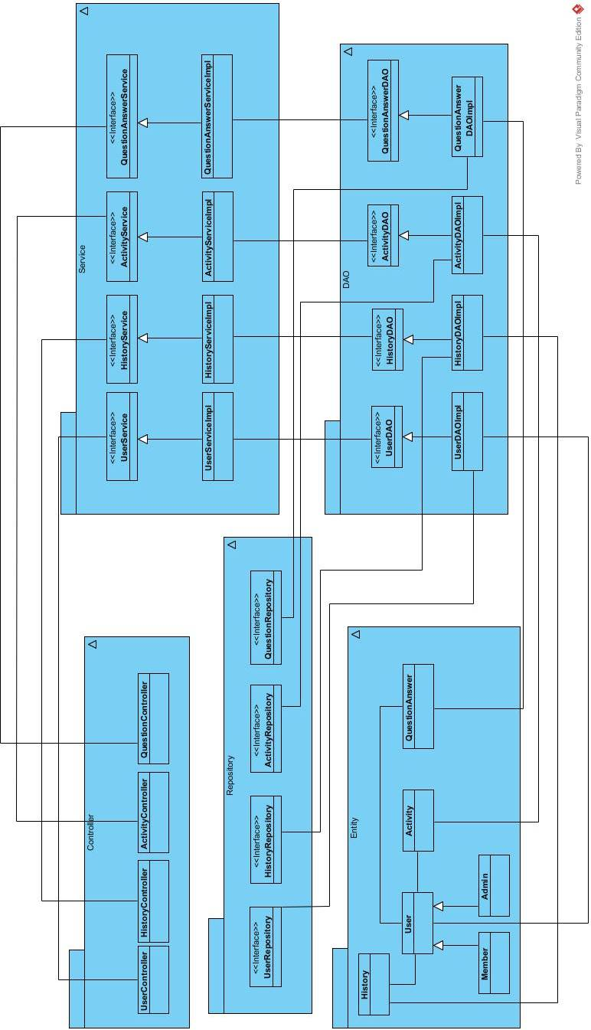

**CD-01: overall class diagram**

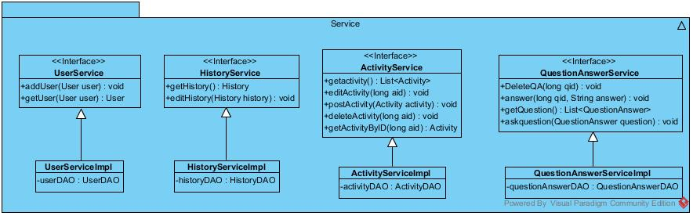

**CD-02: class diagram of service package**

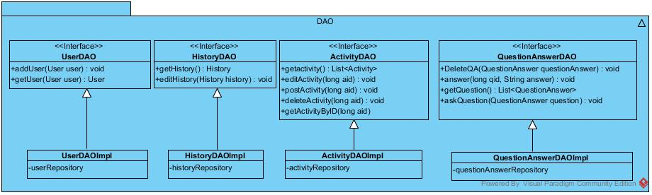

**CD-03: class diagram of DAO package**

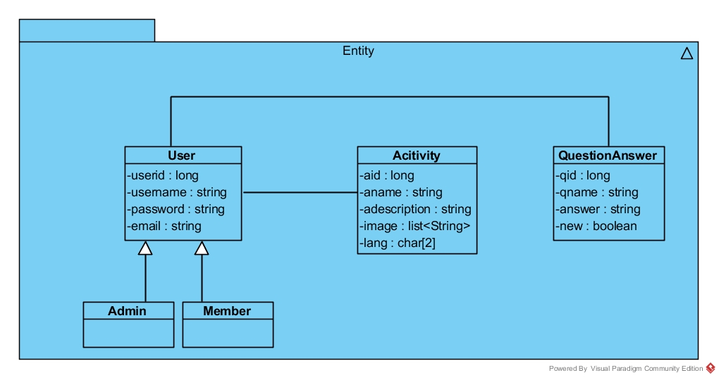

**AD-04: Class diagram of Entity package**

1. **Class description**
   1. **Controller package**

**4.1.1 Class name: UserController**

|  |
| --- |
| **UserController** |
| -userService : UserService |

**Property:**

|  |  |  |  |
| --- | --- | --- | --- |
| **ID** | **Name** | **Description** | **Remark** |
| 1 | userService | Object of UserService, used for control feature about user. | **Type:** UserService |

* + 1. **Class name: HistoryController**

|  |
| --- |
| **HistoryController** |
| -questionService : QuestionService |

**Property:**

|  |  |  |  |
| --- | --- | --- | --- |
| **ID** | **Name** | **Description** | **Remark** |
| 1 | historyService | Object of HistoryService, used for control feature about history. | **Type:** HistoryService |

* + 1. **Class name: ActivityController**

|  |
| --- |
| **ActivityController** |
| -activityService : ActivityService |

**Property:**

|  |  |  |  |
| --- | --- | --- | --- |
| **ID** | **Name** | **Description** | **Remark** |
| 1 | activityService | Object of ActivityService, used for control feature about activity. | **Type:** ActivityService |

* + 1. **Class name: QuestionController**

|  |
| --- |
| **QuestionController** |
| -questionService : QuestionService |

**Property:**

|  |  |  |  |
| --- | --- | --- | --- |
| **ID** | **Name** | **Description** | **Remark** |
| 1 | questionService | Object of QuestionService, used for control feature about question and answer. | **Type:** QuestionService |

* 1. **Service package**

**4.2.1 Class name: UserServiceImpl**

|  |
| --- |
| **UserServiceImpl** |
| **-**userDAO : UserDAO |
| +addUser(User user): void  +getUser(User user): User |

**Property:**

|  |  |  |  |
| --- | --- | --- | --- |
| **ID** | **Name** | **Description** | **Remark** |
| 1 | userDAO | Object of UserDAO, used for call feature about user. | **Type:** UserDAO |

**Method:**

|  |  |  |  |
| --- | --- | --- | --- |
| **ID** | **Name** | **Description** | **Remark** |
| 1 | addUser | Method for create new user in the system. | **Return:** void  **Param:** User |
| 2 | getUser | Method for get user from database in the system. | **Return:** User  **Param:** User |

* + 1. **Class name: HistoryServiceImpl**

|  |
| --- |
| **HistoryServiceImpl** |
| **-**historyDAO : HistoryDAO |
| +getHistory(): History  +editHistory(History history): void |

**Property:**

|  |  |  |  |
| --- | --- | --- | --- |
| **ID** | **Name** | **Description** | **Remark** |
| 1 | historyDAO | Object of HistoryDAO, used for call feature about history. | **Type:** HistoryDAO |

**Method:**

|  |  |  |  |
| --- | --- | --- | --- |
| **ID** | **Name** | **Description** | **Remark** |
| 1 | getHistory | Method for get history from database in the system. | **Return:** History |
| 2 | editHistory | Method for edit history in the system. | **Return:** void  **Param:** History |

* 1. **Service package**
     1. **Class name: ActivityServiceImpl**

|  |
| --- |
| **ActivityServiceImpl** |
| **-**activityDAO : ActivtyDAO |
| +getActivity(): List<Activity>  +editActivity(long aid): void  +postActivity(Activity activity): void  +deleteActivity(long aid): void  +getActivityByID(long aid):Activity |

**Property:**

|  |  |  |  |
| --- | --- | --- | --- |
| **ID** | **Name** | **Description** | **Remark** |
| 1 | activityDAO | Object of ActivityDAO, used for call feature about activity. | **Type:** ActivityDAO |

**Method:**

|  |  |  |  |
| --- | --- | --- | --- |
| **ID** | **Name** | **Description** | **Remark** |
| 1 | getActivity | Method for get all activity from Database in the system. | **Return:** List<Activity> |
| 2 | editActivity | Method for edit activity in the system. | **Return:** void  **Param:** Long |
| 3 | postActivity | Method for post activity in the system. | **Return:** void  **Param:** Activity |
| 4 | deleteActivity | Method for get all activity from Database in the system. | **Return:** void  **Param:** Long |
| 5 | getActivityByID | Method for get activity from Database in the system. | **Return:** Activity  **Param:** Long |

* + 1. **Class name: QuestionAnswerServiceImpl**

|  |
| --- |
| **QuestionAnswerServiceImpl** |
| **-**questionAnswerDAO : QuestionAnswerDAO |
| +DeleteQA(long qid): void  +answer(long qid, String answer): void  +getQuestion(): List<QuestionAnswer>  +askquestion(QuestionAnswer question): void |

**Property:**

|  |  |  |  |
| --- | --- | --- | --- |
| **ID** | **Name** | **Description** | **Remark** |
| 1 | questionAnswerDAO | Object of QuestionAnswerDAO, used for call feature about question and answer. | **Type:** QuestionAnswerDAO |

**Method:**

|  |  |  |  |
| --- | --- | --- | --- |
| **ID** | **Name** | **Description** | **Remark** |
| 1 | DeleteQA | Method for delete question and answer in the system. | **Return:** void |
| 2 | answer | Method for add answer in the system. | **Return:** void  **Param:** Long, String |
| 3 | getQuestion | Method for get all question and answer from Database in the system. | **Return:** List<QuestionAnswer> |
| 4 | askquestion | Method for create question in the system. | **Return:** void  **Param:** QuestionAnswer |

* 1. **Dao Package**

**4.4.1 Class name: UserDAOImpl**

|  |
| --- |
| **UserDAOImpl** |
| -userRepository : UserRepository |
| +addUser(User user) : void  +getUser(User user) : User |

**Property:**

|  |  |  |  |
| --- | --- | --- | --- |
| **ID** | **Name** | **Description** | **Remark** |
| 1 | userRepository | Used for controller to database. | **Type:** UserRepository |

**Method:**

|  |  |  |  |
| --- | --- | --- | --- |
| **ID** | **Name** | **Description** | **Remark** |
| 1 | addUser | Used for registration | **Return:** void  **Param:** User |
| 2 | getUser | Used for verify | **Return:** User  **Param:** User |

* + 1. **Class name: HistoryDAOImpl**

|  |
| --- |
| **HistoryDAOImpl** |
| -historyRepository : HistoryRepository |
| +getHistory(): History  +editHistory(History history): void |

**Property:**

|  |  |  |  |
| --- | --- | --- | --- |
| **ID** | **Name** | **Description** | **Remark** |
| 1 | historyRepository | Used for controller to database. | **Type:**HistoryRepository |

**Method:**

|  |  |  |  |
| --- | --- | --- | --- |
| **ID** | **Name** | **Description** | **Remark** |
| 1 | getHistory | Used for retrieve history from database | **Return:** History |
| 2 | editHistory | Used for change information about history | **Return:** void  **Param:** History |

* + 1. **Class name: ActivityDAOImpl**

|  |
| --- |
| **ActivityDAOImpl** |
| -activityRepository : ActivityRepository |
| +getactivity() : List<Activity> +editActivity(Activity activity) : void  +postActivity(Activity activity) : void  +deleteActivity(Activity activity) : void  +getActivityByID(long aid): Activity |

**Property:**

|  |  |  |  |
| --- | --- | --- | --- |
| **ID** | **Name** | **Description** | **Remark** |
| 1 | activityRepository | Used for controller to database. | **Type:**ActivityRepository |

**Method:**

|  |  |  |  |
| --- | --- | --- | --- |
| **ID** | **Name** | **Description** | **Remark** |
| 1 | getactivity | Used for retrieve list of activity in the database | **Return:** List<Activity> |
| 2 | editActivity | Used for change information about Activity | **Return:** void  **Param:** Activity |
| 3 | postActivity | Used for adding new Activity to the database. | **Return:** void  **Param:** Activity |
| 4 | deleteActivity | Used for delete activity | **Return:** void  **Param:** Activity |
| 5 | getActivityByID | Used for retrieve activity in the database | **Return:** Activity  **Param:** Long |

* + 1. **Class name: QuestionAnswerDAOImpl**

|  |
| --- |
| **QuestionAnswerDAOImpl** |
| -questionAnswerRepository : QuestionRepository |
| +DeleteQA(QuestionAnswer questionAnswer) : void  +answer(long qid, String answer) : void  +getQuestion() : List<QuestionAnswer>  +askQuestion(QuestionAnswer question) : void |

**Property:**

|  |  |  |  |
| --- | --- | --- | --- |
| **ID** | **Name** | **Description** | **Remark** |
| 1 | questionAnswerRepository | Used for controller to database. | **Type:**QuestionRepository |

**Method:**

|  |  |  |  |
| --- | --- | --- | --- |
| **ID** | **Name** | **Description** | **Remark** |
| 1 | getQuestion | Used for retrieve list of question in the database | **Return:** List<QuestionAnswer> |
| 2 | DeleteQA | Used for delete Question. | **Return:** void  **Param:** QuestionAnswer |
| 3 | answer | Used for adding answer on selected question. | **Return:** void  **Param:** Long, String |
| 4 | askQuestion | Used for adding new question into database | **Return:** void  **Param:** QuestionAnswer |

**4.5 Entity package**

**4.5.1 Class name: User**

|  |
| --- |
| **User** |
| -userid :long  -username: string  -password : string  -email: string |

**Property:**

|  |  |  |  |
| --- | --- | --- | --- |
| **ID** | **Name** | **Description** | **Remark** |
| 1 | userid | Store the id of the user | **Type:**long |
| 2 | username | Store the user name of the user | **Type:** String |
| 3 | password | Store the password of the user | **Type:** String |
| 4 | email | Store the email of the user | **Type:** String |

**4.5.2 Class name: Activity**

|  |
| --- |
| **Activity** |
| -aid :long  -aname: string  -adescription : string  -image: list<String>  -lang:char[2] |

**Property:**

|  |  |  |  |
| --- | --- | --- | --- |
| **ID** | **Name** | **Description** | **Remark** |
| 1 | arid | Store the id of the activity | **Type:**long |
| 2 | aname | Store the name of the activity | **Type:** String |
| 3 | adescription | Store description of the activity | **Type:** String |
| 4 | image | Store the image url of the activity | **Type:** String |
| 5 | Lang | Store the langeage type of the activity | **Type** : array of char  char[2] |

**4.5.3 Class name: QuestionAnswer**

|  |
| --- |
| **QuestionAnswer** |
| -qid :long  -qname: string  -answer : string  -newQ : boolean |

**Property:**

|  |  |  |  |
| --- | --- | --- | --- |
| **ID** | **Name** | **Description** | **Remark** |
| 1 | qrid | Store the id of the question | **Type:**long |
| 2 | qname | Store the name of the question | **Type:** String |
| 3 | Answer | Store answer | **Type:** String |
| 4 | newQ | Store the image url of the question | **Type:** Boolean |

**Sequence diagram**

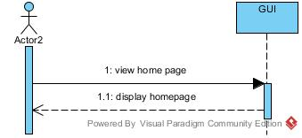

**SD-01: view the home page of the website.**

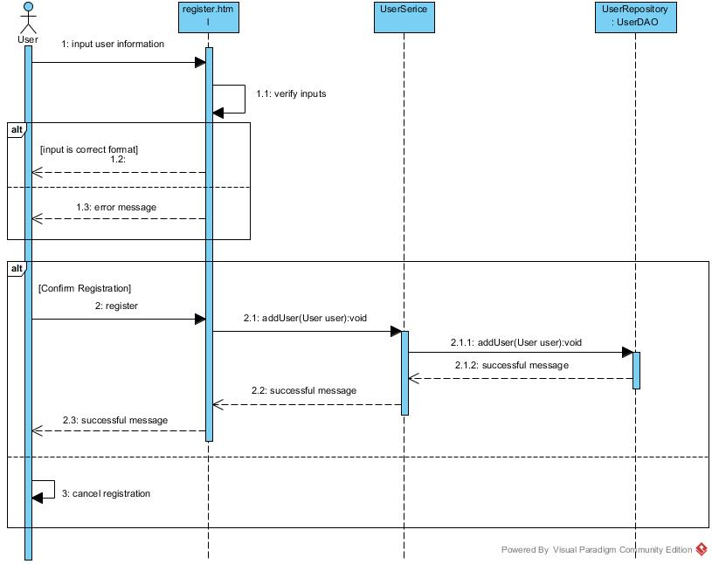

**SD-02: register to be a member**

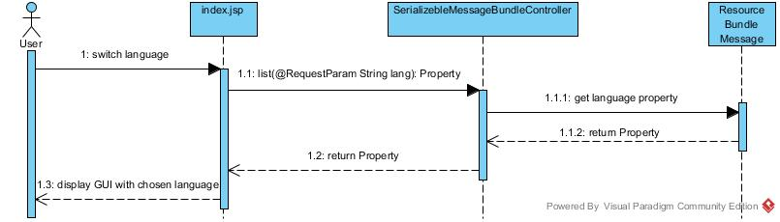

**SD-03: switch website language**

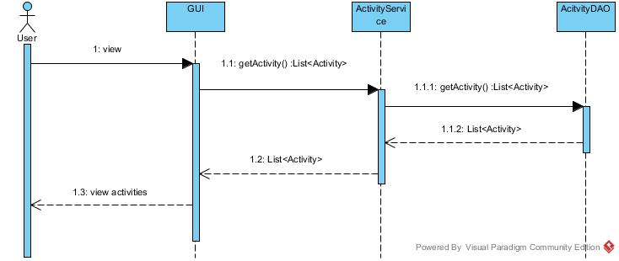

**SD-04: view all activities**

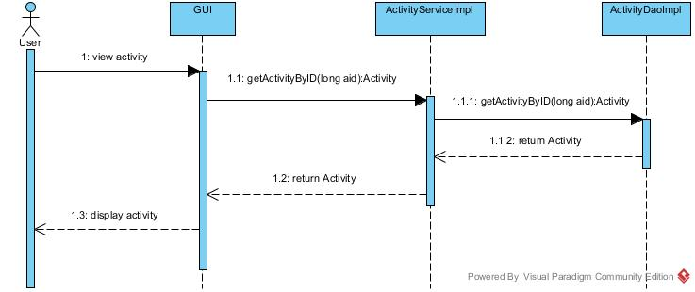

**SD-05: view the detail of selected activity.**

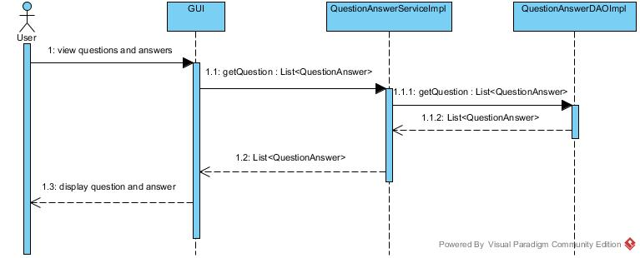

**SD-06: view the Q&A page**

**SD-07: view the temple’s history page.**

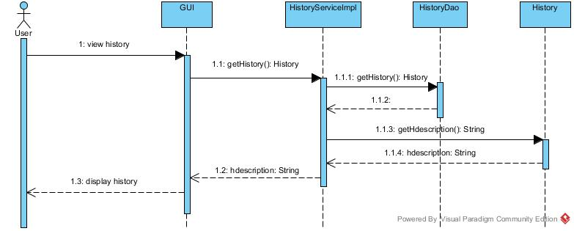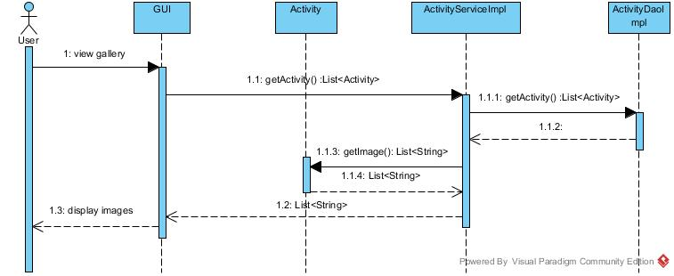

**SD-08: view the gallery page.**

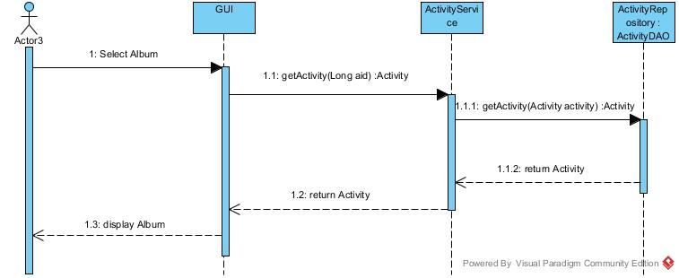

**SD-09: view pictures of selected album.**

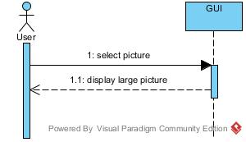

**SD-10: view the larger size of selected picture.**

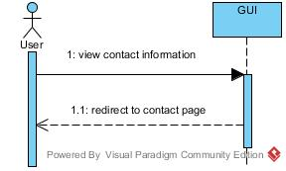

**SD-11: view the contact page.**

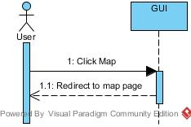

**SD-12: view the map page.**

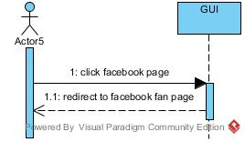

**Sd-13: redirect to the temple’s Facebook fan page.**

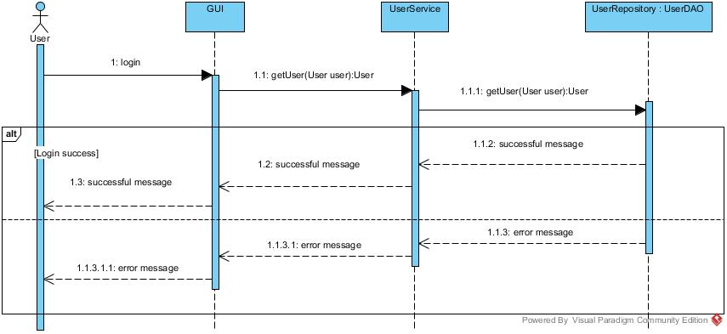

**SD-14: login to the Wat Pra Singh web site.**

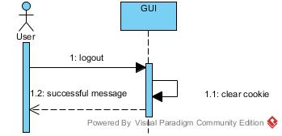

**SD-15: log out from the Wat Pra Singh web site.**

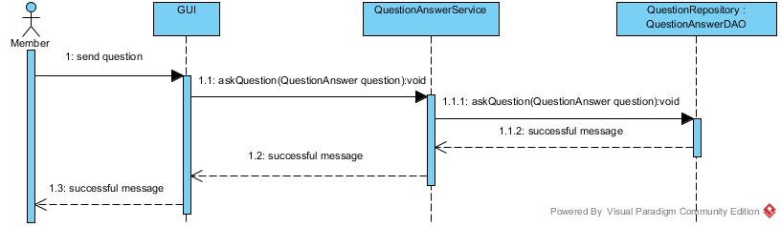

**SD-16: send the Dharma question.**

**SD-17: receive the activity news from the temple via the registered email**

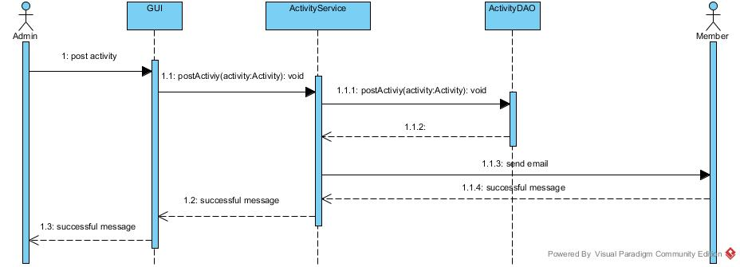

**SD-18: add the temple’s activities**

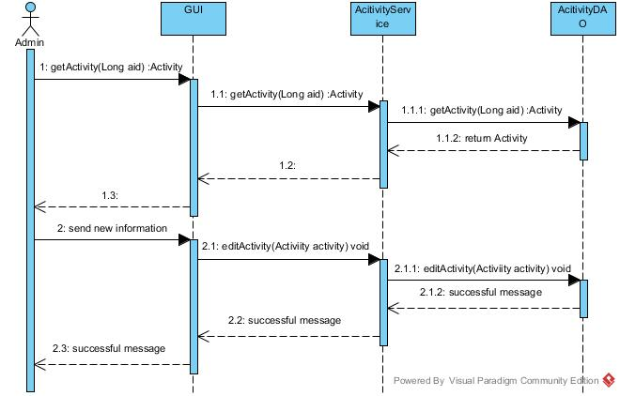

**SD-19: edit the temple’s activities**

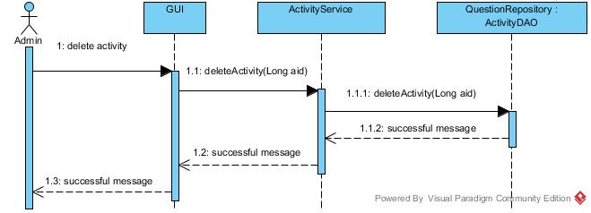

**SD-20: delete the temple’s activities**

**SD-21: view unanswered Dharma question.**

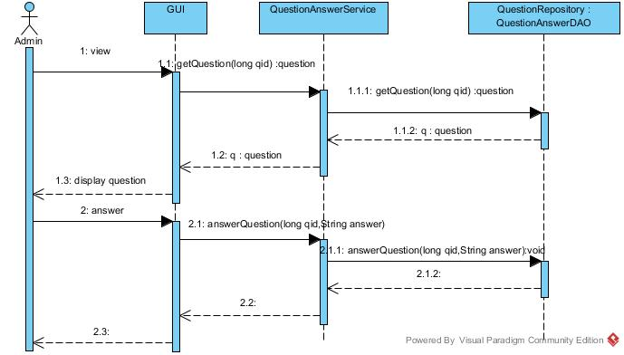

**SD-22: answer the Dharma question**

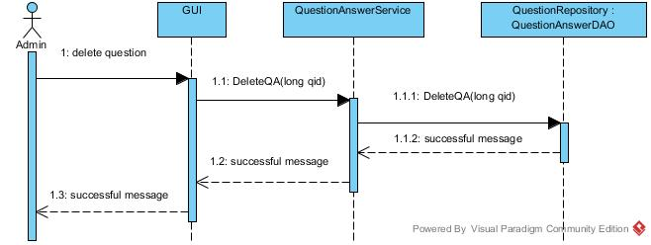

**SD-23: delete the Dharma question**

**SD-24: edit the temple’s history**

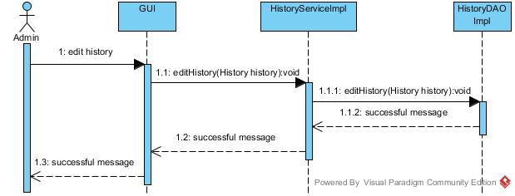

**Traceability Matrix**

|  |  |  |  |  |  |  |
| --- | --- | --- | --- | --- | --- | --- |
| **No.** | **URS ID** | **URS** | **SRS ID** | **UC** | **AD** | **SD** |
| 1 | 01 | Visitor, Member, and Admin can view the home page of the website. | 01- 04 | 01 | 01 | 01 |
| 2 | 02 | Visitor can register to be a member of the Wat Pra Singh web site. | 01, 05-30 | 02 | 02 | 02 |
| 3 | 03 | Visitor, Member, and Admin can switch website language between Thai and English language. | 01,31,32 | 03 | 03 | 03 |
| 4 | 04 | Visitor, Member, and Admin can view the activities announcement page. | 01,02,33,34,35 | 04 | 04 | 04 |
| 5 | 05 | Visitor, Member, and Admin can view the detail of selected activity. | 02,36,37 | 05 | 05 | 05 |
| 6 | 06 | Visitor, Member and Admin can view the Q&A page. | 01,02,38,39 | 06 | 06 | 06 |
| 7 | 07 | Visitor, Member, and Admin can view the temple’s history page. | 01,02,40,41 | 07 | 07 | 07 |
| 8 | 08 | Visitor, Member, and Admin can view the gallery page. | 01,02,42,43,44 | 08 | 08 | 08 |
| 9 | 09 | Visitor, Member, and Admin can view pictures of selected album. | 02,45 | 09 | 09 | 09 |
| 10 | 10 | Visitor, Member, and Admin can view the larger size of selected picture. | 46 | 10 | 10 | 10 |
| 11 | 11 | Visitor, Member, and Admin can view the contact page. | 01,02,47,48 | 11 | 11 | 11 |
| 12 | 12 | Visitor, Member, and Admin can view the map page. | 02,49,50,51,52 | 12 | 12 | 12 |
| 13 | 13 | Visitor, Member, and Admin can redirect to the temple’s Facebook fan page. | 02,53 | 13 | 13 | 13 |
| 14 | 14 | Member and Admin can login to the Wat Pra Singh web site. | 01,54-61 | 14 | 14 | 14 |
| 15 | 15 | Member and Admin can log out from the Wat Pra Singh web site. | 60,62,63 | 15 | 15 | 15 |
| 16 | 16 | Member can send the Dharma question. | 03,64-67 | 16 | 16 | 16 |
| 17 | 17 | Member can receive the activity news from the temple via the registered email. | 68 | 17 | 17 | 17 |
| 18 | 18 | Admin can add the temple’s activities in the update activities page. | 69-73 | 18 | 18 | 18 |
| 19 | 19 | Admin can edit the temple’s activities in the update activities page. | 70,73-78 | 19 | 19 | 19 |
| 20 | 20 | Admin can delete the temple’s activities in the update activities page. | 73,79-82 | 20 | 20 | 20 |
| 21 | 21 | Admins can view unanswered Dharma question. | 01,02,36,83 | 21 | 21 | 21 |
| 22 | 22 | Admin can answer the Dharma question in the Question page. | 84-88 | 22 | 22 | 22 |
| 23 | 23 | Admin can delete the Dharma question in the Question page. | 82,88-91 | 23 | 23 | 23 |
| 24 | 24 | Admin can edit the temple’s history page. | 77,78,92-99 | 24 | 24 | 24 |