**URS-01: Visitor can register to be a member of Wat Pra Singh Website.**

|  |  |
| --- | --- |
| **Use case ID** | URS-01 |
| **Use case name** | Register. |
| **Description** | Visitor can register to the website for receive news and use Q&A. |
| **Actor(s)** | Visitor |
| **Precondition** | User enters website. |
| **Post condition** | User becomes member of the website. |
| **Normal flow** | 1. User selects home on the menu bar. 2. System shall provide the user interface to display the home page with the menu bar. 3. System shall provide register link to link to register page. 4. User selects register link. 5. System shall provide register page which include username textbox, password text box, re-password text box, email text box, and submit button. 6. User input information in every box and click submit. 7. System shall provide a success message “Register is succeeded”. |
| **Alternative flow** | If username was not input,   1. System shall provide an error message “Username is required. Please input username”. 2. User need to input and click submit again. 3. Go to 7 in Normal flow.   If password was not input,   1. System shall provide an error message “Password is required. Please input password”. 2. User need to input and click submit again. 3. Go to 7 in Normal flow.   If Re-password was not input,   1. System shall provide an error message “Re-password is required. Please input Re-password”. 2. User need to input and click submit again. 3. Go to 7 in Normal flow.   If E-mail was not input,   1. System shall provide an error message “Email is required. Please input Email”. 2. User need to input and click submit again. 3. Go to 7 in Normal flow.   If Username was contain other character except a-z, A-Z,   1. System shall provide an error message “Username is invalid. Please use only a-z, A-Z”. 2. User need to input and click submit again. 3. Go to 7 in Normal flow.   If Username’s length was not between 5-10 characters,   1. System shall provide an error message “Username should be between 5-10 characters”. 2. User need to input and click submit again. 3. Go to 7 in Normal flow.   If Username was exist in Database,   1. System shall provide an error message “Username is existed”. 2. User need to input and click submit again. 3. Go to 7 in Normal flow.   If Password was contain other character except a-z, A-Z, 0-9,   1. System shall provide an error message “Password is invalid. Please use only a-z, A-Z, 0-9”. 2. User need to input and click submit again. 3. Go to 7 in Normal flow.   If Password’s length was not between 6-12,   1. System shall provide an error message “Password should be between 6-12 characters”. 2. User need to input and click submit again. 3. Go to 7 in Normal flow.   If Password and Re-password was not match,   1. System shall provide an error message “Password and re-password is not matched. Please try again”. 2. User need to input and click submit again. 3. Go to 7 in Normal flow.   If Email was not in format,   1. System shall provide an error message “Email is in wrong format. Please try again”. 2. User need to input and click submit again. 3. Go to 7 in Normal flow.   If Email was exist in Database,   1. System shall provide an error message “Email is existed”. 2. User need to input and click submit again. 3. Go to 7 in Normal flow. |
| **Exception** | - |

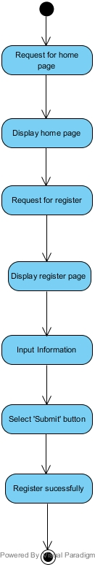

**URS-02: Visitor, Member or Admin can view home page of the website.**

|  |  |
| --- | --- |
| **Use case ID** | URS-02 |
| **Use case name** | View home page. |
| **Description** | Users can view current temple’s picture in the home page of the website. |
| **Actor(s)** | Visitor, Member or Admin. |
| **Precondition** | User enters to the website. |
| **Post condition** | User known current temple’s appearance. |
| **Normal flow** | 1. User selects home on the menu bar. 2. System shall provide the user interface to display the home page with the menu bar. 3. System shall provide slide show image to display the temple’s area. 4. User sees the temple’s pictures. |
| **Alternative flow** | - |
| **Exception** | - |

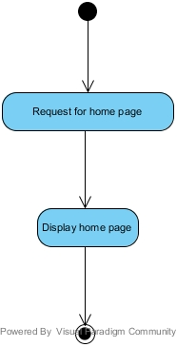

**URS-03: Visitor, Member or Admin can switch website language between Thai and English language.** Switch normal flow 1-2

|  |  |
| --- | --- |
| **Use case ID** | URS-03 |
| **Use case name** | Switch Language |
| **Description** | User can switch website language between Thai and English language. |
| **Actor(s)** | Visitor, Member or Admin. |
| **Precondition** | User enters to the website. |
| **Post condition** | User seen web in difference language. |
| **Normal flow** | 1. System shall provide language button in every pages to switch the language of website between Thai and English. 2. User selects a language in the top right of the web page. 3. User see language changed. |
| **Alternative flow** | - |
| **Exception** | - |

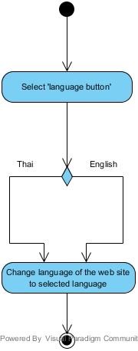

**URS-04: Visitor, Member or Admin can view activities announcement page.**

|  |  |
| --- | --- |
| **Use case ID** | URS-04 |
| **Use case name** | View activities list |
| **Description** | Visitor can view all activities in the activities announcement page. |
| **Actor(s)** | Visitor, Member or Admin. |
| **Precondition** | User enters to the website. |
| **Post condition** | User sees all of the temple activities. |
| **Normal flow** | 1. User select activity on the menu bar. 2. System shall provide the user interface to display the activities announcement page which contain menu bar. 3. System shall separate each activity into the form of list. 4. System shall provide link of each activity named by activity topic that arranged by date of activities for 10 latest topic. |
| **Alternative flow** | - |
| **Exception** | - |

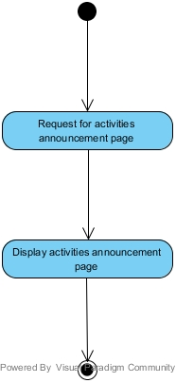

**URS-05: Visitor, Member or Admin can view detail of each activity.**

|  |  |
| --- | --- |
| **Use case ID** | URS-05 |
| **Use case name** | View activities |
| **Description** | Visitor can view detail of each activity. |
| **Actor(s)** | Visitor, Member or Admin. |
| **Precondition** | View activities list. |
| **Post condition** | User gets the detail of the temple activities. |
| **Normal flow** | 1. User selects activity in the list. 2. System shall provide the user interface to display the activities detail page which contain menu bar. 3. System shall provide activity detail page which contain name of activity, picture, activity date, and activity information. 4. User sees detail of activity. |
| **Alternative flow** | - |
| **Exception** | - |

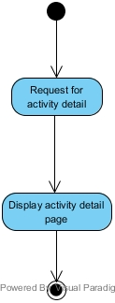

**URS-06: Visitor, Member or Admin can view Q&A page.**

|  |  |
| --- | --- |
| **Use case ID** | URS-06 |
| **Use case name** | View Q&A. |
| **Description** | Users can view the Dharma question and answer by go to Q&A page. . |
| **Actor(s)** | Visitor, Member or Admin. |
| **Precondition** | Users enter to the website. |
| **Post condition** | Users known current temple’s appearance. |
| **Normal flow** | 1. Users select Q&A on the menu bar. 2. System shall provide the user interface to display Q&A page which contain the menu bar. 3. System shall separate each Dharma question with an answer into form of post arrange by the latest answer date. 4. Users see the Dharma questions & answers. |
| **Alternative flow** | - |
| **Exception** | - |

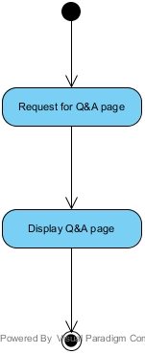

**URS-07: Visitor, Member or Admin can view temple’s history page.**

|  |  |
| --- | --- |
| **Use case ID** | URS-07 |
| **Use case name** | View temple’s history. |
| **Description** | User can view temple’s history by go to history page. |
| **Actor(s)** | Visitor, Member or Admin. |
| **Precondition** | User enters to the website. |
| **Post condition** | User gets information about temple history. |
| **Normal flow** | 1. User selects history on menu bar. 2. System shall provide the user interface to display the history page which contains the menu bar. 3. System shall provide temple's history information. 4. User sees temple’s history. |
| **Alternative flow** | - |
| **Exception** | - |

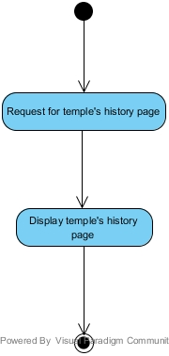

**URS-08: Visitor, Member or Admin can view gallery page.**

|  |  |
| --- | --- |
| **Use case ID** | URS-08 |
| **Use case name** | View gallery. |
| **Description** | Users can view all temple activity’s album by go to the gallery page. . |
| **Actor(s)** | Visitor, Member or Admin. |
| **Precondition** | User enters to the website. |
| **Post condition** | User sees thumbnail of all albums in gallery page. |
| **Normal flow** | 1. Users select gallery on the menu bar. 2. System shall provide the user interface to display the gallery page which contains the menu bar. 3. System shall provide the thumbnail and the album’s name. |
| **Alternative flow** | - |
| **Exception** | - |

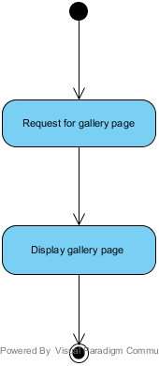

**URS-09: Visitor can view all pictures in selected album.**

|  |  |
| --- | --- |
| **Use case ID** | URS-09 |
| **Use case name** | View pictures in selected album. |
| **Description** | Users can view pictures of selected album. . |
| **Actor(s)** | Visitor, Member or Admin. |
| **Precondition** | View gallery. |
| **Post condition** | User sees pictures of each album. |
| **Normal flow** | 1. User selects album. 2. System shall provide user interface to display all pictures of the chosen activity album. 3. User sees all pictures of album. |
| **Alternative flow** | - |
| **Exception** | - |

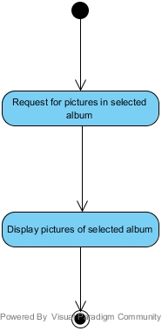

**URS-10: Visitor, Member or Admin can view the larger size of each activity picture.**

|  |  |
| --- | --- |
| **Use case ID** | URS-10 |
| **Use case name** | Users can view the larger size of each activity picture. |
| **Description** | Users can view the larger size of each activity picture by click on picture that user want to see it. . |
| **Actor(s)** | Visitor, Member or Admin. |
| **Precondition** | View pictures in selected album. |
| **Post condition** | Users see larger size of picture. |
| **Normal flow** | 1. Users choose picture in the album. 2. System shall provide user interface to display the larger size of chosen picture in the album. 3. Users see larger size of picture. |
| **Alternative flow** | - |
| **Exception** | - |

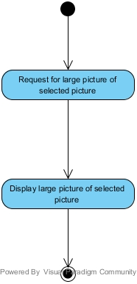

**URS-11: Visitor, Member or Admin can view the contact page.**

|  |  |
| --- | --- |
| **Use case ID** | URS-11 |
| **Use case name** | View contact. |
| **Description** | Users can view contact’s information by go to contact page. . |
| **Actor(s)** | Visitor, Member or Admin. |
| **Precondition** | User enters website. |
| **Post condition** | User gets contact’s information. |
| **Normal flow** | 1. Users select contact on menu bar. 2. System shall provide the user interface to display the contact page which contains the menu bar. 3. System shall provide the contact information which contains temple’s address, phone number, and email. 4. Users see larger size of picture. |
| **Alternative flow** | - |
| **Exception** | - |

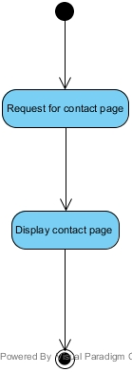

**URS-12: Visitor, Member or Admin can view the map page.**

|  |  |
| --- | --- |
| **Use case ID** | URS-12 |
| **Use case name** | View map. |
| **Description** | Users can view map by go to map page. . |
| **Actor(s)** | Visitor, Member or Admin. |
| **Precondition** | User enters website. |
| **Post condition** | User gets map. |
| **Normal flow** | 1. Users select map on menu bar. 2. System shall provide the user interface to display the map page which contains the menu bar. 3. System shall pin point the temple location. 4. Users see map. |
| **Alternative flow** | - |
| **Exception** | - |

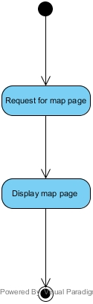

**URS-13: Visitor, Member or Admin can redirect to the temple’s Facebook fan page.**

|  |  |
| --- | --- |
| **Use case ID** | URS-13 |
| **Use case name** | View Facebook page. |
| **Description** | Users can view temple’s Facebook fan page by selected Facebook on menu bar. . |
| **Actor(s)** | Visitor, Member or Admin. |
| **Precondition** | User enters website. |
| **Post condition** | User gets Facebook fan page. |
| **Normal flow** | 1. Users select Facebook on menu bar. 2. System shall redirect to the Facebook fan page. 3. User sees Facebook fan page. |
| **Alternative flow** | - |
| **Exception** | - |

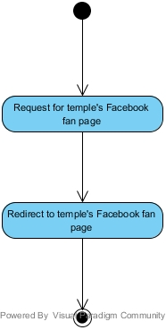

**URS-14: Member or Admin can login to the Wat Pra Singh website.**

|  |  |
| --- | --- |
| **Use case ID** | URS-14 |
| **Use case name** | Login. |
| **Description** | Member or Admin can login to the Wat Pra Singh website. |
| **Actor(s)** | Member or Admin |
| **Precondition** | View home page. |
| **Post condition** | User can use member’s feature or admin’s feature. |
| **Normal flow** | 1. User selects login button. 2. System shall provide a login interface which contain username textbox, password text box, and submit button. 3. User input information on the boxes and selects submit button. 4. System shall provide a success message “login success”. 5. System shall provide the member or admin feature to user. 6. System shall redirect to the home page after login complete. |
| **Alternative flow** | If user input invalid username and password   1. System shall display error message “Username or password are not correct”. |
| **Exception** | - |

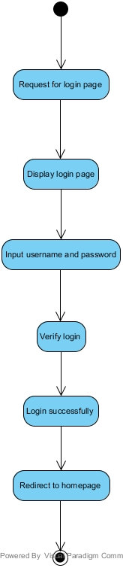

**URS-15: Member or Admin can logout from the Wat Pra Singh website.**

|  |  |
| --- | --- |
| **Use case ID** | URS-15 |
| **Use case name** | Logout. |
| **Description** | Member or Admin can logout from the Wat Pra Singh website. |
| **Actor(s)** | Member or Admin. |
| **Precondition** | Login. |
| **Post condition** | User can’t use member’s feature or admin’s feature. |
| **Normal flow** | 1. User selects logout button on the menu bar. 2. System shall redirect to the home page. 3. User sees home page. |
| **Alternative flow** | - |
| **Exception** | - |

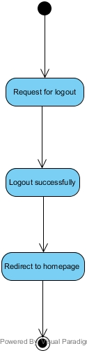

**URS-16: Member can send the Dharma question.**

|  |  |
| --- | --- |
| **Use case ID** | URS-16 |
| **Use case name** | Users send the Dharma question. |
| **Description** | Member can send the Dharma question. |
| **Actor(s)** | Member |
| **Precondition** | Login and view Q&A. |
| **Post condition** | Users have sent the Dharma question to admin. |
| **Normal flow** | 1. System shall provide user interface to display the question form which contains question text box, and submit button. 2. User input information in the boxes and selects submit. 3. System shall provide success message “Your question was sent”. |
| **Alternative flow** | If user not input question,   1. System shall provide error message “Please fill in the Question”. |
| **Exception** | - |

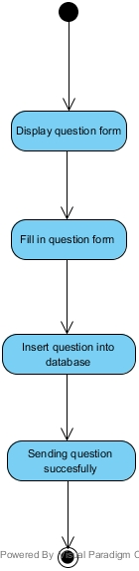

**URS-17: Member can receive the activity news from temple via the registered email.**

|  |  |
| --- | --- |
| **Use case ID** | URS-17 |
| **Use case name** | Subscription |
| **Description** | Member can receive the activity news from temple via the registered email**.** |
| **Actor(s)** | Admin |
| **Precondition** | Admin’s post activity. |
| **Post condition** | Member gets new activity. |
| **Normal flow** | 1. System shall able to send the activity announcement to user’s email. 2. Member receives an email. |
| **Alternative flow** | - |
| **Exception** | - |

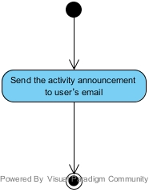

**URS-18: Admins can add the temple’s activities in the update activities page.**

|  |  |
| --- | --- |
| **Use case ID** | URS-18 |
| **Use case name** | Post activity. |
| **Description** | Admins can add the temple’s activities in the update activities page. |
| **Actor(s)** | Admin |
| **Precondition** | Logged in as admin & view activities. |
| **Post condition** | New activity has been post to the website |
| **Normal flow** | 1. System shall provide add button on activity announcement page. 2. Admin selects add button. 3. System shall provide user interface to display update activity page which contain the topic title textbox, date, time, place of the activity, submit button, and cancel button. 4. Admin input information of activity and selects submit button. 5. System shall display the success message “Add success”. 6. System shall redirect to the activity announcement page. 7. Admin sees list of activities. |
| **Alternative flow** | If admin selects cancel button,   1. System shall redirect to the activity announcement page. |
| **Exception** | - |

**URS-19: Admins can edit the temple’s activities in the update activities page.**

|  |  |
| --- | --- |
| **Use case ID** | URS-19 |
| **Use case name** | Edit activity. |
| **Description** | Admins can edit the temple’s activities in the update activities page. |
| **Actor(s)** | Admin |
| **Precondition** | Logged in as admin & view activities. |
| **Post condition** | The selected activity has been edited |
| **Normal flow** | 1. System shall provide edit button after the activity title on the activity announcement page. 2. Admin selects edit button. 3. System shall provide user interface to display update activity page which contain the topic title textbox, date, time, place of the activity, submit button, and cancel button. 4. System shall display the topic title, date, time, and place on the text box. 5. Admin edit information of activity in the boxes. 6. System shall display the success message “Edit success”. 7. System shall redirect to the activity announcement page. 8. Admin sees list of activities. |
| **Alternative flow** | If admin selects cancel button,   1. System shall redirect to the activity announcement page. |
| **Exception** | - |

**URS-20: Admins can delete the temple’s activities in the update activities page.**

|  |  |
| --- | --- |
| **Use case ID** | URS-20 |
| **Use case name** | Delete activity. |
| **Description** | Admins can delete the temple’s activities in the update activities page. |
| **Actor(s)** | Admin |
| **Precondition** | Logged in as admin & view activities. |
| **Post condition** | The selected activity has been delete |
| **Normal flow** | 1. System shall provide delete button after the activity title on the activity announcement page. 2. Admin selects delete button. 3. System shall provide confirm user interface “Are you sure to delete this activity?” 4. Admin confirm. 5. System shall display the success message “Delete success”. 6. System shall redirect to activity announcement page. 7. Admin sees list of activities. |
| **Alternative flow** | If Admin cancel,   1. System shall redirect to activity announcement page. |
| **Exception** | - |

**URS-21: Admins can view Dharma Question page.**

|  |  |
| --- | --- |
| **Use case ID** | URS-21 |
| **Use case name** | View question. |
| **Description** | Admins can view Dharma Question page. |
| **Actor(s)** | Admin |
| **Precondition** | Logged in as admin & view Q&A. |
| **Post condition** | Admin gets unanswered question. |
| **Normal flow** | 1. System shall separate each Unanswered Dharma question into form of post arrange by the latest question date. 2. Admin sees unanswered question. |
| **Alternative flow** | - |
| **Exception** | - |

**URS-22: Admins can answer the Dharma question in the Dharma Question page.**

|  |  |
| --- | --- |
| **Use case ID** | URS-22 |
| **Use case name** | Answer question. |
| **Description** | Admins can answer the Dharma question in the Dharma Question page. |
| **Actor(s)** | Admin |
| **Precondition** | Logged in as admin & view Question. |
| **Post condition** | The selected question has been post with answer. |
| **Normal flow** | 1. System shall provide the answer button next to the question. 2. Admin selects answer button. 3. System shall provide user interface to display the answer form which contain textbox, submit button, and cancel button. 4. Admin input an answer. 5. System shall display success message “Answer success”. 6. System shall redirect to Q&A page. 7. Admin sees list of questions |
| **Alternative flow** | If Admin selects cancel button,   1. System shall redirect to Q&A page. |
| **Exception** | - |

**URS-23: Admins can delete the Dharma question in the Dharma Question page.**

|  |  |
| --- | --- |
| **Use case ID** | URS-23 |
| **Use case name** | Delete question. |
| **Description** | Admins can delete the Dharma question in the Dharma Question page. |
| **Actor(s)** | Admin |
| **Precondition** | Logged in as admin & view Q&A page. |
| **Post condition** | The selected question has been deleted. |
| **Normal flow** | 1. System shall provide the delete button next to the question. 2. Admin selects delete button. 3. System shall display confirm user interface “Are you sure to delete this question” 4. Admin confirm. 5. System shall display success message “Delete success”. 6. System shall redirect to Q&A page. 7. Admin sees list of questions |
| **Alternative flow** | If Admin selects cancel button,   1. System shall redirect to Q&A page. |
| **Exception** | - |

**URS-24: Admins can edit the temple’s history.**

|  |  |
| --- | --- |
| **Use case ID** | URS-24 |
| **Use case name** | Edit the temple’s history |
| **Description** | Admins can edit the temple’s history. |
| **Actor(s)** | Admin |
| **Precondition** | Logged in as admin & view history page. |
| **Post condition** | The selected activity has been delete |
| **Normal flow** | 1. System shall provide edit button on the temple’s history page. 2. Admin selects edit button. 3. System shall provide text field, update button, and cancel button. 4. System shall display the temple’s history on the text field. 5. Admin edit information and selects update button. 6. System shall display the success message “Edit success”. 7. System shall redirect to the temple’s history page. 8. Admin sees temple’s history. |
| **Alternative flow** | If Admin selects cancel button,   1. System shall redirect to the temple’s history page. |
| **Exception** | - |