Kourtney Stewart
Indranil Roy
CS155-02
May 1, 2026

Description:
This project is a Student Grade Management System created using Java and one-dimensional arrays. The program allows users to add student names, grade, display all stored records, search for the student grade, calculate the class average, and find the highest and lowest grades. The system is menu-driven and includes input validation to prevent errors and ensure correct data entry.

Program Logic:
This program uses two parallel one-dimensional arrays to store student data. One array stores students name, and the other stores student’s grades. Each index in the arrays represents a single student, meaning the name and grade at the same index correspond to each other.
A menu-driven interface allows the user to select different operations. The program uses loops, conditionals, and methods to perform actions such as adding students, displaying records, searching for student, calculating averages, and finding the highest and lowest grades. Input validation is also implemented to ensure grades remain with the valid range of 0 to 100.

Method Explanation:
- addStudent() – Allows the user to enter a students name and grade, validates the input, and stores the data in the arrays.
- displayStudents() – Displays all stored student names along with their grades.
- findStudentGrade() – Searches for a student by name and displays their grade if found.
- calculateAverage() – Calculates and displays the averages grade of all students.
- findHighestandLowest() – Identifies and displays the student with the highest and lowest grades.
- displayMenu() – Displays the menu options for the user to select from.

Screenshots:
Figure 1: Complete program execution showing all system features 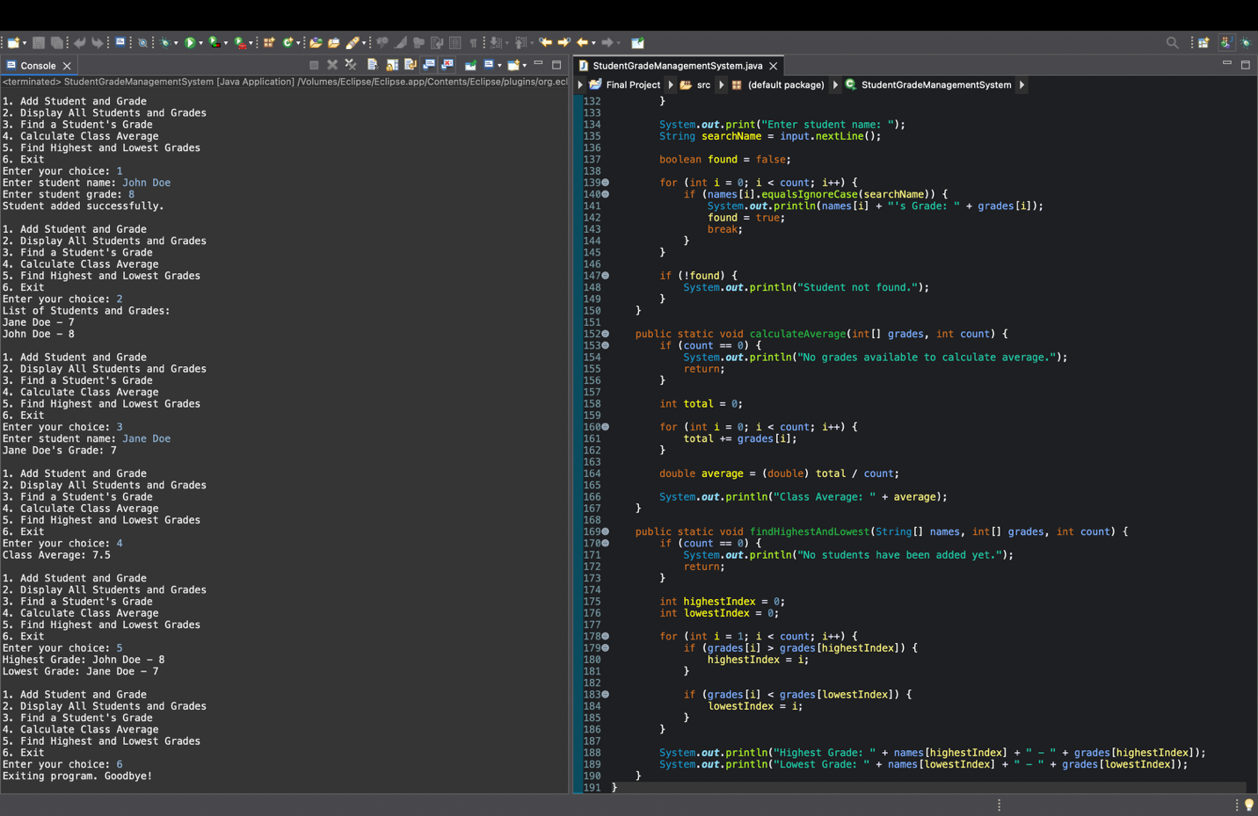
Figure 2: Invalid input handling (grade outside the valid range of 0-100) 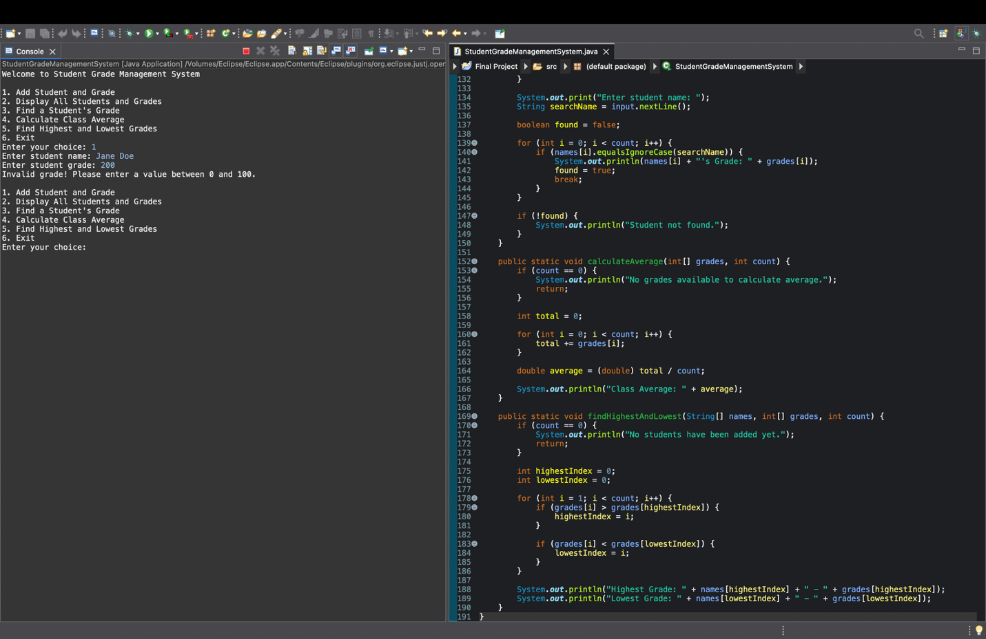

Contributions:
I completed the full project, including program development, testing, documentation, and GitHub setup. I attempted to coordinate with my group members, but due to lack of communication, I completed the project individually to meet the deadline.

GitHub Repository:
https://github.com/kourtneystewart/student-grade-management-kourtneystewart

