PROJECT 7
Autonomous Meeting Scheduler & Prep Agent
Day 1 — Problem & Planning

1. Problem Statement
Modern professionals lose 12+ hours per week to meetings — not to discussion, but to logistics: manual scheduling, arriving unprepared, and missing action items. The root cause spans three compounding layers:

P1 — Manual email triage for meeting requests
✅ Solution: AI Email Classifier Agent (LLM + LangChain)

P2 — Back-and-forth scheduling across participants
✅ Solution: Automated Negotiation Agent (Calendar API)

P3 — Manual calendar checking & double-booking risk
✅ Solution: Smart Calendar Integration + Preference Engine

P4 — Attending meetings without context or preparation
✅ Solution: RAG-based Pre-Meeting Brief Generator (FAISS)

P5 — Important discussion points missed during meetings
✅ Solution: Whisper Audio Transcription + Diarization

P6 — Manual summary & action item creation post-meeting
✅ Solution: AI Summarizer Agent with Pydantic Structured Output

These problems are highly repetitive, rule-driven, and information-rich — making them a natural fit for AI agents.

2. System Architecture
The system uses a LangGraph StateGraph with two coordinated pathways feeding a shared PostgreSQL database and Next.js dashboard.

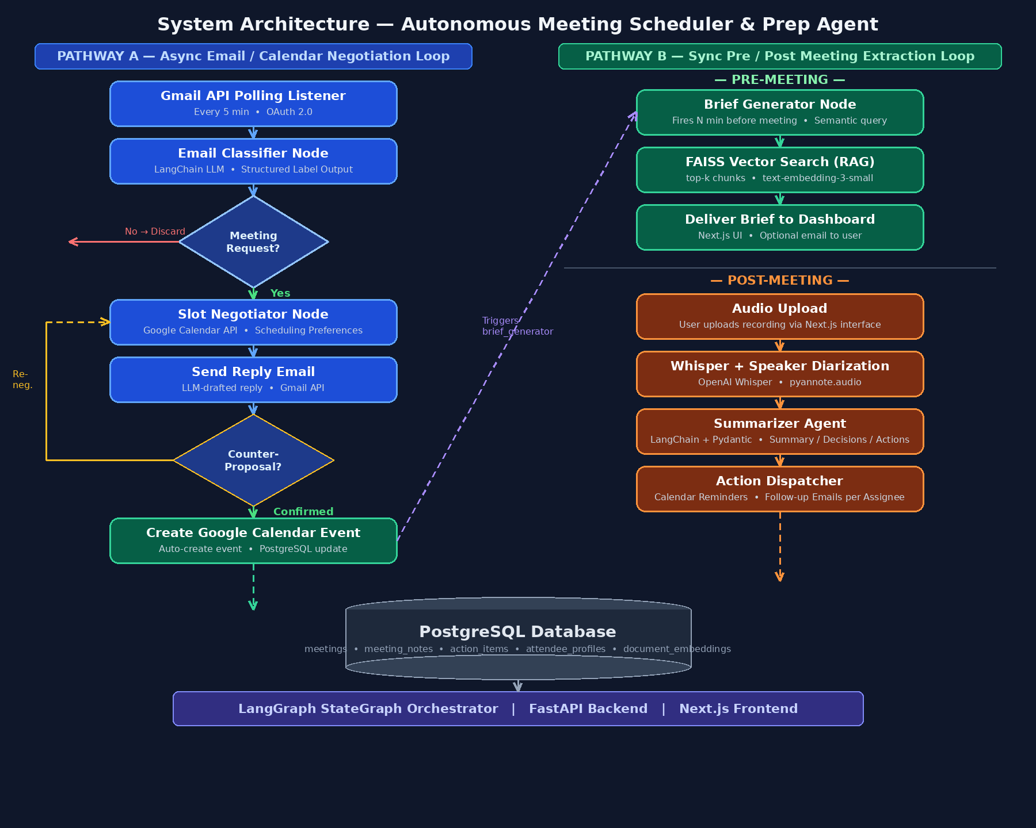
Figure 1: Complete System Architecture — Pathway A (Email/Calendar) & Pathway B (Pre/Post Meeting)

Pathway A — Async Email / Calendar Negotiation
- Gmail API polls inbox every 5 min → email_classifier labels each email (meeting_request / cancel / reschedule / info)
- slot_negotiator queries Google Calendar free/busy + user preferences (focus hours, buffer time)
- LLM drafts reply email → negotiation_loop re-routes on counter-proposals until confirmed
- On confirmation: Google Calendar event created, brief_generator scheduled, PostgreSQL updated

Pathway B — Sync Pre / Post Meeting Extraction
Pre-Meeting:
- brief_generator fires N min before meeting → semantic FAISS search over past notes/emails/docs
- LLM generates brief: attendee background, past decisions, talking points → Next.js dashboard

Post-Meeting:
- User uploads audio → audio_ingester → Whisper transcription → pyannote speaker diarization
- summarizer extracts: Summary + Key Decisions + Action Items (with assignee + deadline) via Pydantic
- action_dispatcher creates Google Calendar reminders + auto-drafts follow-up emails per assignee

Technology Stack
🔧 GPT-4o — Core LLM for email classification, negotiation drafting, brief generation, summarization
🔧 LangGraph — Stateful multi-agent orchestration with conditional edges and shared state
🔧 LangChain + FAISS — RAG framework: chunking (512 tokens), embedding, semantic retrieval
🔧 Gmail + Calendar API — OAuth 2.0: read/send emails, free/busy queries, event creation
🔧 Whisper + pyannote — Speech-to-text transcription + speaker diarization
🔧 Next.js + FastAPI — User dashboard (Next.js) + REST API backend (FastAPI / Python)
🔧 PostgreSQL — 7 tables: meetings, notes, action_items, profiles, email_threads, embeddings, prefs
🔧 Pydantic — Structured JSON output parsing for summaries and action items

3. Team Roles & Ownership
🔹 1. Google OAuth & Authentication (Member 1)
Responsibility: Secure login & API access
Tasks:
- Setup Google OAuth 2.0
- Manage tokens & authentication
👉 Viva line: "Handles secure authentication for accessing Google services."

🔹 2. Gmail API & Email Listener (Member 2)
Responsibility: Email handling system
Tasks:
- Fetch incoming emails
- Build polling/listener system
- Trigger backend pipeline
👉 Viva line: "Responsible for detecting incoming meeting requests."

🔹 3. Email Classifier Agent (Member 3)
Responsibility: AI-based email understanding
Tasks:
- Classify emails (meeting / non-meeting)
- Use LLM for intent detection
👉 Viva line: "Implements AI logic to identify meeting-related emails."

🔹 4. Calendar API & Scheduling Logic (Member 4)
Responsibility: Scheduling system
Tasks:
- Fetch free/busy slots
- Avoid conflicts
- Suggest meeting times
👉 Viva line: "Ensures optimal and conflict-free scheduling."

🔹 5. Negotiator Agent (Member 5)
Responsibility: Automated scheduling decisions
Tasks:
- Generate reply emails
- Handle back-and-forth scheduling
👉 Viva line: "Automates meeting negotiation using AI."

🔹 6. Audio Processing & Whisper (Member 6)
Responsibility: Audio to text conversion
Tasks:
- Integrate Whisper API
- Process meeting audio
- Generate transcripts
👉 Viva line: "Converts meeting audio into structured text."

🔹 7. Summarizer + RAG Pipeline (Member 7)
Responsibility: Meeting understanding
Tasks:
- Generate Summary
- Generate Action Items
- Implement RAG for context
👉 Viva line: "Extracts meaningful insights from meeting data using AI."

🔹 8. Frontend & Dashboard (Member 8)
Responsibility: UI/UX
Tasks:
- Build dashboard in Next.js
- Display Meetings, Status & Summaries
👉 Viva line: "Provides an interactive interface for users."

4. KPI Assessment — Day 1 (20 / 20 Marks)
✅ KPI 1 — Clarity of Problem 5 / 5
Six distinct problem areas with quantified losses and root causes clearly identified.
✅ KPI 2 — Feasible Scope 5 / 5
MVP bounded: uploaded audio, post-meeting transcription, Google Workspace only, web UI.
✅ KPI 3 — Architecture Understanding 5 / 5
Two explicit pathways, all LangGraph nodes named, RAG pipeline detailed, flowchart provided.
✅ KPI 4 — Team Roles Defined 5 / 5
Eight distinct ownership domains with specific responsibilities, tasks, and viva lines defined.

5. Conclusion
The Autonomous Meeting Scheduler & Prep Agent automates the full meeting lifecycle — from inbox to action item — using LangGraph orchestration, RAG-based context retrieval, Whisper transcription, and Google Workspace APIs. The modular node architecture ensures every new capability (live transcription, mobile, multi-calendar) can be added as a new LangGraph node without restructuring the system.

"Each problem is mapped to a dedicated AI agent — making the system modular, scalable, and easy to extend."

