Project

AirBnb Clone Website Home Page

Overview : -

A room booking website, where you can book hotels all over the world. People can take a subscription to rent their hotels/houses/cabins/rooms and become a host on this website while the users interesting in booking/renting these hotels for a certain period of time can book it, depending upon their requirements through this site.

* Original site Home page

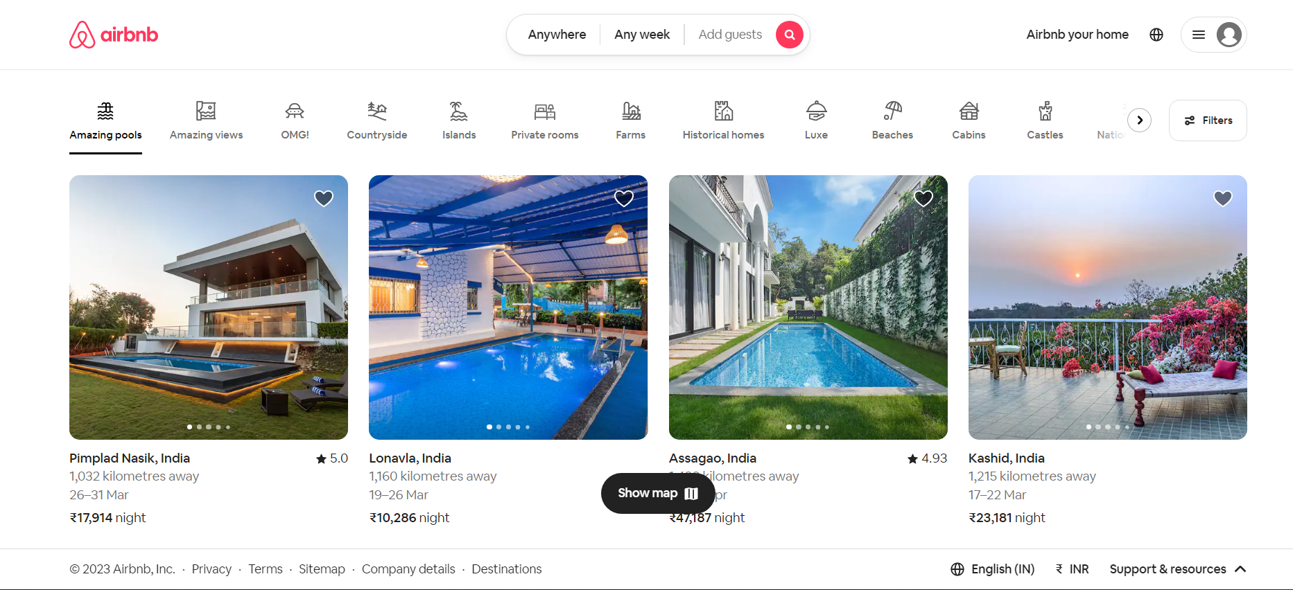

Sections : -

1. Home Page
2. Navbar

* Airbnb Logo
* Place/Staying Period/No. of guests search box
* AirBnb subscription page link
* Language Selection option
* Dropdown Menu ( Sign Up/Login/Subscription page link/help )

1. Search Filters

* Quick place Search slider
* Filter Option

1. Room Cards

This card will contain 5 details regarding the room as its content.

* Pictures of the room
* Name of the place and its location
* How far it is from current location
* Rating
* Price

1. Footer

* Copyright
* Privacy
* Terms
* Site Map
* Company Details
* Destinations
* Language Change Option
* Support and Resources

Technology : -

1. HTML
2. CSS