DyFlow-T: Extending Dynamic LLM Workflow Synthesis with Real Tool Execution Grounding

A PROJECT REPORT
Submitted by

KOUSHIK SELVARAJ [Reg No: RA2212049015105]
Under the Guidance of

Dr. Syed Anwar Hussainy F
Associate Professor, Department of Computer Science and Engineering

In partial fulfilment of the requirements for the degree of

MASTER OF TECHNOLOGY
in

ARTIFICIAL INTELLIGENCE



DEPARTMENT OF COMPUTATIONAL INTELLIGENCE COLLEGE OF ENGINEERING AND TECHNOLOGY SRM INSTITUTE OF SCIENCE AND TECHNOLOGY KATTANKULATHUR – 603 203
MAY 2025

SRM INSTITUTE OF SCIENCE AND TECHNOLOGY KATTANKULATHUR – 603 203
BONAFIDE CERTIFICATE

Certified that this M.Tech project report titled “PERSONALIZED CAR BUYING RECOMMENDATION SYSTEM FOR INDIAN CONSUMERS: LEVERAGING MACHINE LEARNING TO TAILOR PURCHASE DECISIONS” is the bonafide
work of Mr. Keerthy S [Reg. No.: PA2212049010015] who carried out the project work under my supervision. Certified further, that to the best of my knowledge the work reported herein does not form part of any other thesis or dissertation on the basis of which a degree or award was conferred on an earlier occasion for this or any other candidate.

Dr. Syed Anwar Hussainy F
SUPERVISOR
Department of Computer Science and Engineering
Department of Data Science and Business Systems
Dr---------
HEAD OF THE DEPARTMENT
Professor
Department of Computational Intelligence

_{INTERNAL EXAMINER} EXTERNAL EXAMINER

DEPARTMENT OF COMPUTATIONAL INTELLIGENCE

SRM Institute of Science and Technology Own Work Declaration Form
Degree/ Course : M.Tech in Artificial Intelligence
Student Names : Koushik Selvaraj
Registration Number : RA2212049015105
Title of Work : DyFlow-T: Extending Dynamic LLM Workflow Synthesis with Real Tool Execution Grounding

I hereby certify that this assessment compiles with the University’s Rules and Regulations relating to Academic misconduct and plagiarism, as listed in the University Website, Regulations, and the Education Committee guidelines.
I confirm that all the work contained in this assessment is my own except where indicated, and that I have met the following conditions:
- Clearly references / listed all sources as appropriate
- Referenced and put in inverted commas all quoted text (from books, web, etc.)
- Given the sources of all pictures, data etc. that are not my own
- Not made any use of the report(s) or essay(s) of any other student(s) either past or present
- Acknowledged in appropriate places any help that I have received from others (e.g. fellow students, technicians, statisticians, external sources)
- Compiled with any other plagiarism criteria specified in the Course handbook / University website
I understand that any false claim for this work will be penalized in accordance with the University policies and regulations.

DECLARATION:
I am aware of and understand the University’s policy on Academic misconduct and plagiarism and I certify that this assessment is my own work, except were indicated by referring, and that I have followed the good academic practices
noted above.
Keerthy S PA2212049010015

ACKNOWLEDGEMENT

I express my humble gratitude to Dr. C. Muthamizhchelvan, Vice-Chancellor, SRM Institute of Science and Technology, for the facilities extended for the project work and his continued support. I extend my sincere thanks to Dean-CET, SRM Institute of Science and Technology, Prof. M. Leenus J Martin, for his invaluable support.

I wish to thank Dr. Revathi Venkataraman, Professor & Chairperson, School of Computing, SRM Institute of Science and Technology, for her support throughout the project work. I sincerely appreciate Dr. R. Annie Uthra, Professor and Head, Professor, Department of Computational Intelligence, SRM Institute of Science and Technology, for her guidance and support that has been invaluable to my success. I am incredibly grateful to my Program Coordinator, Dr. S. Ganesh Kumar, Professor, Department of Data Science and Business Systems, SRM Institute of Science and Technology, for his suggestions and encouragement at all the stages of the project work.

I want to convey my thanks to my Project Coordinator, Dr. A. Shobana Devi, Associate Professor and the Panel Head, Dr. K. Sornalakshmi , Associate Professor Department of Data Science and Business Systems, SRM Institute of Science and Technology, for their inputs during the project reviews and support.

I register my immeasurable thanks to my Program Manager, Mr. Ben Kingsley, Program Manager, Great Learning for leading and helping us to complete the course.
My inexpressible respect and thanks to the guide, Dr. A. Shobana Devi, Associate Professor, Department of Data Science and Business Systems, SRM Institute of Science and Technology, for providing me with an opportunity to pursue my project under her mentorship. She provided us with the freedom and support to explore the research topics of my interest. Her passion for solving problems and making a difference in the world has always been inspiring.

I sincerely thank the Department of Computational Intelligence staff and students, SRM Institute of Science and Technology, for their help during my project. Finally, I would like to thank parents, family members, and friends for their unconditional love, constant support, and encouragement.

Koushik Selvaraj [RA2212049015105]

C.NO. | TITLE | PAGE NO.
 | Abstract | vi
 | List of Tables | vii
 | List of Figures | viii
 | List of Symbols and Abbreviations | ix
1. | INTRODUCTION | 1
 | 1.1 General | 1
 | 1.2 Purpose | 2
 | 1.3 Scope | 4
 | 1.4 Artificial Intelligence, Machine Learning and Deep Learning | 6
2 | LITERATURE REVIEW | 10
 | 2.1 Random Forest Classifier | 10
 | 2.2 BERT | 11
 | 2.3 Graph-Based and Context-Aware Models | 12
 | 2.4 Knowledge Graph | 13
 | 2.5 Hybrid Filtering and Sentiment-Aware Systems | 14
3 | PROPOSED METHODOLOGY | 17
 | 3.1 Dataset | 17
 | 3.2 Feature Extractor | 20
 | 3.3 Similarity Scoring and Recommendation System | 26
 | 3.4 Algorithm | 31
4 | RESULTS | 35
5 | CONCLUSION | 42
6 | FUTURE SCOPE | 45
7 | REFERENCES | 48
 | APPENDIX | 50
 | PAPER PUBLICATION STATUS | 59
 | PLAGIARISM REPORT | 60
 | AI CHECK REPORT | 61

ABSTRACT

Agentic reasoning systems built over large language models have achieved notable progress in multi-step planning and task decomposition, yet still their workflows remain fundamentally constrained by static instructions and the absence of real-world tool execution. Existing frameworks such as ReAct, Toolformer, and AFlow augment LLM with tool invocation but still it rely on fixed action schema and task-based fine-tuning, failing to generalize across diverse task types. This inflexibility forces agents to simulate execution results through parametric memory alone, producing hallucinated queries with fabricated numerical answers, and outdated factual responses that cannot be corrected without grounding in real day to day changing data. DyFlow (NeurIPS 2025) advances the state of the art by introducing a dynamic designer-executor architecture that adaptively synthesizes multi-stage reasoning workflows per problem using intermediate feedback; however, DyFlow explicitly acknowledges that there is a limitation like the absence of search engine access, database queries, and environment interaction, and it confirms that all execution are based on LLM trained knowledge and reasoning without any external grounding. To address this gap, this paper presents DyFlow-T, a tool-augmented extension that integrates real external tool execution into the dynamic workflow pipeline through a ToolRegistry. Here I introduce five new operator types including SQL_QUERY, WEB_SEARCH, and a structured TOOL_REVIEW quality gate that validates every tool result before it enters reasoning. Enabling Controlled experiments across GAIA, LiveNewsBench, and BIRD benchmark dataset with tool availability as the sole experimental variable demonstrate consistent accuracy gains of +26.8%, +30%, and +50% respectively, confirming that execution grounding is the decisive contribution over parametric reasoning alone.

vi

LIST OF TABLES
    - Summary of Literature Survey 15
    - Focus Areas Coverage in Literatures 16
    - Dataset Sources and Description 17
    - Various Features available in Dataset 20
3.2.5 Dataset Features Consolidation 24
    - Feature Encoding and Normalization 28
    - Evaluation Metrics 37
    - Summary of Outputs 41

vii

LIST OF FIGURES
    - AI, ML and DL in the System 9
    - Random Forest Classifier 10
    - BERT Model 11
2.3.2 Contextual Bandits 13
3.1.1 Raw User Review Data Sample 18
3.1.6 ZOHO Survey 19
    - Sales Trend Score 4 & 5 Output 21
    - Schematic Diagram of DistilBERT 22
    - User Sentiment Analysis 23
    - Sentiment Score 23
    - Sample of Master Dataset 24
3.3.8 Conceptual Work Flow for Recommendation 30
3.4.1 Master Architecture for Car Recommendation 31
3.4.10 Sample Output for Top 5 Recommendation 34
    - Output for Test Case 1 38
    - Output for Test Case 2 39
    - Output for Test Case 3 40

viii

LIST OF SYMBOLS AND ABBREVIATIONS

SIAM | Society of Indian Automobile Manufacturers
NLP | Natural Language Processing
EV | Electric Vehicle
SUV | Sports Utility Vehicle
BERT | Bidirectional Encoder Representations from Transformers
GNN | Graph Neural Network
AI | Artificial Intelligence
ML | Machine Learning
DL | Deep Learning
EMI | Equated Monthly Installments
CF | Collaborative Filtering
KG | Knowledge Graph
OEM | Original Equipment Manufacturer
OCR | Optical Character Recognition
CNG | Compressed Natural Gas
AMT | Auto Manual Transmission
USS | User Satisfaction Score
PDS | Price Deviation Score
PMR | Preferred Match Rate
FFS | Financial Feasibility Score
WSC | Weighted Score Consistency

ix

CHAPTER 1 INTRODUCTION

1.1 General

Artificial intelligence has witnessed a great paradigm shift from simple question answering toward autonomous multi-step Agent based reasoning, where large language models (LLMs) are deployed as agents capable of decomposing complex problems, planning sequences of actions, and iteratively refining their outputs based on intermediate feedback [1]. These types of agentic systems have demonstrated remarkable capability across various domains including mathematical and logical reasoning, code generation, Industrial Produce support, and social interaction, Customer Support [2], [3]. At their core, such systems rely on a planning mechanism that structures the reasoning process into simple discrete, executable stages like design that fundamentally determines both their flexibility and their ceiling performance across diverse real-world tasks.
Despite being progressed, the “planning” architecture of the most underlying LLM agent frameworks remains rigid and poorly suited for the heterogeneous demands of most real-world deployment. Static workflow systems such as MetaGPT [4] and AutoGen [5] encode agent roles, execution order, and interaction protocols as fixed templates that proceed without modification regardless of intermediate task signals. When a sub-task fails or produces flawed output, these architectures typically halt or propagate errors downstream, lacking any mechanism for revising plans or recovering gracefully from intermediate failures. CAMEL and OpenAgents further entrench this paradigm by hardcoding API usage and agent roles, producing systems that operate effectively only within their design envelope.
A complementary line of research has explored automated workflow construction to reduce reliance on manual engineering. AFlow [3] optimises code-centric workflows offline using Monte Carlo Tree Search guided by dataset-level performance signals, while ADAS performs meta-search over agent architectures at design time. Although these systems automate workflow construction, they commit to a fixed plan before execution begins and cannot revise operator configurations in response to runtime feedback. DyLAN and MaAS offer query-specific agent configuration but neither provides mechanisms to adapt subgoal plans dynamically based on real-time execution signals. The separation between planning and execution remains a structural weakness across this body of work.
DyFlow [6], presented at NeurIPS 2025, represents the most significant advance toward execution-adaptive workflow planning. DyFlow introduces a hierarchical designer-executor architecture in which the designer dynamically plans subgoals and their corresponding operator execution graphs based on task requirements and intermediate feedback, while the executor carries out each stage using dynamic operators with context-aware parameterization. Unlike prior frameworks, DyFlow continuously collects intermediate outputs, tool feedback, and error signals, using this updated context to revise the subgoal plan at each step. Evaluated across five reasoning domains, DyFlow demonstrates substantial Pass and improvements over chain-of-thought baselines and exhibits robust cross-domain generalization.
However, DyFlow carries a critical limitation explicitly acknowledged in the original paper: the operator set is confined to symbolic and textual reasoning and does not support external tool integration. The executor must simulate real time data from tool execution results through parametric LLM memory where knowledge froze at training time. When a task requires a COUNT of transactions in a real database, or current stock price of gold or oil that time DyFlow fabricates a plausible-sounding number. When a question asks about a 2025 news event, DyFlow recalls or invents an answer from parametric memory rather than retrieving the actual fact. On BIRD's 33,000-row databases and LiveNewsBench's post-training news questions, this limitation is not an incidental gap but a fundamental barrier to correct answers.
This paper presents DyFlow-T, a tool-augmented extension of DyFlow that directly addresses this limitation. DyFlow-T preserves the core designer-executor architecture and dynamic subgoal planning while introducing a ToolRegistry, a ToolAwareWorkflowExecutor, with five new operator types, and a TOOL_REVIEW quality gate. A central design principle is that both systems use the same LLM to generate SQL and web search queries. this tool availability is the sole experimental variable is directly isolating the contribution of execution grounding from generation quality. The results demonstrate that this single change produces gains of +26.8%, +30.4%, and +29.3% across GAIA, LiveNewsBench, and BIRD respectively.
A. Tool-Augmented LLM Agents
ReAct [1] interleaves chain-of-thought reasoning with action steps but uses a fixed action schema that cannot be revised mid-execution. It lacks dynamic workflow redesign and produces simulated rather than real tool outputs when live APIs are unavailable, making it structurally incapable of grounding answers in post-training knowledge.
Toolformer [2] fine-tunes the LLM to insert API calls inline within generated text, providing autonomous tool invocation without manual annotation. However, fine-tuning dependency limits cross-domain generalization, and the absence of a quality gate means incorrect tool outputs propagate silently through the pipeline.
AFlow [3] optimizes code-centric workflows offline using Monte Carlo Tree Search. Once constructed, the workflow is fixed and cannot adapt at inference time. This offline-planning approach performs reasonably on stable structured tasks but fails to generalize to open-ended retrieval requiring dynamic chain selection.
DyFlow [6] represents the current state of the art in dynamic workflow planning, synthesizing per-problem operator sequences from intermediate feedback. However, its operator set is entirely parametric — no external tool execution — making it structurally incapable of retrieving real data. This is the critical limitation DyFlow-T addresses.
B. Benchmarks
GAIA [7] provides a multi-level QA benchmark requiring current factual knowledge, multi-step web retrieval, and real-world reasoning across three difficulty levels. The published gap between GPT-4 with plugins (15%) and human performance (92%) remains one of the clearest quantitative demonstrations of the inadequacy of parametric memory for live-knowledge tasks. Level 1 requires single-hop retrieval of live facts; Level 2 chains two or more retrieved sources; Level 3 demands multi-source synthesis across heterogeneous web content.
LiveNewsBench [8] specifically evaluates LLM web search capabilities using freshly curated post-training news questions where parametric recall is structurally impossible. Every question in the dataset refers to a specific news event that occurred after the LLM training cutoff questions about 2025 election margins, sporting results, and legal proceedings are simply unanswerable from parametric memory regardless of model size or reasoning quality. Unlike GAIA, which mixes current-knowledge and reasoning tasks, LiveNewsBench isolates web retrieval as the sole variable, making it the most direct benchmark for evaluating the contribution of the WebSearchTool in DyFlow-T.
occasionally guess aggregate results and masking the grounding gap at real-world scale. BIRD [8] uses databases with over 33,000 rows with dirty data and domain-specific evidence hints, making execution grounding essential. GAIA [9] provides multi-level QA requiring current factual knowledge and multi-step web retrieval. LiveNewsBench [10] specifically evaluates LLM web search capabilities using post-training news questions that parametric memory structurally cannot answer — every question refers to a specific event after the LLM training cutoff.
III. PROPOSED SYSTEM
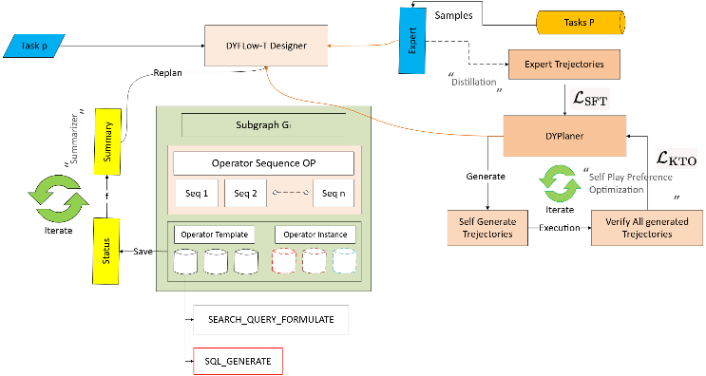
Architecture Diagram
A. Architecture Overview
DyFlow-T preserves the core designer-executor architecture and dynamic subgoal planning of DyFlow while adding four principal components: a ToolRegistry that maps operator type strings to BaseTool implementations; a ToolAwareWorkflowExecutor that routes SQL_QUERY to SQLite via SQLAlchemy and WEB_SEARCH to the Tavily API; five new operator types partitioned into parametric reasoning operators and tool execution operators; and a TOOL_REVIEW quality gate that validates every tool result before state transition.
B. Operator Chains
The five new operator types from two execution chains are selected dynamically by the designer. For structured database tasks:
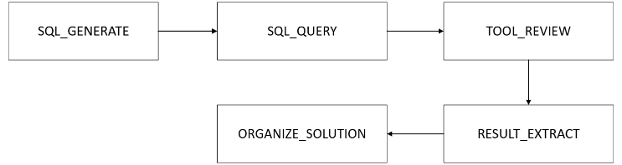

For open-domain web retrieval tasks:

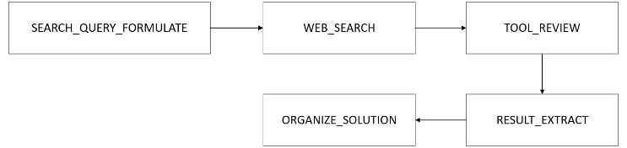
SQL_GENERATE and SEARCH_QUERY_FORMULATE are parametric operators the agent writes the query artifact. SQL_QUERY and WEB_SEARCH are tool operators that invoke external systems and return real data. Both DyFlow and DyFlow-T generate queries using the LLM; DyFlow-T additionally executes them. This distinction directly isolates execution grounding as the experimental variable.

TABLE I: Algorithm Comparison Across Tool-Augmented LLM Frameworks
Algorithm | Workflow | Tool Exec. | Live Data
ReAct [1] | Fixed | Simulated | No
Toolformer [2] | Static FT | API inject | No
AFlow [3] | Offline opt | None | No
DyFlow [6] | Dynamic | Parametric | No
DyFlow-T | Dynamic | SQLite + Tavily | YES

C. Formal Definition
Let O = {O₁, O₂, O₃, ….. O_{N}} each corresponding to a basic type of reasoning or execution step. and Operator Instance as per original paper
O = (O_{k}, φ, ψ) and o ∈ V_{t}
contained in stage subgraph G_{t} = (V_{t}, E_{t}, v^{t}_{start}, C^{t}_{end}). Here
O_{k} ∈ 𝒪 the operator template (e.g. GENERATE_ANSWER, REVIEW_SOLUTION)
Φ fine-grained instruction string tailored to the current context
Ψ list of input keys referencing outputs in global memory buffer ℳ
ℳ global memory buffer storing previous outputs as key–value pairs
All Operators in original Paper Operator template set
𝒪 = {GENERATE_PLAN, DECOMPOSE_PROBLEM, GENERATE_ANSWER, REVIEW_SOLUTION, REFINE_ANSWER, GENERATE_CODE, REFINE_CODE, ORGANIZE_SOLUTION, ENSEMBLE, DEFAULT, TERMINATE}
Output_{o} = 𝔼_{LLM}(φ, ψ, s_{t}) ∀ O_{k} ∈ 𝒪
For DyFlow-T (Proposed system) derives from base DyFlow
𝒪 = 𝒪_{P} ∪ 𝒪_{T}, 𝒪_{P} ∩ 𝒪_{T} = ∅
Realtime Tools 𝒪_{T} = {SQL_QUERY, WEB_SEARCH}
And Operators
𝒪_{P} = {SQL_GENERATE, SEARCH_QUERY_FORMULATE, TOOL_REVIEW, TOOL_REFINE, RESULT_EXTRACT, ORGANIZE_SOLUTION}
Output_{o} = {
𝔼_{LLM}(φ, ψ, s_{t}) if O_{k} ∈ 𝒪_{P}
ℝ[O_{k}].execute(φ, ψ) if O_{k} ∈ 𝒪_{T}
}
Tool operators dispatch to ToolRegistry (ℝ) to real SQLite execution or live Tavily retrieval. Parametric operators remain LLM-executed as in DyFlow.
Summary of how formula evolved
DyFlow | DyFlow
Routing always → 𝔼_{LLM} | Routing 𝔼_{LLM} or ℝ[O_{k}]
𝒪 is flat | 𝒪 = 𝒪_{P} ∪ 𝒪_{T}

The TOOL_REVIEW operator issues a verdict v ∈ {ACCEPT, RETRY, ESCALATE}. ACCEPT updates state normally; RETRY invokes TOOL_REFINE to rewrite the query and re-execute (up to R_{max} = 1); ESCALATE triggers designer replanning via f_{replan}(s_{t}).
D. Fitness Function
The unified fitness function evaluates trajectory τ against ground truth y*:
DyFlow: Objective Function (original paper, Eq. 4)
J(π) = 𝔼_{p~D} R(p; π)
J(π) in the original DyFlow is a policy objective. it will evaluate the planner policy π over the distribution of tasks.
This used for training the DyFlow Planner with base operators
For DyFlow-T
J_{T}(τ, y*) = EX(ŷ, y*) + F1_{token}(ŷ, y*) + ER(τ) + TE(τ)
J_{T}(τ, y*) (trajectory evaluation function) = it evaluates a single completed execution trace (τ) against a ground truth answer y*. It is used for scoring/benchmarking, not training.
EX(ŷ, y*) = exact answer correctness. This is needed for QA benchmarks GAIA and LiveNewsBench for normalized match
F1_{token}(ŷ, y*) = partial entity credit. This use for news answers vary in phrasing (Balen vs Balendra) fuzzier match
ER(τ) = tool reliability. This is specific to DyFlow-T tools TOOL_REVIEW ESCALATE verdicts need penalizing
TE(τ) = step efficiency
And finally…
ΔJ = J_{T}(DyFlow-T) − J_{T}(DyFlow) > 0
Where ΔJ difference value that proves your paper improves over the original.
E. Algorithm 1 — DyFlow (Original)
Algorithm 1 DyFlow Framework for Complex Reasoning
Require: Task p, templates 𝒪, designer π_{θ}, executor π_exec, budget T_{max}, summarizer f_{summary}
Ensure: Final answer s_{T} and trajectory τ
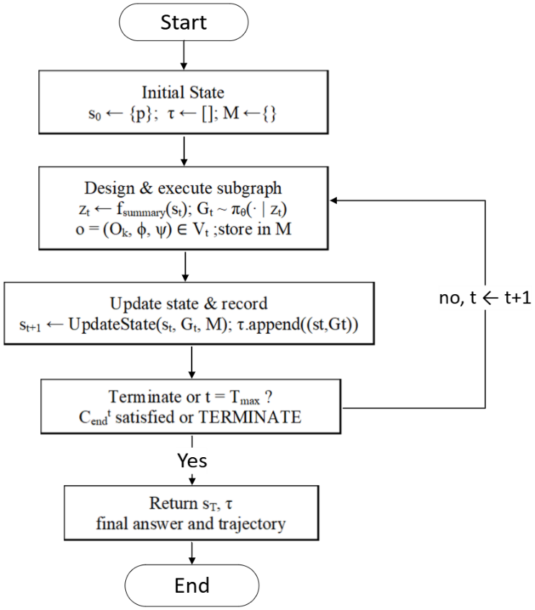
F. Algorithm 2 — DyFlow-T (Proposed)
Algorithm 2: DyFlow-T Tool based workflow
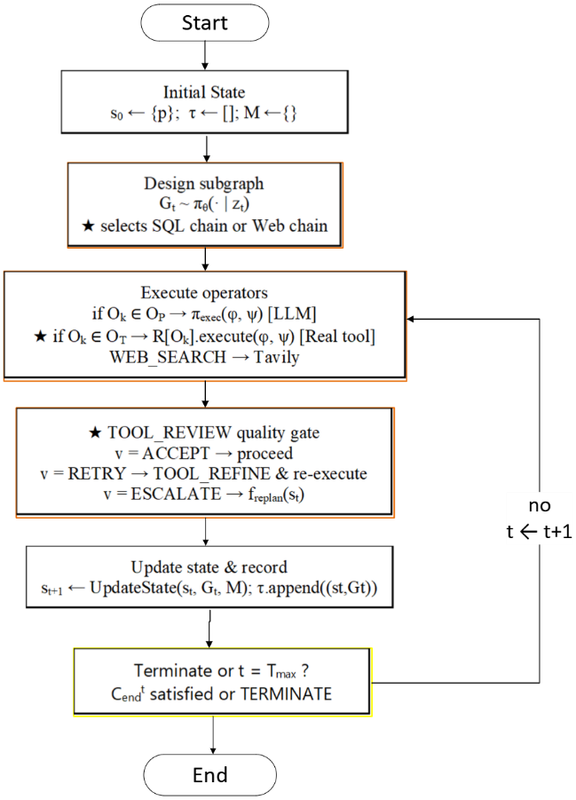

Algorithm 2 extends Algorithm 1 at five points: Line 3 (designer now selects between SQL and Web chains), Line 6 (conditional routing to O_T), Line 8 (real external execution via ToolRegistry), Line 9 (TOOL_REVIEW quality gate), and Line 11 (TOOL_REFINE query correction). All other lines are structurally identical, confirming DyFlow-T is a minimal non-breaking extension of DyFlow. Complexity overhead is at most four additional LLM/API calls per trajectory constantly relative to the accuracy gains demonstrated.

1

