PROJECT DOCUMENTATION
Script-Controlled ACL – Restrict Record Access Based on Field Value
ServiceNow Access Control List (ACL) Implementation
Date | 03/10/26
Team ID | SWTID-2026-7810
Team Size | 3
Team Leader | Koushik G L
Team Member | Aadhithyan V T
Team Member | Bhuvanakrishna M
Platform | ServiceNow

.

Document Structure
1. IDEATION
- Empathize & Discover
- Define Problem Statements
- Brainstorm & Idea Prioritization
2. REQUIREMENT ANALYSIS
- Functional Requirements
- Non-functional Requirements
- Data Flow Diagram
- User Stories
3. PROJECT DESIGN
- Proposed Solution
- Problem–Solution Fit
- Solution Architecture
- Technology Stack
4. PROJECT PLANNING
- Product Backlog & Sprint Plan
- Project Tracker
- Velocity & Burndown
- Planning Logic
5. PROJECT DEVELOPMENT
- Functional Specification
- Implementation & Evidence
- Functional Testing / UAT
6. PROJECT DOCUMENTATION
- Project Overview
- Verification Summary
- Known Issues
- Future Enhancements
- Outcome

PHASE 1 — IDEATION
Script-Controlled ACL – Restrict Record Access Based on Field Value
Date: 3/10/26
Team ID: SWTID-2026-7810

1.1 Empathize & Discover — Empathy Map
The empathy map is framed around the actual actors in the documented ServiceNow ACL workflow: an EEE user who needs authorized access to EEE records, users who should be restricted, and an administrator who requires full access.
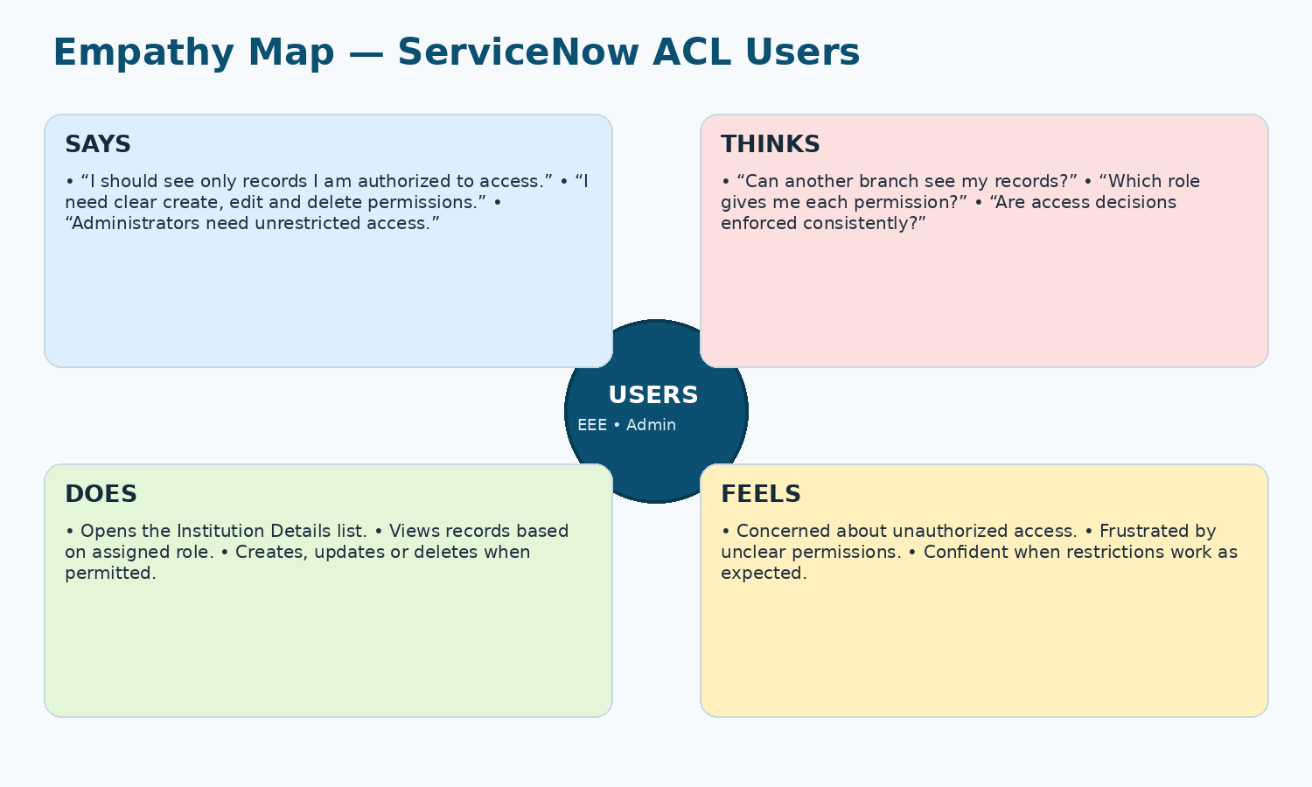
Figure 1. Project-specific empathy map for ServiceNow ACL stakeholders.

1.2 Define the Problem Statements
PS No. | I am (Customer) | I’m trying to | But | Because | Which makes me feel
PS-1 | EEE branch user | Access only EEE branch records | Other branch records may be exposed without proper restriction | Access is not automatically filtered by branch and role | Concerned about privacy and unauthorized access
PS-2 | Administrator | Manage record access consistently | Different operations need different permissions | A single unrestricted permission model does not enforce least privilege | Responsible for maintaining secure access

1.3 Brainstorm & Idea Prioritization
S.No. | Idea | Priority
1 | Create separate roles for READ, CREATE, WRITE and DELETE operations | High
2 | Restrict READ access using Branch = EEE | High
3 | Use a server-side scripted ACL for role-based validation | High
4 | Retain full administrator access | High
5 | Verify each permission with separate user/role combinations | Medium
Selected approach: combine a Branch = EEE data condition and scripted READ control with dedicated role-based CREATE, WRITE and DELETE ACLs. This directly reflects the supplied implementation.

Selected Project Idea & Scope
Item | Project Scope
Selected idea | Implement record-level access control for Institution Details in ServiceNow using ACLs, roles and a branch-specific script.
In scope | User and role creation; custom table and fields; ECE/EEE/CSE sample records; READ/CREATE/WRITE/DELETE ACLs; impersonation-based verification.
Primary stakeholders | EEE user, users without the required role, and administrator.

PHASE 2 — REQUIREMENT ANALYSIS
Script-Controlled ACL – Restrict Record Access Based on Field Value
Date: 3/10/26
Team ID: SWTID-2026-7810

2.1 Functional Requirements
FR No. | Functional Requirement (Epic) | Sub Requirement (Story / Sub-Task)
FR-1 | User & Role Setup | Create EEE test user; create bb1–bb4 roles; assign roles to the test user.
FR-2 | Institution Details Data | Create u_institution_details; add required fields; create records across ECE, EEE and CSE.
FR-3 | Script-Controlled READ | Require bb1; apply Branch is EEE; evaluate the scripted access rule.
FR-4 | Role-Controlled CRUD | bb2 → CREATE; bb3 → WRITE; bb4 → DELETE.
FR-5 | Verification | Impersonate users and verify allowed / denied record visibility and operations.

2.2 Non-functional Requirements
NFR No. | Requirement | Description
NFR-1 | Security | Access must be enforced through roles, a branch condition and server-side ACL logic.
NFR-2 | Usability | Authorized users should experience clear and predictable permissions.
NFR-3 | Reliability | The same access rules should be consistently applied to each record operation.
NFR-4 | Performance | ACL logic should remain focused and should not add unnecessary processing.
NFR-5 | Availability | Authorized users should be able to access the table when the ServiceNow instance is available.
NFR-6 | Scalability | The role-and-condition model can be extended to additional branches and operations.

2.3 Data Flow Diagram (DFD)
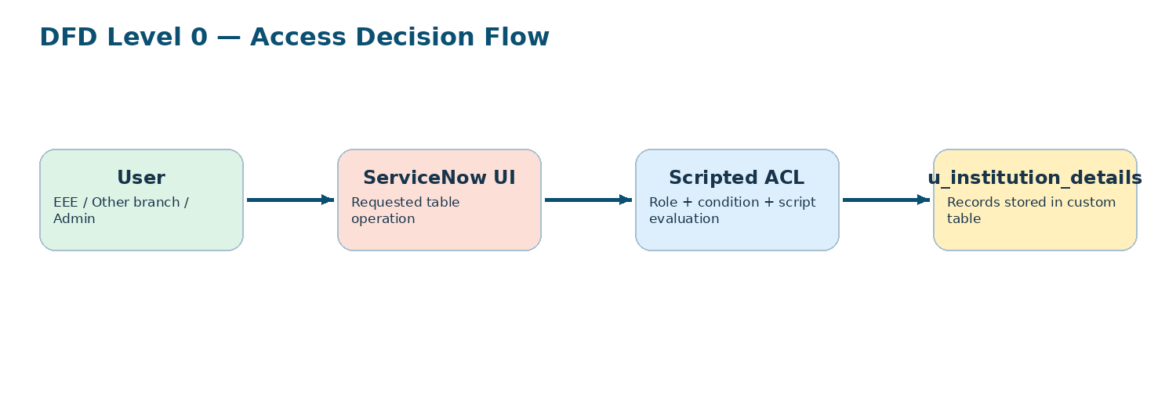
Figure 2. Level-0 logical data flow for the ACL decision.

ACL Requirement Matrix
Operation | Required Role | Condition | Expected Access
READ | bb1 | Branch = EEE + script | EEE records only for the EEE user
CREATE | bb2 | No additional data condition | Create operation available as configured
WRITE | bb3 | No additional data condition | Permitted records can be edited
DELETE | bb4 | No additional data condition | Permitted records can be deleted
READ (Admin) | admin | Admin check in script | All records for the documented READ scenario

2.4 User Stories
User Type | Epic | US No. | User Story / Task | Acceptance Criteria | Priority
EEE User | READ | US-1 | As an EEE user with bb1, I can view only EEE branch records. | Only Branch = EEE records are displayed. | High
Restricted User | READ | US-2 | As a user without the required access, I cannot view restricted records. | Restricted records are not visible. | High
Authorized User | CREATE | US-3 | As a user with bb2, I can create Institution Details records. | The New action and create operation are available as configured. | High
Authorized User | WRITE | US-4 | As a user with bb3, I can update permitted records. | Permitted records can be edited and saved. | High
Authorized User | DELETE | US-5 | As a user with bb4, I can delete permitted records. | Permitted records can be deleted. | High
Administrator | Full Access | US-6 | As an administrator, I can perform administrative access actions without the implemented READ restriction. | All records are visible for the documented READ scenario. | High

PHASE 3 — PROJECT DESIGN
Script-Controlled ACL – Restrict Record Access Based on Field Value
Date: 3/10/26
Team ID: SWTID-2026-7810

3.1 Proposed Solution
Parameter | Description | Project-Specific Definition
Problem Statement | Problem to be solved | Prevent unauthorized access to Institution Details records and enforce operation-specific permissions.
Idea / Solution | Solution description | Use ServiceNow ACLs with custom roles, a Branch = EEE condition and a server-side script for READ; use dedicated roles for CREATE, WRITE and DELETE.
Novelty / Uniqueness | What differentiates the approach | Combines field-value restriction with role-based ACL scripting at record level.
Social Impact / Customer Satisfaction | Expected benefit | Reduces accidental exposure of branch-specific student information and makes access behaviour explicit.
Business Model | Revenue model | Not applicable to the supplied educational ServiceNow lab; value is security, governance and controlled access.
Scalability | Future expansion | Add more branch-specific roles/conditions, field-level ACLs and additional test accounts.

3.2 Problem–Solution Fit
Customer Need | Current Risk | ACL Response | Expected Fit
See only authorized branch data | Unrelated branch records may be visible | Branch = EEE condition + bb1 role + script | Record visibility is aligned to branch authorization.
Separate CRUD permissions | One role may expose unnecessary operations | bb2 / bb3 / bb4 per operation | Permissions are separated by operation.
Administrative override | Admins still need to manage records | admin check in READ script | Administrative visibility is preserved for the documented scenario.

3.3 Solution Architecture
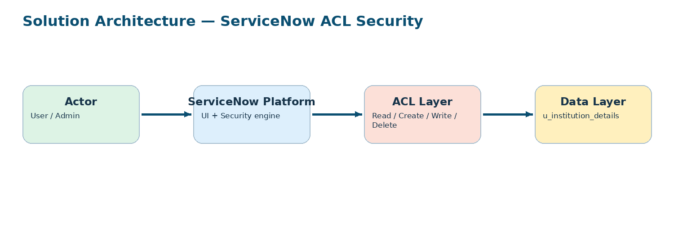
Figure 3. Logical architecture showing where ACL evaluation occurs.

3.4 Technology Stack
Component | Description | Technology
User Interface | User and administrator interaction with the records and security configuration. | ServiceNow UI / Now Platform
Application Logic | Server-side access decision logic for READ. | ServiceNow ACL Script (JavaScript / Glide APIs)
Access Control | Operation-level permission rules. | ServiceNow Access Control Lists
Data Storage | Custom record table and fields. | ServiceNow table: u_institution_details
Identity & Roles | User and role assignment. | ServiceNow Users / Roles
Infrastructure | Execution and persistence platform. | ServiceNow instance / platform

3.5 Application Characteristics
Characteristic | Description | Implementation
Security | Role- and condition-based access control. | bb1–bb4 roles, Branch = EEE condition, scripted READ control
Scalable Architecture | Rules can be extended without redesigning the table. | Additional roles, branches and field-level ACLs
Availability | Security runs inside the ServiceNow platform. | ServiceNow instance availability
Performance | Keep ACL scripts small and deterministic. | Simple role check + condition evaluation

PHASE 4 — PROJECT PLANNING
Script-Controlled ACL – Restrict Record Access Based on Field Value
Date: 3/10/26
Team ID: SWTID-2026-7810

4.1 Product Backlog & Sprint Plan
Sprint | Epic | US No. | User Story / Task | Story Points | Priority | Owner
Sprint 1 | User & Role Setup | USN-1 | Create EEE test user and roles bb1–bb4; assign roles. | 3 | High | Team
Sprint 1 | Data Model | USN-2 | Create Institution Details table and required fields. | 5 | High | Team
Sprint 1 | Sample Records | USN-3 | Create ECE, EEE and CSE records for validation. | 2 | Medium | Team
Sprint 2 | READ ACL | USN-4 | Configure READ ACL, bb1, Branch = EEE and script. | 5 | High | Team
Sprint 2 | CREATE ACL | USN-5 | Configure CREATE ACL with bb2. | 3 | High | Team
Sprint 2 | WRITE ACL | USN-6 | Configure WRITE ACL with bb3. | 3 | High | Team
Sprint 2 | DELETE ACL | USN-7 | Configure DELETE ACL with bb4 and verify CRUD behaviour. | 5 | High | Team
Planning estimate: 26 story points across two sprints. These points are planning estimates derived from the supplied Fibonacci-style scale; they are not claimed as measured execution results.

4.2 Project Tracker
Sprint | Total Story Points | Duration | Start Date | Planned End Date | Actual Release
Sprint 1 | 10 | 3 Days | 30/09/26 | 02/10/26 | 03/10/26
Sprint 2 | 16 | 4 Days | 30/09/26 | 03/10/26 | 03/10/26

4.3 Velocity & Burndown
Velocity and burndown values should be completed from actual sprint execution. The project source does not contain measured completion data, so no fabricated actual velocity or burndown chart is included.
Metric | Definition | Status
Velocity | Total story points completed / number of sprints | To be recorded after execution
Burndown | Remaining work plotted against sprint time | To be recorded after execution

4.4 Planning Logic
Story-point scale used by the supplied planning template: 1 = very easy, 2 = normal, 3 = moderate, 5 = difficult. The team decomposes the ACL project into small configuration tasks and groups them into two logical implementation sprints.

PHASE 5 — PROJECT DEVELOPMENT
Script-Controlled ACL – Restrict Record Access Based on Field Value
Date: 3/10/26
Team ID: SWTID-2026-7810

5.1 Functional Specification
Area | Specification | Acceptance Condition
User configuration | EEE User is created with required identity details. | User record exists and can be impersonated.
Role configuration | Roles bb1–bb4 are created and assigned to the test user. | Role records exist and assignments are present.
Data model | u_institution_details contains the specified fields. | Table and fields are available.
READ security | bb1 + Branch = EEE + script are applied. | EEE user sees only EEE records; admin retains documented access.
CREATE security | bb2 is required. | User with required roles can use create operation.
WRITE security | bb3 is required. | User with required roles can edit permitted records.
DELETE security | bb4 is required. | User with required roles can delete permitted records.

5.2 Implementation Summary
- Create the EEE test user and roles bb1–bb4.
- Create u_institution_details and the required student/faculty/branch/contact fields.
- Create sample records with ECE, EEE and CSE values.
- Elevate security_admin before ACL configuration.
- Create the READ ACL with bb1, Branch = EEE and the supplied script.
- Create CREATE, WRITE and DELETE ACLs using bb2, bb3 and bb4.
- Impersonate users and verify access to lists and record operations.

5.3 Implementation Evidence
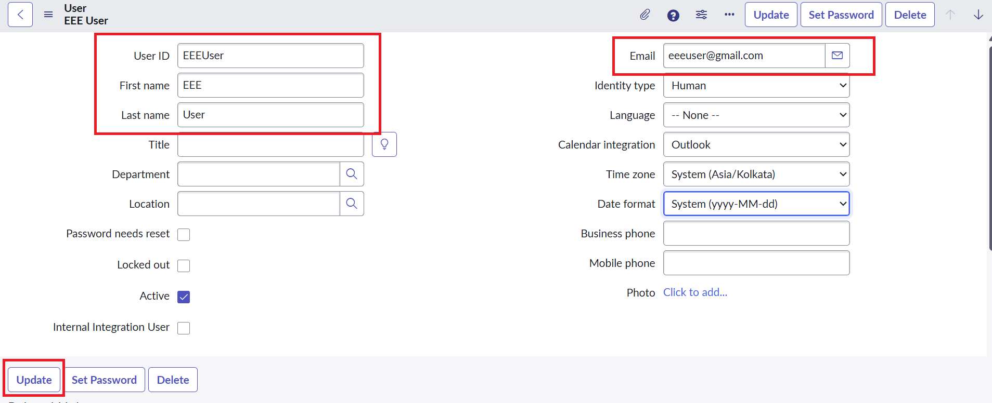
Figure 4. EEE test user — identity and email fields.
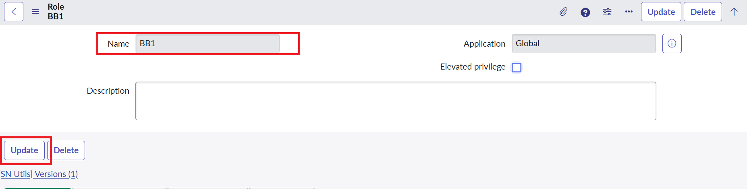
Figure 5. Custom role BB1 configuration.

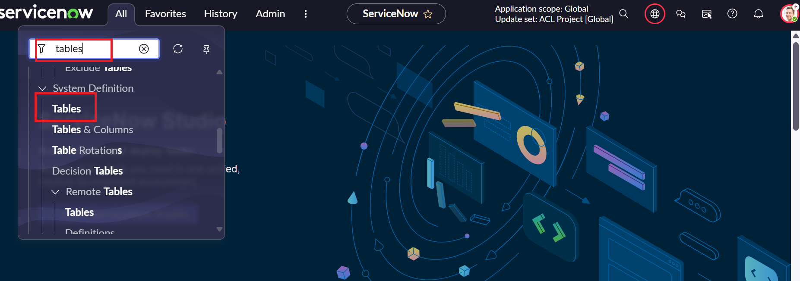
Figure 6. System Definition → Tables navigation.
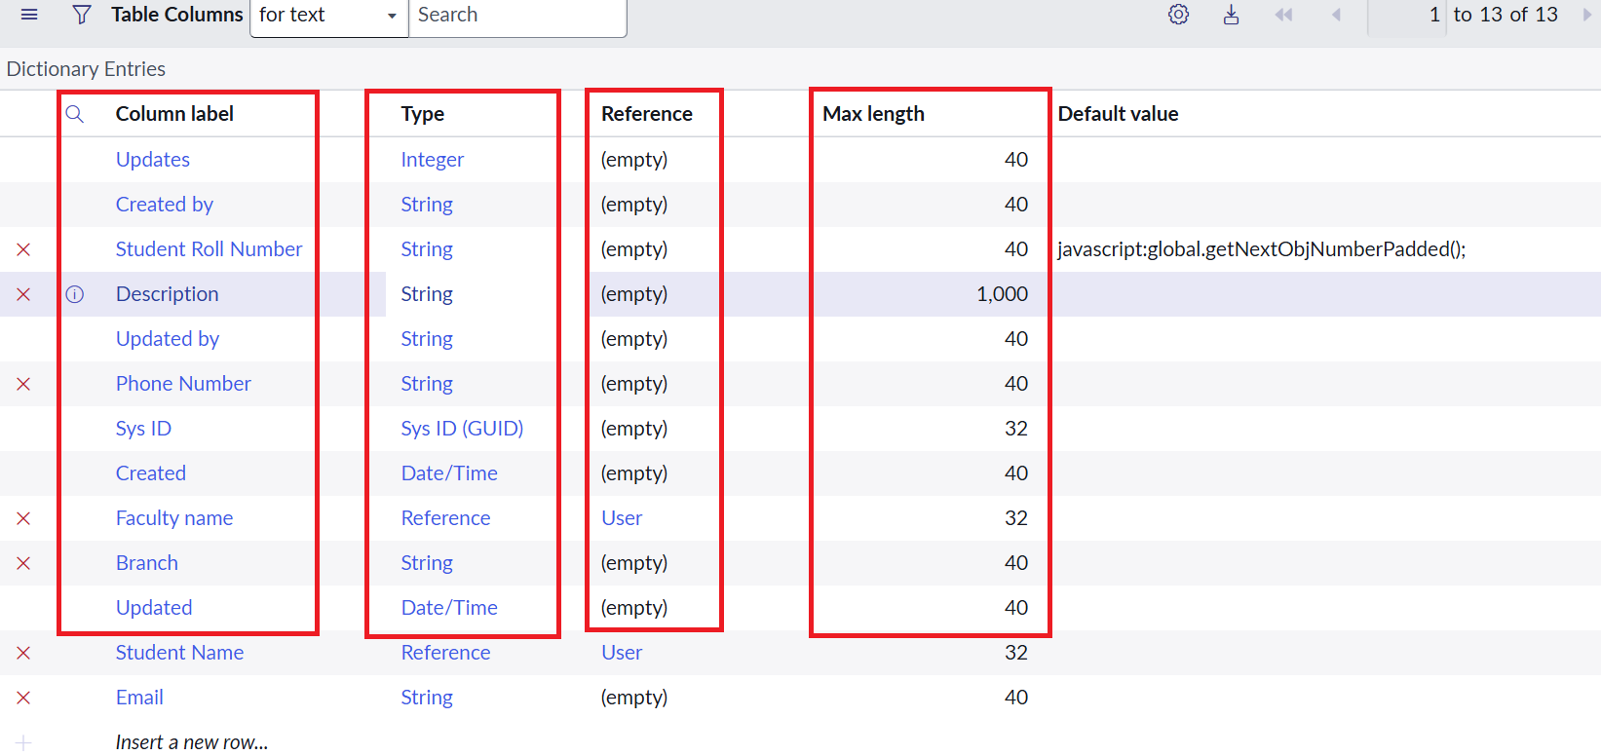
Figure 7. Institution Details fields and types.

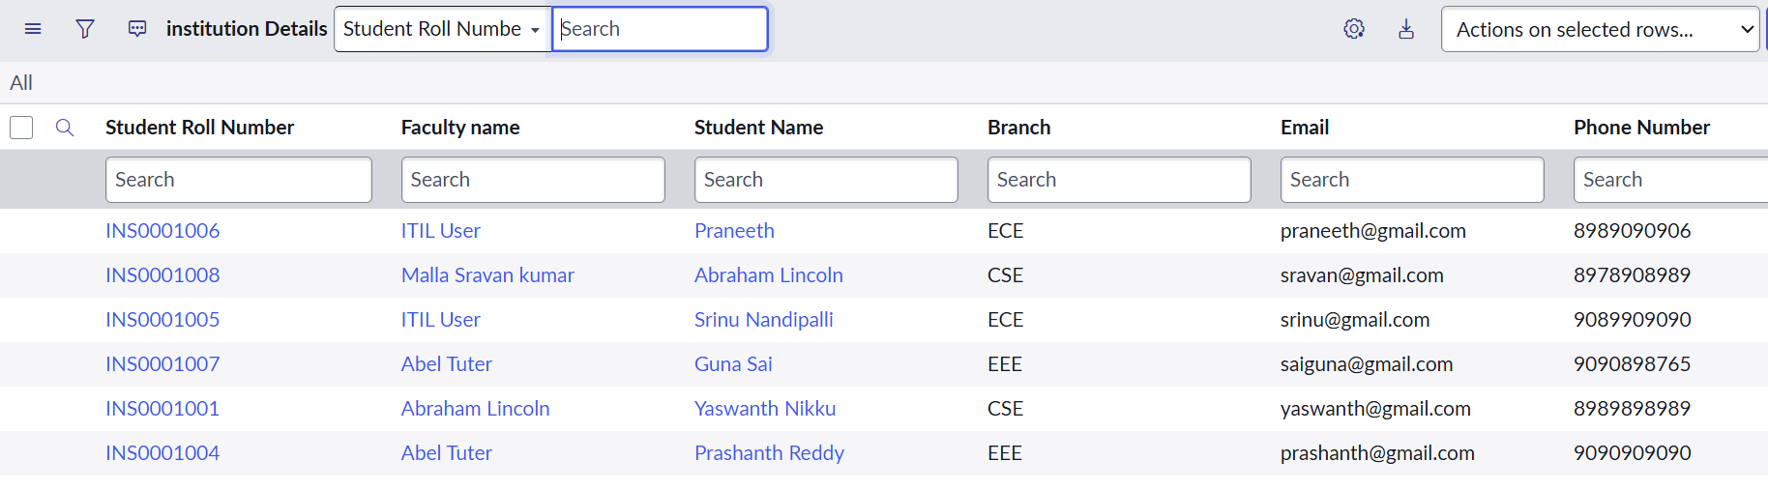
Figure 8. Institution Details records with different branch values.
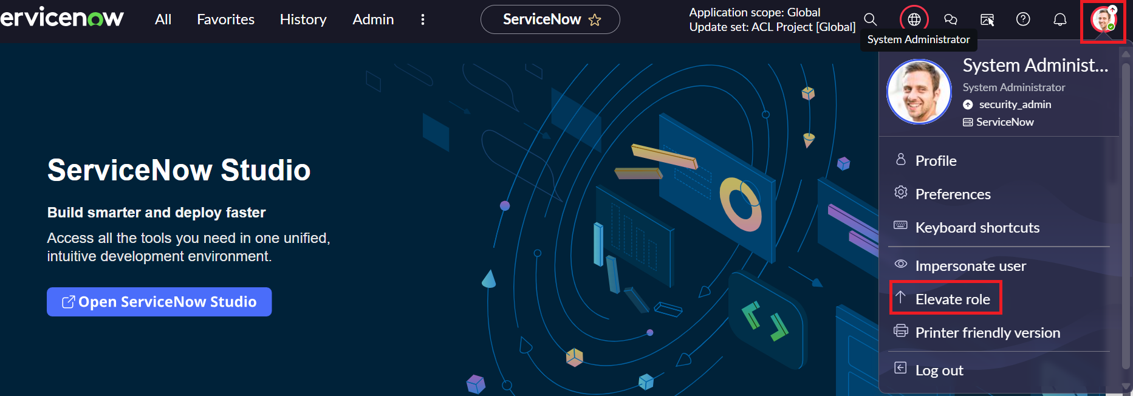
Figure 9. security_admin elevation entry.

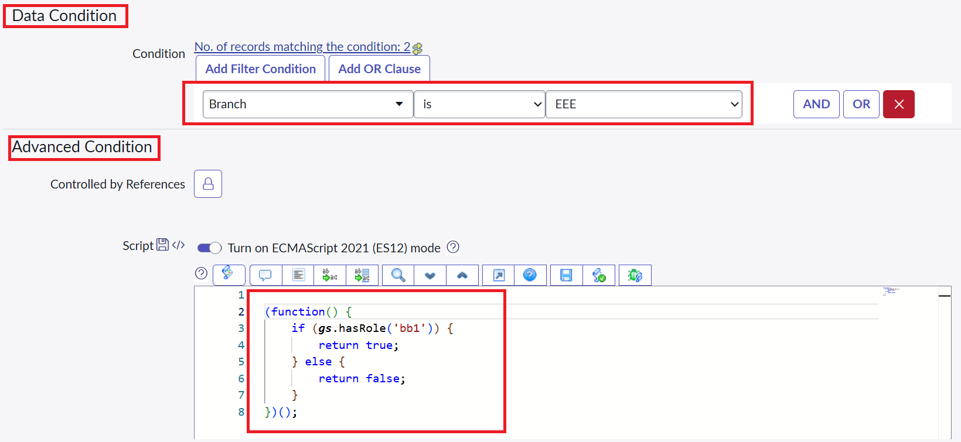
Figure 10. READ ACL data condition and script area.
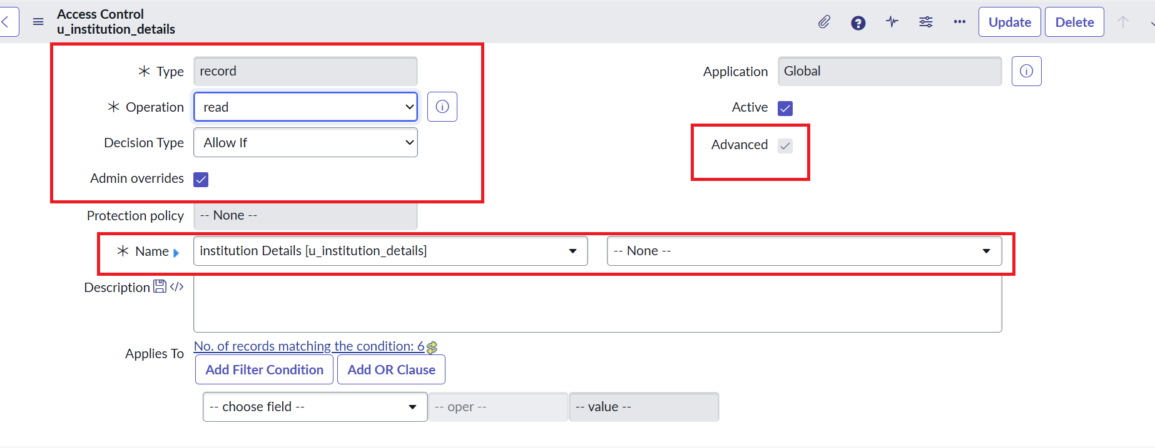
Figure 11. ACL record configuration.

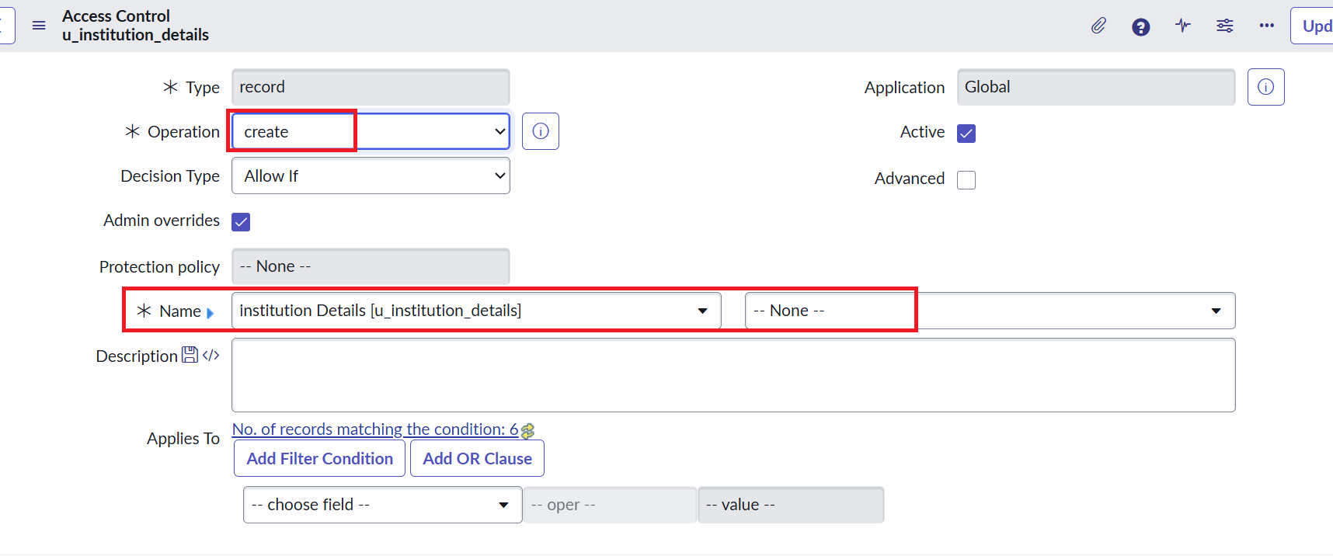
Figure 12. ACL role configuration.
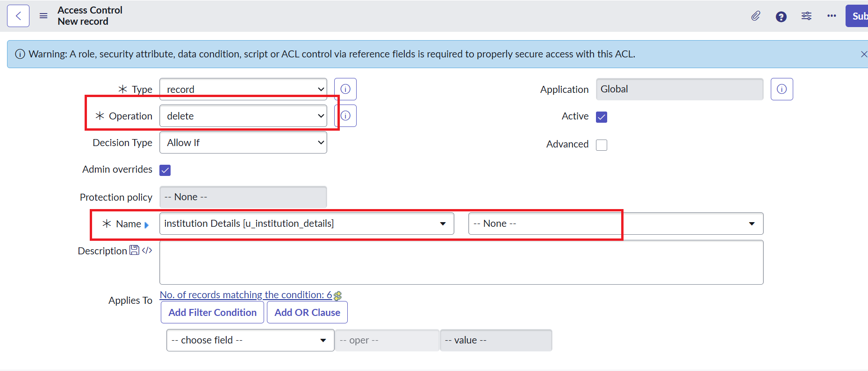
Figure 13. CRUD ACL configuration.

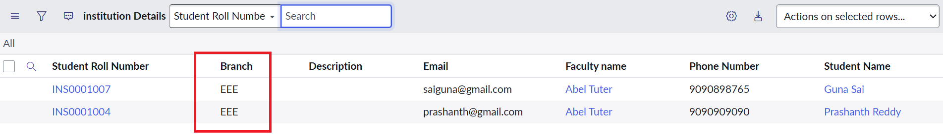
Figure 14. Verification — EEE branch records visible.
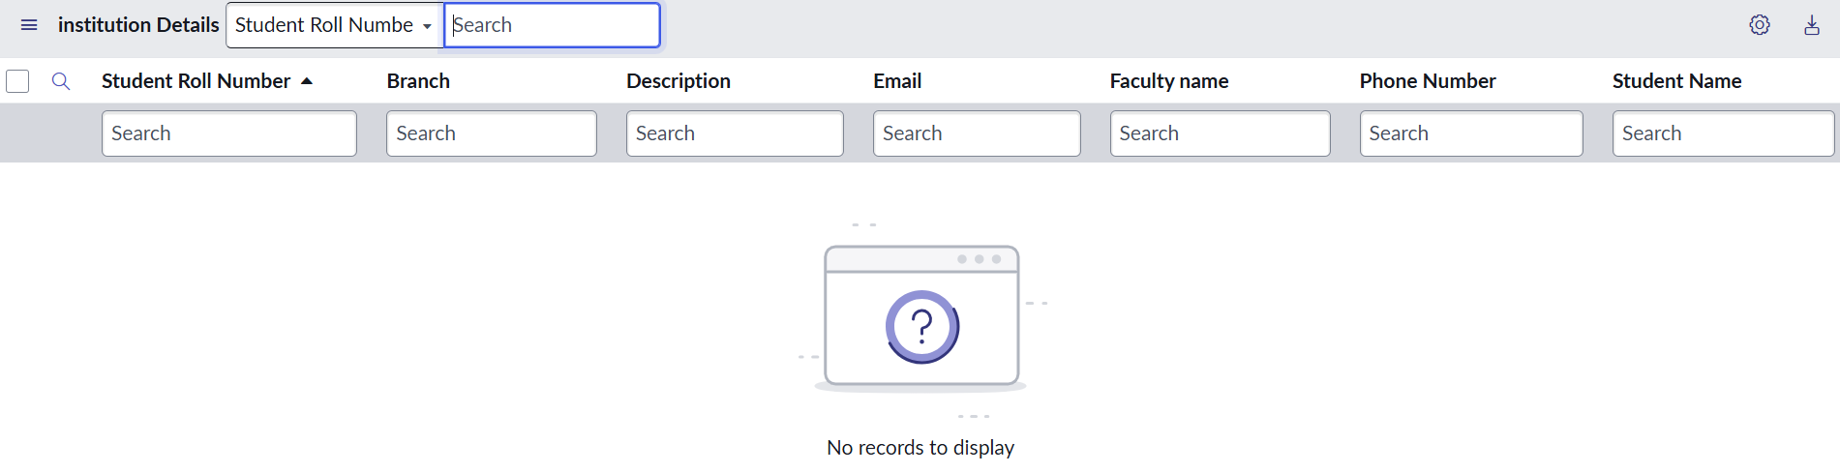
Figure 15. Verification — restricted list view.

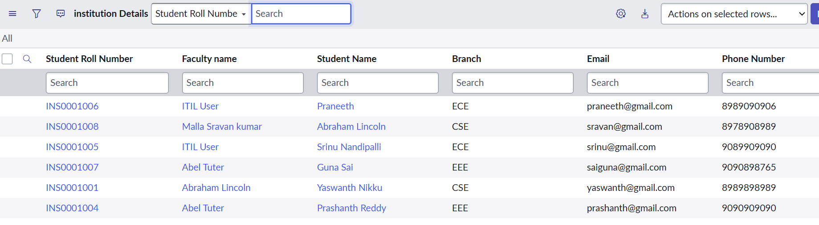
Figure 16. Administrator verification — all branch records.
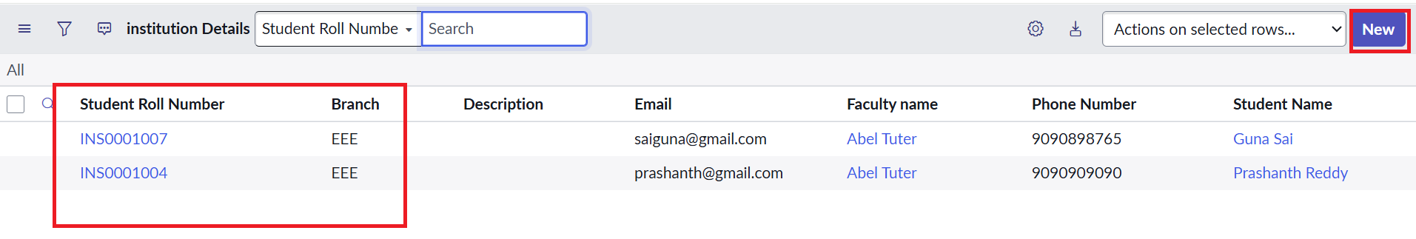
Figure 17. CREATE verification — New button availability.

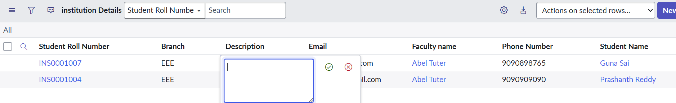
Figure 18. WRITE verification — editable EEE records.
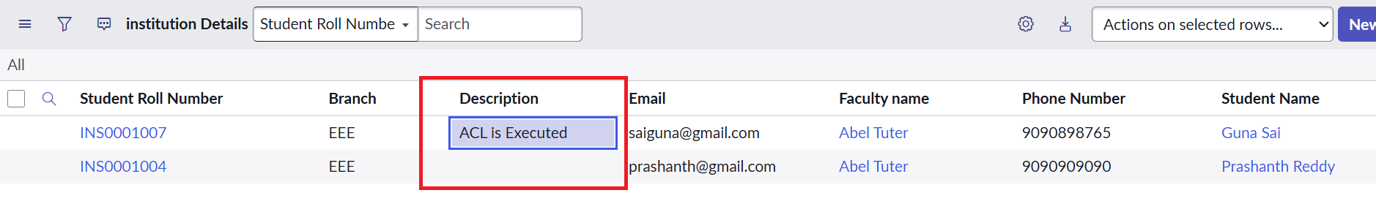
Figure 19. Final DELETE/record-operation evidence.

5.4 Functional Testing / UAT
Test ID | Scenario | Steps | Expected Result | Actual Result | Status
TC-01 | EEE user READ | Impersonate EEE user and open u_institution_details list. | Only EEE records are visible. | To be recorded | Pending
TC-02 | Unauthorized READ | Use a user without the required access. | Restricted records are not visible. | To be recorded | Pending
TC-03 | CREATE | Use bb2 role combination and open create flow. | Create operation is available and succeeds when permitted. | To be recorded | Pending
TC-04 | WRITE | Use bb3 role combination and edit an allowed record. | Update is available and succeeds when permitted. | To be recorded | Pending
TC-05 | DELETE | Use bb4 role combination and delete an allowed record. | Delete is available and succeeds when permitted. | To be recorded | Pending
TC-06 | Admin READ | Impersonate administrator and open the list. | All branch records are visible for the documented READ scenario. | To be recorded | Pending
UAT note: actual Pass/Fail status must be filled after the team completes the tests in the target ServiceNow instance. No unverified test outcome is presented as completed.

PHASE 6 — PROJECT DOCUMENTATION
Script-Controlled ACL – Restrict Record Access Based on Field Value
Date: 3/10/26
Team ID: SWTID-2026-7810

6.1 Project Overview
The project implements record-level security in ServiceNow using Access Control Lists. The central table is u_institution_details, containing student identity, faculty, branch and contact-related fields. The documented implementation separates permissions by operation and restricts READ access using the EEE branch condition.

6.2 Configuration Summary
Component | Configuration | Purpose
Custom table | u_institution_details | Stores Institution Details records.
READ ACL | bb1 + Branch = EEE + script | Controls record visibility.
CREATE ACL | bb2 | Controls record creation.
WRITE ACL | bb3 | Controls record modification.
DELETE ACL | bb4 | Controls record deletion.
Administrator | admin check in READ script | Retains full access for the documented READ scenario.

6.3 Verification Summary
- EEE user with bb1: only EEE branch records should be visible.
- User without the required role: restricted records should not be visible.
- Administrator: all branch records are visible for the documented READ scenario.
- bb2 / bb3 / bb4: separate CREATE / WRITE / DELETE operations are controlled through role requirements.

6.4 Known Issues / Limitations
- The supplied source does not contain completed UAT results for every test case; final status must be entered after execution.
- The current READ script and configuration are documented for the EEE branch scenario; other branches require additional rules if they need equivalent isolation.

6.5 Future Enhancements
- Extend branch-specific access rules to additional departments or branches.
- Add field-level ACLs for sensitive attributes such as Email and Phone Number.
- Create dedicated positive and negative test accounts for each CRUD path.
- Capture final signed UAT evidence for every permission scenario.

6.6 Final Access Control Matrix
ACL | Role | Rule | Documented Result
READ | bb1 | Branch = EEE + script | EEE user can view EEE records only
CREATE | bb2 | Role required | Create operation available as configured
WRITE | bb3 | Role required | Update operation available as configured
DELETE | bb4 | Role required | Delete operation available as configured
READ | admin | Admin check in script | Administrator can view all records in the documented scenario

6.7 Outcome
The project demonstrates how ServiceNow ACLs can combine role checks, field-value conditions and server-side scripts to enforce record-level security. The resulting model separates READ, CREATE, WRITE and DELETE permissions while preserving administrator access for the documented READ scenario.

6.8 Final Verification Checklist
- User and roles configured: EEE User, bb1, bb2, bb3, bb4.
- Custom table and required fields configured: u_institution_details.
- READ rule configured with Branch = EEE, bb1 and the supplied script.
- CREATE / WRITE / DELETE ACLs configured with bb2 / bb3 / bb4.
- Verification evidence inserted from the supplied project screenshots.
- Final UAT status to be completed against the target ServiceNow instance.

