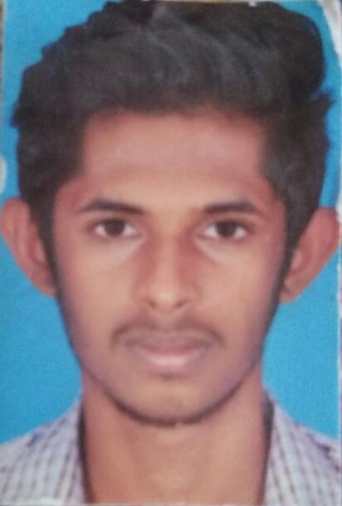**KOUSHIK MUTHESH P**

Information Technology

+91 9344690751



koushikm2021@srishakthi.ac.in



Koushikmuthesh24



183/200,Dr. Radhakrishnan rd, Tatabad, Sivanantha colony,

Coimbatore  641 012.

Seeking the position to utilize my skills and abilities in the field of Information Technology industry that offers professional as well as personal growth. I would like to utilize my skills and experience to the fullest potential while demonstrating my ability and eagerness on taking responsibility to develop a harmonious relationship between co-workers in reaching an organizational growth.



ACADEMIC CREDENTIALS

**B.TECH Information Technology**

Percentage : 7.3*(upto 5th semester)   
Year of passing : 2021

**H.S.L.C  State Board**

Percentage : 94 %  
Year of passing : 2017  
**S.S.L.C -Matriculation**

Percentage : 80%  
Year of passing : 2015



AREAS OF INTEREST

* Machine Learning
* Android Projects



IT SKILLS

* Languages : Python, Java
* Software : MS Office, Android Studio, Visual Studio.

PROJECTS

**WEBSITE DESIGNED**

|  |  |  |  |  |
| --- | --- | --- | --- | --- |
|  |  |  |  |  |
| **Institution** | : Sri Shakthi Institute of Engineering and Technology, CBE**.** | | | |
| **Duration** | : 10 days | | | |
| **Project Title** | : Xenera | | | |
| **Description** | : Developed a website for social welfare organization. | | | |
| **Link** |  | : www.Xenera.org.in | | |
| **MINI PROJECT** | | | | |
|  |  |  |  | |
| **Institution** | : Sri Shakthi Institute of Engineering and Technology, CBE**.** | | | |
| **Duration** | : 1 Month | | | |
| **Project Title** | : Hospital Management System | | | |
| **Description** | : Developed an online consultancy and appointment fixing | | | |

|  |  |  |  |  |
| --- | --- | --- | --- | --- |
|  |  |  |  |  |
| **Institution** | : Sri Shakthi Institute of Engineering and Technology, CBE**.** | | | |
| **Duration** | : on going | | | |
| **Project Title** | : Movie Recommendation System | | | |
| **Description** | : Developing a Movie Recommendations System using Python. | | | |
|  |  | | | |
| **Institution** | : Sri Shakthi Institute of Engineering and Technology, CBE**.** | | | |
| **Duration** | : Developing | | | |
| **Project Title** | : Chatbot | | | |
| **Description** | : Developing a Basic Chatbot using Python | | | |

IN-PLANT TRAINING / INDUSTRIAL VISITS

**IN-PLANT TRAINING:**

|  |  |  |  |
| --- | --- | --- | --- |
|  |  |  |  |
| **1.** | **Company Name** | : Live Stream Technologies. | |
|  | **Duration** | : 10 Days. | |
|  | **Purpose** | : Training on Python in Data science.. | |

**INDUSTRIAL VISITS:**

|  |  |
| --- | --- |
| **1. Company Name** | : ISRO. |
| **Duration** | : 1 Day. |



KEY STRENGTHS

* Quick learner.
* Hard worker.
* Self motivated.
* Multi tasking.
* Pressure handling.



ACADEMIC / EXTRA-CURRICULAR ACTIVITIES

* Progressed to semi finals level in Hackathon conducted in Sri Eshwar college of engineering.
* International level chess player and U-19 Silver medal holder.



PERSONAL DETAILS

Date of Birth

Gender

Father’s Name

Mother’s Name

Language Read, Write

Speak

Hometown

Nationality

Hobbies

: 10-01-2000

: Male

: Mr Padmanabhan N

: Mrs Vidhya p

: Tamil, English

: English, Tamil, Malayalam

: Coimbatore

: Indian

: Chess, Reading



DECLARATION

I hereby declare that the above information are true to the best of my knowledge.

**DATE : 5/14/20**

**PLACE : Coimbatore**

**KOUSHIK MUTHESH P**