I am this kind of error some time.  
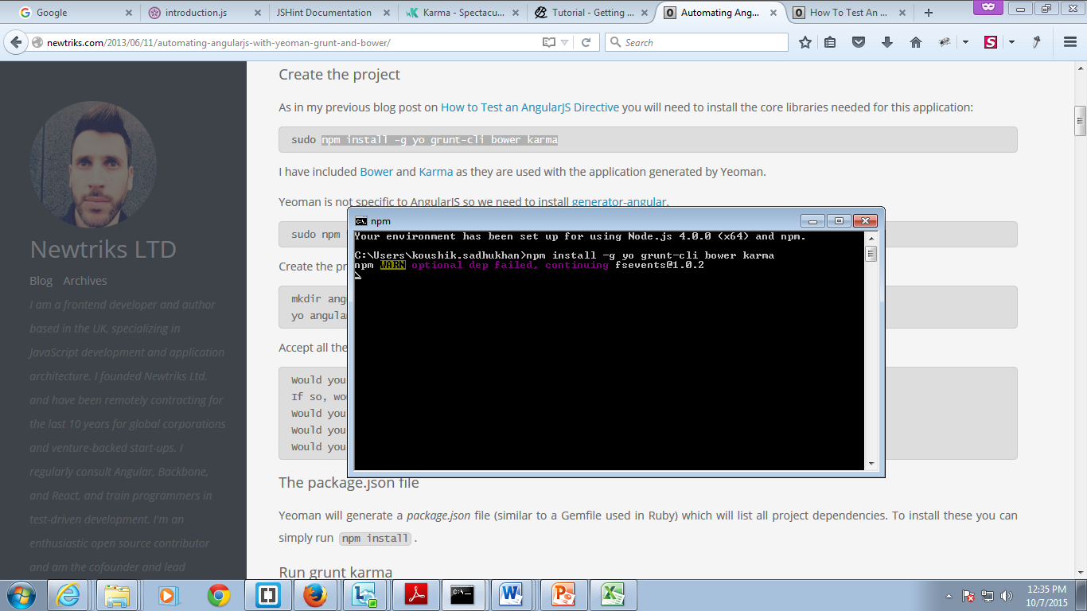  
This warning will impact anywhere?

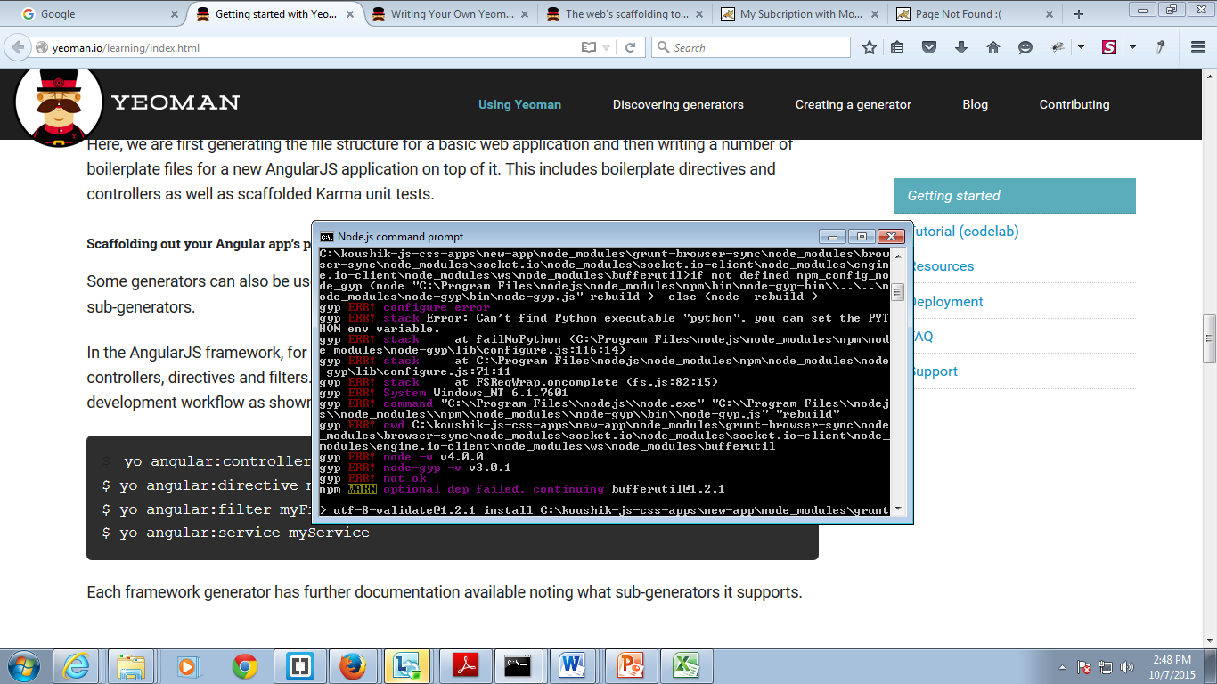  
How can I manage this one. When I fire the command “yo webapp” it generates files, but in node command prompt I am getting these errors.

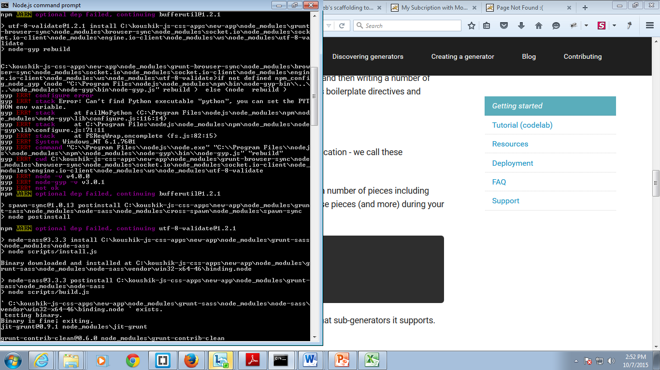

The same error as above.

I tried to bower.json to be updated, by command “bower install jquery-pjax --save”  
I am getting error as below,

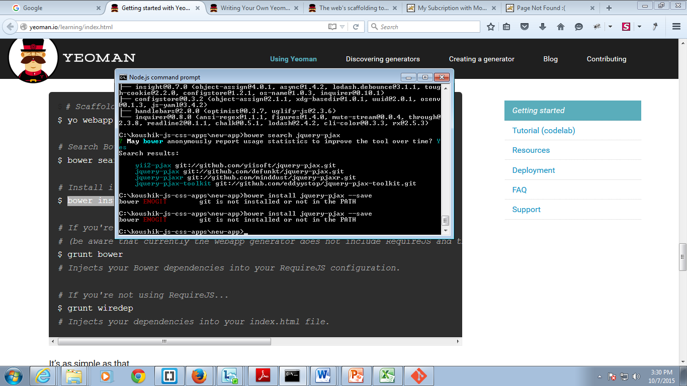  
But I have initiated GIT to the folder by git init command.  
I tried to do as recommended google, then I got the following screen. According to google I found GIT installation path should be added in PATH environment variable.  
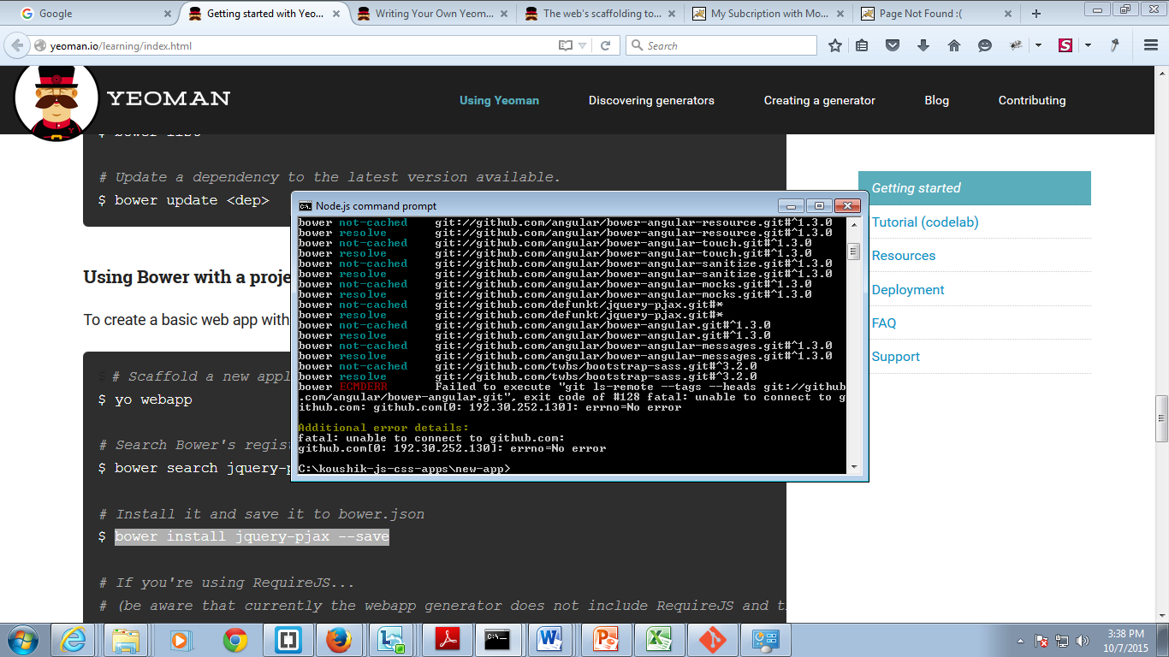

After that I tried to start grunt task runner. I need to start server so that I can access the application by <http://localhost:9000/> by this way. But I am getting errors, which I do not have concept to resolve.  
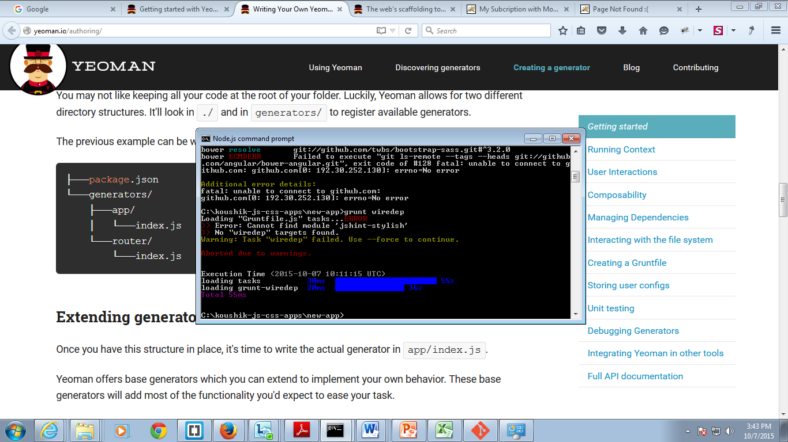

I am trying to create new app again, don’t know when I fire the command “yo angular” it showing error in the terminal, refer to the below picture.  
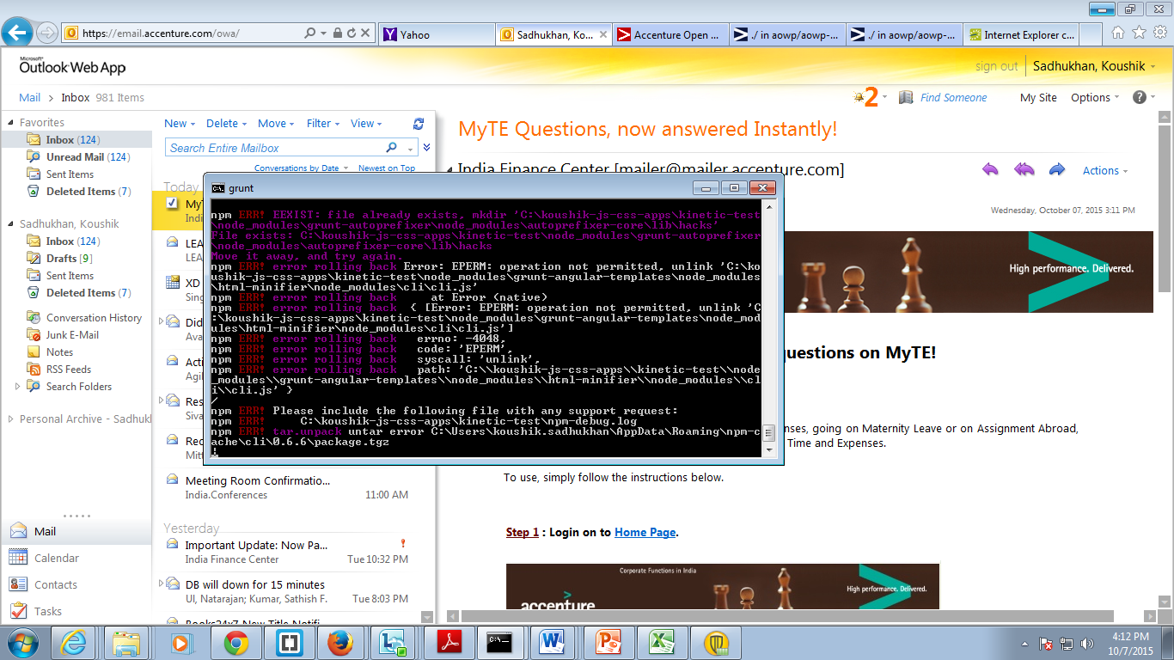

[9-10-2015]

Today I was again trying to generate the code by yeoman, grunt.  
Trying to create angular app with this tool.  
When I put “yo angular”, it generating the files but suddenly it stop and in node cmd prompt I could not see the prompting came back, lastly I had to ctrl+c  
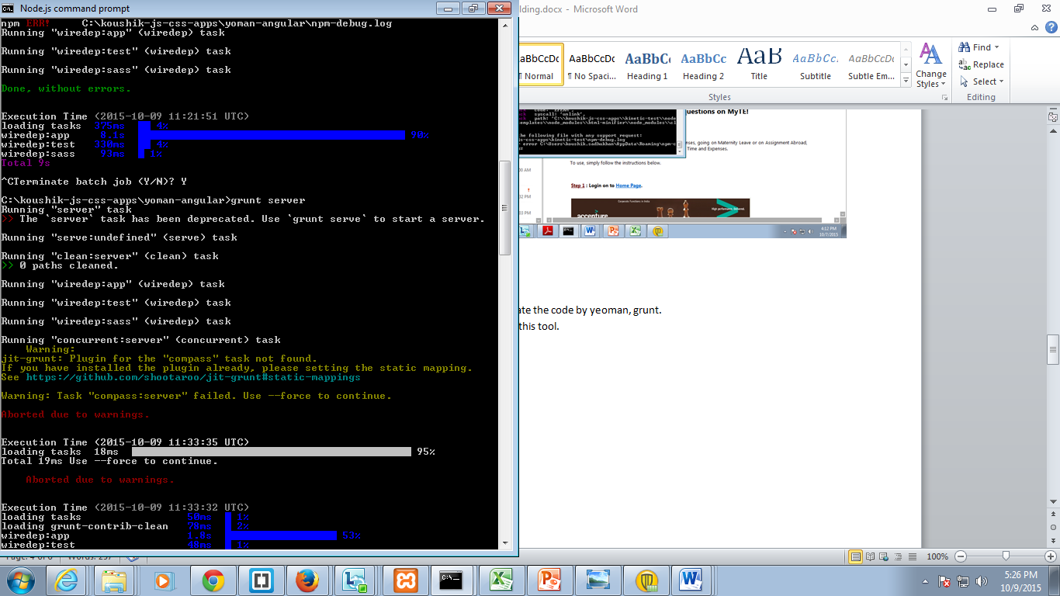

Then I tried to run “grunt serve”, but it also aborted.  
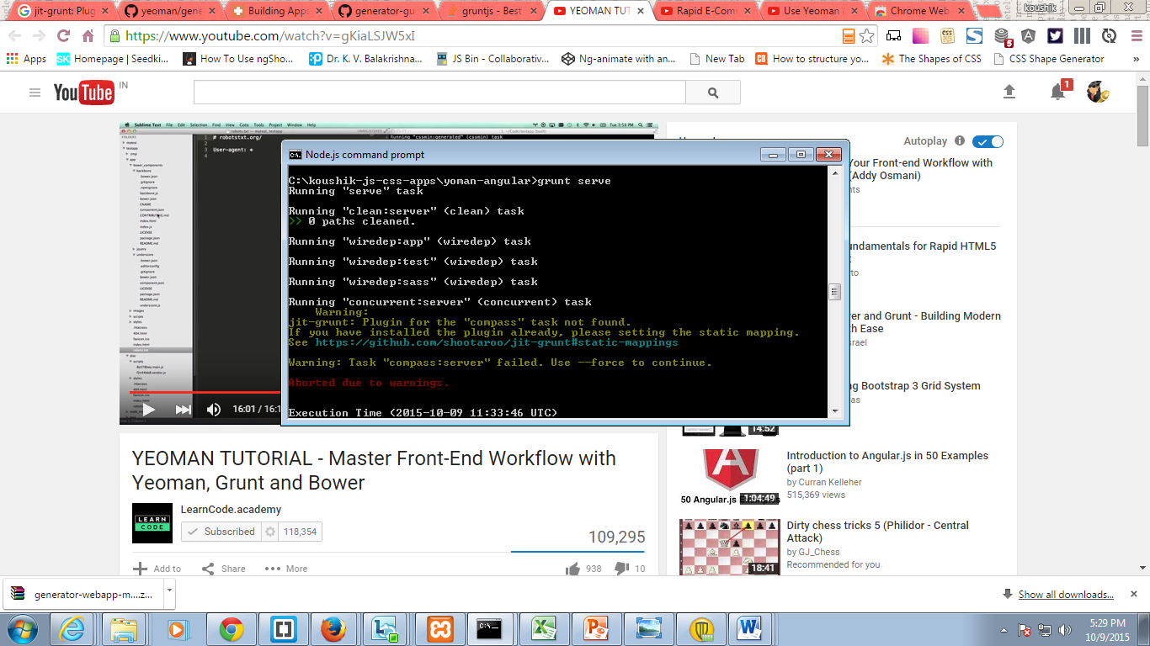

I tried to sort out by own, and trying to install grunt-contrib-compass, and then try to run command “grunt serve” again, but then I got another error.  
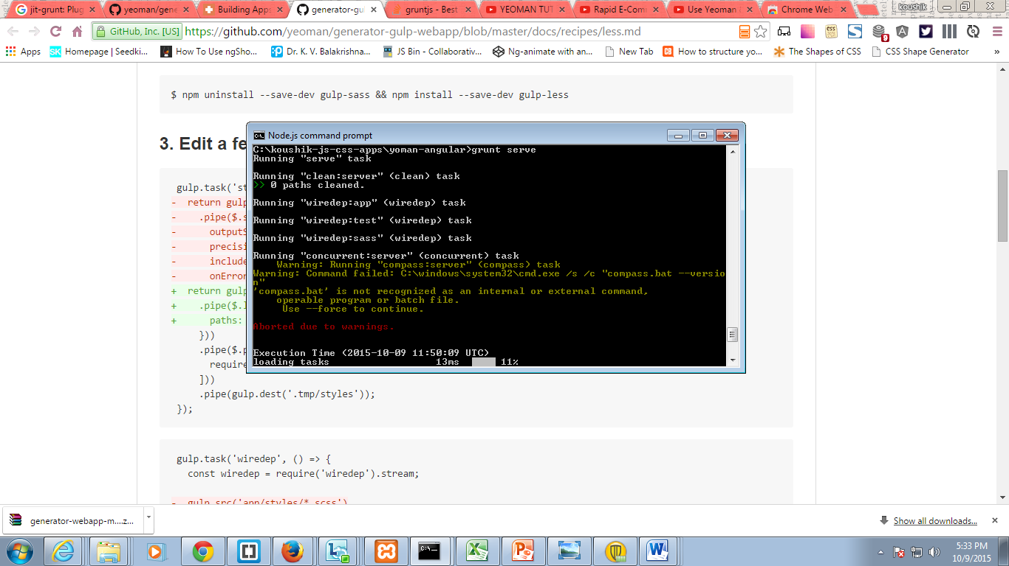

Can it be suggested, how can I set the less generator to the time of scaffolding. As when I do scaffold with the “yo angular”/”yo webapp” every time it try to set sass generator.

7358030527

[121@in.aritel.com](mailto:121@in.aritel.com)

MYUSE = 121

Static code review with JSHINT:  
I have integrated the JSHint with the Brackets IDE, now how to configure and check the code!! Please share the initial concept.  
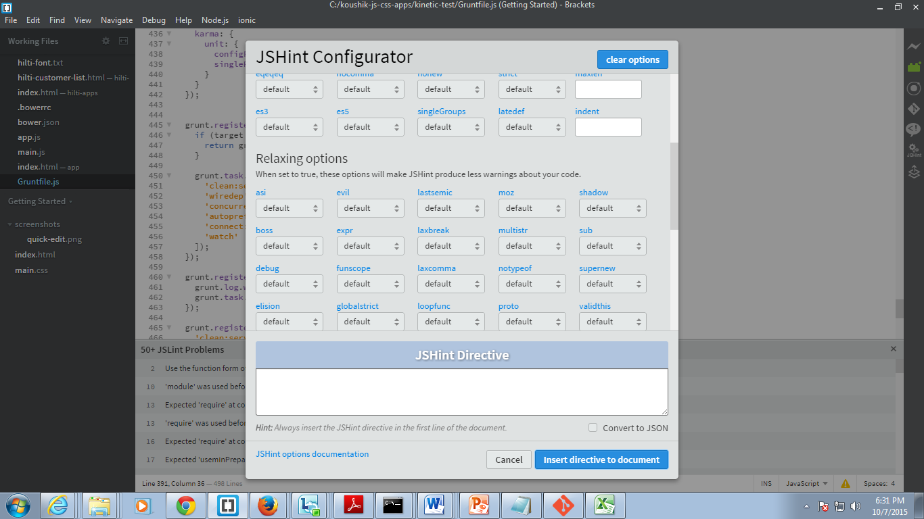

In JsLint static code reviewer also integrated with the brackets IDE, in the following picture the 1st line of JSLint reviewer showing error. I need at least initial concept to resolve it and can update those by own.  
