Helm business questions
This document explains how Helm works today, page by page, and asks how your studio wants it to work. Read Part 0 first (a guided tour, no questions), then Part 1 (the ways a studio can run Helm). Part 1 and Parts A to G then ask 437 questions, most important first.
How to answer. Each question starts with what Helm does today and where to find it (Menu > Page > Section). Each question has a short "What this means" note where needed. Write your answer in the box first, then tick the options below it. Skip anything you are unsure about. Where an option says "(recommended)", that is only our suggestion; the decision is yours.
Contents
Part 0 — How Helm works: a guided tour
1. What Helm is and the working model
2. The roles
3. The screen layout
4. Home / Dashboard
5. The end-to-end journey
6. Control Center
7. Client-facing pages
8. Sign-up, free trial, studio and plans
9. Glossary
Part 1 — Ways to run your studio: choose your workflow
Ways to run your studio — choose your workflow
Workflow 1: One person does everything (owner as Admin, solo) — CURRENT DEFAULT
Workflow 2: Full team relay (Sales → Planner → Event manager → Crew) — suggested alternative
Workflow 3: Event-manager-led with a crew — suggested alternative
Workflow 4: Client self-serve (proposal link, approval, payment milestones) — suggested alternative
Workflow 5: Large studio (designer, vendors, finance, quality) — suggested alternative
Role vs page (default setup; change it in Settings → Users & access)
Common mistakes (and how to avoid them)
Part A — Organisation, roles, sign-up and security
A-1. How Helm is organised: studios, owners and admins
A-2. Roles and what each role can see and change
A-3. The end-to-end workflow and the event page
A-4. Sign-up, free trial, plans and payment
A-5. Studio setup wizard (onboarding)
A-6. Signing in, passwords, invites and security
A-7. Helm HQ (the platform owner's page)
A-8. Features switched ON and OFF today
Part B — Sales: dashboard, leads, quotes, builder, client pages
1. Dashboard
2. Leads
3. Nurture
4. CRM archive
5. Quotes list
6. Creating a quote and the quote editor
7. Layout builder (2D / 3D)
8. Proposal, client approval, booklet, invitations and payments
9. Messages to clients from these pages
Part C — Operations: planning, staff, stock, event day, money, reports
C-1. Planning an event: Resource plan, Run sheet, Tasks, Operations
C-2. Staff page (directory), departments, job titles, import
C-3. Crew experience (what a crew member sees)
C-4. Inventory (your own stock)
C-5. Vendors & partners, bookings, payments, vendor bills
C-6. Logistics, Readiness gate, Event-day command, Issues, Teardown
C-7. Calendar and conflicts
C-8. Payments & invoice (Settlement), Budget & margin, Closure & P&L
C-9. Business, Insights, Reports, Audit log
C-10. Templates and checklists
C-11. Smart import (what can be imported)
C-12. Empty screens, wording and what is switched off
Part D — Control Center, team, notifications, themes
D. Settings, team, security and integrations
D-1. Control Center: how settings are organised
D-2. Settings search and where two-step sign-in lives
D-3. Users & invites: three ways to add a person
D-4. Roles & access (the access matrix)
D-5. Plan & billing
D-6. Hide amounts (privacy PIN)
D-7. Client links & packages
D-8. Pricing & coupons
D-9. Menus & catalog, layout rules, import & custom fields
D-10. Data & compliance (export, retention, deletion)
D-11. Notifications (the bell) and communication settings
D-12. Team chat
D-13. Integrations: e-mail and Razorpay (all off today)
D-14. Colour themes
D-15. Profile, sign-out and session timeout
D-16. Using Helm on a phone
Part E — Open decisions (money rules and business rules)
Already decided (for confirmation)
Money rules
Sales
Manager/Planner/Admin
Crew & event-day staff
Other business rules
Access and approval rules found in the security review
Part F — Legal documents for review (edit and send back)
F1. Privacy Policy
F2. Terms of Service
F3. Refund Policy
F4. Cookie Policy
F5. Acceptable Use Policy
F6. Data Processing Addendum (DPA)
F7. Sub-processors
F8. Service Level Agreement (SLA)
F9. Grievance Redressal
F10. Data Deletion
F11. Accessibility Statement
F12. AI Notice
F13. Copyright and Takedown Policy
F14. Security
Part G — Landing page and public website review

Part 0 — How Helm works: a guided tour
Read this part first. It has no questions. It explains how Helm works today, so the questions that follow make sense. Each later question points back to a screen described here.

1. What Helm is and the working model
How it works today
Helm is an online workspace for an events studio. It covers one event from the first enquiry to the final profit report.
- Studio = organization. Each studio has its own private space. Your team, clients, prices and events are seen only by your studio.
- The quote is the event. There is no separate "event" record. When you create a quote, that same record becomes the event once the client approves and pays the advance.
- One record from lead to closure. The record moves through 11 stages: Lead, Discovery, Proposal, Quote, Confirmed, Planning, Resources, Ready, Event Day, Settlement, Closed. Every page (run-sheet, logistics, settlement and so on) opens for that one record.
- Email goes out from notifications@helm.events. When a client replies, the reply goes to your studio's own email.
- WhatsApp is set up separately.
- Look: dark mode is off. The default colour theme is Emerald.

2. The roles
Helm has 10 staff roles plus the Client. An admin can change what each role sees in Control Center > People > Roles & access. The table shows the starting (default) access.
How it works today
Role | What they do | Default access
Admin | Studio owner. Sets everything up. | Everything, including users, Control Center and the audit log.
Event manager | Runs events and the team day to day. | Sees and edits almost every area, including money and Control Center. Can create quotes.
Planner | Plans events in detail. | Sees and edits pipeline, quotes, planning, event day and money. Can create quotes.
Sales | Handles enquiries and quotes. | Edits leads, CRM, nurture, proposals and quotes. Sees money but edits only quotes. Can create quotes.
Event coordinator | Coordinates the planning work. | Sees leads and quotes; edits staff, stock, vendors, calendar, run-sheet, logistics, readiness and event day.
Supervisor | Leads the crew on site. | Sees quotes and planning; edits event-day command, issues and media.
Quality engineer | Checks quality. | Starts with little or nothing switched on; the admin sets it.
Operations | Stock, vendors, logistics. | Sees quotes and planning; edits staff, inventory, vendors, resource plan and issues.
Designer | Floor layouts and the look of the event. | Suggested set: edit layouts, design, proposal, media; view quotes, calendar, templates.
Crew | Works on the event day. | Sees only the run-sheet and calendar (their shift and brief).
Client | The customer. Does not sign in to the studio app. | Only the links you send: proposal, approval, booklet, client portal, invitation site.

3. The screen layout
Every app page has a left menu and a top bar. A person sees only the menu items their role allows.
How it works today

Left menu, top to bottom
- Pinned — any item you starred, for quick access.
- Workspace — Dashboard, Quotes, Leads, Calendar, Chat.
- Manage — CRM archive, Nurture, Staff, Inventory, Vendors, Templates.
- Admin — Business (studio money), Control Center, Insights, Reports, Audit log, Studio setup.
- Bottom of the menu — Take a guided tour, Colour theme (Emerald, Cobalt, Midnight, Graphite, Studio), and your avatar.
A pin button keeps the menu open with labels. Otherwise it stays slim and opens when you hover.

Top bar buttons
- Search ("Search or jump to…", press / or Ctrl K) — finds quotes, leads, clients and pages.
- Privacy eye — hides all amounts on screen, for when a client is looking. Showing them again needs the studio's 4-digit PIN (0000 until an admin changes it). Amounts hide again after 5 minutes idle. It only hides the screen; it changes no data.
- Chat — opens team chat. A badge shows unread messages.
- Bell — notifications: approvals, payments, mentions.
- New quote — starts a new quote. Its dropdown also offers New lead, Checklist template, Inventory item, Vendor and Staff member.
- Avatar menu (bottom of the left menu) — Profile, Account settings, User manual, Insights and Control Center (if allowed), Customize dashboard, Sign out.
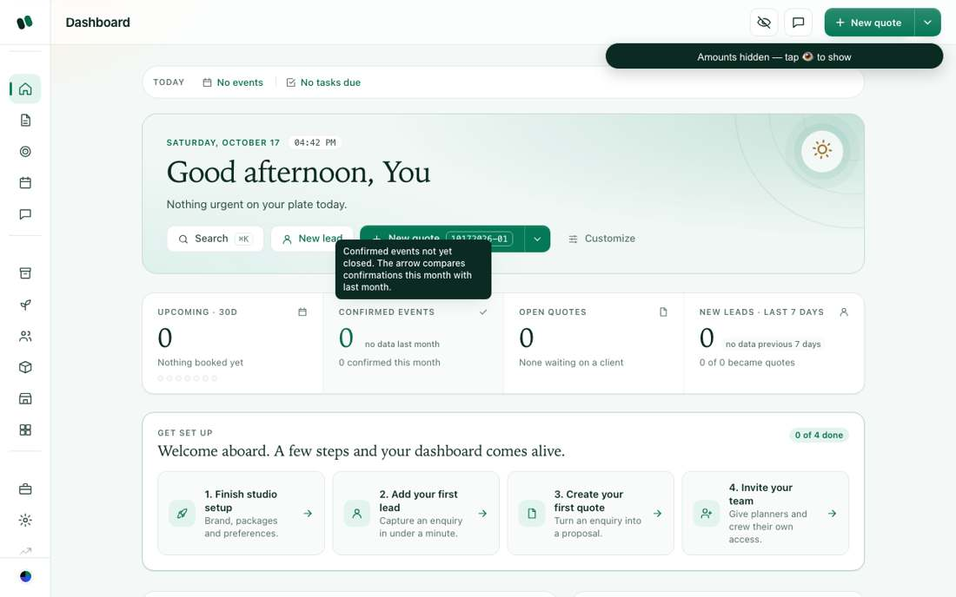
The left menu, top bar and dashboard.

4. Home / Dashboard
How it works today
- Greeting and summary, with buttons: Setup (for new studios), Search, New lead, Generate a quote, Customize (reorder or hide blocks).
- Next event countdown — the next confirmed event (crew see their next shift).
- Four number tiles — Upcoming in 30 days, Confirmed events, Open quotes, New leads in the last 7 days (or Tasks overdue). Crew and site roles see Tasks today, Overdue, Blocked, Completed instead.
- Get set up (new studio only) — Finish studio setup, Add your first lead, Create your first quote, Invite your team.
- Blocks — My next shift, Your month (calendar), Needs attention, Coming up in 30 days, Follow-ups, Revenue (money roles only), Pipeline, My work, My tasks, All quotes, Desk notes, Team board, Recent activity.

5. The end-to-end journey
This is one event from start to finish. Each step says who does it, where, what you fill in and what happens next.
How it works today
- Lead. Sales or manager. Workspace > Leads > New lead. Fill contact name, phone, email, stage, source, event type, event date, budget, guest count, birthday, anniversary, notes. Next: press "Convert →" to turn it into a quote.
- Generate the quote. Top bar > New quote, or Dashboard > Generate a quote. Helm creates the record and opens the quote workspace.
- Fill the details (quote workspace, 9 steps).
- Client & event — client name, company, email, phone, event type, date, city, state, guests.
- Discovery — meeting date, mode (in person, phone, video), who attended, notes.
- Requirements — services wanted, each marked must-have, optional or nice-to-have.
- Venue & access — venue name, contact, indoor/outdoor, address, load-in notes, menu/service notes.
- Menu package — pick a package such as Standard, Gold or Premium.
- Proposal — concept, theme, scope highlights.
- Floor layout — guests, hall length and breadth; generate or adjust the layout.
- Quotation — chairs, plates, chair rate, plate price, décor/setup, discount, coupon. The live price shows on the right.
- Advance payment & booking — see step 7 below.
- Floor plan / builder. Planner or designer. Event page > Floor layout > Open builder. Place tables, stage and decor to exact size, in 2D and 3D.
- Proposal. Event page > Proposal & mood-board. Concept, colour palette, inspiration images. The client sees it as a web page.
- Client approval (OTP). From the quote, "Send for approval →" creates a private link. The client opens it, gets a 6-digit code by SMS on their phone, enters it and accepts the terms. You are notified.
- Advance payment. Approval alone does not book the date. In step 9 you set the advance % or amount and choose cash/offline or an online link. A receipt is issued and both sides are notified.
- Confirmed. Once the advance is recorded, the event is confirmed. You can now create an event team chat and a digital invitation site.
- Planning. Planner, coordinator, operations. From the event page:
- Resource plan — what is needed, covered in-house, and the gaps.
- Inventory — reserve stock.
- Tasks (Operations) — assign set tasks to staff.
- Staff and Vendors on this event.
- Run-sheet — the minute-by-minute plan.
- Logistics — transport and movement.
- Readiness gate — checks to pass before the day.
- Event day. Supervisor and crew. Event-day command — arrivals and checks, live. Issues & incidents — log and fix problems. Media & gallery for photos.
- Teardown. Pack up, return stock, hand back the venue.
- Settlement. Payments & invoice — invoice the balance, settle vendors, collect.
- Closure & P&L. Feedback, profit and loss, archive. Budget & margin compares costs with the quote.
The event page always shows one "Next step" button: Send quote, then Record advance, then Plan the day, then Close the event.
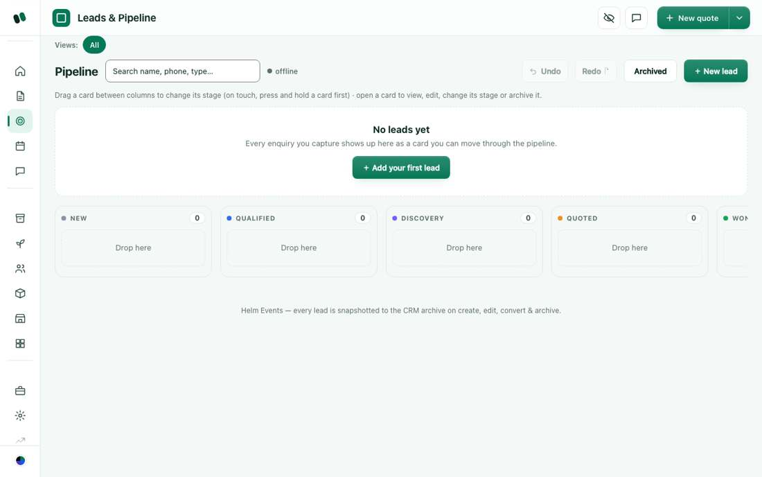
Leads.
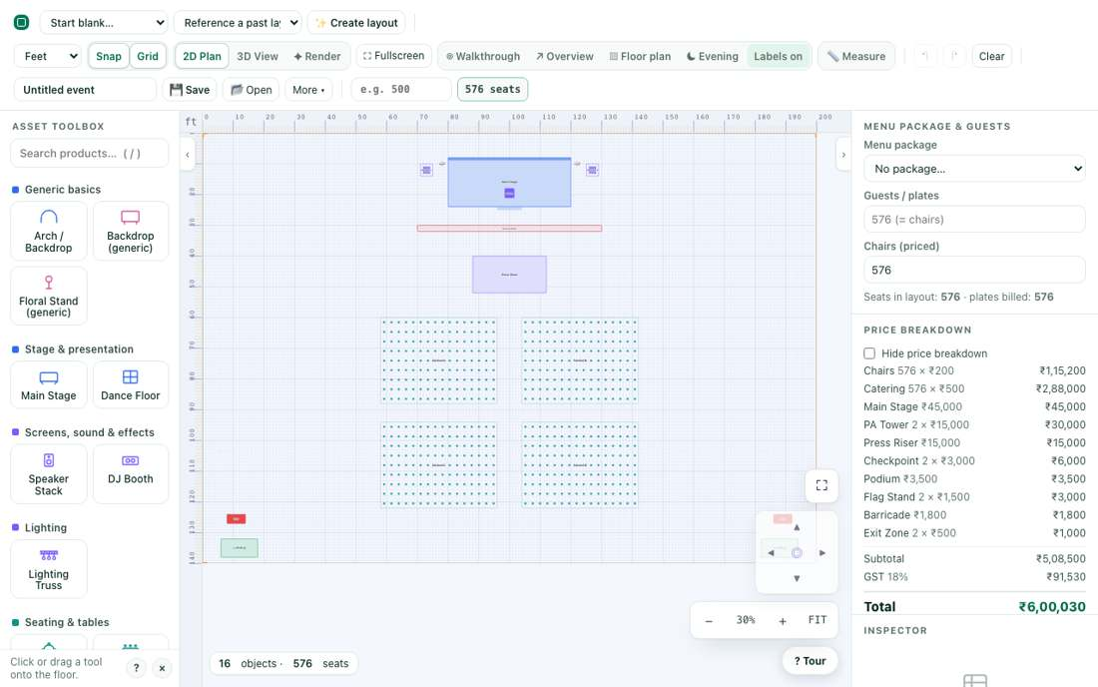
The floor plan builder.
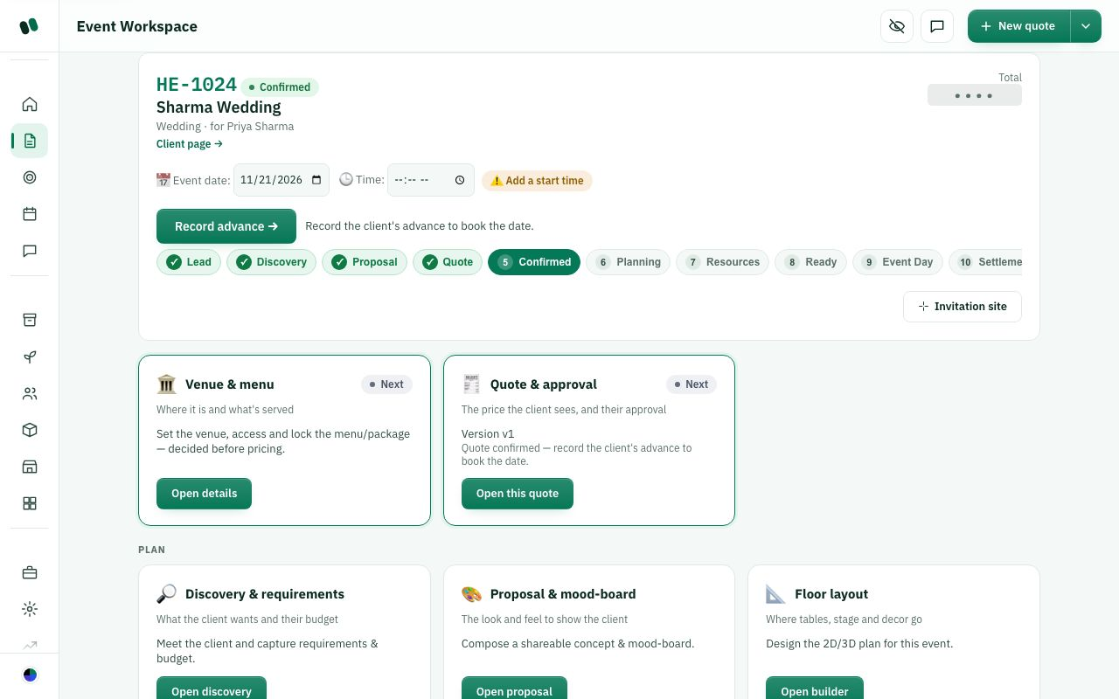
The event page with its stages and modules.
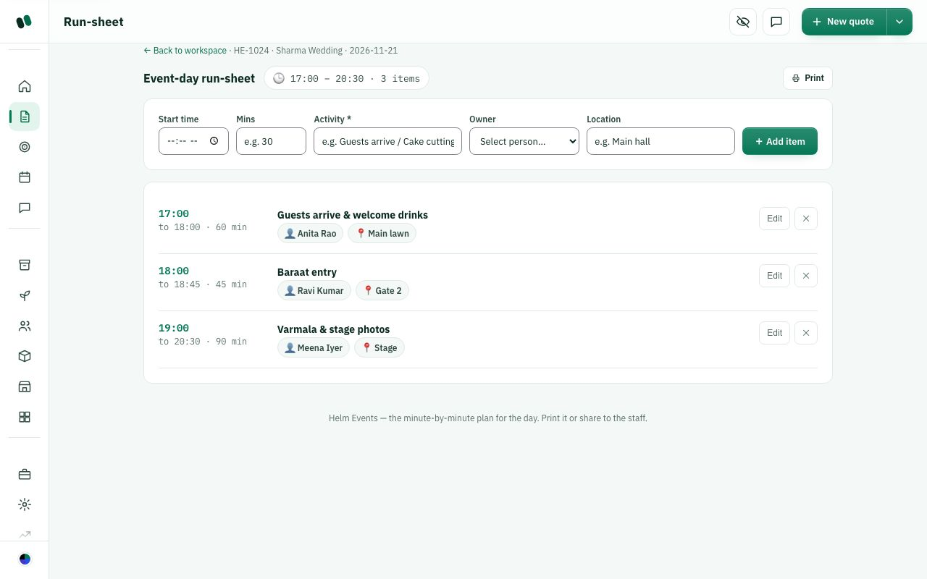
Run-sheet.
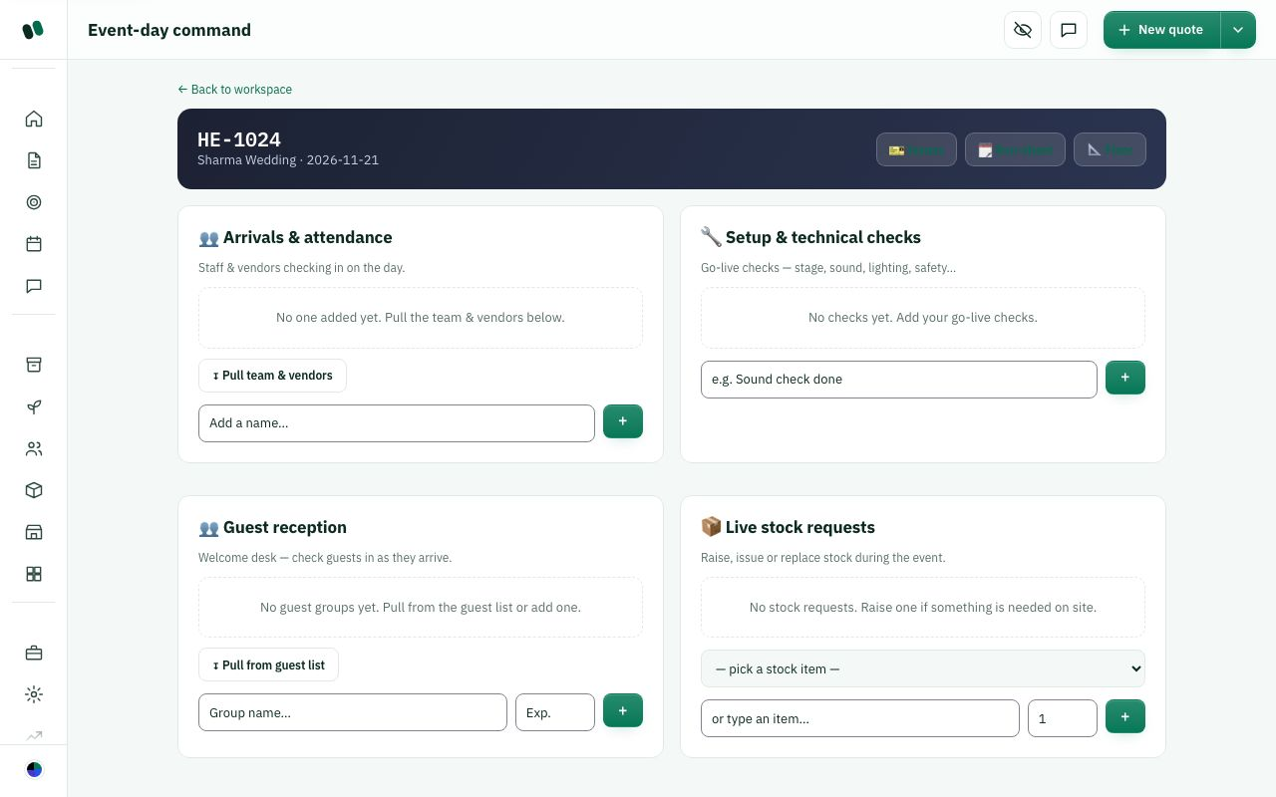
Event-day command.
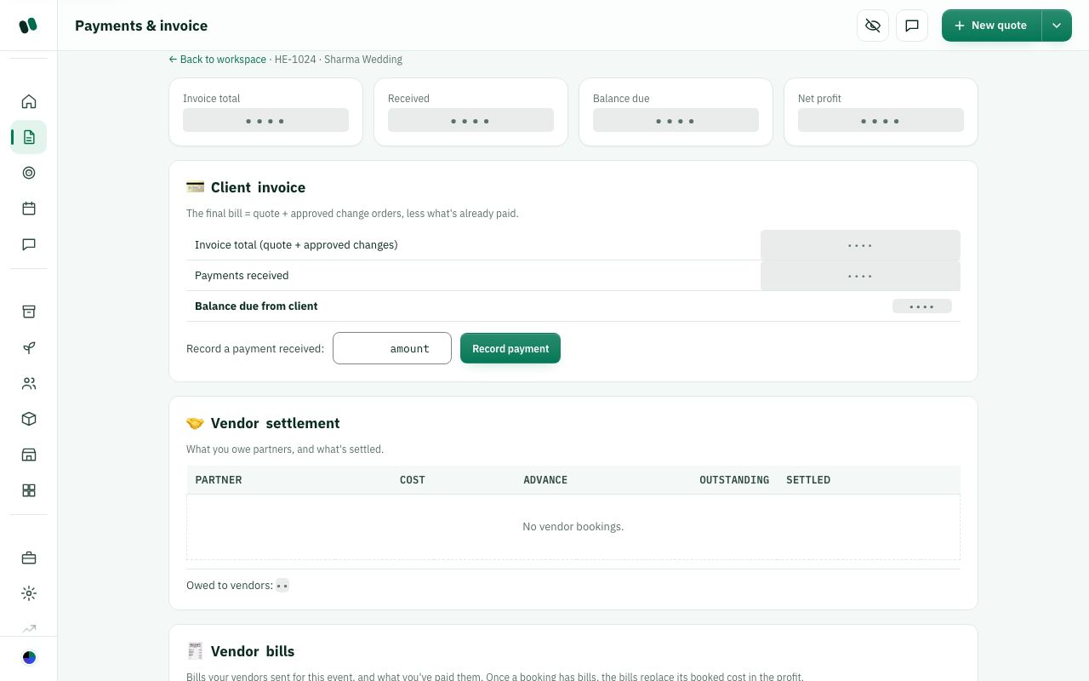
Settlement.
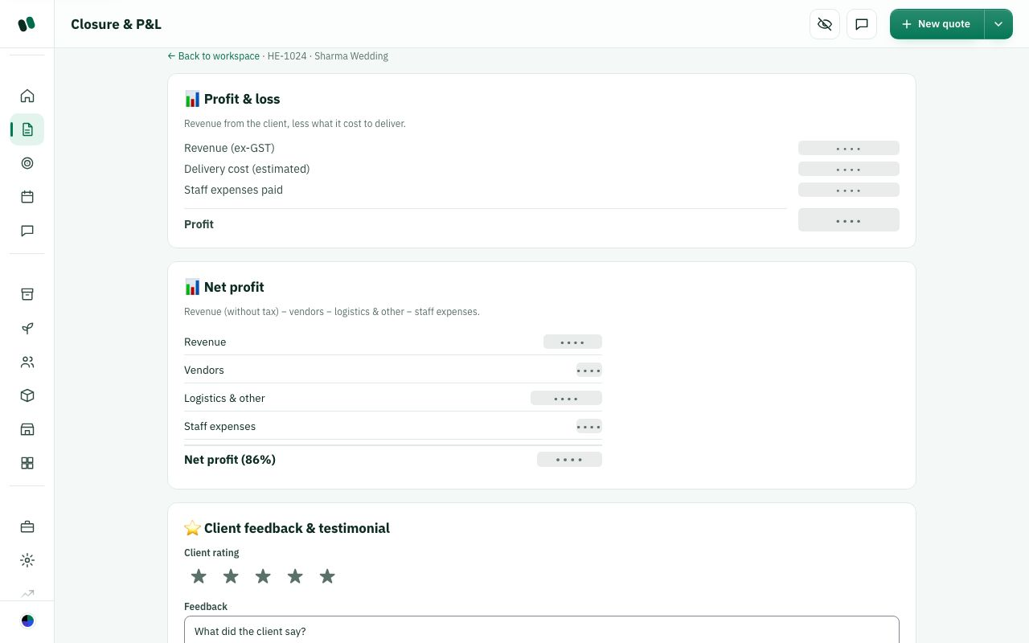
Closure & P&L.

6. Control Center
Admin > Control Center. Settings are grouped on the left. There is a search box for settings.
How it works today

Workspace
- General — studio name, country and tax, contact, billing address, client link name.
- Plan & billing — your Helm subscription, plan and invoices.
- Hide amounts (privacy PIN) — the studio's 4-digit PIN.
- Client links & packages — how long client links stay open; how clients pick a package.

Sales
- Pricing & coupons — default pricing, rate cards, builder prices and limits, coupons.
- Menus & catalog — chairs, plates, dishes and menu packages.
- Layout rules — what the layout generator uses per event type.
- Import & custom fields — import from Excel; add your own fields.

People
- Users & invites — add teammates, change roles, send join links.
- Roles & access — what each role can see and edit.
- Data & compliance — download an archive of your studio's data.

Communication
- Notifications — who hears about what, plus per-person overrides.
- Reminders & client messages — event and payment reminders, client follow-ups, stock warnings.
- Photo renders — monthly limits for photo-like renders.

Operations
- Venues — halls you work in, with area and capacity.
- Layout templates — reusable floor layouts.
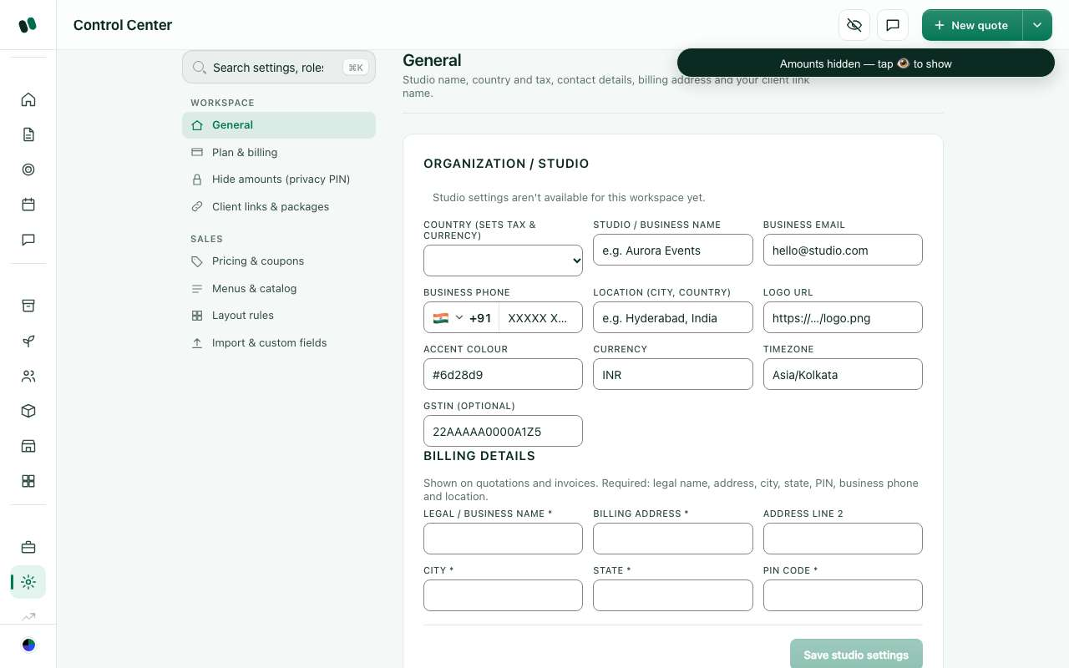
Control Center.

7. Client-facing pages
Clients never sign in. They open private links you send.
How it works today
- Proposal — "Your event proposal": concept, colour palette, mood images.
- Approval — "Approve your event": the quote, terms, SMS OTP and accept.
- Booklet — "Your event booklet": event details you choose to share; the client can confirm a package here.
- Client portal — "Your event": one page for the client's event, branded with your studio.
- Invitation site — a public invitation web page for guests, at /i/<name>. Five designs: Eternal, Promise, Confetti, Summit, Soirée. Available once the event is confirmed.
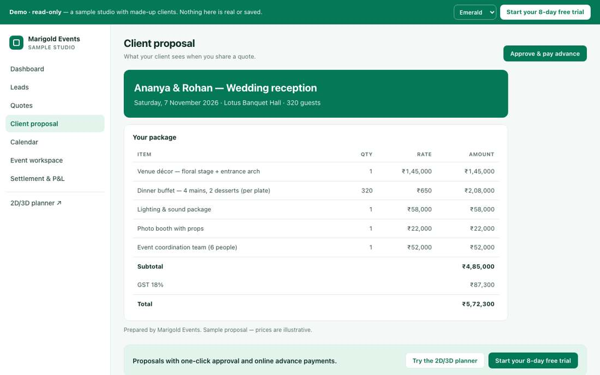
A client proposal page.

8. Sign-up, free trial, studio and plans
How it works today

Two ways in
- Free trial — 8 days, no card. Studio name is optional (left empty it is called "Demo N"). Then you choose: Try with demo data (a sample studio, every row marked "Demo ·", nothing sent to anyone) or Start with my own data (empty, with default templates).
- Create studio directly — no trial. You pick a plan and pay on the checkout page before the app opens.
Google sign-in is also offered.

Plans (proposed prices, not final)
- Starter — ₹1,999/month. Up to 3 team members.
- Studio — ₹4,999/month. Up to 15 team members, roles, inventory, crew app, chat, client portal, invitation site.
- Enterprise — custom price. Unlimited members, branches, photo renders.

Onboarding wizard (Admin > Studio setup)
- Business details (required)
- Studio details (required)
- Branding
- Team
- Venues
- Menu dishes
- Item prices
- Inventory
- Vendors
- Staff
- Payment terms
- WhatsApp & email (only when that feature is switched on)
- Packages & templates
- Finish
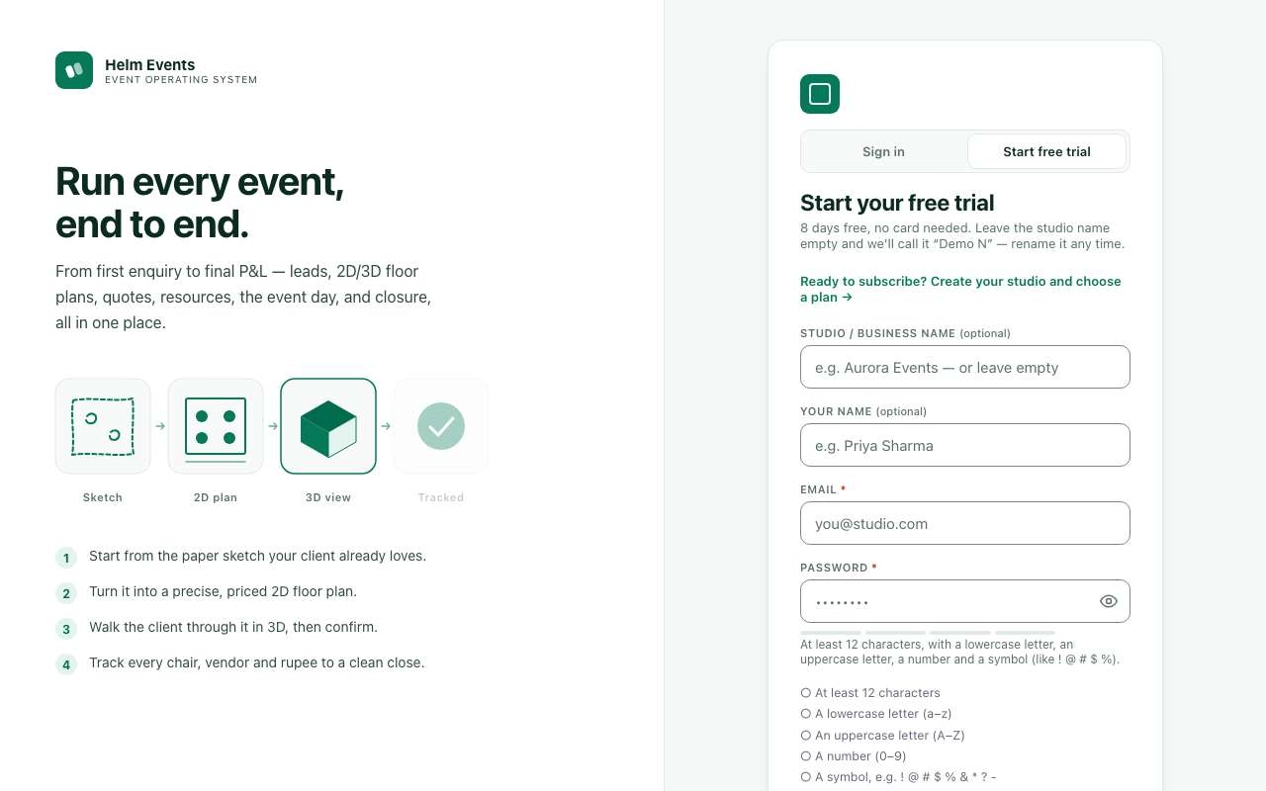
Free trial sign-up.
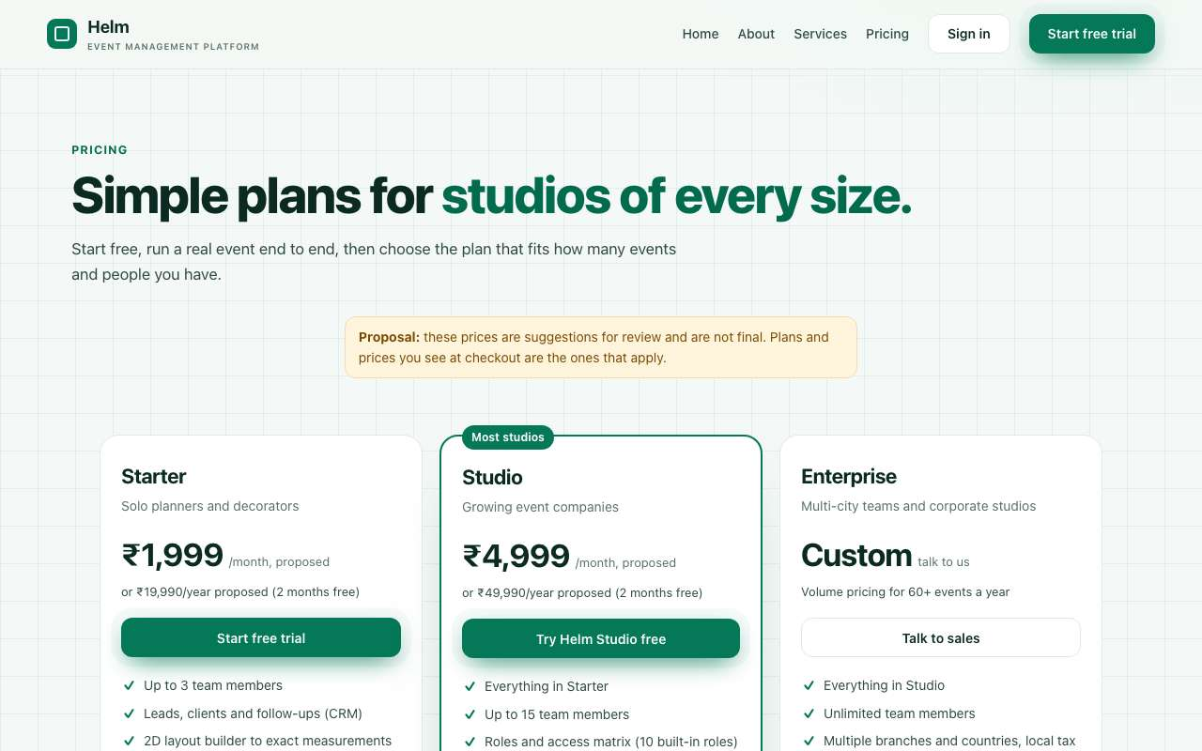
Plans.
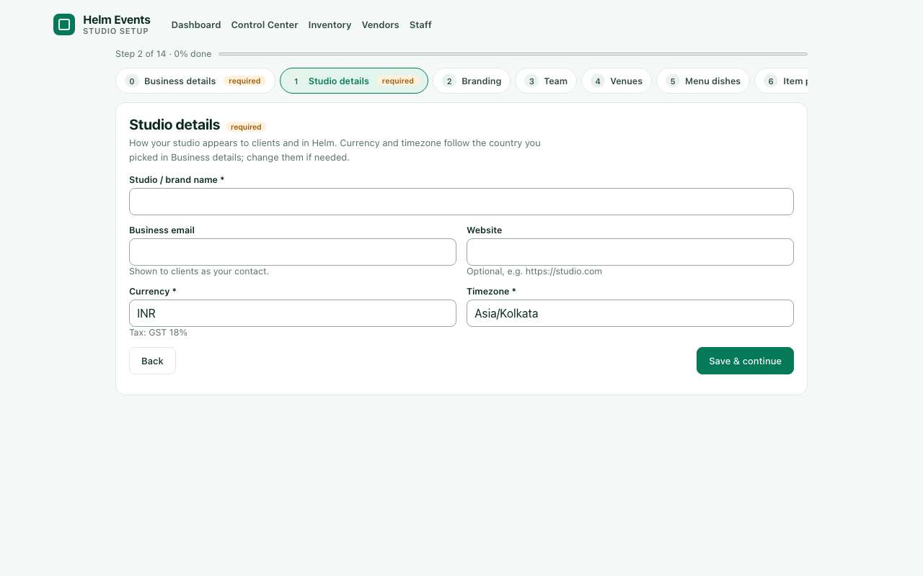
The onboarding wizard.

9. Glossary
How it works today
Term | Meaning
Studio | Your company's private space in Helm.
Lead | An enquiry, before it becomes a quote.
Quote / event | The one record for an event, from quote to closure.
Stage | Where the event is: Lead to Closed (11 stages).
Quote workspace | The 9-step page where you fill in a quote.
Builder | The 2D/3D floor plan tool.
Proposal | The concept and mood-board shown to the client.
OTP | A one-time 6-digit code sent by SMS to approve.
Advance | The first payment. Recording it confirms the booking.
Resource plan | What the event needs and who or what covers it.
Run-sheet | Minute-by-minute plan for the day.
Readiness gate | Checks to pass before event day.
Command | The live event-day screen.
Teardown | Packing up and returning stock after the event.
Settlement | Final invoice, collecting the balance, paying vendors.
Closure & P&L | Feedback, profit and loss, and archiving.
Booklet | A private page for the client with the event details.
Client portal | The client's own page for their event.
Invitation site | A public guest invitation page.
Privacy eye / PIN | Hides amounts on screen; the PIN shows them again.
Access matrix | The grid of what each role can view and edit.
Control Center | The studio settings area.

Part 1 — Ways to run your studio: choose your workflow

Ways to run your studio — choose your workflow
This part shows five team setups that work in Helm: who does each step, where they click, what the client sees, and where the money is tracked. Workflow 1 is how Helm is set up by default today. Workflows 2 to 5 are suggested alternatives you can switch to in Settings → Users & access.
Remember this one thing: in Helm, the quote is the event. A lead becomes a quote. When the client says yes, that same quote is confirmed and holds the floor plan, the tasks, the payments and the closure. Nobody types anything twice. Each person just works on their part of the same record.
How it works today

Where things live (your web address)
Every studio page sits under your studio's link name, for example helm.events/<studio>/...
What | Address | Menu name
Home / dashboard | /<studio>/dashboard | Dashboard (Home)
Leads | /<studio>/leads | Leads
Quotes and events list | /<studio>/quotes (also /events) | Quotes
One event's hub | /<studio>/events/<event number> | opens from Quotes
Floor plan (builder) | /<studio>/events/<n>/floor-plan | "Floor plan" button on the event
Event tasks | /<studio>/events/<n>/tasks | "Tasks" on the event
Calendar | /<studio>/calendar | Calendar
Team chat | /<studio>/chat | Chat
Staff, Inventory, Vendors, Templates | /staff, /inventory, /vendors, /templates | Resources group
CRM archive, Nurture | /crm, /nurture | Pipeline group
Run-sheet, Resource plan, Logistics, Readiness, Teardown | /runsheet, /resources, /logistics, /ready, /teardown | Planning steps on the event
Event-day command | /<studio>/command | Event day
Budget, Settlement, Closure and P&L | /budget, /settlement, /closure | Finance steps on the event
Business, Insights, Reports, Audit log | /business, /insights, /reports, /audit | Owner menu
Settings (Control Center: users, access, pricing, venues, codes) | /<studio>/settings | Settings
Studio setup | /<studio>/onboarding | Owner menu
Integrations | /<studio>/integrations | Hidden on the live site today (the address sends you back to the dashboard)
Client's page | /<studio>/clients/<client ref> | from the event
Client booklet (shareable) | /<studio>/booklet/<secret link> | "Share booklet"
Digital invitation website | /i/<event link> | Invitation site on a confirmed event

Note: the Design studio is hidden for now — it does not appear in the menu or on the builder.

Roles and basic rights
Roles: Admin, Event manager, Planner, Sales, Event coordinator, Supervisor, Quality engineer, Operations, Designer, Crew and Client. Worker is an old name and now counts as Crew.
Who can do what is set by you in Settings → Users & access: turn each area (Leads, Budget & finance, Settlement and so on) on or off per role. When an area is off it is blocked on the server, not just hidden — typing the address won't get around it.
- Admin: everything, including deleting and managing users.
- Event manager, Planner, Sales: view, create and edit. Planners can also delete.
- Coordinator, Supervisor, Quality, Operations, Designer: view and edit, but cannot create new quotes.
- Crew and Client: view only.
- Create new quotes is its own switch. By default it is on for manager, planner and sales.
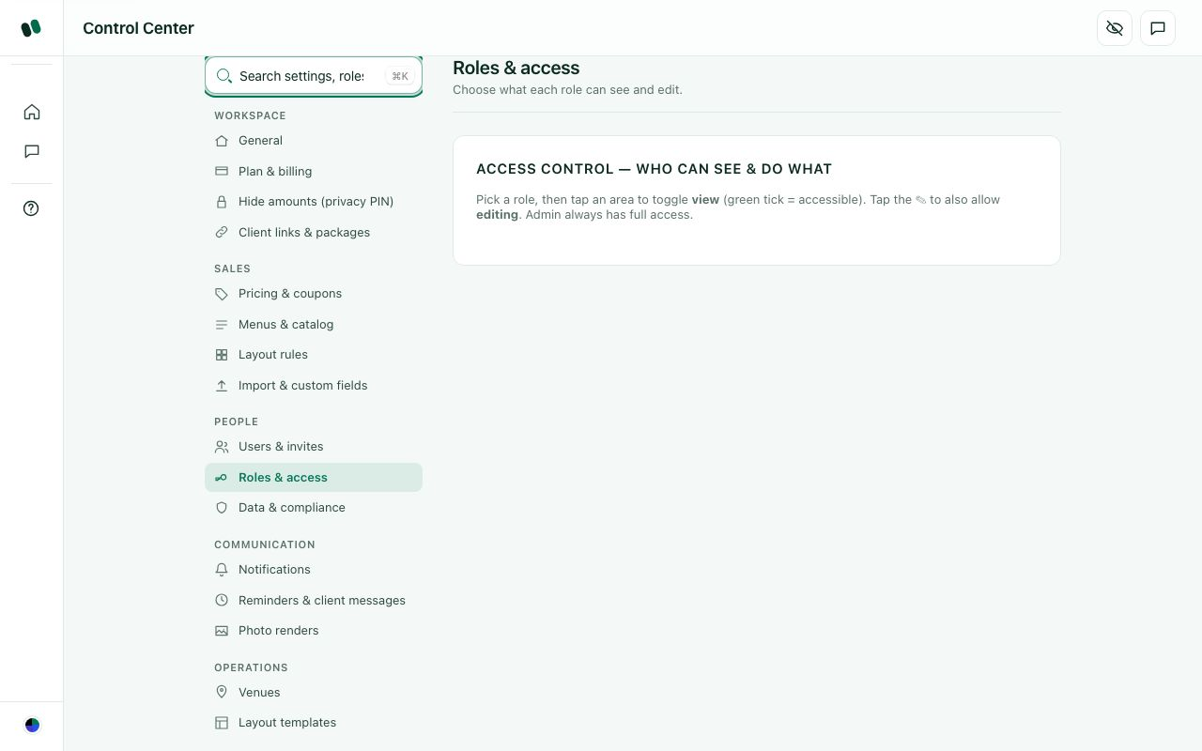
Settings → Users & access: switch each area on or off per role.

Workflow 1: One person does everything (owner as Admin, solo) — CURRENT DEFAULT
How it works today

This is how Helm is set up today
A new studio starts with one Admin login (the owner) who sees and does everything. Best for: a new or small studio where the owner sells, plans and runs events.
- Set up once. Open Studio setup (/<studio>/onboarding). Add your logo, venues and prices (Settings → Item pricing). On Inventory, press Load starter items, then fix quantities and prices.
- Enquiry comes in. Leads → New lead: name, phone or email, event type, date and budget.
- Qualify it. Use the Discovery questions on the lead. When it's real, press Convert → on the lead (or Generate a quote on the Dashboard). This creates the event with a number.
- Build the quote. Open the event and pick a package or menu. Open Floor plan to drag in stages, tables and seating. The price updates as you go, and each save keeps a version.
- Send the proposal. Publish the proposal from the event and share the link with the client.
- Client approves and pays the advance. The client approves with a one-time code. You record the advance against the payment milestones, and the event becomes Confirmed.
- Plan. Fill in the event's Venue & menu, Resource plan, Run-sheet, Logistics and Readiness steps. Check Calendar for clashes.
- Event day. Use Event-day command to tick off the run-sheet and log any issues.
- Close. Use Settlement to add extras and collect the balance. Then Closure and P&L: review costs against revenue and close the event.
- Where money lives: the event's payment milestones, then Budget, Settlement and Closure. Business, Insights and Reports show totals across all events.
- Handoffs and notifications: none. You get bell alerts when the client approves or picks a package. Emails to clients come from notifications@helm.events; WhatsApp must be set up separately.
- Who can't see what: not relevant — you see everything. When you hire, give each person their own login with the right role. Never share the admin login.
Step 1 — Studio setup.
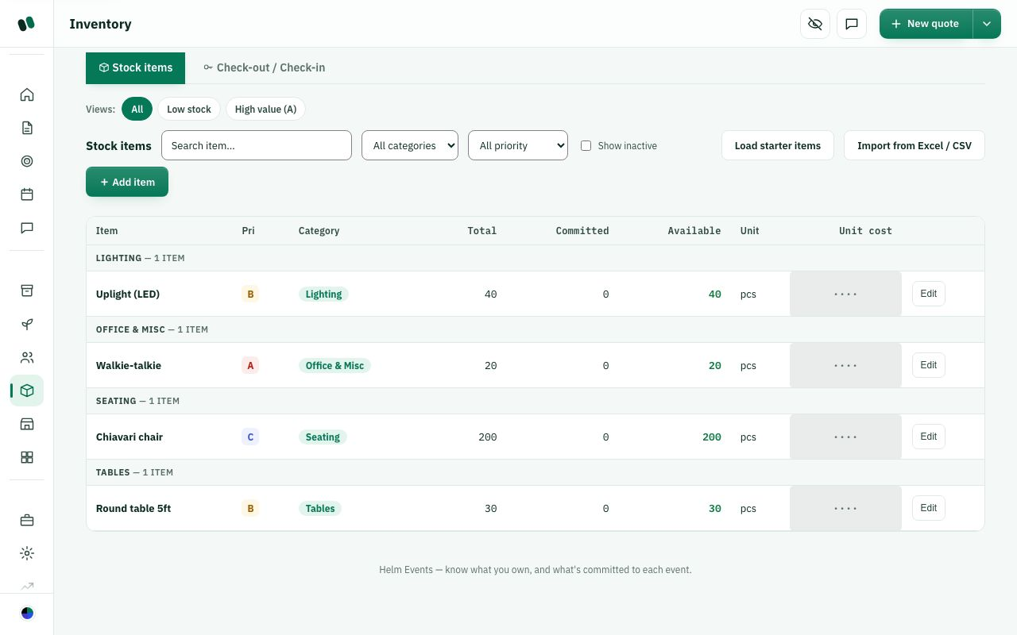
Step 1 — Inventory, where "Load starter items" lives.
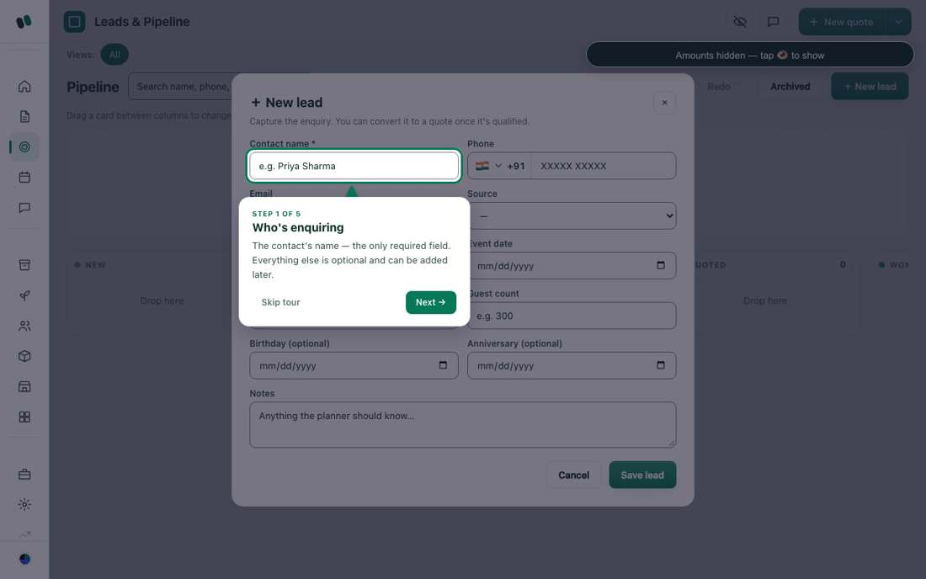
Step 2 — Leads → New lead.
Step 3 — Convert a qualified lead into a quote.
Step 4 — Floor plan with live price.
Step 5 — The proposal the client sees.
Step 7 — Run-sheet.
Step 8 — Event-day command.
Step 9 — Settlement.
Step 9 — Closure and P&L.

W1. Does this fit how your studio works? (Workflow 1 — owner solo, current default)
What this means: Workflow 1 is how Helm is set up today: one owner login (Admin) does everything, from the first enquiry (Lead) to the quote, floor plan, client approval, event day and final closure.
If not exactly, which steps don't match how you actually work, and how do you do them instead?

☐ Yes, exactly
☐ Mostly, with small changes
☐ No, we work differently
☐ Other: ______________________________

W2. What would you change in this flow? (Workflow 1)
What this means: Example answers: 'Skip Discovery questions for repeat clients', or 'Add a venue visit before building the floor plan'.
Which step would you add, remove or move, and why?

☐ Fewer steps
☐ Different order of steps
☐ Add a step
☐ Nothing
☐ Other: ______________________________

Workflow 2: Full team relay (Sales → Planner → Event manager → Crew) — suggested alternative
How it works today
Best for: a growing studio with a person for each stage.
Step | Who | Where | What they do
1 | Sales | Leads → New lead | Records the enquiry and qualifies it with Discovery
2 | Sales | Lead → Convert → (or Dashboard → Generate a quote) | Creates the event and a draft price
3 | Planner | Quotes → open event → Floor plan | Designs the layout and chooses packages and menu. Price updates live
4 | Planner or Sales | Event → publish proposal | Sends the proposal link to the client
5 | Client | proposal link | Reviews, picks a package, approves with a one-time code
6 | Event manager | Event → package review and payments | Accepts or declines the package choice, records the advance. Event becomes Confirmed
7 | Planner | Run-sheet, Resource plan, Logistics | Turns the confirmed event into a plan
8 | Event manager | Event → Tasks | Assigns tasks to crew with due times
9 | Crew | Dashboard → My tasks, or their task link | Sees only their own tasks and marks them started or done
10 | Event manager | Settlement → Closure and P&L | Collects the balance and closes the event

- Handoffs: each step changes the event's status. The event then appears on the next person's Dashboard, and alerts ring the bell (approvals, package picks, payments). Use Chat for quick questions.
- What the client sees: only the proposal page, the approval screen, their booklet and later the invitation site — never your leads, other quotes or payments.
- Where money lives: payment milestones on the event, then Settlement, then Closure. Sales usually doesn't need Settlement or Closure, so switch those off for Sales if you like.
- Who can't see what: Crew sees no prices, leads, clients' money or Settings. Sales and Planner can't open Settings unless you turn on "Control Center" for them. Only Admin can manage users.
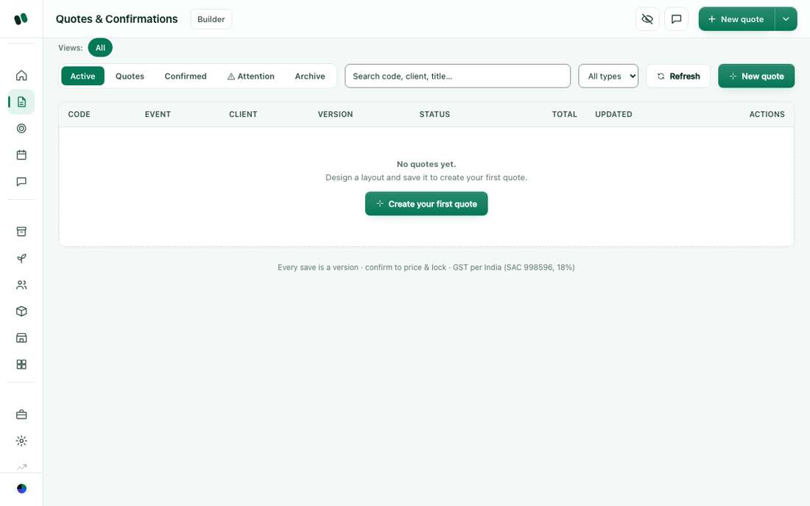
Step 3 — Planner opens the event from Quotes.
Step 6 — Event hub: package review and payments.
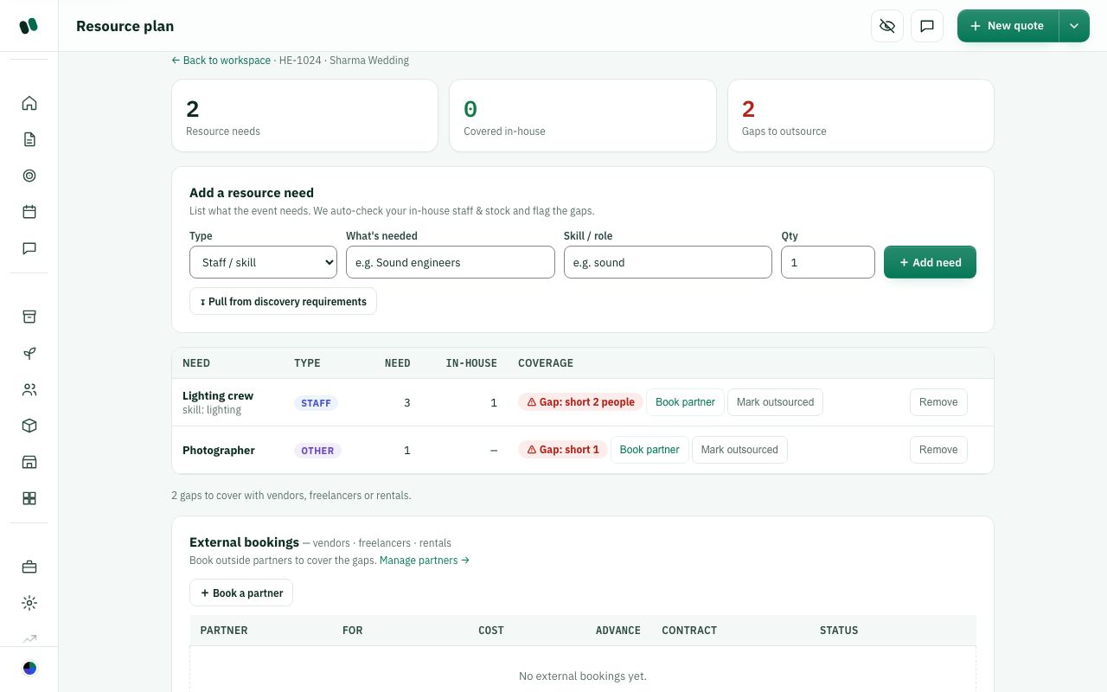
Step 7 — Resource plan.
Step 9 — Dashboard, where each person sees their next work.

W3. Does this fit how your studio works? (Workflow 2 — full team relay)
What this means: In this setup each person handles one stage: Sales takes the enquiry, the Planner designs the layout, the Event manager confirms and assigns work, and Crew do the tasks. When one person finishes, the event shows up on the next person's Dashboard and the bell icon alerts them.
Who in your team would do each step? Name any step that would go to someone else.

☐ Yes, exactly
☐ Mostly, with small changes
☐ No, we work differently
☐ Other: ______________________________

W4. What would you change in this flow? (Workflow 2)
Which step should go to a different person or come in a different order? Tell us who and why.

☐ Different person for a step
☐ Different order of steps
☐ Add a step
☐ Nothing
☐ Other: ______________________________

Workflow 3: Event-manager-led with a crew — suggested alternative
How it works today
Best for: studios where one or two managers own each event from start to finish and lead a crew.
- Manager creates the lead (Leads → New lead) and the quote. Managers can create quotes by default.
- Manager builds the floor plan and packages, publishes the proposal, then records the client's approval and advance.
- Manager plans the event (Run-sheet, Resources, Logistics, Readiness) and assigns tasks. A Coordinator or Supervisor can help edit tasks and the run-sheet, but cannot create new quotes.
- Crew work from My tasks on the Dashboard: Today, Overdue, Blocked, Completed. A Supervisor or Quality engineer checks the work marked done.
- Manager runs Settlement and Closure.
- Owner's job: check Business and Insights weekly. Decide in Settings whether managers can see Insights money and the Control Center.
- Who can't see what: Coordinator, Supervisor and Operations see planning and event-day pages but, by default, no Leads, CRM or finance. Crew sees only their assigned tasks.
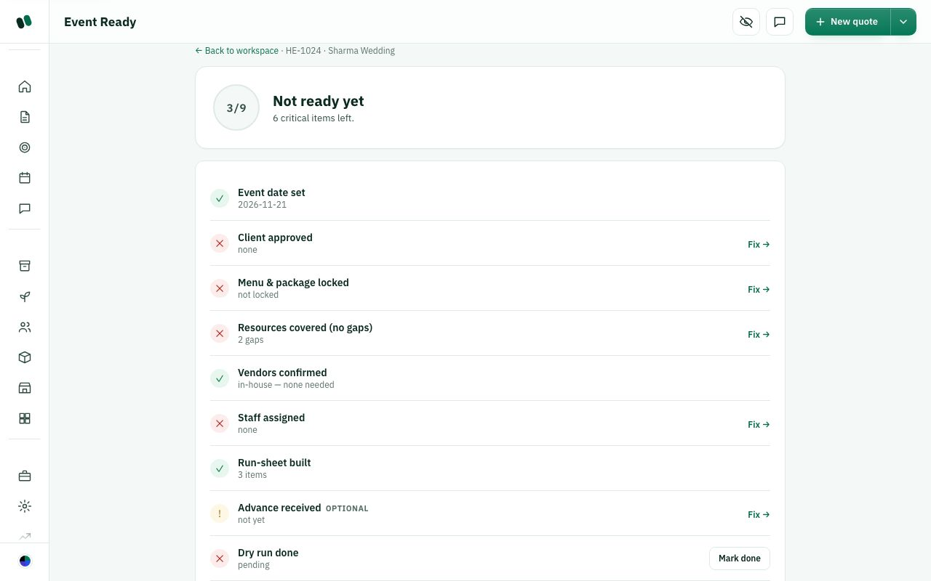
Step 3 — Readiness check.
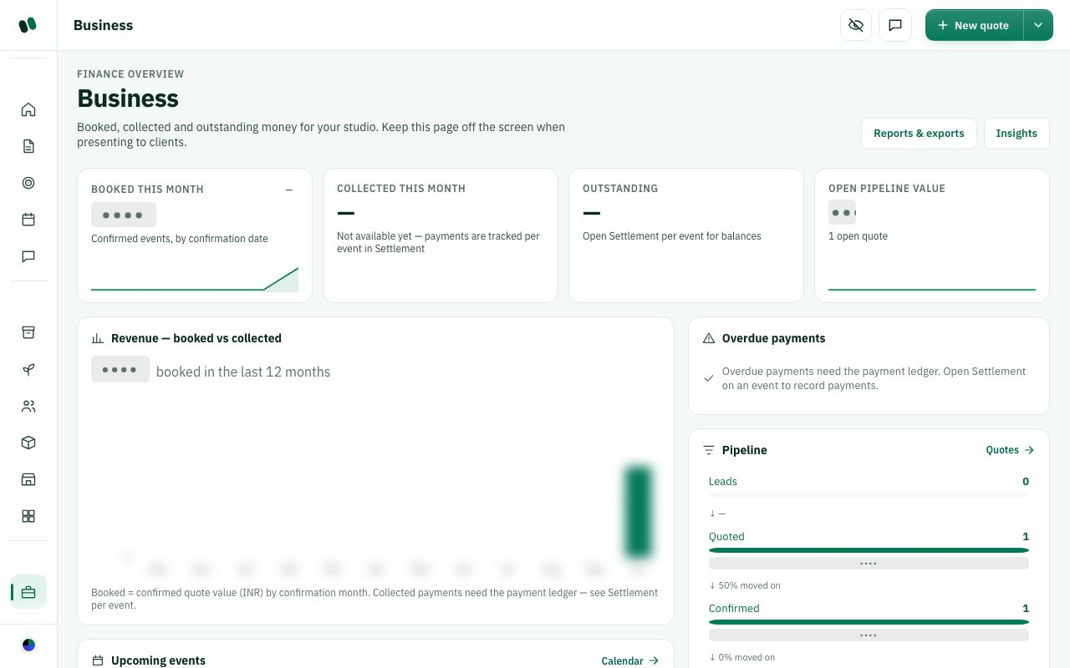
Owner's weekly check — Business.

W5. Does this fit how your studio works? (Workflow 3 — manager-led with crew)
What this means: Here one Event manager runs each event from enquiry to closure and leads a crew. Coordinators and Supervisors can help edit tasks and the run-sheet (the minute-by-minute plan for the day), but they can't create new quotes. The owner just checks the Business page every week.
Do your managers really own events from start to end? What part would they hand off to others?

☐ Yes, exactly
☐ Mostly, with small changes
☐ No, we work differently
☐ Other: ______________________________

W6. What would you change in this flow? (Workflow 3)
What this means: 'Access' means which Helm pages each role can open. For example, by default Crew see only their own tasks, never prices or client payments. You can change this in Settings → Users & access.
What should crew or managers be able to see or do that they can't today, or the other way round?

☐ Give the crew more access
☐ Give the manager less access
☐ Add a step
☐ Nothing
☐ Other: ______________________________

Workflow 4: Client self-serve (proposal link, approval, payment milestones) — suggested alternative
How it works today
Best for: studios that want the client to do as much as possible online.
- Your team creates the quote and publishes the proposal (Workflow 1 or 2, up to step 5).
- Client opens the link. They see the proposal with pricing, packages and a picture of the layout, can choose a package and see a live price.
- Client approves with a one-time code. Wrong codes are counted and lock out after several tries; each code works once. Helm keeps the approval as a consent record.
- Your team is told. The bell alerts whoever has "Package selections (review)" turned on. The manager accepts or declines the choice.
- Payment milestones (e.g. advance, mid-payment, balance). Each payment is recorded against a milestone, and Helm refuses an overpayment. Online payment links (Razorpay) are built but switched off until set up. Until then, record payments by hand.
- Client keeps seeing progress on their booklet link (/<studio>/booklet/<secret>) and, once confirmed, on their invitation website (/i/<event link>) to share with guests.
- Your team finishes the work and closes the event as usual.
- What the client can't see: your studio pages, other clients, leads, costs, margins or staff. The client role is view-only and the server returns nothing from the studio to them.
- Tip: email to clients is sent from notifications@helm.events. WhatsApp is built but must be set up separately (the Integrations page is hidden on the live site today). Until then, send the link yourself.
Step 2 — Client view of the proposal.
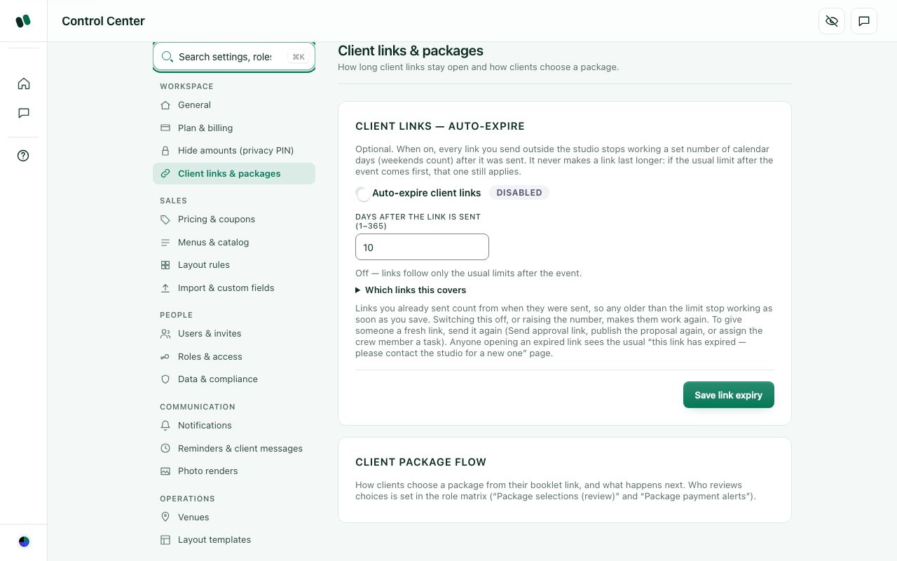
Step 6 — Shareable client links.
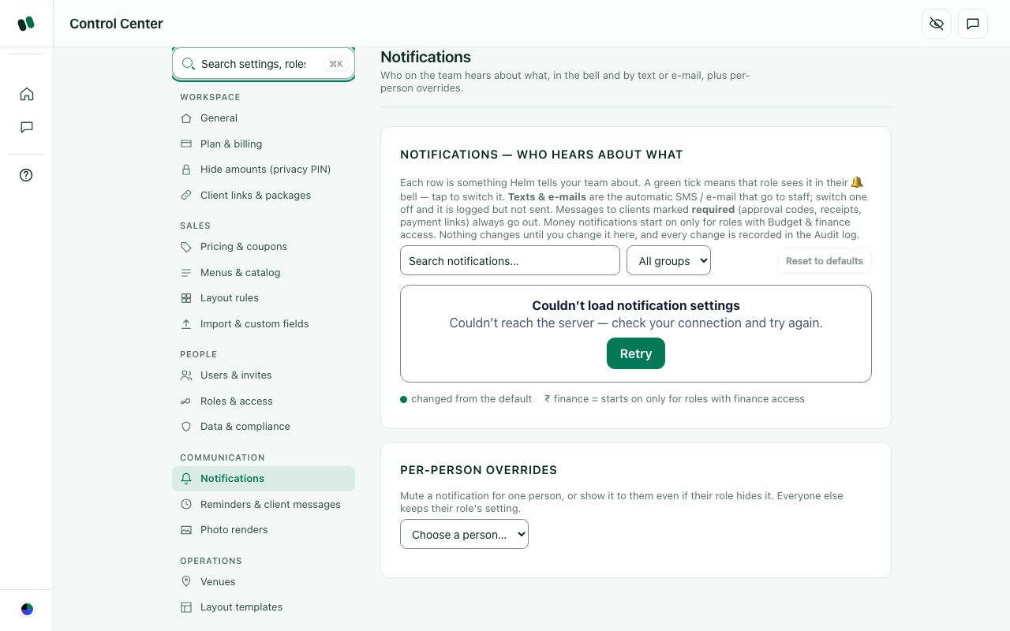
Step 4 — Who gets told.

W7. Does this fit how your studio works? (Workflow 4 — client self-serve)
What this means: Here the client does most things online. They open the proposal link, pick a package, and approve with a one-time code (a number sent to them, like a bank OTP). Then they follow progress on their booklet page and the invitation website.
How do your clients like to approve and pay today: online, by phone, or face to face?

☐ Yes, exactly
☐ Mostly, with small changes
☐ No, our clients prefer to talk to us
☐ Other: ______________________________

W8. What would you change in this flow? (Workflow 4)
What this means: Online payment (Razorpay payment links) and automatic WhatsApp messages are already built, but they stay switched off until they're set up. Until then your team records payments by hand and sends the links themselves.
What must clients be able to do online that Helm doesn't let them do yet?

☐ Online payment is a must
☐ WhatsApp reminders are a must
☐ Let clients change more themselves
☐ Nothing
☐ Other: ______________________________

Workflow 5: Large studio (designer, vendors, finance, quality) — suggested alternative
How it works today
Best for: studios running several events a week with specialist staff.
Who | Main pages | Does
Sales | Leads, Nurture, CRM archive | Captures and follows up enquiries, creates quotes
Designer | Floor plan (builder), Photo renders if allowed | Lays out the venue and makes the look. Can edit but cannot create quotes. (Design studio is hidden for now.)
Planner | Quotes, Run-sheet, Resource plan, Templates | Plans and uses checklist templates
Operations | Inventory, Vendors, Logistics, Teardown | Stock, vendor bookings, transport and pack-down
Event manager | Event hub, package review, Settlement | Approves and owns delivery
Coordinator / Supervisor / Quality | Run-sheet, Event-day command, Issues | Run the day and check the work
Crew | My tasks | Do the tasks
Finance person (Event manager role, or Admin) | Budget, Settlement, Closure and P&L, Reports | Chases payments and closes the books

- Flow: Sales → Designer and Planner → Manager (approval and advance) → Operations and Planner (resources and vendors) → Coordinator and crew (event day) → Finance (settlement and closure).
- Where money lives: payment milestones on each event, then Settlement, then Closure and P&L. Across all events: Business, Insights and Reports. Vendor bills and payouts are not built yet, so track vendor costs on the event budget.
- Who can't see what: there is no separate "finance" role. Give money areas (Budget & finance, Settlement, Closure) only to roles that need them. Designer, Operations and Crew normally have finance switched off. The Audit log (owner menu) records who changed what.
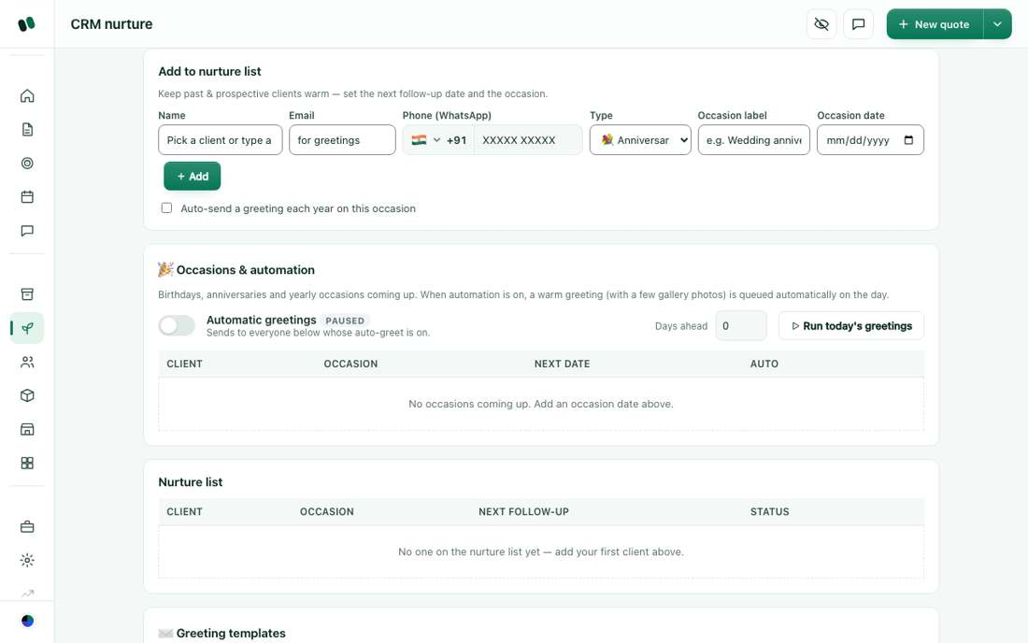
Sales — Nurture follow-ups.
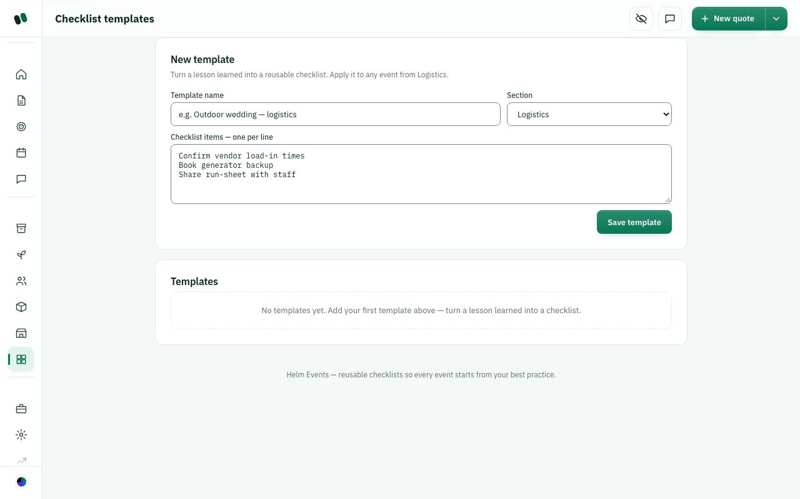
Planner — checklist Templates.
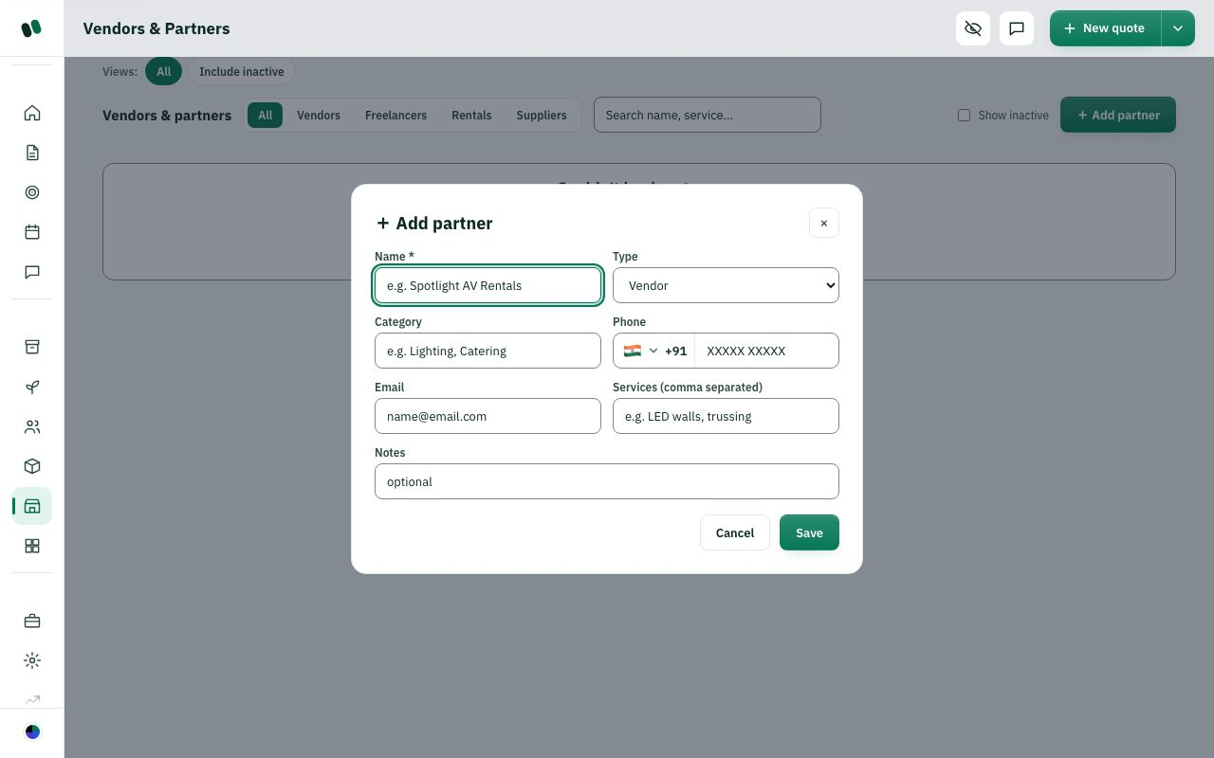
Operations — Vendors.
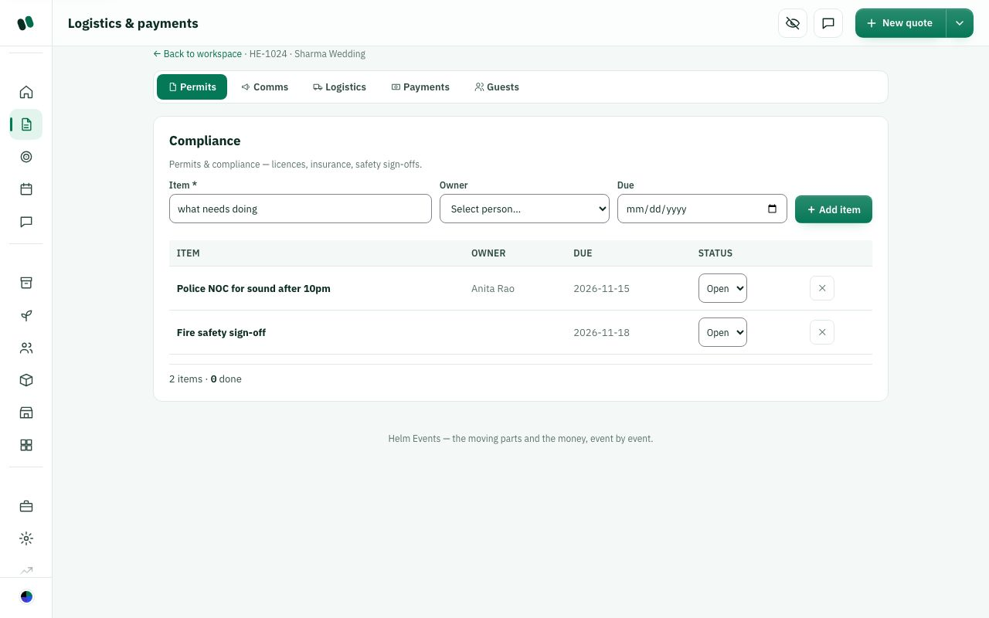
Operations — Logistics.
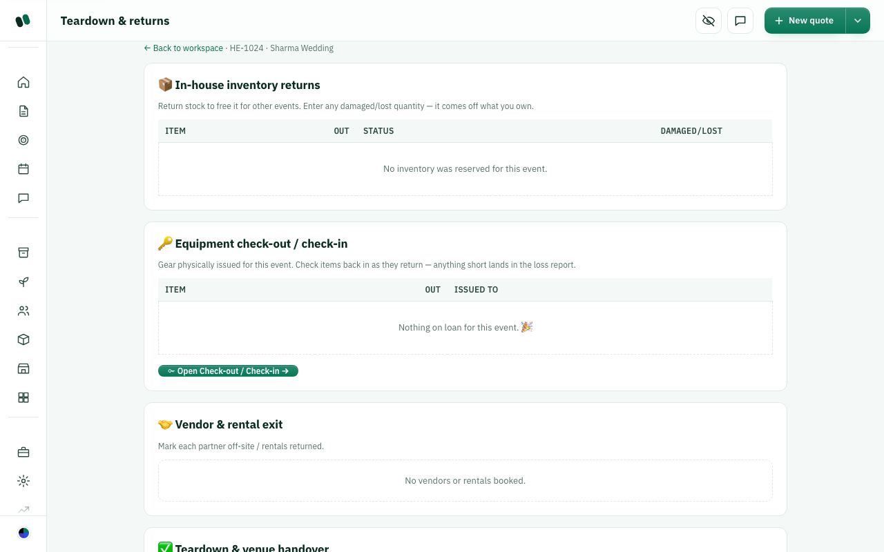
Operations — Teardown.
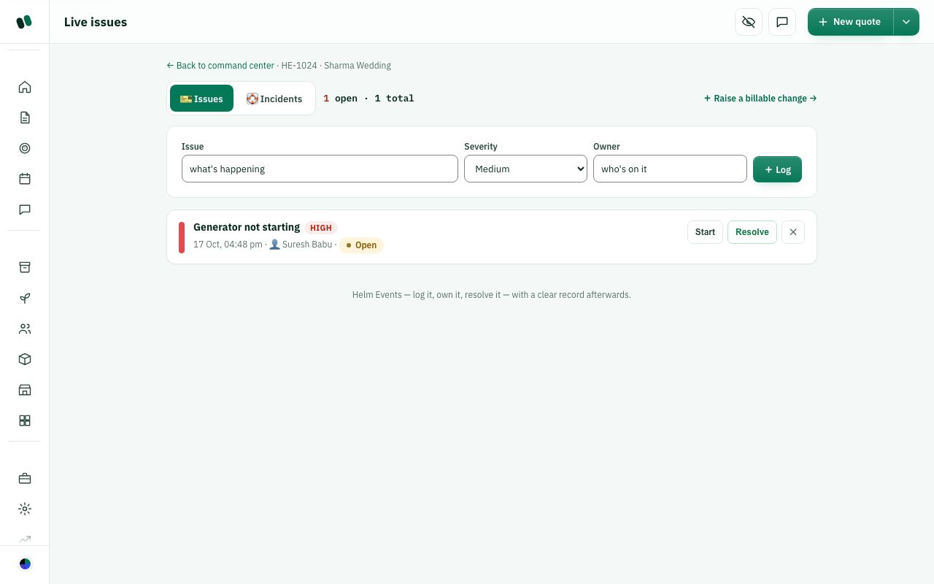
Coordinator / Quality — Issues on event day.
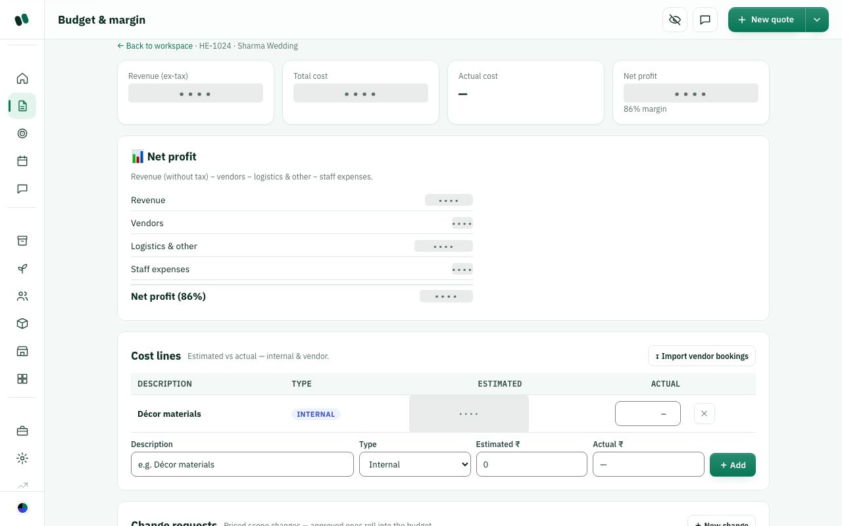
Finance — Budget.
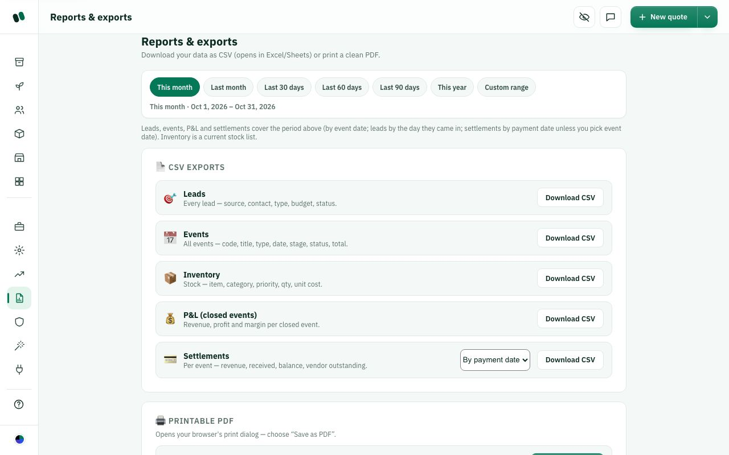
Finance — Reports.

W9. Does this fit how your studio works? (Workflow 5 — large studio)
What this means: This setup is for big studios where each job has its own specialist: Designer (layout), Operations (stock, vendors, transport), Quality (checks the work) and a finance person (payments and closing the books).
How many events a week do you run, and which of these specialist roles do you actually have?

☐ Yes, exactly
☐ Mostly, with small changes
☐ No, we are not this big
☐ Other: ______________________________

W10. What would you change in this flow? (Workflow 5)
What this means: Helm has no separate 'Finance' role today. Money pages are switched on only for the roles that need them. 'Vendor bills and payouts' means recording what you owe and pay to suppliers like caterers or decorators. Helm records these on the event's Settlement page (vendor bills and payouts).
What would you change for a large team? Say which person, role or money feature you need.

☐ We need a separate Finance role
☐ We need vendor bills and payouts
☐ Different person for a step
☐ Nothing
☐ Other: ______________________________

Role vs page (default setup; change it in Settings → Users & access)
How it works today
Key: Full = view and edit. Edit = view and change, but can't create new quotes. View = look only. — = hidden and blocked.
Page / area | Admin | Event manager | Planner | Sales | Coordinator / Supervisor / Operations | Quality / Designer | Crew | Client
Dashboard and My tasks | Full | Full | Full | Full | Edit | Edit | View (own tasks) | —
Leads, CRM, Nurture | Full | Full | Full | Full | — | — | — | —
Quotes and event hub | Full | Full | Full | Full | Edit | Edit (as allowed) | — | —
Floor plan (builder) | Full | Full | Full | Full | Edit | Edit | — | sees the proposal picture
Staff, Inventory, Vendors, Calendar, Templates | Full | Full | Full | Full | Edit | as allowed | — | —
Run-sheet, Resources, Logistics, Readiness, Event-day command | Full | Full | Full | Full | Edit | as allowed | own tasks only | —
Budget, Settlement, Closure and P&L | Full | Full | Full | Full | — | — | — | —
Business, Insights, Reports | Full | as allowed | as allowed | as allowed | — | — | — | —
Settings (Control Center), Users & access | Full | if "Control Center" is on | — | — | — | — | — | —
Audit log | Full | as allowed | — | — | — | — | — | —
Proposal, approval, booklet, invitation site | send | send | send | send | — | — | — | View and approve

Quality engineer and Designer start with no access to some areas. Turn on just what they need in Settings.
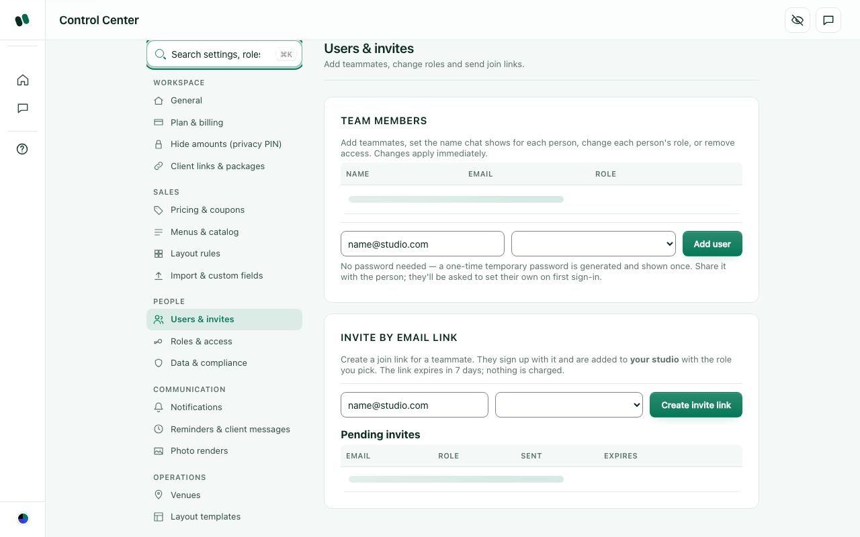
Settings → Users: one login per person.

Common mistakes (and how to avoid them)
How it works today
- Sharing one login. Give every person their own account and role, or the Audit log and "My tasks" mean nothing.
- Making everyone Admin. Admin can delete and see all the money. Use Event manager for trusted leads.
- Making a new lead for an existing client. Search Leads and Quotes first. The same email can overwrite or duplicate the client details.
- Starting a second quote instead of a new version. Edit the same event and save; it keeps versions. A second quote splits the payments.
- Confirming before the client approves. Wait for the one-time-code approval and the advance. That approval is your proof of agreement.
- Recording payments outside Helm. If a payment isn't on a milestone, Settlement and Closure will show the wrong balance.
- Closing with money still owed. Check the Settlement balance is zero before closing. Closed events drop off everyone's lists.
- Expecting coordinators or designers to create quotes. They can't by design. Have Sales, a Planner or a Manager create it, or turn on "Create new quotes" for that role.
- Forgetting Settings after hiring. When roles change, check Settings → Users & access. Remove people who leave.
- Waiting for automatic WhatsApp or online payments. Email goes out from notifications@helm.events, but WhatsApp and Razorpay payment links are switched off until set up separately (the Integrations page is hidden on the live site). Until then, send links and record payments yourself.

W11. Which workflow should be Helm's default for your studio?
What this means: This choice decides how a brand-new studio account is set up the first time (roles and who can open what). It can still be changed later in Settings.
Which workflow should new studios start with, and why that one?

☐ Workflow 1 — owner solo (current default)
☐ Workflow 2 — full team relay
☐ Workflow 3 — manager-led with crew
☐ Workflow 4 — client self-serve
☐ Workflow 5 — large studio
☐ A mix (say which parts)
☐ Other: ______________________________

W12. Which steps are missing from all of them?
What this means: Example: a 'site visit / venue recce' would be a step where someone visits the venue to measure it and take photos before the floor plan is drawn. 'Post-event feedback' would ask the client to rate the event after it's closed.
Which missing step matters most, and at what point in the event should it happen?

☐ Site visit / venue recce
☐ Vendor bills and payouts
☐ Post-event feedback from the client
☐ Nothing is missing
☐ Other: ______________________________

Part A — Organisation, roles, sign-up and security

A-1. How Helm is organised: studios, owners and admins
Helm is sold to event companies. Each company is called a studio (the same thing as an "organization"). Everything a studio creates (leads, events, quotes, stock, staff, money) belongs only to that studio. No other studio can see it. Each person who signs in belongs to one studio and has one role in it.
How it works today
- Owner: the person who created the studio (sign-up). Helm stores them as the studio's creator. The owner gets the Admin role. Only the owner keeps access after an unpaid free trial ends.
- Admin: full access to everything, always. Admin cannot be limited by the access matrix. A studio can have more than one admin (any admin can give the Admin role to another user in Control Center > People > Users & invites).
- One studio per person: a person signed in to a studio cannot also join a second studio with the same email. The sign-up screen warns invited people: "Don't create a studio here, open the invite link instead."
- Client link name (the studio's web name): Control Center > Workspace > General > "Client link name". Every link sent to clients and crew starts with it, for example www.helm.events/your-studio/quote/…. Rules: 3–40 lowercase letters, numbers or dashes. Button: "Save link name". Links already sent keep working after a change.
- Studio details live in Control Center > Workspace > General: Country (sets tax and currency), Studio / business name, Business email, Business phone, Location, Logo URL, Accent colour, Currency, Timezone, GSTIN (optional), then Billing details (Legal name*, Billing address*, Address line 2, City*, State*, PIN code*). Button: "Save studio settings".
- There is no "branch" or "multi-city" concept inside one studio today. Each studio is one business with one currency and one timezone.
Control Center > Workspace > General (shown in a local test copy, so the fields are empty).

A1. Is "one company = one studio" the right model for your customers?
What this means: A "studio" is your whole company's private space in Helm. Your leads, events, quotes, stock, staff and money live inside it, and no other company can see them. Example: Aurora Events has one studio with one currency and one timezone.
Does your company have branches or cities? How should Helm handle them?

☐ Yes
☐ No: a company with several branches/cities should have one studio with branches inside
☐ No: each branch should be its own studio, linked to a parent company
☐ Other: ______________________________

A2. Who should be the "owner" of a studio?
What this means: The owner is the person who signed up and created the studio. They always get Admin, and they are the only one who keeps access if the free trial ends unpaid.
Who should own the studio, and what happens if that person leaves?

☐ The person who signed up (today)
☐ The owner should be changeable later (hand over ownership)
☐ There should be two owners allowed (for example partners)
☐ Other: ______________________________

A3. How many Admins should a studio be allowed to have?
What this means: An Admin can see and change everything, including money. Any Admin can make another user an Admin in Control Center > People > Users & invites.
How many Admins do you need, and who would they be?

☐ Any number (today)
☐ Only one Admin (the owner)
☐ Up to 2–3 Admins
☐ Depends on the plan
☐ Other: ______________________________

A4. Should one person be able to belong to more than one studio (for example a freelancer working for two companies)?
What this means: Right now one email address can belong to only one studio. Example: a freelance decorator who works for two event companies would need two different emails.
Who would need more than one studio? Give a real example.

☐ No, one studio per email (today)
☐ Yes, with a studio switcher
☐ Only for freelancers/crew, not office staff
☐ Other: ______________________________

A5. The client link name (www.helm.events/ your-studio /…): is this needed and are the rules right (3–40 lowercase letters, numbers, dashes)?
What this means: This is the short name at the start of every link sent to clients and crew. Example: www.helm.events/aurora-events/quote/... You set it in Control Center > Workspace > General > "Client link name". Links you have already sent keep working if you change it.
Is this web name useful to you? What rules or format would you prefer?

☐ Yes, keep it
☐ Make it chosen automatically from the studio name, no setting
☐ Allow the studio's own web domain instead (e.g. events.mystudio.com)
☐ Change the rules (write below)
☐ Other: ______________________________

A6. Should the studio be able to change its own currency and timezone after it has events?
What this means: Currency and timezone are set in Control Center > Workspace > General. Changing them after quotes exist can make old amounts and dates look wrong. Example: a quote made in INR would then show in AED.
When would you need to change currency or timezone? What should stop it?

☐ Yes, any time (today)
☐ Only before the first quote is sent
☐ Only Helm support can change them
☐ Other: ______________________________

A-2. Roles and what each role can see and change
Every user has one role. The role decides which parts of Helm they see ("view") and change ("edit"). Studio admins can change this in a grid called the access matrix. The defaults below are what a brand-new studio gets on day one.
How it works today
Where: Control Center > People > Roles & access ("Access control — who can see & do what"). The admin picks a role, then ticks View / Edit per area. For Designer and Crew, when the selected role has no areas switched on at all, a note appears with a button "Apply suggested access" that switches on a suggested starter set (it asks to confirm first). Edit always includes View. Users are added in Control Center > People > Users & invites.
Basic powers per role (fixed in the app, the matrix comes on top):
Role | Basic powers
Admin | view, create, edit, delete, manage. Always sees and edits every area; the matrix cannot limit Admin.
Event manager | view, create, edit (no delete). Can create quotes by default (switch "Create new quotes").
Planner | view, create, edit, delete. Can create quotes by default.
Sales | view, create, edit. Can create quotes by default.
Event coordinator | view, edit (cannot create new records).
Supervisor | view, edit.
Quality engineer | view, edit.
Operations | view, edit.
Designer | view, edit (no create).
Crew | view only. (The old "Worker" role was merged into Crew.)
Client | view only.

Default access in a new studio (M = Event manager, P = Planner, S = Sales, C = Event coordinator, Sv = Supervisor, Q = Quality engineer, O = Operations, D = Designer, Cr = Crew). Admin always has everything. Client has nothing inside the studio app (clients use their own links).
Area | Who can VIEW | Who can EDIT
Leads | M P S C | M P S
CRM archive | M P S C | M P S
Nurture | M P | M P
Discovery | M P | M P
Proposal | M P D | M P D
Quotes & workspace | M P C Sv O Q D(view) | M P
Create new quotes | M P S (switch) | M P S
Floor layouts | M P C Sv O Q D | P D
Design studio (hidden) | M P D | M P D
Staff | M P C Sv O Q | M P C O
Inventory | M P C Sv O Q | M P C O
Vendors | M P C Sv O Q | M P C O
Calendar | M P C Sv O Q D Cr | M P C
Templates | M P C O Q D | M P C
Resource plan | M P C Sv O Q | M P C O
Run-sheet | M P C Sv O Q Cr | M P C
Venue & menu | M P C Sv O Q | M P C
Logistics | M P C Sv O Q | M P C
Readiness | M P C Sv Q | M P C
Budget & finance | M P | M P
Settlement | M P | M P
Closure & P&L | M P | M P
Event-day command | M P C Sv O Q | M P C Sv Q
Issues & incidents | M P C Sv O Q | M P C Sv O Q
Media & gallery | M P C Sv O Q D | M P C Sv D
Control Center | M | M
Coupons & codes | M P | M P
Users & access | nobody (Admin only) | —
Venues, Insights, Item pricing, Photo renders, Package review, Package payment alerts | nobody (Admin only) until an admin ticks them | —

Notes: Dashboard and Team chat are open to every signed-in member. Older studios may have a slightly wider matrix (for example Sales also seeing Quotes) because they were set up with an earlier default list.
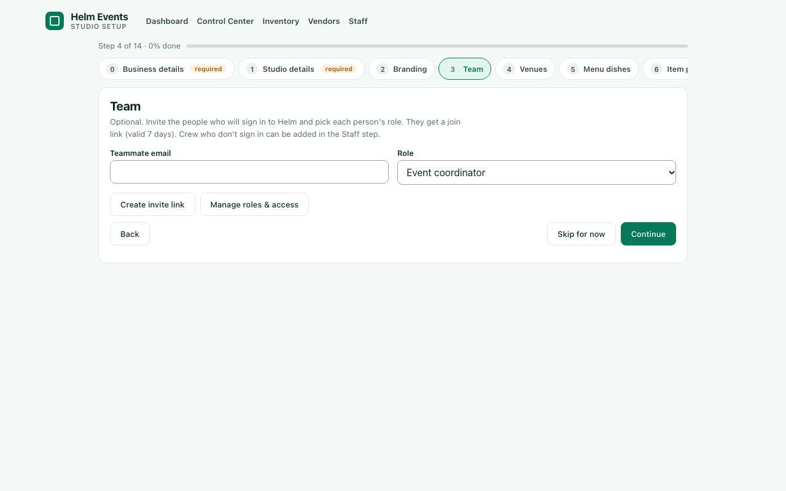
Setup wizard > Team step: the role list offered when inviting someone (default shown: Event coordinator).

A7. Role Event manager : is its default access (see the table above) right for your studios?
What this means: Every role has a default set of areas it can "view" (see) or "edit" (change). This grid is called the access matrix (Control Center > Roles & access). Example: whether an Event manager can see Finance.
Which areas should an Event manager see or change? Which should they not?

☐ Yes, keep the default
☐ Give it MORE (write which areas)
☐ Give it LESS (write which areas)
☐ Remove this role completely
☐ Other: ______________________________

A8. Role Planner : is its default access (see the table above) right for your studios?
What this means: The Planner role has its own default view/edit access in the access matrix (Control Center > Roles & access). Check the table above for what it gets today.
Which areas should a Planner see or change? Which should they not?

☐ Yes, keep the default
☐ Give it MORE (write which areas)
☐ Give it LESS (write which areas)
☐ Remove this role completely
☐ Other: ______________________________

A9. Role Sales : is its default access (see the table above) right for your studios?
What this means: The Sales role has its own default view/edit access in the access matrix (Control Center > Roles & access). See the table above.
Which areas should Sales see or change? Which should they not?

☐ Yes, keep the default
☐ Give it MORE (write which areas)
☐ Give it LESS (write which areas)
☐ Remove this role completely
☐ Other: ______________________________

A10. Role Event coordinator : is its default access (see the table above) right for your studios?
What this means: The Event coordinator role has its own default view/edit access in the access matrix (Control Center > Roles & access). See the table above.
Which areas should an Event coordinator see or change? Which should they not?

☐ Yes, keep the default
☐ Give it MORE (write which areas)
☐ Give it LESS (write which areas)
☐ Remove this role completely
☐ Other: ______________________________

A11. Role Supervisor : is its default access (see the table above) right for your studios?
What this means: The Supervisor role has its own default view/edit access in the access matrix (Control Center > Roles & access). See the table above.
Which areas should a Supervisor see or change? Which should they not?

☐ Yes, keep the default
☐ Give it MORE (write which areas)
☐ Give it LESS (write which areas)
☐ Remove this role completely
☐ Other: ______________________________

A12. Role Quality engineer : is its default access (see the table above) right for your studios?
What this means: "Quality engineer" is the person who checks that the setup and service meet the standard. It has its own default access in the access matrix (Control Center > Roles & access).
What does a Quality engineer do at your studio? What should they access?

☐ Yes, keep the default
☐ Give it MORE (write which areas)
☐ Give it LESS (write which areas)
☐ Remove this role completely
☐ Other: ______________________________

A13. Role Operations : is its default access (see the table above) right for your studios?
What this means: The Operations role (stock, logistics, setup) has its own default access in the access matrix (Control Center > Roles & access). See the table above.
Which areas should Operations see or change? Which should they not?

☐ Yes, keep the default
☐ Give it MORE (write which areas)
☐ Give it LESS (write which areas)
☐ Remove this role completely
☐ Other: ______________________________

A14. Role Designer : is its default access (see the table above) right for your studios?
What this means: The Designer role (decor and floor layouts) starts with very little access. An Admin can apply a starter set. See the table above.
Which areas should a Designer see or change? Which should they not?

☐ Yes, keep the default
☐ Give it MORE (write which areas)
☐ Give it LESS (write which areas)
☐ Remove this role completely
☐ Other: ______________________________

A15. Role Crew : is its default access (see the table above) right for your studios?
What this means: Crew are the on-ground workers at the event. By default they see very little. Example: they might need Tasks and the event-day screen but not prices.
What should on-site crew see on their phone? What should they never see?

☐ Yes, keep the default
☐ Give it MORE (write which areas)
☐ Give it LESS (write which areas)
☐ Remove this role completely
☐ Other: ______________________________

A16. Role Client : is its default access (see the table above) right for your studios?
What this means: Client is the role for your customer. Today clients mostly use the links you send them, such as the quote approval, portal and booklet. They do not get full sign-ins.
What should your clients be able to see or do in Helm?

☐ Yes, keep the default
☐ Give it MORE (write which areas)
☐ Give it LESS (write which areas)
☐ Remove this role completely
☐ Other: ______________________________
How it works today
Control Center > Roles & access: when Designer or Crew has nothing switched on, "Apply suggested access" turns on a starter set. Designer: Design studio, Floor layouts, Proposal, Media (view + edit); Quotes, Calendar, Templates (view). Crew: Run-sheet, Calendar (view).

A17. Are the suggested starter sets for Designer and Crew right?
What this means: In Control Center > Roles & access, if Designer or Crew has nothing switched on, the button "Apply suggested access" turns on a ready-made set in one click. Example: for Designer it switches on Design studio, Floor layouts, Proposal and Media.
Which areas are missing or not needed in these starter sets?

☐ Yes, keep them
☐ Designer needs more (write which)
☐ Crew needs more (write which, e.g. Tasks, Event-day command)
☐ Offer a suggested set for every role, not only Designer and Crew
☐ Other: ______________________________

A18. The Sales role, in a NEW studio, can see Leads and CRM but NOT Quotes, Discovery, Proposal or Finance (only "Create new quotes" is on). Is that what you want?
What this means: In a brand-new studio, Sales can work on leads and contacts (CRM) and create a new quote. They cannot open existing quotes, Discovery (the client's needs brief), Proposal, or Finance.
What should a salesperson see once a lead becomes a quote?

☐ Yes
☐ No: Sales should also see and edit Quotes
☐ No: Sales should also see Discovery and Proposal
☐ No: Sales should see the money of their own events
☐ Other: ______________________________

A19. Are 11 roles too many for a small studio?
What this means: Helm has 11 roles: Admin, Event manager, Planner, Sales, Event coordinator, Supervisor, Quality engineer, Operations, Designer, Crew and Client. A 5-person studio may only need a few of them.
Which roles does your team really use? Which would you merge or drop?

☐ Keep all 11
☐ Merge some (e.g. Supervisor + Quality engineer + Operations into one)
☐ Offer a simple set by default (Admin, Manager, Staff, Crew) and the rest as optional
☐ Let each studio create its own custom roles
☐ Other: ______________________________

A20. Should Admin also be limitable (e.g. a second admin who cannot see money)?
What this means: Today Admin always sees everything, and the access matrix cannot restrict it. Example: a second admin who manages staff but should not see profits.
What should a limited admin not be able to see or do?

☐ No, Admin always sees everything (today)
☐ Yes, allow a "limited admin"
☐ Only the owner sees everything; other admins follow the matrix
☐ Other: ______________________________

A21. Should access be per event as well (a coordinator sees only events they are assigned to)?
What this means: Today anyone with access to Events sees all of the studio's events. Example: a coordinator on one wedding can also open every other wedding.
Which roles should see only the events they are assigned to?

☐ No, a role sees all events of the studio (today)
☐ Yes, Crew/Coordinator/Supervisor only see their assigned events
☐ Yes, for every role except Admin and Manager
☐ Other: ______________________________

A-3. The end-to-end workflow and the event page
Every event moves through a fixed path of 11 stages, from first enquiry to the final profit report. The event page (Menu > Quotes > open an event) shows a progress bar of the stages, a "Now:" hint, and only the cards (work areas) that matter for the current stage.
How it works today
Where: Menu > Quotes > click an event. At the top: the stage steps, a "Now:" hint and a button "Advance to <next stage> →" (shown to people with edit rights). When Helm shows a "Next step →" button with its own reason, the "Now:" hint and the "Advance to …" button are hidden; people with edit rights can still click a stage step to move it. Below, the cards for the current stage. A card is hidden if the person's role cannot view that area. Also on the page: Files ("＋ Add file", PDF/PNG/JPG/WEBP) and, for confirmed events, "Event team chat" ("Create event group").
Stage | Hint shown on screen | Cards shown at this stage
1. Lead | Capture the enquiry and qualify it. | Discovery, Quote
2. Discovery | Meet the client and capture requirements before quoting. | Discovery, Quote
3. Proposal | Share the concept and design direction. | Proposal, Floor layout, Venue & menu, Quote
4. Quote | Lock the menu first, design the floor, then price the event. | Venue & menu, Floor layout, Quote
5. Confirmed | Lock the details and get the client's approval. | Quote, Venue & menu
6. Planning | Assign tasks, plan resources and build the run-sheet. | Resource plan, Run-sheet, Budget
7. Resources | Map needs, cover in-house, flag the gaps. | Resource plan, Inventory, Tasks
8. Ready | Pass the readiness gate, then brief the team. | Readiness, Run-sheet, Logistics
9. Event Day | Run the day and handle issues live. | Event-day command, Issues
10. Settlement | Tear down, then invoice, settle vendors and collect. | Teardown, Settlement, Budget
11. Closed | Feedback, P&L and archive. | Closure

What each card is for (wording from the screen):
- Discovery: what the client wants and their budget
- Venue & menu: where it is and what's served
- Proposal: the look and feel to show the client
- Floor layout: where tables, stage and decor go
- Quote: the price the client sees, and their approval
- Tasks: who does what, and when
- Run-sheet: minute-by-minute plan for the day
- Event-day command: arrivals and checks, live
- Issues: problems on the day and how they were fixed
- Readiness: is everything in place?
- Logistics: guests, permits and the payment schedule
- Closure: profit, feedback and archive
- Settlement: final bill, payments in and vendors paid
- Teardown: pack up, return stock, hand back the venue
- Budget: costs against the quote, and your margin
- Resource plan: what you need and what to hire in
- Inventory: your own stock set aside for this event
Screenshot not available: the event page needs a signed-in studio with a real event.

A22. Is the order of the 11 stages right?
What this means: Every event moves through 11 fixed stages, from first enquiry (Lead) to Closed. The event page shows the current stage and an "Advance to ..." button.
Write the stage order your team really follows, and why.

☐ Yes, keep the order
☐ Move Proposal before Discovery
☐ Merge Lead and Discovery
☐ Merge Planning and Resources
☐ Other order (write the order below)
☐ Other: ______________________________

A23. Are there stages you never use and want removed or made optional?
Which stages do you skip in real life, and why?

☐ No, all are needed
☐ Proposal is optional
☐ Ready (readiness gate) is optional
☐ Settlement and Closed could be one stage
☐ Studio should switch stages on/off itself
☐ Other: ______________________________

A24. Are any stages missing?
What this means: A "recce" or site visit is when the team visits the venue before planning.
Which stage is missing, and where in the order should it go?

☐ No
☐ "Site visit" / recce stage
☐ "Advance received / Booked" as its own stage
☐ "Post-event feedback" as its own stage
☐ Other: ______________________________

A25. Who should be allowed to move an event to the next stage (the "Advance to …" button)?
What this means: The "Advance to ..." button on the event page moves the event to its next stage, for example from Quote to Confirmed.
Who should move an event forward at each stage?

☐ Anyone with edit rights (today)
☐ Only Admin and Event manager
☐ Each stage has its own owner role
☐ Other: ______________________________

A26. Should Helm stop an event from moving forward until the stage's work is done (e.g. no "Confirmed" without the advance payment)?
What this means: Example: Helm could refuse "Confirmed" until the advance payment is recorded, or only show a warning and let you continue.
Which stages should be blocked, and until what work is done?

☐ No, only show a warning
☐ Yes, block on key stages (Confirmed, Ready, Closed)
☐ Yes, block on every stage
☐ Other: ______________________________

A27. At Quote stage the hint says "Lock the menu first, design the floor, then price". Is that the real order your team works in?
What this means: "Lock the menu" means finalising the dishes. "Design the floor" means the seating and decor layout in the 2D/3D builder. "Price" means building the quote amount.
What order does your team really use for menu, floor and price?

☐ Yes
☐ No: price first, then menu and floor
☐ No: floor layout first, then menu, then price
☐ Other: ______________________________

A28. Which cards on the event page are NOT useful? (tick all that apply)
What this means: Cards are the boxes on an event page. Example: Budget (planned spend), Resource plan (staff and stock needed), Readiness (checklist before the event), Logistics (transport), Teardown (packing up after), Media (photos).
Why are the ticked cards not useful? What would you show instead?

☐ Proposal
☐ Budget
☐ Resource plan
☐ Readiness
☐ Logistics
☐ Teardown
☐ Media
☐ Other: ______________________________

A29. Should the event page show ALL cards at once (with the current stage's cards on top) instead of only the stage's cards?
What this means: Today the event page shows only the cards for the current stage. Example: during Planning you do not see the Teardown card.
How would your team rather see the event page, and why?

☐ Only the stage's cards (today)
☐ All cards, current stage first
☐ Let each user choose
☐ Other: ______________________________

A-4. Sign-up, free trial, plans and payment
This is how a new event company starts using Helm and how it pays. There are two doors: a free 8-day trial (no card) or creating a studio directly and paying first.
How it works today
- Start free trial (home page button, or /login?trial=1): form with Studio / business name (optional, empty = "Demo N"), Your name (optional), Email*, Password* (with a live checklist), Confirm password. Button "Start free trial →". A link "Ready to subscribe? Create your studio and choose a plan →" switches to the direct path. After the email is confirmed ("Check your inbox" screen with "Open Gmail", "Open Outlook", "Resend email"), the person picks "Try with demo data" (a sample studio, every row named "Demo ·") or "Start with my own data" (empty studio with Helm's default templates and catalogs). Trial length: 8 days, no card. Continue with Google also works.
- What a trial studio gets: every feature of a paying studio; no limits on events, users or pages. Demo data (if chosen): sample inventory, vendors, staff, menu packages, venues, dishes, leads and events, all marked "Demo". Demo records can never send real messages or take real money. Trial staff can be invited; the Staff page says "Trial: staff access ends when the trial ends on <date>". In a running trial, studio members see "Skip OTP (trial test mode)" on the client approval page.
- Reminders: bell notifications to admins 3 days before the end, the day before, and on the last day (e-mail copies are ready but switched off until e-mail sending is turned on).
- After the trial ends without payment: the studio becomes read-only (nothing is deleted or hidden; owner can view, export and pay). Every member except the owner loses access and sees "This studio's trial has ended - ask the owner to subscribe". Paying brings everyone back automatically.
- Create studio (pay first) (/login?direct=1, tab "Create studio"): Studio / business name*, Your name (optional), Email*, Password* (with a live checklist), Confirm password. Then the plan page (/checkout, "Choose your Helm plan"): Monthly / Yearly switch, plan cards, Billing details (Studio legal name, Country, Billing address, State / region …), tick "I agree to the Terms of Service, Privacy Policy, Refund & Cancellation Policy", Order summary. Payment is by Razorpay. Today online payment is not switched on, so the page says "Payments are being set up" and offers "Start 8-day free trial instead". A "Skip payment (testing only)" button also exists for internal testing. Until paid, a direct studio cannot change anything.
- Plans (public pricing page and checkout): Starter ₹1,999/month or ₹19,990/year ("Solo planners and decorators": up to 3 team members, CRM, 2D/3D builder, quotes with tax and approval links, tasks and calendar, payments and profit per event). Studio ₹4,999/month or ₹49,990/year ("Growing event companies": everything in Starter, up to 15 team members, roles and access matrix, inventory, staff and crew app, vendor tasks, client portal, booklet, invitation site). Enterprise: Custom (unlimited team, 60+ events a year). Prices are marked "proposed". Helm HQ can change plans and prices.
- What a paying studio gets: same app as the trial, no end date, no read-only lock. Today the plans do not switch features on or off and team-size limits are not enforced; only storage (default 2 GB) and uploads per hour (default 200) have limits.
2D/3D builder product library: 142 products, the same for every studio (trial or paid):
Group | Products
Structure (15) | Main Stage; Dance Floor; Canopy; Arch / Backdrop; Tent; Truss Tower; Greenery; Carpet / Aisle; VIP Riser; Walkway / Ramp; Entrance Gate; Dais with Chairs; Banner / Hoarding Frame; Stage Roof Truss; Varmala Platform
Sound, light & screens (27) | Podium; Press Riser; DJ Booth; Photo Booth; LED Screen; Speaker Stack; Uplight; Grand Piano; Line Array; Subwoofer; Stage Monitor; FOH Console; Moving Light; LED Video Wall; Lighting Truss; LED Wall; Smoke Machine; Dancers; Lectern; PA Tower; Lighting Tree (T-Bar); Mic Stand; Teleprompter / Confidence Monitor; Projector Screen; TV Screen on Stand; Interpreter Booth; Cold Pyro / CO2 Jet
Seating (19) | Chair Row; Seating Block; Round Table; Banquet Table; Head Table; Cocktail Table; Lounge Set; Sofa; Loveseat; Armchair; Ottoman; Bench; Coffee Table; Chair (single); Bar Stool; Bleachers; Couple Sofa; Rectangular Table; Floor Seating (Gaddi)
Security (6) | Barricade; Fence Line; Checkpoint; Stage Barrier; Stanchions (rope & post); Watch Tower / CCTV
Logistics & food (30) | Expo Booth; Reg Desk; Food Truck; Bar; Buffet Line; Gift Table; Cake Table; Restrooms; Coat Check; Parking Zone; Patio Heater; Signage Easel; Generator; Power Distro; Cable Ramp; Green Room; Chocolate Fountain; Live Food Counter; Kids Zone; Air Cooler / Fan; Trophy Display; Signage / Standee; Mobile Light Tower; Shoe Rack; Dessert / Candy Table; Coffee / Tea Station; Food / Merch Stall; Display Counter; Check-in Kiosk; Ticket Booth
Safety (4) | Exit Zone; First Aid; Fire Point; Ambulance Bay
Decor & floral (41) | Floral Centerpiece; Floral Arch; Decor Mandap; Decor Pillar; Pipe & Drape; Chandelier; Fountain; Wedding Chariot; Branding Wall; Phoolon ki Chadar; Swing / Jhoola; Haldi Setup; Mehendi Lounge; Selfie Frame; Welcome Board; Fairy Light Canopy; Entrance Floral Arch; Stage Floral Backdrop; Flower Wall; Garland Toran; Floral Pillar; Aisle Floral Stand; Tall Centrepiece; Balloon Arch; Balloon Bouquet; Flag Stand; Brass Deepam Stand; Havan Kund; Rangoli / Kolam; Lantern Cluster; Hanging Floral Ceiling; Neon Sign Wall; Backdrop (generic); Floral Stand (generic); Decor Item (generic); Flower Urli; Decor Umbrellas; Doli / Palki; Kalash / Purna Kumbh; Pooja Altar / Idol Platform; Display Plinth

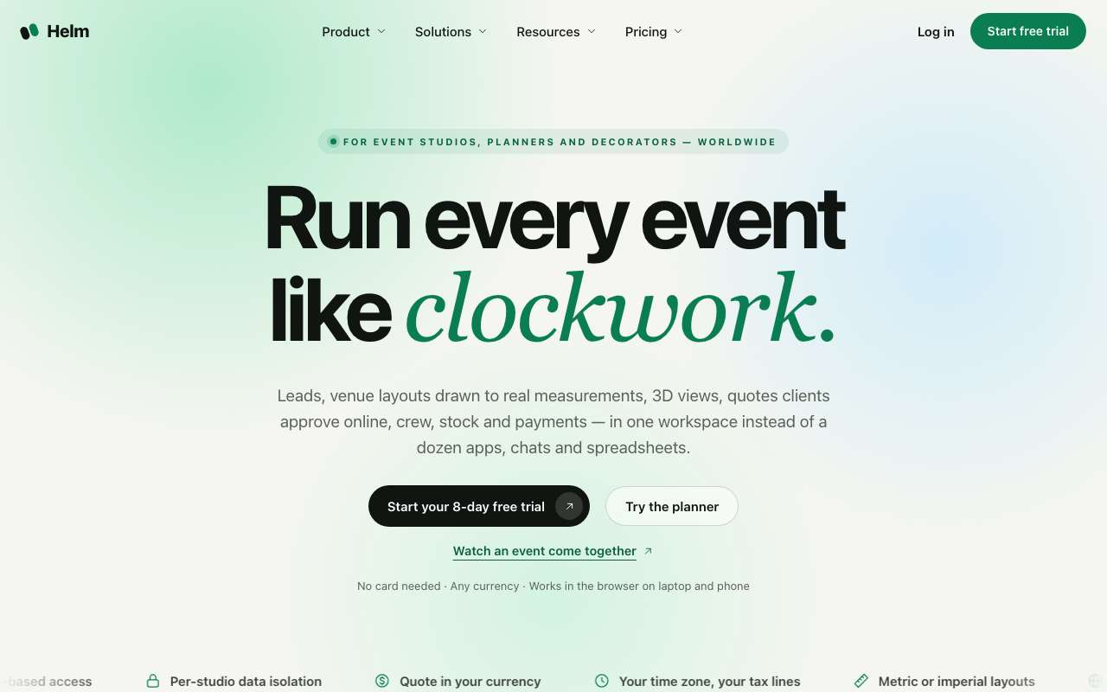
Public home page (signed out).
Sign-in page, "Start free trial" tab (/login?trial=1).
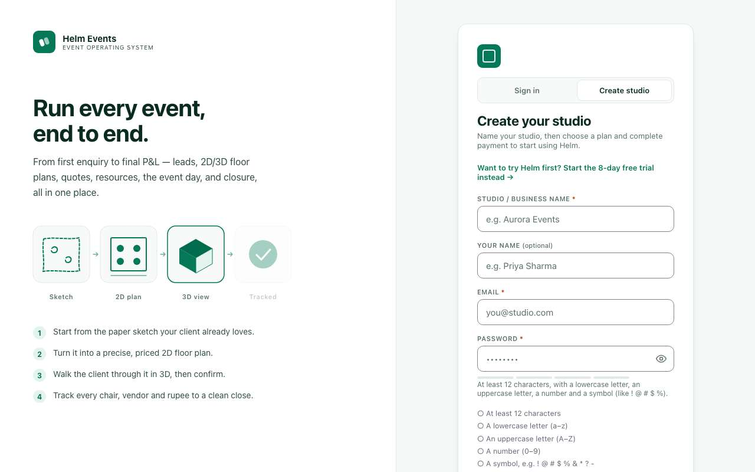
Sign-in page, "Create studio" tab, direct path (/login?direct=1): "Name your studio, then choose a plan and complete payment".
Public pricing page: Starter, Studio, Enterprise.

A30. Is there a free trial at all?
What this means: Today a new company can try Helm free for 8 days without a card, or pay first and create a studio.
Should there be a free trial? Why or why not?

☐ Yes, keep a free trial
☐ No trial, pay from day one
☐ Free trial only on request (sales call)
☐ Other: ______________________________
How it works today
The public website has About, Services and Pricing pages. Visitors see these before they sign up.

A31. Is the public About / Services / Pricing wording right?
What this means: These are the public pages on www.helm.events that visitors see before signing up.
What wording or prices on the public pages should change? Quote the line.

☐ Yes
☐ Prices shown must change
☐ Wording should change
☐ Hide pricing (show "contact us" instead)
☐ Other: ______________________________

A32. How long should the free trial be?
How many days should the trial last, and why that number?

☐ 8 days (today)
☐ 7 days
☐ 14 days
☐ 30 days
☐ Other: ______________________________

A33. Should a credit card be needed to start the trial?
Should a card be required to start the trial? Why?

☐ No card (today)
☐ Card needed, charged after the trial
☐ Card needed only for the Studio plan trial
☐ Other: ______________________________

A34. Demo data: at the start the trial owner picks "Try with demo data" or "Start with my own data". Keep both choices?
What this means: "Demo data" fills the studio with sample leads, events and quotes so the owner can explore. "My own data" starts empty.
Which start do you prefer for new studios, and why?

☐ Keep both (today)
☐ Always demo data
☐ Always empty (own data)
☐ Other: ______________________________

A35. What should a trial studio be allowed to do?
What this means: Today a trial studio can do everything a paying studio can, including messaging real clients and collecting payments.
What should a trial studio not be able to do? Give limits or numbers.

☐ Everything a paying studio can do (today, nothing is limited)
☐ Everything, but limit the number of events (write number)
☐ No real client messages (WhatsApp/SMS/email) during trial
☐ No real payments collected during trial
☐ Other: ______________________________

A36. Trial test mode: inside a running trial, the client approval page shows "Skip OTP (trial test mode)" to studio members so the owner can test approvals alone. Keep it?
What this means: OTP is a one-time code sent to the client's phone to confirm they approved the quote. During a trial, studio members see a "Skip OTP" button so the owner can test the approval alone, without a client.
Should trial owners be able to skip the client OTP while testing? Why?

☐ Keep it
☐ Remove it, always require the real OTP
☐ Keep it but show a clear "TEST" stamp on the approval
☐ Other: ______________________________

A37. Can a trial studio invite real staff?
How many people should a trial studio be able to invite?

☐ Yes, like a paid studio (today)
☐ Yes, but at most 2–3 people
☐ No, the owner tests alone
☐ Other: ______________________________

A38. When the trial ends without payment, what should happen?
What this means: Today, when an unpaid trial ends, the owner can only view (read-only), staff lose access, and nothing is deleted.
What should happen when the trial ends unpaid? How many days, if any?

☐ Studio becomes read-only for the owner, staff lose access, nothing deleted (today)
☐ Owner and staff keep read-only access
☐ Data is deleted after X days (write number)
☐ Studio stays fully usable for a few grace days (write number)
☐ Other: ______________________________

A39. Trial reminders are sent 3 days before, 1 day before and on the last day (bell for admins; e-mail once switched on). Is that right?
What this means: "Bell" is the notification bell icon at the top of Helm. Email reminders will start once email sending is switched on.
When and how should trial reminders go out, and to whom?

☐ Yes
☐ Add a reminder on day 1 (welcome)
☐ Also remind staff, not only admins
☐ Also send WhatsApp reminders
☐ Other: ______________________________

A40. After paying, a former trial studio can choose "Start fresh" (remove the demo rows) or "Keep the sample data". Keep this choice?
What this means: Demo rows are the sample leads, events and quotes added when the trial started with demo data.
After paying, what should happen to the demo data?

☐ Keep the choice
☐ Always remove demo data on payment
☐ Always keep it
☐ Other: ______________________________

A41. Two ways in: "Start free trial" and "Create studio" (pay first). Keep both?
Which ways in should new customers have, and why?

☐ Keep both (today)
☐ Only the free trial
☐ Only Create studio (pay first)
☐ Other: ______________________________
How it works today
If someone signs in (for example with Google) and has no studio yet, login.html shows a "Set up your studio" form: Business / studio name (placeholder "e.g. Aurora Events"), Location (city, country) (placeholder "e.g. Hyderabad, India"), Currency (INR, USD, EUR, GBP, AED, SGD) and Timezone (7 choices), plus the warning "Were you invited by a colleague? Don't create a studio here...".

A42. Is the short "Set up your studio" form for people who sign in with Google and have no studio yet right?
What this means: When someone signs in with Google and has no studio, Helm shows a short form: studio name, city, currency and similar. Email sign-ups go through the trial / create-studio choice instead.
What should happen when a Google user has no studio yet?

☐ Keep it as it is
☐ Send these people to the same Start free trial / Create studio choice as email sign-up
☐ Ask fewer fields (name only) and fill in the rest in the setup wizard
☐ Other: ______________________________

A43. Plans and prices: Starter ₹1,999/month (₹19,990/year) and Studio ₹4,999/month (₹49,990/year), shown as "proposed", plus Enterprise "Custom". Are these right?
What prices and plans would your customers actually pay for?

☐ Yes, as shown
☐ Change prices (write below)
☐ Add a free plan for very small users
☐ Add more plans (write below)
☐ Other: ______________________________

A44. Team-size limits (Starter up to 3, Studio up to 15, Enterprise unlimited) are only written on the pricing page; Helm does NOT block a 4th user today. Should Helm enforce them?
What this means: Example: today a Starter studio, meant for up to 3 users, can still add a 4th and 5th user.
Should Helm stop a studio from adding users above its plan limit?

☐ Yes, block adding users above the limit
☐ Yes, but only warn and ask to upgrade
☐ No, team size is not a limit
☐ Other: ______________________________

A45. Starter vs Studio: which features should be Studio-only? (tick all)
What this means: The access matrix is the role-permission grid. The client portal is the client's own page. The booklet is the event booklet given to the client. The invitation site is the public wedding/event website. Renders are realistic photo images of the 3D layout.
Which features justify paying more for Studio? Why?

☐ Roles and access matrix
☐ Inventory and stock check-out
☐ Staff and crew app, vendor tasks
☐ Client portal, booklet and invitation site
☐ 3D view / photo renders
☐ Nothing, both get everything (only team size differs)
☐ Other: ______________________________

A46. Billing period options:
Which billing periods do your customers prefer, and what discount?

☐ Monthly and yearly (today, yearly = 2 months free)
☐ Monthly only
☐ Yearly only
☐ Quarterly too
☐ Other: ______________________________

A47. Should the 2D/3D builder product library be the same fixed list for every studio?
What this means: The builder is the 2D/3D floor planner. Its product library holds the items you place, such as tables, chairs, stages and lights. Every studio gets the same list today.
Should each studio be able to add or hide products in the builder?

☐ Yes, one Helm list (today)
☐ Yes, plus each studio can add its own products
☐ Each studio can hide products it doesn't offer
☐ Other: ______________________________

A48. Is anything missing or wrong in the builder product list above?
Which products are missing, wrong or wrongly priced? Name them.

☐ List is fine
☐ Missing products (write below)
☐ Some products should be removed (write below)
☐ Prices per product need review
☐ Other: ______________________________

A-5. Studio setup wizard (onboarding)
After a studio is created, the owner is guided through a step-by-step setup so Helm knows the business, its prices, stock and people. Progress is saved on the studio, so it can be continued on any device.
How it works today
Where: opens after sign-up; later via Menu > Studio setup (or Control Center search "Studio setup"), page /onboarding. Top: "Step X of 13/14 · N% done" and a chip per step. Each step has Back, "Skip for now" (optional steps) and "Save & continue"/"Continue".
- Business details (required): Country*, Legal / business name*, Billing address*, Address line 2, City*, State*, PIN code*, Business phone*, Primary location / city*, GSTIN (optional).
- Studio details (required): Studio / brand name*, Business email ("Shown to clients as your contact"), Website (optional), Currency* and Timezone* (follow the country; tax shown, e.g. "Tax: GST 18%").
- Branding: Logo (https link to an image) and Accent colour (#hex).
- Team: Teammate email + Role; buttons "Create invite link" (join link valid 7 days) and "Manage roles & access".
- Venues: The studio's halls/spaces (same editor as Control Center > Venues).
- Menu dishes: Import or add dishes: Dish name*, Category, Veg / Non-veg.
- Item prices: Rate list: Name*, Price*, Applies to (e.g. per plate).
- Inventory: Item name*, Category, Quantity*, Unit, Unit cost.
- Vendors: Vendor name*, Category, Phone, Email.
- Staff: Name*, Phone*, Role, Department (crew who don't sign in).
- Payment terms: Advance % (default 10%, 0–100), Balance due days (0–365), Payment terms note.
- Email setup (WhatsApp: set up separately by the owner): Only when the Integrations feature is switched on (today: on for local testing only, off on the live site).
- Packages & templates: Checklist: "Review menu packages", "Review checklist templates", "Customize your own templates" (opens the builder in template mode).
- Finish: Done screen.
Setup wizard, step "Studio details" (local test copy). The chips across the top are the steps.

A49. Is the setup wizard needed at all?
What this means: The setup wizard is the step-by-step guide after a studio is created. It covers business details, prices, stock and team.
Is the setup wizard helpful? What would you change?

☐ Yes, keep it
☐ Shorter: only the 2 required steps, rest later from a checklist
☐ No wizard, just a checklist on the dashboard
☐ Other: ______________________________

A50. Which steps should be REQUIRED (cannot skip)? Today only Business details and Studio details.
Which steps must every new studio finish, and why?

☐ Keep as is
☐ Also Payment terms
☐ Also Team
☐ Also Menu dishes / Item prices
☐ Other: ______________________________

A51. Is the step order right?
What step order makes most sense? Write it out.

☐ Yes
☐ Business details should come after Studio details
☐ Payment terms should come earlier (right after Studio details)
☐ Other order (write below)
☐ Other: ______________________________

A52. Branding: logo is a web link (https://…) today. Should the owner upload a logo file instead?
What this means: Today the owner pastes a web address of the logo image (https://...) instead of uploading the file from their computer.
How should owners add their logo?

☐ Yes, upload a file
☐ Both upload and link
☐ Link is fine
☐ Other: ______________________________

A53. Default advance is 10% of the quote. Is that right for most studios?
What this means: The advance is the first payment the client makes to confirm the booking. Example: on a ₹5,00,000 quote, 10% is ₹50,000.
What advance percentage do you usually take, and why?

☐ 10% is right
☐ 25%
☐ 50%
☐ Each studio must type its own (no default)
☐ Other: ______________________________

A54. Should the wizard import data from Excel for menu, prices, inventory, vendors and staff (today it does)?
Which lists would you really import from Excel?

☐ Yes, keep import
☐ Import only for inventory and staff
☐ Remove import from the wizard
☐ Other: ______________________________

A55. The dashboard shows "Finish setting up your studio · X% done · Resume setup" to admins until setup is finished. Keep this reminder?
Should the setup reminder stay? For how long?

☐ Keep
☐ Show it only for the first 7 days
☐ Remove
☐ Other: ______________________________

A-6. Signing in, passwords, invites and security
How people get into Helm and how accounts are protected.
How it works today
- Sign in (/login): Email, Password (eye button to show), "Sign in →", "Forgot password?", "or Continue with Google", "Resend confirmation link" for new accounts. No sign-in by SMS/OTP. Bot protection (Cloudflare Turnstile) exists but is switched off.
- Password rule: at least 12 characters with a lowercase letter, an uppercase letter, a number and a symbol. A live checklist and strength bar show while typing.
- Forgot password: "Reset your password" form (email, "Send reset link →"). The answer is always the same whether or not the email exists. The link opens a page to choose a new password.
- Change password: account panel > Password > "Change password" (confirm current password first; other devices are signed out). Google-only accounts have no Helm password.
- Session timeout: none. Idle sign-out and maximum session length are both OFF (owner decision 2026-10-16). The account panel has "Sign out other devices".
- Add user: Control Center > People > Users & invites > "Team members": email + role + "Add user". "No password needed — a one-time temporary password is generated and shown once." On first sign-in the person must set their own password.
- Invite link: same page > "Invite by email link": email + role + "Create invite link". "The link expires in 7 days; nothing is charged." The invitee sets name + password ("Set password & continue →") and joins the studio. Also in the setup wizard Team step.
- Two-step verification: optional for every role. Turned on/off by each person in their account panel (avatar > Account settings > "Two-step verification"; also found by searching "Two-step sign-in (2FA)" in Control Center). Admins only get a reminder banner. A switch exists to make it required for admins (currently off). Anyone who has it on must enter the 6-digit code at every sign-in. 5 wrong codes = locked 15 minutes. Lost phone: email security@helm.events.
- Hide amounts (privacy PIN): eye button in the top bar. Amounts are hidden by default each browser session; showing them needs the 4-digit studio PIN (default 0000). It re-hides after 5 minutes without activity or when the tab was away more than 1 minute. Admins change/reset the PIN in Control Center > Workspace > "Hide amounts (privacy PIN)" (Current PIN, New PIN, Type the new PIN again, "Save privacy PIN", "Forgot the PIN? Reset to 0000"). This is a privacy screen for client meetings, not security.
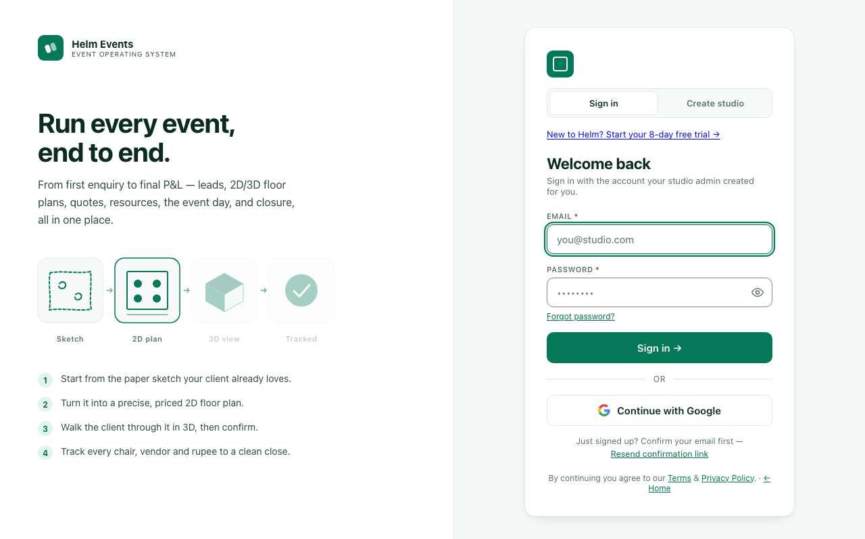
Sign-in page: email + password, "Forgot password?", "Continue with Google".

A56. Which sign-in options should Helm offer?
What this means: OTP sign-in means getting a one-time code by SMS, WhatsApp or email instead of typing a password.
Which sign-in methods does your team actually need?

☐ Email + password and Google (today)
☐ Also sign-in with a one-time code by email
☐ Also sign-in with OTP on mobile (SMS/WhatsApp)
☐ Also Microsoft / Apple
☐ Other: ______________________________
How it works today
If someone forgets their password, they click "Forgot password?" on the sign-in page. Helm emails a reset link (from notifications@helm.events) that opens a page to choose a new password.

A57. Is self-service password reset enough?
Who should be able to reset a forgotten password?

☐ Yes
☐ An Admin should also be able to reset a teammate's password
☐ Staff should ask their Admin instead (no self-reset)
☐ Other: ______________________________

A58. Password rule: at least 12 characters with lowercase, uppercase, a number and a symbol. Is that right?
Is this password rule too hard for your staff? What would you prefer?

☐ Keep it
☐ Make it easier: 8 characters, any mix
☐ Make it stricter
☐ Different rule for crew (e.g. PIN)
☐ Other: ______________________________

A59. Automatic sign-out after inactivity is OFF today (people stay signed in). What do you want?
What this means: Auto sign-out protects a shared or lost device. Today people stay signed in until they sign out.
After how long idle should Helm sign people out, if at all?

☐ Keep OFF
☐ Sign out after 30 minutes idle
☐ Sign out after 8 hours idle
☐ Always sign out after 24 hours
☐ Other: ______________________________
How it works today
Account panel has "Sign out other devices"; changing password also signs out other devices.

A60. Should changing a password, or an admin removing a user, always sign that person out on every device?
When should a person be signed out on all their devices?

☐ Yes, sign out everywhere (today for password change)
☐ Only when the person chooses "Sign out other devices"
☐ Other: ______________________________

A61. Adding a user: Admin types email + role and clicks "Add user"; a one-time temporary password is shown once, the admin shares it, and the person must set their own password on first sign-in. Keep this?
What this means: A temporary password is a one-time password shown once to the admin. The admin passes it on, and the new person must set their own on first sign-in.
How should a new teammate get their first password?

☐ Keep it
☐ Only invite links (no temp passwords)
☐ Send the temp password by email automatically
☐ Send it by WhatsApp automatically
☐ Other: ______________________________

A62. Who may add users and send invites?
Who in your studio should be able to add new users?

☐ Only Admins (today)
☐ Admins and Event managers
☐ Any role with "Users & access" ticked in the matrix
☐ Other: ______________________________

A63. Two-step verification (6-digit code from an authenticator app) is OPTIONAL for everyone today. Admins get a reminder banner ("Turn on two-step verification", "Later" = snooze 3 days). What do you want?
What this means: Two-step verification (2FA) means that after the password you also type a 6-digit code from a phone app such as Google Authenticator. It stops someone who only knows the password.
Who should be required to use two-step verification?

☐ Optional for all (today)
☐ Required for Admins, optional for others
☐ Required for Admins and anyone who sees money
☐ Required for everyone
☐ Other: ______________________________

A64. Two-step is set up in the person's own account panel (avatar > Account settings > Two-step verification, or Control Center search "Two-step sign-in (2FA)"). Is that easy enough to find?
Where would you expect to find the two-step setting?

☐ Yes
☐ Also put it in Control Center > People > Users & invites for admins to see who has it
☐ Show a setup step in the setup wizard
☐ Other: ______________________________

A65. Lost authenticator: today the person emails security@helm.events to reset two-step. OK?
What this means: Backup codes are a few one-time codes you save when you turn on two-step. Each one can replace the phone app once.
How should someone recover if they lose their authenticator phone?

☐ OK
☐ Studio Admin should be able to reset it for their staff
☐ Give backup codes at setup
☐ Other: ______________________________

A66. "Hide amounts": money is HIDDEN by default every browser session; the eye button shows it after the studio PIN (default 0000). It hides again after 5 minutes idle or 1 minute away. Is that right?
What this means: "Hide amounts" blurs rupee figures on screen, for example when a client is looking over your shoulder. The eye button shows them after you enter the studio PIN.
Should money be hidden by default? What timings feel right?

☐ Yes, keep it
☐ Amounts should be SHOWN by default; hide only when I press the eye
☐ Only Admin/Manager need the PIN; others never see amounts
☐ Change the timings (write below)
☐ Other: ______________________________

A67. The privacy PIN is 4 digits, one per studio, default 0000, changed only by Admins (Control Center > Workspace > Hide amounts (privacy PIN); also "Forgot the PIN? Reset to 0000"). OK?
What this means: This PIN only unhides money on screen. It is not a sign-in password. Admins change it in Control Center > Workspace > Hide amounts (privacy PIN).
How should the privacy PIN work for your studio?

☐ OK
☐ Each person should have their own PIN
☐ Force admins to change 0000 at setup
☐ Use the sign-in password instead of a PIN
☐ Other: ______________________________

A68. Wrong-code limits: 5 wrong two-step codes lock code entry for 15 minutes; 5 wrong privacy PINs lock for 30 seconds. OK?
What this means: A lockout stops someone guessing codes. Example: after 5 wrong PIN tries, the PIN box is blocked for 30 seconds.
Are these lockout limits right? What would you change?

☐ OK
☐ Stricter
☐ Looser
☐ Other: ______________________________

A-7. Helm HQ (the platform owner's page)
Helm HQ is the private page for the people who run Helm itself (not for studios). It lists all studios, their people, and what each studio has paid Helm. It is the place to manage plans, record subscription payments and suspend studios.
How it works today
- Access: address /hq. Not linked from anywhere. Signed out = goes to the sign-in page. Signed in but not an operator = an ordinary "We couldn't find that page" (it never admits the page exists). Operators are listed in the database (seeded: admin@helm.events and security@helm.events); more can be added in HQ > Activity log > "HQ operators" > "Add operator (e-mail)". Every HQ action is checked on the server and written to the HQ activity log. Two-step for operators is optional today (one switch can make it required).
- Header: "Helm HQ — Studios · people · Helm subscriptions — no studio business data", buttons Refresh, Sign out.
- Overview: number boxes Studios (+new in 7d / 30d), MRR, Paid this month, Past due (+reminders queued), Suspended (read-only studios), Users (+active in 7 days), Sign-ins (7 days); lists "Studios by subscription status" and "Two-step verification" (who has it).
- Studios: filter by status (Trial, Active, Past due, Suspended …) and search (name, slug, owner). Table: Studio, Primary contact, State, Plan, Status, Period ends, People, Paid Helm, Last sign-in. Click a studio: subscription details, change Plan / Status (trial, active, past due, cancelled) / trial end / period dates, "Save subscription", "Suspend (read-only)…" / "Reactivate studio", account details, people, payments to Helm, "Record a payment for this studio".
- Billing: From/To dates, Show, Export CSV, Refresh past-due; totals Collected, MRR, Past due; payments table (Paid on, Studio, Invoice, Method, Period, Amount, Status, Invoice / Void). "Record a payment" form (Amount incl. tax, Currency, Rate to INR, Paid on, Method UPI/Bank/Cash/Card/Other, Period start/end, Reference). Lists Past due, Reminder queue, Export payments not yet realised (FIRA/FIRC, "Mark realised"). Invoice settings (Legal name, GSTIN, Address, Seller country/state, LUT number and dates, Default GST %, Invoice prefix). "Studio checkout (new studios)": switches "Online payment is live", "Testing bypass: show Skip payment (testing only)" ("Turn OFF before launch"), Terms version.
- Plans: plan table (Code, Name, Per month, Status, Studios) + form to add/edit a plan; "Checkout details per plan" (description, what's included, Razorpay plan ids monthly/yearly); "Tax rules" per country (regime, rate, dates, invoice note).
- People: every user across studios: E-mail, Studio, Role, Joined, Last sign-in, Confirmed, 2-step; search.
- Activity log: HQ actions (When, Operator, Action, What); Security alerts by studio; HQ operators list.
Screenshot not available: Helm HQ needs a signed-in Helm operator account.

A69. Is Helm HQ needed in this form?
What this means: Helm HQ is a private page for the Helm company itself, not for studios. It lists every customer studio, its people and its payments to Helm.
Is Helm HQ useful as it is? What would you change?

☐ Yes, keep it
☐ Yes, but simpler (only studios and payments)
☐ Use an outside tool instead (spreadsheet / accounting software)
☐ Other: ______________________________

A70. HQ deliberately shows NO studio business data (no events, clients or amounts of studios). Keep that rule?
How much of a studio's data should Helm staff be able to see?

☐ Keep: never show studio business data
☐ Show counts only (number of events, quotes per studio)
☐ Allow HQ to open a studio in read-only mode for support
☐ Other: ______________________________

A71. What else should HQ show? (tick all)
What else should HQ show? Why would it help?

☐ Studios close to trial end
☐ Which studios are most / least active
☐ Studios that never finished setup
☐ Revenue per month chart
☐ Support tickets / messages from studios
☐ Other: ______________________________

A72. Who should be an HQ operator?
What this means: An HQ operator is someone at Helm (the software company) who can manage all studios' plans and accounts.
Who should run Helm HQ? Name the people.

☐ admin@helm.events and security@helm.events (today)
☐ Only the owner
☐ Owner plus named staff (write below)
☐ Other: ______________________________

A73. Two-step for HQ operators is OPTIONAL today. Should it be required?
What this means: HQ operators can suspend or change any studio, so their accounts are the most sensitive in Helm.
Should two-step be required for HQ operators? Why?

☐ Required
☐ Optional (today)
☐ Other: ______________________________

A74. HQ can suspend a studio (read-only, data kept). Who decides and when?
What this means: Suspending makes a studio read-only. Its data is kept, but nobody can make changes.
Who should suspend a studio, and after how many days unpaid?

☐ HQ operator, any time with a reason (today)
☐ Automatically after X days past due (write number)
☐ Only the owner decides
☐ Other: ______________________________

A75. Should HQ be able to extend a trial or give a free plan to a studio?
When should HQ extend a trial or give a free plan?

☐ Yes (today: change status / trial end date)
☐ Yes, but every change needs a note
☐ No
☐ Other: ______________________________
How it works today
HQ > Billing > "Studio checkout (new studios)" has "Testing bypass: show Skip payment (testing only)", which is ON in config today (allowPaymentBypass: true).

A76. When should the "Skip payment" testing bypass be turned off?
What this means: "Skip payment" is a testing button that lets a new studio be created without paying. It is ON today, so anyone could skip paying.
When should the Skip payment bypass be turned off?

☐ Before launch (switch off now)
☐ Keep it for demo studios only
☐ Other: ______________________________

A-8. Features switched ON and OFF today
Some parts of Helm are built but switched off (or on only for testing) by a setting in the app. This list shows each switch as it is on the live site today, so you can tell us what should be on at launch.
How it works today
- Dark mode: OFF. The app is always light. The light/dark toggle is hidden; the same menu action opens the colour theme picker instead.
- Colour themes (picker in the side menu): Emerald (default, green), Cobalt (blue), Midnight (dark indigo), Graphite (black/white), Studio (purple). Saved per browser.
- Design studio: HIDDEN (owner decision 2026-10-11). Its menu entry and the builder chip are switched off; the access-matrix row still exists.
- Integrations page (e-mail setup, plus the setup-wizard step and getting-started step): ON only on a local test copy (localhost); OFF on the live site, which redirects it to the dashboard.
- Online payments (Razorpay): OFF. Payment links are simulated; nothing is charged. Checkout shows "Payments are being set up".
- WhatsApp: set up separately by the owner.
- SMS / OTP by text (MSG91): OFF (simulated).
- E-mail sending: OFF (e-mail copies of reminders are prepared but not sent). Sender (decided): notifications@helm.events, with Reply-To set to the studio's own business email.
- "Skip payment (testing only)" on checkout (allowPaymentBypass): ON. The code notes say to turn it (and the HQ switch "Testing bypass") OFF before launch.
- Two-step required for admins (mfaRequiredForAdmins): OFF (optional for everyone).
- Session timeout: OFF (no idle sign-out, no maximum session length).
- Bot protection on sign-in (Cloudflare Turnstile): OFF.

A77. Dark mode is OFF today (always light). What do you want at launch?
What this means: Dark mode shows Helm with a dark background and light text. Today Helm is always light.
Do you want dark mode at launch? Why?

☐ Keep OFF (light only)
☐ Turn ON with a light/dark switch
☐ Follow the phone/computer setting automatically
☐ Other: ______________________________

A78. Colour themes: Emerald (default), Cobalt, Midnight, Graphite, Studio. Keep this list?
What this means: Themes change Helm's accent colour (buttons, highlights). Example: Emerald is green and Cobalt is blue.
Which colour themes should stay, and who picks them?

☐ Keep all 5, Emerald default
☐ Only one fixed Helm colour
☐ Fewer themes (write which)
☐ Let the studio pick one theme for all its staff
☐ Other: ______________________________

A79. Design studio is hidden today. Should it come back?
What this means: Design studio is a hidden area for decor design work. Floor layouts and the 2D/3D builder stay available.
Does your team need Design studio? Who would use it?

☐ Keep hidden
☐ Bring it back for Designer / Planner
☐ Remove it completely (also from the access matrix)
☐ Other: ______________________________

A80. The Integrations page (e-mail setup) is on only in local testing. On the live site?
What this means: Integrations lets a studio connect its own email account, so client emails come from bookings@yourstudio.com instead of notifications@helm.events.
Should studios send emails from their own address?

☐ Keep OFF: Helm's own e-mail is used for every studio
☐ Turn ON so each studio can connect its own e-mail
☐ Only for the Studio / Enterprise plan
☐ Other: ______________________________

A81. Which channels must be switched ON before launch? (tick all)
What this means: "Simulated" means Helm acts as if it sent the message or took the payment, but nothing real happens. Razorpay is the online payment service for client payments.
Which channels must work for real on launch day?

☐ Online payments (Razorpay)
☐ E-mail
☐ SMS OTP
☐ None yet, launch with them simulated
☐ Other: ______________________________

A82. The "Skip payment (testing only)" button is ON today. When should it go OFF?
What this means: This is the same testing bypass as A76. It lets someone create a studio without paying.
When should the Skip payment button go off, and for whom?

☐ Before launch (as the code notes say)
☐ Keep it for HQ staff only
☐ Keep it on
☐ Other: ______________________________

A83. Bot protection (Cloudflare Turnstile) on sign-in / sign-up is OFF. Turn it on?
What this means: Cloudflare Turnstile is a small automatic "are you human?" check on sign-in and sign-up. It blocks fake sign-ups by bots, and most real people never notice it.
Should we add the bot check at launch? Why?

☐ Yes, at launch
☐ Only if we see fake sign-ups
☐ No
☐ Other: ______________________________
How it works today
public/config.js auth.session idleMinutes:0, maxHours:0 (owner 2026-10-16: no app-side session limit)

A84. There is no automatic sign-out today (no idle timeout, no maximum session length). What do you want at launch?
What this means: This is the same idea as A59. Today nobody is signed out automatically, however long they are idle.
How many minutes idle, or hours total, before sign-out?

☐ Keep no limit
☐ Sign out after a period of no activity (write minutes)
☐ Force re-login after a maximum time (write hours)
☐ Both
☐ Other: ______________________________
How it works today
public/config.js auth.mfaRequiredForAdmins=false (comment: flip together with HQ helm_hq_settings.hq_require_mfa for launch)

A85. Two-step sign-in is optional for everyone today. Should it be required for admins at launch?
What this means: This is the same two-step code as A63, a 6-digit code from a phone app after the password.
Who must use two-step sign-in at launch?

☐ Yes, require for admins at launch
☐ Require for all staff
☐ Keep optional
☐ Other: ______________________________

Part B — Sales: dashboard, leads, quotes, builder, client pages

1. Dashboard
The Dashboard is the first page after sign-in (Menu > Dashboard, the house icon). It answers one question: what needs my attention today? On purpose it shows counts, not money. The only amounts appear in the Today strip and the Revenue card, and they are hidden until someone enters the studio PIN.
How it works today
- Today strip (top line): events today; tasks due and overdue (shown red if any are overdue); payments overdue and payments due today with their amount (finance roles only).
- Greeting: "Good afternoon, <name>" with your role badge. Below it, a summary line: events this week, quotes waiting on clients, leads awaiting reply, tasks due today, overdue items. With nothing pending it says "Nothing urgent on your plate today". Buttons: setup progress chip (admin/manager), Search (⌘K), New lead, New quote ▾, Customize. A countdown shows the next confirmed event; crew see their next shift instead.
- New quote ▾ dropdown: New quote, New lead, New client, Inventory item, Vendor, Staff member. Each item appears only if you have permission for it.
- 4 tiles (clicking a tile opens the related page): "—" means no number is available (no access or no data). Crew and task roles see different tiles: Tasks today / Overdue / Blocked / Completed.
Tile | Number | Extras
Upcoming · 30d | Events dated from today to 30 days ahead | "Next: name, date". 7 dots = the next 7 days; a filled dot means an event that day. Opens the Calendar.
Confirmed events | Confirmed events not yet closed | "N confirmed this month". The arrow ▲/▼ X% compares with last month (green = better, red = worse, grey = no change; "new" when last month was 0).
Open quotes | Quotes in progress, including sent ones | "N sent, waiting for client reply".
New leads · last 7 days | Leads created in the last 7 days | Arrow compares with the previous 7 days. "X of N became quotes · N not contacted yet" (still "New" after more than a day). Users without lead access see "Tasks overdue" instead.

- Get set up card (brand-new studio only): 1 Finish studio setup, 2 Add your first lead, 3 Create your first quote, 4 Invite your team, with an "X of 4 done" count.
- Panels:
- Your month: a calendar with up to 3 coloured dots per day.
- Needs attention: overdue task → Open; settlement pending → Settle; payment overdue → Collect; event within 3 days that still has open tasks → Review; event inside the reminder window → Get ready; blocked task → Unblock.
- Coming up in 30 days, with a readiness ring showing tasks done.
- Follow-ups: leads not contacted, and quotes with no reply after 3 days.
- Revenue (finance roles only): booked and collected, with a 12-month bar chart.
- Pipeline: Leads → Quoted → Confirmed → Completed, with "↓ X% move on" between stages.
- My tasks, All quotes, Team board, Desk notes (private), Recent activity (last 12 entries, admin/manager).
- See more: each list shows 4 rows ("All quotes" shows 5). "See more (N)" expands the list in place, then "Show less".
- Customize: drag blocks to reorder them and use the eye icon to hide a block. Buttons: Reset to default / Cancel / Done. Saved per person.
- Eye icon (top bar): amounts are hidden by default as ••••. Showing them needs the studio's 4-digit PIN.
Dashboard of a new, empty studio (welcome tour on top, amounts hidden)
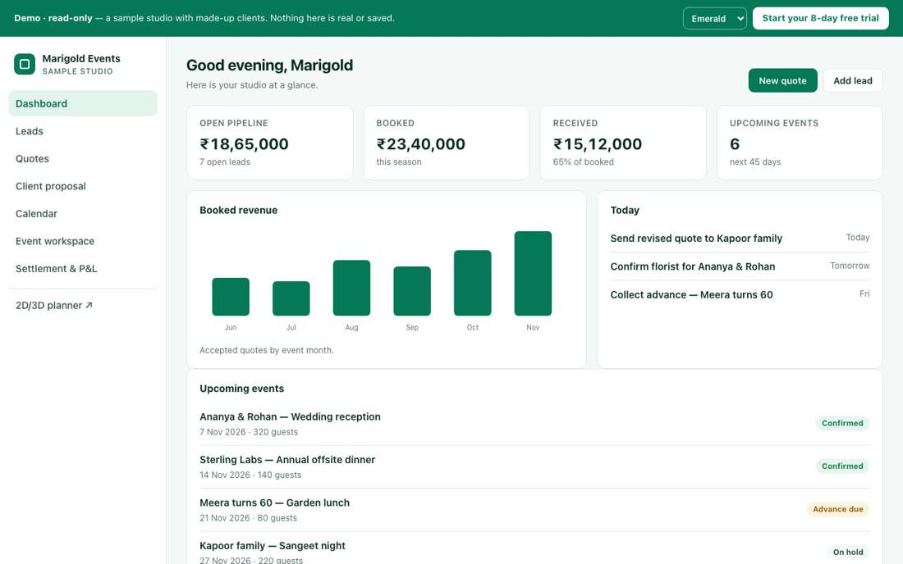
Public demo dashboard with sample numbers

B1. Are the 4 tiles the right numbers for you to see first?
Which number do you check first each morning? Which tile would you swap, and for what?

☐ Yes, keep as is
☐ Swap one for money booked this month
☐ Swap one for payments due
☐ Add more tiles
☐ Other: ______________________________

B2. Should the dashboard ever show money amounts in the tiles?
What this means: Today the tiles show only counts, like '5 confirmed events'. Money such as '₹4.2L booked this month' shows only in the Today strip and Revenue card, after the studio PIN is entered.
Who should see money on the tiles, and which amounts (booked, due, received)?

☐ No, counts only (as today)
☐ Yes, for admins only
☐ Yes, for admins and managers
☐ Other: ______________________________

B3. Is 30 days the right window for the Upcoming tile?
How far ahead do you plan events? Which window works best, and why?

☐ Yes, keep as is
☐ 7 days
☐ 14 days
☐ 60 days
☐ Other: ______________________________

B4. Should amounts be hidden by default behind a PIN?
What this means: The studio PIN is a short number code. Amounts stay hidden (shown as ••••) until someone types it, so staff or visitors near the screen cannot see revenue. The eye icon shows or hides them once unlocked.
Who might see the screen over your shoulder? Should amounts be hidden or shown by default?

☐ Yes, keep as is
☐ Show by default, hide on request
☐ No PIN, just the eye toggle
☐ Other: ______________________________

B5. Is 'no reply after 3 days' the right time for a quote follow-up?
How many days after sending a quote should Helm remind you to chase the client?

☐ Yes, keep as is
☐ 2 days
☐ 5 days
☐ 7 days
☐ Other: ______________________________

B6. A lead counts as 'not contacted' after 1 day in New. Is that right?
How fast must a new enquiry get its first call? What should the deadline be?

☐ Yes, keep as is
☐ Same day
☐ 2 days
☐ Other: ______________________________

B7. Which panels do you actually want on the dashboard?
What this means: Panels are the boxes under the tiles. Examples: 'Needs attention' lists overdue items, 'Follow-ups' lists quotes waiting on a client reply, and 'Desk notes' is a shared sticky-note area.
Tick the panels you would use. Which ones would you never look at?

☐ Your month
☐ Needs attention
☐ Coming up
☐ Follow-ups
☐ Revenue / Pipeline / Desk notes
☐ Other: ______________________________

B8. Should each list show 4 rows before 'See more'?
How many rows should each list show before 'See more'?

☐ Yes, keep as is
☐ Show 6
☐ Show 10
☐ Show everything
☐ Other: ______________________________

B9. Should staff be allowed to customize their own dashboard?
What this means: 'Customize' on the dashboard lets a user hide, show or reorder the panels for themselves only.
Who should decide the dashboard layout, and should staff be able to change their own?

☐ Yes, keep as is
☐ No, the admin sets one layout for all
☐ Admin sets a default; staff can adjust it
☐ Other: ______________________________

B10. Is the 'Get set up' checklist useful for new studios?
What this means: 'Get set up' is a list new studios see at first, with steps like add your logo, add staff, set prices, and create your first quote. It disappears once everything is done.
Did the checklist help you get started? Which steps were useful and which were not needed?

☐ Yes, keep as is
☐ Shorten it
☐ Remove it
☐ Other: ______________________________

2. Leads
Leads (Menu > Leads) holds every enquiry before it becomes a quote. Leads are shown as a board of columns (a pipeline) that you move cards across.
How it works today
- Columns: New, Qualified, Discovery, Quoted, Won, Lost. Each shows a count and "Load more".
- + New lead form:
- Contact name (the only required field), Phone, Email.
- Source: Referral / Website / Google / Instagram / Walk-in / Other social / Ad / Other.
- Event type, Event date (cannot be in the past), Guest count (max 100,000), Budget ₹.
- Birthday and Anniversary (optional), Notes. Then Save lead.
- Card shows name, event type · date · guests, phone, budget and source. Buttons: Client →, Workspace → (if a quote exists), Convert →.
- Moving a card: drag it to another column, or change the Stage in the detail view. A "Moved to X" message offers Undo. Undo/Redo apply to stage moves only.
- Search looks across name, phone, email, type and source. Views: the "+ Save view" button saves the current search under a name. Admins can share a view with the whole studio, and you can mark one as your default (★).
- Archive asks "Archive this lead? You can restore it from Archived anytime." The Archived button lists archived leads with Restore. There is no permanent delete.
- Duplicates: if a new lead's phone or email matches an existing lead, you get a warning "Possible duplicate lead" with Add anyway / Cancel. It is a warning, not a block.
- Convert creates a quote and opens it.
- Not there today: no lead owner or assignment, and no lead scoring.
Leads pipeline (empty studio)
New lead form (a help tip is showing)

B11. Are the 6 pipeline stages right?
What this means: Each stage is a column on the Leads board, and you drag a lead card from left to right. 'Discovery' means the first meeting where you learn what the client wants.
Describe your real sales steps from enquiry to booking. Which stage names would you change?

☐ Yes, keep as is
☐ Rename some
☐ Add a stage (e.g. Site visit, Negotiation)
☐ Remove Discovery
☐ Other: ______________________________

B12. Is 'Contact name' as the only required field right?
What is the least you must know to save an enquiry?

☐ Yes, keep as is
☐ Also require Phone
☐ Also require Event date
☐ Also require Source
☐ Other: ______________________________

B13. Are the Source options right?
What this means: Source records where a lead came from, such as Instagram, a referral, a walk-in or the website. Helm uses it to show which channels bring the most business.
Where do your enquiries really come from? List any sources that are missing.

☐ Yes, keep as is
☐ Add WhatsApp
☐ Add Facebook / JustDial / WeddingWire
☐ Let us edit the list ourselves
☐ Other: ______________________________

B14. Should each lead have an owner (the salesperson responsible)?
Who should own a lead, and can ownership change later?

☐ Yes, assigned by a manager
☐ Yes, whoever creates it
☐ No
☐ Other: ______________________________

B15. When a duplicate is found, what should happen?
What this means: Helm finds a duplicate when a new lead has the same phone or email as an existing one. Today it only shows a warning and still saves both.
If the same client enquires twice, what should Helm do?

☐ Warn only (as today)
☐ Block it
☐ Offer to merge the two
☐ Other: ______________________________

B16. Should leads be scored (hot / warm / cold)?
Would hot/warm/cold help you? If yes, what makes a lead 'hot'?

☐ No
☐ Yes, set by hand
☐ Yes, automatically
☐ Other: ______________________________

B17. What should moving a lead to 'Lost' require?
Should Helm ask why a lead was lost? List the usual reasons (price, date, went elsewhere).

☐ Nothing (as today)
☐ A reason picked from a list
☐ A typed reason
☐ Other: ______________________________

B18. Should leads ever be permanently deleted?
What this means: Today 'delete' only archives a lead. It is hidden but can be restored from the CRM archive. Permanent deletion cannot be undone.
Should old leads ever be erased for good? If yes, who decides and after how long?

☐ Never; archive only (as today)
☐ Admins only
☐ After a set number of years
☐ Other: ______________________________

B19. Who may convert a lead into a quote?
Who on your team should turn an enquiry into a quote?

☐ Anyone who can create quotes (as today)
☐ Managers only
☐ Sales and managers
☐ Other: ______________________________

B20. Are saved views useful?
What this means: A saved view keeps a set of filters under a name, for example 'Weddings in December' or 'My leads not contacted', so you can open it in one click.
Which filtered lists do you open again and again? Name any ready-made views you want.

☐ Yes, keep as is
☐ Add ready-made views (My leads, This month)
☐ Not needed
☐ Other: ______________________________

3. Nurture
Nurture (Menu > Nurture) keeps past and prospective clients warm. It tracks birthdays, anniversaries and yearly occasions, sends greetings, and reminds you to follow up.
How it works today
- Add to nurture list: Name (pick an existing client or type a new one), Email, Phone (WhatsApp).
- Type: Birthday / Anniversary / Corporate annual day / Client relationship anniversary / Festival / Custom.
- Occasion label, Occasion date, and a tick box "Auto-send a greeting each year".
- Occasions & automation:
- Main switch "Automatic greetings" (Paused or Active). When on, a greeting with a few gallery photos is queued automatically on the day.
- Days ahead: 0–30. The "Run today's greetings" button sends today's greetings straight away.
- Table: Client, Occasion, Next date, Auto. Buttons: Send greeting (email), WhatsApp (opens WhatsApp with a ready-written wish).
- Nurture list: Client, Occasion, Next follow-up, Status (Active / Won / Dormant). Buttons: Followed up, → Lead, ✕ (remove).
- Greeting templates: one per occasion type, each with a subject and body. Fill-ins: {{name}}, {{occasion}}, {{years}}, {{last_event}}, {{studio}}.
- Message library: festivals (New Year, Diwali, Holi, Raksha Bandhan, Dussehra, Ramadan, Eid, Christmas, UAE National Day) and follow-ups (thank you, review request, quote follow-up, payment reminder, referral, re-engagement). Library messages are not sent on their own; for festivals and occasions that support it, a "Use for automatic greetings" button can save a library message as the automatic greeting. Fill-ins: {{client_name}}, {{studio_name}}, {{event_date}}, {{planner_name}}, {{phone}}, {{years}}.
Nurture page

B21. Do you want automatic greetings at all?
What this means: Nurture can send a birthday or anniversary wish to past clients on its own each year. Example: 'Happy anniversary, Priya! It has been 2 years since your wedding with us.'
If greetings are automatic, should someone check each one before it goes? Why?

☐ Yes, automatic
☐ Yes, but a person approves each one first
☐ No, manual only
☐ Other: ______________________________

B22. Which channel should greetings use?
What this means: Email and WhatsApp sending are switched off today. The WhatsApp button only opens WhatsApp on your own phone with the message already typed.
How do your clients prefer to hear from you: email, WhatsApp, or both?

☐ Email
☐ WhatsApp
☐ Both
☐ Other: ______________________________

B23. Are the occasion types right?
What this means: Occasion types are what Helm tracks per client, such as Birthday, Anniversary, Corporate annual day, or the date the client first worked with you ('relationship anniversary').
Which occasions do you want to remember for clients? List any that are missing.

☐ Yes, keep as is
☐ Add more (which?)
☐ Remove some
☐ Other: ______________________________

B24. Which festivals should be in the library?
What this means: The library has ready-written festival messages (Diwali, Holi, Eid, Christmas, and more) you can reuse or set as automatic greetings. Today it has no regional ones like Sankranti or Bonalu.
Which festivals do your clients celebrate? List the ones to add or remove.

☐ Yes, keep as is
☐ Add regional festivals (Sankranti, Ugadi, Bonalu, Onam…)
☐ Fewer festivals
☐ Other: ______________________________

B25. Are the statuses Active / Won / Dormant right?
What this means: Active = still in touch, Won = booked again, Dormant = gone quiet. These apply to people on the Nurture list.
What statuses describe your past clients? Is a 'Do not contact' option needed?

☐ Yes, keep as is
☐ Add 'Do not contact'
☐ Rename them
☐ Other: ______________________________

B26. How often should follow-ups be due?
How often should Helm remind you to check in with a past client?

☐ Set by hand (as today)
☐ Every 3 months
☐ Every 6 months
☐ Other: ______________________________

B27. Should greetings include gallery photos?
What this means: Gallery photos are pictures of past events your studio has uploaded to Helm's Gallery. When Helm sends an automatic greeting, it can add a few of them below the message, for example a birthday wish to Priya with 3 photos from weddings you decorated. Today Helm picks these photos itself.
Should photos go with greetings? If yes, which ones: past events, the client's own event, or chosen by hand?

☐ Yes, keep as is
☐ No photos
☐ Let us choose the photos
☐ Other: ______________________________
How it works today
Nurture: each greeting template has a tick box 'Use this template for automatic greetings', and the automation has a 'Days ahead' setting (0-30).

B28. How many days ahead should automatic greetings be prepared?
What this means: 'Days ahead' (0 to 30) sets how early Helm prepares the greeting before the date. Example: with 3, Priya's 10 March birthday greeting is ready on 7 March so someone can check it. With 0 it goes on the day itself.
How many days before the occasion should the greeting be ready, and why that number?

☐ On the day (0)
☐ 1 day ahead
☐ 3 days ahead
☐ 7 days ahead
☐ Other: ______________________________

4. CRM archive
The CRM archive (Menu > CRM archive) is a permanent record of every lead. A snapshot is saved each time a lead is created, edited, converted or archived. Records are only ever added; nothing is overwritten.
How it works today
- Columns: When, Action, Name, Phone, Source, Event, Date, Budget, Guests, Stage, Open →. "Open →" goes to the quote workspace if there is one, otherwise to the lead.
- Filters: All sources, All stages, search box, and a Full history tick. With it off you see only the latest record per lead; with it on you see every snapshot.
- Restore appears on archived ("deleted") rows: "Restore '<name>' to Leads with its saved details? The archive record is kept."
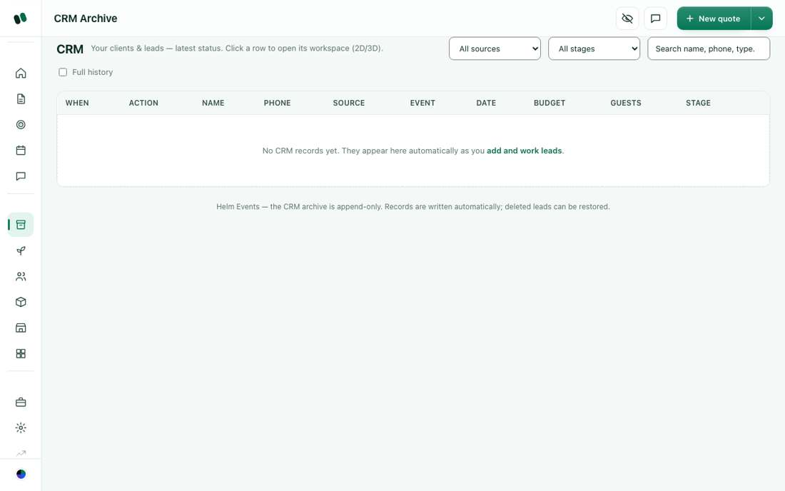
CRM archive (empty studio)

B29. Is the CRM archive useful to you as it is?
What this means: The CRM archive is a permanent history of every lead. Each create, edit, convert or delete saves a snapshot that is never changed, so you can see what a lead looked like at any time and restore deleted leads.
What do you use the archive for? Would one row per client be more useful?

☐ Yes, keep as is
☐ Turn it into a proper client list (one row per client)
☐ Hide it from non-admins
☐ Other: ______________________________

B30. Which columns matter most?
Which columns do you actually look at? Which would you add or drop?

☐ All of them
☐ Fewer columns: Name, Phone, Stage, Date
☐ Add total spent and number of events
☐ Other: ______________________________

B31. Who should be able to restore archived leads?
Who should be trusted to bring a deleted lead back?

☐ Anyone who can edit leads (as today)
☐ Admins only
☐ Other: ______________________________

B32. Should the archive be exportable to Excel?
What this means: Exporting means downloading the list as an Excel file. It contains client phone numbers and budgets, so think about who should be allowed to take it out of Helm.
Would you export it? If yes, who may download it and why?

☐ Yes
☐ No
☐ Other: ______________________________
How it works today
CRM archive Full history tick: off shows only the latest record per lead; on shows every snapshot.

B33. Should the CRM archive open with Full history on or off?
What this means: Off: one line per lead showing its latest details. On: every saved snapshot, so one lead edited 5 times shows 5 lines.
When you open the archive, do you want each lead once, or every change?

☐ Off: latest record per lead (as today)
☐ On: every snapshot
☐ Other: ______________________________

5. Quotes list
Quotes (Menu > Quotes) lists every quote and event. In Helm a quote is the event: once it is confirmed, the same record becomes the booked event.
How it works today
- Tabs: Active, Quotes, Confirmed, ⚠ Attention, Archive. Also a search box ("Search code, client, title…"), All types (event-type filter), ↻ Refresh and ✨ New quote.
- Columns: Code, Event, Client, Version, Status, Total, Updated, Actions.
- Statuses seen in code: Quote, Confirmed (including "Confirmed · awaiting client approval"), Cancelled, plus client-side pills Sent, Approved, Paid. Rows can also show ⚠ Overdue (event date passed but not closed), Archived, Deleted and "Closed · Archived". There is no Draft or Expired status pill.
- Row actions: 👁 View quote & layout, Edit layout (opens the builder), 📄 Details, ⚙ Ops (assign and track work), 🔗 Approve link (copy, send as text message, or send a new approval link), Mark paid, Download, 💬 Event group, 🗄 Archive, ✕ Delete (moves it to a restorable Deleted tab) / ↩ Restore. The first 3 actions are shown; the rest sit under a ⋯ menu. Empty drafts untouched for 24h are moved to Deleted automatically. Completed events also have a closure / P&L view.
- Details / pricing panel:
- Client name, company/host, phone, email, client / event state, and a place-of-supply dropdown. (A 15-digit client TRN field appears only for UAE studios; there is no GSTIN field.)
- Tax type: Intra-state (CGST + SGST) or Inter-state (IGST).
- Venue and address, event date, guests/plates, chairs.
- Catering source: In-house, Outsourced vendor, or Client-provided (no plate charge). There is also an extra catering charge field.
- Discount % and Discount ₹, Coupon (from a list of codes), a Tax-exempt client tick, and notes. Payment terms are not typed here; they come from studio settings and print on the quote.
- Buttons: Save pricing (keep as quote), and ✓ Confirm & lock. When the quote is already confirmed, the panel title (and the row button) reads "Re-price" instead of "Confirm".
- Footer: "Every save is a version · confirm to price & lock · GST per India (SAC 998596, 18%)".
Quotes list (empty studio)
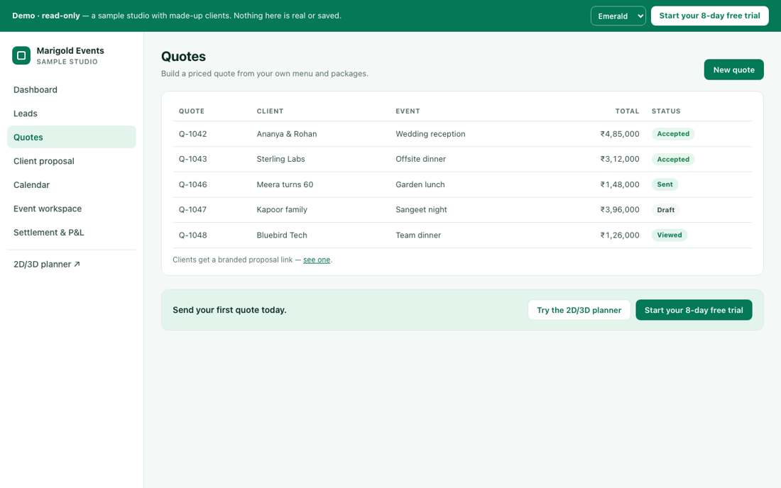
Public demo quotes list with sample statuses

B34. Are the 5 tabs right?
Which tabs do you need? Is a 'Lost / declined' tab missing?

☐ Yes, keep as is
☐ Add 'Lost / declined'
☐ Merge Active and Quotes
☐ Other: ______________________________

B35. Are the columns right?
What this means: Version is how many times the quote was revised: V1 is the first draft and V3 the third revision.
Which columns do you need at a glance? Which would you add or remove?

☐ Yes, keep as is
☐ Add Event date
☐ Add Amount paid / Balance
☐ Remove Version
☐ Other: ______________________________
How it works today
The Version column has a dropdown showing the current version (e.g. V3).

B36. What should picking an older version in the list do?
What this means: Each saved change creates a version (V1, V2, V3). Restoring makes an older version the current quote again, for example going back to V2 after the client rejects V3's price.
When you pick an older version, what should happen: view only, or restore it?

☐ Just view it
☐ Allow restoring it as the current version
☐ Remove the dropdown
☐ Other: ______________________________

B37. Is the action list on each row too long?
Which row actions do you use often, and which rarely?

☐ It is fine
☐ Move rare actions into a ⋯ menu
☐ Tell us which to remove
☐ Other: ______________________________

B38. Should a quote expire automatically?
Should prices in a quote stay valid forever? If not, after how many days should it expire?

☐ No
☐ After 15 days
☐ After 30 days
☐ Other: ______________________________

B39. Should archived quotes ever be permanently deleted?
What this means: Today archived quotes are only hidden and can come back. Permanent deletion also removes their payment and version history, and cannot be undone.
Should old quotes ever be erased for good? If yes, who decides and after how long?

☐ Never
☐ Admins only
☐ After X years
☐ Other: ______________________________

B40. Do you need a 'Duplicate quote' action to reuse a past event?
How often do you repeat a past event's setup? What should a copy keep or reset?

☐ Yes
☐ No
☐ Other: ______________________________

6. Creating a quote and the quote editor
A quote can start from a converted lead, from New quote, or from the builder (save the layout, then return to the quotation). The price is the layout items plus catering (menu package × plates), minus any discount, plus GST.
How it works today
- ✨ New quote (on the Quotes page, a single button with no dropdown) creates a blank quote with the next code and opens the step-by-step editor. The editor has 9 steps:
- Client & event: name, company, email, phone, event type, date, city, client state, guests, budget range (min – max).
- Discovery: meeting date, mode (in person / phone / video), who attended, notes.
- Requirements: each item marked Must-have / Optional / Nice-to-have.
- Venue & access: venue name, venue contact, indoor / outdoor / both, address, load-in notes.
- Menu package: package cards plus a dish editor.
- Proposal: concept, theme, scope.
- Floor layout: hall size and "✨ Generate default layout".
- Quotation: chairs, guests, plates, chair rate, plate price, décor & setup, Discount ₹, Coupon, Tax-exempt. Buttons: Download quote PDF, Save quotation (new version).
- Advance payment & booking: Advance %, amount, method (cash/offline or online link), receipt no. Recording the advance is what confirms the booking.
- Auto event name: TYPE_CITY_GUESTS_DATE, e.g. WED_HYD_1000_19AUG26. "Reset to auto name" puts it back.
- Sizing defaults: chairs = 70% of guests; tables = chairs ÷ 8. Typed numbers override both.
- Menu packages (older seed list, which may differ for a new studio), price per plate: Standard Veg ₹450 / Non-veg ₹650, Gold ₹700 / ₹950, Premium ₹1,000 / ₹1,400. Prices are set in Control Center. Clients can also pick a package in the booklet; staff then Accept (optionally with a different price) or Decline (a reason is required).
- Discounts: applied in this order: fixed ₹, then %, then coupon, capped at the subtotal. Tax is charged after the discount. There is no per-role limit and no manager approval today.
- Tax: India GST 18% (SAC 998596), CGST+SGST within the state or IGST between states. UAE VAT 5%. A tax-exempt tick removes tax. A saved quote keeps the rate it was priced with.
- Versions: each "Save quotation" keeps a version. It refuses if nothing changed. There is no side-by-side compare.
- Approval: Quote → Confirmed · awaiting client approval → client approves with OTP → Paid. If the price changes after approval: "⚠ Price changed after approval — client must approve again" plus Send new approval link.
- Reprice banner: when your studio rates change, open future quotes show "Prices changed since this quote was priced — Review & re-price" with a "Keep current prices" option.

B41. Is the 9-step editor the right order?
Which steps do you skip or do in a different order? Which could be merged?

☐ Yes, keep as is
☐ Too many steps; merge some
☐ Make Discovery and Requirements optional
☐ Other: ______________________________

B42. Should the advance payment be what confirms a booking?
What makes a booking final for you: approval, advance, or your call?

☐ Yes, keep as is
☐ Client approval is enough
☐ Manager decides per event
☐ Other: ______________________________

B43. Who may give discounts?
Who on your team should be able to give a discount?

☐ Anyone who edits quotes
☐ Managers and admins only
☐ Admins only
☐ Other: ______________________________

B44. Should discounts have a maximum?
What is the biggest discount staff may give without asking someone?

☐ No limit
☐ Up to 10% without approval
☐ Up to 20% without approval
☐ Other: ______________________________

B45. Do you use coupon codes?
What this means: A coupon code is a word like DIWALI10 typed into the quote to apply a set discount automatically.
Do you run offers with codes? If yes, give an example of how you use them.

☐ Yes
☐ No, hide them
☐ Other: ______________________________

B46. Is GST at 18% always correct for you?
Which GST rates apply to your services? Note any items taxed differently.

☐ Yes
☐ Different rates for catering and decor
☐ Other: ______________________________
How it works today
Each quote has a 'Tax-exempt client (no tax charged)' tick in both the Details panel and the Quotation step.

B47. Should anyone editing a quote be able to tick 'Tax-exempt client'?
What this means: Ticking 'Tax-exempt client' removes GST from the whole quote. It is meant for clients who legally pay no GST, such as some government bodies. Used wrongly, it under-charges tax.
Who should be allowed to mark a client as tax-free, and how often does it happen?

☐ Yes, keep as is
☐ Managers and admins only
☐ Hide it, we never use it
☐ Other: ______________________________

B48. After a client approves, a change needs fresh approval. Is that right?
After a client approves, which changes should need their approval again?

☐ Yes, keep as is
☐ Only for price increases
☐ Only above a certain amount
☐ Other: ______________________________

B49. Should every save make a new version?
What this means: A version is a frozen copy of the quote at that moment. Today every save makes one, so a quote edited 10 times has 10 versions.
When should Helm keep a separate saved copy of the quote?

☐ Yes, keep as is
☐ Only when sent to the client
☐ Only when I choose 'Save as version'
☐ Other: ______________________________

B50. Should the client see older versions?
Should clients see earlier quotes? If not, why not?

☐ No, only the latest
☐ Yes
☐ Other: ______________________________

B51. Who may 'Confirm & lock' a quote?
What this means: 'Confirm & lock' turns the quote into a booked event and freezes its prices, so they cannot be edited by mistake.
Who should be able to lock a quote as a confirmed booking?

☐ Managers and admins
☐ Admins only
☐ Sales too
☐ Other: ______________________________

B52. Should a quote need a manager's approval before it goes to the client?
Should a manager check quotes before they go out? If only some, which ones?

☐ No
☐ Yes, always
☐ Only above a set value / discount
☐ Other: ______________________________

B53. Should there be a minimum number of plates?
Do you have a minimum order for catering? If yes, how many plates?

☐ No
☐ Yes, per package
☐ Yes, studio-wide
☐ Other: ______________________________

B54. How should chairs be billed?
How do you charge for chairs today? Give a typical example.

☐ Per chair (as today)
☐ Included in the per-plate price
☐ Other: ______________________________
How it works today
Catering source: In-house, Outsourced vendor (with vendor picker and an extra catering charge), or Client-provided (no plate charge).

B55. Are the three catering source options right?
Who provides catering in your events? Which options do you need?

☐ Yes, keep as is
☐ We never outsource catering
☐ Remove 'Client-provided'
☐ Other: ______________________________

7. Layout builder (2D / 3D)
The builder (Quotes > Edit layout, or Menu > Builder) is where you draw the event floor plan. Every item you place is priced, and the price flows into the quote.
How it works today
- Top bar:
- Start blank… / Reference a past layout / ✨ Create layout (a wizard).
- Feet or Metres, Snap (items jump to the grid), Grid (show or hide the lines).
- 2D Plan / 3D View / ✦ Render, Fullscreen.
- Walkthrough / Overview / Floor plan / Evening (3D camera and lighting modes), Labels on.
- 📏 Measure (distances to other items and walls), Undo / Redo, Clear (removes every object).
- Second row: event name, 💾 Save (each save is a new version), 📂 Open, More (download PNG, download or import JSON), ✓ Save & back to quote and 📸 Update client images (shown when opened from a quote), the venue capacity box, and a "seats placed vs venue capacity" meter. Keyboard shortcuts open from the ? / ⌨ Shortcuts button in the Asset Toolbox.
- Event-type starters: Political / Rally, Conference & Expo, Wedding & Gala, Outdoor Festival, Concert / Live Music, Gala & Private (these are groups inside the Start blank… template dropdown), Corporate & Sports.
- Right panel:
- Menu package; Guests / plates; Chairs (priced); "Seats in layout · plates billed".
- Price breakdown with each line, Subtotal, GST 18% and Total, plus a "Hide price breakdown" tick.
- Inspector for the selected item: size, seats, rows × columns.
- Prices: a rate set in Control Center > Item pricing always wins. Otherwise the default price below applies. Chairs and tables are billed per seat at the chair rate.
Every predefined product (default ₹ price):
- Structure: Main Stage 45,000; Dance Floor 20,000; Canopy 25,000; Arch / Backdrop 9,000; Tent 35,000; Truss Tower 6,000; Greenery 800; Carpet / Aisle 8,000; VIP Riser 18,000; Walkway / Ramp 6,000; Entrance Gate 25,000; Dais with Chairs 30,000; Banner / Hoarding Frame 12,000; Stage Roof Truss 60,000; Varmala Platform 25,000.
- Seating:
- Billed per seat: Chair Row, Seating Block, Round Table (8), Banquet Table (12), Head Table (8), Cocktail Table (3), Rectangular Table (3), Chair (single), Bar Stool.
- Fixed price: Lounge Set 6,000; Sofa 2,500; Loveseat 2,000; Armchair 1,200; Ottoman 500; Bench 800; Coffee Table 800; Bleachers 15,000; Couple Sofa 8,000; Floor Seating (Gaddi) 3,000.
- AV & Stage: Podium 3,500; Press Riser 15,000; DJ Booth 10,000; Photo Booth 12,000; LED Screen 60,000; Speaker Stack 4,000; Uplight 500; Grand Piano 30,000; Line Array 40,000; Subwoofer 12,000; Stage Monitor 1,500; FOH Console 20,000; Moving Light 2,500; LED Video Wall 1,20,000; Lighting Truss 9,600; LED Wall 18,000; Smoke Machine 5,000; Dancers 14,000; Lectern 4,000; PA Tower 15,000; Lighting Tree (T-Bar) 3,500; Mic Stand 500; Teleprompter / Confidence Monitor 6,000; Projector Screen 8,000; TV Screen on Stand 4,000; Interpreter Booth 15,000; Cold Pyro / CO2 Jet 3,000.
- Security: Barricade 1,800; Fence Line 1,500; Checkpoint 3,000; Stage Barrier 9,000; Stanchions (rope & post) 1,200; Watch Tower / CCTV 8,000.
- Logistics: Expo Booth 8,000; Reg Desk 2,500; Food Truck 25,000; Bar 12,000; Buffet Line 9,000; Gift Table 1,500; Cake Table 1,500; Restrooms 12,000; Coat Check 5,000; Parking Zone 10,000; Patio Heater 2,500; Signage Easel 500; Generator 15,000; Power Distro 3,000; Cable Ramp 600; Green Room 8,000; Chocolate Fountain 9,000; Live Food Counter 7,000; Kids Zone 15,000; Air Cooler / Fan 1,500; Trophy Display 3,000; Signage / Standee 1,200; Mobile Light Tower 4,000; Shoe Rack 1,000; Dessert / Candy Table 3,500; Coffee / Tea Station 3,000; Food / Merch Stall 6,000; Display Counter 2,500; Check-in Kiosk 3,000; Ticket Booth 5,000.
- Safety: Exit Zone 500; First Aid 4,000; Fire Point 300; Ambulance Bay 6,000.
- Decor: Floral Centerpiece 1,500; Floral Arch 15,000; Decor Mandap 75,000; Decor Pillar 2,000; Pipe & Drape 2,400; Chandelier 12,000; Fountain 20,000; Wedding Chariot 20,000; Branding Wall 9,600; Phoolon ki Chadar 6,000; Swing / Jhoola 12,000; Haldi Setup 18,000; Mehendi Lounge 15,000; Selfie Frame 3,500; Welcome Board 2,500; Fairy Light Canopy 8,000; Entrance Floral Arch 30,000; Stage Floral Backdrop 35,000; Flower Wall 12,000; Garland Toran 4,000; Floral Pillar 4,500; Aisle Floral Stand 1,800; Tall Centrepiece 2,500; Balloon Arch 6,000; Balloon Bouquet 800; Flag Stand 1,500; Brass Deepam Stand 2,500; Havan Kund 3,500; Rangoli / Kolam 2,500; Lantern Cluster 1,200; Hanging Floral Ceiling 18,000; Neon Sign Wall 4,000; Backdrop (generic) 6,000; Floral Stand (generic) 1,500; Decor Item (generic) 2,000; Display Plinth 1,000; Flower Urli 2,500; Decor Umbrellas 5,000; Doli / Palki 12,000; Kalash / Purna Kumbh 800; Pooja Altar / Idol Platform 8,000.
3D View could not be captured: the 3D library loads from the internet, which was blocked in the screenshot browser. It shows the same plan as a 3D model you can rotate.
Photo Render (described only, never run): it takes pictures of the plan and asks AI (OpenAI) to make a realistic photo of the set-up in a chosen style. There is a monthly quota (60 photos by default; an admin can set 0–10,000), an hourly limit (20 by default), and a counter "This month: X of Y photos used". Only users given permission can use it.
Layout builder with a starter layout and live price

B56. Is the builder something your team will actually use for every quote?
What this means: The builder is a drawing tool where you place stages, tables and decor on a hall floor plan. Each item has a price that flows into the quote.
For which events would your team draw a floor plan? What would stop them?

☐ Yes
☐ Only for big events
☐ Rarely; we mostly quote by text
☐ Other: ______________________________

B57. Are the 7 product categories right?
Which categories would you rename or add?

☐ Yes, keep as is
☐ Add categories
☐ Rename some
☐ Other: ______________________________

B58. Are the default prices realistic for Hyderabad?
Which prices look wrong? Give your real rates where you can.

☐ Roughly right
☐ Too high
☐ Too low
☐ We will set all our own
☐ Other: ______________________________

B59. Which products are missing?
List the items you rent or set up that are missing from the builder.

☐ Add specific items (list below)
☐ None missing
☐ Other: ______________________________

B60. Which products should be removed?
Which items will your studio never offer?

☐ Political / rally items
☐ Concert items
☐ None
☐ Other: ______________________________

B61. Should every builder save make a new version?
Should every layout save keep a copy, or only when you choose?

☐ Yes, keep as is
☐ Only when I choose
☐ Other: ______________________________

B62. Should the client ever see prices on the floor plan?
Should clients see prices on the floor plan? If not, how should price be shown?

☐ No
☐ Yes
☐ Other: ______________________________
How it works today
The right panel has a 'Hide price breakdown' tick that hides item-by-item prices and shows one 'Event price' amount the planner types instead (builder.js priceDisp).

B63. When you hide the price breakdown, is typing one overall event price the way you want to show it?
When item prices are hidden, how should the total be shown to the client?

☐ Yes, keep as is
☐ Show category totals instead
☐ Other: ______________________________

B64. Who may use Photo Render?
What this means: Photo Render turns your floor plan into a realistic AI picture of the decorated venue to show clients. Each render uses up part of the monthly quota.
Who should be allowed to create photo renders?

☐ Admins only
☐ Admins and planners
☐ Everyone
☐ Other: ______________________________
How it works today
Photo Render offers styles such as Royal Indian, Pastel floral, Arabian luxury, Bollywood glam, Corporate clean, Political rally, Concert stage, plus lighting (Golden hour, Evening, Daylight, Indoor ballroom) and camera angle options.

B65. Are the Photo Render style and lighting options right for your clients?
Which styles and lighting suit your clients? List any to add or remove.

☐ Yes
☐ Add styles (list)
☐ Remove some
☐ Other: ______________________________

B66. Is 60 photos a month the right quota?
What this means: The quota is the number of AI photo renders your studio may create each month. Today it is 60.
How many renders a month would your studio really use?

☐ Yes, keep as is
☐ Fewer
☐ More: ____
☐ Other: ______________________________

B67. Do you need the 3D view?
Do clients ask for a 3D view? When would you use it?

☐ Yes
☐ 2D is enough
☐ Other: ______________________________

B68. Feet or metres by default?
Which unit do you and your venues measure halls in?

☐ Feet
☐ Metres
☐ Other: ______________________________
How it works today
The template dropdown offers 18 ready layouts (e.g. Theatre seating rally, Banquet + dance floor, Club / DJ night) and the ✨ Create layout wizard builds one from hall size, guests, chairs (default 70% of guests), tables and facilities.

B69. Are the starter templates and the Create layout wizard useful, and which templates should be added or removed?
Which templates help you? List any to add or remove.

☐ Useful as is
☐ Add templates (list)
☐ Remove some (list)
☐ Other: ______________________________

8. Proposal, client approval, booklet, invitations and payments
These are the screens your client sees, plus how payments are recorded.
How it works today
- Proposal & mood-board (studio side): Concept & design direction, Share with client, Feasibility & risk checklist. The client view shows Your event, the concept, colour palette, mood & inspiration, what's included, and the investment (price).
- Client approval (link from 🔗 Approve link): An expired link shows "Link not found".
- The client sees the event and amounts, including GST.
- Confirm it's you, then Verify & consent: they enter their name and mobile and tap "Send code on WhatsApp" (the code goes to the mobile number the planner has on file, not the typed one; there is also "Send OTP to my phone by SMS" and, if WhatsApp fails, "Send code by email instead"). They enter the 6-digit code, which expires in 10 minutes, and tick the terms.
- They see "Approved & consented". The time and the terms version are recorded.
- They then see "Payment link ready" or "Your planner will share payment details".
- Booklet: a shareable event booklet with the top-down floor plan, a 3D preview, and a "Confirm your package" step.
- Client page: a client-facing page for the event (its full contents were not reviewed).
- Invitation Studio: build a public invitation website for a confirmed event.
- Steps: 1 template, 2 details, 3 photos, 4 music, 5 schedule.
- Templates: Eternal (wedding), Promise (engagement), Confetti (birthday), Summit (corporate), Soiree (general).
- Fields: names, headline, date, time, venue, address, map link, welcome message, hosted by, contact, dress code, reply-by date.
- Payment milestones: each one is Due, Invoiced, Waived or Paid. "Mark paid" records the payment, creates a receipt, blocks overpaying, and notifies both sides. The demo uses Advance 30% (India). Invoices show CGST and SGST.
- Razorpay online payment: built but switched off. Until it is on, clients are told the planner will share payment details.
The studio-side proposal, approval, booklet and invitation pages need a real event, so they could not be captured in the empty local studio. The public demo's client proposal is shown below.
Client proposal, from the public demo studio

B70. Is the proposal content right (concept, palette, mood, included, price)?
What this means: A mood board is a page of pictures and colours that shows the look and feel planned for the event.
What does a client need to see before saying yes? What is missing?

☐ Yes, keep as is
☐ Add a timeline
☐ Add terms
☐ Add photos of past events
☐ Other: ______________________________

B71. Should approval need a WhatsApp code (OTP)?
What this means: An OTP is a one-time code sent to the client's phone. Typing it in proves the real client approved the quote, not someone else who has the link.
How should Helm prove the client really approved? Is a code too much effort?

☐ Yes, keep as is
☐ Email code
☐ No code, just a button
☐ Other: ______________________________
How it works today
The approval page offers WhatsApp code, an SMS OTP button, and an email fallback when WhatsApp fails.

B72. Which ways of getting the approval code should the client be offered?
Which ways of receiving the code do your clients have and use?

☐ WhatsApp only
☐ WhatsApp + SMS
☐ WhatsApp + SMS + email fallback (as now)
☐ Other: ______________________________

B73. What must the client accept when approving?
What must the client agree to when approving? List anything to add.

☐ Terms only
☐ Terms and cancellation policy
☐ Terms, cancellation and payment schedule
☐ Other: ______________________________

B74. Can the client pick between several packages on the approval page?
Do you give clients package choices (e.g. silver/gold)? Should they pick on the page?

☐ Yes
☐ No, one package only
☐ Other: ______________________________

B75. Is the booklet useful to send to clients?
What this means: The booklet is a printable summary of the event (layout, items, schedule and price) you can send to the client as a PDF.
Would you send the booklet? What should it contain?

☐ Yes
☐ No
☐ Merge it into the proposal
☐ Other: ______________________________

B76. Are the 5 invitation templates enough?
What this means: Invitation sites are simple web pages for an event (e.g. helm.events/i/priya-wedding) that the client shares with guests, showing date, venue and details.
Which event types need their own invitation design?

☐ Yes, keep as is
☐ Add Haldi / Mehendi / Sangeet
☐ Add a festival template
☐ Other: ______________________________

B77. Should invitation sites collect RSVPs?
What this means: RSVP means guests reply 'coming / not coming' and how many people, which helps confirm plate counts.
Would RSVPs help you plan numbers? What should guests be able to answer?

☐ Yes
☐ No
☐ Other: ______________________________

B78. Who may publish an invitation site?
Who should be allowed to put an invitation page live for guests?

☐ Planners
☐ Managers / admins only
☐ Other: ______________________________

B79. What is your standard payment schedule?
What this means: A milestone is one planned payment, for example 30% advance at booking and 70% a week before the event.
Describe your usual payment split and timing.

☐ 30% advance, rest before the event
☐ 50% / 50%
☐ 40 / 40 / 20
☐ Varies per event
☐ Other: ______________________________

B80. Can a milestone be waived, and by whom?
What this means: Waiving a milestone means marking a planned payment as not needed, for example forgiving the last 5% as a goodwill gesture.
When would you let a client skip a payment, and who should decide?

☐ Admins only
☐ Managers and admins
☐ Never
☐ Other: ______________________________

B81. When should we switch on Razorpay online payment?
What this means: Razorpay sends the client a payment link to pay by UPI, card or netbanking. It is built but switched off today.
Do clients ask to pay online? When should online payment start?

☐ Now
☐ Later
☐ Never; we take bank transfers
☐ Other: ______________________________

B82. Who pays the Razorpay fee?
What this means: Razorpay charges about 2% per online payment. Example: on a ₹1,00,000 payment the fee is about ₹2,000.
Who should bear the online payment fee, and is adding it to the bill acceptable?

☐ Studio
☐ Client (added on top)
☐ Other: ______________________________

B83. Should receipts go to the client automatically?
How should clients get their payment receipts?

☐ Yes, by email
☐ Yes, by WhatsApp
☐ No, we send them by hand
☐ Other: ______________________________

B84. Should an event be confirmed only after the advance is paid?
Should a booking be confirmed only after the advance arrives? Any exceptions?

☐ Yes
☐ No, approval is enough
☐ Other: ______________________________

9. Messages to clients from these pages
Nurture greetings, quote approval links and payment reminders on these pages depend on Helm's message channels.
How it works today
- E-mail, SMS and online payment (Razorpay) are all switched OFF today: actions run in a simulated mode, nothing reaches the client automatically. The Nurture "WhatsApp" button only opens WhatsApp on your own phone with a ready-written message.
- E-mail sender (decided): notifications@helm.events with Reply-To = the studio's business email. WhatsApp: set up separately by the owner.

B85. Until online payment is on, "Mark paid" on the Quotes list records cash/bank payments by hand. Is that enough for launch?
What this means: 'Mark paid' means you record by hand that money arrived by cash or bank transfer. Helm does not collect the money itself.
Is recording payments by hand enough to start? If not, what is needed at launch?

☐ Yes
☐ No, online payment links are needed at launch
☐ Other: ______________________________

Part C — Operations: planning, staff, stock, event day, money, reports
About the screenshots: they were taken on a test copy of Helm running on this computer with made-up sample data (for example "HE-1024 Sharma Wedding"). Nobody signed in, so some boxes show "Couldn't load… Supabase not configured" or show amounts as dots (privacy mode). That is a test effect, not what your studio sees. Where a page could not be captured, it is described in words.

C-1. Planning an event: Resource plan, Run sheet, Tasks, Operations
Every event has its own Event workspace (Quotes > open an event). Its cards open the planning pages. Four of them all describe "who does what": Resource plan (what the event needs, and what is missing), Run sheet (minute-by-minute plan for the day), Tasks (jobs given to staff, opened through the Operations page) and the Staff on this event card. They overlap. Please tell us how your team really plans, so we can merge or trim.
How it works today
Event workspace cards today (in order): Discovery & requirements, Venue & menu, Proposal & mood-board, Floor layout, Quote & approval, Tasks, Staff on this event, Vendors & partners, Run-sheet, Event-day command, Issues & incidents, Readiness gate, Logistics, Closure & P&L, Media & gallery, Payments & invoice, Teardown & returns, Budget & margin, Resource plan, Inventory. Not all cards show at once. A stage strip across the top shows 11 stages (Lead, Discovery, Proposal, Quote, Confirmed, Planning, Resources, Ready, Event Day, Settlement, Closed) with a "Now:" hint for the current stage. Before the event is confirmed, only the current stage's own cards show. After confirmation, the stage's recommended cards come first (marked "Next"), then the rest under headings Plan / Event day / Money, with a "Show less" / "Show all tools (N more)" button (all tools shown by default; the choice is remembered on that browser). Budget, Payments and Closure cards are hidden from people without finance access; Discovery and Proposal from people without pipeline access. When no next step applies, an "Advance to [next stage]" button appears. A big green "next step" button suggests one action: Send quote, then Record advance, then Plan the day (run sheet), then Close the event.
Quotes > open an event = Event workspace with stage strip and tool cards.

C1. The event workspace has about 20 cards. Is that the right amount?
What this means: A "card" is one of the boxes on an event's page (Quotes > open an event), such as Run-sheet, Payments, or Floor layout. Each one opens a separate planning tool. Right now an event can show about 20 of them.
Which cards does your team actually use, and which could be hidden or grouped?

☐ Yes, keep all
☐ Too many: hide cards until the event is confirmed
☐ Too many: group them into 4 tabs (Plan / Day / Money / Close)
☐ Let each studio switch cards on/off
☐ Other: ______________________________
A list of everything the event needs (people with a skill, stock items, or "other" things), with an automatic check of whether you have it in-house, and a place to book outside partners for the gaps.
How it works today

Resource plan
Navigation: Quotes > event > Resource plan card > "Open resource plan".
- Top tiles: Resource needs, Covered in-house, Gaps to outsource.
- Add a resource need: Type (Staff / skill, Inventory item, Other), What's needed (e.g. Sound engineers), Skill / role (staff only), Item (inventory only, picked from stock), Qty, button "+ Add need". Button "Pull from discovery requirements" copies each discovery requirement in as an "Other" need.
- Needs table columns: Need, Type, Need (qty), In-house, Coverage, Actions. Coverage shows "In-house", "Gap: short N" or "Outsourced". Gap rows get "Book partner" and "Mark outsourced"; Remove deletes the need.
- How "in-house" is counted: staff = number of staff whose skills, role or department match the word typed, regardless of whether they are free that day or already assigned; stock = free quantity on the busiest day across all events (not just this event's date), plus anything already reserved for this event; Other = always a gap until marked outsourced.
- External bookings table: Partner, For, Cost, Advance, Contract, Status (Enquiry / Booked / Confirmed / Delivered / Cancelled), Actions (Edit, Remove). "Book a partner" form: Covers need, Partner (from Vendors), Cost, Advance (cannot exceed cost), Status, Contract signed tick, Note. The same partner cannot be booked twice for the same need.
Note: this is the only place where vendors are booked for an event. Those bookings feed Readiness ("Vendors confirmed"), Settlement (vendor settlement) and Budget (import vendor bookings).
Resource plan: needs with gaps, then external bookings.

C2. Staff "in-house" coverage counts everyone with the skill, even if they are busy that day. What should it count?
What this means: In the Resource plan you list what an event needs, for example "3 sound engineers". Helm then shows how many you already have "in-house". Today it counts everyone whose skill matches, even people already working at another event that day.
What should the "in-house" number count, and how do you check staff availability today?

☐ Keep as is (just a rough guide)
☐ Only staff free on the event date
☐ Only staff actually assigned to this event
☐ Drop staff needs; use Tasks instead
☐ Other: ______________________________

C3. Vendor booking lives inside the Resource plan. Where should a manager book a vendor?
What this means: Booking a vendor means recording an outside partner (a florist, a rental company) for one event, with the cost and the advance. Today you can only do this from the event's Resource plan, under "Book partner".
Where would your manager naturally look to book a vendor, and why there?

☐ Keep in Resource plan
☐ Move to the Vendors & partners card of the event
☐ Both places (same data)
☐ From the Budget page as a cost line
☐ Other: ______________________________

C4. Booking statuses are Enquiry, Booked, Confirmed, Delivered, Cancelled. Are these right?
Which statuses do you really use when booking vendors? Name any missing or unneeded ones.

☐ Yes
☐ Add "Advance paid"
☐ Add "Contract sent"
☐ Fewer: Booked / Confirmed / Cancelled only
☐ Other: ______________________________

C5. Is the Resource plan needed at all?
What this means: The Resource plan is a checklist of what one event needs (people with a skill, stock items, other things). Helm shows which needs you can cover yourself and which are "gaps" you must hire for. Example: 200 chairs needed, 150 owned, so the gap is 50.
Do you list an event's needs before assigning work? If not, how do you plan?

☐ Yes, we plan needs first
☐ Only for big events (make it optional)
☐ No, remove it; we go straight to tasks and bookings
☐ Merge it with the Readiness gate
☐ Other: ______________________________
The minute-by-minute plan for the event day, printable and shareable with staff.
How it works today

Run sheet
Navigation: event workspace > Run-sheet card. Crew who are assigned to the event land here instead of the workspace.
- Header shows the day window (e.g. "17:00 - 20:30 · 3 items") and a Print button.
- Add row: Start time, Mins (1 to 1440), Activity (required), Owner (drop-down of staff and vendors, stored as a name only), Location, "+ Add item". Tick "Also post in the event group" posts the line into the event's team chat.
- Each line: time, "to" end time, duration, activity, owner and location tags, Edit, remove (x). Edit adds a Note field.
- Crew see a read-only run sheet plus a "My tasks for this event" box with buttons Accept / Can't do it / Start / Mark done.
- Limits: one day only (no date per line); owner is not linked to Tasks; no reminders fire from run-sheet times.
Run sheet with three timed items and owners.

C6. Multi-day events (mehendi, sangeet, wedding). How should the run sheet handle them?
What this means: The Run sheet is the minute-by-minute plan for the event day, for example "17:00 Guests arrive, 18:30 Cake cutting". Today it covers one day only, so a 3-day wedding cannot get a separate plan per day.
How do you plan multi-day functions today, and what should the run sheet show for each?

☐ Add a date to each line
☐ One run sheet per function/day
☐ Not needed, one day is enough
☐ Link to the calendar time slots
☐ Other: ______________________________

C7. Should a run-sheet line create a task for its owner automatically?
What this means: Each Run sheet line has an "owner", the person responsible for it. A "task" is a job sent to a staff member's phone that they accept and mark done. Today the two are not connected, so being named on a line does not notify the person.
If a line became a task, what should the owner receive, and when?

☐ Yes, every line becomes a task
☐ Only when I tick "make it a task"
☐ No, keep them separate
☐ Send a reminder X minutes before instead
☐ Other: ______________________________

C8. Should the printed run sheet include phone numbers of owners?
Who uses the printout on the day, and what contact details do they need on it?

☐ Yes
☐ No
☐ Other: ______________________________

C9. Who should be allowed to see the run sheet?
What this means: "By link" means a private web link you send by WhatsApp or SMS. The person opens it without logging in to Helm.
Who needs the day's plan, and what should each of them be allowed to see?

☐ All staff on the event
☐ Also vendors (by link)
☐ Also the client (by link)
☐ Managers only
☐ Other: ______________________________
Tasks are small jobs ("Erect stage trusses") given to a staff member or a vendor. They are managed on the Operations page of each event. Staff open their tasks through a personal worker link (no login needed) or in the app.
How it works today

Tasks and the Operations page
Navigation: event workspace > Tasks card > "Open operations" (page title "Operations").
- Staff box: chips of all staff, plus a quick-add row: Name, Phone, Department, "+ Add staff". The Department list here is the task sections (Stage setup, Carpets...), not the departments used on the Staff page.
- Assign work: section tabs from the task template catalogue. Starter sections (about 76 tasks): Stage setup (10), Carpets (7), Backdrops (7), Flower decoration (8), Mandapam (8), Lighting (8), Catering (8), Labour (7), Transport (7), AV & sound (6). Tick tasks (or "Select all in this category"), choose "In-house staff" or "Outsource", pick the person or vendor, press "Assign selected". A clash warning appears if the person/vendor is on another event that date. Suggestions show up to 5 staff with a star for skill match and "free"/"busy".
- "+ Add to template": Section + New task adds a task to the studio catalogue (no edit/delete of template tasks here).
- Live status, view "By section" or "By staff". Each task shows status (Unassigned, Assigned, Accepted, In progress, Completed, Rejected, Cancelled), vendor tag, QC tag, and buttons: Schedule (start time + "depends on" another task, no loops, not in the past), Bell (special task = reminder every 5 minutes until done), Reassign (only when Assigned or Rejected), QC "Pass"/"Reject" (only admin, manager, planner, quality; reject needs a reason), and crew notes/photos/voice.
- Top buttons: "Remind due" (sends reminders for special tasks) and "Fire due tasks" (notifies people whose scheduled time has come and whose prerequisite is done). These are manual buttons.
- Worker links: one link per person. Today the link is shown to copy; when SMS is switched on it is texted.
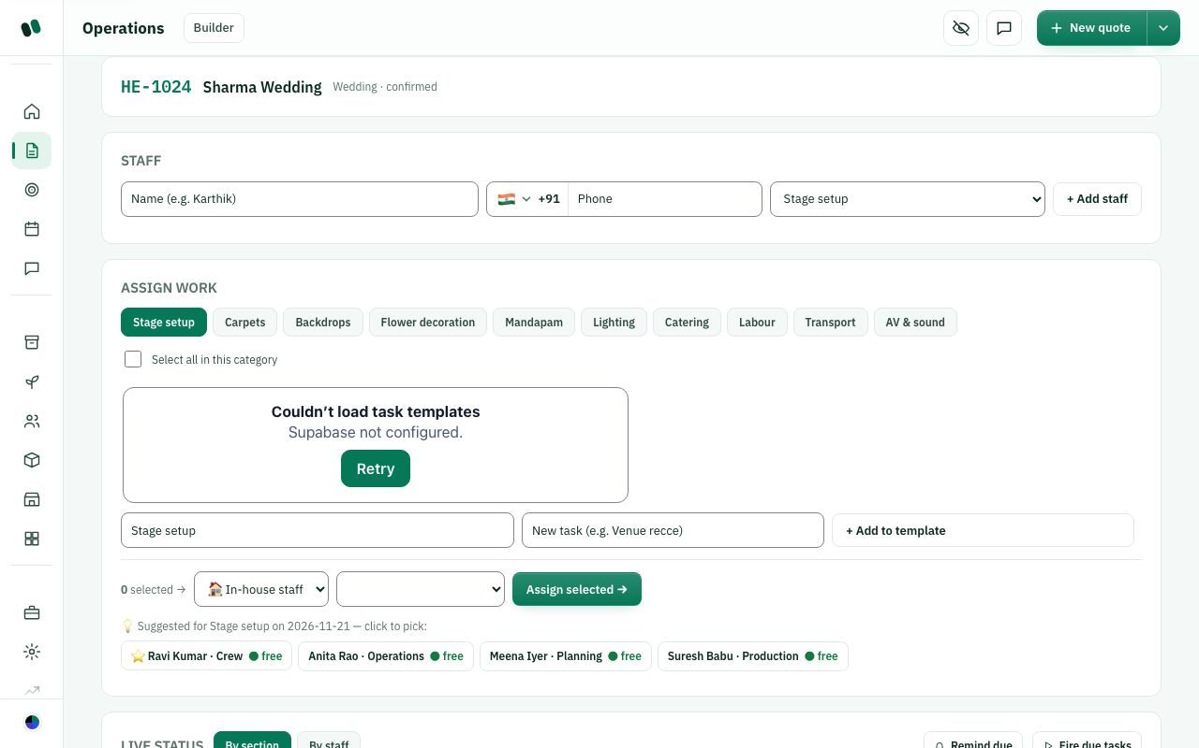
Operations: Staff quick add, Assign work by section, suggestions. (The "Couldn't load task templates" box is a test effect.)

C10. Task sections today are wedding-décor trades (Stage setup, Mandapam...). What sections does your studio use?
What this means: On the Operations page, ready-made jobs are grouped into sections such as Stage setup (10 jobs), Mandapam (8) and Catering (8), about 76 jobs in total. You tick jobs and assign them to a person. These sections are wedding-décor trades.
List the sections or departments your studio uses to divide work for an event.

☐ Keep these
☐ Replace with our departments
☐ Let each studio edit/rename/delete sections and tasks
☐ Different set per event type (wedding, corporate, birthday)
☐ Other: ______________________________

C11. Adding staff on the Operations page uses task sections as "department", different from the Staff page. What should happen?
What this means: The Operations page has a quick "+ Add staff" box. Its Department dropdown shows task sections (Stage setup, Carpets) and not the real departments on the Staff page (Sales, Operations). So the same person can end up with two different "departments".
Where should staff be added, and which department list should be used?

☐ Remove quick add here; add staff only on the Staff page
☐ Keep quick add but use the real department list
☐ Keep as is
☐ Other: ______________________________

C12. "Special" tasks remind the person every 5 minutes until done. Is that right?
What this means: A "special" task has a bell icon. Helm reminds the assigned person every 5 minutes until they mark it done. Example: "Confirm generator is running".
How often should an urgent task remind someone? Give an example of an urgent task.

☐ Yes
☐ Too often: every 15 / 30 minutes
☐ Let me choose the interval per task
☐ Remove special tasks
☐ Other: ______________________________

C13. "Remind due" and "Fire due tasks" are buttons a manager must press. Should they run on their own?
What this means: There are two buttons on the Operations page. "Remind due" re-sends reminders for urgent tasks. "Fire due tasks" alerts people whose scheduled start time has come. Today nothing happens unless a manager presses them.
Should reminders go out without anyone pressing a button? Who should be reminded, and when?

☐ Yes, automatic
☐ Keep manual
☐ Automatic, plus the manual button
☐ Other: ______________________________

C14. QC (quality check) Pass/Reject after a task is done. Is it needed?
What this means: QC (quality check): after a crew member marks a task done, an admin, manager, planner or quality person can press Pass or Reject. Reject needs a reason. Example: the stage is built, and the supervisor inspects it before guests arrive.
Who checks finished work today, and for which kinds of tasks?

☐ Yes, for every task
☐ Only for chosen tasks
☐ Only for outsourced tasks
☐ Remove QC
☐ Other: ______________________________
How it works today
Operations > task > Schedule: a start time plus an optional 'depends on' task (no loops, not in the past); a task waiting on another shows 'waits on ...'.

C15. Do you need task scheduling and 'depends on' links between tasks?
What this means: Scheduling gives a task a start time. "Depends on" means it waits for another task first. Example: "Lay carpet" waits on "Erect stage trusses", so it shows "waits on Erect stage trusses" until that task is done.
Give an example of tasks that must happen in order. Would you set this up in Helm?

☐ Yes, keep both
☐ Start time only, no dependencies
☐ Remove scheduling
☐ Other: ______________________________

C16. Run sheet vs Tasks vs Resource plan vs Staff card: four places about people. What would you prefer?
Describe how your team plans who does what. Which of the four places would you actually use?

☐ Keep all four
☐ Merge Tasks + Run sheet into one plan
☐ Merge Resource plan into Tasks
☐ One "Team & plan" page with tabs
☐ Other: ______________________________

C17. Can a task be given to a vendor (outsourced)? Today yes, with a checklist link. Keep?
What this means: An outsourced task is given to a vendor rather than your own staff. The vendor gets a checklist link to mark the task done, the same way crew do.
Do vendors do work you need to track as tasks? How would they update you?

☐ Yes
☐ Only internal staff get tasks
☐ Other: ______________________________

C-2. Staff page (directory), departments, job titles, import
The studio's list of people: in-house team and freelancers. A staff record can be just a record (no app login) or can be invited to sign in. Skills on the record are used to suggest people for tasks and to check resource coverage.
How it works today
Navigation: left menu > Manage > Staff (also opened from an event as "View event staff", which adds a "This event only / Show all staff" switch).
- Filters: search (name, role, skill), All departments, All skills, "Show inactive" tick, count "x of y". Buttons: "Import from Excel / CSV", "+ Add staff".
- Staff card: initials/photo, name, role, tags (Linked account, Active user / Invited / No login, department, employment type, Inactive, "Invalid phone"), skills, custom fields (up to 6 shown), phone, email, day rate. Buttons: Edit, Deactivate/Reactivate, Invite to log in / Copy invite link, Resend email. There is no delete, only deactivate.
- Add staff form fields: Helm login choice (admins only): "Save as a record only - no login" or "Save and invite to sign in" (needs e-mail and role); Name*; Role (the studio's login roles: Admin, Event manager, Planner, Sales, Event coordinator, Supervisor, Quality engineer, Operations, Designer, Crew); Department (default list: Management, Planning, Sales, Operations, Production, Design, Quality, Crew, plus "+ Add new department"); Employment (Full-time, Part-time, On-call); Phone*; Email; Day rate; Skills (comma separated); Notes; Custom fields.
- Rules: a role or a department is required; duplicate name+phone is blocked; same name with another phone asks "Save anyway"; a phone owned by a linked account cannot be reused. For linked accounts, name/phone/email/department come from their own profile and are locked here.
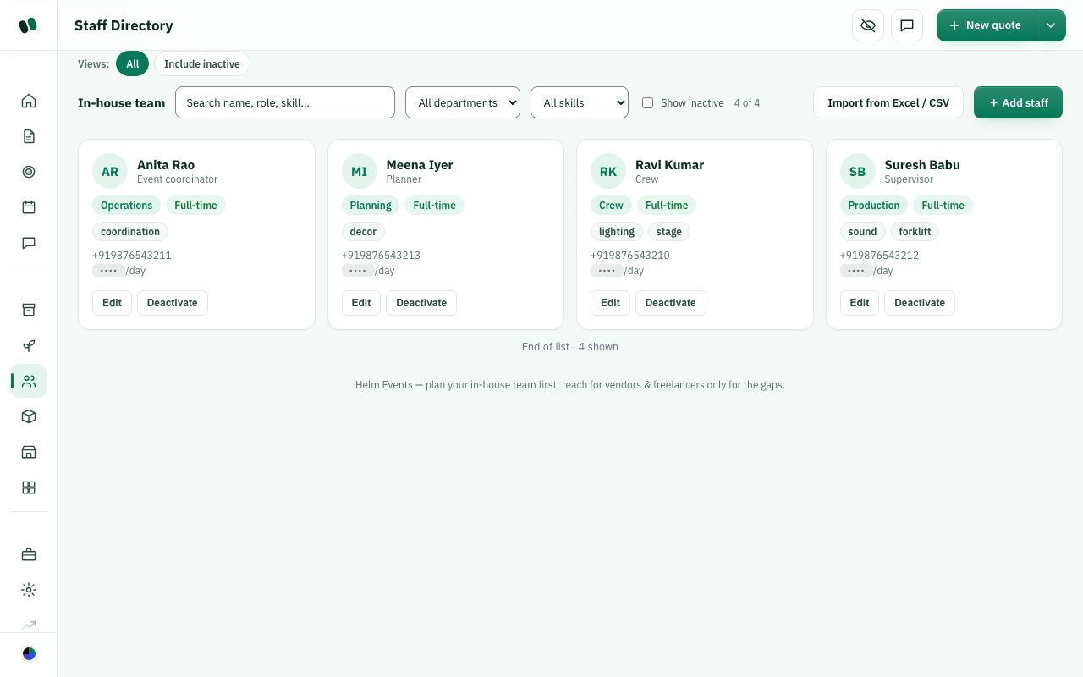
Manage > Staff: cards with role, department, employment, skills, day rate.
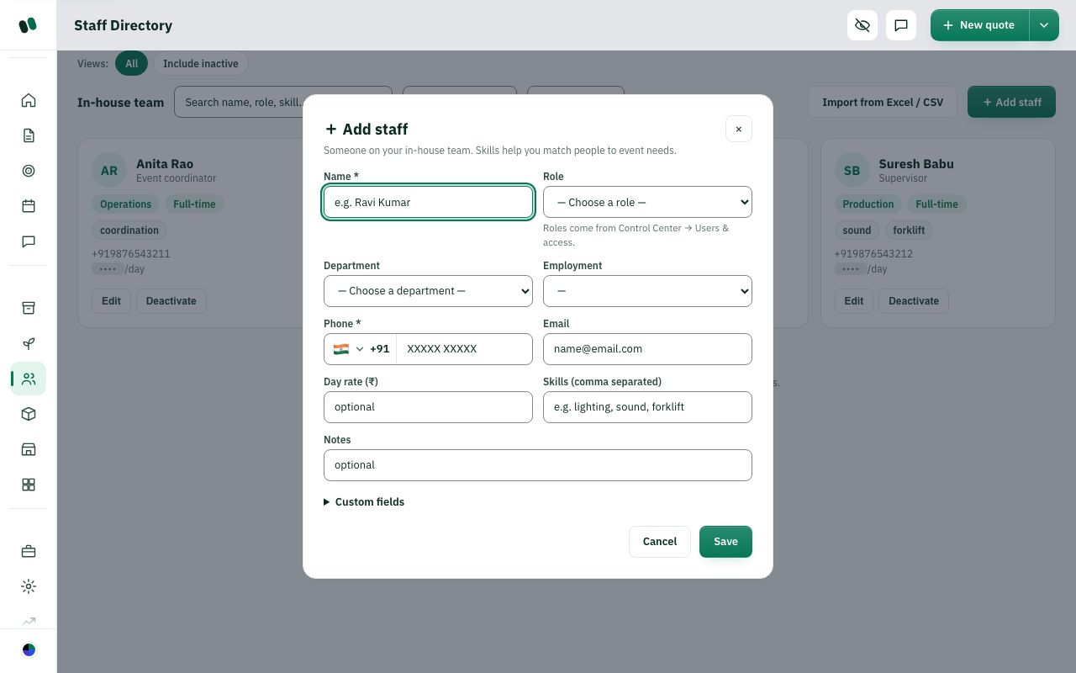
"+ Add staff" form.

C18. "Role" on the Staff form is the same list as login roles (it decides which pages they can open). Is one list right?
What this means: Today "Role" does two jobs at once. It is the person's title, and it also decides which Helm pages they can open. Example: making someone "Crew" also hides money pages from them. A florist would need a title like "Florist" but still Crew-level access.
Give examples of job titles you use and the app access each person needs.

☐ Yes, one list
☐ No: separate "job title" (free text, e.g. Florist) from "app access role"
☐ Add more roles (please list)
☐ Other: ______________________________

C19. Departments: Management, Planning, Sales, Operations, Production, Design, Quality, Crew. Right list?
Which departments does your studio have? List any to add or remove.

☐ Yes
☐ Add: Décor, Catering, Logistics, Accounts
☐ Let each studio build its own list only
☐ Departments not needed
☐ Other: ______________________________

C20. Which fields must be required for a staff record?
What is the minimum you know when adding a new person, and what do you need later?

☐ Name + phone (as today)
☐ Name + phone + department
☐ Name + phone + day rate
☐ Name only
☐ Other: ______________________________
How it works today
Add staff form: Employment drop-down offers Full-time, Part-time, On-call (optional).

C21. Employment types Full-time / Part-time / On-call: right list?
How do you engage your people? List any missing employment types.

☐ Yes
☐ Add Freelancer / Contract
☐ Add Daily-wage labour
☐ Not needed
☐ Other: ______________________________

C22. Extra fields to add as standard (not custom)?
Which details do you collect for every staff member, and who should see them?

☐ ID proof (Aadhaar/PAN)
☐ Bank / UPI for payouts
☐ Emergency contact
☐ Joining date and date of birth
☐ Other: ______________________________
How it works today
Skills are typed free-text, comma separated (e.g. lighting, sound, forklift); they drive task suggestions and resource coverage matching.

C23. Should skills be free text or picked from a fixed list?
What this means: Skills are typed as words, for example "lighting, sound, forklift". Helm uses them to suggest people for tasks. Free text means spelling differences such as "Lights" and "lighting" may not match.
Give examples of skills your team uses. Does a fixed list help or limit you?

☐ Free text (as today)
☐ Pick from a studio-managed list
☐ Both: list plus free text
☐ Other: ______________________________

C24. Staff can never be deleted, only deactivated. OK?
What this means: Deactivating hides the person but keeps their history: past events, tasks and payments. Deleting would erase the record.
When would you need to fully delete a staff record, and who should be allowed?

☐ Yes, keep history
☐ Allow delete if they never worked on an event
☐ Allow delete for admins
☐ Other: ______________________________

C25. Adding a person: record only vs invite to app. Which should be the default?
What this means: "Record only" saves the person's details with no app login, which is enough for task links. "Invite" emails them so they can sign in to Helm with the access their role allows.
For most new people, do they need to log in to Helm? Which should be the default?

☐ Record only (as today)
☐ Invite
☐ Ask every time with no default
☐ Other: ______________________________

C26. Should day rate, salary and bank details be hidden from non-admin managers?
Who in your studio should see pay and bank details, and why?

☐ Yes, admin only
☐ Visible to managers too
☐ Configurable per role
☐ Other: ______________________________
Instead of typing, you upload your own staff sheet. There is no fixed template file to download: Helm reads any column names in any order and suggests a match.
How it works today

Import staff from Excel / CSV
Navigation: Staff > "Import from Excel / CSV" (also Control Center > Sales > Pricing & coupons > "Import from Excel" card > Import staff). Steps: 1. File (.xlsx, .xls, .csv, .tsv, .txt, up to 5,000 rows, 80 columns), 2. Columns (each sheet column goes to a field, "Keep as custom field" or "Ignore"), 3. Rows (New / Already in Helm / Repeated row / Fix needed; choose "Skip them" or "Update them with this sheet"; "Download rows to fix"), 4. Done ("Download results (CSV)").
Staff fields Helm recognises (main fields marked *):
Full name* (required), First name, Last name, Phone* (required), Alternate phone, Email*, Role / title*, Designation, Department*, Skills*, Languages, Daily rate*, Hourly rate, Monthly salary, Employment type*, Joining date, Date of birth, Gender, Address, City, ID proof type, ID number (Aadhaar/PAN/passport...), Bank account no., IFSC / routing code, Bank name, UPI ID, Emergency contact name, Emergency contact phone, Vehicle, Blood group, Uniform size, Experience (years), Status, Notes*.
Fields without * are stored as extra details. Any other column becomes a custom field (max 64). Hindi headers like नाम, मोबाइल are understood.
Custom fields can be added, renamed or hidden in Control Center > Sales > Import & custom fields (types Text, Number, Date, Yes/No) for Staff, Dishes, Inventory, Vendors.
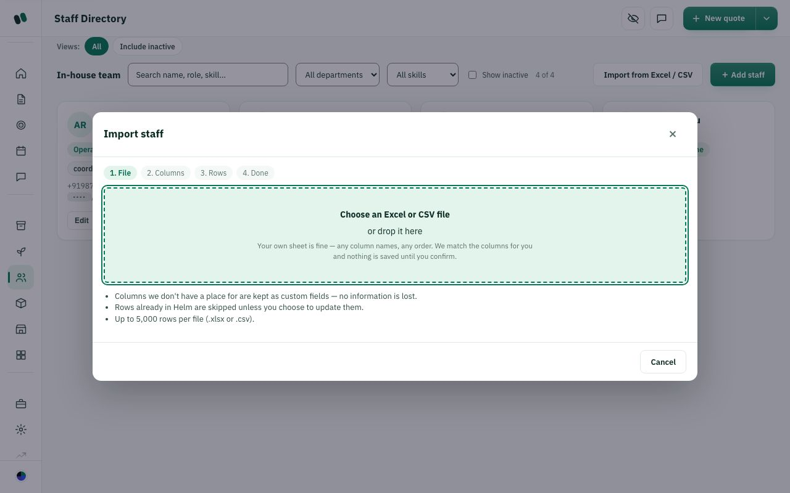
Import staff, step 1 (choose file).

C27. Should we offer a downloadable sample sheet (template) as well as "any sheet"?
What this means: Today you can upload your own Excel sheet with any column names, and Helm suggests which column goes to which field. A template would be a downloadable blank sheet with fixed columns to fill in.
Would a ready-made sample sheet help your team? What columns should it have?

☐ Yes, give a template with our columns
☐ No, any sheet is enough
☐ Other: ______________________________

C28. Sensitive columns (ID number, bank account) are imported and kept. Is that OK?
Should Helm store Aadhaar/PAN and bank numbers? If so, who may see them?

☐ Yes
☐ Import but show only to admins
☐ Do not import ID / bank numbers at all
☐ Other: ______________________________

C29. When a person already exists, import default is "skip". Right?
What this means: "Already exists" means a person with the same details is already in Helm. "Skip" keeps the Helm record unchanged. "Update" overwrites it with the sheet's values.
When the sheet has someone already in Helm, what should happen, and why?

☐ Yes, skip
☐ Update by default
☐ Ask per row
☐ Other: ______________________________

C-3. Crew experience (what a crew member sees)
Crew are people with role "Crew". They should see only their own work, never money or client details.
How it works today
- Dashboard for crew: "Next shift" ticket (event, date, call time, "Open" goes to the run sheet), My tasks counts (Today, Overdue, Blocked, Done), "This week". No money tiles, pipeline, leads, calendar or follow-ups.
- Menu: Dashboard and Chat always; other pages only if their role allows.
- If a crew member opens an event, they are sent to the run sheet (read-only) with "My tasks for this event": Accept, Can't do it, Start, Mark done.
- Worker link (no login, page "My tasks"): greeting, progress bar "x / y", tasks grouped by section with Accept / Reject / Start task / Mark done; Reject asks an optional reason (1000 chars), a voice note up to 2 minutes and up to 10 photos; Mark done allows up to 10 proof photos. Also "Your run-sheet" and "Equipment to return" (Return + quantity). Works offline from the last saved view; refreshes each minute. Expired link shows "Link expired".
- Bell (notifications) shows: tasks assigned / accepted / rejected / started / completed, task reminder, task due, event coming up, plus payment and security alerts for roles that may see them.
- Crew cannot see: quotes, prices, client name/phone, budgets, settlement, other people's tasks.
Screenshot not captured: the crew dashboard and a valid worker link need a real signed-in crew account / real link, which we did not create.

C30. Should crew sign in to the app, or only use the worker link?
What this means: The worker link is a private web link sent to each crew member. It opens their task list with no password. App login means they sign in to Helm with an email and password, or with Google.
How tech-comfortable is your crew? Which way would they actually use?

☐ Worker link only (no login)
☐ App login only
☐ Both (as today)
☐ Other: ______________________________

C31. What should crew see on their screen?
What does crew need to know on the day, and what must stay hidden from them?

☐ Only their tasks + run sheet (as today)
☐ Also venue address & map
☐ Also client contact on the day
☐ Also their pay for the event
☐ Other: ______________________________

C32. Should crew be able to reject a task?
When crew can't do a task, how should they tell you, and is a reason needed?

☐ Yes, with reason (as today)
☐ Yes, but reason required
☐ No, only call the manager
☐ Other: ______________________________

C33. Proof photo when marking done:
For which tasks do you need photo proof, and why?

☐ Optional (as today)
☐ Required for every task
☐ Required only for chosen tasks
☐ Other: ______________________________

C34. Worker link delivery:
What this means: Each crew member gets a personal link to their tasks. SMS sending is switched off today, so a manager copies the link and sends it themselves, for example on WhatsApp.
How should crew receive their task link? Is copying it by hand workable?

☐ SMS
☐ Manager copies and sends
☐ Other: ______________________________

C-4. Inventory (your own stock)
Your own stock: chairs, lights, linen, walkie-talkies. Helm tracks how many you own, how many are promised to events, and what went out and came back.
How it works today
Navigation: Manage > Inventory. Two tabs: "Stock items" and "Check-out / Check-in". From an event ("Reserve stock") a panel "Reserve for this event" appears on top.
- Stock table: Item, Pri (A/B/C), Category, Total, Committed, Available, Unit, Unit cost, Actions (Edit). Filters: search, category, priority (A high value, B mid, C low), Show inactive; views All / Low stock / High value. Buttons "Load starter items", "Import from Excel / CSV", "+ Add item".
- Add item: Name*, Category (suggested: Seating, Tables, Linens, Lighting, Sound & AV, Staging & Structures, Decor & Florals, Catering Equipment, Tableware, Power & Cabling, Tents & Canopies, Signage, Office & Misc), Total quantity, Unit, Priority class, Unit cost, Notes, Custom fields. Deactivate instead of delete.
- Starter items (23): Chiavari chair 200, Folding chair 200, Round table 5ft 30, Rectangular table 6ft 30, White table linen 120, Uplight (LED) 40, Par can 24, Speaker (powered) 8, Wireless mic 12, Mixer 12-ch 4, Stage deck 4x4 20, Truss section 10ft 16, Backdrop frame 6, Centerpiece vase 80, Chafing dish 30, Beverage dispenser 20, Dinner plate 200, Water goblet 200, Extension cord 25ft 40, Power distro box 6, 10x10 canopy 10, Directional sign 24, Walkie-talkie 20. All are loaded with priority C and unit cost 0 (even walkie-talkie, which the form calls an "A" example).
- Availability is date-aware: "Committed" = the busiest single event date, plus stock reserved for undated events and stock still physically out. Cancelled/closed events free their reservations.
- Event reservation: Item, Quantity, Note, "Reserve"; status Reserved, Allocated, Returned, Cancelled. Over-booking asks "Reserve anyway?" and shows as a calendar conflict.
- Check out: Item, Qty out, Issued to (staff), Note. If short, options: check out what is free, check in overdue items, add a vendor/sub-rent request, reduce quantity, or use a substitute item. Check in: how many came back, "Confirmed by (your name)"; anything short is written off as lost and appears in the Loss report (Item, Event, Out, Back, Missing, Value lost, Signed off, When).
Overlap: there are two systems, reservations (Reserve/Allocate/Return) and check-out/check-in. Both appear again on the Teardown page.
Manage > Inventory > Stock items.
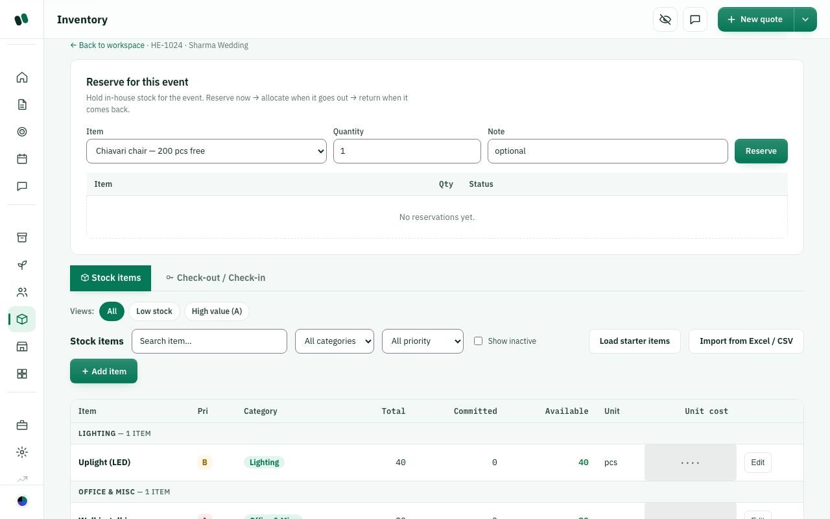
Inventory opened from an event: "Reserve for this event".

C35. Starter items list: is it useful?
What this means: "Load starter items" fills your stock with 23 common items in one click, for example 200 chiavari chairs and 20 walkie-talkies, so you don't start from an empty list.
Which items should the starter list include for your studio? List any to add or remove.

☐ Yes, keep
☐ Change the list (tell us items)
☐ Different list per event type
☐ Remove; studios import their own
☐ Other: ______________________________

C36. Starter items load with unit cost 0 and priority C. What should happen?
What this means: Starter items load with cost 0 and priority C (low value). That means loss reports show ₹0 lost, and valuable items such as walkie-talkies are not marked high value (A).
Would you fill costs later, or should Helm ask or suggest them while loading?

☐ Keep (we fill later)
☐ Load with typical cost and correct priority
☐ Ask cost during loading
☐ Other: ______________________________
How it works today
At check-in, anything that does not come back is written off as lost straight away and shows in the Loss report.

C37. When items come back short at check-in, what should happen?
What do you do today when items don't come back, and who pays?

☐ Write off as lost straight away (as today)
☐ Mark as 'missing' first, write off later
☐ Charge the cost to the client or the person it was issued to
☐ Other: ______________________________

C38. Reservation (Reserve, Allocate, Return) and Check-out/Check-in are two systems. What do you want?
What this means: There are two ways to track stock for an event. Reservation promises items to an event in advance (Reserve, Allocate, Return). Check-out/check-in records items physically leaving and coming back, and who took them. Both show up again on the Teardown page.
How do you track stock today: promise it, then send it out? Which flow fits you?

☐ Keep both
☐ Only check-out/check-in
☐ Only reservation, with return
☐ Merge: reserve, then check-out = allocate, check-in = return
☐ Other: ______________________________

C39. Missing items at check-in are written off from stock automatically. Right?
What this means: At check-in, if 200 chairs went out and 195 came back, Helm reduces your stock by 5 straight away and lists them in the Loss report.
Who should confirm a loss before stock is reduced?

☐ Yes
☐ Ask manager approval first
☐ Charge to staff/client option
☐ Other: ______________________________

C40. Should stock show where it is kept (warehouse / godown)?
How many storage places do you have, and do you need quantities per location?

☐ Yes, one location per item
☐ Yes, quantity per location
☐ Not needed
☐ Other: ______________________________

C41. Low-stock alert when available drops under a level?
Which items need an alert, at what level, and who should be told?

☐ Yes, bell alert
☐ Yes, on dashboard only
☐ Not needed
☐ Other: ______________________________

C42. Priority classes A/B/C: needed?
What this means: Each stock item has a priority class: A = high value (e.g. mixers), B = mid, C = low (e.g. plates). Today it is only used for filtering.
Do you treat costly items differently? How should A/B/C be used?

☐ Yes
☐ No, remove
☐ Use it to require sign-off for A items
☐ Other: ______________________________

C-5. Vendors & partners, bookings, payments, vendor bills
Outside partners (vendors, freelancers, rental companies, suppliers) who fill gaps.
How it works today
Navigation: Manage > Vendors (page "Vendors & Partners").
- Type tabs: All, Vendors, Freelancers, Rentals, Suppliers; search; Show inactive; "+ Add partner".
- Add partner: Name*, Type (Vendor, Freelancer, Rental, Supplier), Category, Phone, Email, Services (comma separated), Notes. Deactivate/Reactivate (warns about open bookings). No delete.
- Card: name, type, category, services, phone/email, History (last 5 events with code, client, date).
- Booking a vendor: only from the event's Resource plan (see C-1).
- Paying vendors happens in two places on the event's Payments page: (1) Vendor settlement table: Partner, Cost, Advance, Outstanding, Settled, button Settle/Unsettle (one click clears the whole balance); (2) Vendor bills: Add a bill (Vendor booking, What for, Bill no., Bill date, Due date, Amount, Photo/PDF, "Quick add from WhatsApp"), bill status Unpaid / Part paid / Paid / Overdue / Void; "Record payout" (Amount, Paid on, How e.g. Bank transfer / Cheque, Reference UTR); "Void bill" needs a reason, bills are never deleted. Once a booking has bills, the bills replace the booked cost in profit.
- Vendor import fields: Vendor name*, Category, Contact person, Phone, Alternate phone, Email, City, Address, GSTIN, Typical rate, Payment terms, Bank account, IFSC, Rating, Notes.
Manage > Vendors > "+ Add partner". (The vendor list itself did not load in the test copy.)

C43. Vendor form fields: anything missing as standard?
What this means: GSTIN is the vendor's GST registration number, needed for tax invoices. A rate card is the vendor's standard price list.
What do you always record about a vendor? Which fields are missing?

☐ GSTIN
☐ Bank / UPI
☐ Rate card / typical price
☐ Contact person
☐ Rating
☐ Other: ______________________________

C44. Two ways to pay vendors ("Settle" button and Vendor bills + payouts). Which to keep?
What this means: There are two ways to pay vendors on an event's Payments page. "Settle" marks the whole balance paid in one click. "Vendor bills" records each bill (number, date, photo) and each payout (amount, date, UTR).
How do you pay vendors today: one lump sum or bill by bill? Which method should stay?

☐ Only bills + payouts (proper record)
☐ Only the simple Settle button
☐ Keep both
☐ Other: ______________________________

C45. Vendor bills: should a bill need approval before payout?
Who approves vendor payments today? Above what amount should approval be needed?

☐ Yes, manager approves
☐ No
☐ Only above an amount
☐ Other: ______________________________

C46. Vendor types Vendor / Freelancer / Rental / Supplier. Right?
What kinds of partners do you work with? Which types are missing or overlap?

☐ Yes
☐ Merge Freelancer into Staff
☐ Add "Venue"
☐ Add more (list)
☐ Other: ______________________________

C47. Should vendors get a link to see their booking, tasks and payments?
What should a vendor see about their booking, and how would they use it?

☐ Yes
☐ No
☐ Only tasks
☐ Other: ______________________________

C-6. Logistics, Readiness gate, Event-day command, Issues, Teardown
How it works today

Logistics & payments
Navigation: event workspace > Logistics card. Five tabs:
- Permits (compliance), Comms, Logistics: checklist rows Item*, Owner (staff/vendor), Due date, Status (Open / Done / N/A), remove. "Apply a template" adds a checklist template.
- Payments: client payment milestones: Milestone*, Due date, Amount, Status (Due, Invoiced, Paid, Waived), "Covered" if ledger payments reach it, Remind (sends reminder by e-mail when switched on; WhatsApp: set up separately by the owner). Totals Scheduled / Paid / Outstanding, warning if schedule is more than invoice.
- Guests: Group*, Headcount, Status (Pending / Confirmed / Declined), total expected guests.
Overlap: the client payment schedule is here, but recording payments is on the Payments & invoice (Settlement) page.
Logistics > Permits tab with two items.

C48. Payment milestones sit inside Logistics. Where should they live?
What this means: Payment milestones are the client's planned instalments, for example 30% advance and 70% before the event. Today they sit in the Logistics card, but payments received are recorded on a different page (Payments & invoice).
Where would you look for the client's payment schedule? Should it sit next to recorded payments?

☐ Move to Payments & invoice
☐ Keep in Logistics
☐ Show in both
☐ Other: ______________________________

C49. Logistics tabs Permits / Comms / Logistics / Payments / Guests. Needed?
What this means: "Comms" is a checklist for communications, for example "send invitation proofs". "Guests" tracks guest groups and headcount. "Permits" covers approvals such as police, fire or music licences.
Which tabs do you use? What would you drop, merge or add?

☐ All needed
☐ Drop Comms
☐ Drop Guests (use invitations)
☐ Merge Permits + Logistics
☐ Other: ______________________________
How it works today

Readiness gate
Navigation: workspace > Readiness gate. A score "x / 9" of critical checks and a list with Fix links:
- Event date set
- Client approved
- Menu & package locked
- Resources covered (no gaps) - needs at least one need
- Vendors confirmed (none in "Enquiry")
- Staff assigned
- Run-sheet built
- Dry run done (manual "Mark done")
- Team briefed (manual "Mark done")
- Advance received - optional
When all critical checks pass, "Mark Event Ready" moves the event to the Ready stage. Not checked: permits, logistics checklist, stock reserved.
Readiness: 3/9, list of checks.

C50. Which checks must block "Event Ready"?
What this means: The Readiness gate scores 9 critical checks (date set, client approved, vendors confirmed, and so on). Only when all of them pass can you press "Mark Event Ready". Example: an event with 3/9 cannot be marked ready.
What must be true before you call an event ready? Which checks should block it?

☐ As today
☐ Make advance received required
☐ Add: permits done
☐ Add: stock reserved / checked out
☐ Make Resources optional
☐ Other: ______________________________

C51. Readiness vs Logistics checklists: overlap?
Do the two checklists repeat each other? Which one would your team actually use?

☐ Keep both
☐ Readiness should include Logistics items
☐ Remove Readiness, use Logistics only
☐ Other: ______________________________
How it works today

Event-day command
Navigation: workspace > Event-day command. Quick links Issues / Run-sheet / Floor. Four boxes:
- Arrivals & attendance: "Pull team & vendors" (assigned staff + booked vendors) or add a name; status Expected / Arrived / Left / No-show.
- Setup & technical checks: add a check (e.g. Sound check done); Pending / Done / Issue.
- Guest reception: "Pull from guest list" (Logistics > Guests), group name + expected count, check-in counts, walk-ins.
- Live stock requests: pick or type an item + quantity; Requested / Issued / Replaced / Cancelled. This is a note only; it does not change inventory.
Event-day command with four boxes.

C52. Live stock requests do not touch inventory. Should "Issued" check stock out?
What this means: On the event day, someone can log a request such as "10 more chairs" and mark it Issued. Today this is only a note, and your stock count does not change.
When extra stock is sent on the day, should Helm reduce stock automatically? Why?

☐ Yes, link to check-out
☐ No, keep as note
☐ Remove live stock requests
☐ Other: ______________________________

C53. Guest check-in at the welcome desk: do you use it?
Do you check guests in at a welcome desk? For which events?

☐ Yes
☐ No, remove
☐ Only for corporate events
☐ Other: ______________________________
How it works today

Issues & incidents
Navigation: workspace > Issues & incidents (or from command). Tabs Issues / Incidents. Add: Issue text, Severity (Low/Medium/High), Owner (free text), "+ Log". Status Open > In progress > Resolved, Reopen, remove. Link "+ Raise a billable change" goes to Budget change requests.
Issues log with one high-severity open issue.

C54. Issues vs Incidents: both needed?
What this means: An Issue is a problem to fix, such as "mic not working". An Incident is a safety or serious event, such as an injury or a fire. Today they are two separate lists.
How do you separate ordinary problems from safety incidents today?

☐ Yes
☐ One list with a "safety" tag
☐ Only issues
☐ Other: ______________________________

C55. Should a High issue alert the manager immediately (bell)?
Which problems need an instant alert, and who should get it?

☐ Yes
☐ No
☐ Only incidents
☐ Other: ______________________________
How it works today

Teardown & returns
Navigation: workspace > Teardown & returns. Four boxes: In-house inventory returns (Item, Out, Status, Damaged/lost, Return); Equipment check-out/check-in (Item, Out, Issued to, Check in) with link to inventory; Vendor & rental exit (Mark returned/exited); Teardown & venue handover checklist (+ Add, e.g. "Venue walkthrough with manager").
Teardown & returns.

C56. Is Teardown as a separate page needed?
What this means: Teardown is packing up after the event: returning stock, vendors leaving, and handing the venue back.
How do you wrap up after an event? Where should teardown steps live?

☐ Yes
☐ Merge into Closure
☐ Merge into Event-day command
☐ Other: ______________________________

C-7. Calendar and conflicts
How it works today
Navigation: Workspace > Calendar (page "Resource Calendar"). This page is a list by date, not a month grid (the dashboard has a small month calendar).
- Conflicts box: double bookings of the same stock, vendor, staff member or venue on the same date ("No conflicts - every commitment fits" when clear). Times are not checked yet.
- Upcoming events & commitments: grouped by date; each event shows code, title, Confirmed / Tentative, counts of staff, stock and partners, "Open". Leads with a date show as a light "Lead" marker.
- No date set: events without a date.
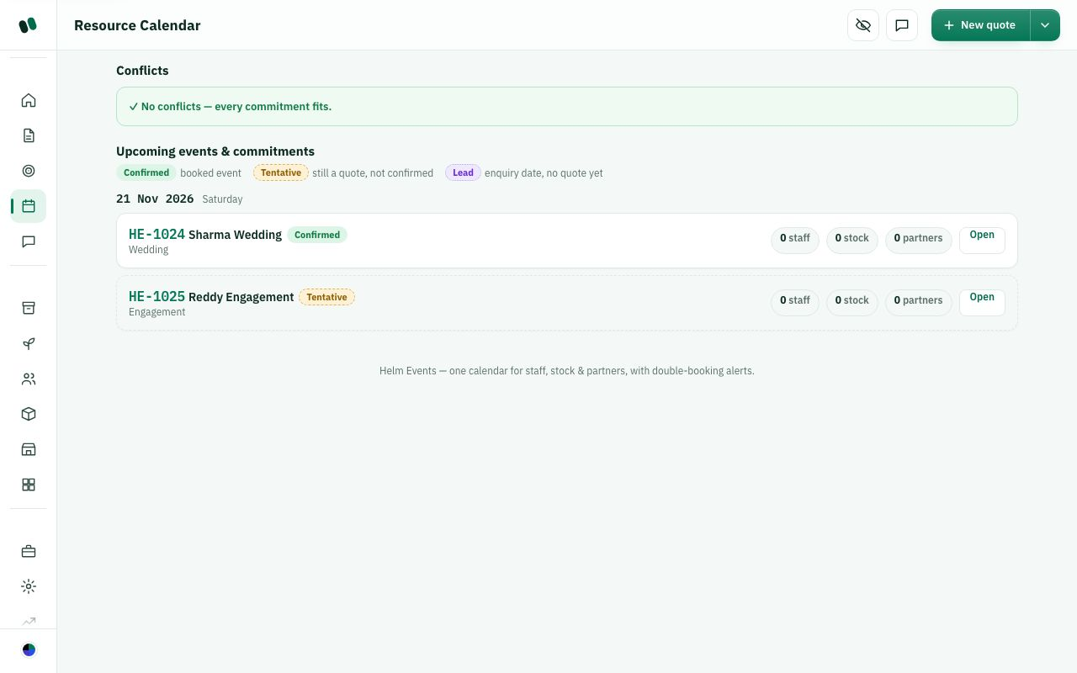
Calendar: two events on 21 Nov, no conflicts.

C57. Which calendar view do you want?
How do you look at upcoming events today? Which view helps most?

☐ List (as today)
☐ Month grid
☐ Week view with times
☐ All, with a switch
☐ Other: ______________________________

C58. Conflicts are by date only. Should times matter (morning event + evening event same day)?
What this means: A conflict is the same chairs, staff member, vendor or venue booked on two events. Today Helm only compares dates, so a morning and an evening event on the same day are flagged even if they don't overlap.
Do you run morning and evening events on the same day? Should Helm check times?

☐ Yes, check times
☐ Date is enough
☐ Other: ______________________________

C59. Should tentative quotes count in conflicts?
What this means: A tentative quote is an event the client hasn't confirmed yet.
Should unconfirmed quotes block resources? How sure must an event be to count?

☐ Yes
☐ No, only confirmed
☐ Show as a warning only
☐ Other: ______________________________

C-8. Payments & invoice (Settlement), Budget & margin, Closure & P&L
Three money pages per event. Today they show one shared "Net profit" number on each page, but the small cards on the event workspace still differ: the Budget card shows estimated margin from your cost lines; the Closure card shows the profit from bills and claims. So the workspace can show two different % for one event.
How it works today
Payments & invoice (workspace > Payments & invoice): tiles Invoice total, Received, Balance due, Net profit. Client invoice (quote + approved change orders - paid); "Record a payment received": amount only (no date, method or reference field). Vendor settlement (Partner, Cost, Advance, Outstanding, Settled, Settle). Vendor bills (C-5). Staff expense claims: Who, For, Amount; Pending > Approved > Paid / Rejected. Refunds & recovery: Type (Refund to client, Recover from client, Deduction from deposit), Reason, Amount; Pending > Approved > Processed / Rejected.
Budget & margin: tiles Revenue (ex-tax), Total cost, Actual cost, Net profit + %. Cost lines: Description, Type (Internal, Vendor, Other), Estimated, Actual; "Import vendor bookings". Change requests: Title, Detail, Charge client (before tax, negative = discount), Extra cost; approved ones roll into invoice and budget.
Closure & P&L: Profit & loss box, Net profit box (Revenue - vendors - logistics & other - staff expenses), client rating (stars), Feedback, Testimonial, consent tick for marketing, Lessons learned, Rate vendors & staff (1-5 stars), "+ Add CRM follow-up lead", "Mark event closed & archived".
Close rules: cannot close if still a quote or unpriced, if client balance is due, if equipment is still checked out, or if reservations are not returned. Non-admins are blocked; an admin can override money blockers with a reason of 5-1000 characters (saved in audit log), but nobody can override equipment that is still reserved/allocated. Extra warnings for unsettled vendors and future event dates. Re-open: admin only, needs a reason, moves the event back to Settlement.
Payments & invoice (amounts hidden by privacy mode).
Budget & margin: cost lines and Net profit.
Closure & P&L.

C60. Recording a client payment asks only the amount. What else should it ask?
What this means: UTR is the bank's reference number for a transfer or UPI payment, used to match it in your bank statement.
What details do you note when a client pays? List everything you need.

☐ Date received
☐ Method (cash, UPI, bank, cheque)
☐ Reference / UTR
☐ Upload receipt
☐ Other: ______________________________

C61. Budget "estimated cost" vs Net profit from bills: which should the workspace card show?
What this means: Estimated margin comes from the cost lines you planned in Budget. Net profit comes from actual vendor bills and expense claims. So one event can show two different percentages.
Which profit number helps you most on the event page, before and after the event?

☐ Estimated before the event, actual after
☐ Always actual
☐ Show both side by side
☐ Other: ______________________________

C62. Do you need Budget and Closure P&L as separate pages?
How many money pages per event make sense to your team? Which would you merge?

☐ Yes
☐ Merge into one "Money" page
☐ Merge Budget into Payments
☐ Other: ______________________________

C63. Who may close an event with money still outstanding?
Should anyone be allowed to close an event with unpaid money? Who, and when?

☐ Admin with reason (as today)
☐ Nobody
☐ Manager too
☐ Other: ______________________________

C64. Re-opening a closed event:
When would you need to reopen a closed event, and who should be allowed?

☐ Admin only with reason (as today)
☐ Manager too
☐ Not allowed
☐ Other: ______________________________

C65. Staff expense claims: who adds them?
How do staff claim expenses today, such as fuel or snacks? Who should enter them?

☐ Manager on the page (as today)
☐ Crew from their phone with bill photo
☐ Other: ______________________________

C66. Feedback, testimonial, ratings: keep in Closure?
How do you collect client feedback today? Where should it live in Helm?

☐ Yes
☐ Send client a feedback link instead
☐ Remove
☐ Other: ______________________________

C-9. Business, Insights, Reports, Audit log
How it works today
Business (Admin > Business, finance access only): Booked this month, Collected this month, Outstanding (confirmed value not collected), Open pipeline value; Revenue booked vs collected (12 months); Pipeline funnel (Leads, Quoted, Confirmed, Completed); Overdue payments (10 oldest); Top clients by value; Upcoming events (30 days); Vendor payables & net profit (Owed to vendors, Paid to vendors, net profit by month, top events by profit; 12 months back and forward).
Insights (Admin > Insights): period picker (This month, Last month, Last 30/60/90 days, This year, Custom). Events in period (Events incl. open quotes, Confirmed, Completed, Cancelled), Money (Revenue ex-tax, Costs, Profit, Avg event value), Collected vs outstanding, Profit per event table (Event, Date, Currency, Revenue, Cost, Profit, Margin, Collected, Outstanding), Top event types, Team participation, Vendor reliability, Task rejections by section, Inventory losses by item and over time, Margin trend (closed events).
Reports & exports (admin, manager, planner): same period picker; CSV: Leads, Events, Inventory, P&L (closed events), Settlements (by payment date or event date); printable P&L PDF. The P&L, Settlements and PDF parts are hidden from people without finance access.
Audit log (admin): When, Who, Action, Area, Change, Event; area filter, search, Refresh.
Admin > Business.
Reports & exports.
Insights and Audit log could not load data in the test copy; described in words above.

C67. Business, Insights and Reports overlap. What do you prefer?
What this means: Business shows monthly totals and charts. Insights shows profit and trends for a period you pick. Reports lets you download Excel (CSV) files and PDFs. Some numbers appear on more than one of them.
Which money/report pages do you open, and would one page with tabs suit you?

☐ Keep three pages
☐ One "Business" page with tabs
☐ Move money tiles back to the dashboard
☐ Other: ______________________________

C68. Which numbers matter most to you weekly?
Which numbers do you check every week, and why those?

☐ Booked
☐ Collected
☐ Outstanding / overdue
☐ Profit per event
☐ Pipeline value
☐ Other: ______________________________

C69. Missing reports?
Which reports do you prepare by hand today that Helm should produce?

☐ Staff payouts per person
☐ Vendor payables report
☐ GST / tax report
☐ Inventory utilisation
☐ Other: ______________________________

C70. Should managers (not only admins) see the audit log?
What this means: The audit log is a history of who changed what and when. Example: "Ravi changed the quote total on HE-1024 at 3:15 pm".
Should managers see who changed what? For which events or areas?

☐ Yes
☐ No
☐ Only for their own events
☐ Other: ______________________________

C-10. Templates and checklists
How it works today
Navigation: Manage > Templates ("Checklist templates"). Form: Template name, Section (Logistics, Permits, Comms, Guests), items one per line, Save; list with Edit and Delete (delete cannot be undone). Templates are applied from an event's Logistics tab ("Apply a template"). Starts empty.
Other "templates" elsewhere: task templates (Operations page sections, C-1), floor layout templates (Control Center > Layout templates, builder). There are no templates for run sheets, teardown or resource needs.
Manage > Templates.

C71. Which templates do you want?
What this means: A template is a reusable checklist or plan. You set it up once and apply it to each new event, for example a standard "Wedding setup checklist".
What do you repeat on every event that a template could save time on?

☐ Run sheet templates (per event type)
☐ Teardown checklist templates
☐ Full "event type" template (tasks + run sheet + checklists in one)
☐ Keep as is
☐ Other: ______________________________

C72. Should Helm ship ready-made checklists?
Would ready-made checklists help you start? For which event types?

☐ Yes (wedding, corporate, birthday)
☐ No, start empty
☐ Other: ______________________________

C73. Task templates live on the Operations page, checklist templates on the Templates page. Merge?
Would you look for all templates in one place? Where?

☐ Yes, all templates in one place
☐ Keep separate
☐ Other: ______________________________

C-11. Smart import (what can be imported)
How it works today
Navigation: Control Center > Sales > Pricing & coupons > "Import from Excel" card: Import staff, Import dishes, Import inventory, Import vendors, Import price list (opens studio setup). Also buttons on Staff and Inventory pages.
- Staff: see C-2.
- Inventory: Item name*, SKU / code, Category, Sub-category, Quantity, Unit, Condition, Location / warehouse, Purchase price (per unit), Rental price, Replacement cost, Vendor / supplier, Purchase date, Dimensions, Weight, Colour, Material, Reorder level, Notes.
- Dishes (menu): Dish name*, Course / category, Diet (veg / non-veg / Jain...), Cuisine, Price per plate, Food cost, Description, Allergens, Spice level, Serving size, Live counter, Minimum order (plates).
- Vendors: see C-5.
- Rules: up to 5,000 rows, existing rows skipped unless "update", errors downloadable, nothing deleted, extra columns kept as custom fields.
Not importable today: leads/clients, past events, payments, venues.

C74. What else should be importable?
What old data do you have in Excel that you want moved into Helm?

☐ Leads / clients
☐ Past events with amounts
☐ Venues
☐ Payments received
☐ Other: ______________________________

C75. Is "any sheet, we match the columns" easy enough for your team?
What this means: "Any sheet" means you upload your own Excel file with any column names. Helm guesses which column is Name, Phone and so on, and you confirm or fix each match.
Could your team import a sheet themselves? Which part feels hard?

☐ Yes
☐ Prefer a fixed template
☐ Prefer someone from Helm to import for us
☐ Other: ______________________________

C76. Inventory "Rental price" and "Purchase price": both needed?
Do you rent out items, buy them, or both? Which prices do you track?

☐ Yes
☐ Purchase only
☐ Rental only
☐ Other: ______________________________

C-12. Empty screens, wording and what is switched off
What people see on these pages before any data exists, and which parts depend on features that are off today.
How it works today
- Resource plan: "No needs yet. Add what the event requires." and "No external bookings yet."
- Run sheet: "No run-sheet items yet. Add the first one above." Crew with nothing: "No tasks assigned to you on this event."
- Operations: "No tasks assigned yet. Pick a section above, select tasks, choose a staff member, and Assign."
- Staff: "No team members yet." (plus a hint to add the first one for editors); with filters: "No staff match these filters. Try clearing the search or filters."
- Inventory: "No items match these filters.", "No reservations yet.", "Nothing out on loan.", Loss report: "No missing items — everything came back. 🎉"
- Vendors: "No partners yet." / "No partners match this filter. Try another type or clear the search."
- Calendar: "No dated events yet."; undated box: "Give these events a date so they appear on the calendar and get conflict-checked." Crew see only "Events you are assigned to" ("No events assigned to you yet. New shifts will show here and on your dashboard.").
- Templates: "No templates yet. Add your first template above — turn a lesson learned into a checklist."
- Issues: "No issues logged." / "No incidents logged. Good — keep it that way." Teardown: "No teardown items yet.", "No vendors or rentals booked.", "Nothing on loan for this event. 🎉"
- Placeholders (grey hint text) are Indian-style examples: "e.g. Ravi Kumar", "Name (e.g. Karthik)", "+91…", "e.g. Guests arrive / Cake cutting", "e.g. Gold chiavari chair".
- Switched off today: SMS and e-mail sending (WhatsApp: set up separately by the owner) (worker links are copied by hand; "Remind" on payment milestones and task reminders do not reach phones yet), automatic task firing (the "Remind due" / "Fire due tasks" buttons are pressed by hand), time-of-day conflict checks on the calendar.

C77. The workspace shows only the current stage's cards before confirmation. Is that right?
What this means: Before the client confirms, the event page shows only the cards for the current stage. Example: at Quote, you see Quote & approval but not Run-sheet.
Before confirmation, should the team see all cards or only the current step?

☐ Yes, keep it
☐ Show all cards always
☐ Show all, but grey out the ones not yet useful
☐ Other: ______________________________

C78. Is the 11-stage strip (Lead to Closed) the right set of stages?
Which stages match how your events really move? Name any to merge, add or rename.

☐ Yes
☐ Too many; merge some (write which)
☐ Missing a stage (write which)
☐ Let us rename stages
☐ Other: ______________________________

C79. Should the event move to the next stage by itself (for example when the advance is recorded) or only when someone presses "Advance"?
Which steps should move the stage by themselves, and which need a person?

☐ Automatically
☐ Only by hand (button)
☐ Automatic, but ask to confirm
☐ Other: ______________________________

C80. Until texts are switched on, worker links are copied by hand. Is that workable for the first weeks?
Can you send task links by hand at first? How many people per event?

☐ Yes, we will send them ourselves
☐ No, this must be automatic before we start
☐ Other way: print a QR code per person
☐ Other: ______________________________

C81. Are the empty-screen messages and example names clear and friendly?
What this means: These are the short messages shown on a page before anything is added, such as "No tasks assigned yet", and the grey example text inside boxes, such as "e.g. Ravi Kumar".
Which messages are unclear or feel off? Write the wording you would prefer.

☐ Yes
☐ Too chatty (remove emoji)
☐ Add a short "how to start" video or link
☐ Other: ______________________________

Part D — Control Center, team, notifications, themes

D. Settings, team, security and integrations
This part covers the "back office" of Helm: the Control Center where studio settings live, who can use Helm and what they can see, the privacy PIN, notifications, team chat, outside connections (WhatsApp, e-mail, online payment), colour themes, your own profile and using Helm on a phone. Please tick what you agree with and write anything that should change. A note on the screenshots: they were taken on a test copy with no studio signed in, so boxes are empty and some lists show "Loading" or an error. The layout is real, but the data is missing.

D-1. Control Center: how settings are organised
The Control Center is the one place where an admin (and anyone the role matrix allows) sets up how the studio works: prices, menus, team, notifications and so on. It exists so these rules are set once and then used automatically on every quote and event.
How it works today
How to get there: click your round avatar (top-right) > Control Center. This item shows only if your role is allowed to view "Control Center". On the left is a search box and a list of sections in 5 groups. On a phone the list becomes a drop-down.
Group | Section | What is inside today
Workspace | General | Studio account (details Helm uses for its invoices to you), Organization / studio (country, which sets tax and currency; name, business e-mail, phone, city, logo link, accent colour, currency, time zone, GSTIN), Billing details (legal name, address, city, state, PIN code), Client link name (the short name used in your client links). Demo-data card during a trial.
Plan & billing | Your Helm subscription: plan name and monthly price, status, period end or trial end date, list of payments with an "Invoice" button. Admins only.
Hide amounts (privacy PIN) | The 4-digit PIN that shows amounts again after they are hidden.
Client links & packages | Client links: auto-expire. Client package flow.
Sales | Pricing & coupons | Default pricing for new quotes, item pricing (rate cards), capacity limits for the layout builder, object and item prices for the builder, coupons.
Menus & catalog | Chair types and prices, plate types and prices, dishes catalogue (Veg / Non-veg / Special), menu packages (Standard / Gold / Premium).
Layout rules | Default layout rules for each event type (seats per guest, one buffet table per N guests, number of bars).
Import & custom fields | Import from Excel. Custom fields for Staff, Dishes, Inventory or Vendors (type: Text, Number, Date, Yes/No).
People | Users & invites | Team members list (filter: Everyone / Incomplete profiles / Complete profiles), Add user, Invite by email link, Pending invites.
Roles & access | The access matrix: which role can see and edit which area.
Data & compliance | "Download studio data archive" (one JSON file). Admins only.
Communication | Notifications | Which role sees which alert in the bell, texts and e-mails to staff, and per-person overrides.
Reminders & client messages | Event reminders, payment reminders and follow-ups to clients, low-stock warnings, WhatsApp forwarding.
Photo renders | On/off switch, photos per month, render requests per hour.
Operations | Venues | Halls and spaces with usable area and capacity.
Layout templates | Reusable floor layouts.

If your role cannot see anything in a section, it first shows "Loading…" and, after a few seconds, says: "Nothing to set here yet. This section opens for studio admins, or once your studio has this feature switched on." If you leave a section with unsaved changes, a bar appears with "Dismiss" and "Go to Save".
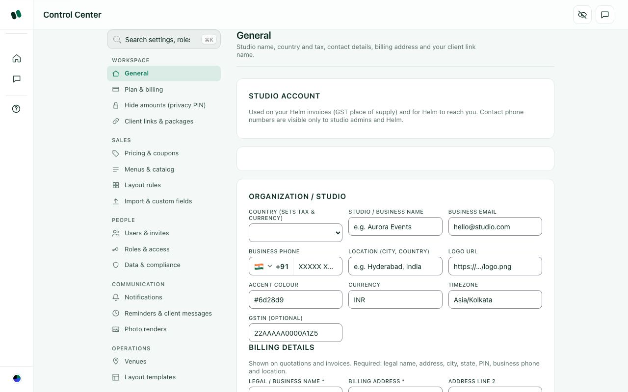
Control Center > Workspace > General. The 5 groups are listed on the left (test copy, no studio data).

D1. Do these 5 groups (Workspace, Sales, People, Communication, Operations) make sense to you?
Which group names feel wrong or unclear, and what would you call them instead?

☐ Yes, keep them as they are
☐ Yes, but rename some groups (write below)
☐ Fewer groups, with more inside each
☐ Order them by how often we use them, not by topic
☐ Other: ______________________________

D2. Which sections are in the wrong group?
Which section, and which group should it move to? Why?

☐ None, all are fine
☐ "Data & compliance" should not be under People (for example, under Workspace or a new "Security" group)
☐ "Hide amounts" should be with security, not Workspace
☐ "Layout rules" should be under Operations, next to Venues and Layout templates
☐ "Photo renders" is not communication and should move
☐ Other: ______________________________

D3. "General" holds a lot (studio details, tax, billing address, client link name). Should we split it?
What this means: "General" is the first section in Control Center. It holds your studio name, country (this sets tax and currency), GSTIN, billing address and the short name shown in client links, for example helm.events/q/
.
If yes, how should it be split? If no, why keep it together?

☐ Keep it as one page
☐ Split into "Studio profile" and "Tax & billing address"
☐ Move "Client link name" into "Client links & packages"
☐ Other: ______________________________

D4. Who should be able to open the Control Center?
What this means: The "role matrix" is a table in Control Center > Roles & access. It lists each role (Planner, Crew and so on) against each part of Helm and says what that role can see or change. Today it also decides who can open Control Center.
Which roles should open it, and what should the others see instead?

☐ Admin only
☐ Admin and Event manager
☐ Whoever the role matrix allows (today's behaviour)
☐ Everyone can open it, but each person only sees the sections for their role
☐ Other: ______________________________

D5. Should "Control Center" also be in the main left menu, not only in the avatar menu?
If yes, where in the left menu? If no, why is the avatar menu enough?

☐ Yes, add it to the left menu
☐ No, the avatar menu is enough
☐ Rename it to "Settings"
☐ Other: ______________________________

D-2. Settings search and where two-step sign-in lives
With dozens of settings, people forget where things are. The search box at the top of the Control Center finds any setting by name. Two-step sign-in (2FA) means a 6-digit code from a phone app is needed at sign-in as well as the password.
How it works today
Search: Control Center > search box at top-left ("Search settings, roles, pages…"; shortcut Ctrl K / Cmd K or "/"). It understands:
- words with the same meaning (for example "hide money" finds Hide amounts, "gst" finds tax, "staff invite" finds Invite by email link)
- small typing mistakes ("whatsap", "notifcations", "pasword")
- parts of words
Results are labelled Setting, Section, Role, Page or "Your account". Clicking a result jumps to that setting and highlights it. The search also finds other pages (Integrations, Audit log, Insights, Reports, Studio setup, Staff & crew, Team chat, User manual) and your own account items.
Where 2FA is set up today: it is not a Control Center section and it is not on the General page. It lives in your personal Account settings window: avatar (top-right) > Account settings > part "Two-step verification" > Turn on. Then you scan a QR code with an authenticator app and type the 6-digit code. The same window has: E-mail address, Sign-in activity (last sign-in and up to 6 devices), Password ("Change password"), Two-step verification, and Other devices ("Sign out other devices").
From the Control Center you can only reach it through search: typing "2fa", "two-step" or "otp" shows "Two-step sign-in (2FA)" as a "Your account" result, which opens that same window.
Today's rules: 2FA is optional for every role, and each person turns it on or off for their own account. Only admins without 2FA see a reminder card ("Turn on two-step verification"), at most once per browser session; "Later" snoozes it for 3 days. A "required for admins" switch exists but is off. When it is on, an admin without 2FA sees a set-up screen that cannot be closed. After 5 wrong codes, code entry is locked for 15 minutes. During a trial, a "Turn on two-step sign-in" step also appears in the getting-started checklist, for admins only.
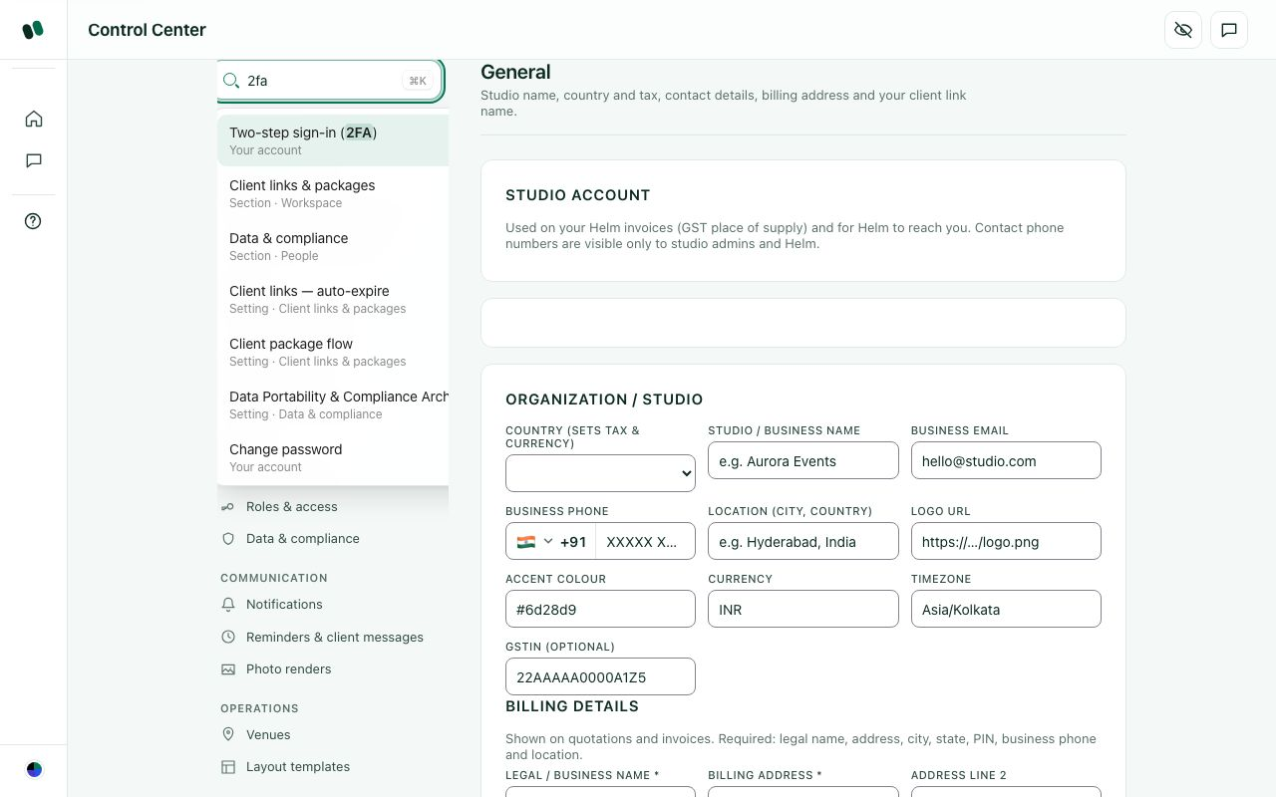
Typing "2fa" in the Control Center search: the first result is "Two-step sign-in (2FA)", marked "Your account".

D6. Is the settings search useful?
What this means: This is the search box at the top-left of Control Center. For example, typing "PIN" takes you straight to the hide-amounts section.
What did you search for, and did it find the right section?

☐ Yes, keep it
☐ Yes, and add one search for the whole app (settings, clients and events together)
☐ We would rarely use it; a clear menu is enough
☐ Other: ______________________________

D7. Where should two-step sign-in (2FA) be set up?
What this means: 2FA (two-step sign-in) means that after your password you also type a 6-digit code from a phone app, so a stolen password alone is not enough to get in. Today you turn it on from avatar > Account settings > Two-step verification.
Where would your team expect to find it, and why?

☐ Keep it in avatar > Account settings (each person's own account)
☐ Also add a "Security" section in the Control Center with a link to it
☐ Move it to the Profile page
☐ Put it in a new Control Center group "Security" with password, devices and the privacy PIN
☐ Other: ______________________________

D8. Should 2FA be required?
Required for which roles? If not required, how should we encourage it?

☐ Optional for everyone (today)
☐ Required for admins only
☐ Required for admins and anyone who can see money
☐ Required for everyone
☐ The admin chooses this per studio in the Control Center
☐ Other: ______________________________

D9. Should an admin be able to see which team members have 2FA on?
If yes, what should the admin do with that list (remind them, block them)?

☐ Yes, show a "2FA on/off" column in Users & invites
☐ Yes, and let the admin send a reminder
☐ No, it is each person's own business
☐ Other: ______________________________

D10. The admin 2FA reminder snoozes for 3 days. Is that right?
What this means: Admins who have not turned on 2FA see a reminder. Clicking "later" hides it for 3 days, then it shows again.
If not 3 days, how often should the reminder come back, and why?

☐ Yes
☐ Remind less often (once a week)
☐ Do not remind at all
☐ Remind every time until it is done
☐ Other: ______________________________

D11. 2FA uses an authenticator app (such as Google Authenticator). Is that acceptable for your team?
What this means: An authenticator app is a free phone app, such as Google Authenticator. It shows a new 6-digit code every 30 seconds. You scan a QR code once to link it to Helm.
If not, what would your team prefer (SMS, e-mail code)? Why?

☐ Yes
☐ We would prefer an SMS code
☐ We would prefer an e-mail code
☐ Other: ______________________________

D-3. Users & invites: three ways to add a person
There are three ways to put a person into Helm. They exist because some people need a Helm login and some (for example day crew) only need to be on a list so they can be assigned work, called and paid.
How it works today
Way | Where | What happens
1. Add user (temporary password) | Control Center > People > Users & invites > bottom of "Team members": e-mail and role (Crew is pre-selected), then Add user | The account is created straight away. A one-time temporary password is generated and shown once. You pass it on to the person yourself, and they must set their own password at first sign-in.
2. Invite by email link | Same page > "Invite by email link": e-mail and role, then Create invite link (with a Copy button) | A join link is created and Helm tries to e-mail it straight away; if automatic e-mails are not switched on, you copy the link and send it yourself. The person signs up through the link and joins your studio with the role you picked. The link expires in 7 days and nothing is charged. "Pending invites" lists e-mail, role, sent date, expiry date and the actions Copy link, Resend email and Revoke. "Resend email" can be used once every 10 minutes per invite.
3. Staff record only | Left menu > Staff > ＋ Add staff > "Helm login" choice | "Save as a record only": no login. The person can still be assigned, called and paid. Or "Save and invite to sign in": they get an invitation e-mail and a link you can copy (needs an e-mail and a role).

In the Team members list you can change each person's role, set the name chat shows for them, or remove their access. Changes apply immediately. Roles you can choose: Admin, Event manager, Planner, Sales, Event coordinator, Supervisor, Quality engineer, Operations, Designer, Crew, plus Client. ("Worker" was merged into Crew.)
Control Center > People > Users & invites.

D12. Do we need all three ways to add a person?
Which way of adding people do you actually use, and which can go?

☐ Yes, all three are useful
☐ Remove "Add user with temporary password" and use invite links only
☐ Remove invite links and use temporary passwords only
☐ Combine them into one "Add person" button that asks "needs a login?"
☐ Other: ______________________________

D13. Where should adding people live?
Where would you look first to add a team member?

☐ Users in the Control Center, crew on the Staff page (today)
☐ Everything on the Staff page
☐ Everything in the Control Center
☐ Other: ______________________________

D14. Invite links expire after 7 days. Is that right?
What this means: When you invite someone, Helm sends them an e-mail link to set up their account. After 7 days the link stops working and you have to send a new one.
If not 7 days, how many days should the invite link work, and why?

☐ 7 days is fine
☐ Shorter (2–3 days)
☐ Longer (14–30 days)
☐ The admin chooses
☐ Other: ______________________________
How it works today
Pending invites have Copy link, Resend email and Revoke; resend is limited to once every 10 minutes per invite.

D15. Is once every 10 minutes the right limit for resending an invite e-mail?
What this means: To stop spam, Helm lets you resend the same invite e-mail only once every 10 minutes.
If not, how long should the wait be, and why?

☐ Yes
☐ Shorter (1–2 minutes)
☐ Longer (1 hour)
☐ No limit
☐ Other: ______________________________

D16. Who may add or remove team members?
What this means: "Users & access edit rights in the matrix" means: whoever the admin has ticked as allowed to edit the Users & access area in Control Center > Roles & access.
Which roles, and should removing need extra approval?

☐ Admin only
☐ Admin and Event manager
☐ Anyone with "Users & access" edit rights in the matrix (today)
☐ Other: ______________________________

D17. When someone leaves the studio, what should "remove" do?
What should happen to their login, their past work and their chats?

☐ Block their login, but keep their name on past events and tasks
☐ Block the login and also move their open tasks to someone else
☐ Ask me each time
☐ Other: ______________________________

D18. Are these 10 roles right for your studio (Admin, Event manager, Planner, Sales, Event coordinator, Supervisor, Quality engineer, Operations, Designer, Crew)?
Which roles would you add, remove, merge or rename?

☐ Yes
☐ Too many; we would use only a few (write which)
☐ Some names should change (write below)
☐ We need extra roles (for example Accounts, Driver, Chef)
☐ Let the admin create their own roles
☐ Other: ______________________________
How it works today
Add user pre-selects Crew and Invite pre-selects Event coordinator; Client is also offered as a role in both dropdowns.

D19. Which role should be pre-selected when adding or inviting someone, and should "Client" be offered there at all?
What this means: When you add or invite a person, a drop-down asks for their role. One role is already picked. "Client" in that list would give a customer their own Helm login.
Which role should be the default, and why? Should Client stay in the list?

☐ Keep today (Crew for Add user, Event coordinator for invites, Client offered)
☐ Same default for both (write which)
☐ No default; the admin must pick
☐ Remove Client from these dropdowns
☐ Other: ______________________________

D-4. Roles & access (the access matrix)
The access matrix decides, for each role, which parts of Helm a person can see and which they can change. It exists so that, for example, crew do not see prices, and sales cannot change settlement.
How it works today
Where: Control Center > People > Roles & access. Pick a role tab, then tap an area: a green tick means the role can see it, and the pencil (✎) also allows editing. Admin always has full access and cannot be changed. If a role has nothing switched on, people with it only see their own portal, and an "Apply suggested access" button offers a starting set for that role. Every change is saved straight away, with a short confirmation message.
Every area in the matrix today:
- Pipeline: Leads, CRM archive, Nurture, Discovery, Proposal
- Workspace: Quotes & workspace, Create new quotes (on by default for Event manager, Planner and Sales), Floor layouts, Design studio (page hidden for now), Photo renders
- Resources: Staff, Inventory, Vendors, Calendar, Templates, Venues
- Planning: Resource plan, Run-sheet, Venue & menu, Logistics, Readiness
- Finance: Budget & finance, Settlement, Closure & P&L, Package selections (review), Package payment alerts
- Event day: Event-day command, Issues & incidents, Media & gallery
- Admin: Control Center, Insights, Coupons & codes, Item pricing (rate cards), Users & access
Control Center > People > Roles & access. On the test copy the matrix itself did not load, so only the heading and instructions show.

D20. Is "see" and "edit" for each area enough control?
What this means: For each area (for example Quotes), a role can have "see" (view only) or "edit" (change things). Example: Sales can see Inventory but cannot edit stock counts.
If not, what extra level do you need (for example approve or delete)?

☐ Yes
☐ We also need "delete" as a separate right
☐ We also need "only my own events" (see only events they are assigned to)
☐ It is too detailed; give us 3–4 ready-made levels instead
☐ Other: ______________________________

D21. Should anyone other than Admin see money (prices, payments, profit)?
Which roles should see money, and which amounts exactly?

☐ Admin and Event manager only
☐ Admin, Event manager and Sales
☐ Whoever the admin switches on in the matrix (today)
☐ Other: ______________________________

D22. Is the list of areas clear to you, or are some names confusing?
What this means: "Areas" are the parts of Helm in the Roles & access table, such as Leads, Nurture, Discovery, Quotes & workspace, Item pricing (rate cards) and Users & access.
Which area names are confusing, and what would you call them?

☐ Clear
☐ Some names are confusing (write which)
☐ Too many areas; group them more
☐ Show a short explanation next to each area
☐ Other: ______________________________

D23. Should changes to the access matrix need a second confirmation or approval?
What this means: The "access matrix" is the table in Control Center > Roles & access where you tick what each role can see or edit. Today each tick is saved straight away, and every change is recorded.
If approval is needed, who should approve the change?

☐ No, save instantly (today; every change is recorded in the Audit log)
☐ Ask "Are you sure?" first
☐ Send the change to a second admin for approval
☐ Other: ______________________________

D24. Can one person need different access from others with the same role (an exception for one person)?
What this means: Example: two Planners, but only one of them should also see payments. Today access is set per role only, not per person.
Give an example of someone who needs different access from their role.

☐ No, role-based is enough
☐ Yes, allow per-person exceptions
☐ Yes, by letting one person have two roles
☐ Other: ______________________________
How it works today
When a role has nothing switched on, an "Apply suggested access" button fills in a starting set.

D25. Should Helm suggest a starting access set for each role?
What this means: In Roles & access there is a "Suggested access" button. It fills in a sensible starting set of ticks for a role, which you can then change.
If yes, should it apply on its own or only when you click it?

☐ Yes, keep the suggestion button
☐ Apply suggestions automatically for new roles
☐ No, start every role empty
☐ Other: ______________________________

D-5. Plan & billing
This is what your studio pays Helm, not what clients pay you. It lets the admin check the plan, the renewal date and download Helm's invoices.
How it works today
Where: Control Center > Workspace > Plan & billing (admins only). It shows the plan name and monthly price, the status (for example trial or active), "current period ends …" or "trial ends …", and a list of payments (date, amount, invoice number, "void" if cancelled) with an Invoice button. There is no "change plan" or "pay now" button. The text says: "Billing is managed by Helm. Questions about your plan or an invoice? Contact Helm." If the subscription is suspended, the whole workspace becomes read-only: you can view and export everything, but nothing can be created, changed or deleted. The "Studio account" card on General holds the details Helm puts on its invoices (legal name, tax ID by country, address, contacts, team size and similar).
(No useful screenshot: on the test copy this card is empty because it needs a real admin account.)

D26. What should the admin be able to do on Plan & billing?
What this means: Plan & billing is about your own Helm subscription (what your studio pays Helm), not your clients' payments. Today it only shows the plan, status and invoices, with no pay button.
Which billing actions do you need (upgrade, pay, download invoice)? Why?

☐ Only view the plan and invoices (today)
☐ Also upgrade or downgrade the plan themselves
☐ Also pay or renew online
☐ Also see how many users or events the plan allows and how many are used
☐ Other: ______________________________

D27. Before the trial or plan ends, how should we be warned?
How many days before the end, and through which channel?

☐ Notice in the bell only
☐ Bell and e-mail
☐ Banner across the top of every page in the last few days
☐ Other: ______________________________

D28. When a subscription is suspended, everything becomes read-only. Is that fair?
What this means: "Suspended" means your Helm subscription is unpaid or stopped. Then you can still view and export everything, but you cannot create or change anything.
If not fair, what should still work while suspended, and for how long?

☐ Yes
☐ Give a few grace days first
☐ Keep events within the next 7 days fully working
☐ Other: ______________________________

D-6. Hide amounts (privacy PIN)
When you show Helm to a client on your screen, you may not want them to see your costs, margins or other clients' amounts. The eye button hides every amount on screen. A PIN is needed to show them again, so a client cannot simply click it back.
How it works today
Using it: the eye button in the top bar (on any page) hides all amounts. A note appears: "Amounts hidden — tap the eye to show". Showing them again asks for the 4-digit PIN. After 5 wrong PINs it locks for 30 seconds; each further lock doubles, up to 15 minutes (counted per person).
Setting the PIN: Control Center > Workspace > Hide amounts (privacy PIN). Fields: Current PIN, New PIN (4 digits), Type the new PIN again, then Save privacy PIN. There is one PIN for the whole studio, stored securely. Until an admin changes it, the PIN is 0000. Only studio admins can change it. "Forgot the PIN? Reset to 0000" puts it back to 0000 after a confirmation. For safety, the reset only works within 15 minutes of signing in; otherwise it asks you to sign out and back in first.
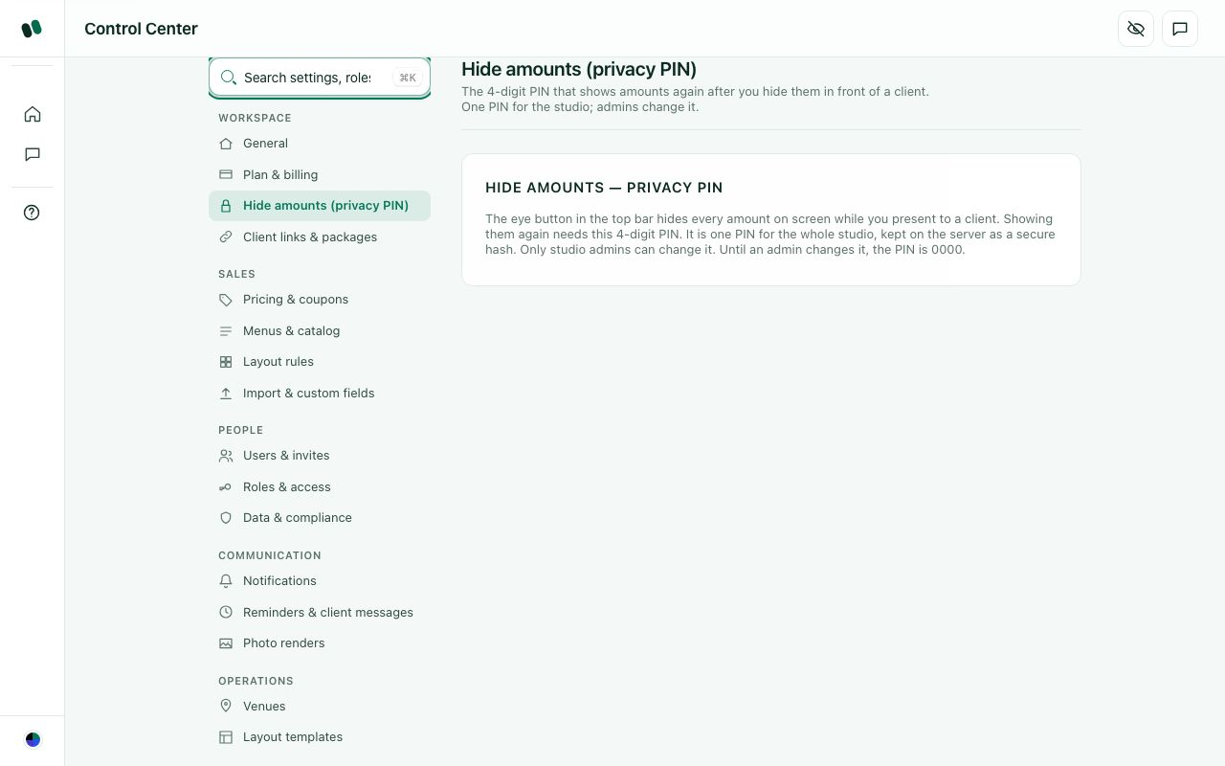
Control Center > Workspace > Hide amounts (privacy PIN).

D29. Is a hide-amounts button with a PIN useful in client meetings?
What this means: The hide-amounts button blurs every price on the screen, for example while a client is looking at your laptop. Typing a 4-digit PIN shows the amounts again.
When would you use it? If not useful, why?

☐ Yes, keep it as it is
☐ Yes, but no PIN is needed; one click to show again is fine
☐ We would rather have a separate "client view" screen
☐ We would not use it
☐ Other: ______________________________

D30. One studio-wide PIN, or one PIN per person?
Which do you prefer, and why?

☐ One PIN for the studio (today)
☐ Each person sets their own PIN
☐ Use the person's sign-in password instead of a PIN
☐ Other: ______________________________

D31. The default PIN is 0000 until an admin changes it. Is that OK?
What this means: Until an admin sets a new PIN, anyone can type 0000 to show hidden amounts again.
If not, what should happen instead (forced change, no default)?

☐ Yes
☐ Force the admin to choose a PIN during studio setup
☐ Remind the admin until it is changed
☐ Other: ______________________________
How it works today
Resetting the privacy PIN to 0000 is only allowed within 15 minutes of the admin signing in (privacy-pin-settings.js / 0157).

D32. Resetting a forgotten PIN needs the admin to have signed in within the last 15 minutes. Is that OK?
What this means: For safety, an admin can reset the PIN only if they signed in within the last 15 minutes. If not, they sign in again first.
If not, how should a forgotten PIN be reset?

☐ Yes, keep it
☐ No, a confirmation is enough
☐ Ask for the admin's password instead
☐ Other: ______________________________

D33. Should amounts be hidden automatically on some screens (for example the client proposal or when the screen is shared)?
Which screens should hide amounts automatically?

☐ No, only when I press the eye
☐ Hidden by default for some roles (write which)
☐ Hidden by default for everyone, shown with the PIN
☐ Other: ______________________________

D-7. Client links & packages
Helm sends clients links (quote approval, payment, proposal, invitation website) and crew links (tasks). This section controls how long those links keep working, and how a client picks a menu package from their booklet link.
How it works today
Where: Control Center > Workspace > Client links & packages.
Client links — auto-expire (off by default). When it is on, every outside link stops working a set number of calendar days after it was sent (1–365 days, weekends count). It never makes a link last longer than the usual limit after the event. It covers: the quote approval link (and the client portal and payment pages it opens), payment links, proposal links, crew task links, and invitation websites (warning: these usually go out weeks before the event). When an unapproved quote's link expires, you choose: Keep it in Quotes (default), Move to Archive, or Move to Deleted quotes (nothing is erased and it can be restored). Confirmed or paid events never move. Button: "Save link expiry".
Client package flow: a switch "Require a WhatsApp code before a client's choice is sent"; "Client messages go by": WhatsApp / Email / Both; "If a client pays more than the updated quote": Keep as credit / Manual refund; "Lock package choices this many days before the event" (0–90). Button: "Save package flow". Who reviews a client's choice is set in the access matrix ("Package selections (review)"). Accepting creates an updated quote, which the client must approve again. Declining needs a reason, which is shown to the client.
Control Center > Workspace > Client links & packages.

D34. Should client links expire automatically?
What this means: A client link is the web link you send a client to view and approve their quote or choose a package. Auto-expire means the link stops working after a set number of days.
If yes, after how many days? If no, why not?

☐ No, keep it off (today's default)
☐ Yes, after 30 days
☐ Yes, after 60–90 days
☐ Different limits for each link type (approval, payment, invitation, crew)
☐ Other: ______________________________

D35. When an unapproved quote's link expires, what should happen to the quote?
What should happen to the quote, and should anyone be told?

☐ Stay in Quotes
☐ Move to Archive
☐ Move to Deleted quotes (can be restored)
☐ Notify me and let me decide
☐ Other: ______________________________

D36. Package flow: should the client confirm their package choice with a confirmation code?
What this means: A confirmation code is a short code sent to the client by WhatsApp or e-mail. They type it to confirm their package choice, so a wrong click cannot change the booking.
If only for some packages, above what amount? Why?

☐ Yes, always
☐ No, a click is enough
☐ Only for packages above a certain amount
☐ Other: ______________________________

D37. If a client has paid more than the new quote total, what should Helm do by default?
What this means: Example: the client paid Rs 2,00,000, then moved to a cheaper package costing Rs 1,80,000. Helm needs to know what to do with the extra Rs 20,000.
Which default do you want, and who should approve a refund?

☐ Keep it as credit for this event
☐ Mark it for a manual refund
☐ Ask me each time
☐ Other: ______________________________

D38. How many days before the event should package choices lock?
What this means: After this date the client can no longer change their package or menu online. Your team then has time to order and prepare.
How many days before the event, and why that number?

☐ 7 days
☐ 14 days
☐ 3 days
☐ Never lock
☐ Other: ______________________________

D-8. Pricing & coupons
These are the studio's standard prices and limits, used automatically on every new quote, so nobody types prices by hand each time.
How it works today
Where: Control Center > Sales > Pricing & coupons. Cards:
- Default pricing (applies to every new quote): price per chair, price per plate, chair/rental GST %, catering GST %, tax name (shown only for some countries), a "My prices already include tax" tick box, service charge % (optional), layout & setup fee, venue booking gap (hours between two bookings of the same venue), country (tax, currency and phone codes), state.
- Item pricing (rate cards): prices for items you adjust in the layout builder (stage by size, generator by kVA and days, DJ, lighting, LED wall, chandelier, photo booth and others); items that are not adjusted keep their flat catalogue price.
- Capacity limits (layout builder): max guests, chairs, plates, round tables, bars, food trucks/stalls, expo booths, restrooms, exits, hall length/breadth (ft).
- Object & item prices (layout builder): the price of each object you place on a floor plan.
- Coupons: code with "% off" or "₹ off".
Changing a default affects new quotes only. Existing quotes keep their prices.
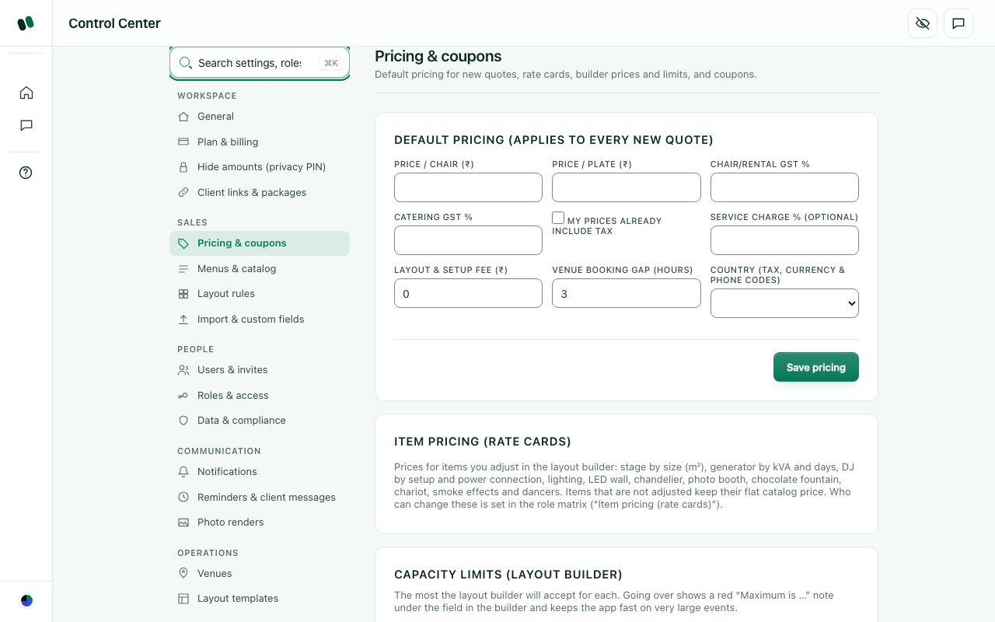
Control Center > Sales > Pricing & coupons.

D39. Is this the right list of default prices?
What this means: Default prices are the starting prices Helm puts on every new quote, such as chair, plate and decor rates. You can still change them on each quote.
Which default prices are missing, wrong or not needed?

☐ Yes
☐ We price per package, not per chair/plate; simplify it
☐ We need prices by season or by day (weekday / weekend)
☐ We need prices by venue
☐ Other: ______________________________
How it works today
Default pricing has a "My prices already include tax" tick box, an optional service charge %, and a venue booking gap (default placeholder 3 hours) used for calendar clash warnings.

D40. Do you enter prices with tax included or added on top, and what venue booking gap should Helm use?
What this means: "Venue booking gap" is the free time Helm keeps between two events at the same venue, for setup and cleanup. Example: 1 day.
Tax included or added on top? How many hours or days between venue bookings?

☐ Prices exclude tax; gap 3 hours
☐ Prices include tax; gap 3 hours
☐ Different gap (write hours)
☐ We do not need a booking gap check
☐ Other: ______________________________

D41. Coupons: what do you need?
Which coupon rules do you need? If you never use coupons, say so.

☐ % off and fixed ₹ off are enough
☐ Expiry date and usage limit per coupon
☐ Only an admin or manager may give a discount above a set %
☐ We do not use coupons; hide it
☐ Other: ______________________________

D42. Capacity limits for the layout builder: are they needed?
What this means: Capacity limits are maximums for the floor-plan builder, such as max guests, chairs, bars or hall size. Example: the builder warns if you place 600 chairs in a hall set for 500.
If needed, which limits matter, and should they be per venue?

☐ Yes, keep them
☐ Set them per venue instead of studio-wide
☐ Not needed; remove
☐ Other: ______________________________
How it works today
Object & item prices (layout builder) set a per-unit price for each object on the floor plan; blank uses the built-in default.

D43. Should every object on the floor plan carry its own price in the quote?
What this means: The layout builder is the floor-plan drawing tool. Example: placing a photo booth on the plan would add its price to the quote automatically.
If only some objects, which ones? How do you price the rest?

☐ Yes, keep per-object prices
☐ Only some objects (write which)
☐ No, price only by package / chair / plate
☐ Other: ______________________________

D-9. Menus & catalog, layout rules, import & custom fields
The catalogue is your list of chairs, plates and dishes and the menu packages clients choose from. Layout rules tell the automatic floor-plan generator how much to place for each event type. Import brings existing Excel lists into Helm, and custom fields add your own information boxes.
How it works today
- Control Center > Sales > Menus & catalog: Chair types & prices; Plate types & prices (catering); Dishes catalogue (each dish marked Veg, Non-veg or Special); Menu packages: 6 fixed packages (Standard, Gold and Premium, each as Vegetarian and Non-veg), each with a per-plate price and an editable dish list.
- Control Center > Sales > Layout rules: "Default layout rules (per event type)": for each event type, seats per guest, one buffet table per N guests, number of bars, and which components to include.
- Control Center > Sales > Import & custom fields: "Import from Excel" (.xlsx or .csv): Import staff, Import dishes, Import inventory, Import vendors, plus "Import price list" (opens onboarding). Helm matches columns, shows a preview, skips existing rows unless you choose to update them, and never deletes. Clients are not imported here. "Custom fields": choose Staff, Dishes, Inventory or Vendors, then add a field of type Text, Number, Date or Yes/No; fields can also be renamed or hidden (hiding keeps the saved values).
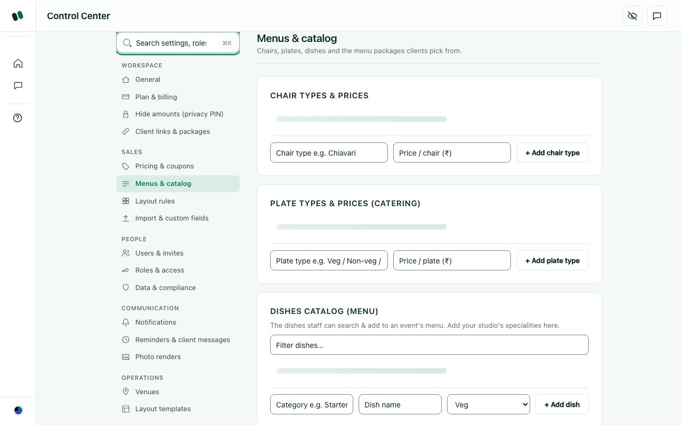
Control Center > Sales > Menus & catalog.
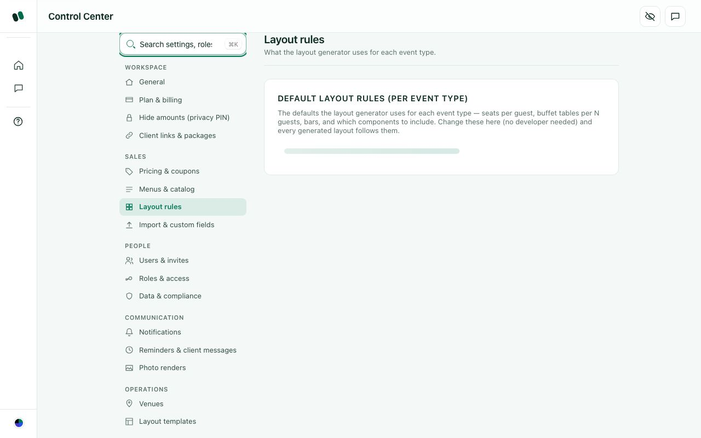
Control Center > Sales > Layout rules.

D44. Menu packages: are three levels (Standard / Gold / Premium) right?
How many levels do you sell, and what are they called?

☐ Yes
☐ We need more packages, with our own names
☐ Different packages for each event type (wedding, corporate, birthday…)
☐ Other: ______________________________

D45. Dishes are marked Veg / Non-veg / Special. Is that enough?
Which other food labels do you need (Jain, egg, vegan)?

☐ Yes
☐ Add Jain / Eggless / Vegan
☐ Add cuisine (South Indian, North Indian, Chinese…)
☐ Add course (starter, main, dessert)
☐ Other: ______________________________

D46. Should menus be in the Control Center or on their own page in the main menu?
Where would your team look for menus, and why?

☐ Control Center (today)
☐ Their own "Menus" page in the main menu
☐ Both
☐ Other: ______________________________

D47. Are the layout rules (seats per guest, buffet tables, bars) the right things to control?
What this means: Layout rules tell the automatic floor-plan generator how to set up an event. Example: "one buffet table per 100 guests" or "2 bars for a wedding".
Which rules are missing or not needed for your events?

☐ Yes
☐ Also add stage, dance floor, photo booth and similar
☐ We never use the automatic layout; hide it
☐ Other: ______________________________

D48. What do you want to import from Excel on day one?
Which lists do you have in Excel today, and which are most important?

☐ Client list
☐ Dishes and menus
☐ Inventory
☐ Staff and vendors
☐ Past events and payments
☐ Other: ______________________________

D49. Custom fields are available for Staff, Dishes, Inventory and Vendors. Where else do you need them?
What this means: Custom fields are extra boxes you add yourself. Example: a "Shirt size" field for Staff or a "Spice level" field for Dishes. They can be Text, Number, Date or Yes/No.
Where else do you need extra fields? Give an example field.

☐ Clients / leads
☐ Events / quotes
☐ Venues
☐ Not needed at all
☐ Other: ______________________________
How it works today
Custom fields can be renamed or hidden; hiding keeps saved values. Imports add unknown columns as custom fields automatically.

D50. When importing, should extra Excel columns automatically become custom fields?
What this means: Example: your staff Excel has a column "Aadhaar last 4" that Helm does not know. Today Helm adds it as a new custom field on its own.
If not automatic, what should Helm do with extra columns?

☐ Yes (today)
☐ Ask me column by column
☐ Ignore extra columns
☐ Other: ______________________________

D-10. Data & compliance (export, retention, deletion)
Indian privacy law (DPDP) and good practice say a studio must be able to take its data out, and that personal data must not be kept forever. This section gives the admin a full copy of the studio's data.
How it works today
Where: Control Center > People > Data & compliance (admins only). One button: Download studio data archive. It downloads a single JSON file with the organisation profile, team members, events (quotes), leads and invitations (invite tokens removed). It is read-only: nothing is changed or deleted. Reports and lists elsewhere also have their own export buttons.
Deleting: deleting a quote moves it to "Deleted quotes", which can be restored. Nothing is erased. There is no in-app button to permanently delete the whole studio. The public "Data Deletion & Export" page promises: acknowledgement within 7 days, deletion of a single record or profile within 30 days, a full export (JSON or CSV) within 30 days, and on account closure the workspace stays read-only for 30 days for export, then the content is permanently deleted from live systems within 60 days, and backups roll off within 35 days after that. There is no automatic "delete data older than X" setting.
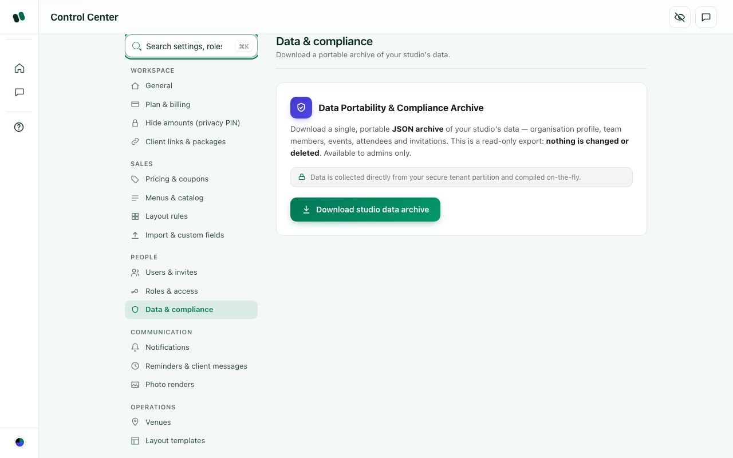
Control Center > People > Data & compliance.

D51. Is a single JSON file useful as an export?
What this means: JSON is a computer file format. It is good as a full backup, but you cannot open it nicely in Excel. It comes from Control Center > Data & compliance > Download studio data archive.
What would you do with the export? Which format do you need?

☐ Yes, as a backup
☐ We also want Excel files (one sheet per list)
☐ We also want PDFs of each event's quote and settlement
☐ Other: ______________________________

D52. How long should Helm keep old client data?
How many years, and for which kinds of data?

☐ Forever, until we delete it
☐ Delete or anonymise personal details 3 years after the event
☐ Keep for 8 years (tax records), then delete
☐ Let the admin choose a retention period
☐ Other: ______________________________

D53. When a client asks to be deleted, who handles it?
Which person or role, and how should they be told?

☐ Admin, through a "Delete this client's personal data" button
☐ We e-mail Helm support and they do it
☐ Other: ______________________________

D54. Where should Data & compliance sit in the Control Center?
Where would you expect to find it, and why?

☐ Under People (today)
☐ Under Workspace
☐ In a new "Security & data" group, with 2FA and the privacy PIN
☐ Other: ______________________________
How it works today
Helm has public legal pages, linked from the site footer and sign-in page: Privacy policy, Terms, Refund policy, Cookie policy, Acceptable use, Data processing agreement, Sub-processors, Service levels (SLA), Grievance officer, Data deletion request, Accessibility, AI notice and Copyright. They carry Helm's standard wording; no lawyer has reviewed them yet.

D55. Which legal pages must be reviewed or changed before launch?
Which pages need changes, and what exactly should change?

☐ All fine as they are
☐ Refund policy needs our real rules
☐ Grievance officer name and contact must be filled in
☐ Have a lawyer review all of them
☐ Remove pages we don't need
☐ Other: ______________________________
How it works today
The Grievance and Data deletion pages tell a client how to complain or ask for their data to be removed. India's privacy law (DPDP) needs a named contact and a reply within a set time.

D56. Who should be the grievance / data-deletion contact, and how fast must they reply?
What this means: A grievance officer is the named person clients contact to complain or ask for their data to be deleted. India's privacy law (DPDP) requires a named contact and a reply within a fixed time.
Name the person or role, and how many days they have to reply.

☐ Studio owner, within 7 days
☐ A named person at Helm, within 30 days
☐ Each studio names its own contact
☐ Other: ______________________________

D-11. Notifications (the bell) and communication settings
The bell (🔔) in the top bar collects alerts about things that happened, such as a client approving or a payment arriving. The admin decides which roles see which alerts, and which automatic texts and e-mails go out.
How it works today
Where: Control Center > Communication > Notifications. A table "Notifications — who hears about what": one row per alert type, one column per role. A green tick means that role sees it in the bell, and you tap to switch it. The last column, "Texts & e-mails", switches the automatic SMS or e-mail to staff on or off (when off, it is logged but not sent). Client messages marked "required" (approval codes, receipts, payment links) always go out. Money alerts start on only for roles with Budget & finance access. Also available: a search box, a group filter, "Reset to defaults", and "Per-person overrides" (choose a person, then for each alert pick Follow role / Always show / Never show). Every change is recorded in the Audit log.
Every alert type today:
Group | Alerts
Sales | Approval link sent; Approval code (OTP) sent; WhatsApp message sent; Birthday / anniversary greeting; Client picked a package; Package accepted; Package declined; Client follow-up sent
Planning | Design stage changed; Tasks assigned
Operations | Task accepted / started / done; Task reminder; Task due; Low stock on an event date
Finance | Payment link sent; Payment reminder sent; Payment receipt; Payment received (studio e-mail); Payment needs attention; Package payment received
Chat | Chat messages
Security | Security alerts
Billing | Free trial reminders
System | Other updates

Control Center > Communication > Reminders & client messages (client messages are off until switched on): event reminders for the team ("Remind the team before each event: [7] days", on by default at 7 days, 1 to 30 allowed); Payment reminders to clients (send by E-mail and/or WhatsApp, days before the due date, then every N days overdue, maximum overdue reminders, remind on the due date, message text with placeholders {client} {studio} {event} {label} {amount} {due} {status}; reminders stop when the payment is made); Client follow-ups when a client opened the booklet or quote but did not approve (days after opening, maximum follow-ups, message; they stop on approval, package choice or cancellation); Inventory (warn in the bell when events on the same date need more of an item than you own). WhatsApp: set up separately by the owner.
Control Center > Communication > Notifications. On the test copy the table shows "Couldn't load notification settings"; with a real studio it shows the grid of ticks.
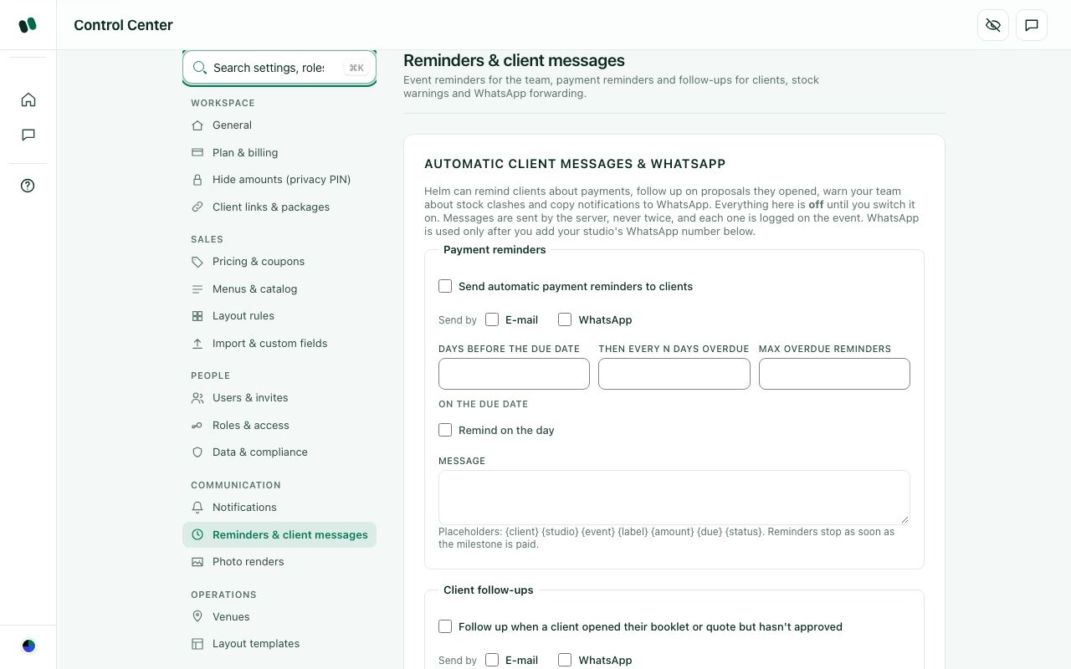
Control Center > Communication > Reminders & client messages.

D57. Is the list of alerts complete? What is missing?
Which alerts are missing? Describe when each should fire.

☐ Complete
☐ Missing: new lead arrived
☐ Missing: client approved the quote / event confirmed
☐ Missing: event tomorrow / event today summary
☐ Missing: an issue was reported on event day
☐ Other: ______________________________

D58. Which alerts are noise and could be off by default?
Which alerts should be off by default, and for which roles?

☐ "Approval link sent" / "Payment link sent" (we sent them ourselves)
☐ Chat messages in the bell (chat has its own badge)
☐ "Other updates"
☐ None; keep all on
☐ Other: ______________________________

D59. Is the grid (alerts × roles) easy enough to use?
What this means: The grid is a table in Control Center > Notifications. Alerts (such as "payment received") run down the side and roles run across the top. A tick means that role gets that alert.
If not easy, what is confusing about it, and what would help?

☐ Yes
☐ Too big; give simple presets ("everything", "only important", "only money")
☐ Let each person choose their own alerts on their profile instead
☐ Other: ______________________________

D60. Should Helm send automatic payment reminders to clients?
If yes, by WhatsApp, e-mail or both? If no, why not?

☐ Yes, by e-mail
☐ No, we prefer to call clients ourselves
☐ Only after a staff member approves each reminder
☐ Other: ______________________________

D61. When should payment reminders go?
How many days before and after the due date, and how often?

☐ 3 days before the due date and on the day
☐ 1 day before and then every 3 days overdue (at most 3)
☐ Only once the payment is overdue
☐ Other: ______________________________

D62. Automatic follow-up when a client opened the quote but did not approve?
If yes, after how many days, and what should the message say?

☐ Yes, 2 days after opening, at most 2 times
☐ Yes, but just alert our salesperson instead of messaging the client
☐ No
☐ Other: ______________________________
How it works today
Control Center > Communication > Reminders & client messages has an 'Event reminders' card: 'Remind the team before each event: [7] days' (1-30), on by default; confirmed events inside the window get one reminder and an 'Upcoming in N days' banner.

D63. How many days before an event should the team be reminded?
How many days before, and why that number?

☐ 7 days (today's default)
☐ 3 days
☐ 1 day (the day before)
☐ Several reminders (e.g. 7 days and 1 day)
☐ Other: ______________________________

D64. Should Notifications and Reminders be one section or two?
One or two? Why?

☐ Two sections (today)
☐ Merge them into one "Messages & alerts" section
☐ Other: ______________________________

D-12. Team chat
Team chat lets the studio talk inside Helm instead of personal WhatsApp groups, so event conversations stay with the business, even when a person leaves.
How it works today
Where: the chat-bubble icon in the top bar or left menu > Team chat. On the left is the chat list with filters All, Unread, Favorites and Groups, plus a search for people and chats. Kinds of chat:
- Everyone: one studio-wide chat for all team members. Its messages count as chat in the bell; when WhatsApp forwarding is on they can also be copied to WhatsApp as "Studio announcements".
- Direct messages between two people.
- Groups: anyone can start a "New group" and pick members.
- Event groups: a group linked to one event (shown as "Event group", with an emoji for the event type, such as 💍 wedding or 🎂 birthday).
People see only the chats they are members of. You can send text, emoji and images (drag and drop) and delete your own message ("Everyone in the chat will see it was removed"). Unread chats show in the bell under "Chat messages". The admin sets the name chat shows for each person in Users & invites.
(Screenshot not usable: the chat page needs a signed-in user, and the test copy showed overlapping empty windows.)

D65. Will your team actually use Helm chat instead of WhatsApp groups?
If not, what would make them switch from WhatsApp?

☐ Yes, for all work talk
☐ Only for event-specific talk
☐ No, we will stay on WhatsApp; hide chat
☐ Other: ______________________________

D66. Event groups: how should they be created?
Should groups be created on their own, by hand, or both? Who joins?

☐ Automatically when a quote is confirmed, with everyone assigned to the event
☐ Manually by the event manager
☐ Not needed
☐ Other: ______________________________

D67. Who should be able to read chats?
Which roles may read which chats, and why?

☐ Only the members of each chat (today)
☐ Admin can read every chat
☐ Admin can read event groups but not direct messages
☐ Other: ______________________________

D68. Should crew (no office login) be in chat?
What this means: Crew are on-ground workers who use a simple worker page, not the full Helm login.
If yes, how would crew get in without an office login?

☐ Yes, crew with a login join chat
☐ Crew only in their event groups
☐ Other: ______________________________

D69. What else should chat do?
Which chat features are missing (voice notes, photos, read ticks)?

☐ Send PDFs and documents
☐ Voice notes
☐ Pin important messages
☐ Only "Everyone" announcements by admin (others read only)
☐ Other: ______________________________

D-13. Integrations: e-mail and Razorpay (all off today)
Integrations connect Helm to outside services so messages and payments happen automatically. They are all built but switched off. Until they are on, Helm only simulates them, and nothing goes out.
How it works today
Where: Integrations page. This page is switched off on the live site today (a feature switch; it only appears on the local test copy, where the screenshot was taken). On the live site its menu entry is hidden, opening its address sends you to the dashboard, and the related getting-started and onboarding steps are hidden too. One loose end: the Control Center search still offers "Integrations (WhatsApp, e-mail, payments)", which then lands on the dashboard. On the test copy it is reached from that search or the link on the Studio setup page. Only people who can open the Control Center can see it, and only those who can edit the Control Center can change it. Each card shows a status such as "Not connected", "Simulated" or "Live".
- E-mail: settings "Sender name" (the "From" name; empty means your studio name) and "Reply-to e-mail" (where a client's reply goes; empty means replies are not read), plus "Send test e-mail to me". Today e-mail is used for teammate invites and, if switched on, client payment reminders and follow-ups. Decided: e-mails come from notifications@helm.events, with Reply-To set to the studio's e-mail. (The set-up notes in the code still show events@helm.events and will be updated to match.)
- WhatsApp: set up separately by the owner.
- Razorpay (online payment): clients pay advances and balances by a payment link, and the money goes into the studio's own Razorpay account. The studio completes Razorpay KYC and sends the keys to Helm support. When paid, Helm marks the payment, sends a receipt, and alerts the studio.
Messages that would go out once switched on: quote approval link (SMS, required), approval code/OTP (SMS, required), payment link (SMS, required), payment reminders, payment receipt (e-mail and SMS, required), client follow-ups, birthday/anniversary greetings (e-mail), crew task assigned / reminder / due (SMS), team invites (e-mail), "payment received" and "payment needs attention" e-mails to the studio.
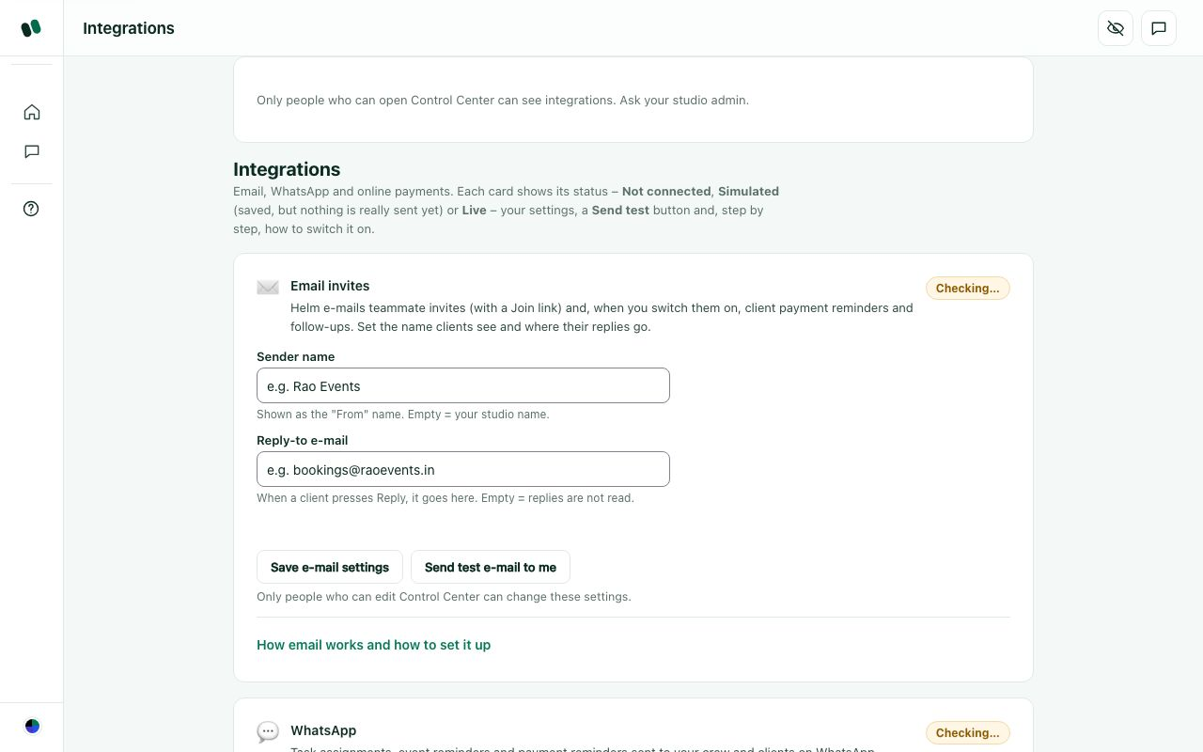
Integrations page on the local test copy: E-mail card (sender name, reply-to).

D70. Which integration matters most to switch on first?
What this means: Integrations connect Helm to outside services: WhatsApp (send messages to clients), e-mail (send invoices and reminders) and online payment (Razorpay payment links).
Which one first, and why is it most important?

☐ E-mail
☐ Razorpay online payment
☐ SMS (approval codes)
☐ Other: ______________________________

D71. Online payment: what do you want?
What this means: Online payment means sending the client a link (through Razorpay) to pay by UPI, card or net banking. Helm then marks the payment as received on its own.
How should clients pay online, and who pays the gateway fee?

☐ Razorpay payment links (money to our own Razorpay account)
☐ UPI QR code on the quote only
☐ Bank transfer details only; we record payments by hand
☐ Not needed now
☐ Other: ______________________________

D72. Where should Integrations live?
Where would you expect to find it, and why?

☐ Its own page (today), found through search
☐ As a section inside the Control Center (Communication group)
☐ Both
☐ Other: ______________________________

D73. The Integrations page is hidden on the live site. What should a studio see about e-mail and payments?
What this means: The Integrations page is built but switched off on the live site until WhatsApp, e-mail and payment accounts are set up.
What should the studio see about e-mail and payments until it is switched on?

☐ Nothing until it works
☐ A simple status card in the Control Center ("E-mail: on via Helm")
☐ The full Integrations page
☐ Other: ______________________________

D74. Settings search still offers "Integrations" while that page is hidden (it lands on the dashboard). What should it do?
What this means: Today, typing "Integrations" in the settings search still shows the page. Clicking it just lands you on the dashboard.
Should search hide it, show "coming soon", or something else?

☐ Remove it from search while hidden
☐ Show it with a "coming soon" note
☐ Other: ______________________________

D-14. Colour themes
Themes change Helm's accent colour so it feels like your studio's own tool. Dark mode is switched off for now.
How it works today
Where: bottom of the left menu > Colour theme button > a small "Theme" box with five colour chips:
- Emerald (default since October 2026): deep green buttons and highlights on a light background. Browsers still on the old default (Cobalt) were moved to Emerald once.
- Cobalt: bright royal-blue accent (the previous default).
- Midnight: very dark indigo / navy accent, a formal look.
- Graphite: pure black and white: white pages, black text, black buttons, grey lines, no colour.
- Studio: warm cream background with a plum (purple) accent, a softer boutique look.
Only colours change; layout, buttons and money figures are the same in every theme. The choice is remembered per browser for that person only. It is not a studio-wide setting, and it does not follow you to another device. There is also a separate "Accent colour" field in Control Center > General (studio branding). Dark mode is off: there is no dark/light switch, and Helm stays light even when the phone or computer is set to dark mode (the dark colours are kept in the code and can be switched back on in one place). Client-facing pages (approval link, booklet, proposal, client portal, crew work link) use the theme saved in the visitor's own browser, so a client who never picked one sees Emerald, not your studio's choice.
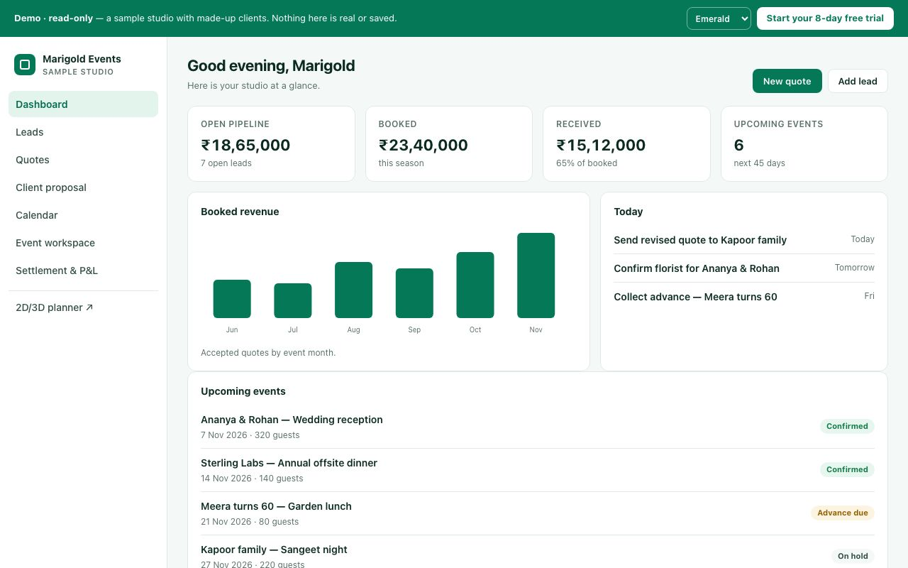
The public demo studio in the Emerald theme (theme picker at top-right of the demo).

D75. Which theme do you prefer as the default?
What this means: A theme is the colour style of the whole app. Emerald (green) is today's default.
Which theme, and why should it be the default?

☐ Emerald (green)
☐ Cobalt (blue)
☐ Midnight (indigo)
☐ Graphite (black and white)
☐ Studio (purple)
☐ Other: ______________________________

D76. Who chooses the theme?
Admin for everyone, or each person for themselves? Why?

☐ Each person for themselves (today)
☐ The admin sets one theme for the whole studio
☐ Admin sets a default; each person may change it
☐ Other: ______________________________

D77. Do you want dark mode?
What this means: Dark mode is a black-background version of the screens, used at night or in dark venues. It is switched off today.
If yes, who would use it and when?

☐ No, keep it off
☐ Yes, as an option
☐ Yes, following the phone or computer setting automatically
☐ Other: ______________________________

D78. Should the theme use our studio logo colour automatically?
What this means: Example: if your logo is maroon, the buttons and highlights in Helm would turn maroon on their own.
If yes, should it apply to the team, to clients, or both?

☐ Yes
☐ No, the 5 themes are enough
☐ Other: ______________________________

D79. Client-facing pages use the visitor's own theme (usually Emerald). What should a client see?
What this means: Client-facing pages are the pages your clients open, such as the quote link and the invitation website. Today they show in the visitor's own theme, usually Emerald green.
Should clients see your studio colours, Helm's colours, or something else?

☐ Always our studio's chosen theme
☐ Always Emerald (Helm look)
☐ A neutral white/black look with our logo
☐ Other: ______________________________

D80. Are the five themes the right set?
Which themes would you add, remove or change?

☐ Keep all five
☐ Fewer: keep only (write which)
☐ Add one in our brand colour
☐ Remove Graphite (too plain)
☐ Remove Studio (too soft)
☐ Other: ______________________________

D-15. Profile, sign-out and session timeout
Each person has their own profile (name, phone, photo) so teammates can reach them and assign work. Sign-out and timeouts protect the studio if a laptop or phone is left open.
How it works today
Avatar menu (top-right round picture): Profile · Account settings · User manual · Insights (only if allowed) · Control Center (only if allowed) · Sign out.
Profile: full name (required), mobile number, WhatsApp number (or "same as mobile"), job title, department, skills, city, emergency contact name and number, and a photo. The text says "Teammates see your name, job title, department and photo." If the name and mobile are missing, a card "Complete your profile" appears ("Later" snoozes it for 7 days). The WhatsApp opt-in tick ("Also send my Helm notifications to my WhatsApp") is also on the profile. When an admin edits a team member, there are extra fields: day rate (₹) and employment type (Full-time / Part-time / On-call).
Account settings: e-mail address (changed through a confirmation link), sign-in activity, password (at least 12 characters with a lowercase letter, an uppercase letter, a number and a symbol; other devices are signed out after a change; Google sign-in users have no Helm password), two-step verification, and "Sign out other devices".
Session timeout: currently off. Helm does not sign people out for being idle or after a fixed number of hours, and people stay signed in until they press Sign out. The switches exist: "sign out after N minutes without activity" (with a warning first) and "always sign out N hours after sign-in". Both are set to 0 (off), and only the Helm owner can change them, not the studio.

D81. Are these the right profile fields?
Which profile fields are missing or not needed?

☐ Yes
☐ Too many; only name, phone and photo
☐ Add date of birth / joining date
☐ Add ID proof / bank details for paying crew
☐ Other: ______________________________

D82. Should Helm sign people out automatically?
If yes, after how long without use?

☐ No (today)
☐ After 30 minutes without activity
☐ After 2 hours without activity
☐ Every day at night / after 12 hours
☐ Let our admin choose
☐ Other: ______________________________

D83. Should the timeout be different on shared office computers versus personal phones?
If yes, what timeout for office computers and for phones?

☐ No, same everywhere
☐ Yes, shorter on computers
☐ Add a "This is a shared computer" tick at sign-in
☐ Other: ______________________________

D84. Should "Profile" and "Account settings" be one page?
What this means: Profile holds your name and photo. Account settings holds your e-mail, password, 2FA and sign-in devices. Both open from the avatar menu.
One page or two? Why?

☐ Keep them separate (today)
☐ Merge into one "My account" page
☐ Other: ______________________________

D85. Should an admin be able to sign a team member out of all devices (for example, a lost phone)?
If yes, who should be allowed to do it?

☐ Yes
☐ No, removing access is enough
☐ Other: ______________________________

D-16. Using Helm on a phone
Event teams are often on site, not at a desk. Helm works in the phone's web browser (there is no app-store app). On small screens it changes its layout.
How it works today
On screens narrower than 820 px, a bottom bar appears with: Home · Quotes · Leads · Chat · More (More opens the full left menu). Quotes, Leads and Chat show only if your role is allowed to view them. The left menu becomes a slide-in drawer. Wide tables turn into cards. The Control Center's section list becomes a drop-down. Crew open their tasks through their own work link without needing a full login.
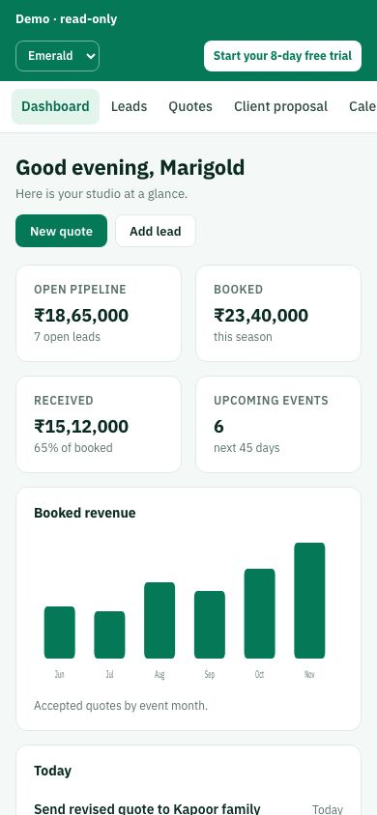
The demo studio on a phone-width screen (390 px).

D86. Who on your team will mainly use Helm on a phone?
Which roles, and what do they mostly do on the phone?

☐ Crew and supervisors on event day
☐ Sales, when meeting clients
☐ The owner/manager, to check numbers
☐ Everyone; phone first
☐ Other: ______________________________

D87. Do you need a real app from the Play Store / App Store?
What this means: Today Helm works in the phone's web browser and can be added to the home screen. A Play Store or App Store app is a separate, bigger build.
If yes, why is the website on the phone not enough?

☐ No, the browser is fine
☐ A "Add to home screen" icon is enough
☐ Yes, a real app (for notifications)
☐ Other: ______________________________

D88. Which 5 buttons should be on the phone's bottom bar?
What this means: On a phone, Helm shows a bar of buttons at the bottom of the screen, for example Dashboard, Quotes, Calendar, Chat and More.
List your 5 buttons in order of importance.

☐ Keep: Home, Quotes, Leads, Chat, More
☐ Replace Search with Calendar
☐ Replace Profile with Chat
☐ Show "Today's events" as a button
☐ Other: ______________________________

D89. Should settings (the Control Center) be usable on a phone?
If yes, which settings do you change on the move?

☐ Yes, everything
☐ Only simple settings (PIN, notifications, users)
☐ No, settings on a computer only
☐ Other: ______________________________

Part E — Open decisions (money rules and business rules)

Already decided (for confirmation)
1. After a refund, what does the client still owe? Decided: the server is right. A refund is money returned, so it does not make the client owe more; the Settlement screen is fixed to show ₹0 (e.g. quote ₹1,18,000, paid ₹1,18,000, refund ₹2,000 → balance due ₹0, matching the close-event check).
2. Can an event be confirmed before the quote has a price? (closing part) Decided: block it. Confirming a ₹0 quote shows "Add a price before confirming"; free events can still use a ₹1 or a "complimentary" line.
9. Garbled text on the close-event message. Decided: fix it (the ₹ sign and dash showed as broken characters when closing is blocked because money is owed). No business choice needed.

Money rules

E1 (3). Should the status badge follow the stage?
How it works today
What happens now: Each quote has a stage (Discovery, Confirmed, Settlement...) and a separate status badge. After confirming, the badge can still say "quote", and the dashboard can say "Confirmed" while the event is already in Settlement.
Recommendation: Keep them in sync: the badge always shows the current stage.
What this means: Every booking moves through stages (Discovery, Confirmed, Settlement, Closed). Separately, each quote card shows a small coloured label called a status badge. Today they can disagree: the stage says Settlement but the badge still says "quote".
Should the badge match the stage? If not, what should the badge show instead?

☐ Yes: keep them in sync, the badge always shows the current stage (recommended)
☐ No: keep stage and status badge separate, as now
☐ Other: ______________________________

E2 (4). Does the vendor advance count toward the vendor bill?
How it works today
What happens now: The limit on paying a vendor ignores the advance you already paid at booking, so a vendor can be paid more than the bill.
Example: Decorator booked for ₹30,000 · advance at booking ₹5,000 · bill ₹30,000. Helm still allows payouts of ₹30,000 → total paid ₹35,000. Recommendation: Count the advance. Total paid to a vendor can't go over the bill unless someone adds an extra bill.
Should the booking advance count toward the bill? If not, how should overpaying a vendor be stopped?

☐ Count the advance: total paid to a vendor can't go over the bill unless someone adds an extra bill (recommended)
☐ Keep as is: the payout limit ignores the advance
☐ Other: ______________________________

E3 (5). Can a payment milestone be bigger than the quote?
How it works today
What happens now: You can add a payment milestone for more than the whole quote.
Example: Quote total ₹50,000 → milestone "Advance" ₹1,00,000 is accepted. Recommendation: Show a warning ("This is more than the quote total") but allow it, because the quote may grow with change orders later.
What this means: A payment milestone is one planned instalment of the client's payment, for example "Advance ₹50,000 due 1 Nov". Each quote can be split into several milestones.
Warn, block or allow? Is there a case where a milestone should be bigger than the quote?

☐ Warn but allow ("This is more than the quote total"), since the quote may grow with change orders later (recommended)
☐ Block it: a milestone can't exceed the quote total
☐ Allow silently, as now
☐ Other: ______________________________

E4 (6). Can a refund be deleted after it's paid out?
How it works today
What happens now: A refund marked "processed" (money already sent) still has a delete button. Deleting it would change profit and the client's balance after the fact.
Recommendation: Lock it. To fix a mistake, record a correcting entry instead, so the history stays honest.
What this means: A correcting entry is a new line that cancels out the wrong one (for example a -₹2,000 entry against a wrong ₹2,000 refund). The history keeps both lines, so you can always see what happened and who did it.
If a refund was entered wrongly, how should staff fix it? Who should be allowed to?

☐ Lock it; fix mistakes with a correcting entry so the history stays honest (recommended)
☐ Keep the delete button, as now
☐ Other: ______________________________

E5 (7). Which events count on the Business page?
How it works today
What happens now: Confirmed events with no event date, or still marked Discovery, are left out of the Business profit page. The top numbers can be blank even when payments came in this month.
Example: Client paid ₹50,000 advance on 5 Oct · event date not set yet. Business page this month: ₹0 received. Recommendation: Include every event that has money in or out, and list undated ones under "No date yet".
What this means: The Business page is the owner's profit summary (money received, spent and profit for the month). "Discovery" is the first stage of a booking, while the enquiry is still being discussed.
Which events should the Business page count? Where should events with no date appear?

☐ Include every event that has money in or out; list undated ones under "No date yet" (recommended)
☐ Keep as is: only dated, non-Discovery events count
☐ Other: ______________________________

E6 (8). What tax rate applies when a quote has none?
How it works today
What happens now: When a quote is confirmed without a tax %, Helm still adds tax to the total but saves no rate. Profit reports then count that tax as your income.
Example: Items ₹1,00,000 + GST ₹18,000 = ₹1,18,000. Profit report counts ₹1,18,000 as revenue (should be ₹1,00,000). Recommendation: Use the studio's default tax rate from Control Center whenever the quote doesn't set one.
What this means: Control Center is the settings area of Helm. It holds a studio-wide default tax rate (for example GST 18%) that can be used when a quote does not set its own.
Which tax rate should apply when the quote leaves it blank, and what is your usual GST rate?

☐ Use the studio's default tax rate from Control Center whenever the quote doesn't set one (recommended)
☐ Require a tax % before a quote can be confirmed
☐ Other: ______________________________

E7 (B5). Can the person who asks for a refund also approve it?
How it works today
What happens now: The same person can request and approve a refund or an expense claim.
Example: Anita requests a Rs 20,000 refund for Priya and approves it herself. Recommendation: (c), with the amount set by you.
What this means: An expense claim is when a staff member asks to be paid back for money they spent for an event, for example ₹3,000 on flowers bought in cash.
Who should approve refunds and expense claims? Above what amount should a second person be needed?

☐ (a) Allowed, as now
☐ (b) A second person must approve (Manager or owner)
☐ (c) Second approval only above an amount, e.g. Rs 10,000 (recommended; amount set by you): amount Rs ____
☐ Other: ______________________________

E8 (B6). Can a payment marked "paid" be undone?
How it works today
What happens now: Once a milestone is marked paid it is locked. A mistake can't be reversed from the screen (it now shows an error instead of failing quietly).
Example: Anita marks Rs 50,000 as paid on the wrong milestone and can't fix it. Recommendation: (b).
What this means: A milestone is one planned instalment of the client's payment. Marking it "paid" records that the money came in, and today that cannot be undone from the screen.
Who should be able to undo a wrong "paid" mark, and should a reason be required?

☐ (a) Keep locked; owner fixes it with a correcting entry
☐ (b) Manager or owner can reverse it, with a reason, and the reversal is recorded (recommended)
☐ (c) Anyone who recorded it can reverse it within 24 hours
☐ Other: ______________________________

E9 (B4). Should clients get a message when the studio records a cash or bank payment?
How it works today
What happens now: When staff mark a cash or bank transfer as received, the client is not told.
Example: Priya pays Rs 1,00,000 by bank transfer. Anita records it. Priya has no confirmation and calls to check. Recommendation: (b). It also catches mistakes and misuse early.
Should the client be told? By WhatsApp, email or both, and what should the message say?

☐ (a) No message
☐ (b) Send "SAI recorded Rs 1,00,000 received. Not right? Reply." with a receipt (recommended; also catches mistakes and misuse early)
☐ (c) Only a receipt on request
☐ Other: ______________________________

Sales

E10 (S1). Sales: should Sales see quotes at all?
How it works today
What happens now: In SAI, the Sales role can only see Leads and the CRM archive (plus Chat). Quotes, calendar, Nurture, events, money pages and Control Center are all closed to Sales. The server enforces this correctly.
Example: Sales adds lead "Priya & Arjun wedding, 300 guests". Sales cannot open a quote, see the calendar, or see what was quoted to Priya. Any option is a switch in Control Center → Access, no code needed. Recommendation: (b) View quotes, so Sales can answer "what did we quote this client?" without being able to change prices.
What this means: Leads are new enquiries. The CRM archive is the list of past and closed leads. Nurture is the follow-up list for leads that are not ready to book yet. Control Center → Access is the screen where the owner switches each role's permissions on or off without any coding.
What should Sales be able to see? What do they need day to day that they cannot reach now?

☐ (a) Keep it: Sales only collects leads, a planner or manager builds the quote
☐ (b) Let Sales view quotes (read-only) (recommended)
☐ (c) Let Sales view and edit quotes
☐ Other: ______________________________

E11 (S2). Sales: can Sales turn a lead into a quote?
How it works today
What happens now: Sales can press "Convert" on a lead. The server creates the quote, but Sales then can't open it (because of S1), so they land on "Quote not found". The fix in testing keeps Sales on the Leads page with a message "Converted, a planner will price it".
Recommendation: (a) if you pick S1 (a); if you open quotes to Sales in S1, Convert simply works as normal.
What this means: "Convert" turns a lead (an enquiry) into a quote (a priced proposal). Today Sales can press it but then cannot open the quote they just made.
Should Sales press Convert? If yes, who should be told it is ready to price?

☐ (a) Allow converting (hand-off to planner) (recommended if S1 is (a))
☐ (b) Only roles that can create quotes may convert; hide Convert for Sales
☐ Other: ______________________________

Manager/Planner/Admin

E12 (R1). Who can delete quotes, leads and events?
How it works today
What happens now: Only Admin and Planner can delete. The Manager (more senior) cannot delete anything.
Example: Meena (manager) makes a duplicate quote for Priya by mistake and cannot remove it. Anita (planner) can delete it, and could also delete Priya's real quote. Recommendation: (c). Nothing is ever lost by mistake, and archived items can be restored. If too strict, (b).
What this means: Archive or cancel hides an item from the normal lists but keeps it so it can be restored later. Delete removes it.
Who should be able to delete? Is archiving (hiding but recoverable) enough for everyone else?

☐ (a) Keep as is: Admin + Planner
☐ (b) Admin + Manager, not Planner (fallback if (c) is too strict)
☐ (c) Only Admin deletes; everyone else archives or cancels (recommended)
☐ Other: ______________________________

E13 (R2). Should the Planner record payments and see profit?
How it works today
What happens now: The Planner has the same money access as the Manager: sees every payment, balance and profit, can mark money as received.
Example: Anita opens Finance, sees SAI made Rs 2.4 L profit on Priya's wedding, and marks Rs 1,00,000 received without Meena knowing. Recommendation: (b) now; (d) later if you hire an accountant.
What this means: Profit is what the studio keeps after paying vendors and costs. "Recording a payment" means marking in Helm that the client's money was received.
What money should a Planner see and do? Do you plan to hire an accountant?

☐ (a) Keep as is
☐ (b) Planner sees what the client paid and still owes on their events, but cannot record payments or see profit (recommended now)
☐ (c) Planner sees no money at all
☐ (d) Later: a separate "Accounts" role for an accountant (recommended later if you hire one)
☐ Other: ______________________________

E14 (R3). Who gives final approval: confirm, lock the plan, close the event?
How it works today
What happens now: Admin, Manager and Planner can each confirm a booking, lock the plan and close an event on their own. Nobody checks anyone else.
Example: Anita confirms Priya's booking, locks the plan and closes the event the next day while a vendor bill is still open. Meena finds out later. Recommendation: (b). A clear chain: Planner, then Manager, then owner informed.
What this means: Confirm means the booking is final. Lock the plan means the event plan (items, vendors, run sheet) is frozen for the day. Close means the event is finished and the accounts are settled.
Who should approve confirm, lock and close? Should the owner be told every time?

☐ (a) Any of the three, as now
☐ (b) Planner prepares and requests; Manager approves confirm, lock and close; owner gets a notification (recommended)
☐ (c) Only the owner closes events
☐ Other: ______________________________

E15 (R4). Can the Manager invite and remove staff?
How it works today
What happens now: Only the Admin can invite people, change roles or remove someone who left.
Example: Ravi joins as crew on Friday for a Saturday event. Meena must wait for the owner to send his invite. Recommendation: (b). Faster day-to-day hiring; the owner keeps control of senior access.
Should the Manager add or remove staff? Which roles should stay owner-only?

☐ (a) Admin only, as now
☐ (b) Manager can invite and remove Crew, Designers and Planners, but not Managers or Admins, and cannot change the access rules (recommended)
☐ (c) Manager has full staff control
☐ Other: ______________________________

E16 (R5). Is there a limit on discounts?
How it works today
What happens now: Anyone who can edit a quote can give any discount, up to 100%, with no approval and no record of who gave it.
Example: Anita gives Priya 25% off to close the deal. About Rs 2,00,000 disappears and nobody is told. Recommendation: (b), with the percentages chosen by you. Also record who gave each discount.
Should discounts have a cap? Which percentage for each role, and who approves above it?

☐ (a) No limit, as now
☐ (b) A cap per role, e.g. Planner up to 10%, Manager up to 20%; above that needs owner approval (recommended; also record who gave each discount): Planner ___% / Manager ___%
☐ (c) Only Manager and Admin give discounts
☐ Other: ______________________________

E17 (R6). Should the owner be separate from other Admins?
How it works today
What happens now: There is no separate "Owner". Every Admin has full control, including changing other people's access. A second Admin could remove the owner.
Example: You make your partner an Admin at SAI. They can change your access rules or remove you. Recommendation: (b) if there will ever be more than one Admin. If you stay the only Admin, (a) is fine for now.
What this means: Admin is the highest role in Helm today. Every Admin can change everyone's access, including another Admin's. An "Owner" role would sit above Admin so nobody can lock you out.
Will there ever be more than one Admin? If yes, what should only you control?

☐ (a) One Admin level, as now (fine if you stay the only Admin)
☐ (b) Add an Owner role above Admin: only the Owner changes access rules, manages Admins and sees full profit (recommended if there will ever be more than one Admin)
☐ Other: ______________________________

E18 (M1). What should the Manager see in Control Center?
How it works today
What happens now: The Manager can open Control Center and see the full staff list (emails, phones, roles), the audit log, studio settings, "Download studio data" and "Add user". Changing the access rules stays admin-only.
Example: Meena opens Control Center, downloads a full archive of the studio's data and sees every staff member's phone number. Recommendation: (b).
What this means: Control Center is Helm's settings area. The audit log is the record of who changed what and when. "Download studio data" exports a full copy of all clients, quotes and payments.
Which parts of Control Center should the Manager see, and which should stay admin-only?

☐ (a) Keep as is
☐ (b) Manager sees the staff list and audit log; studio settings, data download and adding users stay admin-only (recommended)
☐ (c) Manager does not open Control Center at all
☐ Other: ______________________________

E19 (M2). If the Manager can close an event, can they also reopen it?
How it works today
What happens now: The Manager can close an event, but only an Admin can reopen it.
Example: Meena closes Priya's wedding, then a late vendor bill arrives. She cannot reopen it and must wait for the owner. Recommendation: (b). Fits with R3 (who approves closing).
Should whoever closes an event also reopen it? Should a written reason be required?

☐ (a) Keep as is
☐ (b) Whoever can close can also reopen, with a written reason that is recorded (recommended; fits with R3)
☐ (c) Only Admin closes and reopens
☐ Other: ______________________________

E20 (M3). Should the Manager handle money?
How it works today
What happens now: The Manager can see Finance, Settlement and Closure, but cannot record client payments, vendor bills or vendor payouts.
Example: Priya pays Rs 1,00,000 at the venue. Meena can see the balance but cannot record the payment, so the owner has to. Recommendation: (b) or (c). Answer together with R2 (Planner and money).
What this means: A vendor bill is what a vendor (decorator, caterer) charges you. A payout is money you pay the vendor against that bill.
Should the Manager record payments and vendor bills? Above what amount should you approve?

☐ (a) Keep as is (view only)
☐ (b) Manager can record payments, vendor bills and payouts (recommended)
☐ (c) Manager records, owner approves above an amount (recommended): amount Rs ____
☐ Other: ______________________________

Crew & event-day staff

E21 (R7). What should Crew see about their events?
How it works today
What happens now: Crew have Calendar and Run sheet in the menu, but both open empty because event details are locked away from them. In practice they only see "My tasks".
Example: Ravi is crew for Priya's wedding on Saturday. The calendar is blank, so he calls Meena to ask the venue and reporting time. Recommendation: (b). Crew need where and when, not Priya's phone or the price.
What this means: A run sheet is the minute-by-minute plan for the event day (who does what and when).
What do crew need to see before an event day? Anything they must never see?

☐ (a) "My tasks" only; remove the empty pages from their menu
☐ (b) A simple schedule: date, venue, reporting time and their own tasks. No client phone, no price (recommended)
☐ (c) The full run sheet of events they are assigned to
☐ Other: ______________________________

E22 (R8). Should Designers and event-day staff see prices and client phone numbers?
How it works today
What happens now: Designer, Coordinator, Supervisor, Quality and Operations can open quotes and see the full price and Priya's name, phone and email. (Payment receipts are already hidden from them.)
Example: Kiran (designer) opens Priya's event to plan the stage and sees the Rs 8,50,000 total and Priya's personal mobile. Recommendation: (d), with default (c) for Designer, Crew, Quality and Operations, and contact-only for Coordinator and Supervisor (they may call the client on the day).
What this means: Designer plans decor. Coordinator and Supervisor run the event day. Quality checks finished work. Operations handles logistics. A per-role switch means you choose this in Control Center for each role without code.
Which roles should see prices and client phone numbers? Who needs to call the client on the day?

☐ (a) Keep as is
☐ (b) Hide price, keep contact
☐ (c) Hide both; only Manager, Planner and Sales see them
☐ (d) A switch per role in Control Center (recommended; default (c) for Designer, Crew, Quality, Operations; contact-only for Coordinator and Supervisor)
☐ Other: ______________________________

E23 (R9). Who can see other staff's tasks?
How it works today
What happens now: Crew see only their own tasks. Coordinator, Supervisor, Quality and Operations see every task on every event in the studio.
Example: Ravi can't see that his teammate already set up the lights. The quality checker can see and reopen everyone's tasks across all events. Recommendation: (b) and (c) together.
Who should see whose tasks? Should supervisors see all events or only their assigned ones?

☐ (a) Keep as is
☐ (b) Crew also see teammates' tasks on the same event (read-only) (recommended, together with (c))
☐ (c) Supervisors and Quality see only the events they are assigned to (recommended, together with (b))
☐ Other: ______________________________

E24 (C1). Should Crew see other staff's activity in their notifications?
How it works today
What happens now: The Crew bell shows other people's task updates and quote alerts, not only their own work. (Money details are now hidden from Crew.)
Example: Ravi's bell shows "Task completed by Staff A" on another event and "Quote needs re-approval". Recommendation: (b).
What this means: The bell is the notifications icon at the top of Helm that shows recent updates and alerts.
Which notifications should crew get? Anything they are missing today?

☐ (a) Keep as is
☐ (b) Crew only see notifications about their own tasks and events (recommended)
☐ Other: ______________________________

E25 (C2). Can Crew see teammates' email addresses?
How it works today
What happens now: Any staff member, including Crew, can see the email address of everyone in the studio.
Example: Ravi can look up Meena's and the owner's email addresses. Recommendation: (b).
Who should see staff email addresses? Should crew see phone numbers instead?

☐ (a) Keep as is
☐ (b) Crew see names only; emails visible to Manager and Admin (recommended)
☐ Other: ______________________________

E26 (C3). Should the "Overview" and "Business" style pages show their toolbar to roles who have no access?
How it works today
What happens now: Pages a role cannot use show a lock message, but the filters and buttons above it still appear (they do nothing).
Example: Ravi opens Quotes and sees search and filter buttons above "You don't have access". Recommendation: (b). Small polish.
What this means: When a role opens a page it is not allowed to use, Helm shows "You don't have access". The search box and filter buttons above that message still appear, but they do nothing.
Hide the toolbar on locked pages, or show it as now? Any page where it matters?

☐ (a) Keep as is
☐ (b) Hide the whole page content and show only the lock message (recommended)
☐ Other: ______________________________

Other business rules

E27 (B1). Is the same email always the same client?
How it works today
What happens now: When a quote is saved, Helm links it to any lead with the same email and overwrites that lead's name, phone, date and stage. Two different people sharing one email (a couple, a company inbox) get merged.
Example: Priya enquires for her wedding (lead). Her mother books a separate anniversary using Priya's email. The wedding lead's name, phone and date are replaced with the anniversary details. Recommendation: (b).
What this means: A lead is an enquiry. When a quote is saved, Helm looks for a lead with the same email and links the two, copying the quote's details over the lead's.
How should Helm decide two enquiries are the same client? What must never be overwritten?

☐ (a) Keep as is
☐ (b) Link only when email AND phone match, and never overwrite what was typed (only fill blanks) (recommended)
☐ (c) Never link automatically; staff link by hand
☐ Other: ______________________________

E28 (B2). What happens when the same person enquires twice?
How it works today
What happens now: A second enquiry from the same phone or email creates a second lead. Nobody is warned.
Example: Priya fills the website form on Monday and calls on Wednesday. Two "Priya" leads now exist, and two staff may call her. Recommendation: (b).
Warn, merge or allow duplicates? Should the warning use phone, email or both?

☐ (a) Allow duplicates
☐ (b) Warn "This person already exists" with Open existing / Create anyway (recommended)
☐ (c) Merge automatically into the existing lead
☐ Other: ______________________________

E29 (B3). Should the client re-approve when the price changes after approval?
How it works today
What happens now: Some price changes after approval ask the client to approve again, others don't; there is no single rule.
Example: Priya approves Rs 4,50,000. Anita adds 50 more guests (+Rs 60,000). Should Priya get a new approval request? Recommendation: (c). The original approval stays valid, and each change is approved on its own.
What this means: A change order is a small separate add-on the client approves on its own (for example "+50 guests, +₹60,000"). The original approval stays valid and only the change needs a new OK.
Which price changes after approval should need the client's OK? Is a change order clear to you?

☐ (a) Any change needs re-approval
☐ (b) Only increases need re-approval; decreases don't
☐ (c) Use a change order for anything after approval (client approves just the change) (recommended)
☐ Other: ______________________________

E30 (B12). Should a quote that is already paid ask the client to re-approve when the price changes?
How it works today
What happens now: Before any payment, a price change sends the quote back to the client for approval. Once any payment is recorded and the quote is marked "paid", price changes no longer ask the client to re-approve.
Example: Priya approves Rs 4,50,000 and pays Rs 1,00,000 advance. Anita then raises the total to Rs 5,20,000. Priya is not asked to approve the new total. Recommendation: (c), or (b) if you want it simple. Today a paid quote can change price without the client agreeing.
What this means: A change order is a small separate add-on the client approves on its own, for example "+₹70,000 for extra decor", instead of re-approving the whole quote.
After the client has paid, how should price changes be approved by the client?

☐ (a) Keep as is
☐ (b) Any price change after approval, paid or not, asks the client to approve again (simpler alternative)
☐ (c) Price changes after payment must go through a change order the client approves (see B3) (recommended)
☐ Other: ______________________________

E31 (B7). Should Helm stop double bookings?
How it works today
What happens now: Helm warns about clashes (same venue, items, staff on the same day) but lets you book anyway. Venue clashes use start times plus a gap; items and staff only check the date.
Example: Two events on Saturday both reserve all 400 chairs. Helm warns, but both bookings go through. Recommendation: (c).
What this means: A clash (double booking) is when two events on the same day need the same venue, the same items (chairs, lights) or the same staff.
Block or warn on clashes? Who may override, and should a reason be required?

☐ (a) Warn only, as now
☐ (b) Block when items run short; warn only for venue and staff
☐ (c) Block everything that clashes; only Manager or owner can override with a reason (recommended)
☐ Other: ______________________________

E32 (B8). Should events have a start and end time?
How it works today
What happens now: Events have a start time only. Two events on the same day at the same venue count as a clash unless their start times are far enough apart.
Example: A morning haldi (8-11 am) and an evening sangeet (7-11 pm) at the same hall are flagged as clashing. Recommendation: (b).
Should events have an end time? How much gap is needed between two events at one venue?

☐ (a) Start time only, as now
☐ (b) Add end time; clash only when times overlap (recommended)
☐ Other: ______________________________

E33 (B9). One free trial per person?
How it works today
What happens now: Each email address gets a free 8-day trial. Gmail ignores anything after "+", so one person can open many trials (name+1@gmail.com, name+2@gmail.com).
Example: Someone keeps opening new trials every 8 days instead of paying. Recommendation: (a) for now; switch to (b) if you see abuse.
What this means: Gmail treats name+1@gmail.com and name+2@gmail.com as the same inbox as name@gmail.com, so one person can sign up for a new free trial with each variation.
Allow many trials per person for now? If abuse appears, what limit should apply?

☐ (a) Allow it (each trial is an empty demo, no risk to others) (recommended for now)
☐ (b) One trial per real inbox (ignore the +part) and per phone number. Invites still allowed (switch to this if you see abuse)
☐ Other: ______________________________

E34 (B10). How long should people stay signed in?
How it works today
What happens now: Staging: no time limit. Production (until the next push): signed out after 60 minutes idle and after 72 hours.
Example: Meena leaves Helm open on the office computer overnight. Recommendation: (a), since amounts are already hidden after 5 minutes idle. (b) if staff share computers.
What this means: Staging is the test copy of Helm. Production is the live copy your team uses. Today they behave differently on sign-out time.
How long should staff stay signed in? Do staff share office computers or phones?

☐ (a) Stay signed in until sign-out (recommended; amounts are already hidden after 5 minutes idle)
☐ (b) Sign out after 8 hours idle (if staff share computers)
☐ (c) Different per role (e.g. Crew phones stay signed in, office staff 8 hours)
☐ Other: ______________________________

E35 (B11). Which of these parked features should come next? Number them in the order you want, or cross out any you don't want.
How it works today
What happens now: These were parked for later. Pick the order.
Recommendation: 1, 3, 6 first; then 4, 5; 2 once its purpose is described.
What this means: Nurture tabs: the follow-up list for leads not ready to book. Approval certificate: a PDF proof sent to the client after they approve the quote.
Your order for these features, and what should "Layout reminders" remind about?

☐ Order ___ : 1. Dashboard filter: 7 days / 1 month / 6 months / 1 year on the number boxes
☐ Order ___ : 2. "Layout reminders" (tell us what it should remind about): ____________
☐ Order ___ : 3. Quick stage menu on lead cards (change stage in one tap)
☐ Order ___ : 4. Nurture tabs + "Add from lead"
☐ Order ___ : 5. One New button / one search on the dashboard
☐ Order ___ : 6. Approval certificate PDF emailed to the client after approval
☐ Use the recommended order: 1, 3, 6 first; then 4, 5; 2 once its purpose is described
☐ Other: ______________________________

Access and approval rules found in the security review
These came from a review of what the Planner role can do. Nothing here is a security hole; they are business rules that only you can decide.
How it works today
Deleting quotes permanently. Today admins and planners can always permanently delete a quote from the Deleted shelf (paid quotes are protected). There is no switch in Settings to turn this off for planners.

E36. Should permanent delete be a per-role switch in Settings → Roles & access?
What this means: The Deleted shelf is where removed quotes go first, like a recycle bin. Permanent delete empties it for good. Settings → Roles & access is the screen where each role's permissions are switched on or off.
Should permanent delete be switchable per role? Who should have it on by default?

☐ Yes, make it a switch (off for planners by default)
☐ Yes, a switch, but keep planners on by default
☐ Admin only, no switch
☐ Keep as is
☐ Other: ______________________________
How it works today
Delete buttons on Budget, Settlement and Closure. Today the delete buttons on these pages show for admins and planners only, but the server allows anyone with edit rights on that area (e.g. a manager with Finance edit) to delete those rows.

E37. Who should be able to delete rows on Budget, Settlement and Closure?
What this means: Budget lists planned costs, Settlement lists final money in and out, and Closure is the final check before an event is closed. "Edit rights on an area" means the role's switch for that page is set to edit in Roles & access.
Who should delete rows on Budget, Settlement and Closure? Should the buttons match what the server allows?

☐ Anyone with edit rights on that area
☐ Admin and planner only
☐ Admin only
☐ Other: ______________________________
How it works today
Approving expense claims. Today anyone with Finance edit can create an expense claim and approve it themselves. Refunds already need a second person.

E38. Should an expense claim need a second person to approve it?
What this means: An expense claim is a staff request to be paid back for money they spent on an event.
Should a second person approve expense claims? Who, and above what amount?

☐ Yes, the creator can never approve their own claim
☐ Yes, only an admin approves
☐ No, keep as is
☐ Other: ______________________________
How it works today
Approving refunds. Today any planner or manager with Settlement edit can approve a refund someone else entered (nobody can approve their own).

E39. Who should approve refunds?
Who should approve refunds? Should the amount change who approves?

☐ Admin only
☐ Admin and event manager
☐ Anyone with Settlement edit except the person who entered it (today)
☐ Other: ______________________________
How it works today
Planner money and discount powers. Today, by default, planners can record payments, add vendor bills, close events with zero balance, and create coupons/discount codes.

E40. Are these planner powers right by default?
What this means: Coupons or discount codes are codes a client can enter to get a price cut. "Close events with zero balance" means finishing an event once nothing is owed.
Which money powers should Planners have by default? Which should be removed?

☐ Yes, keep all
☐ Remove coupons/discount codes
☐ Remove recording payments
☐ Planner should have no money powers
☐ Other: ______________________________
How it works today
Approving for the client in a trial studio. In a free-trial studio, any staff member can mark a quote as client-approved without the client's one-time code, to test the flow.

E41. Who should be able to do this test approval?
What this means: Normally a client approves a quote by entering a one-time code sent to their phone or email. In a free-trial studio, staff can skip the code to try the flow.
Who should do test approvals in trial studios? Should they be marked as tests?

☐ Admin only
☐ Any staff (today)
☐ Nobody; trial should use the real code flow
☐ Other: ______________________________

Part F — Legal documents for review (edit and send back)

About this part
Below is every legal and policy page on the Helm website, with its full current wording. Each page is a draft template and must be checked by a qualified lawyer before launch. Yellow highlighted text in [brackets] is a blank that must be filled (company name, address, officers, emails). Please edit the text directly on paper or in the document.

F1. Privacy Policy
Explains what personal data Helm collects, why, who it is shared with, and the rights of users under India DPDP, GDPR, UK GDPR and CCPA. Linked in the website footer and the security section and FAQ of the landing page. Web address: helm.events/privacy.
Please edit the text below directly: cross out, add, or comment. Fill every [placeholder].
How it works today

Privacy Policy
How Helm handles personal data, written in plain language, for studios, their teams and their clients worldwide.
Last updated: October 16, 2026

1. Who we are and what this covers
Helm is an event-management platform operated by [LEGAL ENTITY NAME] (company no. [COMPANY REGISTRATION NUMBER]), [REGISTERED ADDRESS] ("Helm", "we", "us"). This policy explains how we handle personal data when you visit our website, start a trial, subscribe, or use the Helm app.
Two roles. For account, billing, website and support data, Helm decides why and how data is used, so we are the Data Fiduciary (India DPDP Act) / controller (GDPR, UK GDPR) / business (CCPA). For the client, guest, vendor and event data a studio stores in its workspace, the studio is the Data Fiduciary / controller and Helm acts only as its Data Processor / processor / service provider under our Data Processing Addendum.
If you are a client or guest of a studio that uses Helm, please contact that studio first about your data. We will help them answer you, and if you contact us directly we will pass your request to them.

2. Personal data we collect
Category | Examples | Source
Account and identity | Name, work email, phone, role, password hash, sign-in provider (e.g. Google), profile photo | You or your studio admin
Studio and billing | Business name, billing address, tax ID (e.g. GSTIN / VAT), plan, invoices, payment status and reference | You; our payment processor
Workspace content (processed for studios) | Leads, clients, guests, quotes, layouts, tasks, crew, vendors, payments recorded, files and chat messages | The studio and its team
Usage and device | IP address, browser, pages used, timestamps, error logs, security events | Collected automatically
Communications | Support emails, feedback, survey answers, marketing preferences | You

We do not ask for sensitive data (such as health, religion, biometric or government ID numbers) and studios should not store it in Helm unless they truly need it and have a lawful basis. We never receive full card numbers; payments are handled by [PAYMENT PROCESSOR, e.g. Stripe / Razorpay].

3. Why we use it and our lawful bases
Purpose | Lawful basis (GDPR / UK GDPR) | DPDP Act ground
Create and run your account, provide the service | Contract (Art. 6(1)(b)) | Consent given at sign-up / legitimate use for the specified purpose
Billing, invoicing, tax and accounting records | Legal obligation (Art. 6(1)(c)); contract | Compliance with law (s. 7)
Security, fraud and abuse prevention, keeping workspaces separate | Legitimate interests (Art. 6(1)(f)) | Legitimate use / consent
Support and service messages (e.g. trial ending, security alerts) | Contract; legitimate interests | Consent
Product improvement using aggregated, de-identified usage data | Legitimate interests | Consent
Marketing emails about Helm | Consent, or legitimate interests where allowed (you can opt out any time) | Consent (withdrawable)
Responding to legal requests and enforcing our terms | Legal obligation; legitimate interests | Compliance with law

Where we rely on consent, you can withdraw it at any time as easily as you gave it (for example from your account settings or by writing to [PRIVACY EMAIL]). Withdrawal does not affect processing already done. We do not sell personal data, we do not "share" it for cross-context behavioural advertising (CCPA/CPRA), and we do not use workspace content to train general-purpose AI models.

4. Notice and consent (India DPDP)
Before or at the time we ask for your personal data we tell you what we collect, the purpose, how to withdraw consent, how to exercise your rights and how to complain to the Data Protection Board of India. This notice is available in English and, on request, in any language listed in the Eighth Schedule to the Constitution of India. Where a Consent Manager registered with the Board is used, you may give, manage and withdraw consent through it.

5. Who we share it with
- Subprocessors that help us run Helm (hosting and database, email delivery, error monitoring, payments, messaging). They act on our instructions under written contracts. The current list is on our Sub-processors page.
- Your studio: if you are a team member, your studio admin can see your activity in that workspace.
- At your direction: when you send a quote, invitation, receipt or message to a client, or connect an integration.
- Legal and safety: where required by law, court order or a lawful government request, or to protect people, our users or Helm.
- Business transfers: in a merger, acquisition or asset sale, under confidentiality and with this policy continuing to apply.
We never sell personal data or rent mailing lists.

6. International transfers
Helm is a global service and data is hosted in [HOSTING REGION(S)]. When personal data moves across borders we use appropriate safeguards: for transfers out of the EEA, the European Commission's Standard Contractual Clauses (SCCs); for the UK, the International Data Transfer Addendum; and for India, we transfer only to countries not restricted by the Central Government under section 16 of the DPDP Act; for the UAE, to countries with adequate protection or under the safeguards in Articles 22–23 of the PDPL. You can ask us for a copy of the relevant safeguards.

7. How long we keep it
Data | Retention
Active account and workspace content | For as long as the subscription or trial is active
Workspace after cancellation or trial expiry | Kept read-only for 30 days so you can export, then deleted within a further 60 days (backups roll off within 35 days after that)
Invoices, payment and tax records | As long as tax and accounting law requires (usually 8 years in India, up to 10 years in some countries)
Security and access logs | Up to 12 months, or 1 year minimum where the DPDP Rules require it for traffic data and logs
Marketing preferences / suppression list | Until you ask us to forget you (we keep a minimal "do not contact" entry so we honour your opt-out)

Under the DPDP Rules, if a user has not interacted with us for the prescribed period we will erase their data, giving at least 48 hours' notice before doing so. See Data Deletion & Export for how to request deletion.

8. Security and breach notification
We use encryption in transit (TLS) and at rest, row-level access controls that keep each studio's workspace separate, role-based permissions, multi-factor authentication options, least-privilege staff access, audit logging, backups and regular security testing.
If a personal data breach occurs we will contain it and, as the DPDP Rules require, inform affected people without delay and the Data Protection Board of India, with a detailed report within 72 hours of becoming aware of it. Under GDPR / UK GDPR we notify the competent supervisory authority within 72 hours where required. Where we act as a processor we notify the studio without undue delay so it can meet its own duties.

9. Your rights
Depending on where you live you may have the right to:
- Access a summary of your personal data and how it is processed, and who it has been shared with.
- Correct, complete or update it.
- Erase it (subject to legal retention).
- Data portability: receive it in a common machine-readable format (GDPR / UK GDPR).
- Object to or restrict processing based on legitimate interests, and object at any time to direct marketing.
- Withdraw consent at any time.
- Nominate another person to exercise your rights if you die or become incapable (DPDP Act s. 14).
- Grievance redressal: a response from our Grievance Officer within 90 days; then complain to the Data Protection Board of India.
- California residents (CCPA/CPRA): know, delete, correct, opt out of sale/sharing (we do neither), limit use of sensitive data, and not be discriminated against for exercising rights. You may use an authorised agent.
- Complain to us (see our Grievance page), then to your local supervisory authority (EU/EEA), the UK Information Commissioner's Office, the UAE Data Office or the Data Protection Board of India.
To exercise a right, email [PRIVACY EMAIL] or follow our data request steps. We verify your identity before acting and reply within one month (GDPR), 45 days (CCPA) or the time required by the DPDP Rules, and in any case within 90 days. Requests are free unless clearly unfounded or excessive.

10. Region-specific information
The rights in the "Your rights" section apply everywhere we can offer them. The following adds what specific laws require.
Jurisdiction | Key points
India (DPDP Act 2023 and DPDP Rules 2025, notified 13 Nov 2025) | Itemised notice in clear language; consent withdrawable as easily as given; rights to access, correction, erasure, nomination and grievance redressal (90 days). Rules phase in: Data Protection Board provisions from Nov 2025, Consent Manager registration from Nov 2026, and notice, consent, security, breach (Board report within 72 hours), retention (1-year log retention; erasure after the prescribed inactivity period with 48 hours' notice) and rights duties from 13 May 2027. We are adopting them early. Until then the IT Act 2000 s. 43A and the SPDI Rules 2011 continue to apply, including reasonable security practices.
UAE (Federal Decree-Law No. 45 of 2021, PDPL) | Rights to information, access, portability, correction, erasure, restriction and objection, including to automated processing; breach notification to the UAE Data Office; cross-border transfers only to adequate countries or with safeguards. Executive Regulations may not yet be in force; we will update this section when they are. If your studio operates in the DIFC or ADGM free zones, the DIFC Data Protection Law No. 5 of 2020 or ADGM Data Protection Regulations 2021 may apply instead to that studio.
United States (state privacy laws) | Residents of California (CCPA/CPRA), Virginia, Colorado, Connecticut, Utah, Texas, Oregon, Montana, Iowa, Delaware, Nebraska, New Hampshire, New Jersey, Tennessee, Minnesota, Maryland, Indiana, Kentucky and Rhode Island may have rights to know/access, delete, correct, port, and opt out of sale, targeted advertising and profiling. We do not sell or share personal data for targeted advertising and we honour Global Privacy Control. If we deny a request you may appeal by replying to our decision; we answer appeals within the period your state law sets (generally 45–60 days) and you may then contact your state Attorney General. California: categories collected in the last 12 months are listed in section 2; we do not use sensitive personal information to infer characteristics; we retain data as in section 7.
United Kingdom (UK GDPR, DPA 2018 as amended by the Data (Use and Access) Act 2025) | You may complain to us first; we acknowledge data protection complaints within 30 days and respond without undue delay (DPA 2018 s. 164A). You may then complain to the ICO. Where we use recognised legitimate interests or automated decision-making, the DUAA safeguards apply: you can ask for human review of significant automated decisions.
European Union / EEA (GDPR) | Rights in the "Your rights" section; complaint to your local supervisory authority. Our lead contact is listed in section "Contact".

Children: Helm is not directed to children under 13 and we do not knowingly collect their data (US COPPA, as amended effective 23 June 2025).

11. Children
Helm is a business tool for adults and is not directed to children. Account holders must be 18 or older. We do not knowingly process data of children (under 18 in India; under 16 or the local age of digital consent elsewhere) except where a studio stores, for example, a child guest's name for an event; the studio must then obtain verifiable consent from a parent or lawful guardian as the DPDP Act s. 9 requires. We do not track, profile or target advertising at children. If you believe a child has given us data, contact [PRIVACY EMAIL] and we will delete it.

12. Cookies
We use essential cookies and browser storage to sign you in and keep Helm secure, and, only with your consent where required, analytics. Details and controls are in our Cookie Policy. We honour Global Privacy Control signals as an opt-out where applicable.

13. Changes to this policy
We will post updates here and change the date above. If a change is material we will tell you by email or in the app at least 30 days before it takes effect, and ask for fresh consent where the law requires it.

14. Contact and grievance officer
- Data Protection / Privacy contact: [DPO / PRIVACY CONTACT NAME], [PRIVACY EMAIL]
- Grievance Officer (India, DPDP Act 2023): [GRIEVANCE OFFICER NAME], [GRIEVANCE OFFICER EMAIL], [GRIEVANCE OFFICER PHONE]
- Postal address: [LEGAL ENTITY NAME], [REGISTERED ADDRESS]
- EU representative: [EU REPRESENTATIVE (Art. 27 GDPR), IF REQUIRED] · UK representative: [UK REPRESENTATIVE, IF REQUIRED]

F1. Is this page ready?
What this means: The Privacy Policy is the public page (helm.events/privacy) that tells studios and their clients what personal data Helm collects and who sees it. Words like 'Data Fiduciary', 'controller' or 'processor' are legal labels for who is responsible for the data. Example: Helm is responsible for your login email, while the studio is responsible for its own client and guest lists.
If not ready, which sections or data uses are wrong or missing? Note any blanks you can fill.

☐ Ready as is
☐ Ready with my edits above
☐ Needs a lawyer
☐ Remove this page
☐ Other: ______________________________

F2. Terms of Service
The main contract between Helm and each studio that signs up: accounts, trial, subscriptions, acceptable conduct, liability. Linked in the website footer and at sign-up. Web address: helm.events/terms.
Please edit the text below directly: cross out, add, or comment. Fill every [placeholder].
How it works today

Terms of Service
The rules for using Helm. Please read them alongside our Privacy Policy and Acceptable Use Policy.
Last updated: October 16, 2026

1. Agreement
These Terms of Service ("Terms") are a contract between [LEGAL ENTITY NAME], [REGISTERED ADDRESS] ("Helm") and the business or person that creates a Helm workspace ("Customer", "you"). By starting a trial, subscribing or using Helm you accept these Terms, our Privacy Policy, Acceptable Use Policy and Data Processing Addendum. If you accept for a company, you confirm you are authorised to bind it. You must be at least 18.

2. The service
Helm is a cloud platform that event businesses use to manage enquiries, clients, layouts, quotes, tasks, crew, vendors, payments and reporting. Features may change as we improve the product; we will not materially reduce core functionality of a paid plan during a paid term.

3. Accounts and team members
- Keep sign-in details confidential and enable multi-factor authentication where offered.
- You are responsible for activity in your workspace and for the people you invite and the permissions you give them.
- Tell us promptly at [ABUSE / SECURITY EMAIL] if you suspect unauthorised access.

4. Free trial
New workspaces may start with an 8-day free trial. No payment card is required to start. At the end of the trial you must choose a paid plan to keep using Helm; if you do not, the workspace becomes read-only and is then handled as described in our Data Deletion policy. We may change or end trial offers for new sign-ups at any time.

5. Plans, fees and taxes
- Prices are shown in US dollars (USD) on our pricing or checkout page and are billed in advance monthly or annually.
- Subscriptions renew automatically for the same period unless cancelled before renewal.
- Payments are processed by [PAYMENT PROCESSOR, e.g. Stripe / Razorpay]; we do not store full card details.
- Fees exclude taxes. You pay applicable sales tax, VAT or GST, which we show on your invoice.
- We may change prices for future periods with at least 30 days' notice; the change applies from your next renewal.
- Overdue amounts may lead to suspension after notice.
Cancellations and refunds follow our Refund & Cancellation Policy.
Billing details. Tax invoices are issued in the name and tax ID you give us. For Indian customers we issue GST-compliant tax invoices showing our GSTIN [OWNER TO FILL: GSTIN], your GSTIN where provided, the place of supply and the SAC code for the service (e.g. 998314 / 998431 [OWNER TO FILL: confirm SAC]); B2B invoices may require e-invoicing (IRN) when our turnover crosses the government threshold. UAE customers receive VAT invoices showing our TRN [OWNER TO FILL: UAE TRN, if registered]. Foreign customers may be charged reverse-charge VAT/GST where applicable.
India consumer information. As required by the Consumer Protection (E-Commerce) Rules 2020 we display our legal name, address, contact details and Grievance Officer (see Grievance & DPO Contact), the total price including taxes before you pay, and our refund and cancellation terms. Helm is a business-to-business service; mandatory consumer rights that cannot be excluded by contract are not affected by these Terms.
Service levels. Availability targets and service credits for paid plans are in our Service Level Agreement. Our use of AI is described in our AI & Automation Notice.

6. Your data
You own the content you put into Helm ("Customer Data"). You grant Helm a limited licence to host, process and display it only to provide, secure and support the service. For personal data in Customer Data you are the controller / Data Fiduciary and Helm is your processor under the DPA, which forms part of these Terms. You are responsible for having a lawful basis, giving notices and obtaining any consents (including from parents or guardians for children's data) for the personal data you store. You can export your data at any time while your account is active and for 30 days after it ends.

7. Acceptable use
You must follow the Acceptable Use Policy. You must not use Helm to break the law, send spam, infringe rights, upload malware, probe or overload our systems, or access another customer's workspace.

8. Our intellectual property
Helm, its software, design and trademarks belong to us or our licensors. These Terms give you a non-exclusive, non-transferable right to use the service during your subscription; they do not transfer ownership. If you send feedback we may use it without obligation.

9. Third-party services
Helm can connect to services such as email, messaging, maps and payment providers. Your use of them is governed by their own terms, and we are not responsible for them.

10. Availability and support
We aim for high availability but the service is provided on an "as is" and "as available" basis. Planned maintenance will be announced where practical. Support is available at [SUPPORT EMAIL].

11. Term, suspension and termination
- You may cancel any time; access continues to the end of the paid period.
- We may suspend access immediately for serious or repeated breach, security risk, or unpaid fees after notice, and terminate if the issue is not fixed within 15 days of notice.
- On termination, your right to use Helm ends and your data is exported (on request) and deleted as set out in the Data Deletion policy.

12. Disclaimers
To the maximum extent permitted by law, Helm disclaims all implied warranties, including merchantability, fitness for a particular purpose and non-infringement. Helm is a tool: you remain responsible for your quotes, contracts, pricing, tax filings, event safety and dealings with your clients and vendors.

13. Limitation of liability
To the maximum extent permitted by law, neither party is liable for indirect, incidental, special, consequential or punitive damages, or lost profits, revenue or data. Each party's total liability under these Terms is limited to the fees you paid Helm in the 12 months before the claim (or USD $100 if you have only used a free trial). These limits do not apply to your payment obligations, breach of the Acceptable Use Policy, either party's fraud, or liability that cannot be limited by law.

14. Indemnity
You will defend and indemnify Helm against third-party claims arising from your Customer Data or your breach of these Terms or the law. Helm will defend you against third-party claims that the service, as provided by us, infringes their intellectual property, and pay resulting damages awarded.

15. Governing law and disputes
These Terms are governed by [GOVERNING LAW, e.g. the laws of India], without regard to conflict-of-law rules. Disputes will be resolved exclusively by [COURTS / ARBITRATION SEAT, e.g. Hyderabad, India], after the parties have tried in good faith for 30 days to settle informally. Nothing here removes mandatory consumer or data-protection rights you have where you live.

16. General
- Changes: we may update these Terms; material changes take effect 30 days after notice, and continued use means acceptance.
- Assignment: neither party may assign without consent, except in a merger or sale of substantially all assets.
- Force majeure: neither party is liable for delays caused by events beyond reasonable control.
- Entire agreement: these Terms and the documents they link to are the whole agreement; if a provision is unenforceable, the rest remains in force.
- Notices: to us at [LEGAL EMAIL]; to you at the email on your account.

17. Contact
[LEGAL ENTITY NAME], [REGISTERED ADDRESS]. Email [LEGAL EMAIL]. Grievance Officer: [GRIEVANCE OFFICER NAME], [GRIEVANCE OFFICER EMAIL].

F2. Is this page ready?
What this means: The Terms of Service are the main contract a studio agrees to when it signs up for Helm, covering fees, what each side must do, and what happens if something goes wrong.
Which terms worry you (payment, liability, cancellation)? What would you change or add?

☐ Ready as is
☐ Ready with my edits above
☐ Needs a lawyer
☐ Remove this page
☐ Other: ______________________________

F3. Refund Policy
Explains trial, cancellations and when money is or is not refunded. Linked in the website footer; payment gateways (e.g. Razorpay) require it. Web address: helm.events/refund-policy.
Please edit the text below directly: cross out, add, or comment. Fill every [placeholder].
How it works today

Refund & Cancellation Policy
Free 8-day trial, cancel any time, and clear rules for refunds. Prices and refunds are in US dollars.
Last updated: October 16, 2026

1. Summary
Try Helm free for 8 days with no card. Cancel any time and keep access until the end of the period you paid for. New annual plans can be refunded in full within 14 days. All amounts are in US dollars (USD).
This policy forms part of our Terms of Service.

2. 8-day free trial
- The trial is free and does not require a payment card.
- You are never charged automatically when the trial ends; you choose whether to subscribe.
- If you add a card during the trial and pick a plan, billing starts on the date shown at checkout.
- One trial per business. We may decline repeat trials.

3. How to cancel
- Workspace owner signs in and opens Settings → Billing.
- Choose Cancel subscription, or email [BILLING EMAIL] from the owner's email address.
- We confirm by email. Renewal stops and access continues until the end of the paid period.

4. Refunds
Situation | What happens
Monthly plan | Not refundable once the billing month has started. Cancelling stops the next renewal.
Annual plan, first purchase, within 14 days | Full refund on request.
Annual plan after 14 days | Not refundable; access continues to the end of the paid year.
Plan downgrade | Takes effect at the next renewal; no partial refund.
Plan upgrade | Charged pro rata for the remaining period, in USD.
Charged in error (duplicate, after cancelling, wrong amount) | Tell us within 60 days and we refund the incorrect amount in full.
Extended outage caused by us | Service credit or pro-rata refund at our discretion, or as required by any service level we have agreed with you.
We discontinue Helm | Pro-rata refund of any prepaid, unused period.
Account terminated for breach of our Terms or Acceptable Use Policy | No refund.

Where local consumer law gives you a right to a refund or cooling-off period (for example, in the EU or UK for consumers), that right applies in addition to this policy.

5. How refunds are paid
Approved refunds are made to the original payment method in USD through [PAYMENT PROCESSOR, e.g. Stripe / Razorpay], usually within 5 to 10 business days after approval. Your bank may take longer, and exchange-rate differences or fees charged by your card issuer are outside our control. Taxes charged on a refunded amount are refunded too, and we issue a credit note where required.

6. Disputes and chargebacks
Please contact [BILLING EMAIL] before raising a chargeback so we can fix the issue quickly. Accounts with an open chargeback may be suspended until it is resolved.

7. Your data after cancellation
Cancelling does not immediately delete your data. You can export it for 30 days after access ends; see Data Deletion & Export.

8. Contact
Billing questions: [BILLING EMAIL]. Postal: [LEGAL ENTITY NAME], [REGISTERED ADDRESS].

F3. Is this page ready?
What this means: The Refund Policy says what happens to money when a studio cancels or ends its trial. Example: a studio pays for a year and cancels after two months. Do they get anything back?
Does this match how we actually want to refund? Give the refund rules you want, e.g. days and amounts.

☐ Ready as is
☐ Ready with my edits above
☐ Needs a lawyer
☐ Remove this page
☐ Other: ______________________________

F4. Cookie Policy
Lists the cookies and browser storage Helm uses and how to control them. Linked in the website footer and from the Privacy Policy. Web address: helm.events/cookie-policy.
Please edit the text below directly: cross out, add, or comment. Fill every [placeholder].
How it works today

Cookie Policy
Helm uses only the cookies and browser storage it needs to work, plus optional analytics with your consent.
Last updated: October 16, 2026

1. What cookies and storage are
Cookies are small files a website stores in your browser. Helm also uses similar technologies such as local storage and session storage. This policy explains which we use and how you control them. It supplements our Privacy Policy.

2. What we use
Category | Purpose | Examples | Consent needed?
Strictly necessary | Sign-in session, security, load balancing, remembering your cookie choice | Authentication session token (local storage), CSRF / security tokens | No (essential for the service)
Functional | Remember preferences like theme, table filters, last-opened workspace | Preference keys in local storage | No in most regions; you can clear them any time
Analytics / performance | Understand page performance and errors to improve Helm | Privacy-respecting usage telemetry, error monitoring | Yes, where the law requires (EU/UK/India)
Marketing | We do not use advertising or cross-site tracking cookies | None | Not applicable

3. Your choices
- Where consent is required we ask before setting non-essential cookies, and you can change your choice at any time from the cookie settings link in the footer.
- You can block or delete cookies in your browser settings; strictly necessary storage is needed to sign in.
- We honour Global Privacy Control (GPC) signals as an opt-out of any sale or sharing (we do neither) and of non-essential analytics where applicable.
UK users. Since 5 February 2026 the Data (Use and Access) Act 2025 allows certain analytics cookies used only to improve our own site, and cookies that adjust appearance or functionality to your preferences, to be set without prior consent provided we tell you and give a simple way to object. We still let you switch analytics off at any time. EU/EEA users. Under the ePrivacy Directive non-essential cookies are set only after your opt-in consent. US users. We honour Global Privacy Control as an opt-out. India. Cookie data that identifies you is personal data under the DPDP Act and handled as in our Privacy Policy.

4. Third parties
Pages that use embedded services, such as the checkout of [PAYMENT PROCESSOR, e.g. Stripe / Razorpay] or Google sign-in, may set their own cookies under their own policies.

5. Changes and contact
We will update this policy when our use of cookies changes. Questions: [PRIVACY EMAIL].

F4. Is this page ready?
What this means: Cookies and 'browser storage' (localStorage) are small files saved in the visitor's browser. For example, they keep you logged in and remember your chosen theme. This page lists them and explains how to switch them off.
Anything unclear or missing about cookies? Should visitors be able to refuse them?

☐ Ready as is
☐ Ready with my edits above
☐ Needs a lawyer
☐ Remove this page
☐ Other: ______________________________

F5. Acceptable Use Policy
Rules on what studios and their teams may not do with Helm (spam, illegal content, abuse). Linked in the website footer. Web address: helm.events/acceptable-use.
Please edit the text below directly: cross out, add, or comment. Fill every [placeholder].
How it works today

Acceptable Use Policy
Simple rules that keep Helm safe, fast and trustworthy for every studio.
Last updated: October 16, 2026

1. Purpose
This Acceptable Use Policy ("AUP") keeps Helm safe and reliable for every studio. It is part of our Terms of Service. It applies to everyone who uses a Helm workspace, including invited team members and anyone viewing shared links.

2. You must not
- Break any law, or use Helm for fraud, money laundering or deceptive practices.
- Store or send content that is unlawful, defamatory, hateful, harassing, sexually exploitative, or that infringes others' intellectual property or privacy.
- Send unsolicited bulk messages (spam) by email, SMS or WhatsApp, or message people without the consent the law requires.
- Collect or store personal data without a lawful basis or required notice, or store special-category data, government ID numbers or full payment card numbers in free-text fields.
- Upload malware, or attempt to probe, scan, test or bypass our security or another customer's workspace, except through our responsible disclosure process.
- Overload the service, scrape it, or use bots beyond documented APIs and rate limits.
- Resell, sublicense or white-label Helm without written permission, or build a competing product using it.
- Impersonate any person or business, or misrepresent your affiliation.

3. Security research
We welcome good-faith reports. Email [ABUSE / SECURITY EMAIL] with details, give us reasonable time to fix the issue, and do not access, change or delete other customers' data.

4. Enforcement
We may investigate suspected violations and remove content, limit features, suspend or terminate accounts, and report unlawful activity to authorities. Where practical we will notify you first and give you a chance to fix the issue, unless urgent action is needed to prevent harm.

5. Report abuse
Report misuse of Helm to [ABUSE / SECURITY EMAIL].

F5. Is this page ready?
What this means: The Acceptable Use Policy lists what studios and their staff must not do with Helm, for example sending spam invitations, uploading other people's photos without permission, or trying to break into the system.
Which banned uses should be added or removed? Give any real misuse you worry about.

☐ Ready as is
☐ Ready with my edits above
☐ Needs a lawyer
☐ Remove this page
☐ Other: ______________________________

F6. Data Processing Addendum (DPA)
Contract terms for the client, guest and vendor data a studio stores in Helm, where Helm acts as processor. Linked in the footer as "Data Processing" and from the Privacy Policy. Web address: helm.events/dpa.
Please edit the text below directly: cross out, add, or comment. Fill every [placeholder].
How it works today

Data Processing Addendum
Terms under which Helm processes personal data on behalf of the studios that use it, aligned with DPDP, GDPR, UK GDPR and CCPA/CPRA.
Last updated: October 16, 2026

1. Scope and roles
This Data Processing Addendum ("DPA") forms part of the Terms of Service between [LEGAL ENTITY NAME] ("Helm", "Processor") and the Customer ("Controller"). It applies when Helm processes personal data in Customer Data on the Customer's behalf. The Customer is the controller under GDPR / UK GDPR, the Data Fiduciary under the India DPDP Act 2023, and the business under CCPA/CPRA; Helm is the processor, Data Processor and service provider respectively.

2. Details of processing
Item | Description
Subject matter and duration | Providing the Helm platform for the term of the subscription plus the deletion periods in Section 10
Nature and purpose | Hosting, storage, organisation, display, transmission and deletion of Customer Data to provide, secure and support the service
Data subjects | Customer's team members, clients, event hosts and guests, vendors, crew and leads
Personal data | Names, contact details, event details, addresses, quotes and payment records, messages, files, usage logs
Special categories | Not intended. Customer must not upload them unless necessary and lawful

3. Processing only on instructions
Helm processes personal data only on the Customer's documented instructions (these Terms, this DPA and the Customer's use of the service), unless required by law, in which case Helm informs the Customer unless legally prohibited. Helm will tell the Customer if it believes an instruction infringes data-protection law. Under CCPA, Helm will not sell or share the data, or use it outside the direct business relationship.

4. Confidentiality
Personnel with access are bound by confidentiality and receive privacy and security training. Access follows least-privilege and is logged.

5. Security measures
- Encryption in transit (TLS 1.2+) and at rest.
- Logical tenant isolation enforced by database row-level security.
- Role-based access, MFA for administrative access, audit logging.
- Backups, tested restoration, and business-continuity planning.
- Vulnerability management, dependency monitoring and periodic security testing.
- Logs retained for at least 1 year as the DPDP Rules require.

6. Subprocessors
The Customer authorises Helm to use the subprocessors listed at helm.events/subprocessors. Helm imposes data-protection terms on each that are at least as protective as this DPA and remains responsible for them. Helm gives at least 30 days' notice of new subprocessors; the Customer may object on reasonable data-protection grounds, and if we cannot resolve it the Customer may terminate the affected service and receive a pro-rata refund.

7. Assisting with data subject requests
Helm provides in-app tools to access, correct, export and delete data, and will promptly forward any request it receives directly and assist the Customer in responding, including within the DPDP 90-day grievance timeline.

8. Personal data breaches
Helm will notify the Customer without undue delay, and in any event within 48 hours, after becoming aware of a breach affecting Customer personal data, so the Customer can meet its 72-hour obligations to the Data Protection Board of India and supervisory authorities. The notice will describe the nature of the breach, likely consequences, data and people affected, and measures taken, with updates as information becomes available.

9. International transfers
Where Helm transfers personal data outside the EEA, UK or India, the parties agree to the EU Standard Contractual Clauses (Module 2 controller-to-processor, and Module 3 where applicable), the UK International Data Transfer Addendum, and compliance with any restriction notified under section 16 of the DPDP Act. These are incorporated by reference.

10. Return and deletion
At the end of the service the Customer may export its data for 30 days; Helm then deletes Customer personal data within 60 days and from backups within a further 35 days, unless law requires retention. On request Helm confirms deletion in writing.

11. Audits and assistance
Helm makes available information needed to demonstrate compliance, including security documentation and summaries of third-party assessments, and assists with DPIAs and prior consultations. On-site audits may take place once a year with 30 days' notice, at the Customer's cost, under confidentiality.

12. Order of precedence and contact
If this DPA conflicts with the Terms, this DPA prevails for personal data; the SCCs prevail over both. Contact: [DPO / PRIVACY CONTACT NAME], [PRIVACY EMAIL]. To request a countersigned copy, write to [LEGAL EMAIL].

F6. Is this page ready?
What this means: The DPA (Data Processing Addendum) is an add-on contract about the client, guest and vendor data a studio stores in Helm. It promises that Helm only uses that data to run the service, keeps it secure, and deletes it when asked. Corporate clients often ask to see one before signing.
Will big clients accept these terms? What do they usually ask for that is missing here?

☐ Ready as is
☐ Ready with my edits above
☐ Needs a lawyer
☐ Remove this page
☐ Other: ______________________________

F7. Sub-processors
The list of outside companies Helm uses to host and process data (hosting, email, payments, etc.). Linked from the DPA and other legal pages, not in the main footer. Web address: helm.events/subprocessors.
Please edit the text below directly: cross out, add, or comment. Fill every [placeholder].
How it works today

Sub-processors
The service providers that may process personal data on our behalf, and how we tell you before we add a new one.
Last updated: October 16, 2026

1. What a sub-processor is
A sub-processor is a third party that Helm engages to process personal data contained in a studio's workspace (Customer Data) or in our own account records. Each one is bound by a written contract with data protection terms at least as protective as our Data Processing Addendum (GDPR Art. 28(4); UK GDPR Art. 28(4); India DPDP Act s. 8(2); UAE PDPL Art. 23).

2. Current sub-processors
Provider | Purpose | Data processed | Location | Transfer safeguard
Supabase, Inc. | Database, authentication, file storage, edge functions | All workspace and account data | [OWNER TO FILL: SUPABASE REGION, e.g. ap-south-1 Mumbai] | SCCs / UK IDTA; DPA
Vercel Inc. | Website and app hosting, CDN | IP address, request logs | Global edge; USA | SCCs / UK IDTA; DPA
Resend, Inc. | Transactional email (invites, receipts, alerts) | Name, email address, message content | USA | SCCs / UK IDTA; DPA
Razorpay Software Pvt. Ltd. | Payment links and subscription billing (where enabled) | Name, email, phone, amount, payment reference | India | DPA; RBI PA guidelines
Meta Platforms (WhatsApp Business Cloud API) | WhatsApp notifications (only if the studio enables them) | Phone number, message content | USA / global | SCCs; Meta business terms
Functional Software, Inc. (Sentry) | Error monitoring | Technical logs, IP, user ID (no workspace content by design) | USA | SCCs / UK IDTA; DPA
OpenAI, L.L.C. | Optional AI photo render of a layout (only when a user starts it) | Layout description and images the user submits | USA | SCCs; API zero-retention where available
Google LLC | Optional "Sign in with Google" | Name, email, Google account ID | USA / global | SCCs; Google terms
Cloudflare, Inc. | Security, DNS and bot protection (where configured) | IP address, request metadata | Global | SCCs / UK IDTA; DPA

[OWNER TO FILL: confirm each provider, entity, region and signed DPA before publishing; remove any not in use]

3. Notice of new sub-processors
We will update this page and email workspace owners who have subscribed to updates at least 30 days before a new sub-processor starts processing Customer Data. You may object on reasonable data protection grounds within that period; if we cannot address the objection, you may terminate the affected service and receive a pro-rata refund of prepaid fees, as set out in the DPA. To subscribe, email [OWNER TO FILL: PRIVACY EMAIL].

4. Studio-chosen integrations
Integrations a studio switches on itself (for example its own Razorpay or WhatsApp account) are engaged by the studio as controller; the provider's own terms apply between the studio and that provider.

F7. Is this page ready?
What this means: Sub-processors are the outside companies Helm relies on to run, for example the database and hosting provider (Supabase) and email or WhatsApp senders. The law requires us to list them publicly.
Is any provider missing or wrong? Are we comfortable publishing this list?

☐ Ready as is
☐ Ready with my edits above
☐ Needs a lawyer
☐ Remove this page
☐ Other: ______________________________

F8. Service Level Agreement (SLA)
Uptime and support commitments. Linked from other legal pages, not in the main footer. Web address: helm.events/sla.
Please edit the text below directly: cross out, add, or comment. Fill every [placeholder].
How it works today

Service Level Agreement
What availability and support you can expect on paid plans, and what happens if we fall short.
Last updated: October 16, 2026

1. Scope
This Service Level Agreement ("SLA") forms part of the Terms of Service and applies to paid subscriptions only. It does not apply to free trials, sandbox or demo workspaces.

2. Availability commitment
Helm targets 99.5% Monthly Uptime for the core web application [OWNER TO FILL: confirm target, e.g. 99.5% / 99.9%]. Monthly Uptime = (total minutes in the month − Downtime minutes) ÷ total minutes × 100. Downtime means the app is unavailable to all users of a workspace, as measured by our monitoring.

3. Exclusions
- Scheduled maintenance announced at least 48 hours ahead (normally during low-traffic hours, India Standard Time), and emergency security maintenance.
- Events beyond our reasonable control (force majeure), including failures of the internet or of third-party networks outside our control.
- Problems caused by your equipment, network, browser, misuse, or breach of the Terms.
- Optional or beta features, third-party integrations (e.g. WhatsApp, payment gateways) and AI features.

4. Service credits
Monthly Uptime | Credit (% of that month's fee)
Below 99.5% but at least 99.0% | 10%
Below 99.0% but at least 95.0% | 25%
Below 95.0% | 50%

To claim, email [OWNER TO FILL: SUPPORT EMAIL] within 30 days after the month ends. Credits apply to future invoices, are not refundable in cash, and are your sole remedy for missing the target, except where law (including consumer law) provides otherwise.

5. Support response targets
Priority | Example | First response (business hours)
P1 Critical | App unavailable or data inaccessible | 4 hours
P2 High | Major feature broken, no workaround | 1 business day
P3 Normal | Question or minor bug | 2 business days

Business hours: [OWNER TO FILL: e.g. Mon–Sat 10:00–19:00 IST]. Targets are for first response, not resolution.

6. Status and notices
Incidents and maintenance are announced in the app and at [OWNER TO FILL: STATUS PAGE URL].

F8. Is this page ready?
What this means: The SLA (Service Level Agreement) is a promise about how reliably Helm stays online and how fast support replies. Example: '99.5% uptime, reply to urgent issues within 4 hours'. Sometimes a studio gets credit back when we miss it.
What uptime and support response times can we realistically promise? Should there be credits?

☐ Ready as is
☐ Ready with my edits above
☐ Needs a lawyer
☐ Remove this page
☐ Other: ______________________________

F9. Grievance Redressal
How users raise complaints and the Grievance Officer details required by Indian law. Linked from the Privacy Policy and other legal pages, not in the main footer. Web address: helm.events/grievance.
Please edit the text below directly: cross out, add, or comment. Fill every [placeholder].
How it works today

Grievance & DPO Contact
One place to reach the people responsible for privacy, complaints and legal notices at Helm.
Last updated: October 16, 2026

1. Who to contact
Role | Details
Grievance Officer (India: DPDP Act 2023 s. 8(10) & 13; IT Rules 2021; Consumer Protection (E-Commerce) Rules 2020 r. 4(4)) | [OWNER TO FILL: NAME, DESIGNATION][OWNER TO FILL: EMAIL][OWNER TO FILL: PHONE][OWNER TO FILL: ADDRESS IN INDIA]
Data Protection Officer / privacy contact (GDPR Art. 37–39 if required; UAE PDPL Art. 10) | [OWNER TO FILL: NAME], [OWNER TO FILL: PRIVACY EMAIL]
EU representative (GDPR Art. 27) | [OWNER TO FILL: NAME AND ADDRESS, IF REQUIRED]
UK representative (UK GDPR Art. 27) | [OWNER TO FILL: NAME AND ADDRESS, IF REQUIRED]
Legal notices and copyright agent | [OWNER TO FILL: LEGAL EMAIL AND POSTAL ADDRESS]
Registered company | [OWNER TO FILL: LEGAL ENTITY NAME], [OWNER TO FILL: REGISTERED ADDRESS], [OWNER TO FILL: CIN / TRADE LICENCE NO.], GSTIN [OWNER TO FILL: GSTIN]

2. How to raise a grievance
- Email the right contact above with your name, studio (if any), what happened and what outcome you want.
- If you are a client or guest of a studio, contact that studio first; we will forward requests about its workspace to it.
- We may need to verify your identity before acting on a request about personal data.

3. Response timelines
Type | Acknowledge | Resolve
Consumer complaint (India E-Commerce Rules) | 48 hours | 1 month
Personal data grievance (India DPDP) | Promptly | Within 90 days (DPDP Rules)
Data protection complaint (UK DUAA 2025 / DPA 2018 s. 164A) | 30 days | Without undue delay
Data subject request (EU/UK GDPR) | — | 1 month (extendable by 2)
Consumer request (CCPA/CPRA and other US states) | 10 business days (CA) | 45 days (extendable by 45)
UAE PDPL data subject request | — | Without undue delay [OWNER TO FILL: confirm once Executive Regulations are in force]

4. If you are not satisfied
- India: Data Protection Board of India (after exhausting our grievance process); consumer commissions / National Consumer Helpline 1915.
- UAE: UAE Data Office; Dubai DED Consumer Protection (for consumer matters).
- UK: Information Commissioner's Office (ico.org.uk).
- EU/EEA: your local data protection authority.
- USA: your state Attorney General (and the California Privacy Protection Agency for CA residents).

F9. Is this page ready?
What this means: Indian law requires a named Grievance Officer: a real person users can complain to about their data, who must reply within set timelines. This page shows that person's contact details.
Who should be the Grievance Officer? Give their name, email and the reply time we commit to.

☐ Ready as is
☐ Ready with my edits above
☐ Needs a lawyer
☐ Remove this page
☐ Other: ______________________________

F10. Data Deletion
How a user or studio asks for their data to be deleted (also needed for Google / Meta app reviews). Linked in the website footer. Web address: helm.events/data-deletion.
Please edit the text below directly: cross out, add, or comment. Fill every [placeholder].
How it works today

Data Deletion & Export
How to export or delete data in Helm, who to ask, how long it takes, and what the law requires us to keep.
Last updated: October 16, 2026

1. Who should I ask?
You are | Whose data | Where to send the request
Studio owner / admin | Your whole workspace, or your studio account | In-app (Settings) or [PRIVACY EMAIL]
Team member of a studio | Your own profile and sign-in | Your studio admin, or [PRIVACY EMAIL] for your Helm login
Client, guest or vendor of a studio | Data a studio stored about you | The studio first (it controls your data). If you cannot reach them, write to [PRIVACY EMAIL] and we will forward it and help them respond.
Website visitor / newsletter subscriber | Marketing and enquiry data | [PRIVACY EMAIL] or the unsubscribe link in any email

2. Export your data
Workspace owners can export clients, events, quotes, payments and other records at any time from the app (CSV / spreadsheet). On request we provide a full machine-readable export (JSON or CSV) within 30 days. Individuals can ask for a copy of their personal data (access / portability).

3. How to request deletion
- Send the request from the email linked to the account, or in-app, stating what you want deleted (one record, your profile, or the whole workspace).
- We verify your identity and authority (for a workspace: the owner). For a request through an authorised agent or nominee, we ask for proof of authority.
- We acknowledge within 7 days and confirm what will be deleted, what must be kept by law, and when.
- We complete the deletion and confirm in writing.

4. Timelines
Action | Timeline
Acknowledgement | Within 7 days
Single record or personal profile deletion | Within 30 days of verification
Account closure: workspace becomes read-only for export | 30 days
Account closure: permanent deletion from live systems | Within 60 days after the read-only period
Removal from encrypted backups | Backups roll off automatically within 35 days after live deletion
Grievance response (DPDP) | Within 90 days at the latest

Under the DPDP Rules, if an account is inactive for the prescribed period, we notify the user at least 48 hours before erasing it, unless they sign in or ask us to keep it.

5. What we may keep
- Invoices, payment references and tax records, for the period tax and accounting law requires.
- Security and access logs, for the minimum period required by law (including at least 1 year under the DPDP Rules).
- Information needed to establish, exercise or defend legal claims, or comply with a lawful order.
- A minimal suppression record (email only) so we do not contact you again.
- Aggregated or de-identified data that can no longer identify you.
Retained data is kept secure, used only for that purpose and deleted when the period ends.

6. Closing a studio account
When a studio closes its account or a trial expires without a subscription: paid subscriptions stop renewing; the workspace is read-only for 30 days for export; then all workspace content (clients, events, layouts, files, chat) and team member access are deleted as above. Studios are responsible for exporting records they must keep themselves before closure.

7. When Helm is the processor
For data a studio stores about its clients, the studio decides whether to delete it. Studios can delete individual clients and records in the app. When we receive a request directly from a studio's client we forward it to the studio without undue delay and assist it, as set out in our Data Processing Addendum.

8. Not happy with the answer?
Contact our Grievance Officer, [GRIEVANCE OFFICER NAME] ([GRIEVANCE OFFICER EMAIL]). If you remain dissatisfied you can complain to the Data Protection Board of India, your EU/EEA supervisory authority, the UK ICO, or the California Privacy Protection Agency, as applicable.

F10. Is this page ready?
What this means: This page explains how a person or a studio asks Helm to erase their data. App stores and privacy laws also require it. Example: a guest asks to have their phone number removed from a studio's event list.
Is the deletion process right? Who handles requests, and how fast should we delete?

☐ Ready as is
☐ Ready with my edits above
☐ Needs a lawyer
☐ Remove this page
☐ Other: ______________________________

F11. Accessibility Statement
What Helm does to be usable by people with disabilities, and how to report problems. Linked from other legal pages, not in the main footer. Web address: helm.events/accessibility.
Please edit the text below directly: cross out, add, or comment. Fill every [placeholder].
How it works today

Accessibility Statement
We want everyone, including people with disabilities, to be able to use Helm and our website.
Last updated: October 16, 2026

1. Our commitment
We aim to conform to the Web Content Accessibility Guidelines (WCAG) 2.2 Level AA, the standard referenced by the European Accessibility Act (applying from 28 June 2025 via EN 301 549), used as the benchmark under the US Americans with Disabilities Act, and aligned with India's Rights of Persons with Disabilities Act 2016 and GIGW guidelines.

2. What we do
- Semantic HTML, landmarks, skip links and visible focus states.
- Keyboard operation of navigation and forms.
- Colour contrast checked against AA ratios; light and dark themes.
- Respect for "reduce motion" settings.
- Text alternatives for meaningful images.
- Responsive layouts that work at 320 px width and 200% zoom.

3. Conformance status
Partially conformant: some parts do not yet fully conform. Known limitations include the visual 2D/3D layout builder (drag-and-drop canvas), which is hard to operate without a pointer, some data-heavy tables on small screens, and generated PDFs that may not be fully tagged. We provide alternatives on request. Last self-assessment: [OWNER TO FILL: DATE OF LAST AUDIT].

4. Feedback and alternative formats
If you hit a barrier, email [OWNER TO FILL: ACCESSIBILITY EMAIL]. We aim to reply within 5 business days and can provide information in an alternative format. EU users may also contact their national market-surveillance authority under the European Accessibility Act.

F11. Is this page ready?
What this means: An Accessibility Statement says how Helm tries to work for people with disabilities, for example screen-reader support, keyboard use and readable colours, and how to report problems.
Are we comfortable with these accessibility promises? Anything we can't actually deliver?

☐ Ready as is
☐ Ready with my edits above
☐ Needs a lawyer
☐ Remove this page
☐ Other: ______________________________

F12. AI Notice
Explains where Helm uses AI features (e.g. renders, suggestions) and how data is handled for them. Linked from other legal pages, not in the main footer. Web address: helm.events/ai-notice.
Please edit the text below directly: cross out, add, or comment. Fill every [placeholder].
How it works today

AI & Automation Notice
Plain-language transparency about the AI and automation features in Helm.
Last updated: October 16, 2026

1. Where we use AI
Feature | What it does | Data sent | Provider
AI photo render (optional) | Turns a floor layout into an illustrative photo-style image | Layout geometry, item names, style choices and reference images you submit | OpenAI (see Sub-processors)
Smart import (optional) | Suggests column mapping when you import spreadsheets | File headers and sample rows [OWNER TO FILL: confirm whether processed locally or by an AI provider] | Helm

2. What we do not do
- We do not use workspace content to train general-purpose AI models, and our AI providers are contracted not to train on it.
- We do not make decisions with legal or similarly significant effects about individuals solely by automated means (GDPR / UK GDPR Art. 22; UK DUAA 2025 ADM safeguards; CCPA ADMT regulations; Colorado AI Act).
- Automated reminders, pricing calculations and scheduling are rule-based and always editable by the studio.

3. Labelling and accuracy
AI-generated images are labelled as illustrative and may not match the real venue, décor or quantities. Do not rely on them as a quote or a contractual promise. Under the EU AI Act Art. 50 transparency duties (applying from 2 August 2026) we label synthetic content, and we follow India's IT Rules amendments on labelling synthetically generated information as they apply.

4. Your choices
AI features run only when a user starts them. Studio owners can ask us to disable AI features for their workspace at [OWNER TO FILL: SUPPORT EMAIL].

F12. Is this page ready?
What this means: The AI Notice explains where Helm uses AI, such as generating décor renders or suggestions, what data goes to the AI provider, and that the results may not be perfect.
Is the AI use described correctly? What should clients be told or allowed to opt out of?

☐ Ready as is
☐ Ready with my edits above
☐ Needs a lawyer
☐ Remove this page
☐ Other: ______________________________

F13. Copyright and Takedown Policy
How rights holders report infringing content and how Helm responds. Linked from other legal pages, not in the main footer. Web address: helm.events/copyright.
Please edit the text below directly: cross out, add, or comment. Fill every [placeholder].
How it works today

Copyright & Takedown
How rights holders can report infringing content, and how users can respond.
Last updated: October 16, 2026

1. Our content
The Helm software, website, design and brand are owned by [OWNER TO FILL: LEGAL ENTITY NAME] or its licensors and protected by copyright and trademark law. Your rights to use them are set out in the Terms of Service. Studios own their workspace content.

2. Reporting infringement
Send a notice to our designated agent at [OWNER TO FILL: COPYRIGHT AGENT NAME, EMAIL, POSTAL ADDRESS] including:
- Your physical or electronic signature;
- Identification of the copyrighted work or right claimed to be infringed;
- The exact location (URL or link) of the material;
- Your contact details;
- A statement of good-faith belief that the use is not authorised; and
- A statement, under penalty of perjury, that the notice is accurate and you are authorised to act.
This follows US 17 U.S.C. § 512(c)(3) (DMCA) and supports notices under India's IT Act s. 79 and IT (Intermediary Guidelines) Rules 2021 (action within 36 hours of a valid court or government order), the UAE Federal Decree-Law 38/2021 on Copyright, and the EU Digital Services Act Art. 16 notice-and-action mechanism. Our DMCA agent registration number is [OWNER TO FILL: US COPYRIGHT OFFICE DMCA DESIGNATION NO.].

3. Counter-notice
If your content was removed and you believe it was a mistake, send a counter-notice with the elements required by 17 U.S.C. § 512(g)(3). We may restore the content after 10–14 business days unless the complainant tells us it has started court proceedings. Under the DSA we will give affected users a statement of reasons and access to our internal complaint process.

4. Repeat infringers
We will terminate, in appropriate circumstances, the accounts of users who repeatedly infringe.

5. Other unlawful content
To report other illegal or abusive content, see our Acceptable Use Policy or contact the Grievance Officer on our Grievance page.

F13. Is this page ready?
What this means: This page tells someone who owns a photo or design how to ask us to remove it if a studio uploaded it to Helm without permission, for example a photographer's picture used on an invitation site.
Is the takedown process acceptable? Who receives reports, and how quickly should we act?

☐ Ready as is
☐ Ready with my edits above
☐ Needs a lawyer
☐ Remove this page
☐ Other: ______________________________

F14. Security
Public description of how Helm protects data and how to report a security issue. Linked from the footer of the other legal pages (the landing page "Security" menu item jumps to a section on the home page, not this page). Web address: helm.events/security.
Please edit the text below directly: cross out, add, or comment. Fill every [placeholder].
How it works today

Security & Trust
An overview of the technical and organisational measures that keep each studio's workspace private and available.
Last updated: October 16, 2026

1. Our approach
Security is built into how Helm stores data, not added later. This page summarises our measures; the binding commitments are in the Data Processing Addendum (Annex: security measures). We do not currently hold a third-party certification such as ISO/IEC 27001 or SOC 2 [OWNER TO FILL: update if certified].

2. Tenant isolation
- Every studio is a separate tenant. PostgreSQL row-level security (RLS) policies scope every table to the signed-in user's studio, enforced by the database itself, not only the app.
- Role-based access control with a configurable permission matrix; studio owners decide what each role can see and change.
- Client links (proposals, approvals, invitations) use unguessable, expiring tokens and are not indexed by search engines.

3. Encryption
- TLS 1.2+ for all traffic, with HSTS.
- Data encrypted at rest by our hosting provider (AES-256).
- Passwords are never stored in plain text; authentication is handled by Supabase Auth with salted hashing.

4. Application security
- Strict Content Security Policy with Trusted Types, no inline scripts, and hashed allow-lists.
- Server-side validation and pricing authority; the browser is never trusted for money calculations.
- Upload checks and quarantine for files.
- Automated test suites run before every release, and periodic security reviews against the OWASP Top 10.

5. Account and staff access
- Multi-factor authentication available for accounts; required for Helm administrator access.
- Account lockout and alerts on suspicious sign-in activity.
- Least-privilege staff access; production access is logged.
- An audit log in each workspace records who changed what.

6. Backups and availability
Daily automated database backups with point-in-time recovery as provided by our database host [OWNER TO FILL: confirm backup plan and retention]. Service targets are in our Service Level Agreement.

7. Incident response
We maintain an incident response process. Where a personal data breach affects your data we will notify you without undue delay and in time for you to meet your legal deadlines: the Data Protection Board of India (intimation without delay and a detailed report within 72 hours under DPDP Rules, r. 7), EU/UK supervisory authorities (72 hours, GDPR / UK GDPR Art. 33), CERT-In (6 hours for reportable cyber incidents under its 28 April 2022 Directions), the UAE Data Office (PDPL Art. 9) and US state breach laws as applicable.

8. Responsible disclosure
Found a vulnerability? Email [OWNER TO FILL: SECURITY EMAIL, e.g. security@helm.events] (also listed in /.well-known/security.txt). Please give us reasonable time to fix it before disclosure and follow the safe-harbour rules in our Acceptable Use Policy. We do not currently run a paid bug bounty.

F14. Is this page ready?
What this means: This public page describes how Helm protects data, for example encryption and each studio's data kept separate, and gives an email for reporting security bugs. Every claim made here must be true.
Is anything here overstated or missing? Who should receive security reports?

☐ Ready as is
☐ Ready with my edits above
☐ Needs a lawyer
☐ Remove this page
☐ Other: ______________________________

Part G — Landing page and public website review

About this part
This is the public home page at helm.events that every new visitor sees first. Below it is described section by section, top to bottom, with the actual words on the page in quotes. Please look at the screenshots and answer the questions after.
Landing page, top (hero) section
Pricing section
How it works today

1. Top menu
Helm logo, then menus Product (CRM & leads, Layout design, Quotes & approvals, Event operations, Money, Analytics, Team, Client-facing), Solutions (Weddings, Corporate & conferences, Festivals, Private parties, Cultural & religious, Galas), Resources (How it works, Compare, Security, About, Try the planner, All services, FAQ, Contact) and Pricing. Right side: "Log in" and "Start free trial".

2. Hero (first screen)
- Small line: "For event studios, planners and decorators — worldwide"
- Headline: "Run every event like clockwork."
- Subtext: "Leads, venue layouts drawn to real measurements, 3D views, quotes clients approve online, crew, stock and payments — in one workspace instead of a dozen apps, chats and spreadsheets."
- Buttons: "Start your 8-day free trial", "Try the planner", link "Watch an event come together"
- Below: "No card needed · Any currency · Works in the browser on laptop and phone", then a scrolling strip: "Role-based access · Per-studio data isolation · Quote in your currency · Your time zone, your tax lines · Metric or imperial layouts · Runs in any browser"
- Hero picture: a product film (2D plan turning into 3D) with a play button and floating tags "Quote approved ✓", "Layout measured · 1.2 m aisle", "Profit +38%".

3. The problem — "The way it's done today"
Headline "Your studio runs on scraps." Text: "Bookings in a diary. Quotes on a calculator. Layouts measured by guess. Payments in a chat thread." Illustrated cards: paper diary, broken Excel quote (#REF!), WhatsApp crew group with 412 unread, sticky notes. Button "Try the planner — no sign-up".

4. "All your apps in one place"
Headline "Every tool in. One Helm out." Animation of diary, spreadsheets, chats, calls, CAD, email, payment proofs etc. merging into "Helm — One event record".

5. Product film — "One event, start to finish, in Helm"
Seven steps with sample screens: Enquiry ("A message arrives at 11:42 pm."), Client meeting ("The client leaves with the whole picture."), Design ("Draw the lawn to measurement."), Quote ("The plan prices itself."), Crew & tasks ("Everyone knows their job — and said yes to it."), Event day ("Doors open. You see everything."), Closure ("Invoiced, settled, closed."). Note: "Sample event, illustrative figures."

6. "Tool by tool"
Headline "All the tools you juggle — and what replaces each." Flip cards filtered by All / Sales / Design / Money / Ops & team / Client. Link "Retire the stack — try Helm free for 8 days".

7. "Plan → 3D → measure"
Headline "Draw it once. See it every way." Switch between Corporate gala and Garden wedding; 2D plan, 3D view, measure view, m/ft toggle; "Photo render — Coming soon". Button "Design your first layout free".

8. "Measure with precision"
Headline "Every gap measured — before the truck leaves." Points: object to object, from walls and axes, snap and grid, clearance checks; Metres/Feet toggle.

9. "The fix"
Headline "One record that moves from enquiry to settlement." Five steps: Capture the lead, Design to measurement, Quote and approval, Run the day, Settle and close.

10. "Crew & task management"
Headline "Assigned, answered, reminded, checked in." Phone mock-up of a crew member accepting/declining, reassign, automatic reminders, check-in. Stats: "1 event record from enquiry to close", "Every role with access you control", "8 days free to run a real event through it".

11. "What you get"
Headline "Every part of your business, one connected platform." Eight module cards: Layout design, CRM & leads, Quotes & approvals, Event operations, Money, Analytics, Team, Client-facing. Button "Explore every module free".

12. "For repeat clients"
Headline "60+ events for one client? One place for every one." Points: reuse what worked, every event side by side, no more spreadsheets. Button "Start a free trial for your studio".

13. "Client experience"
Headline "After they say yes, clients stay in the loop." Phone mock-up of client portal: countdown, payment schedule, design booklet, invitation site. Buttons "Give your next client a portal", "See pricing".

14. "Why Helm"
Headline "No more guessed distances, chat-thread bills or profit on paper." Six points: Precision, not guesswork; One source of truth; Client wow; Money clarity; Built for studios anywhere; Secure & private.

15. "Who gives you what" (comparison table)
Headline "Other tools cover a piece. Helm covers the whole event." Table comparing Paper/spreadsheets + chat, Generic CRM, CAD/layout tools and Helm across 10 needs.

16. "Solutions"
Headline "Built for every kind of celebration." Weddings, Corporate & conferences, Birthdays & private parties, Concerts & festivals, Galas & awards, Cultural & religious.

17. "Why you can trust Helm"
Headline "Your events, your data, your business." Text: "We'd rather show you how Helm works than show logos." Six points: Separate and private, You decide who sees what, Your data stays yours, Encrypted connections, Audit trail, Local money rules.

18. "Our story & mission"
Headline "Event professionals shouldn't manage events through chaos." Leadership: Praneeth (Managing Director), Anil Y (Business Development Manager), Abdul (Senior Architect, Full Stack), Spandana (Sales & Finance Director). Link "More about Helm".

19. "Client stories"
Headline "What studios say — soon." Three placeholder testimonial cards: "A real client quote will go here. Studio name, city". Button "Be one of our first studios, free".

20. Pricing
Headline "Plans from $24 a month. Final pricing coming soon." Note: proposed starting prices in USD before tax, 8-day free trial, no card.
Plan | For | Price | Includes | Button
Starter | Solo planners and decorators | from $24/month · proposed | Up to 3 team members; CRM, 2D layout and 3D view; quotes, tasks and payments | Start free
Studio ("Most studios") | Growing event companies | from $59/month · proposed | Up to 15 team members; inventory, crew app and team chat; client portal, booklet and invite site | Try Studio free for 8 days
Enterprise | Multi-city and multi-country teams | Custom | Unlimited team members; multiple branches and countries; photoreal renders, priority onboarding | Talk to sales

"All prices in USD, proposed and not final." Link "Compare all plans" (helm.events/pricing).

21. FAQ — "Questions, answered."
- What exactly is Helm?
- How long is the free trial? (8 days, no card)
- Who is Helm for?
- Does it work in my country and currency?
- Do I still need a separate CAD tool?
- Can clients and crew use it without installing anything?
- Can Helm handle many events at once?
- How is my data kept safe?
- Are prices inclusive of tax? (shown before tax)
- Can I change plans later?

22. Contact — "Let's talk about your event challenges."
Emails sales@helm.events, info@helm.events, support@helm.events. A form (name, studio, "I'd like…", message) with button "Write to sales" that opens the visitor's own email app.

23. Final call to action
"Your next event could be the first one without the chaos." Buttons "Run your next event on Helm — 8 days free" and "Try the planner".

24. Footer
"One workspace for event studios everywhere: leads, layouts, quotes, crew, payments and profit." Columns Product, Company, Legal (Privacy, Terms, Refund, Data Deletion, Cookie, Data Processing, Acceptable Use), Contact. Bottom line: "© 2026 Helm. Amateurs panic. Professionals go for Helm."

Other public pages
helm.events/about (story, mission, team), helm.events/services (every module in detail), helm.events/pricing (full plan comparison), helm.events/try (try the layout planner with no sign-up).

G1. First impression: within 5 seconds, is it clear what Helm is and who it is for?
If not clear, what did you think Helm was, and what words would fix it?

☐ Yes, very clear
☐ Mostly clear
☐ Confusing
☐ Not clear at all
☐ Other: ______________________________

G2. The headline "Run every event like clockwork." Should we keep it?
Keep, tweak or replace? If replacing, write your headline and why it fits us better.

☐ Keep it
☐ Keep, but tweak the subtext
☐ Replace it (write your headline in comments)
☐ Other: ______________________________

G3. Does the page explain well enough what Helm does?
Which parts were confusing, too long or missing? What should a visitor learn first?

☐ Yes
☐ Too much text, shorten it
☐ Too little, add more detail
☐ Explains the wrong things first
☐ Other: ______________________________

G4. Hero picture / product film at the top
What this means: The 'product film' is the short animation at the top of the home page that shows a flat floor plan turning into a 3D view, with small tags like 'Quote approved'. It is a sample, not a real event.
Which visual would convince a studio owner best? Do you have real event photos we can use?

☐ Keep the film
☐ Use real photos of events instead
☐ Use a screenshot of the app instead
☐ Show both film and photos
☐ Other: ______________________________

G5. Problem section "Your studio runs on scraps."
Does this match real studio pain? Which wording or picture would you change?

☐ Keep as is
☐ Keep, change the wording
☐ Move it higher / lower on the page
☐ Remove this section
☐ Other: ______________________________

G6. "Every tool in. One Helm out." section
Is this animation useful or just decoration? What would you change?

☐ Keep as is
☐ Keep, change the wording
☐ Move it higher / lower on the page
☐ Remove this section
☐ Other: ______________________________

G7. Product film "One event, start to finish"
What this means: Note under the film says 'Sample event, illustrative figures' - the numbers shown are made up for the demo.
Are the seven steps in the right order and realistic? Which step would you change or drop?

☐ Keep as is
☐ Keep, change the wording
☐ Move it higher / lower on the page
☐ Remove this section
☐ Other: ______________________________

G8. "Tool by tool" flip cards
What this means: Flip cards are small cards that turn over when clicked: the front shows a tool studios use today (e.g. Excel, WhatsApp), the back shows what in Helm replaces it.
Are the right tools listed? Which tool is missing or replaced wrongly?

☐ Keep as is
☐ Keep, change the wording
☐ Move it higher / lower on the page
☐ Remove this section
☐ Other: ______________________________

G9. "Plan → 3D → measure" section
What this means: Visitors can switch between a 2D floor plan, a 3D view and a measure view, and toggle metres/feet. 'Photo render' (a realistic photo-like picture) is marked Coming soon.
Do the gala and wedding examples feel real? What would you show instead?

☐ Keep as is
☐ Keep, change the wording
☐ Move it higher / lower on the page
☐ Remove this section
☐ Other: ______________________________

G10. "Measure with precision" section
What this means: 'Clearance checks' means Helm warns if a gap is too small, e.g. an aisle narrower than needed for guests to walk. 'Snap and grid' means objects line up neatly while drawing.
Does precise measuring matter to your clients? What would you add or remove?

☐ Keep as is
☐ Keep, change the wording
☐ Move it higher / lower on the page
☐ Remove this section
☐ Other: ______________________________

G11. "The fix" five-step section
Do these five steps match how your studio actually works? What step is missing?

☐ Keep as is
☐ Keep, change the wording
☐ Move it higher / lower on the page
☐ Remove this section
☐ Other: ______________________________

G12. "Crew & task management" section
Is this how crew work should run? What would your crew need that is missing?

☐ Keep as is
☐ Keep, change the wording
☐ Move it higher / lower on the page
☐ Remove this section
☐ Other: ______________________________

G13. "What you get" module cards
What this means: A 'module' is one area of the app, e.g. CRM & leads (tracking enquiries), Money (payments and invoices), Analytics (reports).
Are module names clear to you? Which name or card would you rename or remove?

☐ Keep as is
☐ Keep, change the wording
☐ Move it higher / lower on the page
☐ Remove this section
☐ Other: ______________________________

G14. "For repeat clients" section
Is '60+ events for one client' accurate for us? What should this section promise?

☐ Keep as is
☐ Keep, change the wording
☐ Move it higher / lower on the page
☐ Remove this section
☐ Other: ______________________________

G15. "Client experience" portal section
What this means: The client portal is a private web page your client opens on their phone (no app install) showing a countdown, payment schedule, design booklet and their invitation website.
Would your clients use this portal? Which feature matters most or is missing?

☐ Keep as is
☐ Keep, change the wording
☐ Move it higher / lower on the page
☐ Remove this section
☐ Other: ______________________________

G16. "Why Helm" six points
Which of the six points matter most to buyers? Which would you drop or reword?

☐ Keep as is
☐ Keep, change the wording
☐ Move it higher / lower on the page
☐ Remove this section
☐ Other: ______________________________

G17. Comparison table "Who gives you what"
What this means: 'Generic CRM' means a general customer-tracking tool not made for events; 'CAD' means technical drawing software used for floor plans.
Is the comparison fair and correct? Which row or competitor would you change?

☐ Keep as is
☐ Keep, change the wording
☐ Move it higher / lower on the page
☐ Remove this section
☐ Other: ______________________________

G18. "Solutions" event types
Which event types do you do most? List any missing ones.

☐ Keep as is
☐ Keep, change the wording
☐ Move it higher / lower on the page
☐ Remove this section
☐ Add more event types (list in comments)
☐ Other: ______________________________

G19. "Why you can trust Helm" section
What this means: 'Per-studio data isolation' means one studio can never see another studio's data. 'Audit trail' is a log of who changed what and when.
Do these points build trust? What proof (certificates, logos) could we add?

☐ Keep as is
☐ Keep, change the wording
☐ Move it higher / lower on the page
☐ Remove this section
☐ Other: ______________________________

G20. "Our story & mission" with leadership names and titles — are names and titles correct?
Write the correct name and title for each person. Can you share team photos?

☐ Correct as shown
☐ Fix names/titles (write in comments)
☐ Add photos of the team
☐ Remove the leadership part
☐ Other: ______________________________

G21. FAQ questions
Which answers are wrong or unclear? Which questions do clients actually ask you?

☐ Keep as is
☐ Change some answers
☐ Add more questions (write in comments)
☐ Remove some questions
☐ Other: ______________________________

G22. Contact section and email addresses
What this means: The form does not send anything by itself - 'Write to sales' opens the visitor's own email app with the message filled in.
Are these emails set up and right? Write any phone, WhatsApp or address to show.

☐ Correct
☐ Change email addresses
☐ Add phone / WhatsApp number
☐ Add office address
☐ Other: ______________________________

G23. Pricing shown on the landing page ($24 Starter, $59 Studio, Custom Enterprise, in USD, "proposed")
What this means: Prices are in US dollars, before tax, and labelled 'proposed' because final pricing is not decided.
What price and currency should we show, and why? Should 'proposed' stay?

☐ Show these prices
☐ Change the prices (write in comments)
☐ Show prices in rupees (INR) for India
☐ Hide prices, show "Contact us"
☐ Remove the word "proposed"
☐ Other: ______________________________

G24. Call-to-action buttons ("Start your 8-day free trial", "Start free trial", "Try the planner", "Create studio")
Which buttons should stay? Is 8 days the right trial length, or how many days?

☐ Wording is good
☐ Too many buttons, reduce them
☐ Change trial length (write days in comments)
☐ Add "Book a demo" button
☐ Other: ______________________________

G25. Trust signals: the "Client stories" section currently shows placeholders
What this means: Placeholders are dummy cards saying 'A real client quote will go here' - they show until we have real testimonials.
Can you get real client quotes or logos? Who could give them, and by when?

☐ I will provide real testimonials
☐ Add client / venue logos
☐ Hide this section until we have real quotes
☐ Add numbers (events run, studios)
☐ Other: ______________________________

G26. Missing sections: what should we add?
What section would most help a studio decide to sign up, and why?

☐ Video demo / walkthrough
☐ Case study of a real event
☐ Partner or integration logos
☐ Awards / press
☐ Nothing missing
☐ Other: ______________________________

G27. About, Services and Pricing pages wording (helm.events/about, /services, /pricing)
Which page needs changes, and what exactly should be reworded or added?

☐ Fine as is
☐ About page needs changes
☐ Services page needs changes
☐ Pricing page needs changes
☐ Other: ______________________________

G28. Mobile view: open helm.events on your phone. How does it look?
Which phone did you use? What looked wrong, and where on the page?

☐ Looks good
☐ Text too small / too long
☐ Something is broken (describe)
☐ Have not checked yet
☐ Other: ______________________________

G29. Overall rating of the landing page
Why this score? What would make it a 5?

☐ 1 — poor
☐ 2
☐ 3 — okay
☐ 4
☐ 5 — excellent
☐ Other: ______________________________

G30. What would make you sign up if you were a studio owner seeing this for the first time?
What single thing would get you to sign up? What would stop you?

☐ Free trial is enough
☐ Seeing a real customer story
☐ A live demo call
☐ Lower price
☐ Rupee pricing
☐ Other: ______________________________

