CREDIT CARD FRAUD DETECTION
A Machine Learning and Explainable AI Approach — Project Documentation
Dataset: European Credit Card Transactions — 284,807 records

1. Executive Summary
This document presents the design, development, and evaluation of a machine learning system for detecting fraudulent credit card transactions. The project uses a real-world, highly imbalanced dataset containing 284,807 transactions, of which only 492 (0.17%) are fraudulent. Several classification models were trained and compared, class imbalance was addressed using two independent techniques, and the best-performing model was tuned, interpreted using SHAP (SHapley Additive exPlanations), and deployed in an interactive Streamlit application with AI-generated investigation reports.
The final tuned XGBoost model achieved an overall accuracy of 99.95%, a precision of 94.2%, a recall of 91.5%, and an ROC-AUC score of 0.998, correctly identifying 83 of 98 fraudulent transactions in the held-out test set while producing only 11 false alarms out of 56,864 legitimate transactions.

2. Dataset Overview
The dataset consists of anonymized transaction records in which the original features have been transformed via Principal Component Analysis (PCA) into 28 numerical components (V1–V28), alongside two directly interpretable features, Time and Amount, and a binary target label, Class (0 = Legitimate, 1 = Fraud). The extreme rarity of fraud relative to legitimate activity is the central challenge addressed throughout this project.
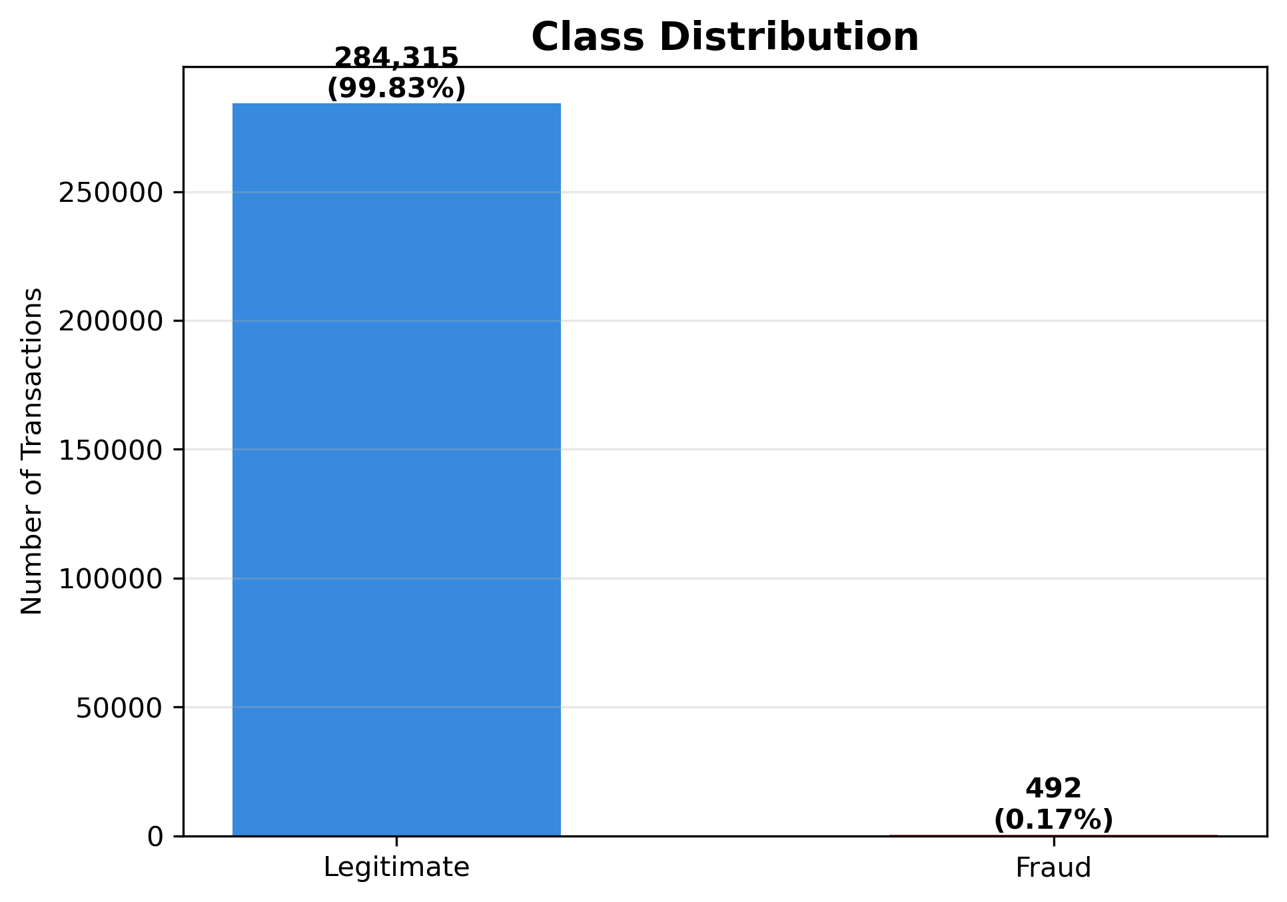
Figure 1. Class distribution — 284,315 legitimate transactions (99.83%) versus 492 fraudulent transactions (0.17%).
Because fraud represents such a small fraction of the data, a naive model that always predicts "legitimate" would already achieve 99.83% accuracy while catching zero fraud. This confirms that accuracy alone is not a suitable evaluation metric, and that precision, recall, F1-score, and ROC-AUC must be used instead.

3. Exploratory Data Analysis
Prior to modelling, the transaction Amount and Time fields were examined to understand their behaviour across the legitimate and fraudulent classes.
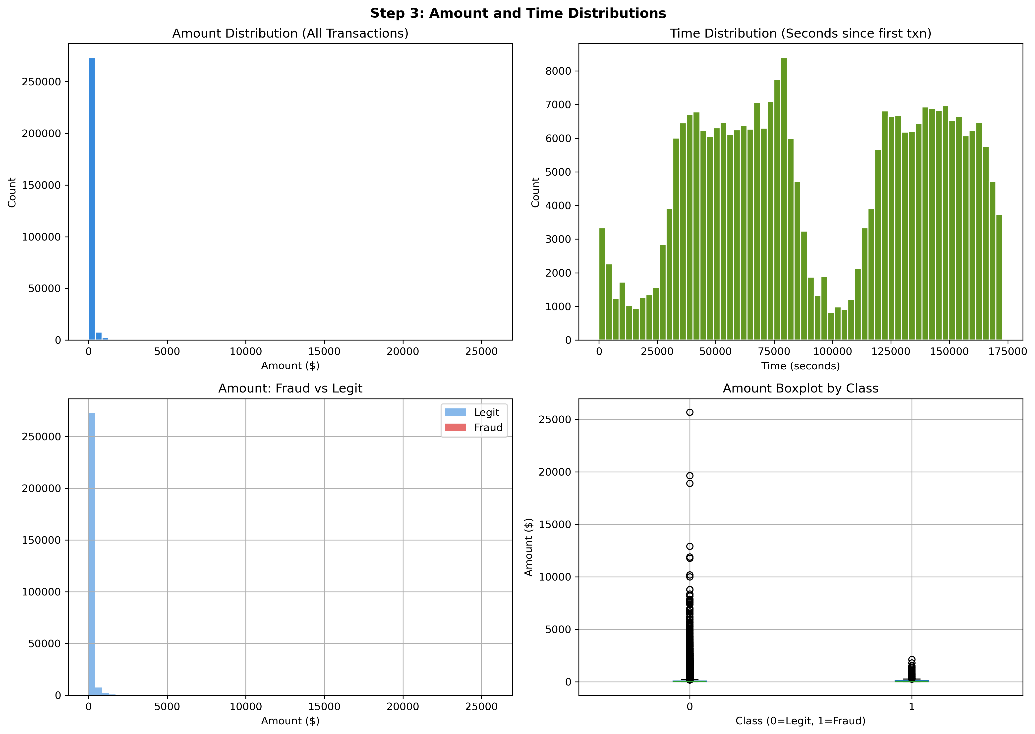
Figure 2. Amount and time distributions. Transaction amounts are heavily skewed toward small values, with rare high-value outliers reaching approximately $25,000. Transaction volume follows two daily activity waves, consistent with normal daytime spending patterns and a lull during overnight hours.
3.1 Feature Correlation with Fraud
Correlation coefficients between each of the 30 features and the fraud label were computed to identify which PCA components carry the strongest signal. Features V17, V14, V12, and V10 show the strongest negative correlation with fraud, while V11, V4, and V2 show the strongest positive correlation. This early signal is later confirmed by the model's SHAP-based feature importance ranking in Section 7.
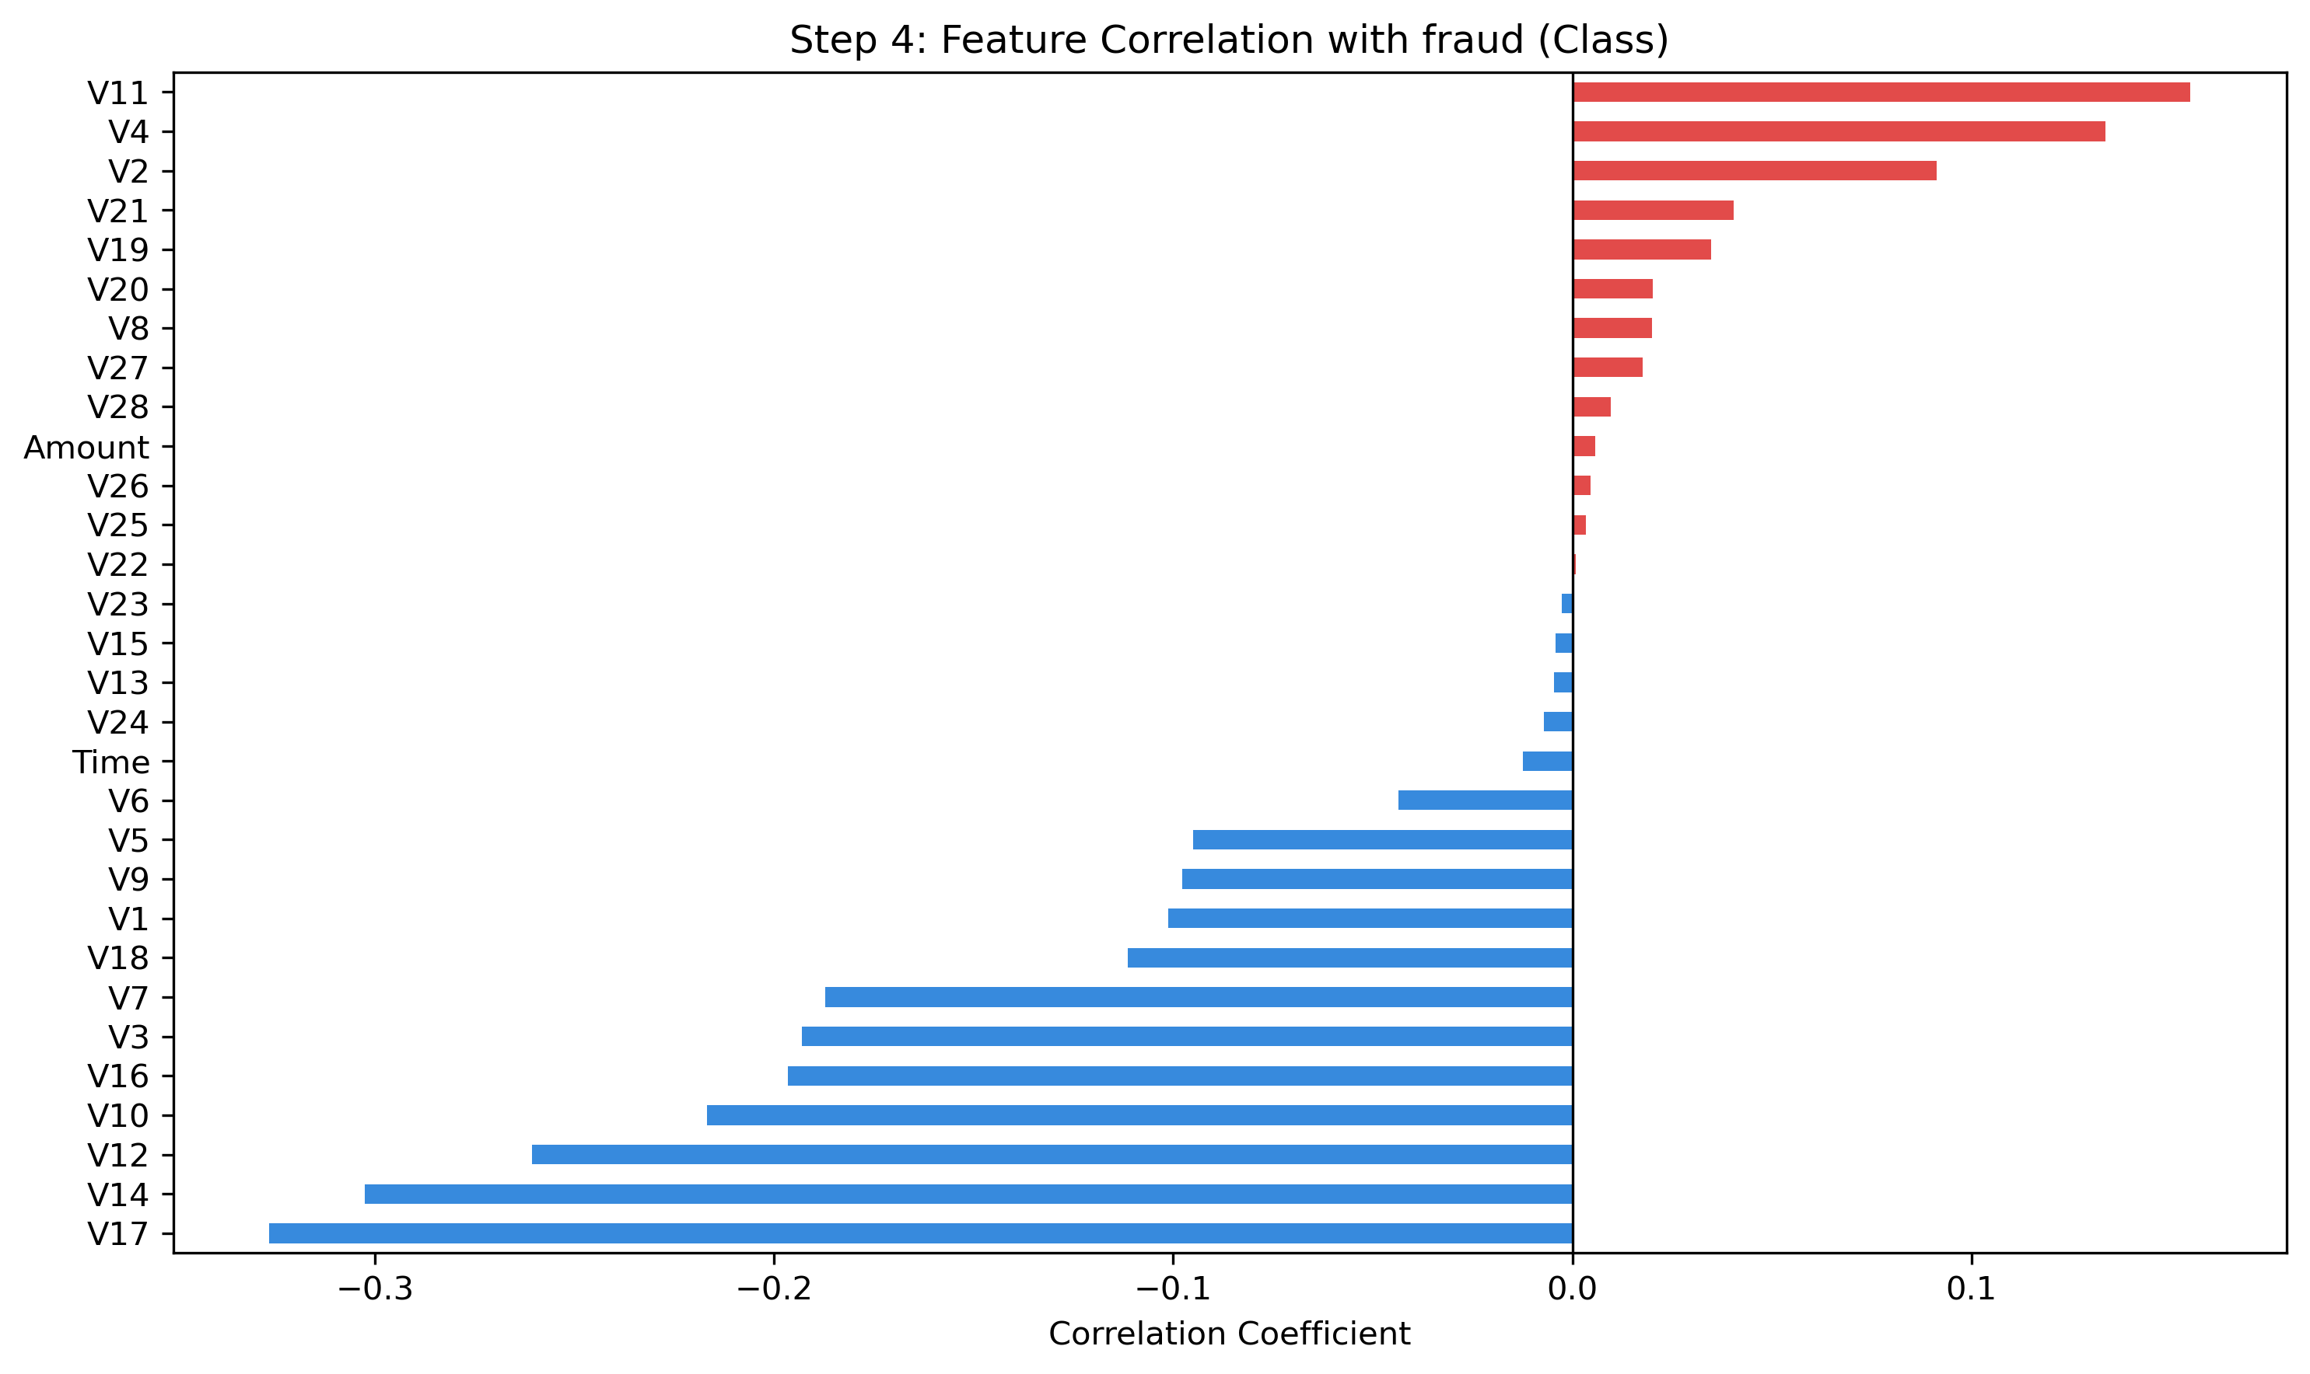
Figure 3. Correlation coefficient of each feature with the fraud label (Class), ranked from strongest negative to strongest positive.

4. Handling Class Imbalance
Two independent strategies were used to address the severe class imbalance present in the training data (227,451 legitimate transactions versus only 394 fraud cases after the train/test split):
- Approach A — scale_pos_weight: an XGBoost hyperparameter that increases the penalty applied to misclassified minority-class (fraud) examples during training, without altering the underlying dataset.
- Approach B — SMOTE (Synthetic Minority Oversampling Technique): synthetically generates new, plausible fraud examples until the minority class matches the size of the majority class.
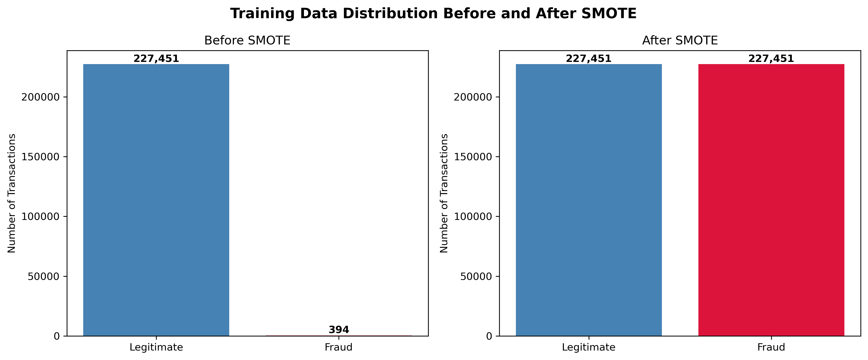
Figure 4. Training data class distribution before SMOTE (227,451 legitimate vs. 394 fraud) and after SMOTE (227,451 vs. 227,451 — perfectly balanced).

5. Model Training and Comparison
Five candidate models were trained and evaluated on the same held-out test set: XGBoost with scale_pos_weight, XGBoost with SMOTE-balanced training data, Random Forest, Logistic Regression, and LightGBM.
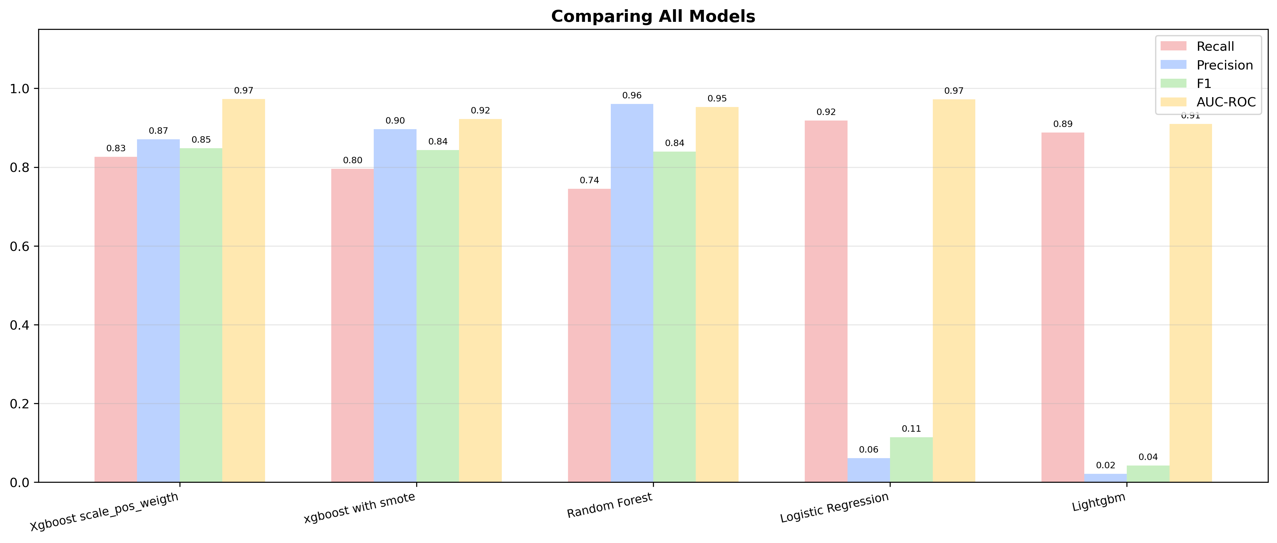
Figure 5. Recall, Precision, F1-score, and ROC-AUC compared across all five candidate models.
XGBoost with scale_pos_weight and Random Forest produced the most balanced results across all four metrics. Logistic Regression and LightGBM achieved high recall but near-zero precision, meaning they flagged large numbers of legitimate transactions as fraudulent and would be impractical in production due to excessive false alarms. Based on this comparison, XGBoost with scale_pos_weight was selected as the best-performing model and carried forward for hyperparameter tuning.

6. Hyperparameter Tuning and Final Model
A grid search was performed over the XGBoost hyperparameter space — max_depth {3, 5, 7}, learning_rate {0.01, 0.1, 0.2}, and n_estimators {100, 200} — producing 18 combinations, each evaluated using 5-fold stratified cross-validation and optimized for F1-score. The best configuration was retrained on the full training set to produce the final model.

Model | Recall | Precision | F1-Score | ROC-AUC
XGBoost (scale_pos_weight) | 0.83 | 0.87 | 0.85 | 0.97
XGBoost (SMOTE) | 0.80 | 0.90 | 0.84 | 0.92
Random Forest | 0.74 | 0.96 | 0.84 | 0.95
Logistic Regression | 0.92 | 0.06 | 0.11 | 0.97
LightGBM | 0.89 | 0.02 | 0.04 | 0.91

6.1 Final Confusion Matrix
Tuning improved the model on every count relative to the untuned baseline: fraud caught increased from 81 to 83, missed fraud cases decreased from 17 to 15, and false alarms decreased from 12 to 11.
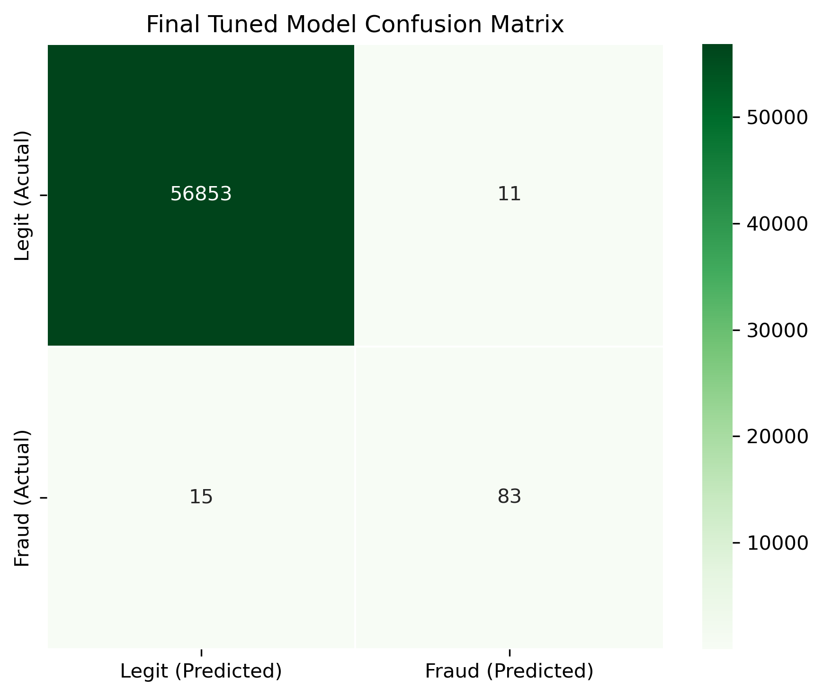
Figure 6. Confusion matrix of the final tuned model on the test set (56,853 true negatives, 11 false positives, 15 false negatives, 83 true positives).

7. Model Explainability (SHAP)
To ensure the model's decisions are transparent and auditable, SHAP (SHapley Additive exPlanations) was applied using a Tree Explainer. SHAP quantifies how much each feature contributes, positively or negatively, to an individual prediction, and can be aggregated to rank overall feature importance.
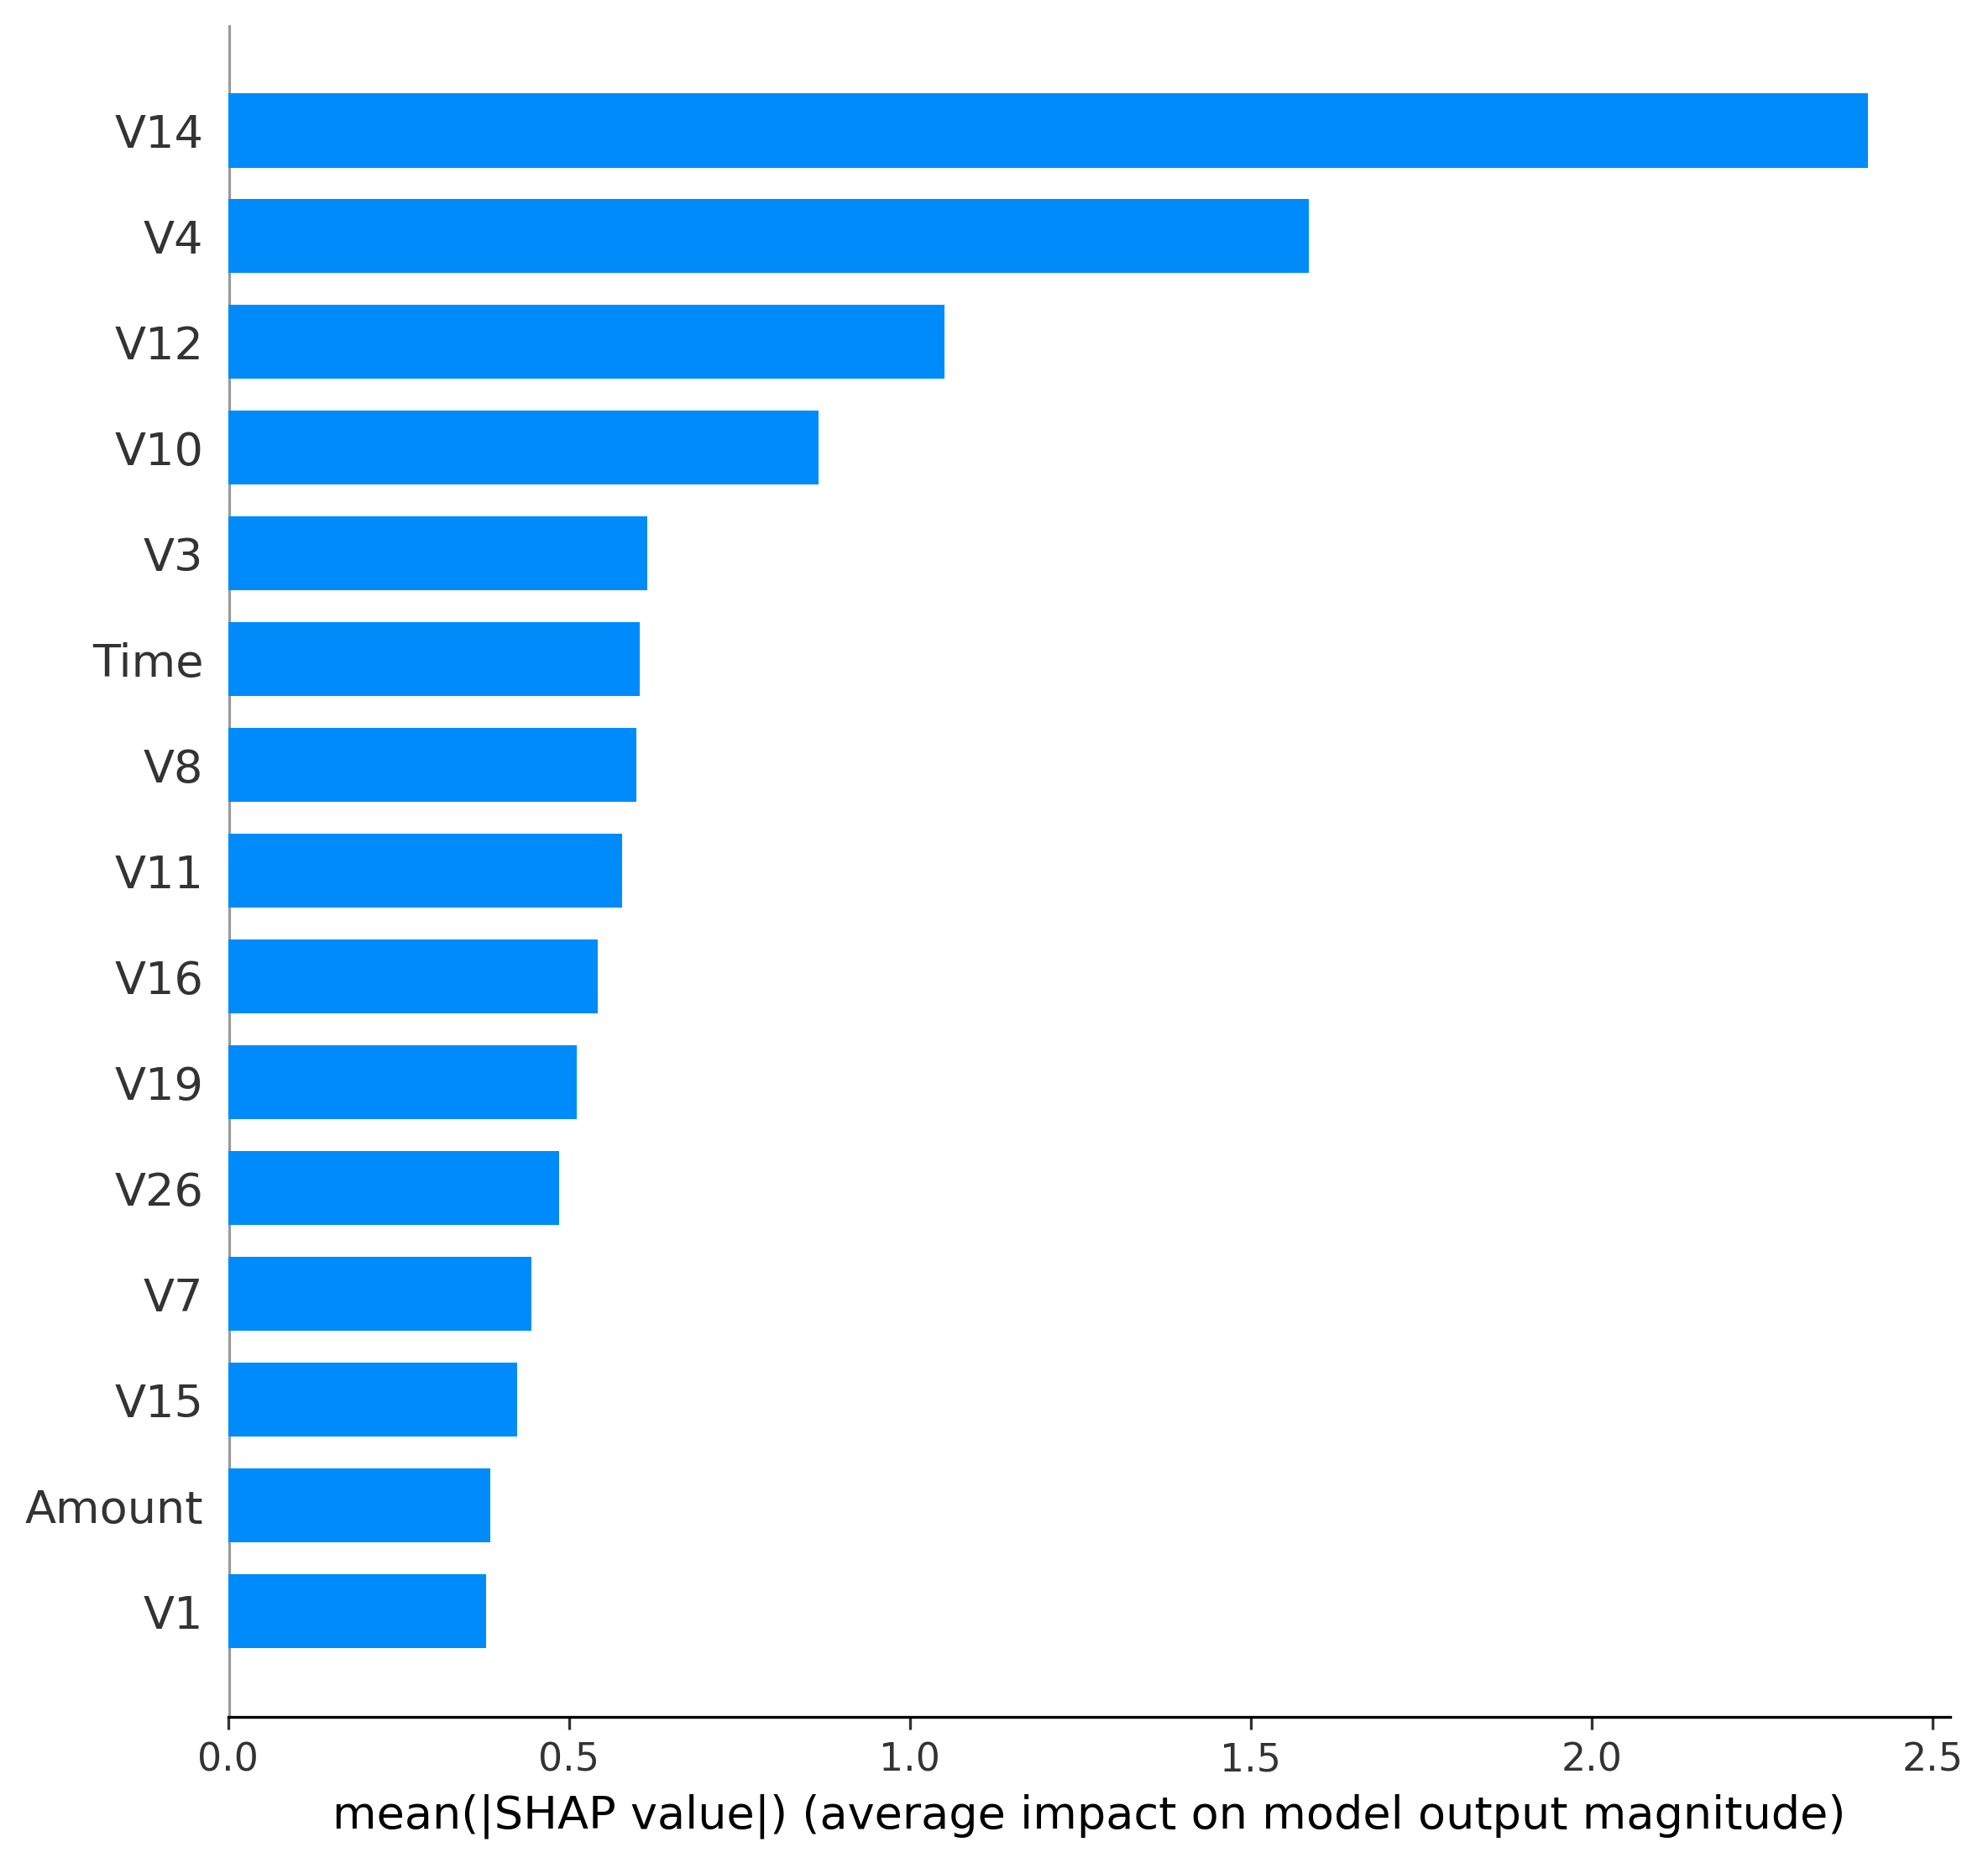
Figure 7. Mean absolute SHAP value per feature, ranking overall importance. V14, V4, V12, and V10 are the dominant drivers of the model's predictions, consistent with the correlation analysis in Section 3.1.
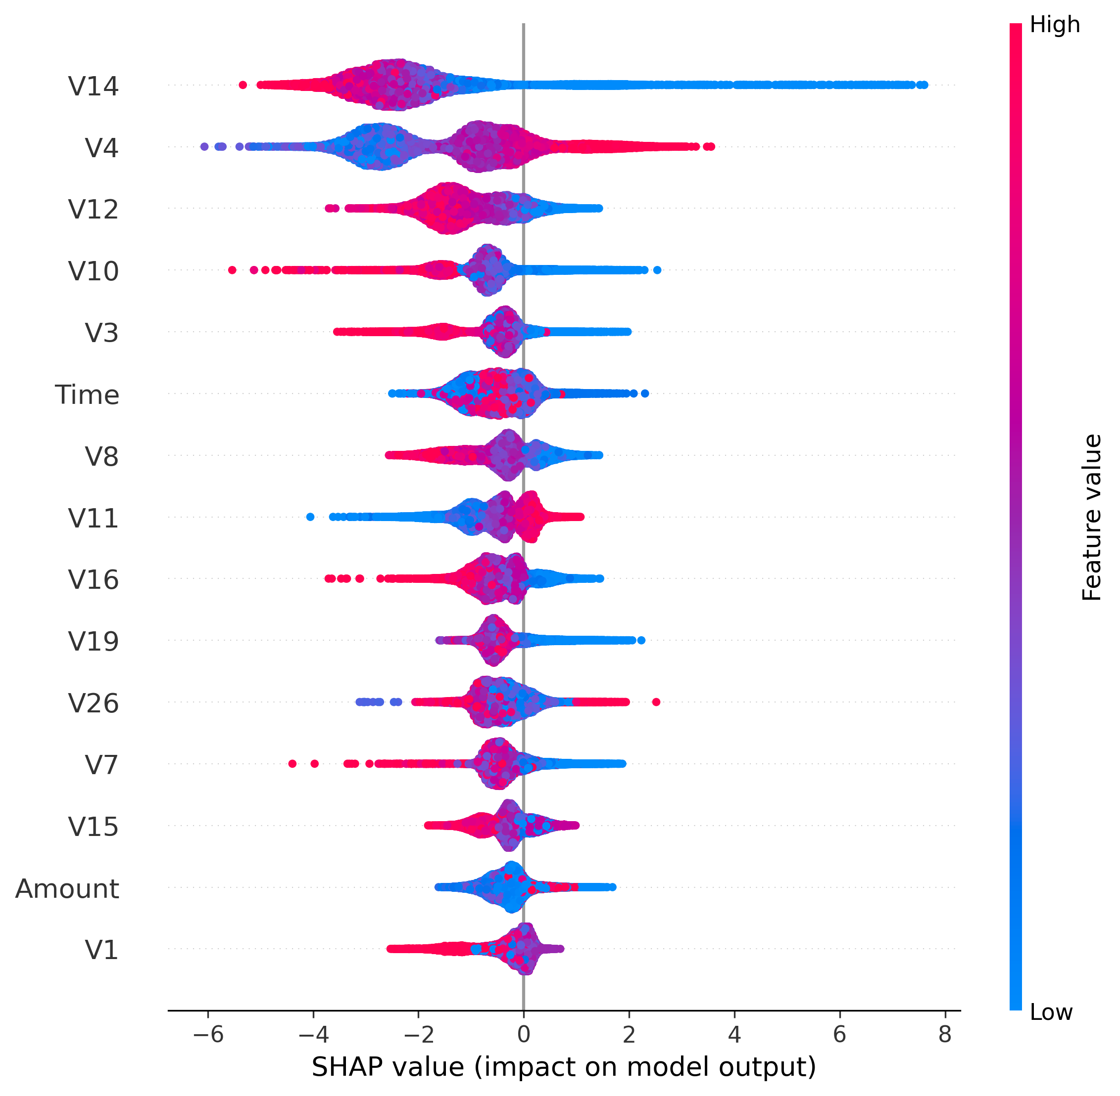
Figure 8. SHAP summary plot showing the direction and magnitude of each feature's effect across all test transactions.

8. Deployment
The final model, together with its associated feature scaler and the held-out test set, was packaged into an interactive Streamlit web application. The application provides four sections: a project overview (Home), an exploratory data analysis dashboard reproducing the figures in this document, a model performance dashboard, and a live fraud-prediction tool that lets a user select any transaction from the unseen test set and obtain an instant prediction with confidence score. For flagged transactions, the application can additionally generate a natural-language fraud investigation report using a large language model (Groq / Llama 3.3), summarizing the model's reasoning in plain English for a fraud analyst.

9. Conclusion
This project demonstrates a complete, production-oriented workflow for fraud detection on severely imbalanced data: careful exploratory analysis, principled handling of class imbalance, systematic comparison of multiple model families, targeted hyperparameter tuning, rigorous evaluation using imbalance-aware metrics, and transparent model interpretation via SHAP. The final tuned XGBoost model provides a strong balance between catching fraudulent activity and minimizing false alarms, and is delivered through a deployable, explainable, and analyst-friendly application.

