Institute of Architecture of Application Systems

University of Stuttgart
Universitätsstraße 38
D–70569 Stuttgart

Study Project

Cellular Automata for Cloud
Resource Alocation

Koushik Ragavendran

Course of Study: Information Technology

Examiner: Prof. Dr. Marco Aiello

Supervisor: Prof. Dr. Marco Aiello

Commenced: November 2, 2020

Completed: February 5, 2021

Abstract

The demand for cloud computing has increased in recent times. Many studies focus on allocating resource in data center for sustainable data center based on different metrics. The study here focus on reducing the cooling cost of the data center by optimizing the resource allocation in the data center.

The cellular automaton is modelled to represent the data center in which each cellular automata represent a host. The cellular automaton is evolved with a rule for finite number of generations and the state of hosts is recorded for each generation. At each optimization of resource allocation the current state of hosts to be configured is determined by the recorded state of hosts at each generation.

The result of the project consist of energy consumed by data center, which include the cooling energy for different number of Virtual machine and different rules of cellular automata evolution. The Wolfram’s rules according to their classification, Rule 23 and Rule 232 are plotted in the results.

1.1 Problem Statement:
The goal of green data center is to reduce the amount of energy consumed by data center. One of the metrics to reduce energy consumed by data center is the "cooling cost of data center". The cooling cost of the data center depends on the host utilization and the neighbours utilization. Therefore the problem is how to reduce the energy consumption by reducing the cooling cost.

1.2 Research Question:

1. How can topology of the hosts in the data center considered to reduce the energy consumption?

2. How can cellular automata be used in resource allocation problem?

1.3 Data Center Component: The data center consists of:

1. Columns: The data center consists of number of columns.

2. Rack: The column consists of number of racks.

3. Host: The rack consists of number of hosts. The hosts are the physical machine on which
Virtual Machines are placed.

4. Virtual Machine: The virtual machine is emulation of computer system that can process application request.

1.4 Assumptions:

1. Each application is served by only one virtual machine.

2. The temperature of host only depends on immediate neighbours and other neighbours are negligible.

3. The relation of temperature of the host and the utilization are assumed to be linear.

1.4 Document Structure:
The remaining part of the document is organised as follows. Chapter 2 gives the related work on sustainable data center and cellular automata. Chapter 3 gives the implementation of the project. Chapter 4 gives the results of simulation. In Chapter 5 we discuss on conclusion of the results. And Chapter 6 gives the future works on this topic.

The metrics to consider for sustainable data center like Energy Efficiency, Cooling, Green, Performance, Thermal and Air Management, Network, Storage, Security and Financial Impact are discussed in[RSR+17]. The cloudsim is a simulation framework that enables modeling, simulation, and experimentation of Cloud Computing Infrastructure[GSA12], which is extended in this project. Task scheduling in data center for minimizing the heat recirculation is discussed in[TGV07], where the tasks are scheduled with Genetic Algorithm. Load and thermal aware VM scheduling in data center reduces the temperature and improving load balancing by not allowing the host in data center to cross the threshold temperature[MJT+13]. Energy aware virtual machine allocation and selection in data center not only reduces energy consumption, but also reduces the violations of Service Level Agreement, which is discussed in[DGR19]. ThermoSim, deep learning framework for predicting temperature of the host with allocation as input and reduce the energy consumption with appropriate allocation[GTT+20], which also proposes that it is better than Thas[MJT+13]. Learning based resource allocation in data center using Reinforcement Learning to reduce energy consumption, which is discussed in[CHM19]. Usage of cellular automata in solving problems in applications like VLSI design and testing, Pseudo random number generation, Cryptography and Pattern Classification is discussed in [GKSS18]. The rules of cellular automata and Wolfram’s classification is discussed in [MSZ12].

3.1 Modelling:
The cloudsim tool is used for cloud simulation in this project. This simulator tool is extended in this project to model the data center and host. The data center and host used in this project are named as Thermal data center and Thermal host.

3.1.1 Thermal host:The Thermal host is extension of Power host from cloudsim simulator tool. It contains the temperature value of the host. The Thermal host is modelled in such a way that the temperature of the host depends on the current utilization of it and neighbour’s utilization. The UML class diagram of Thermal host is given in figure Fig. 1.

Initially, temperature of the host is updated as per utilization of the host. While updating the temperature, previous temperature is added to output of the Thermal model given the utilization of the host as input. And then, temperature is updated as per its neighbours utilization using Thermal factor, which is small constant. While updating the temperature, previous temperature is also added to product of Thermal factor and output of Thermal model given its neighbour’s utilization as input.

)current = )previous + C 4A<0;">34;(DC8;8I0C8>=) + C 4A<0; 02C>A ∗ )neighbour

3.1.2 Thermal data center:The Thermal data center is extension of Power data center from cloudsim simulator tool. It overrides the updateCloudLetProcessingWithoutScheduleFutureEvent and updates the temperature of the host at regular interval. The UML class diagram of Thermal data center is given in figure Fig. 2.

At regular interval, initially the temperature change of host based on utilization is calculated. Then as the temperature change of all the Thermal hosts is calculated, the temperature of host is updated based on its neighbours temperature change and its temperature change.

)change ( >BC(8)) = C 4A<0;">34;(DC8;8I0C8>=)

)neighbour ( >BC(8)) = C 4A<0; 02C>A ∗ ()change ( >BC(8 − 1)) + )change ( >BC(8 + 1)))

)current ( >BC(8)) = )previous ( >BC(8)) + )change ( >BC(8)) + )neighbour ( >BC(8))

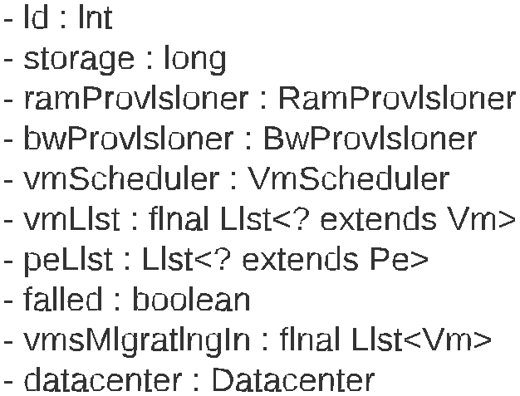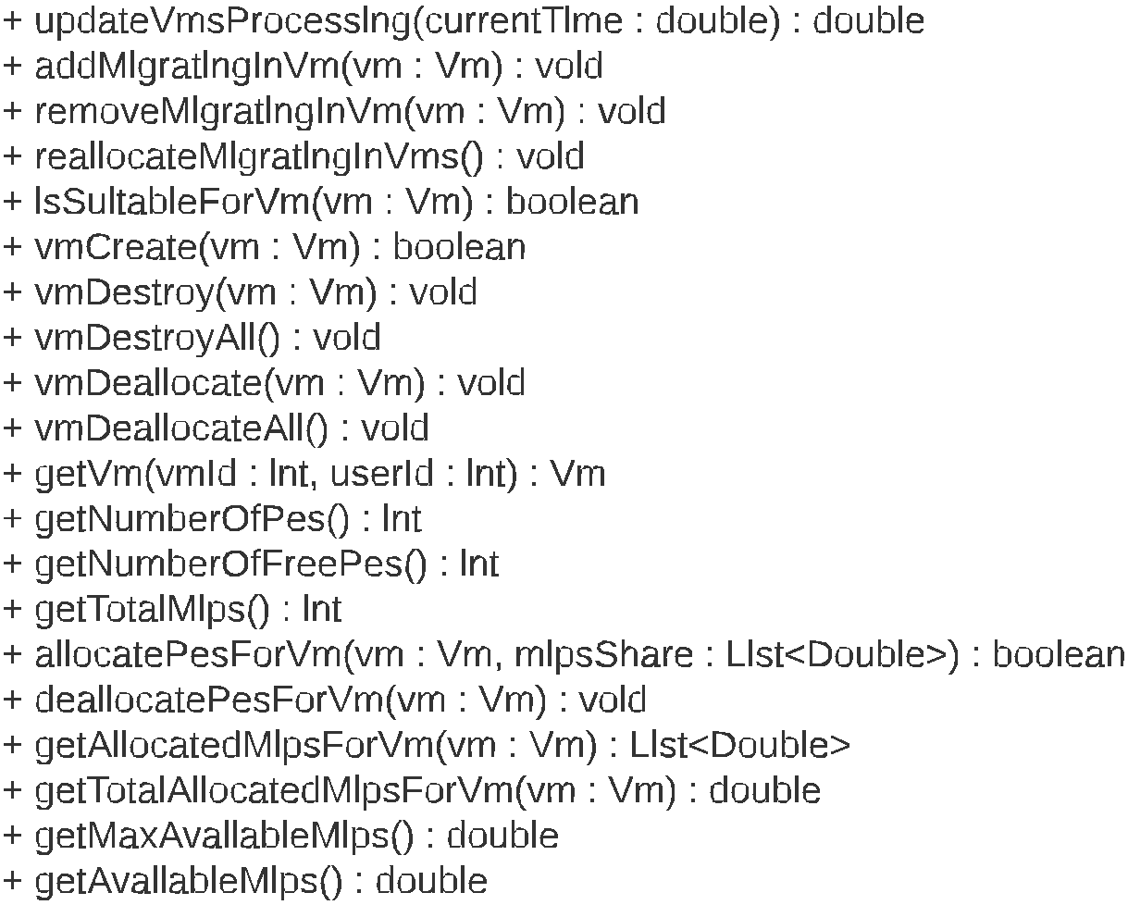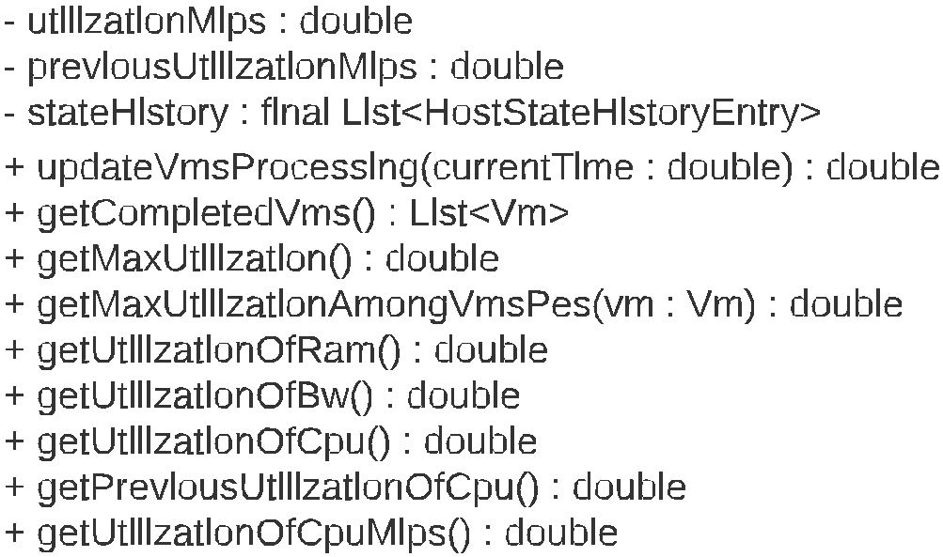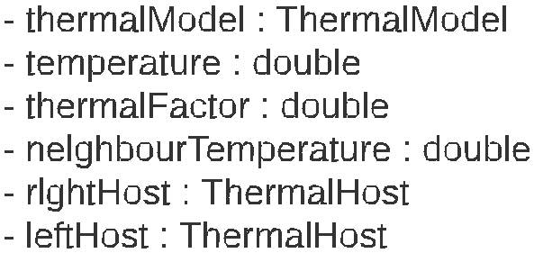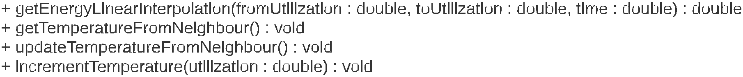The figure Fig. 1. gives the UML class diagram of ThermalHost.

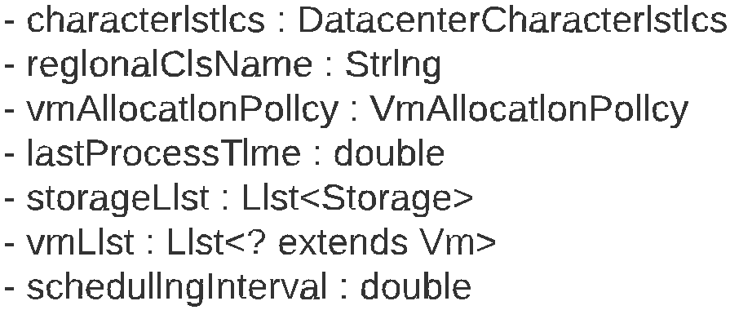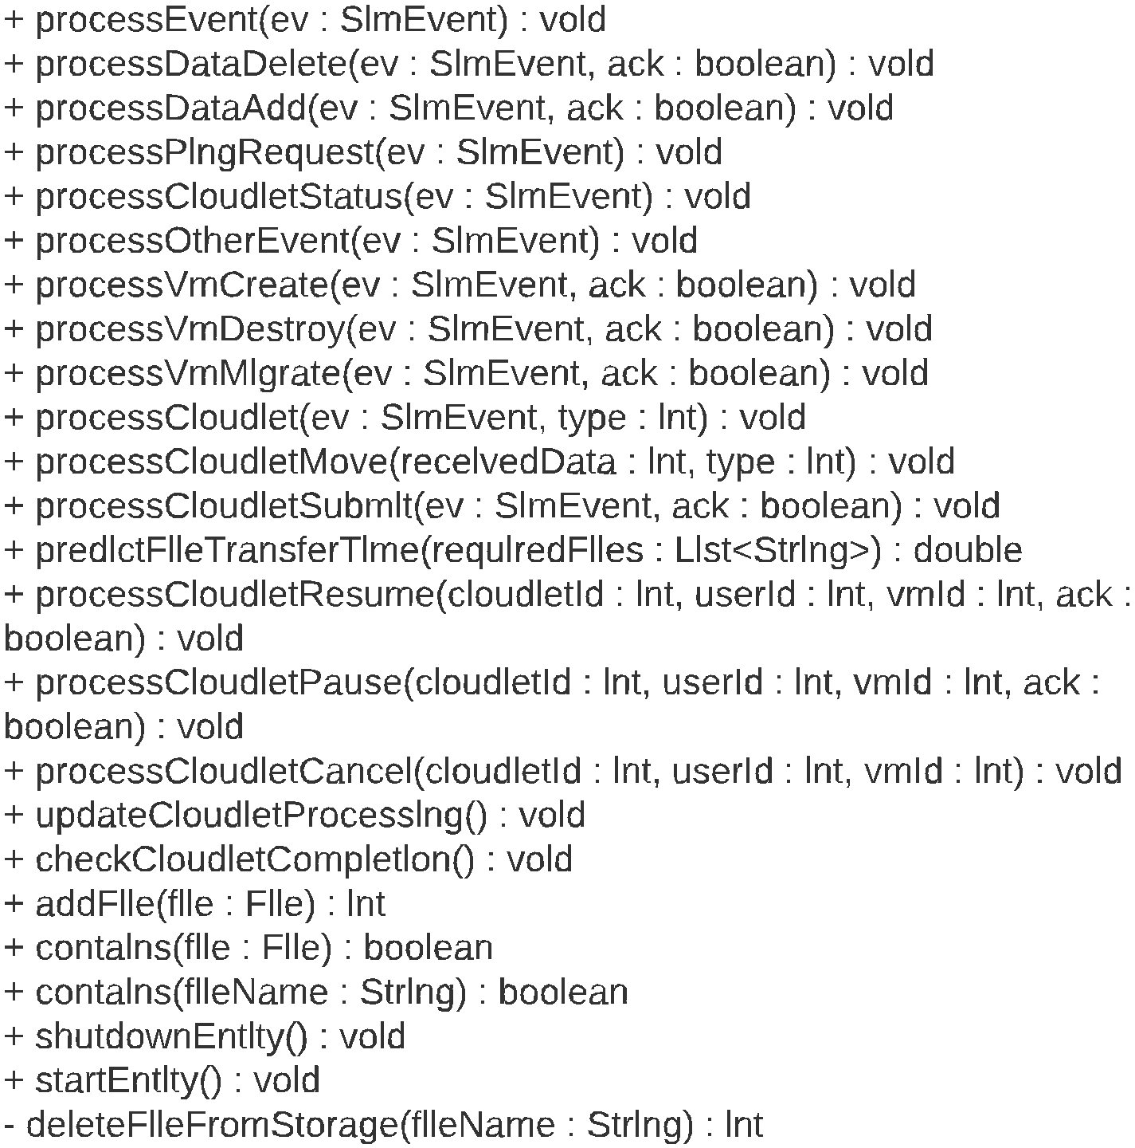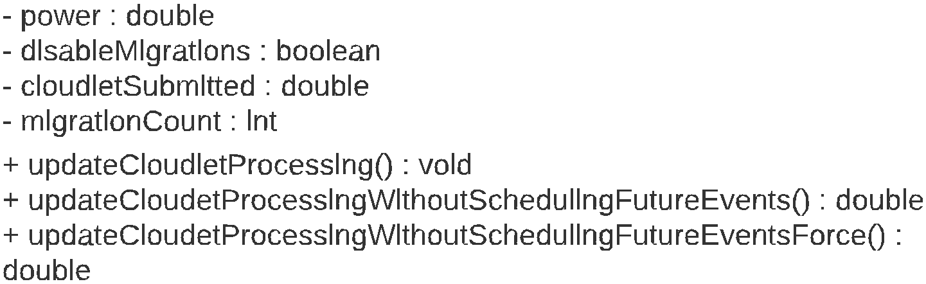The figure Fig. 2. gives the UML class diagram of ThermalDataCenter.

3.2 Simulation:
In this project simulations are done in cloudsim-example package. In these simulations we have created data center with 10 columns, 10 racks per column and 10 host per rack, in total we have created 1000 hosts in the data center. Before the start of each simulation the cellular automaton with 1000 cellular automata is evolved for finite number of generations. The state of host/cellular automata at different generation evolved with Rule 232 and Rule 23 is given in figure Fig. 3. and Fig. 4.. In the figures, the state of cellular automaton at different generation like 0, 5, 10, 50,
100 and 199 is shown and black represent the host is switched on and white represent the host is switched off.

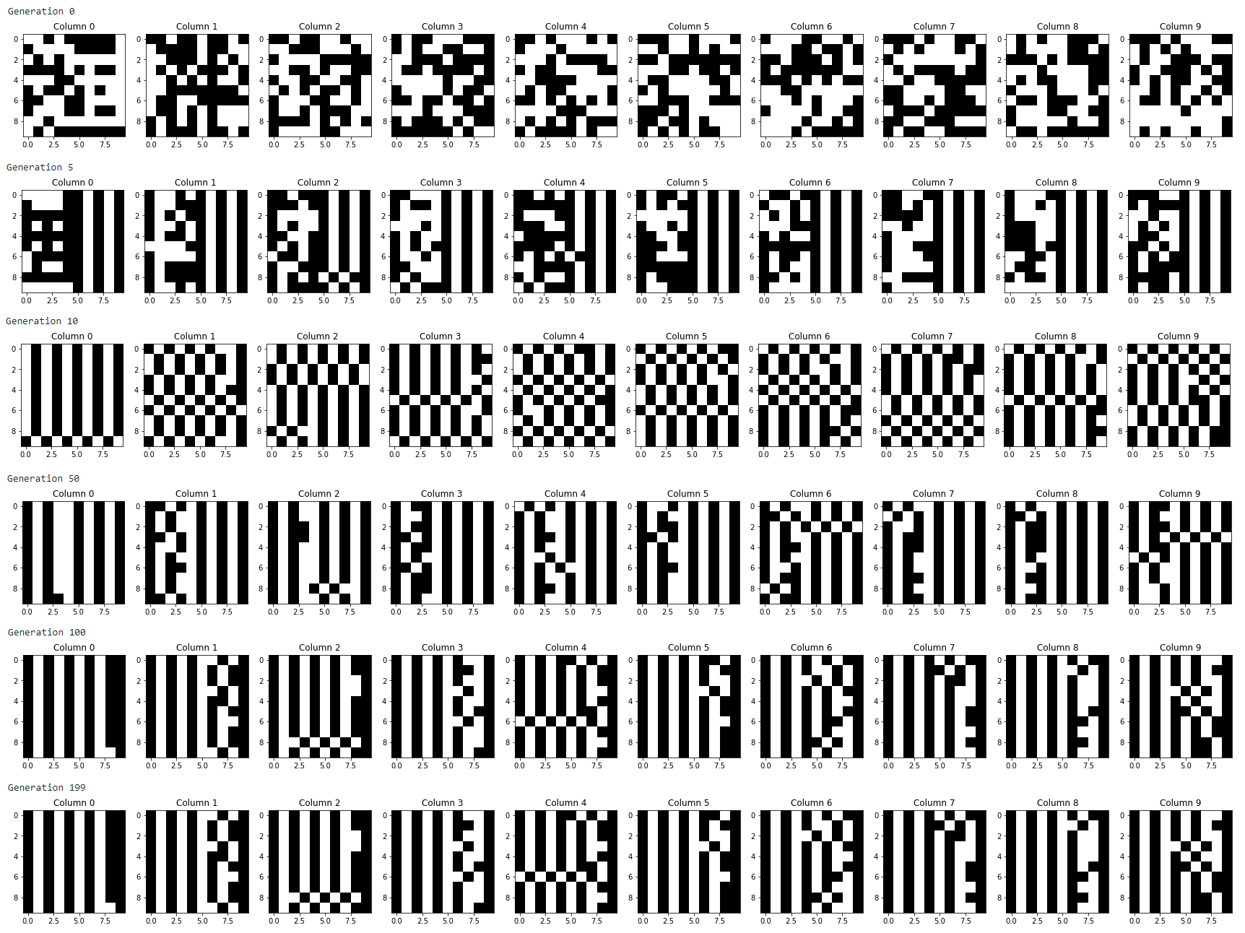

The figure Fig. 3. gives generations with Rule 232.

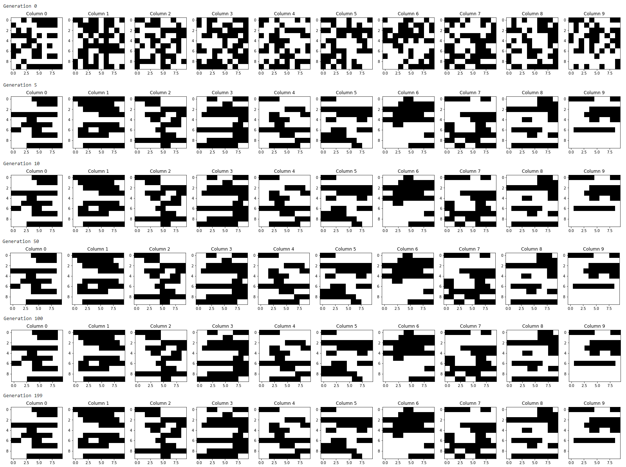

The figure Fig. 4. gives generations with Rule 23.

The simulations is conducted with different number of application to serve and evolving the cellular automata with different rules. For each number of applications to serve, for each rule of evolving cellular automata the simulation is started and after the completion of the simulation the results can be observed. The architecture diagram and sequence diagram of a simulation is given in figure Fig.
5. and Fig. 6. respectively

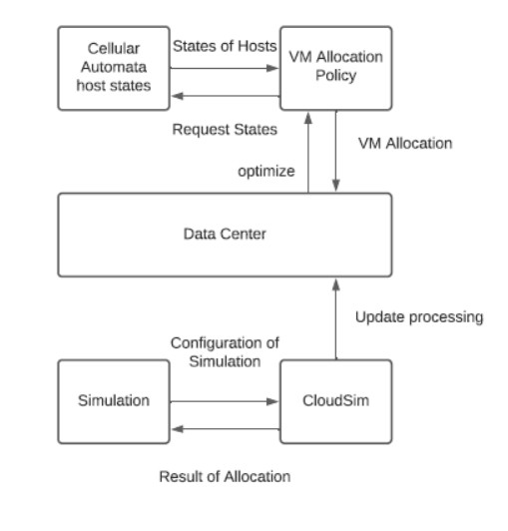
The figure Fig. 5. gives the Architecture of Virtual Machine Allocation.

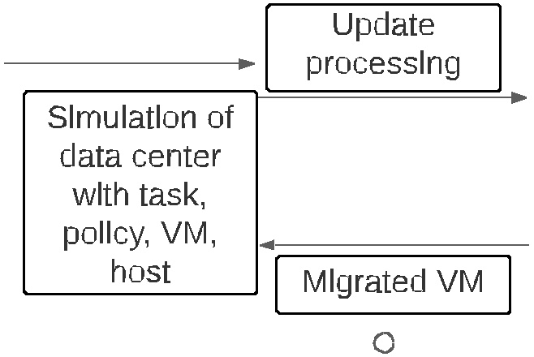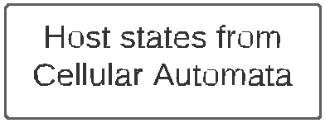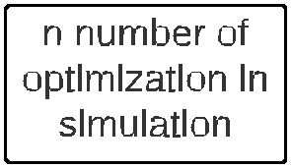

The figure Fig. 6. gives the sequence diagram of simulation.

3.3 Virtual Machine Allocation:
In this project cloudsim simulator tool uses ThermalVmAllocationPolicyCellularAutomaton to optimize the Virtual Machine allocation in the data center. The optimization algorithm of Virtual Machine allocation is given in algorithm Algorithm 3.1.

Algorithm 3.1 ThermalVMAllocationPolicyCellularAutomaton
1: function OptimizationAllocation
2: shutDownHost ← shutDownHostFromCellularAutomataEvolution
3: for all >BC ∈ shutDownHost do
4: vmsToMigrate ← vmsToMigrate ∪ getVmOfHost(host)
5: end for
6: nonShutDownHost ← nonShutDownHostFromCellularAutomataEvolution
7: for all E< ∈ vmsToMigrate do
8: for all >BC ∈ nonShutDownHost do
9: if hostSuitableForVm then
10: migrationMap ← migrationMap ∪ >BC, E<
11: break
12: end if
13: end for
14: end for
15: return migrationMap
16: end function

4 Result

The simulations are done for different number of virtual machine/Application and different rules of cellular Automata evolution. The number of virtual machine/application is increased by 100 from 200 to 700 and rules from 0 to 255 for each simulation. The result are observed with energy consumption.

The energy consumed for number of virtual machine/application for Rule 23 and Rule 232 is given in figure Fig. 7.

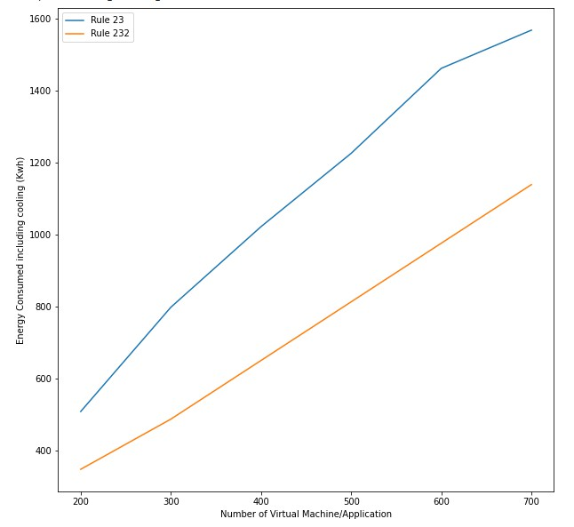
The figure Fig. 7. gives the energy consumed for number of virtual machine/application for Rule
23 and Rule 232.
4 Result

As per Wolfram’s classification of rules, the energy consumed for rules from each Wolfram’s classification is averaged. The energy consumed for number of virtual machine/application for each Wolfram’s classification is given in figure Fig. 8.

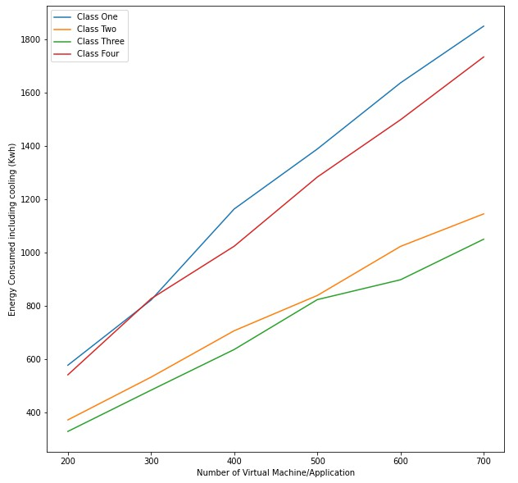
The figure Fig. 8. gives the energy consumed for number of virtual machine/application for each
Wolfram’s classification.

Initially we started with question on how to consider the topology of the hosts in the data center in reducing the energy consumption. This was done using the cellular automata by evolving the state cellular automata as a function of state of itself and its neighbour, so that the thermal effect is spread out in the data center and not concentrated at particular location, this in turn reduces energy consumption due to cooling. And next question was how can cellular automata be used in resource allocation problem. This was done by evolving the cellular automata over finite number of generation and recording them and using the recorded generation to determine the hosts state at every optimization.

4.1 Rule 23 and Rule 232:
The host considered here are itself, right host and left host. Rule 23 switches off the host if less than
2 hosts in consideration is switched on, else switches on the host. The generations with Rule 23 have same allocation where the temperature is not distributed in the data center. Rule 232 switches off the host if more than 1 host in consideration is switched on, else switches on the host. The generations with Rule 232 follows a pattern where the temperature is distributed in data center. Therefore from result we can see that performance of Rule 232 is better than Rule 23.

4.2 Wolfram’s classification:[MSZ12]
The performance order of Wolfram’s classification is class 3 > class 2 > class 4 > class 1 from the results.

1. Class 1: Cellular automata which rapidly converge to a uniform state. Examples are rules 0,
32, 160 and 232.

2. Class 2: Cellular automata which rapidly converge to a repetitive or stable state. Examples are rules 4, 108, 218 and 250.

3. Class 3: Cellular automata which appear to remain in a random state. Examples are rule 22,
30, 126, 150 and 182.

4. Class 4: Cellular automata which form areas of repetitive or stable states, but also form structure that interact with each other in complicated ways. An example is rule 110.

The class 3, which remain in the random state outperforms all the other classification. but, there is no pattern in class 3 we cannot determine whether it can outperform in all cases. From the graph, the performance of class 3 and class 2 are almost equal. In our case, evolution of cellular automata with rules from class 2 has better performance than class 4 and class 1.

In future following study can be done:

1. Relation between performance of different Wolfram’s classification.

2. Relation between performance of rules from same Wolfram’s classification.

3. Compare the result from cellular automata resource allocation and resource allocation from other related work as discussed in the chapter 2.

[CHM19] Z. Chen, J. Hu, G. Min. “Learning-Based Resource Allocation in Cloud Data Center using Advantage Actor-Critic”. In: ICC 2019 - 2019 IEEE International Conference on Communications (ICC). 2019, pp. 1–6. doi: 10.1109/ICC.2019.8761309 (cit. on p. 4).
[DGR19] V. Dinesh Reddy, G. R. Gangadharan, G. S. V. R. K. Rao. “Energy-aware virtual machine allocation and selection in cloud data centers”. In: Soft Computing 23.6 (Mar.
2019), pp. 1917–1932. issn: 1433-7479. doi: 10.1007/s00500-017-2905-z. url:
https://doi.org/10.1007/s00500-017-2905-z (cit. on p. 4).

[GKSS18] M. Ghosh, R. Kumar, M. Saha, B. K. Sikdar. “Cellular Automata and Its Applications”.
In: 2018 IEEE International Conference on Automatic Control and Intelligent Systems
(I2CACIS). 2018, pp. 52–56. doi: 10.1109/I2CACIS.2018.8603689 (cit. on p. 4).

[GSA12] T. Goyal, A. Singh, A. Agrawal. “Cloudsim: Simulator for cloud computing infras- tructure and modeling”. In: Procedia Engineering 38 (Dec. 2012), pp. 3566–3572. doi: 10.1016/j.proeng.2012.06.412 (cit. on p. 4).
[GTT+20] S. S. Gill, S. Tuli, A. Toosi, F. Cuadrado, P. Garraghan, R. Bahsoon, H. Lutfiyya, R. Sakellariou, O. Rana, S. Dustdar, R. Buyya. “ThermoSim: Deep Learning based Framework for Modeling and Simulation of Thermal-aware Resource Management for Cloud Computing Environments”. In: Journal of Systems and Software 166 (Apr.
2020), p. 110596. doi: 10.1016/j.jss.2020.110596 (cit. on p. 4).

[MJT+13] Y. Mhedheb, F. Jrad, J. Tao, J. Zhao, J. Kołodziej, A. Streit. “Load and Thermal- Aware VM Scheduling on the Cloud”. In: Dec. 2013. isbn: 978-3-319-03858-2. doi:
10.1007/978-3-319-03859-9_8 (cit. on p. 4).

[MSZ12] G. J. Martinez, J. Seck Tuoh Mora, H. Zenil. “Wolfram’s Classification and Computa- tion in Cellular Automata Classes III and IV”. In: (Aug. 2012). doi: 10.1007/978-3-
642-35482-3_17 (cit. on pp. 4, 14).

[RSR+17] V. D. Reddy, B. Setz, G. S. V. R. K. Rao, G. R. Gangadharan, M. Aiello. “Metrics for Sustainable Data Centers”. In: IEEE Transactions on Sustainable Computing 2.3 (2017), pp. 290–303. doi: 10.1109/TSUSC.2017.2701883 (cit. on p. 4).
[TGV07] Q. Tang, S. K. S. Gupta, G. Varsamopoulos. “Thermal-aware task scheduling for data centers through minimizing heat recirculation”. In: 2007 IEEE International Conference on Cluster Computing. 2007, pp. 129–138. doi: 10.1109/CLUSTR.2007.
4629225 (cit. on p. 4).

All links were last followed on February 05, 2021.

