**Day 3 – (05/12/2022)**

1. **Program to implement a button (On Click event)**

**Button.js**

function Button()

{

    function Main()

    {

        alert("fuction called");

    }

    return(

        <div>

            <button onClick="{Main}"> Click Me</button>

            <Main/>

        </div>

    );

}

export default Button;

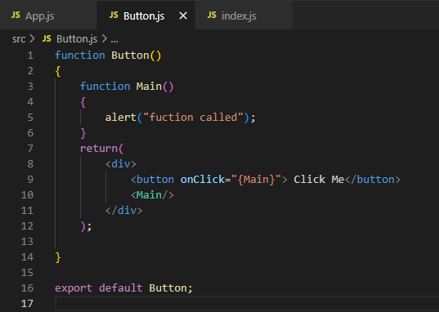

**App.js**

import './App.css';

import Button from './Button';

function App()

{

 return(

  <div>

    <Button/>

  </div>

 );

}

export default App;

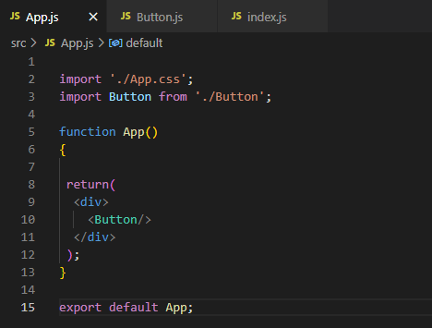

**Index.js**

import React from 'react';

import ReactDOM from 'react-dom/client';

import './index.css';

//

import App from './App';

//import Koushik from './Koushik';

//import FunInFun from './FunInFun';

//import Gitam from './Gitam';

import reportWebVitals from './reportWebVitals';

const root = ReactDOM.createRoot(document.getElementById('root'));

root.render(

  <React.StrictMode>

    <App/>

  </React.StrictMode>

);

// If you want to start measuring performance in your app, pass a function

// to log results (for example: reportWebVitals(console.log))

// or send to an analytics endpoint. Learn more: https://bit.ly/CRA-vitals

reportWebVitals();

**Output :**

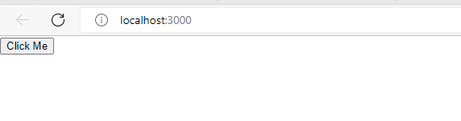

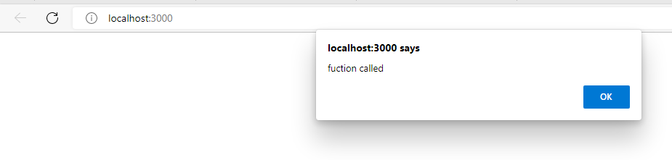

1. **Program to use the arrow function**

**App.js**

import './App.css';

//import Button from './Button';

function App()

{

  function Apple()

  {

    alert("Function Called");

  }

  return (

    <div className="App">

      <button onClick={( )=>alert("hello")}>Click Me</button>

      <Apple/>

    </div>

  );

}

export default App;

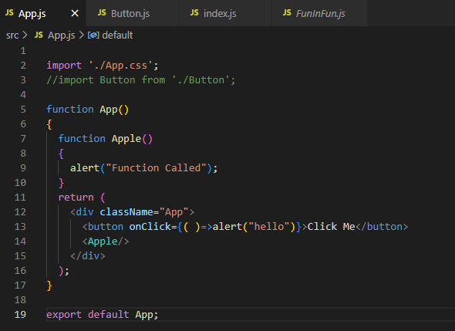

**Output :**

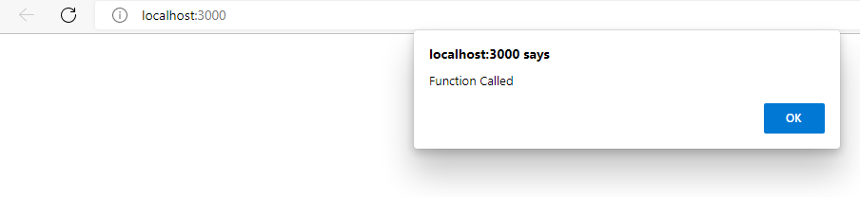

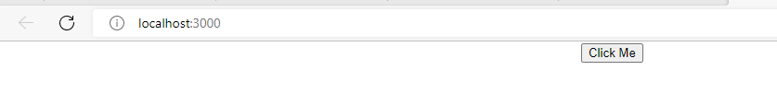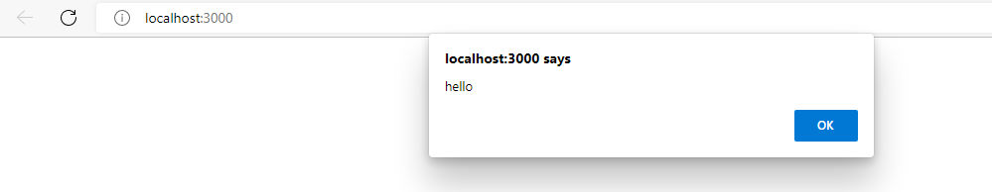

1. **Implementation of Class Component**

**University.js**

import React,{Component} from 'react';

class University extends Component{

    render()

    {

        return (

            <div>

                <h1>Koushik</h1>

                <h1>221910307015</h1>

            </div>

        )

    }

}

export default University;

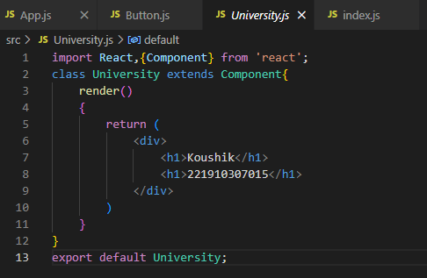

**App.js**

import './App.css';

import University from './University';

function App()

{

  return(

    <div>

      <University/>

    </div>

  )

}

export default App;

**Output:**

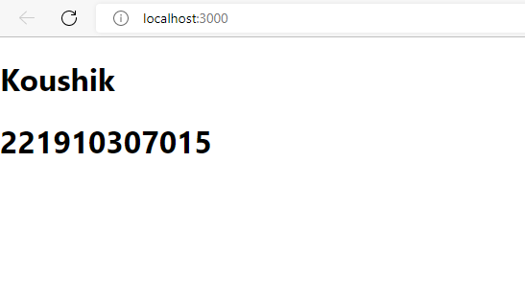

1. **Implementing the variables**

Use of the **let** keyword for declaring a variable

**App.js**

import './App.css';

//import University from './University';

function App()

{

  let data="Gitam";

  function Main()

  {

     alert("Function called");

  }

  return(

    <div>

      <h1>{data}</h1>

      <button onClick={Main}>Click Me</button>

    </div>

  );

}

export default App;

**Output :**

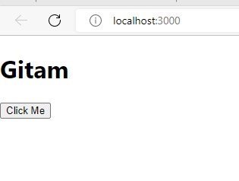

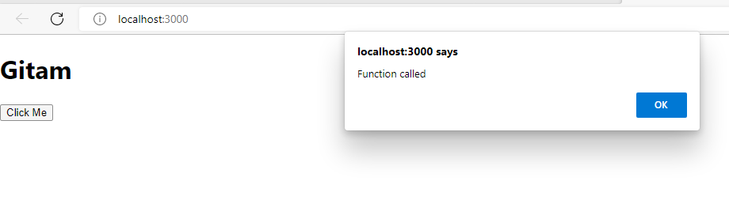

1. **Implementing the variables**

**The data will not be changed to the new value in the variables this is a drawback in the variables**

**App.js**

import './App.css';

//import University from './University';

function App()

{

  let data="Koushik";

  function Main()

  {

    data="Gitam";

     alert(data);

  }

  return(

    <div>

      <h1>{data}</h1>

      <button onClick={Main}>Click Me</button>

    </div>

  );

}

export default App;

**Output :**

