***Assignment – Day 4***

**Code : App.js**

import './App.css';

//import Assign2 from './Assign2';

import {useState} from 'react'

function App()

{

  const[GITAM,setData]=useState("Koushik")

  function Assignment2(){

    //var GITAM="Koushik";

    setData("Assignment3");

}

return (

  <div className="App">

    <h1>{GITAM}</h1>

    <button onClick={Assignment2}>Koushik_Assignment</button>

  </div>

)

}

export default App;

**App.js screenshot**

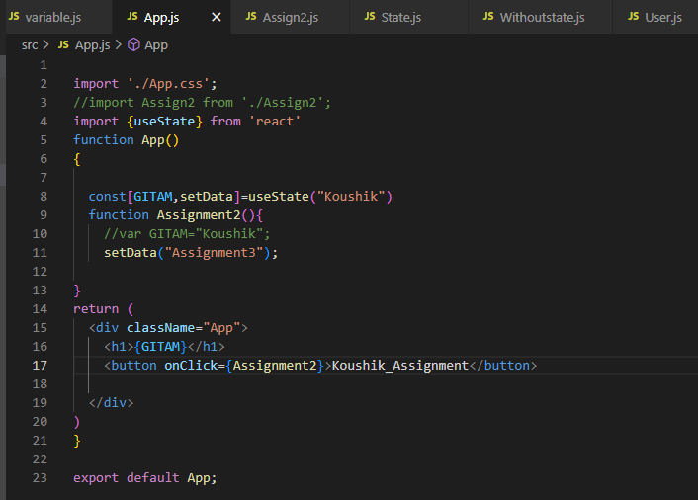

**Output :**

