1. Program to demonstrate the concept of state by using functional component.

**Syntax : Const(Data,setData)= use Data(“abc”);**

Data = name of the variable ; setData = Updating to the new value

Use data = Initialize the starting value of the variables

State can be used in both functional component and class component.

In the class component if we want to use the state concept we need to have one constructor and in that constructor we need to call super constructor and we need to access the variables with the help of **this** keyword.

1. Declaration of a variable with related to state in class component can be return as

**this.data={**

**data=1;**

**}**

1. This can be also declared as

**this.state={**

**data=1;**

**}**

1. setState is used to update the value of the present variable.

**Programs :**

1. Program which explains the drawback of using Variables.

**Withoutstate.js**

function Withoutstate()

{

    let data="Koushik";

    function updateData()

    {

        data="Gitam";

        alert(data);

    }

    return(

        <div className="Withoutstate">

        <h1>{data}</h1>

        <button onClick={updateData} >Update Data </button>

        </div>

    );

}

export default Withoutstate;

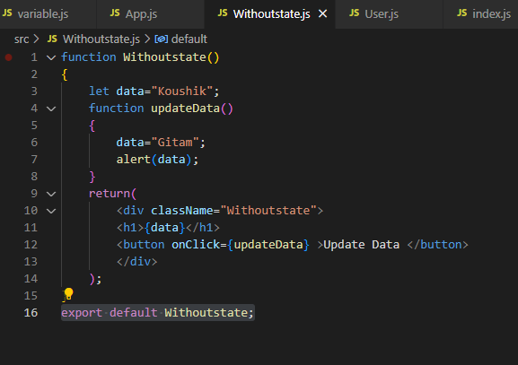

**App.js**

import './App.css';

import Withoutstate from './Withoutstate';

function App()

{

return(

  <div className="App">

    <Withoutstate/>

  </div>

);

}

export default App;

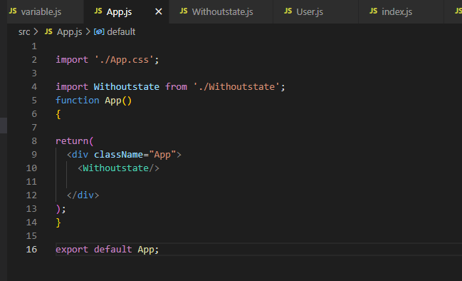

**Output :**

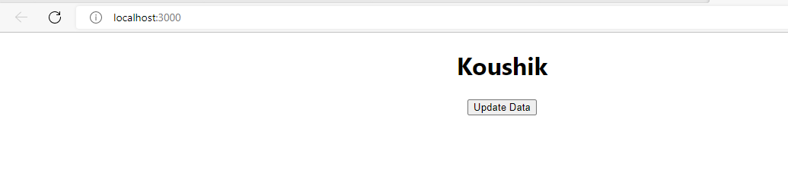

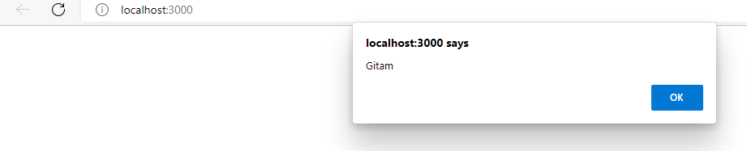

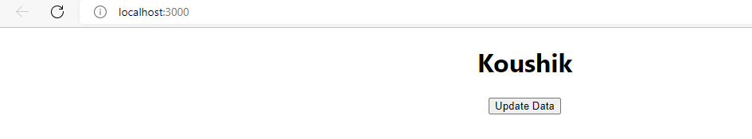

1. **Program to implement the state in functional component**

**Code:**

import {useState} from 'react'

function State()

{

    const[data,setData]=useState("Koushik")

    function updateData()

    {

        setData("Gitam");

    }

    return(

        <div className="State">

            <h1>{data}</h1>

            <button onClick={updateData}>Update Name</button>

        </div>

    )

}

export default State;

**State.js**

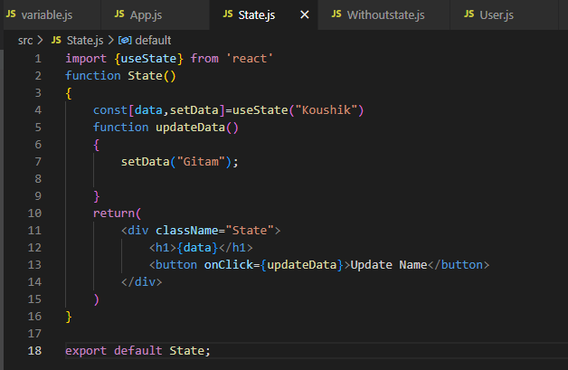

**App.js**

import './App.css';

import State from './State';

function App()

{

return(

  <div className="App">

    <State/>

  </div>

);

}

export default App;

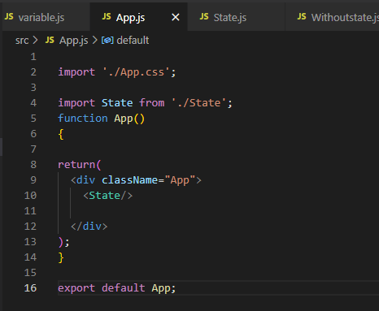

**Output :**

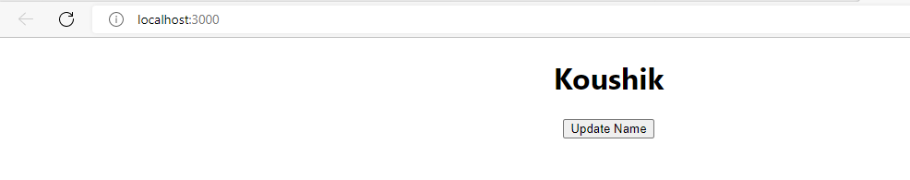

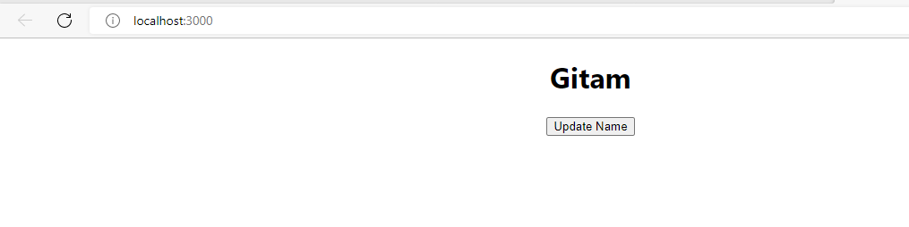

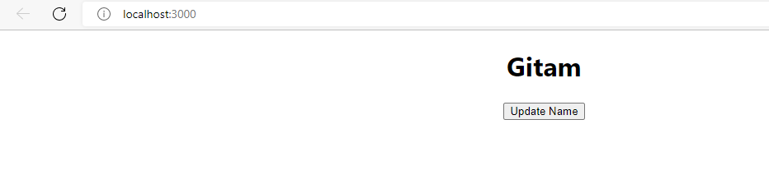

1. **Program to implement state in class component**