**Day 5**

**Implementing props using functional component**

**Std.js**

function Std(Props)

{

    return(

        <div>

            <h1>Name:{Props.name}</h1>

        </div>

    );

}

export default Std;

**App.js**

import './App.css';

import Std from './Std';

function App()

{

    return(

        <div>

           <Std name={"Gitam"} />

        </div>

    );

}

export default App;

**Output:**

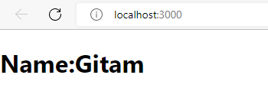

**Implement the following output using functional component :**

**Name: Gitam**

**Name:Koushik**

**Name:Suresh**

**Name:Ramesh**

**Student2.js**

function Student2(props)

{

    return(

        <div>

            <h3>Name: {props.name}</h3>

        </div>

    )

}

export default Student2;

**App.js**

import './App.css';

import Student2 from './Student2';

function App()

{

    return(

        <div>

           <Student2 name={"Gitam"} />

           <Student2 name={"Koushik"}/>

           <Student2 name={"Suresh"}/>

           <Student2 name={"Ramesh"}/>

        </div>

    );

}

export default App;

**Output :**

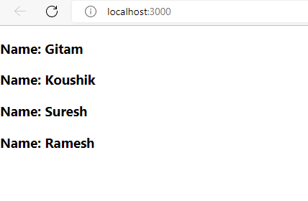

**Implementing props using Class Component**

**User1.js**

import React,{Component} from 'react';

class User1 extends Component{

        render()

    {

        return(

            <div>

                <h1>Name:{this.props.Name1}</h1>

            </div>

        );

    }

}

export default User1;

**App.js**

import './App.css';

import User1 from './User1';

import React,{Component} from 'react';

class App extends Component{

    render()

    {

        return(

            <div>

                <User1 Name1="Koushik"/>

            </div>

        );

    }

}

export default App;

**Output:**

