**Conclusion:**

* Convolving with a Gaussian makes the edge detection insensitive to noise at a scale smaller than sigma.
* Sigma and Lambda act as a threshold for the edge detectors for the noise.
* We are unable to see many variations with a very highly noised image of size 80*80.

Results in Python:

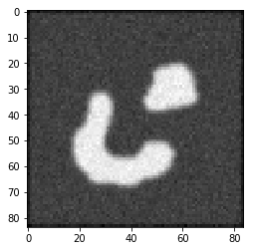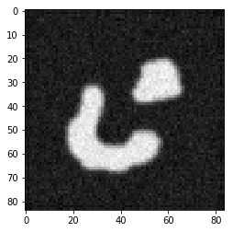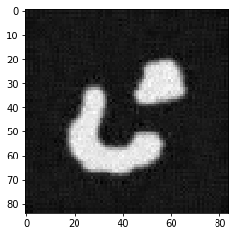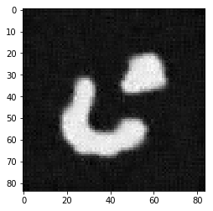

original linear-isotropic nonlinear-isotropic non-linear anisotropic

**Conclusion:**

* Anisotropic diffusion does both reduction of noise and protection of edges.
* Anisotropic diffusion smoothens along the edges using eigenvalues and diffusivity involving the tensor product.
* Linear diffusion is capable of removing all the noise, but the image becomes completely blurred and edges get blurred (correspondence problem).
* In nonlinear isotropic diffusion, edges are hardly effected. Noise elimination and stable edge structure.
* Anisotropic diffusion enhances the image by smoothening isotopically within a region and anisotropic way along edges.
* The anisotropic diffusion filter permits existence, uniqueness, and regularity result and convergences to a constant steady-state as t-> infinity.
* Anisotropic diffusion takes care of gray level shift-invariance and reverses contrast invariance.
* Corresponding filters should be chosen depending on the initial noised image as Anisotropic diffusion can smoothen (make it a bit curvy) the sharp edges of an image that has to be preserved.