AI Assisted Coding
Assignment 3.4
Name: ch.koushik
Hall ticket no: 2303A51938
Batch no: 19

Task 1:Zero-shot Prompt – Fibonacci Series Generator
Prompt:
Generate a Python function that takes an integer N as input and prints the first N Fibonacci numbers starting from 0.
Code & Output:
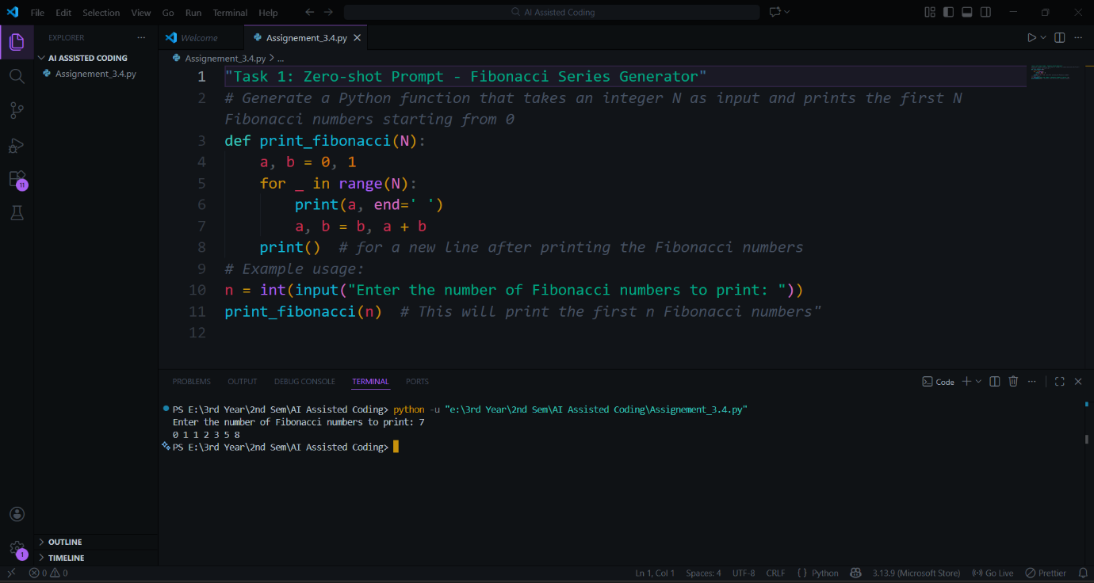
Explanation:
In this task, a zero-shot prompt was used where only the problem description was provided without any examples. Based on this instruction, the AI generated a function to print the Fibonacci series. The program starts with the initial values and iteratively calculates the next numbers in the sequence. This task demonstrates that the AI can correctly understand and solve a problem even when no examples are given.

Task 2: One-shot Prompt – List Reversal Function
Prompt:
Write a Python function that takes a list as input and returns the reversed list.
Example: input = [1, 2, 3], output = [3, 2, 1]
Code & Output:
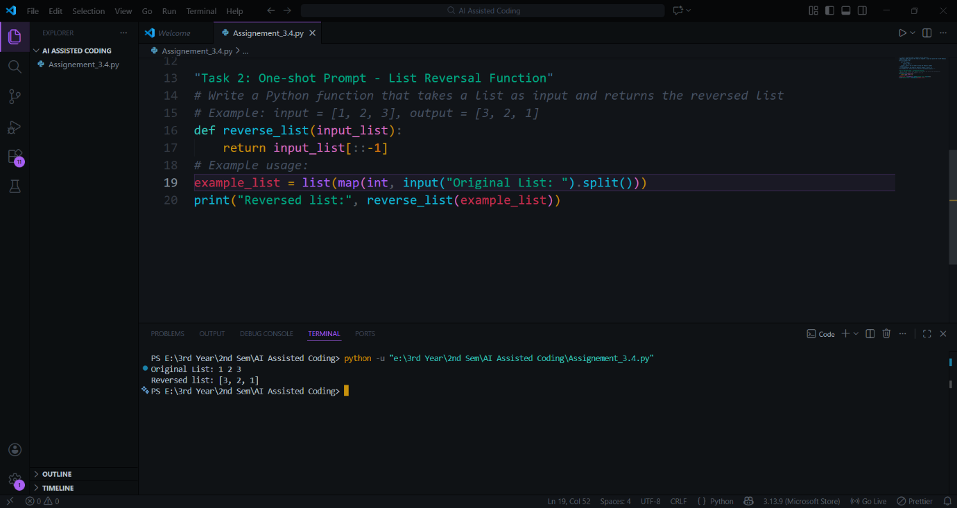
Explanation:
In this task, a one-shot prompt was used by providing a single example along with the task description. The example helped the AI clearly understand the expected input and output format. As a result, the generated solution accurately reverses the list. This shows that adding one example improves the clarity and correctness of the AI-generated code.

Task 3: Few-shot Prompt – String Pattern Matching
Prompt:
Write a Python function is_valid(s) that returns True if a string starts with a capital letter and ends with a period.
Examples:
"Hello world." → True
"hello world." → False
"Hello world" → False
Code & Output:
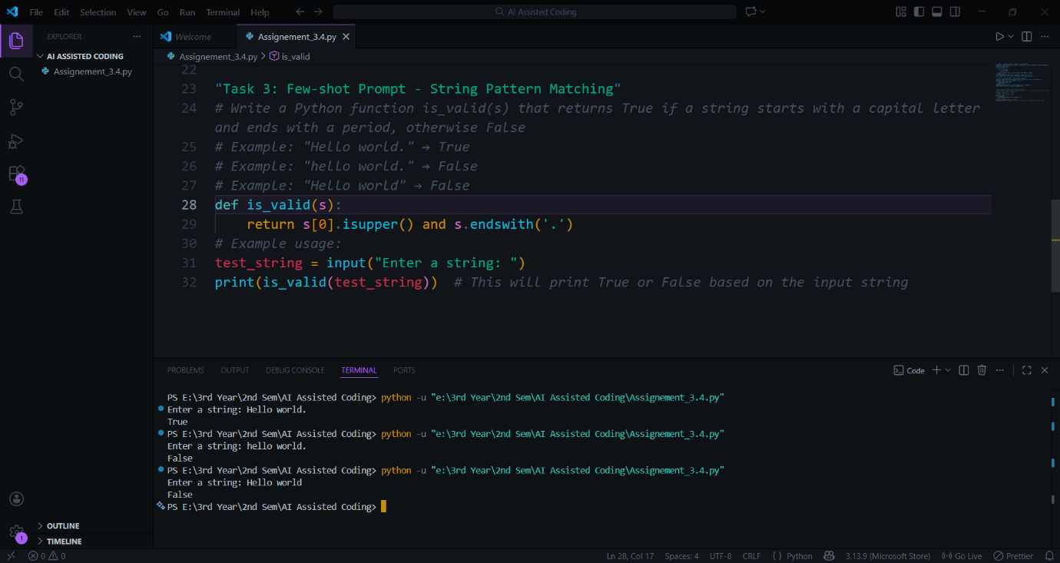
Explanation:
In this task, few-shot prompting was used by providing multiple examples. These examples guided the AI to identify both conditions correctly: the string must start with a capital letter and end with a period. The presence of multiple examples helped the AI generate a more precise and reliable solution compared to zero-shot or one-shot prompting.

Task 4: Zero-shot vs Few-shot – Email Validator
Zero-shot Prompt:
Write a Python function to validate whether an email address is valid or not.
Code & Output:
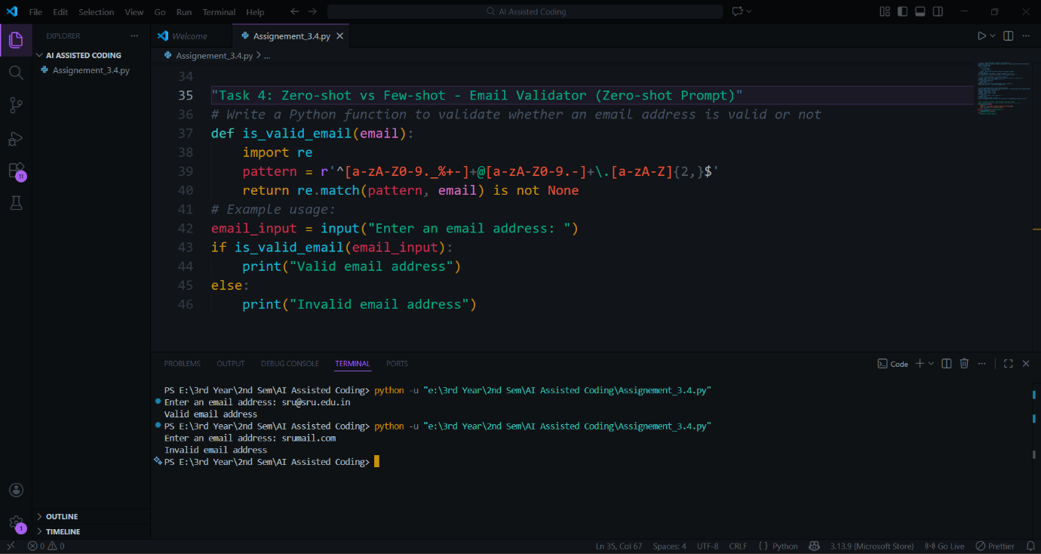
Few-shot Prompt:
Write a Python function is_valid_email(email) that returns True for valid emails and False otherwise.
Examples:
"user@gmail.com" → True
"user123@yahoo.in" → True
"usergmail.com" → False
"user@.com" → False
Code & Output:
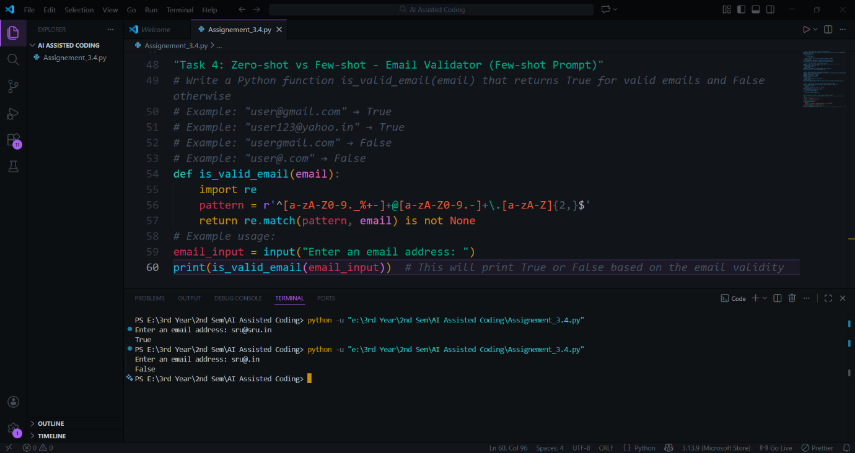
Explanation:
In the zero-shot prompt, the AI produced a basic email validation logic because no examples were provided. In contrast, the few-shot prompt included valid and invalid examples, which helped the AI understand the structure of an email address more clearly. As a result, the few-shot approach generated a more accurate and reliable email validation solution.
Task 5: Prompt Tuning – Summing Digits of a Number
Style 1: Generic Task Prompt
Prompt:
Write a Python function that returns the sum of digits of a given number.
Code & Output:
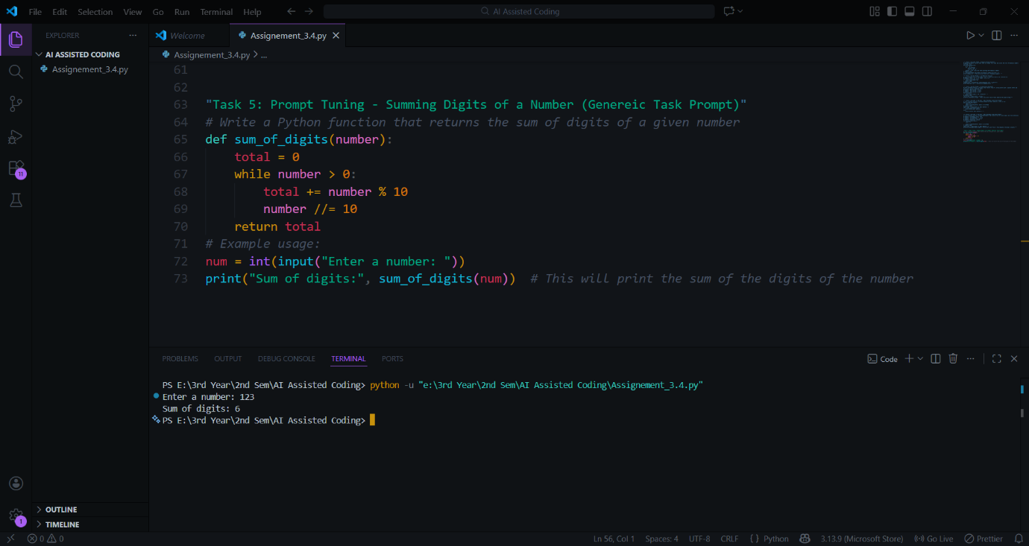
Style 2: Task + Input/Output Example Prompt
Prompt:
Write a Python function sum_of_digits(n) that returns the sum of all digits in a number.
Example: input = 123, output = 6
Code & Output:
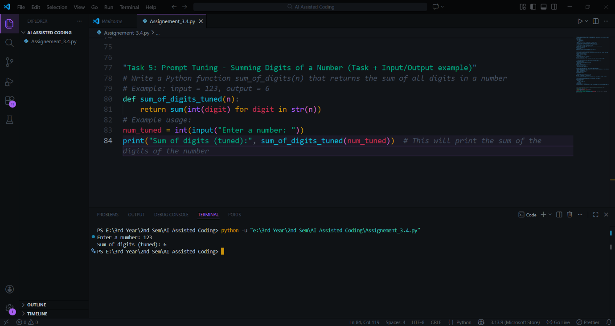
Explanation:
In this task, two different prompt styles were used. The generic prompt resulted in a straightforward solution, while the prompt with an input/output example produced a cleaner and more optimized implementation. This task highlights how prompt tuning can significantly improve code quality and readability.

