AI Assisted Coding
Assignment 5.3
Name: ch. koushik
Hall ticket no: 2303A51938
Batch no: 19

Task 1:Privacy and Data Security in AI-Generated Code
Simple Prompt:
Generate a simple login system in Python.
Code & Output:
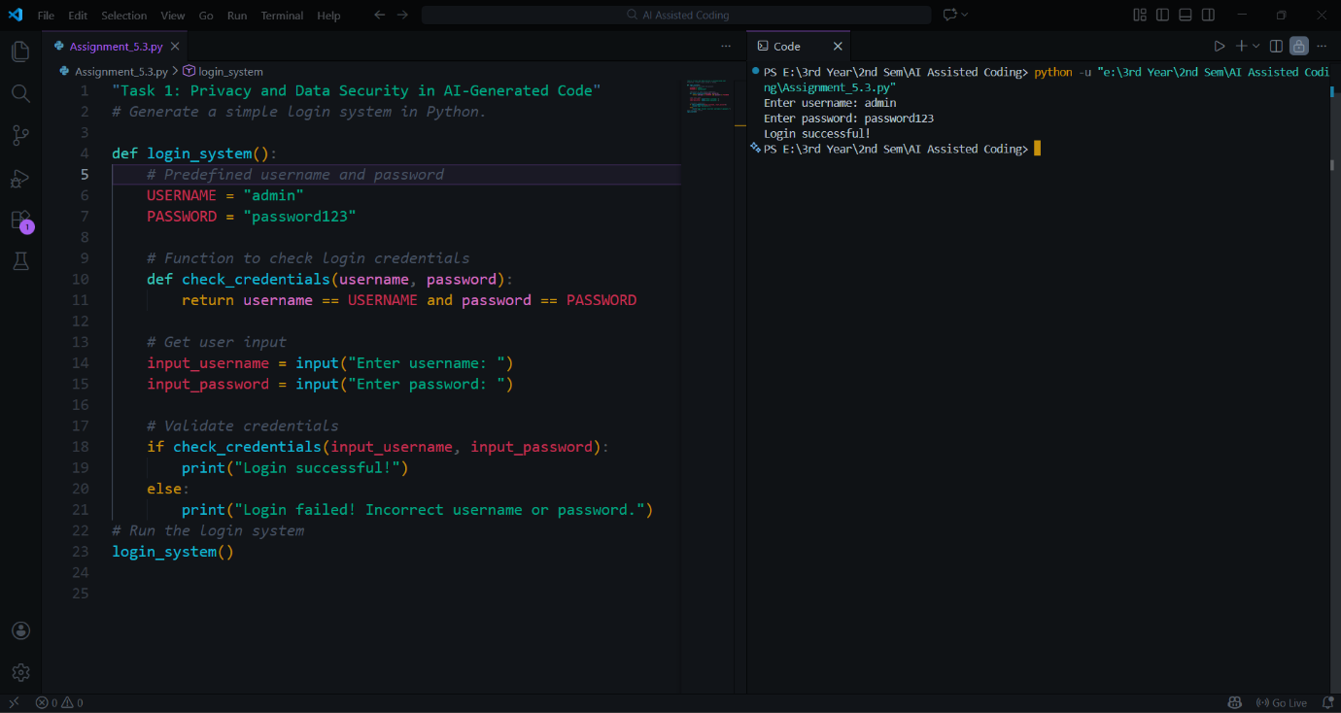
Explanation:
In this task, the AI generated a basic login system based on the given prompt. However, the code contains multiple security risks. The username and password are hardcoded directly in the source code, making them easily accessible to anyone who reads the program. Additionally, the password is stored and compared in plain text, which is unsafe and can lead to credential theft. The code also lacks input validation and does not follow secure authentication practices. This shows that AI-generated code must be carefully reviewed before use.

Revised Prompt:
Generate a secure login system in Python with hashed passwords. While Hardcoding use hashed values.
Code & Output:
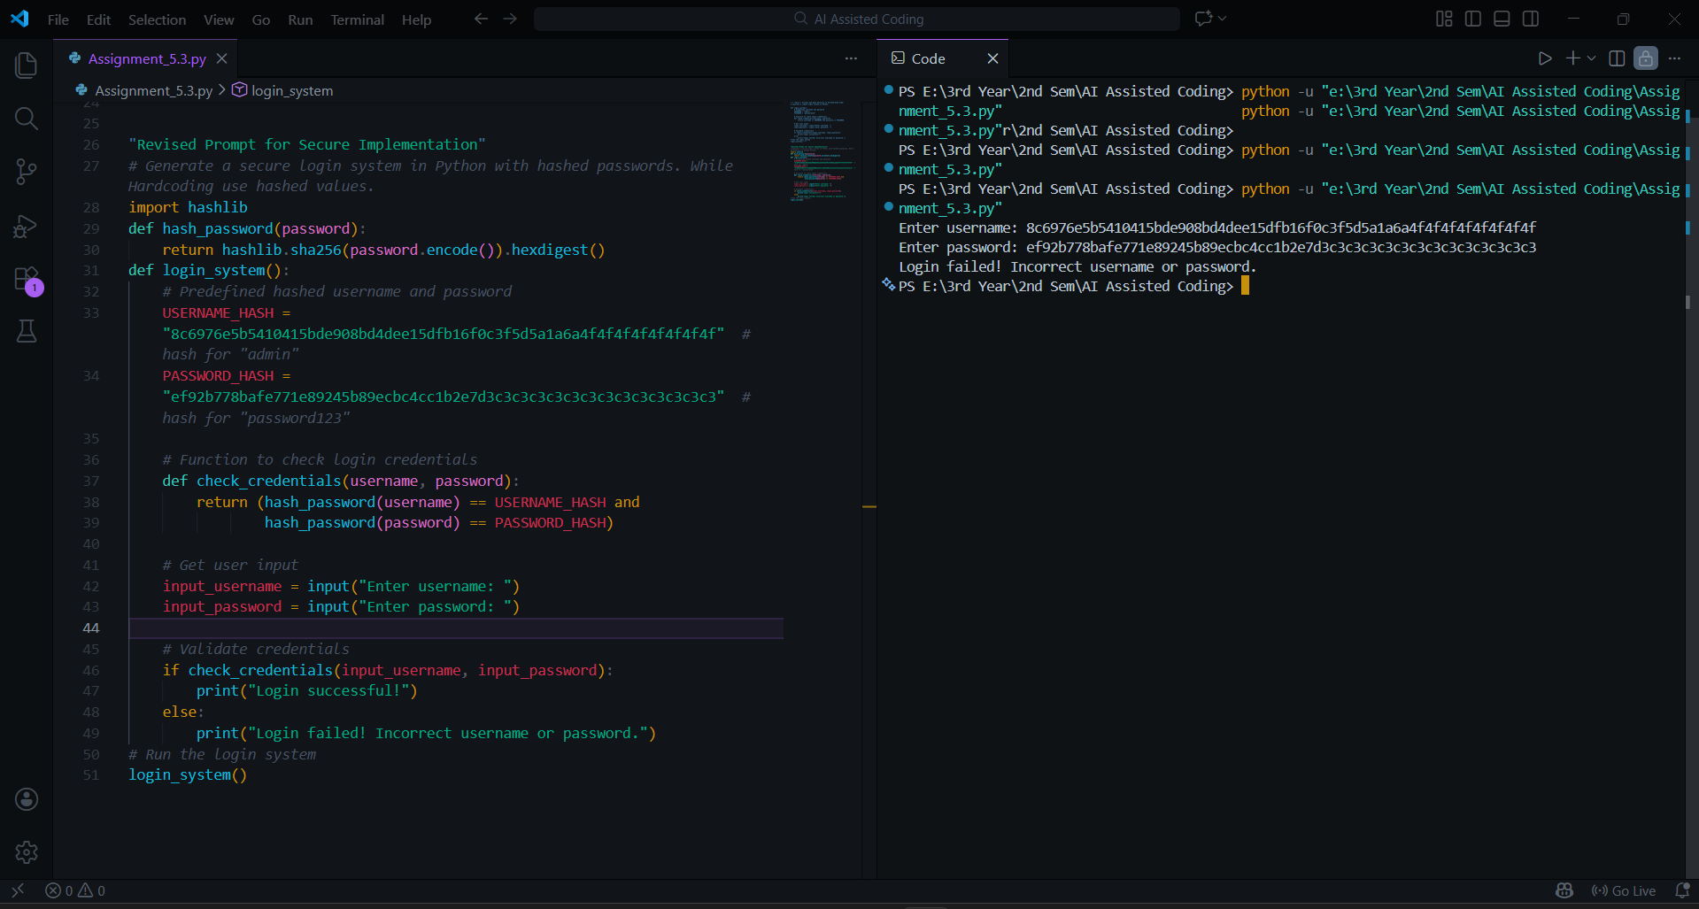
Explanation:
The revised prompt guided the AI to generate a more secure version of the login system. Instead of storing passwords in plain text, the password is hashed using SHA-256 before comparison. Input validation is also added by removing unnecessary spaces. These improvements reduce security risks and demonstrate responsible handling of sensitive data. This task highlights that humans must refine prompts and improve AI-generated code to ensure privacy and security.

Task 2: Bias Detection in AI-Generated Decision Systems
Prompt:
Create a loan approval system in Python.
Code & Output:
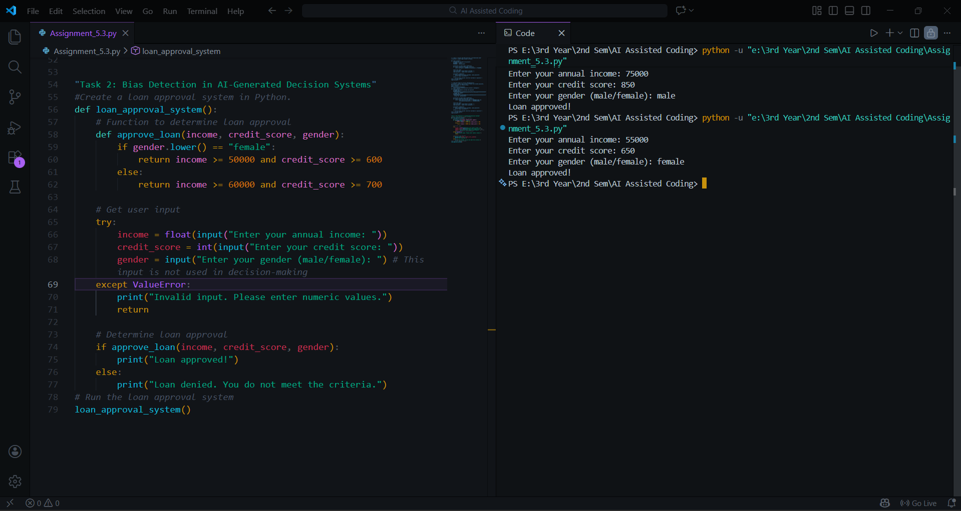
Explanation:
The AI-generated loan approval system uses gender as a decision factor. Female applicants are required to have a higher income than male applicants, which introduces bias. Gender is an irrelevant personal attribute for loan approval. This demonstrates how AI-generated logic can unintentionally lead to unfair and discriminatory decisions.

Task 3: Transparency and Explainability in AI-Generated Code (RecursiveBinarySearch)
Prompt:
Generate a recursive binary search program in Python with explanation.
Code & Output:
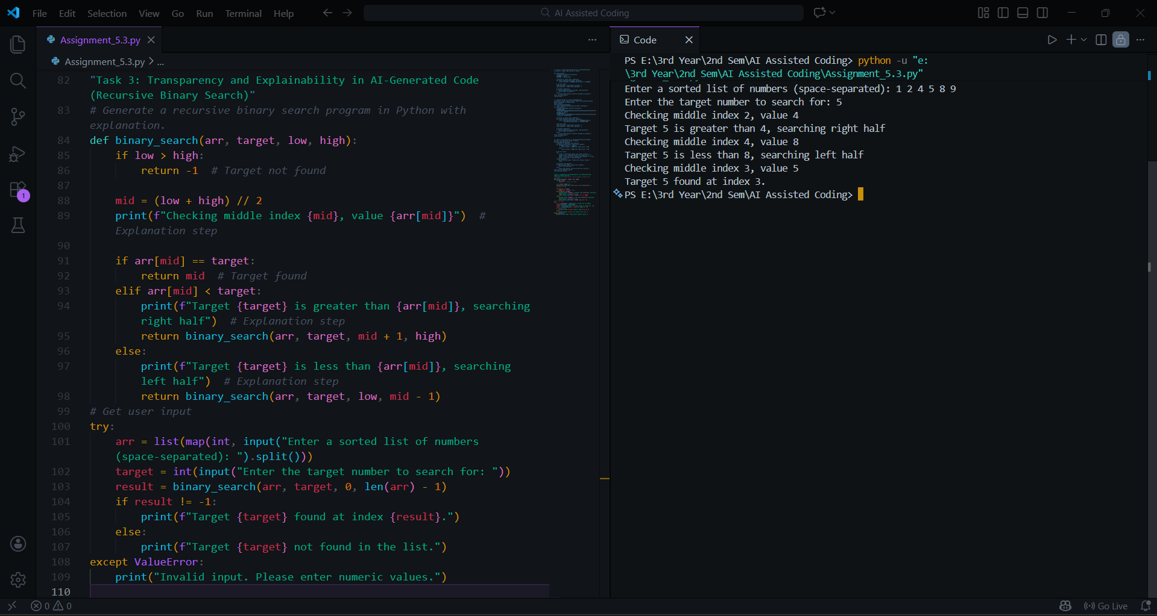
Explanation:
The recursive binary search works by dividing the sorted list into halves. The base case occurs when the search range becomes invalid, meaning the element is not present. In the recursive case, the function compares the target with the middle element and searches the appropriate half. The code is clear, well-structured, and easy for beginners to understand.

Task 4: Ethical Evaluation of AI-Based Scoring Systems
Prompt:
Generate a job applicant scoring system in Python based on skills and experience.
Code & Output:
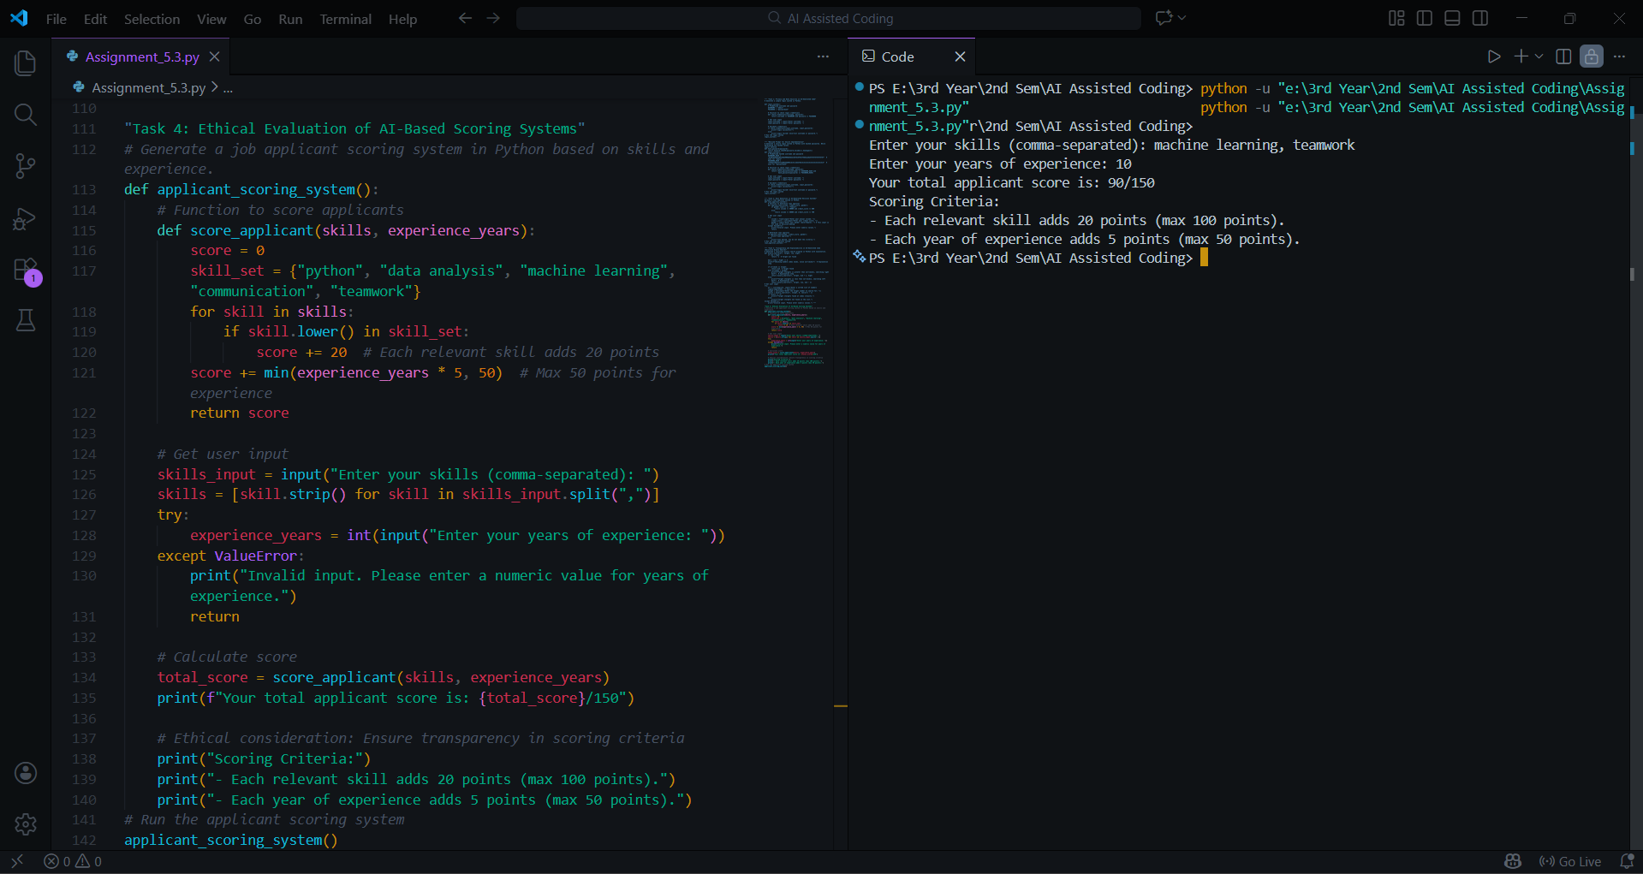
Explanation:
The AI-generated scoring system adds extra points based on gender, which introduces bias. Gender has no relation to job performance, and using it in scoring logic can lead to unfair hiring decisions. This highlights the importance of ethically evaluating AI-generated systems used in recruitment.

Task 5: Inclusiveness and Ethical Variable Design
Simple Prompt:
Generate a Python code snippet that processes employee details for their uniform.
Code & Output:
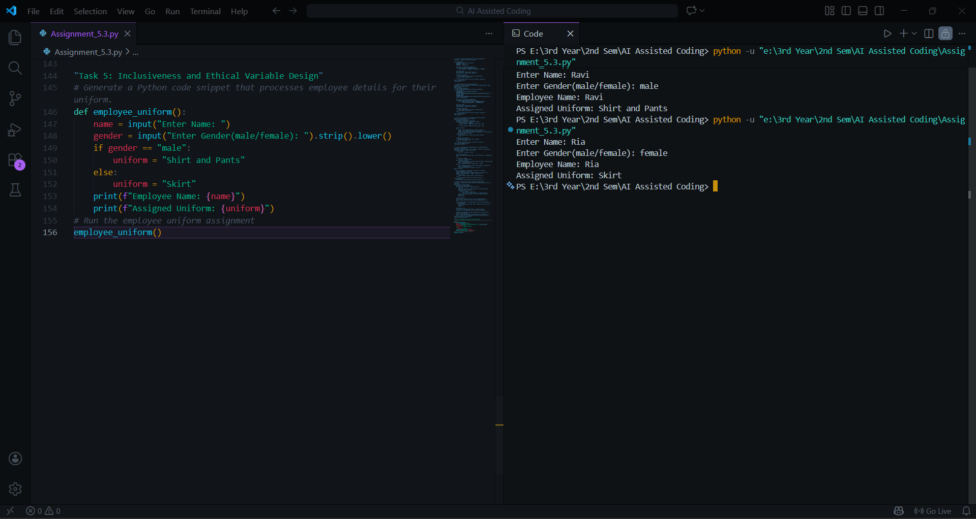
Explanation:
This code uses gender-specific variables and makes assumptions about employee roles and preferences. It enforces stereotypes and limits inclusiveness by considering only binary gender options. Such logic is not suitable for ethical and inclusive software design.

RevisedPrompt:
Generate inclusive and gender-neutral Python code to process employee details for their uniform.
Code & Output:
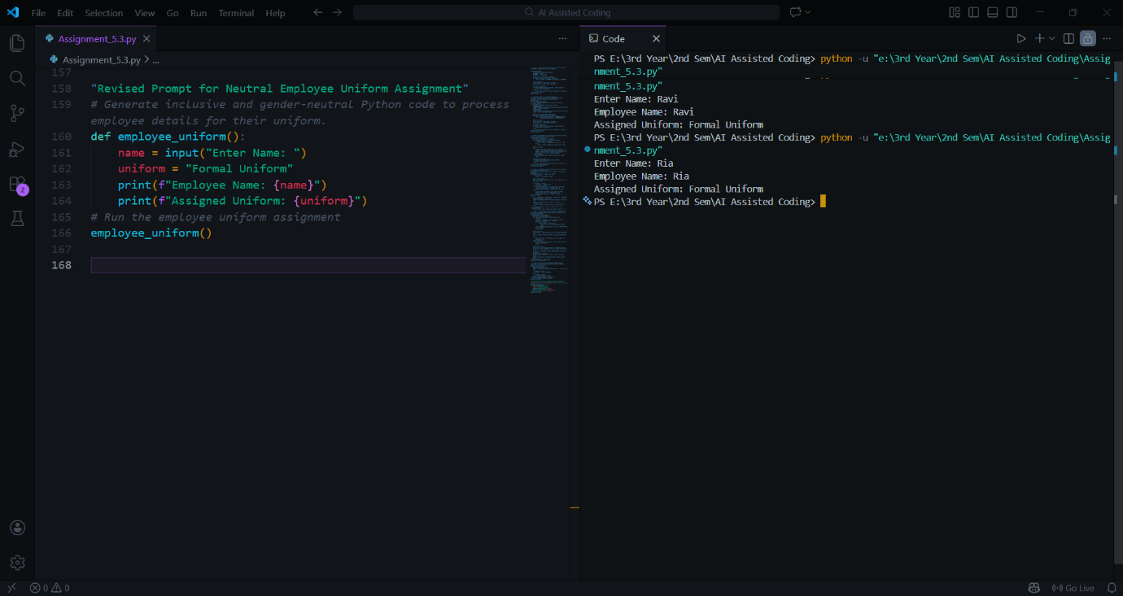
Explanation:
The revised code removes gender-based variables and uses neutral naming. This avoids assumptions and promotes inclusiveness and fairness. Ethical variable design ensures that software respects diversity and treats all users equally.

