AI Assisted Coding
Assignment 6.5
Name: ch. koushik
Hall ticket no: 2303A51938
Batch no: 19

Task 1: AI-Based Code Completion for Conditional Eligibility Check
Prompt:
Generate Python code to check voting eligibility based on age and citizenship.
Code & Output:
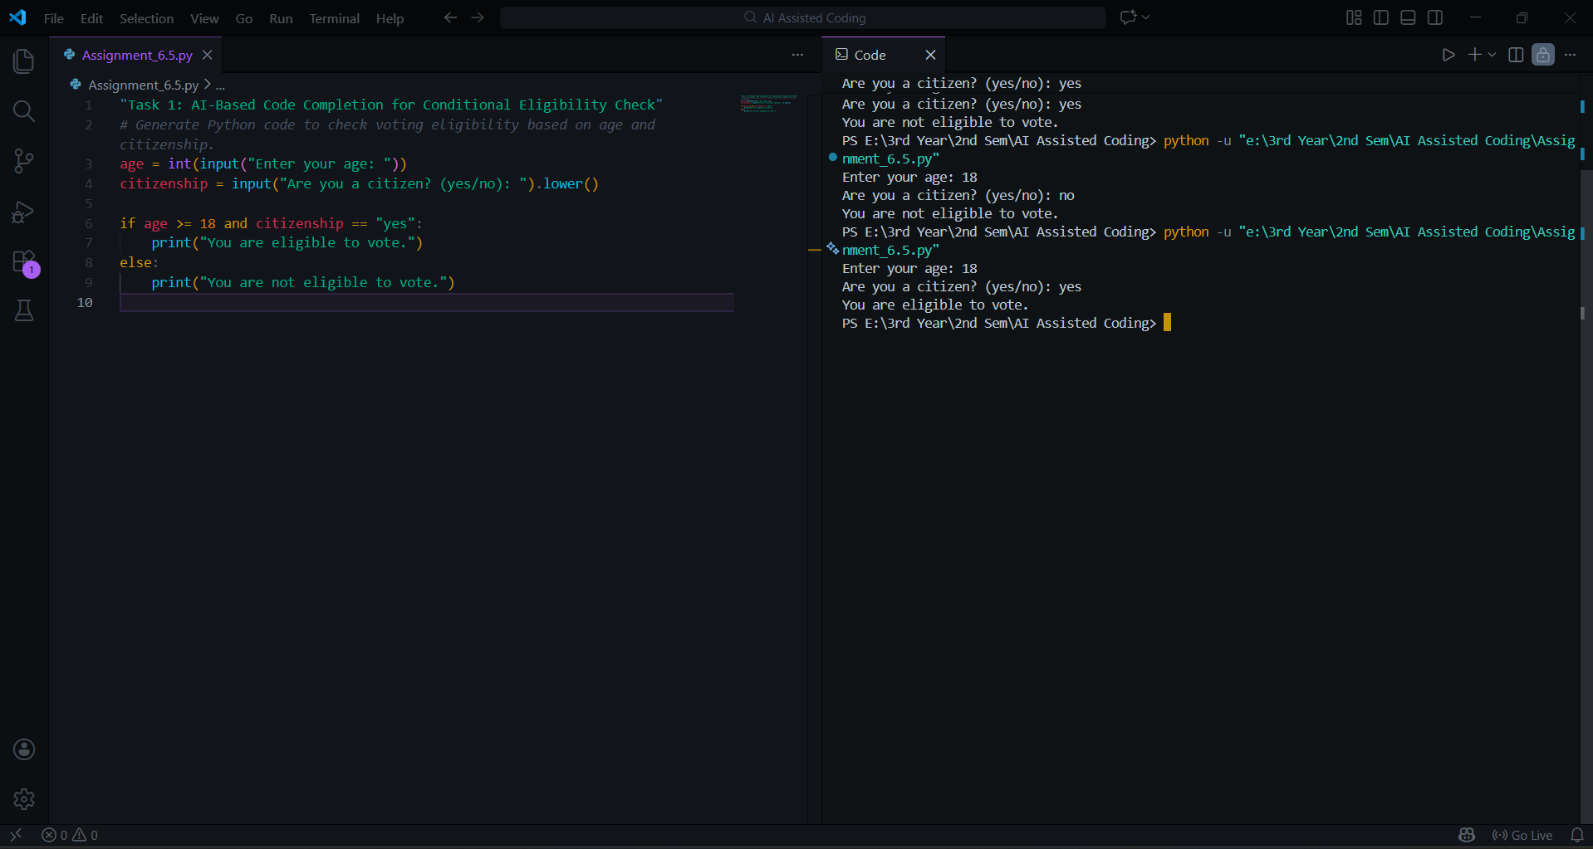
Explanation:
The AI-generated code uses conditional statements to check voting eligibility. It verifies whether the age is 18 or above and whether the user is a citizen. Both conditions must be true for eligibility. This demonstrates correct use of conditional logic generated through AI-based code completion.

Task 2: AI-Based Code Completion for Loop-Based String Processing
Prompt:
Generate Python code to count vowels and consonants in a string using a loop.
Code & Output:
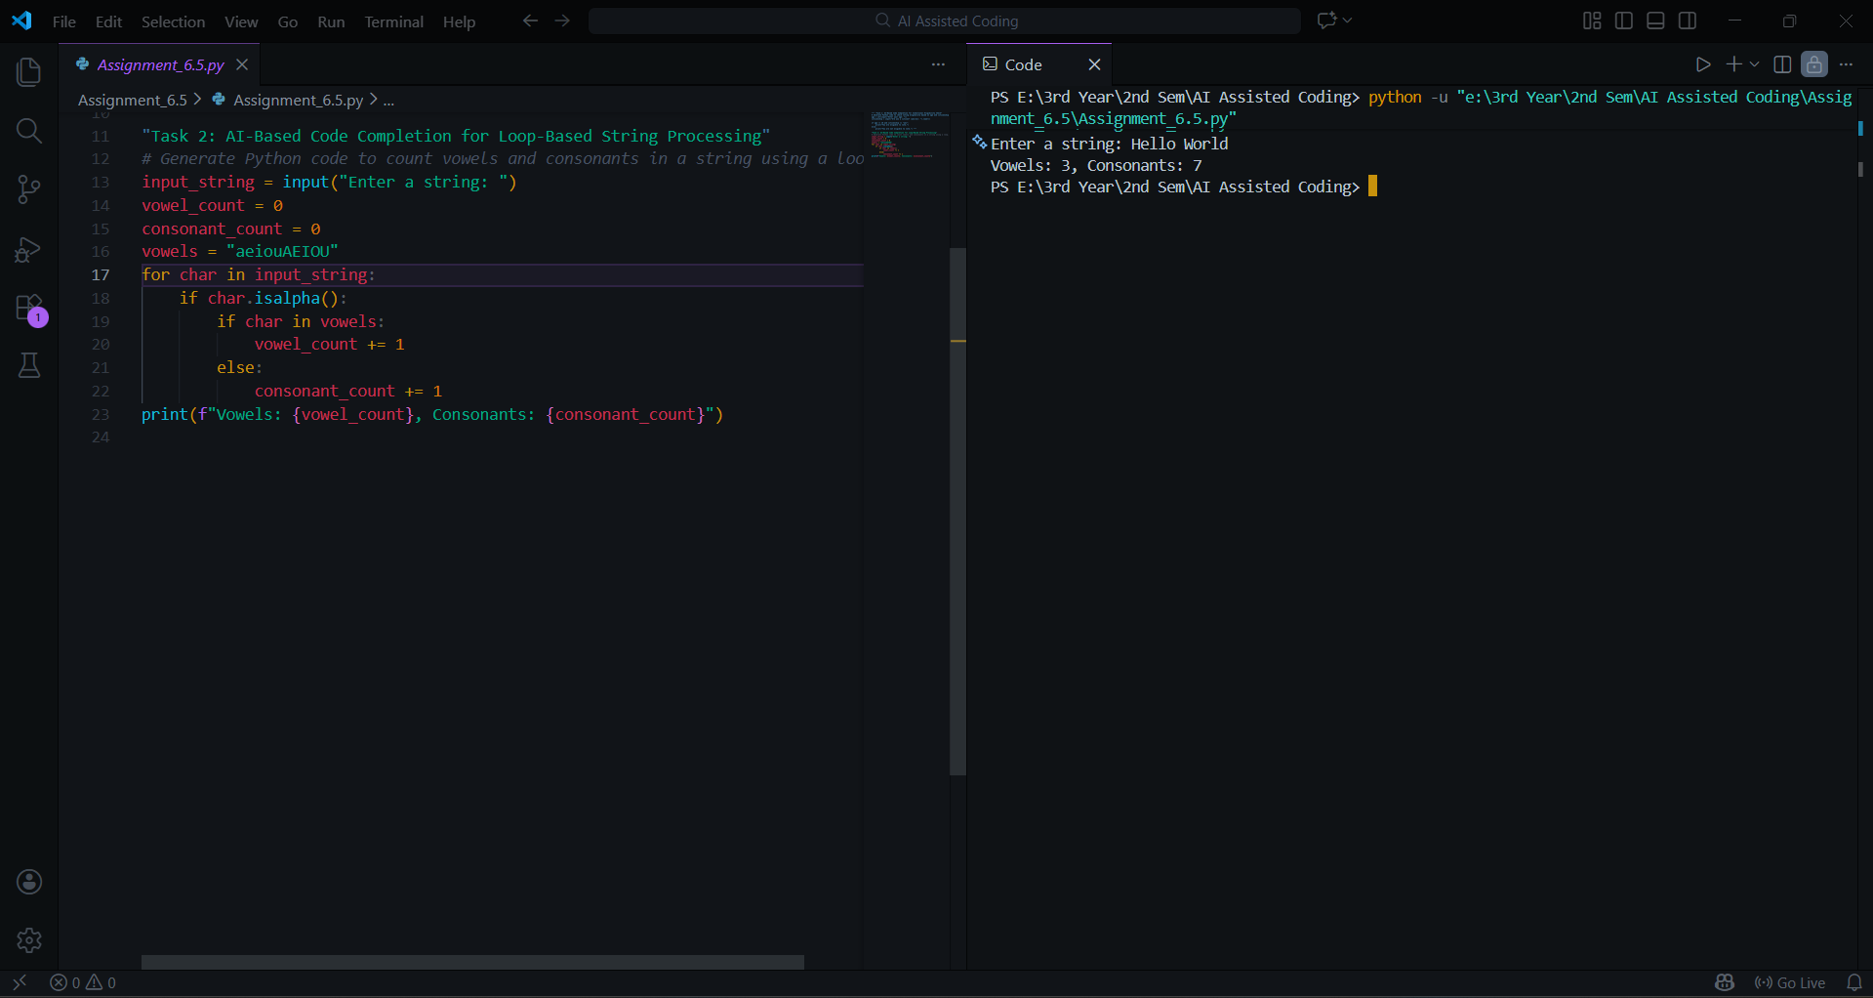
Explanation:
The AI-generated code processes the input string using a loop. Each character is checked to determine whether it is a vowel or a consonant. Alphabetic characters are counted correctly, while non-letter characters are ignored. The output verifies that the logic works as expected.

Task 3: AI-Assisted Code Completion Reflection Task
Prompt:
Generate a Python program for a library management system using classes, loops, and conditional statements.
Code & Output:
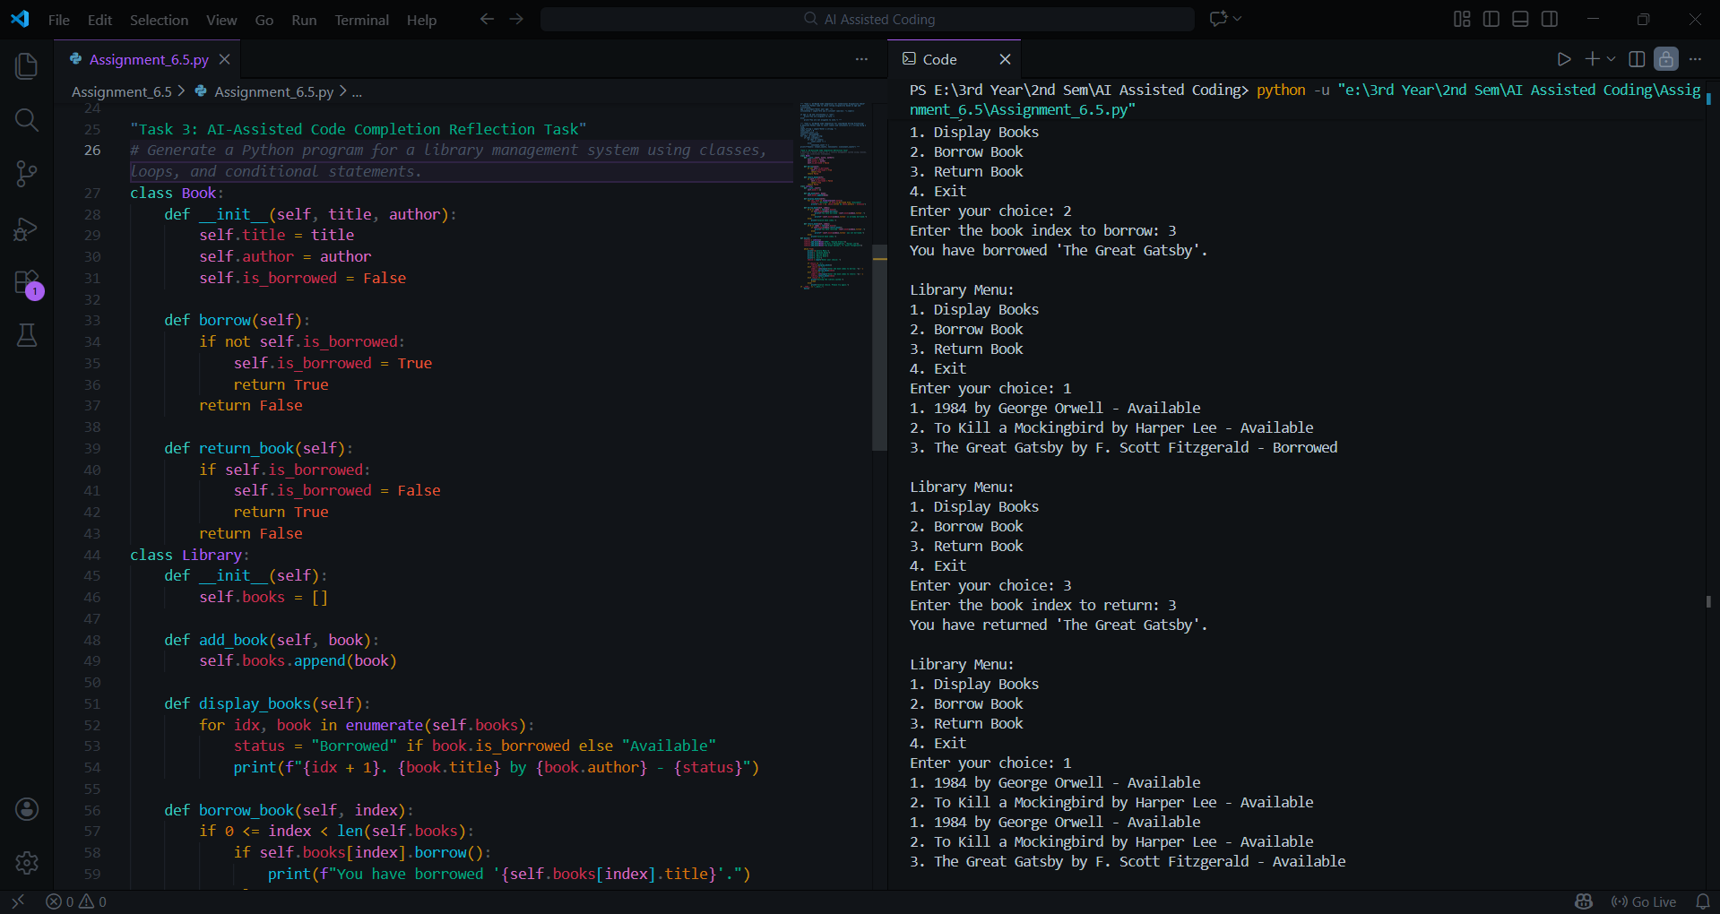
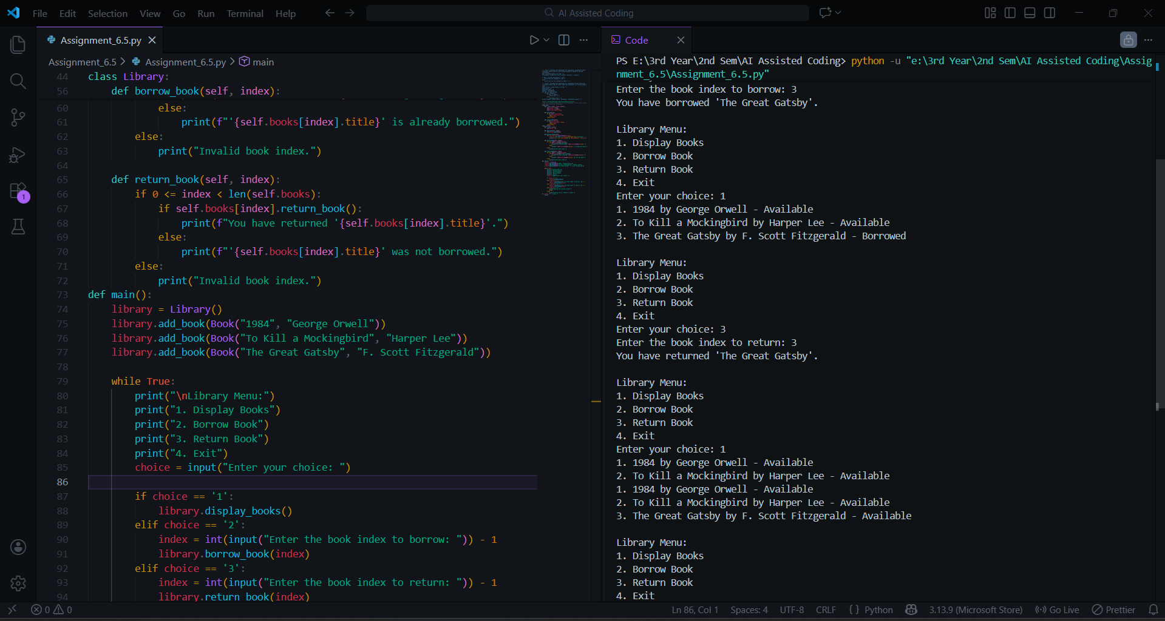
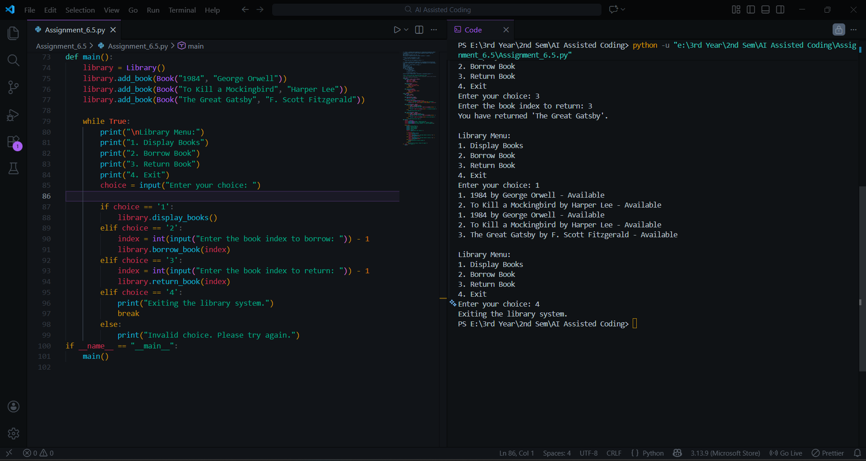
Explanation:
The AI-generated program uses a class to represent a library and includes loops and conditional statements for menu-driven interaction. The loop allows continuous user input, and conditionals control program flow. The program correctly demonstrates AI-assisted use of object-oriented programming concepts.
Reflection on AI-Assisted Coding:
The AI tool generated a complete and functional program quickly. While the logic is correct, the code can be further improved with input validation and advanced features. This task shows that AI is useful for speeding up development but still requires human review and optimization.

Task 4: AI-Assisted Code Completion for Class-Based Attendance System
Prompt:
Generate a Python class to mark and display student attendance using loops.
Code & Output:
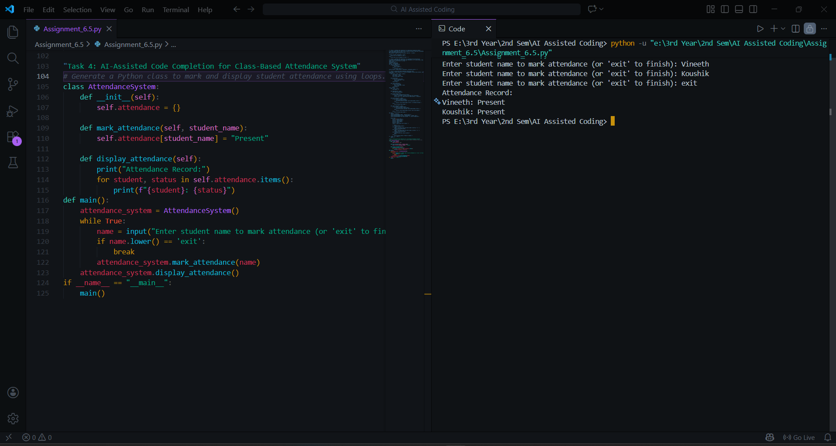
Explanation:
The AI-generated attendance system uses a class to store attendance data. A loop is used to take multiple student entries, and another loop displays the attendance records. The code works correctly and demonstrates class-based AI code completion.

Task 5: AI-Based Code Completion for Conditional Menu Navigation
Prompt:
Generate a Python program using loops and conditionals to simulate an ATM menu.
Code & Output:
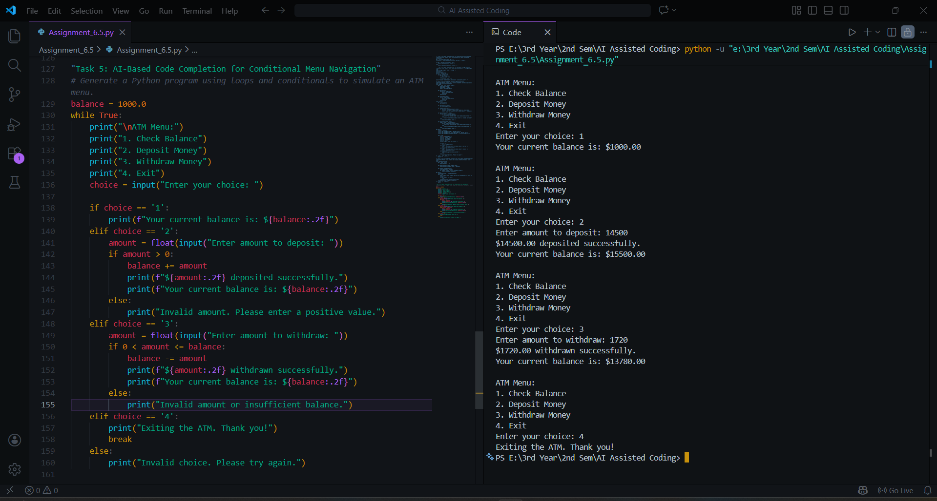
Explanation:
The AI-generated ATM program uses a loop to display the menu repeatedly and conditional statements to handle user choices. The logic correctly updates the balance and prevents invalid withdrawals. This task demonstrates effective AI-based code completion for menu-driven programs.
Final Conclusion:
This experiment shows how AI-based code completion tools can generate useful Python code involving classes, loops, and conditionals. While AI speeds up development, developers must still review logic, handle edge cases, and ensure ethical and responsible use of AI-generated code.

