**1.Osteoporosis**

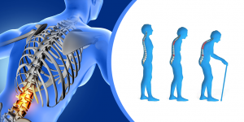

**Symptoms:**

* Shortness of Breath
* Lower Back pain
* change In body posture etc…

**Exercise:**

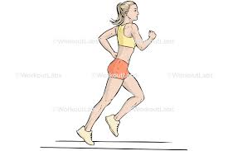 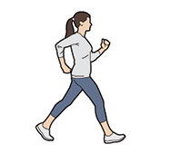 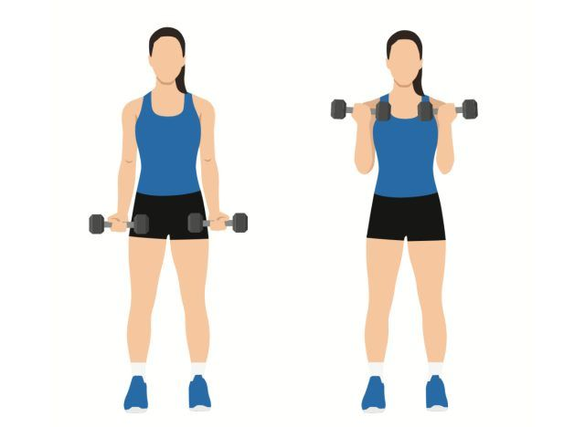

jogging

walking

Weight lifting

**Stretching:**

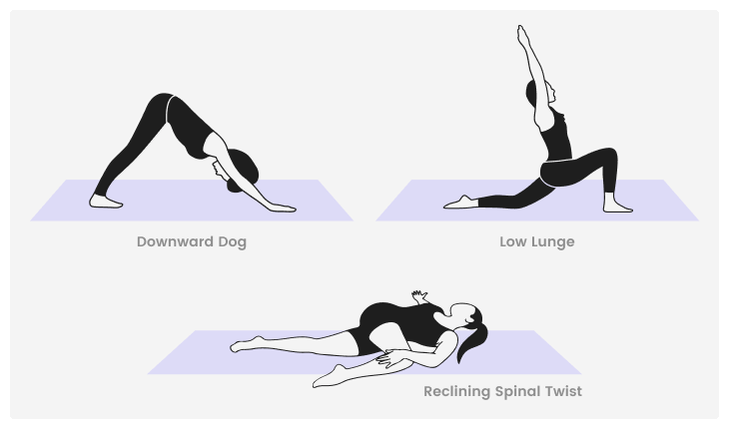

Try to stretch for at least five to 10 minutes after every workout. Hold each stretch for 10 to 30 seconds.



helps increase bone density and slows down bone los



**2.Insomenia**

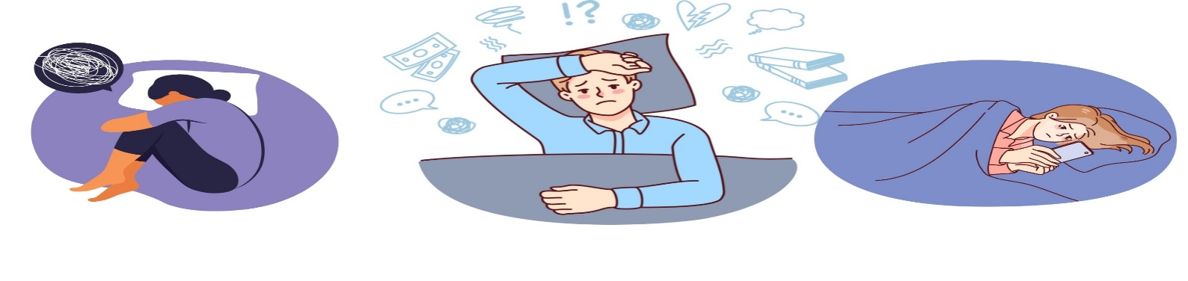

**Symptoms:**

* Having a hard time falling asleep at night.
* Waking up during the night.
* Feeling tired or sleepy during the day.
* Feeling cranky, depressed or anxious.

**Exercise:**

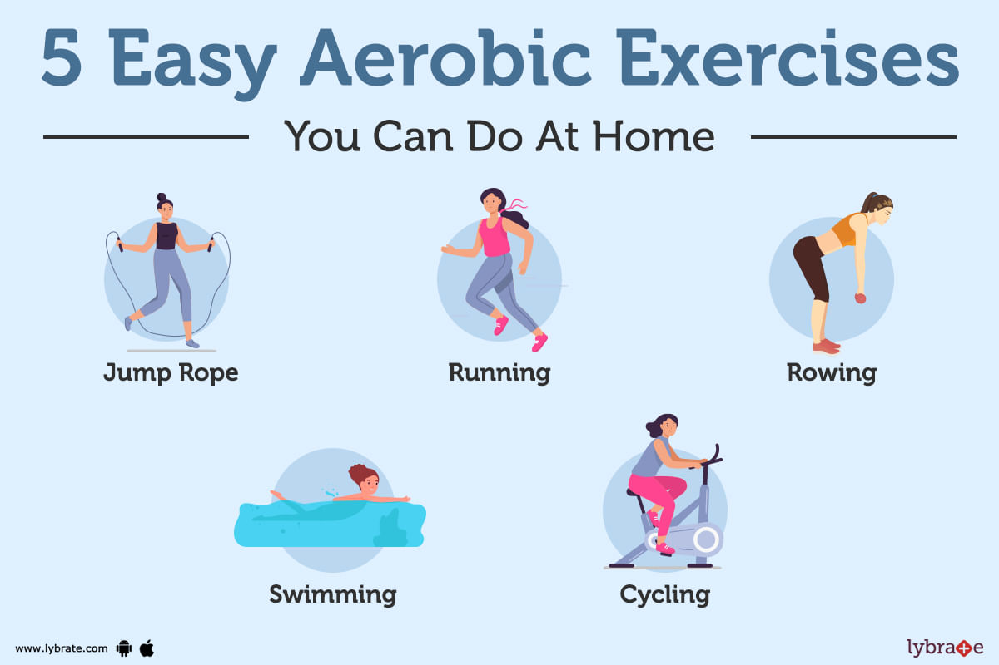

* Jump rope
* Running
* Rowing
* Swimming
* Cycling
* Jogging etc..

**YOGA Practice For Insomenia:**

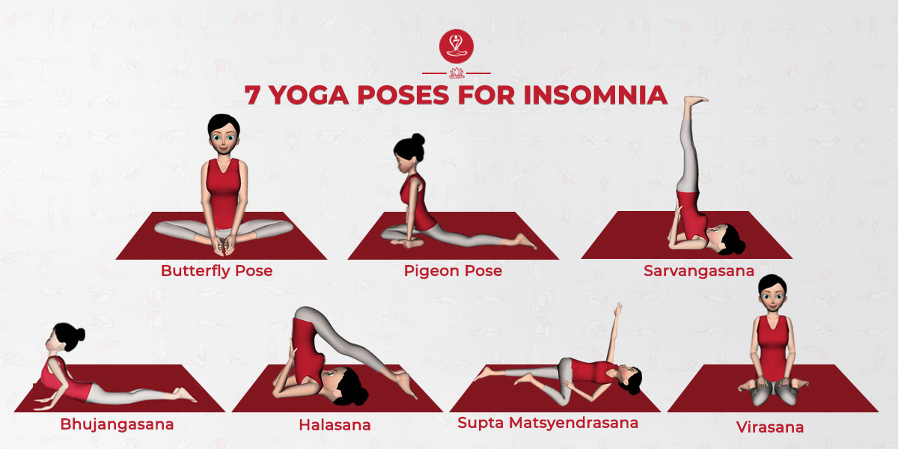

* Butterfly pose
* pigeon pose
* Sasrvangasana
* bhujangasana
* Halasana
* Supta matsyendrasana
* virasana

**Benefits:**

cardio workouts, also called aerobic exercise, such as swimming, biking, jogging, or walking, may help you sleep. You may also see some improvement in sleep apnea symptoms.

**3.Asthama**

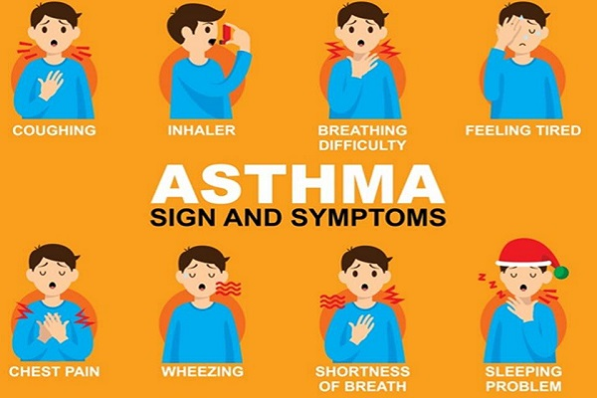

**Symptoms:**

* Shortness of breath.
* Chest tightness or pain.
* Wheezing when exhaling, which is a common sign of asthma in children.
* Trouble sleeping caused by shortness of breath, coughing or wheezing.
* Coughing or wheezing attacks that are worsened by a respiratory virus, such as a cold or the flu.

**Exercise:**

**Yoga practises for asthama**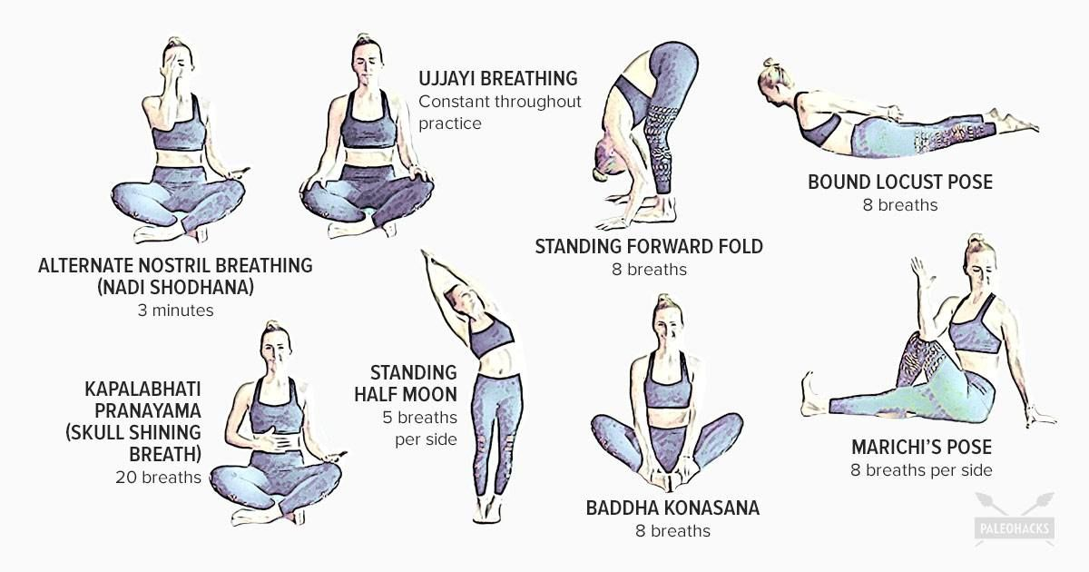

* Ujjayi breathing
* Nadisodhana
* Stand forward fold
* Bound locust phose
* Badda konasana
* Marchis phose
* Kapalabhati
* Standing half moon

**Benefits:**

* Improved lung function and capacity.
* Enhanced relaxation and stress reduction.
* Better control over asthma triggers.
* Reduced reliance on medication.
* Increased overall well-being and quality of life.

**4.Ankle sprains**

A sprain is an injury to the ligaments and capsule of a joint in the body. A strain is an injury to muscles or tendons.

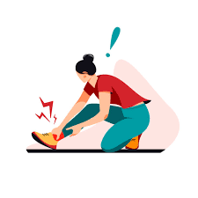

**Symptoms:**

* pain or tenderness
* swelling
* bruising
* muscle spasms or cramping
* muscle weakness
* limited movement in the area

**Exercise:**

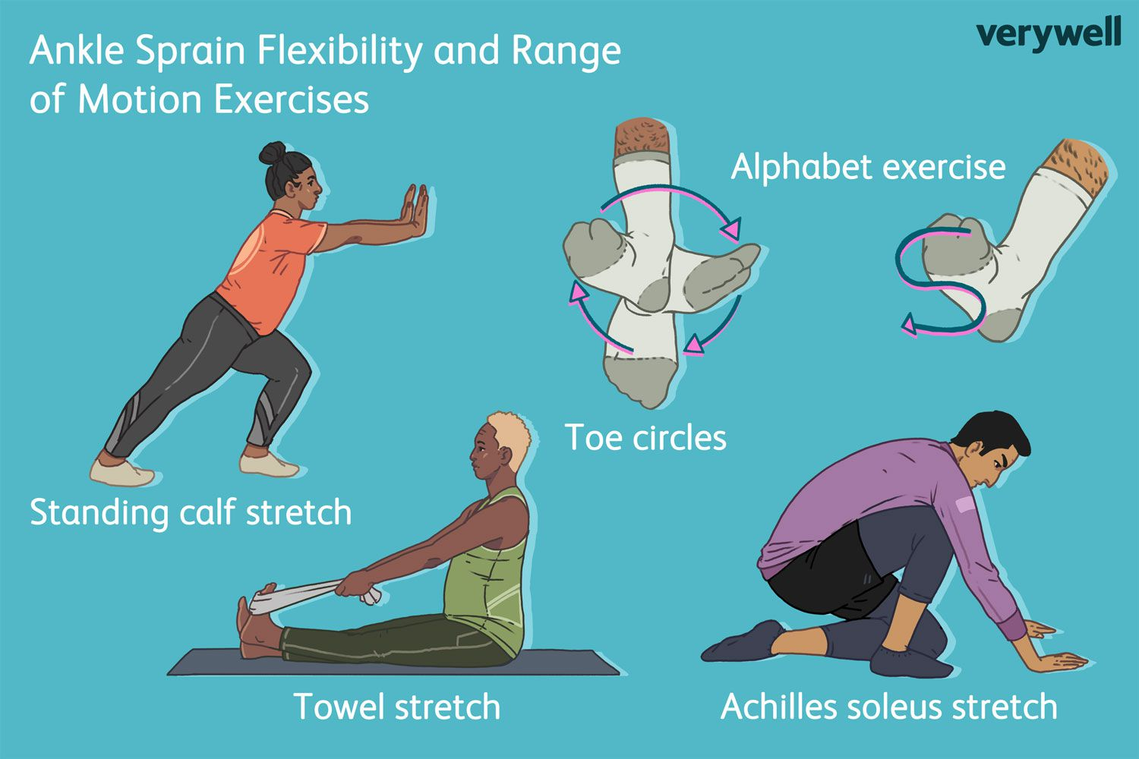

* Standing calf stretch
* Toe circles
* Alphabet exercise
* Towel stretch
* Achilles soleus stretch

**Benefits:**

After an ankle sprain, it's important to start doing exercises again as soon as you can. You might be stiff and sore, but the sooner you get it moving, the quicker you'll recover and better you'll avoid further injury.

**5.Period cramps**

Cramps and pelvic pain with menstruation, with common causes such as heavy flow, passing clots, uterine fibroids or endometriosis.

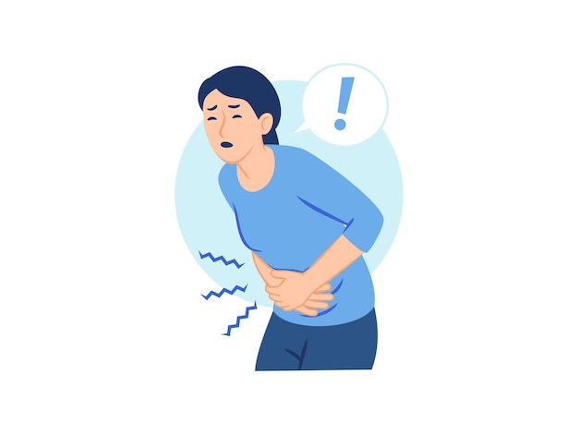

**Symptoms**

* Throbbing or cramping pain in your lower abdomen that can be intense.
* Pain that starts 1 to 3 days before your period, peaks 24 hours after the onset of your period and subsides in 2 to 3 days.
* Dull, continuous ache.
* Pain that radiates to your lower back and thighs.

**Exercise:**

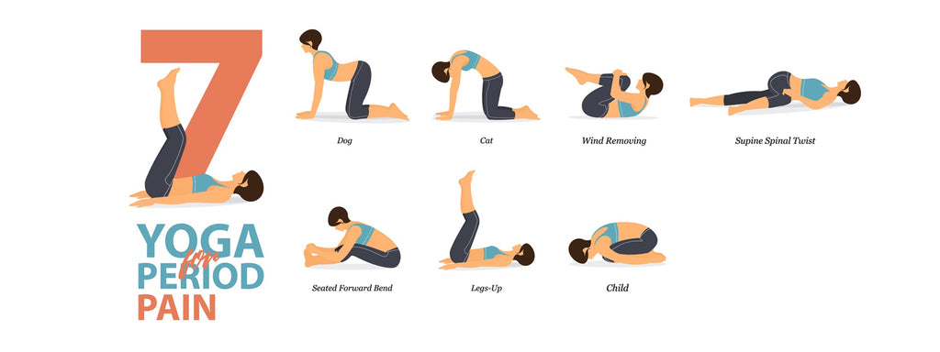

* Wind removing
* Spine spinal twist
* Dog standing position
* Child pose(balasana)
* Seated forward bend
* Legs up
* Cat position

**Benefits:**

During lighter menstrual days, try moderate-intensity aerobic exercises like walking or light jogging. This type of physical activity can reduce bloating (extra water weight) and the pain of cramping. Aerobic exercise helps your blood circulation and the release of “feel-good hormones” called endorphins (en DORF ins).

**6.Stress and anxity**

A mental health disorder characterised by feelings of worry, anxiety or fear that are strong enough to interfere with one's daily activities.

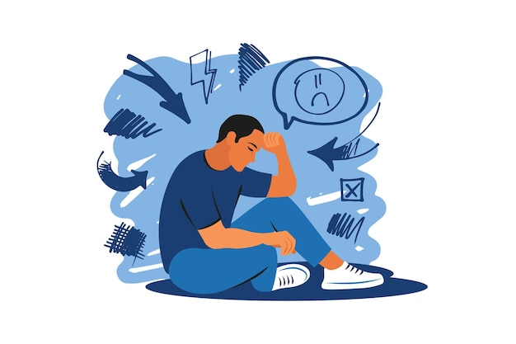

**Symptoms and patterns:**

* trouble concentrating or making decisions.
* feeling irritable, tense or restless.
* experiencing nausea or abdominal distress.
* having heart palpitations.
* sweating, trembling or shaking.
* trouble sleeping.
* having a sense of impending danger, panic or doom.

**Exercise:**

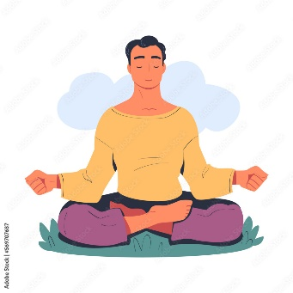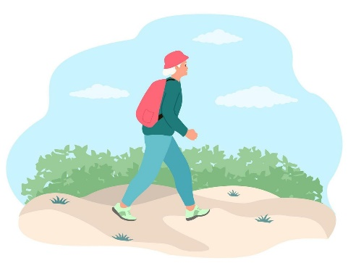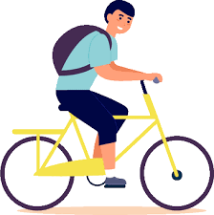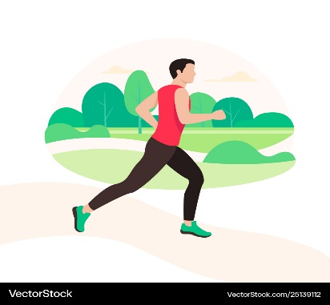

Meditation

Jogging

Cycling

Nature Walk

**Benefits:**

* Improving Mood and Self-Esteem
* Improving Cognitive Function
* Reducing Symptoms of Depression and Anxiety
* Reducing Stress Levels
* Increases confidence
* Keeps you more active
* Feels fresh and relaxed

**7.** **Diabetes**

Diabetes is a chronic disease that occurs either when the pancreas does not produce enough insulin or when the body cannot effectively use the insulin it produces. Insulin is a hormone that regulates blood glucose.

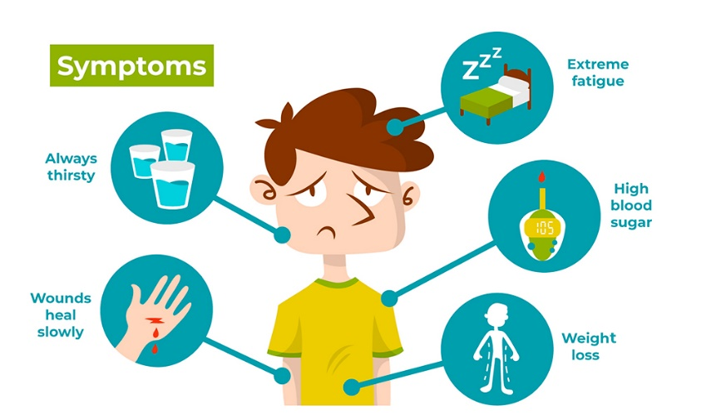

**Symptoms:**

* Urinate (pee) a lot, often at night.
* Are very thirsty.
* Lose weight without trying.
* Are very hungry.
* Have blurry vision.
* Have numb or tingling hands or feet.
* Feel very tired.
* Have very dry skin.

**Exercise:**

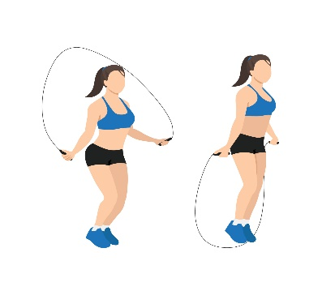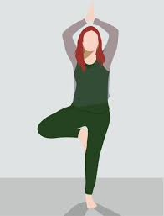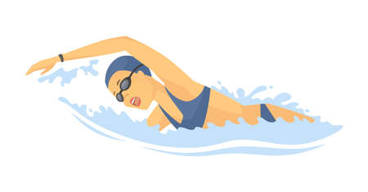

**Walking**

swimming

Surya namaskar

Jump rope

**Benefits:**

Physical exercise and yoga helps the body use insulin better by increasing insulin sensitivity. help you look after your blood pressure, because high blood pressure means you're more at risk of diabetes complications. help to improve cholesterol (blood fats) to help protect against problems like heart disease.

**8.** **Constipation**

Constipation is a condition in which a person has uncomfortable or infrequent bowel movements. Generally, a person is considered to be constipated when bowel movements result in passage of small amounts of hard, dry stool, usually fewer than three times a week..

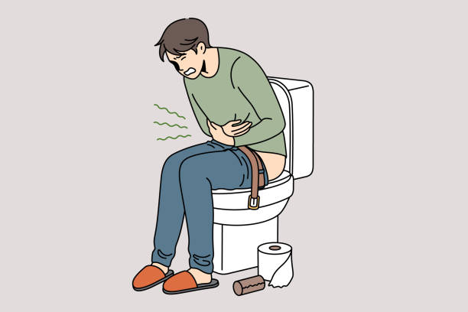

**Symptoms:**

* Fewer than three stools a week.
* Hard, dry or lumpy stools.
* Straining or pain when passing stools.
* A feeling that not all stool has passed.
* A feeling that the rectum is blocked.
* The need to use a finger to pass stool.

**Exercise:**

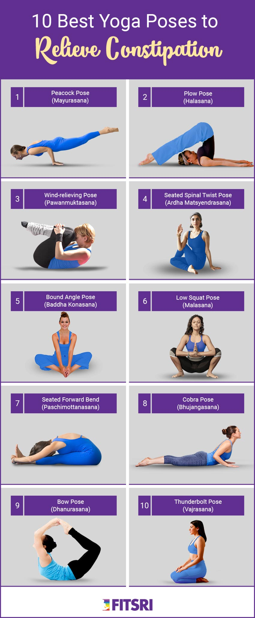

**Benefits:**

Exercise helps constipation by lowering the time it takes food to move through the large intestine. This limits the amount of water your body absorbs from the stool. Hard, dry stools are harder to pass. Plus, aerobic exercise speeds up your breathing and heart rate.

**9.** **Obesity**

Obesity is a chronic complex disease defined by excessive fat deposits that can impair health. Obesity can lead to increased risk of type 2 diabetes and heart disease, it can affect bone health and reproduction, it increases the risk of certain cancers.

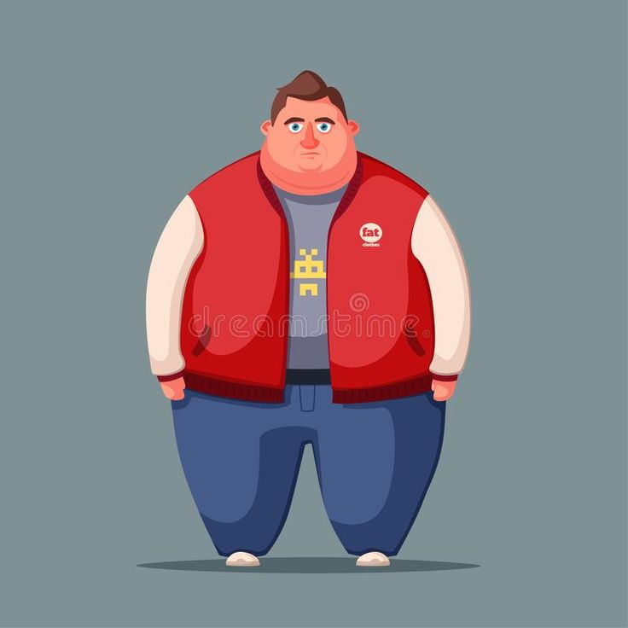

**Symptoms:**

**Day-to-day problems related to obesity include:**

* breathlessness.
* increased sweating.
* snoring.
* difficulty doing physical activity.
* often feeling very tired.
* joint and back pain.
* low confidence and self-esteem.
* feeling isolated.

**Exercise:**

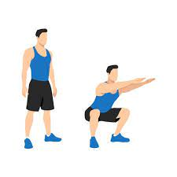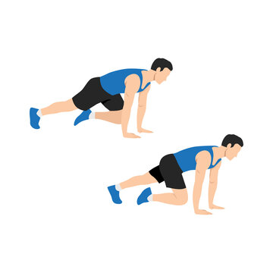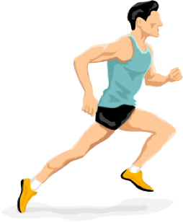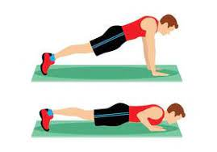

**squaets**

**Mountain climbers**

**runnung**

**pushups**

**Benefits:**

Exercise helps in increasing energy expenditure can help reduce excess adipose tissue and obesity. The current guidelines by the American College of Sports Medicine (ACSM) include aerobic or anaerobic exercise. Aerobic exercise (eg, running, cycling, rowing) is an exercise that exhausts the oxygen in the muscles.

**9.** **Headache**

A headache is pain or discomfort in the head or face area. Types of headaches include migraine, tension, and cluster. Headaches can be primary or secondary. If it is secondary, it is caused by another condition. Avoiding headache triggers is the best prevention. 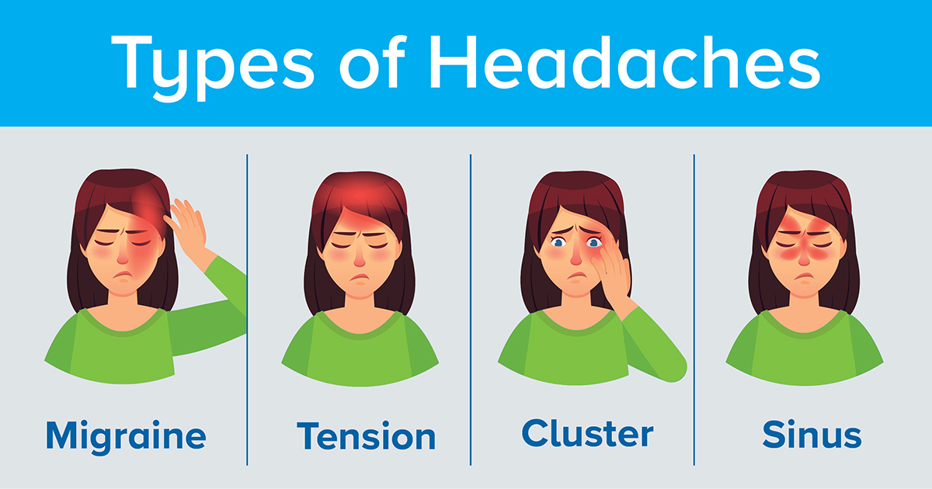

**Symptoms:**

* Pain usually on one side of your head, but often on both sides.
* Pain that throbs or pulses.
* Sensitivity to light, sound, and sometimes smell and touch.
* Nausea and vomiting.

**Exercise:**

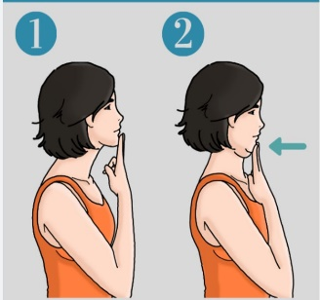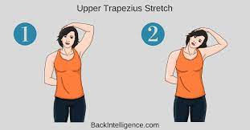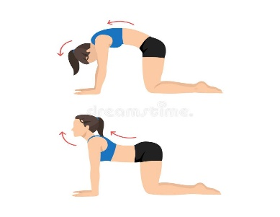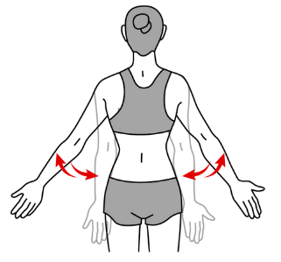

Scapular Retraction

**Cat cow stretch**

**Chin tucks**

**Upper trapezious stretch**

**Benefits:**

Healthcare professionals think stretches for headaches work by relieving tension in the upper body and reducing stress. A variety of stretches can help relieve tension in the neck, shoulders, and back. However, if headaches persist or a person experiences migraine, they should contact a doctor.