Deep Learning-Based Classification for Melanoma Detection Using XceptionNet and DenseNet121.
In this project we have utilized HAM10000 dataset to predict skin cancer as melanoma or non-melanoma. XCEPTION algorithm was applied on augmented images to differentiate between dark and white skin images and then train with DenseNet121 algorithm. After training DenseNet121 giving 98.50% accuracy on white skin images and 99% accuracy on dark skin images.
In below screen showing some images used as dark skin testing
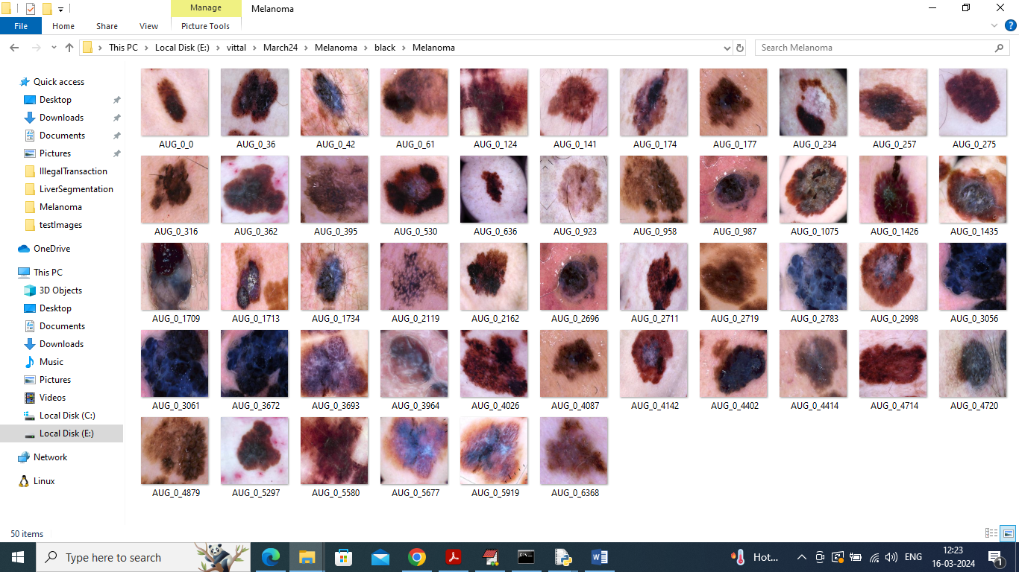
Propose DenseNet121 model works for both white and dark skin.
We have coded this project using JUPYTER notebook and below are the code and output screens with blue colour comments
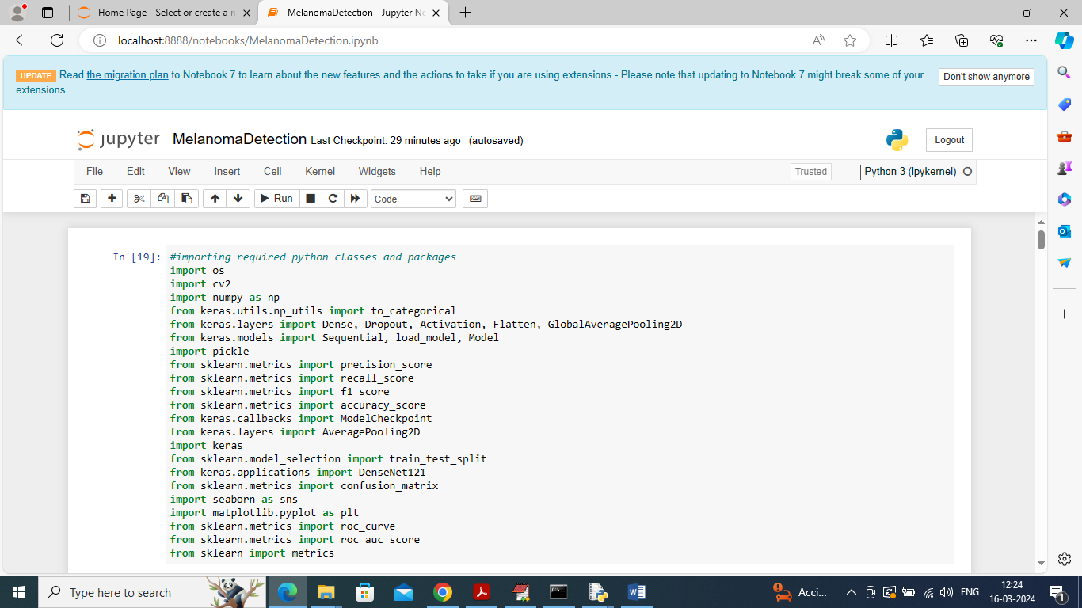
In above screen importing require python classes and packages
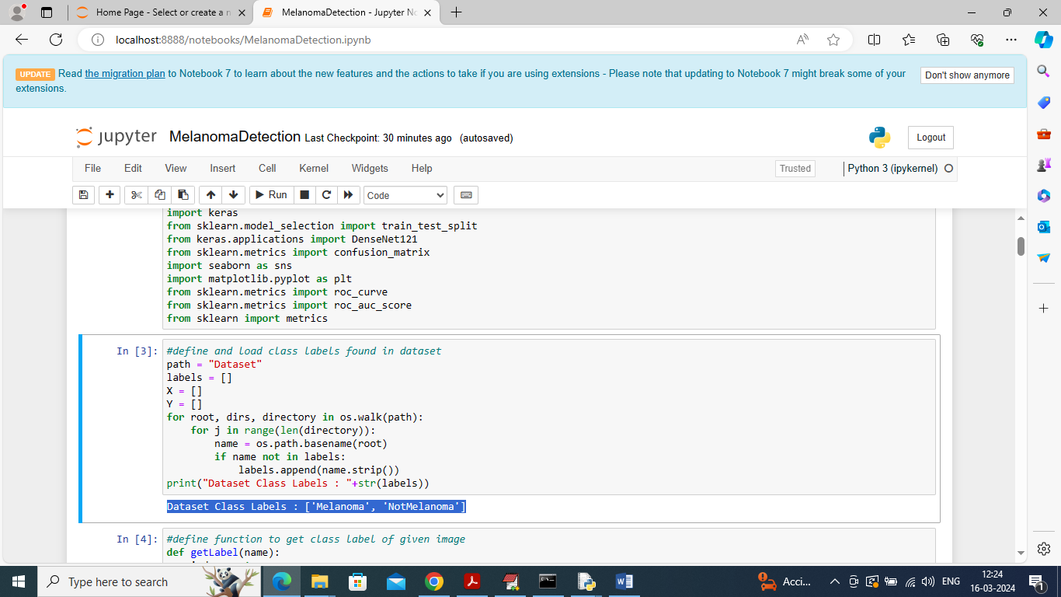
In above screen looping dataset folder to identify different class labels
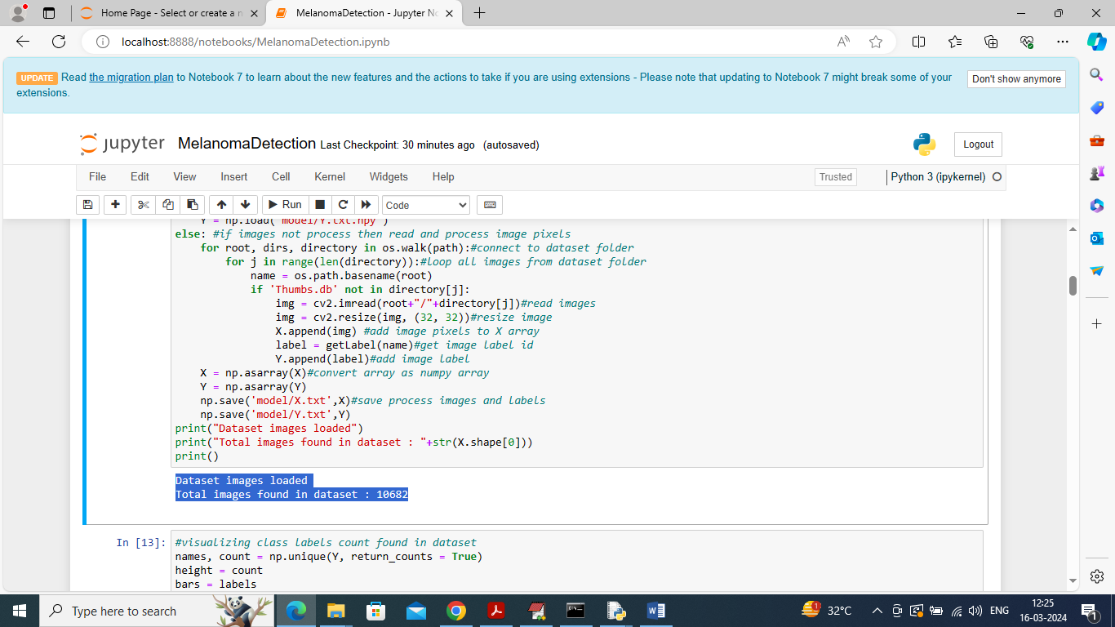
In above screen looping and reading all images from dataset and then creating training X and Y array where X will contains image features and y will contains labels and then in blue colour displaying number of loaded images
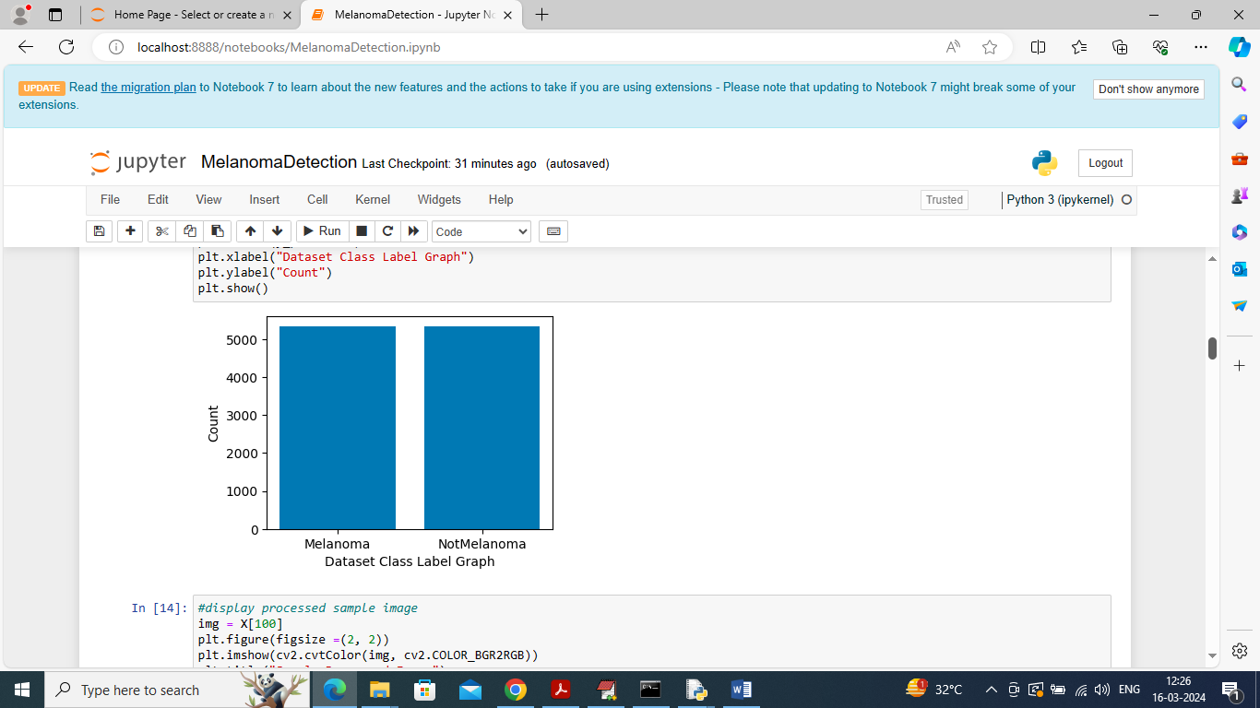
In above graph visualizing number of images found in each class label after augmentation and can see both are having equal images
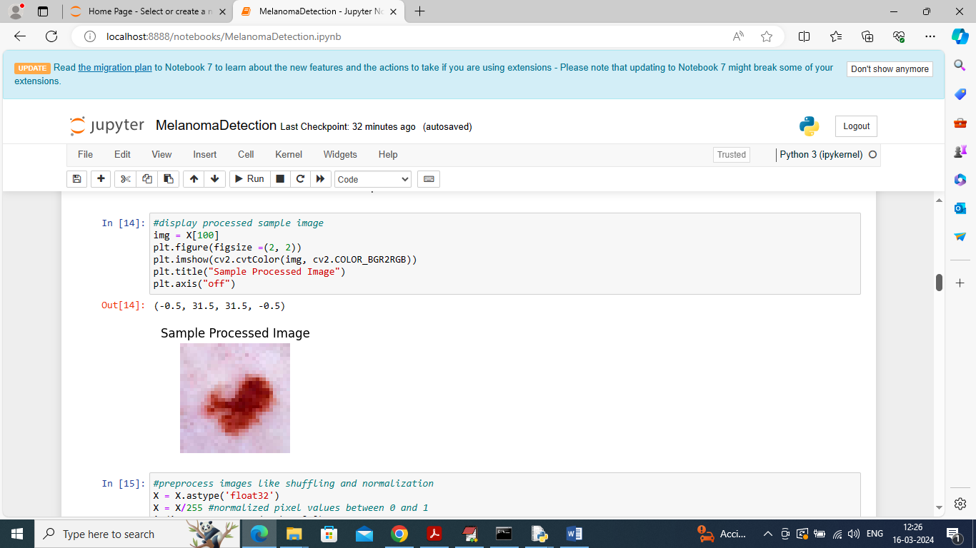
In above screen displaying sample processed image
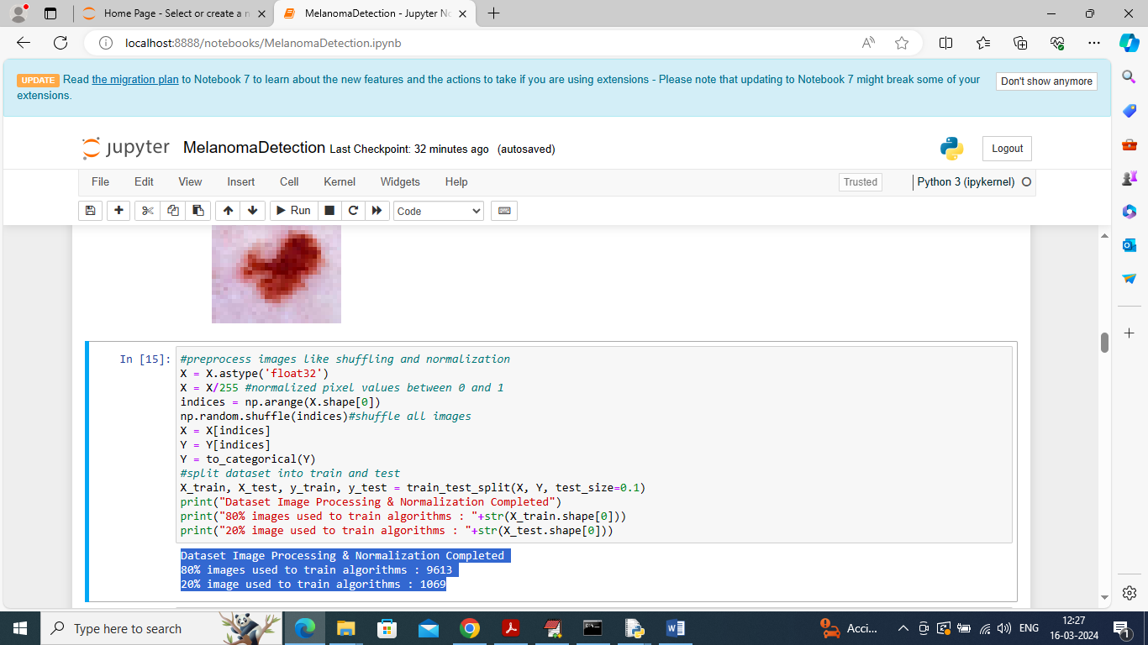
In above screen applying image processing techniques like shuffling, normalization and then splitting to train and test and then in blue colour text can see training and testing images size
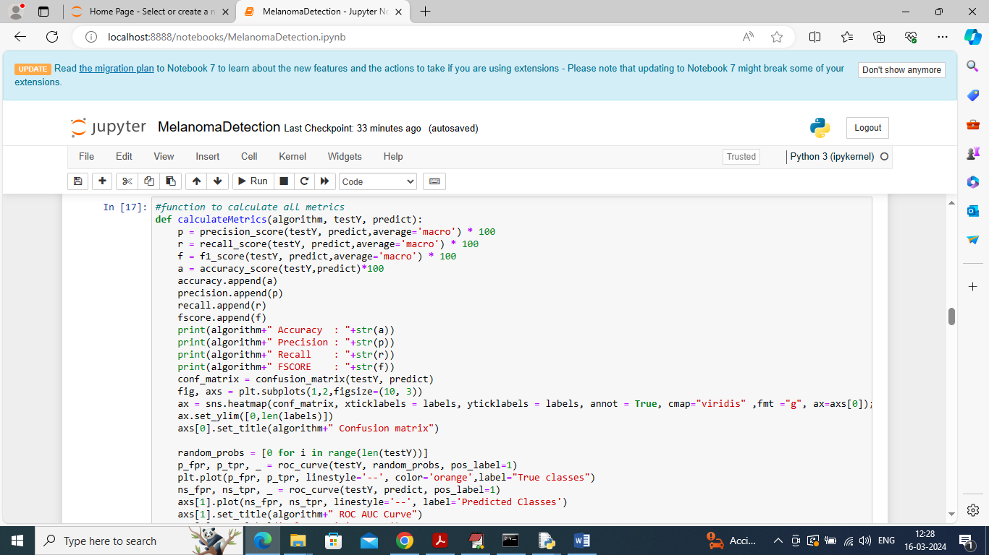
In above screen defining function to calculate accuracy and other metrics
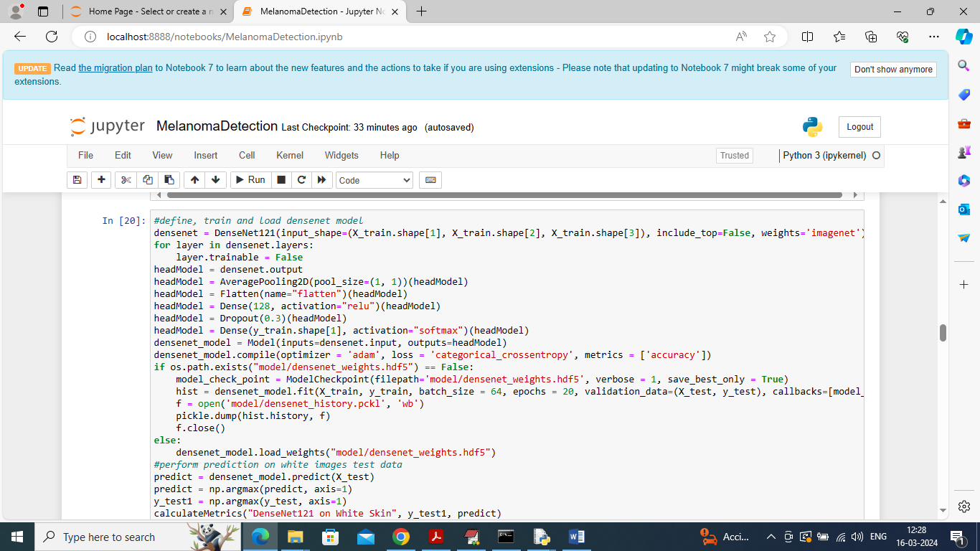
In above screen training and loading DenseNet121 algorithm and then performing prediction on test data and after execution will get below output
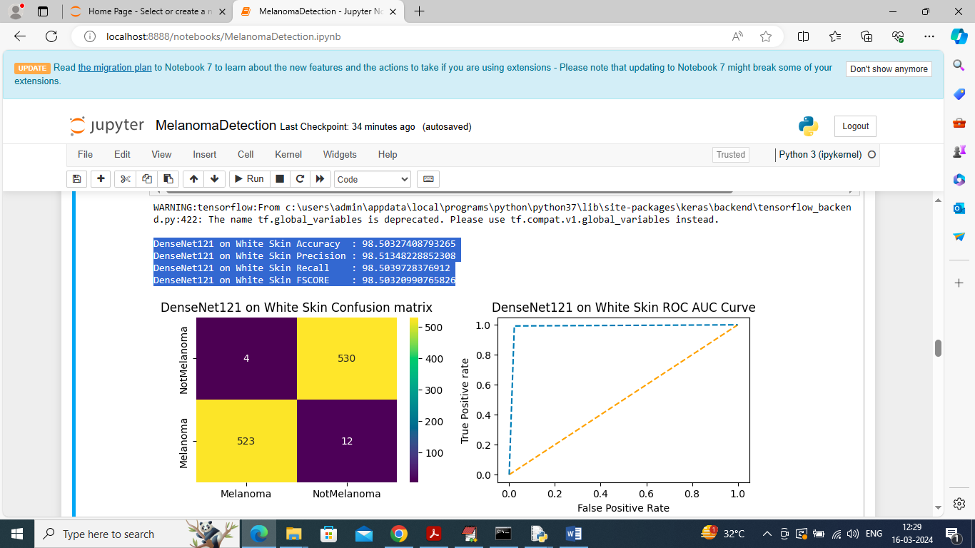
In above screen DenseNet121 algorithm got 98.50% accuracy on white skin test data and can see other metrics like precision, recall and etc. in confusion matrix graph x-axis represents Predicted Labels and y-axis represents True labels and then different color boxes like yellow represents correct prediction count and all blue boxes represents incorrect prediction count which are very few. In ROC graph x-axis represents False Positive Rate and y-axis represents True Positive Rate and if blue lines comes below orange line then all predictions are incorrect or false and if goes above orange line then all predictions are correct or true.
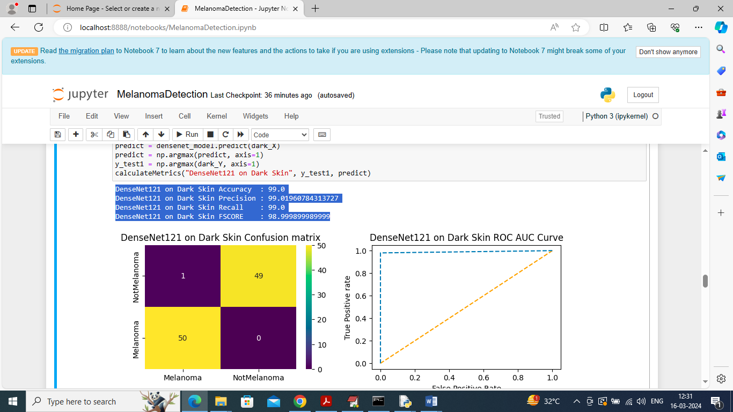
In above screen DenseNet121 got 99% accuracy on dark skin test data and can see other metrics and graph
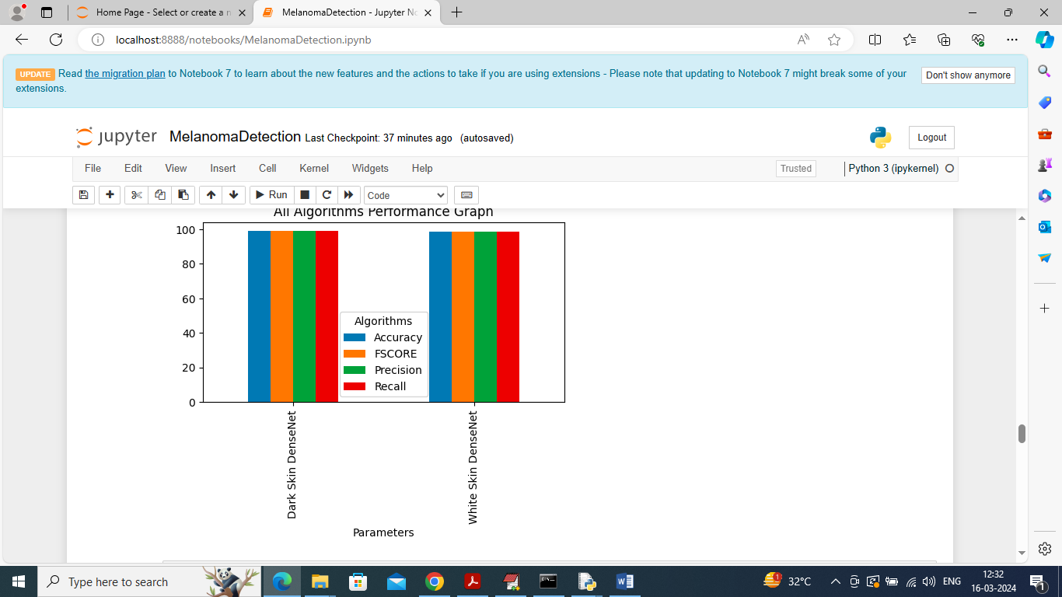
In above screen can see DenseNet121 performance on both dark and white skin where graph x-axis represents skin type and y-axis represents accuracy and other metrics in different colour bars and algorithm got equal accuracy on both skin type with minor difference
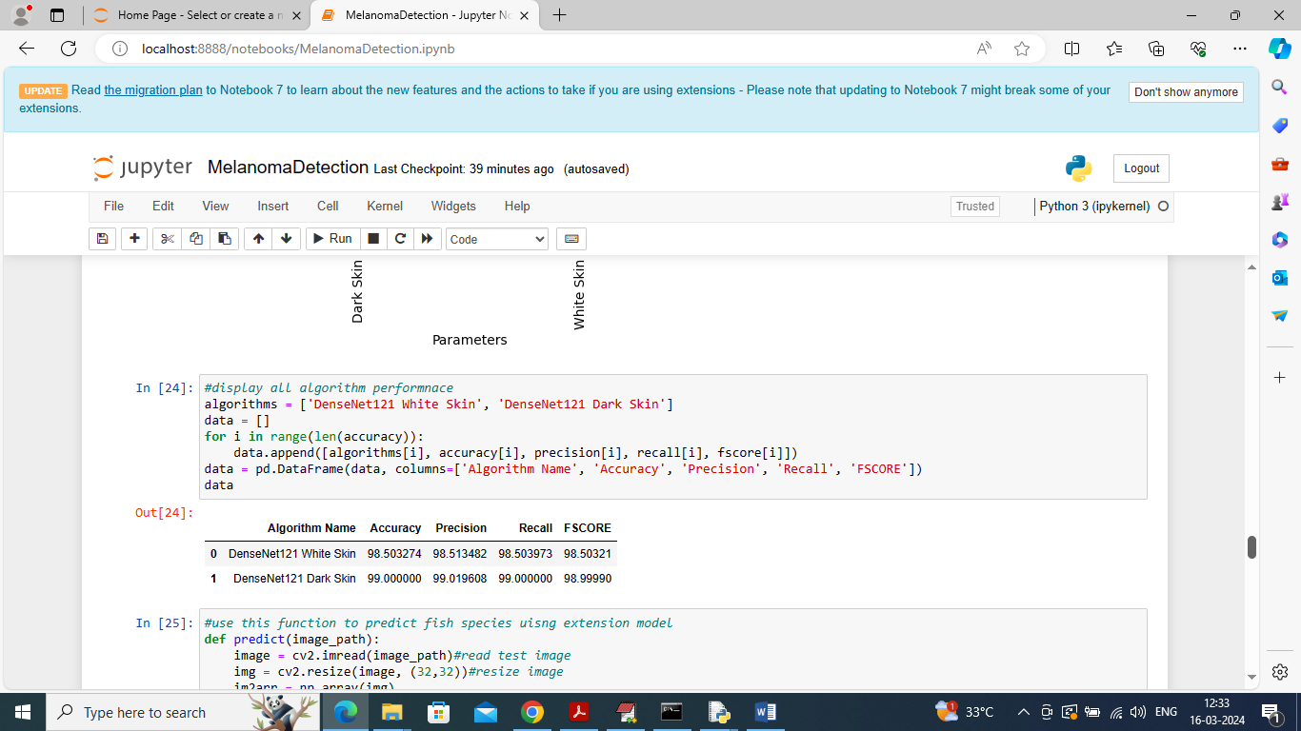
In above screen can see algorithm performance in tabular format
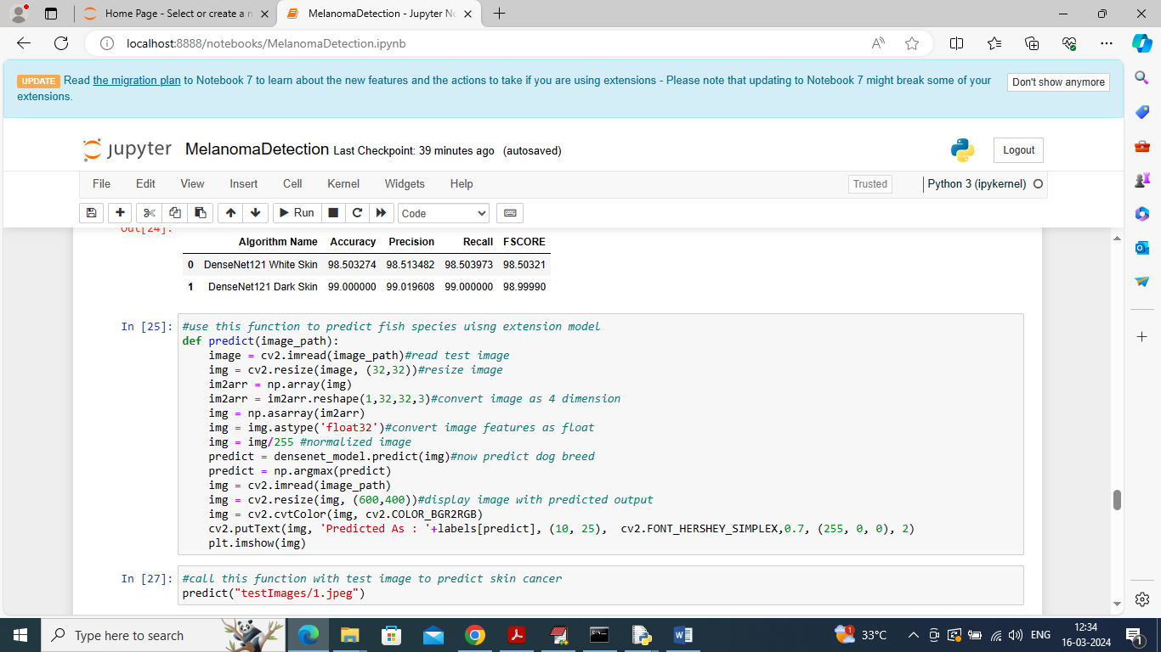
In above screen defining predict function which will take image path as input and then predict skin cancer as melanoma or non-melanoma
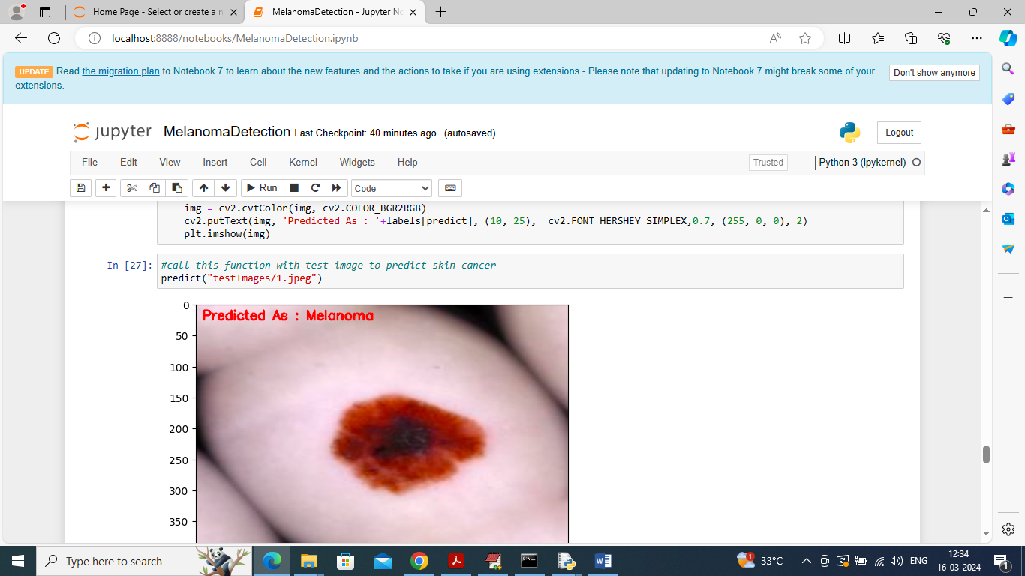
In above screen calling predict function with image path and then in red colour text can see skin cancer detected as Melanoma
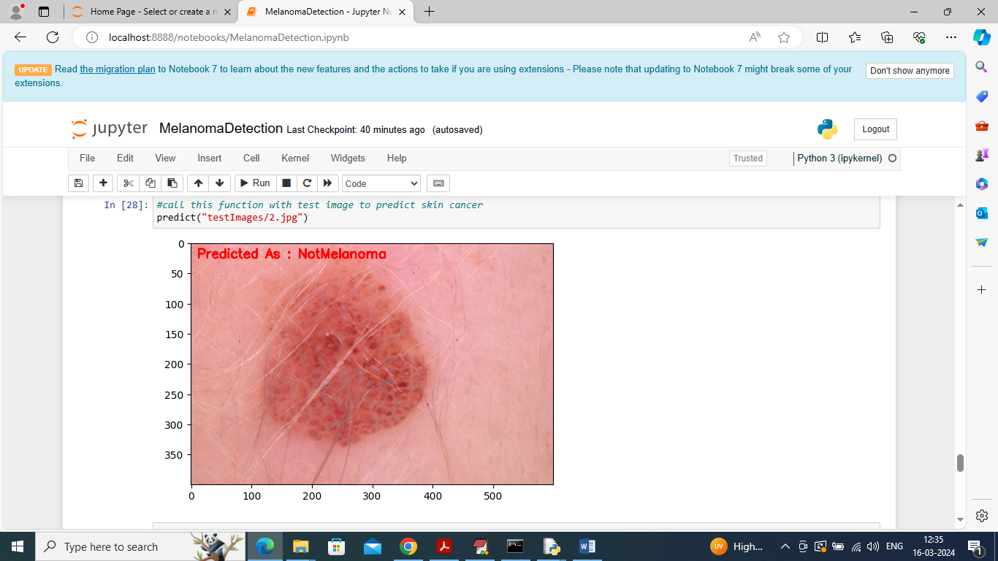
Above image predicted as not-melanoma
