DAY5_1

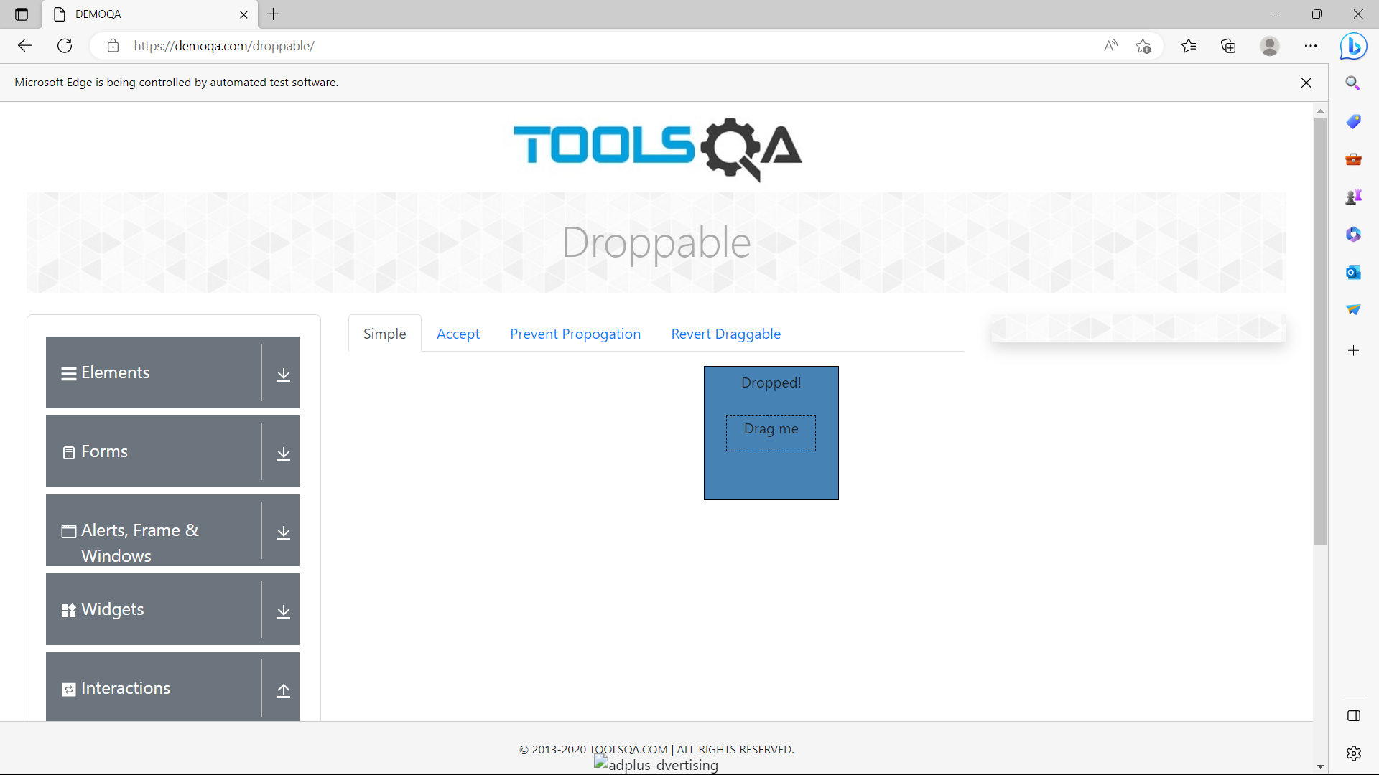 package practise_selenium;

import org.openqa.selenium.By;

import org.openqa.selenium.WebDriver;

import org.openqa.selenium.WebElement;

import org.openqa.selenium.edge.EdgeDriver;

import org.openqa.selenium.edge.EdgeOptions;

import org.openqa.selenium.interactions.Actions;

import io.github.bonigarcia.wdm.WebDriverManager;

public class Day5_1 {

public static void main(String[] args) {

WebDriverManager.edgedriver().setup();

EdgeOptions co = new EdgeOptions();

co.addArguments("--remote-allow-origins=*");

WebDriver driver = new EdgeDriver(co);

driver.manage().window().maximize();

driver.get("https://demoqa.com/droppable/");

Actions a = new Actions(driver);

WebElement source_ele = driver.findElement(By.id("draggable"));

WebElement dest_ele = driver.findElement(By.id("droppable"));

a.clickAndHold(source_ele).release(dest_ele).build().perform();

}

}