**Phase 1**

**Front end: Add To Cart + Checkout page + My Order  
Backend Development : Order and Order Product [Update/Delete]**

**In the product details page option add to cart button**

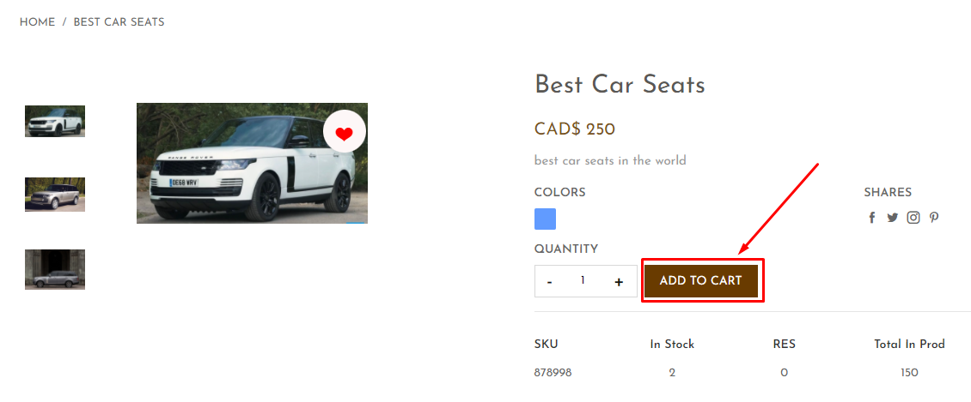

**After Clicking on add to cart button checking if product in stock or not. If not in stock it’s given flash message out of stock**



**After Clicking on add to cart button checking if product in stock then given flash message item added to cart.**



In the top header has Cart icon in right conner show 1 item in cart.

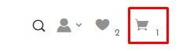

**If you click on cart icon to redirect on cart page**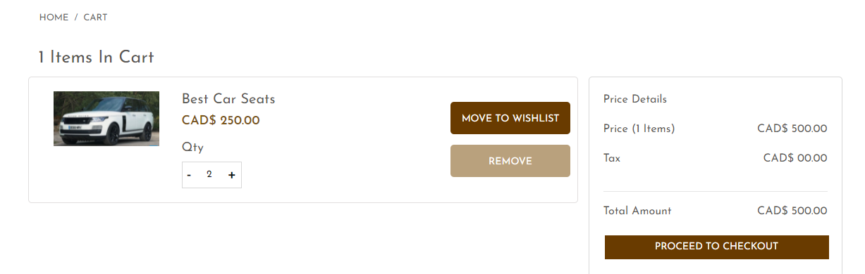

**If you clicking on remove button show confirm message**

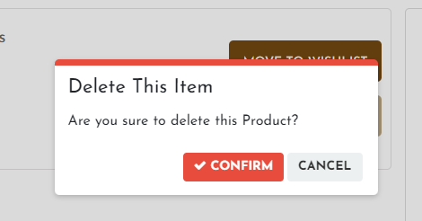

**If you clicking on move to wishlist button show confirm message**

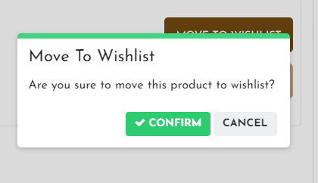

**If you clicking on Proceed to checkout button that redirect to jobs page**

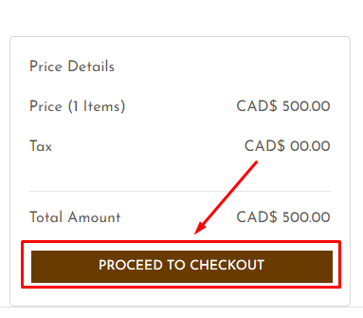

**You can see on checkout page two types of addresses Billing in Shipping**

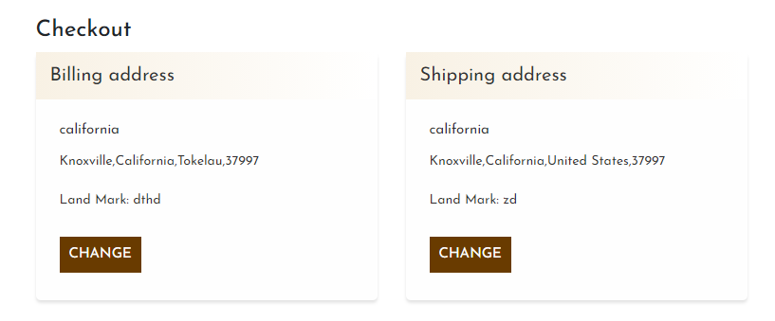

**If you want to change a billing address and shipping address just clicking on change button**

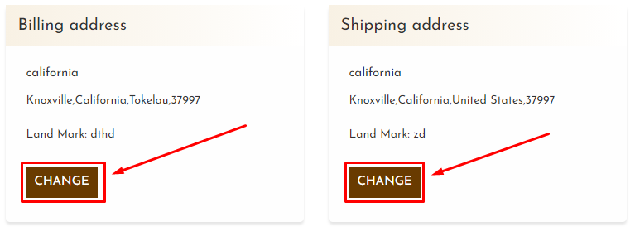

**If you clicking on change button to open popup modal**

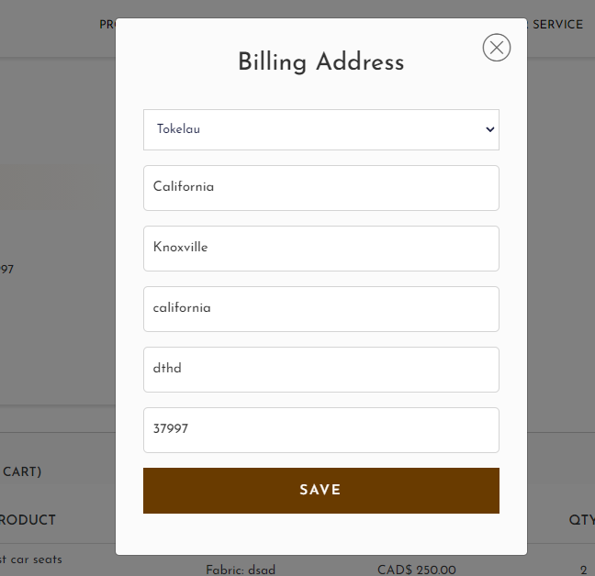

**In Checkout page bottom section given product item cart list**

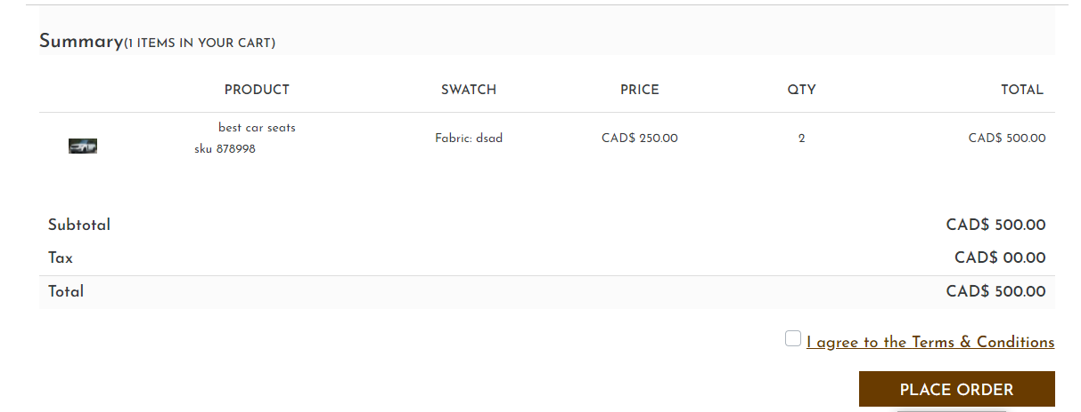

**If you clicking on place order button to redirect my order page**

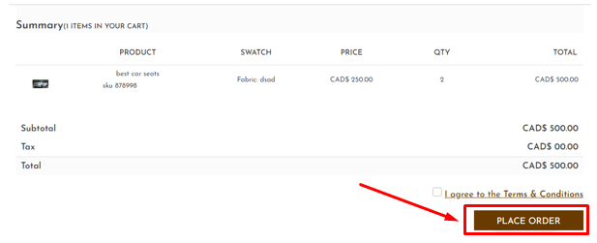

**My order Page show all these order**

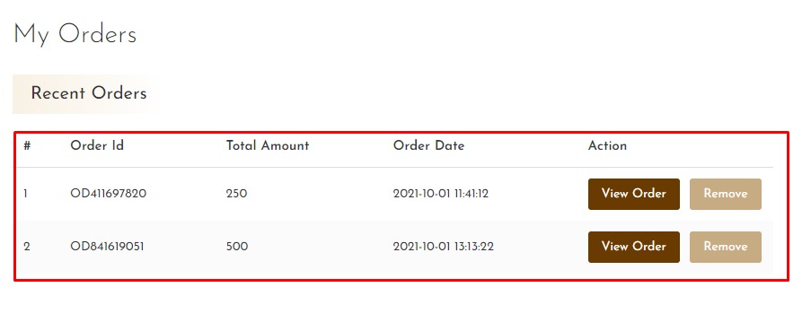

**If you clicking on remove button**

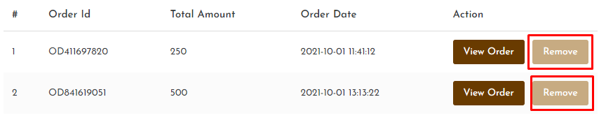

**then alert confirmation popup then remove item**

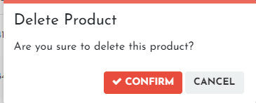

**If you clicking on view Order button to redirect on view order details page**

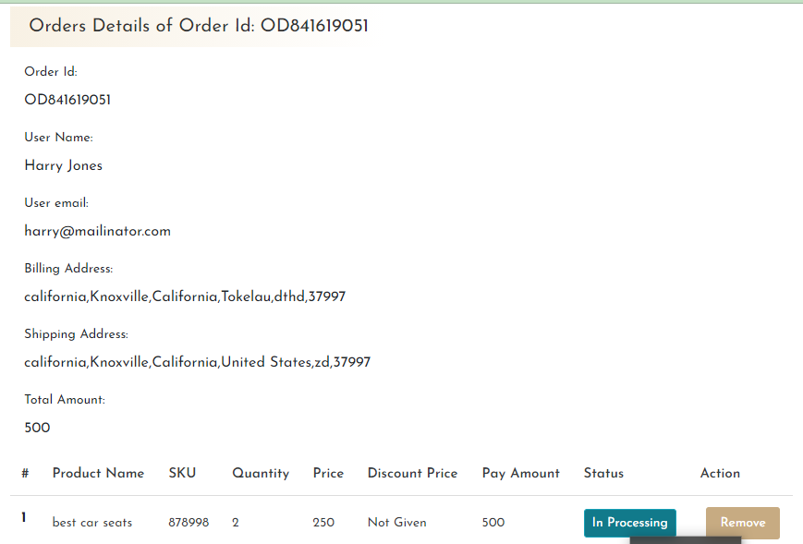

**If you clicking on remove button then remove the product in my order.**

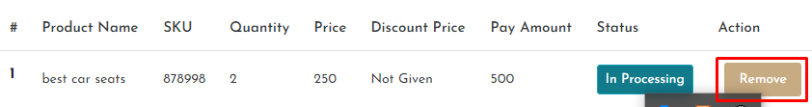

**Backend Development : Order and Order Product [Update/Delete]**

**In Backend admin panel show left side menu Order menu**

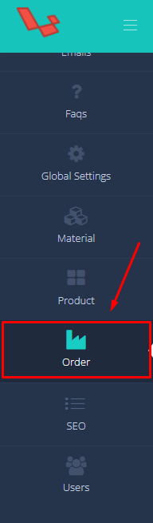

**If you clicking on Order menu to redirect to admin order page**

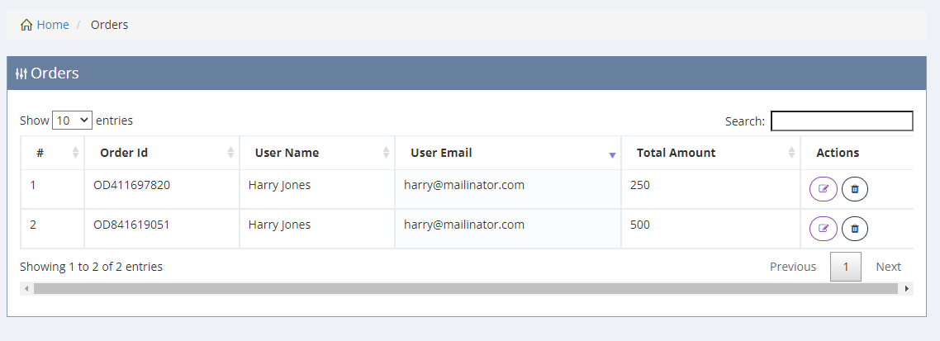

**Here You can see Two types of action first one update**

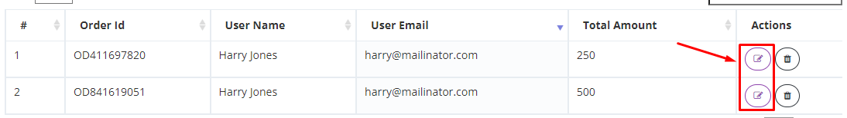

**Here You can see Two types of action Second one delete**

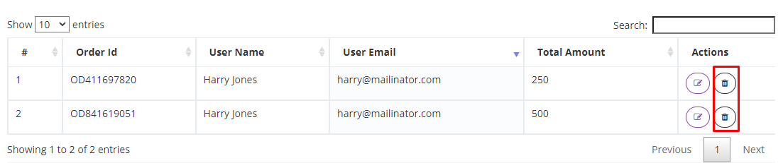

**If you clicking on update button to redirect on admin-updateorder page**

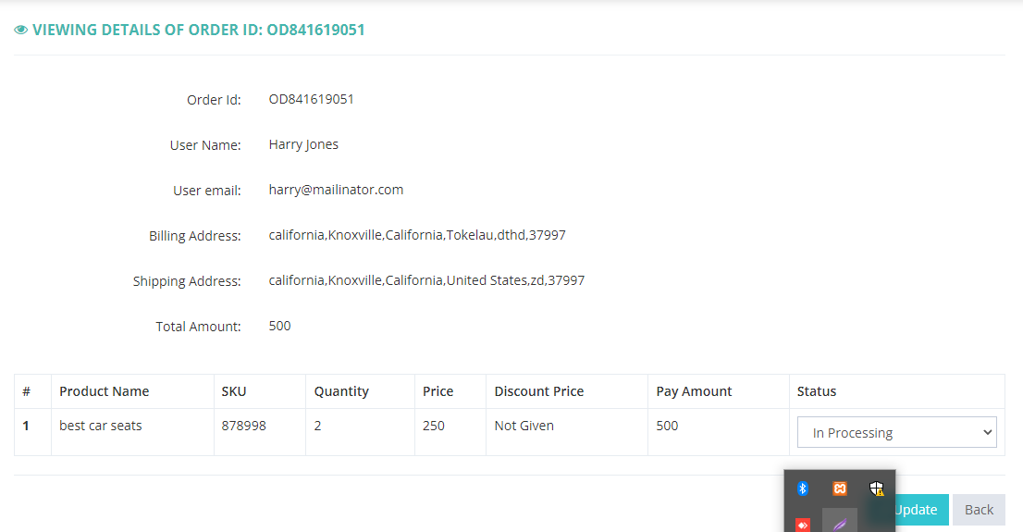

**Here you can see status dropdown to update the status of order product**

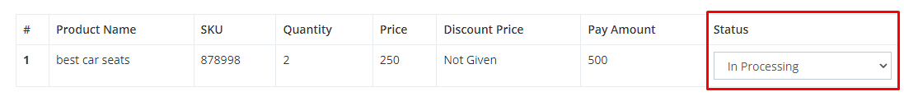

**If you clicking update button then update the product status**

