K-NN Classifier Report (IS201501056,IS201501035,IS201401021)

**Mean and Standard deviation values of no of misclassifications for various values of k during 3-fold cross validation on training set.**

|  |  |  |
| --- | --- | --- |
| K value | Mean | Standard Deviation |
| 1 | 88 | 69.76 |
| 2 | 61.33 | 34.77 |
| 3 | 78 | 50.74 |
| 4 | 66.67 | 37.84 |
| 5 | 62.34 | 33.50 |
| 6 | 57 | 32.78 |
| 7 | 60.34 | 32.12 |
| 8 | 54.67 | 30.01 |
| 9 | 55.34 | 29.53 |
| 10 | 45.34 | 33.5 |

$$k≤\sqrt{size}$$

Where size=size of test set.

**Plot of Standard deviation (no of errors) versus k**

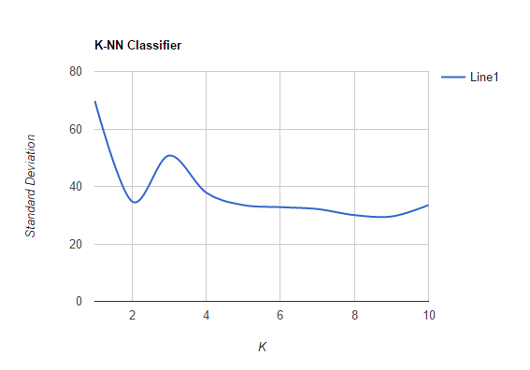

**Plot of Mean (no of errors) versus k.**

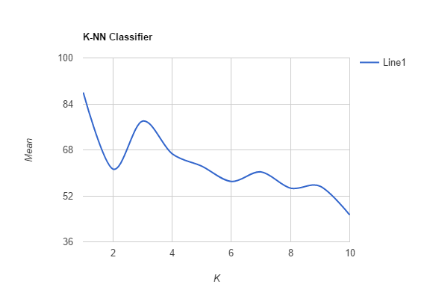

Based on mean of number of errors, we find that at k=10 we get minimum number of errors.

On test set1 with k=10

For weighted k-nn algorithm

Accuracy=96.13%

For k-nn algorithm

Accuracy=95.98%

On test set 2

For weighted k-nn algorithm

Accuracy=96.51%

For k-nn algorithm

Accuracy=96.44%

Based on Standard deviation of number of errors, we find that at k=9 we get minimum number of errors.

On test set1 with k=9

For weighted k-nn algorithm

Accuracy=96.17%

For k-nn algorithm

Accuracy=96.17%

On test set 2

For weighted k-nn algorithm

Accuracy=96.48%

For k-nn algorithm

Accuracy=96.48%

In case of draw we have probability of 0.5 for a given test data to belong to either of the classes. We have assigned class 0 as the class for such cases.