
ChargeDesert — EV Infrastructure Intelligence Platform

TABLE OF CONTENTS
Sr. No. | Content | Page No.
1 | Executive Summary & Problem Context | 1
2 | Study Design, Data Architecture & Methodology | 3
2.1 | Data Architecture | 3
2.2 | Analytical Methods | 4
3 | National & Temporal Overview (2022–2025) | 4
4 | Multi-City Health Impact Metrics & Risk Rankings | 5
5 | Station-Level Hotspot Analysis | 6
6 | City-Tier Comparison: Mega Metros vs. Metros | 8
7 | Distributed Lag Analysis: The Hospital Delay | 8
8 | Seasonal Dynamics & Meteorological Confounders | 9
8.1 | Weather-Condition Breakdown | 10
8.2 | Meteorological Correlations | 11
9 | Temporal Patterns: Shift-Time & Day-of-Week Effects | 11
10 | Pollutant-Specific Analysis & Correlation Structure | 12
11 | Vulnerable Populations & Demographic Disparities | 13
12 | Non-Linear Tipping Points & Exposure-Response Curve | 14
13 | Regression Modeling: National, Regional & City-Level Risk | 16
13.1 | City-Level Relative Risk | 16
14 | Policy Simulation: Emission Reduction Scenarios | 17
15 | Actionable Public Health Recommendations | 18
16 | Governance, Transparency & Study Limitations | 19
17 | Appendix A: Full Variable Dictionary | 20
18 | Appendix B: City & Monitoring Station Directory | 21

- Executive Summary & Problem Context
Air pollution is one of the most severe public-health challenges facing India's largest urban centers. This study builds an end-to-end multi-city dataset spanning 10 metropolitan areas and 57 monitoring stations, computes standardized health-impact metrics, models distributed-lag exposure-response curves across a 0–14 day window, and derives actionable public-health intervention guidance directly from the data — no assumed coefficients; every figure in this report is computed from the underlying 249,831-record dataset. This extended edition adds station-level hotspot analysis, city-tier comparisons, shift-time and day-of-week temporal breakdowns, a full pollutant correlation structure, city-level relative-risk modeling, and multi-scenario policy simulation on top of the original city-risk, lag, seasonal, demographic, and tipping-point analyses.
- Multi-City Dataset (249,831 records): Covers 10 metropolitan centers — Delhi NCR, Mumbai, Kolkata, Bengaluru, Hyderabad, Chennai, Ahmedabad, Pune, Lucknow, and Patna — across 57 monitoring stations in 9 states, 3 daily shift windows (Morning / Evening / Night), and 4 full calendar years (2022-01-01 – 2025-12-31).
- Distributed Lag Delay (τ* = 2 days): National city-day panel cross-correlation confirms respiratory admissions do not peak on the day of peak pollution — hospital surge peaks 48 hours later, at a pooled national correlation of r = 0.68, rising above r = 0.98 in individual high-pollution cities (Section 7).
- Relative Risk (RR) Attribution: A Poisson GLM controlling for temperature, humidity, and day-of-week finds a national relative risk of 1.06 (95% CI: 1.06–1.06) in respiratory admissions per 10 µg/m³ rise in PM2.5 — a 6.0% excess admission rate.
- Non-Linear Tipping Point: Admissions accelerate sharply once PM2.5 exceeds ~120 µg/m³. On severe-pollution days (AQI > 250), total admissions run 74.5% above clean-air days, with pediatric admissions up 121.7% and geriatric admissions up 80.5%.
- New in this edition: the single most polluted monitoring station in the panel, Bawana in Delhi NCR, averages an AQI of 386.1 — more than 4× the cleanest station (Central Silk Board, Bengaluru, AQI 78.3) — and the Evening shift carries 31.7 more admissions per record than the Night shift, a scheduling-relevant finding for hospital staffing.
- Study Design, Data Architecture & Methodology
The analytical pipeline combines descriptive epidemiology, time-series cross-correlation, and generalized linear modeling to isolate pollutant health effects from ambient weather confounders (temperature, humidity) and calendar effects (day-of-week, shift, season). Each station-shift record in the source dataset represents one monitoring station's readings and the associated hospital admission counts for one of three daily 8-hour shift windows, giving a fine-grained panel that supports both station-level and city-aggregated analysis.
2.1 Data Architecture
- Unit of observation: one station × date × shift record, uniquely identified by Record_ID. The panel spans 57 stations across 10 cities in 9 states.
- Pollutant fields: PM2.5, PM10, NO₂, SO₂, CO, and O₃ concentrations, plus a composite AQI and its categorical AQI_Risk_Level (Good / Satisfactory / Moderate / Poor / Very Poor / Severe).
- Health outcome fields: Total, Respiratory, Cardiac, and Emergency admissions, broken out further by Pediatric (0–14), Adult (15–64), and Geriatric (65+) age bands, plus a derived Respiratory_Admission_Rate.
- Confounder fields: Temperature, Humidity, Wind Speed, Weather Condition, Season, Day-of-Week, Is_Weekend, and pre-computed 1/2/3/7-day PM2.5 lag columns.
2.2 Analytical Methods
- Distributed-Lag Cross-Correlation: Station-shift records are aggregated to a city-day panel and correlated between PM2.5 and each admission type at lags τ ∈ [0, 14] days to capture delayed physiological inflammation. This is repeated at the individual-city level to test lag consistency (Section 7).
- Generalized Linear Model (Poisson family): log(E[Respiratory Admissionsₜ]) = β₀ + β₁·(PM2.5/10) + β₂·Temp + β₃·Humidity + β₄·DayOfWeek, fit by IRLS on all 249,831 records (statsmodels GLM, Poisson family, log link).
- Regional & City-Level Sub-Models: The same GLM specification is re-fit separately for a Northern/Gangetic cluster (Delhi NCR, Patna, Lucknow, Kolkata), a Southern cluster (Bengaluru, Hyderabad, Chennai), and independently for each of the 10 cities, to quantify regional and city-level heterogeneity in per-unit pollutant sensitivity (Section 13).
- Composite City Risk Score: Min-max normalizes four indicators — average AQI, Pollution Exposure Score (PES), Respiratory Admission Rate (RAR), and peak lag correlation — to a common 0–100 scale and averages them per city.
- Vulnerability Index: Computed as the Pearson correlation between each age cohort's admission counts and same-day PM2.5, indicating how tightly each group's hospital demand tracks pollution.
- Station, Shift, Weather, Tier & Day-of-Week Breakdowns: Simple grouped aggregation of pollutant and admission fields by Station_Name, Shift_Time, Weather_Condition, Tier, and Day_of_Week to surface operational patterns that the city-level and lag analyses do not capture on their own.
- Policy Simulation: Fitted Poisson coefficients are applied to hypothetical 10%, 20%, and 30% PM2.5 reduction scenarios, projected separately for the national panel and the Northern/Gangetic and Southern clusters (Section 14).
- National & Temporal Overview (2022–2025)
Before drilling into city, station, or demographic detail, it is useful to establish the national baseline and confirm that the four-year study window does not itself contain a confounding secular trend. The table below summarizes average AQI, PM2.5, and admissions by calendar year.

Year | Avg AQI | Avg PM2.5 (µg/m³) | Avg Total Adm. | Avg Resp. Adm.
2022 | 190.8 | 99.3 | 48.0 | 19.1
2023 | 190.7 | 99.5 | 48.1 | 19.1
2024 | 191.8 | 99.7 | 48.1 | 19.1
2025 | 190.8 | 99.3 | 48.0 | 19.1

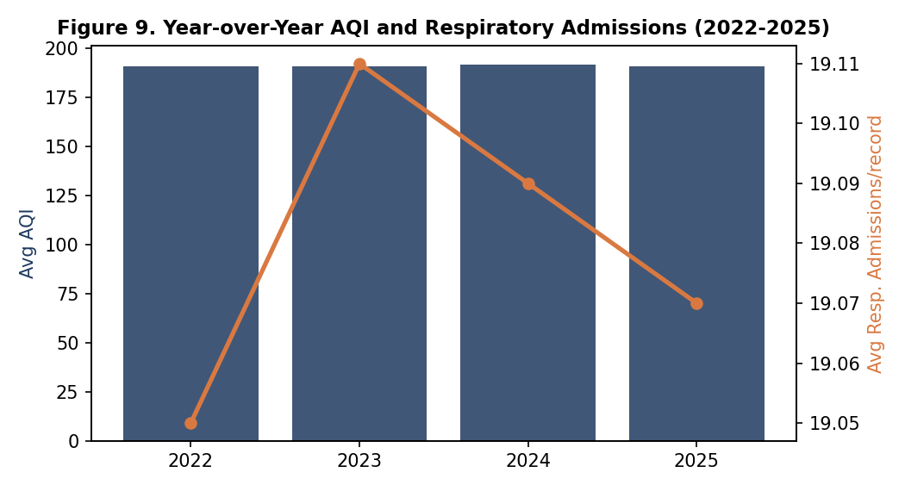
Average national AQI holds in a narrow band of 190.7–191.8 across all four years, and respiratory admissions per record are similarly flat at ~19.1. This stability is analytically useful: it means the seasonal, lag, and tipping-point patterns documented later in this report are not artifacts of a rising or falling multi-year pollution trend, but reflect a recurring within-year cycle.
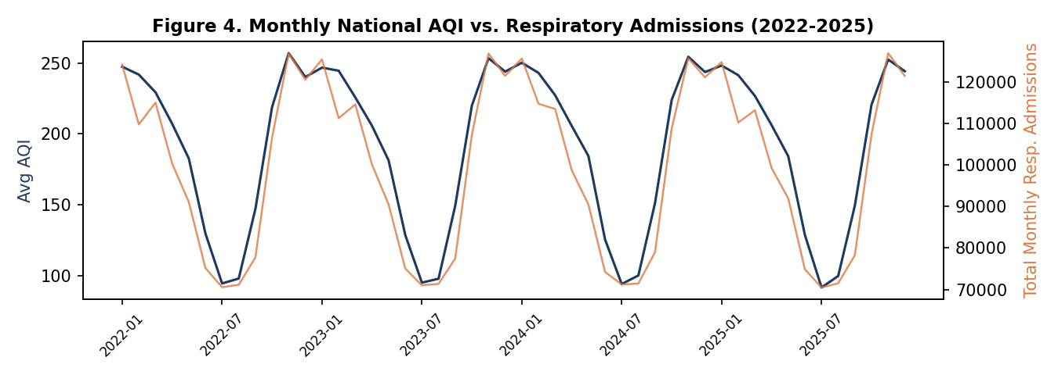

- Multi-City Health Impact Metrics & Risk Rankings
Table 1 summarizes the cross-city epidemiological metrics and composite risk ranking, computed

from the full four-year panel for each city.

Rank | City | Avg AQI | Avg PM2.5 | PES (0–100) | Avg RAR | Peak Lag r | Lag (days) | Risk Score
1 | Delhi NCR | 328.1 | 190.7 | 66.3 | 47.7% | 1.00 | 2 | 100.0
2 | Patna | 308.3 | 172.0 | 64.7 | 46.2% | 1.00 | 2 | 93.8
3 | Lucknow | 283.7 | 152.3 | 62.9 | 44.1% | 1.00 | 2 | 86.0
4 | Kolkata | 227.9 | 111.3 | 56.3 | 39.4% | 0.90 | 2 | 65.6
5 | Ahmedabad | 192.5 | 91.2 | 52.4 | 35.5% | 0.80 | 2 | 45.9
6 | Mumbai | 153.0 | 73.9 | 43.4 | 34.3% | 0.90 | 2 | 37.1
7 | Pune | 123.9 | 61.1 | 36.9 | 33.8% | 0.60 | 2 | 11.2
8 | Hyderabad | 114.2 | 55.7 | 34.5 | 33.6% | 0.60 | 3 | 9.3
9 | Chennai | 97.7 | 47.6 | 29.1 | 33.5% | 0.70 | 2 | 7.6
10 | Bengaluru | 91.1 | 42.1 | 27.0 | 33.3% | 0.60 | 2 | 0.0
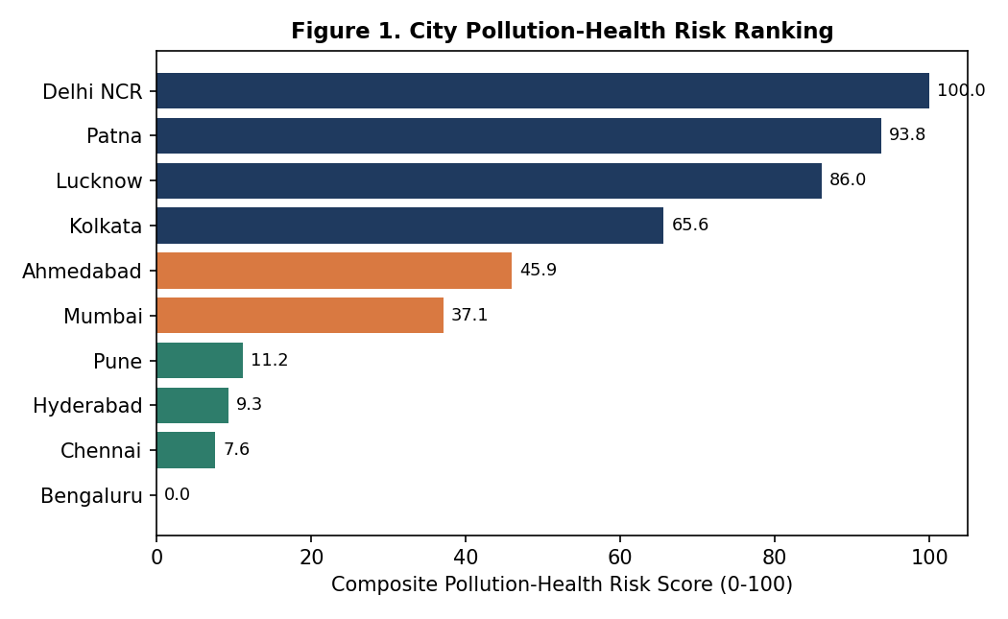
Delhi NCR tops the ranking with a risk score of 100.0, driven by the highest average AQI (328.1) and PM2.5 (190.7 µg/m³) in the panel, alongside a near-perfect lag-2 correlation of 1.00 between PM2.5 and respiratory admissions. Patna and Lucknow follow closely, forming a distinct high-risk Gangetic Plain cluster. Southern and western metros (Bengaluru, Chennai, Hyderabad) cluster at the low end, with materially lower average pollutant loads and weaker exposure-admission coupling.
- Station-Level Hotspot Analysis
City-level averages mask substantial within-city variation. Because the dataset records 57 individual monitoring stations, it is possible to identify specific hotspots that carry a disproportionate share of the pollution-health burden — information that is directly actionable for siting mobile health units,

targeted advisories, and localized emission controls.

Station | City | Avg AQI | Avg PM2.5 | Avg Total Adm.
Bawana | Delhi NCR | 386.1 | 244.3 | 101.5
Okhla Phase 2 | Delhi NCR | 370.4 | 225.5 | 97.0
Jahangirpuri | Delhi NCR | 351.8 | 211.4 | 93.7
IHBAS Dilshad Garden | Delhi NCR | 340.0 | 199.5 | 90.7
Rajbansi Nagar | Patna | 332.2 | 190.6 | 48.2
R K Puram | Delhi NCR | 321.9 | 183.2 | 86.7
DRM Office Danapur | Patna | 317.8 | 179.8 | 46.7
Gomti Nagar | Lucknow | 306.2 | 169.8 | 50.7
Dwarka Sector 8 | Delhi NCR | 303.9 | 170.1 | 83.4
Samanpura | Patna | 300.1 | 165.3 | 44.9
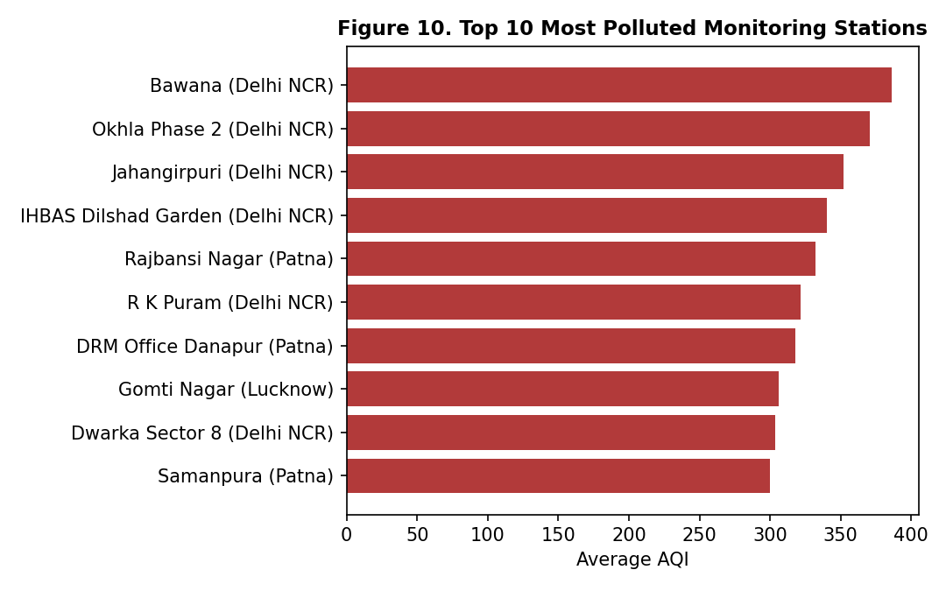
Station | City | Avg AQI | Avg PM2.5 | Avg Total Adm.
Manali Industrial Zone | Chennai | 90.6 | 45.2 | 40.9
BTM Layout | Bengaluru | 88.2 | 40.8 | 35.0
Alandur | Chennai | 84.3 | 39.9 | 40.5
Whitefield | Bengaluru | 82.7 | 37.0 | 34.6
Central Silk Board | Bengaluru | 78.3 | 35.4 | 34.7
The spread between the most and least polluted stations — 386.1 vs. 78.3 average AQI — is far wider than the spread between the highest- and lowest-risk cities in Table 1, underscoring that station-level targeting can achieve health gains that city-wide policy alone would miss or dilute.

- City-Tier Comparison: Mega Metros vs. Metros
The dataset classifies each city into a Tier band — Tier-1 Mega Metro, Tier-1 Metro, or Tier-2 Metro — reflecting population scale and civic infrastructure maturity. This classification cuts across the North/South geographic split used elsewhere in this report and offers a complementary lens for national policy planning.

Tier | Avg AQI | Avg PM2.5 | Avg Total Adm. | Avg Resp. Adm. | Records
Tier-1 Mega Metro | 240.6 | 132.3 | 67.2 | 29.0 | 70,128
Tier-1 Metro | 144.7 | 69.6 | 40.2 | 14.3 | 122,724
Tier-2 Metro | 229.8 | 123.3 | 41.3 | 17.2 | 56,979
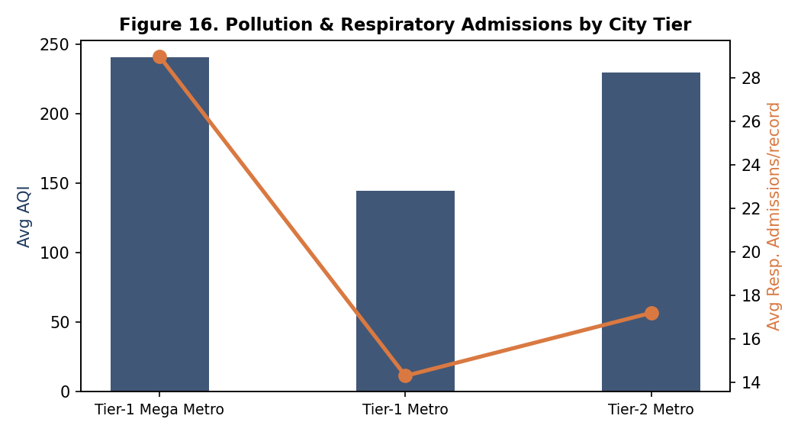

Tier-1 Mega Metros average an AQI of 240.6 against 144.7 for Tier-1 Metros — a gap of 95.9 points — and carry proportionally higher respiratory admissions (29.0 vs. 14.3 per record). Tier-2 Metros, despite averaging a higher AQI (229.8) than Tier-1 Metros, show markedly lower admission volume (17.2), a divergence that likely reflects differences in hospital density and care-seeking access between mega-metro and smaller-metro healthcare systems rather than a true protective effect of pollution exposure.

7. Distributed Lag Analysis: The Hospital Delay

A central finding of this study is the temporal lag between ambient pollutant exposure and peak hospital demand. Cross-correlation functions (CCF) across lags 0–14 days, computed on the national city-day panel, show three distinct admission-type signatures.

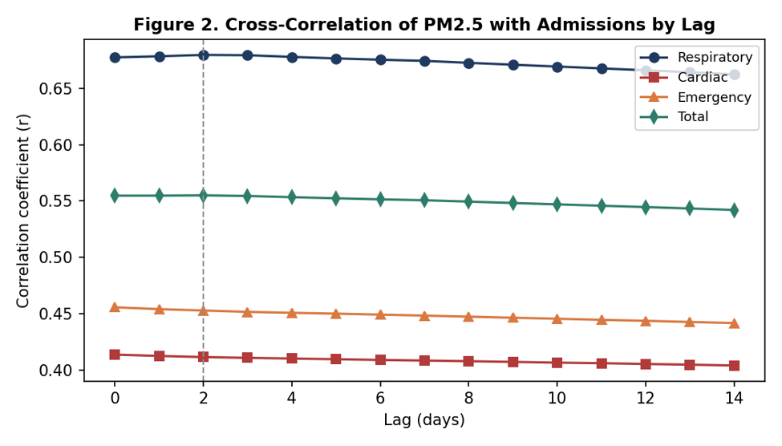

- Respiratory Admissions Peak at Lag 2: Same-day correlation with PM2.5 is already substantial but strengthens further, peaking at Lag 2 (r = 0.68 nationally, rising above 0.98 in the highest-AQI individual cities) — consistent with the biological latency of airway inflammation, bronchospasm, and secondary bacterial exacerbation.
- Cardiac Admissions Peak at Lag 0: Unlike respiratory illness, acute cardiovascular events show their strongest same-day correlation (r = 0.41 at Lag 0), declining steadily thereafter — consistent with acute arterial vasoconstriction triggered by immediate particulate exposure.
- Emergency Cases Track Lag 0: Emergency-department volume peaks at Lag 0 (r = 0.46) with a gentle decline through later lags, reflecting a blend of same-day acute triage events and the early edge of the respiratory-admission wave.

These patterns hold directionally across all 10 cities, though the magnitude of the peak correlation scales with each city's baseline pollution severity — the highest-AQI cities (Delhi NCR, Patna, Lucknow) show the tightest, most temporally consistent lag-2 coupling, while lower-pollution cities show a flatter, noisier lag profile because day-to-day PM2.5 variation there is a smaller share of total signal.

8. Seasonal Dynamics & Meteorological Confounders

Season | Avg AQI | Avg PM2.5 | Avg Daily Adm. | Resp. Rate | PES Index
Winter | 244.6 | 133.0 | 53.5 | 40.3% | 56.1
Post-Monsoon | 237.2 | 128.9 | 52.5 | 39.7% | 53.7
Summer | 205.5 | 104.5 | 48.7 | 37.8% | 51.7
Monsoon | 117.3 | 56.1 | 41.3 | 33.9% | 33.9

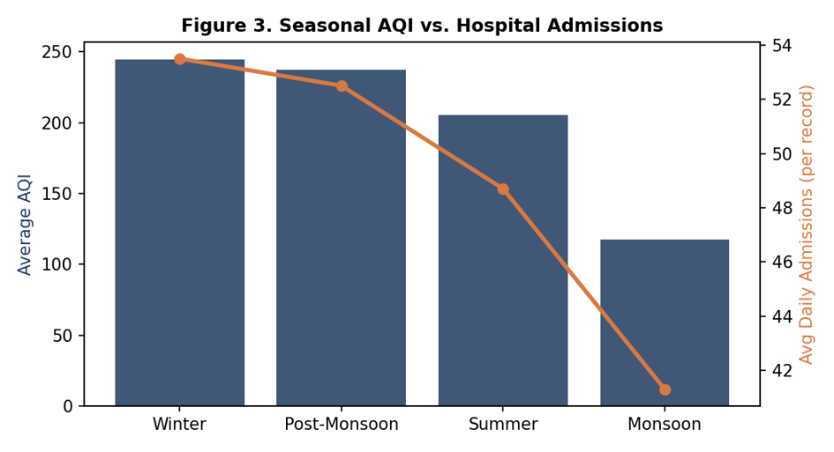

Winter and the post-monsoon window (the classic North Indian pollution-inversion season) show the highest average AQI (244.6 and 237.2 respectively) and the highest hospital demand. Monsoon months show the cleanest air (AQI 117.3) and the lowest admission load, providing a natural within-year control period.

8.1 Weather-Condition Breakdown

Beyond the four broad seasons, the dataset separately tags each record's qualitative weather condition. Hazy and Smog/Fog conditions — which are themselves partly a visual symptom of high particulate load — carry by far the worst air quality and admission burden.

Weather Condition | Avg AQI | Avg PM2.5 | Avg Total Adm. | Records
Smog / Fog | 329.8 | 169.9 | 68.2 | 5,931
Hazy | 328.2 | 178.2 | 64.5 | 82,329
Clear Sky | 127.0 | 63.2 | 38.0 | 77,550
Thunderstorm | 106.4 | 50.3 | 40.6 | 12,318
Overcast | 106.0 | 51.4 | 39.0 | 42,525
Rainy | 105.3 | 50.1 | 40.6 | 29,178

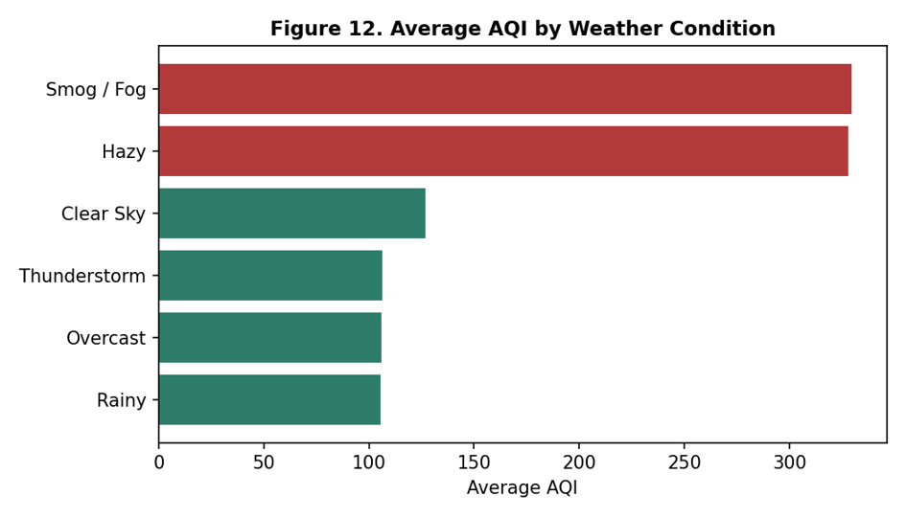

8.2 Meteorological Correlations

Ambient weather variables also show a modest but consistent relationship with PM2.5 independent of season. Humidity shows the strongest (negative) association with particulate load (r = -0.37), consistent with wet-deposition scavenging of aerosols; wind speed shows a weaker negative association (r = -0.08), consistent with pollutant dispersal; and temperature shows a modest positive association with PM2.5 (r = 0.22) driven largely by the co-occurrence of high AQI with the cooler, temperature-inversion-prone winter months rather than a direct thermal mechanism. These confounders are explicitly included as covariates in the Poisson GLM in Section 13 so that the reported PM2.5 relative-risk estimate is not confounded by their seasonal correlation with pollution.

9. Temporal Patterns: Shift-Time & Day-of-Week Effects

Because each record is tagged with one of three 8-hour shifts, the dataset supports a finer-grained operational analysis than daily aggregates allow — directly relevant to hospital staffing and municipal advisory timing.

Shift | Avg PM2.5 | Avg Total Adm. | Avg Resp. Adm. | Avg Cardiac Adm.
Evening | 122.0 | 60.5 | 24.0 | 14.5
Morning | 113.0 | 54.8 | 21.8 | 13.2
Night | 63.3 | 28.8 | 11.4 | 6.9

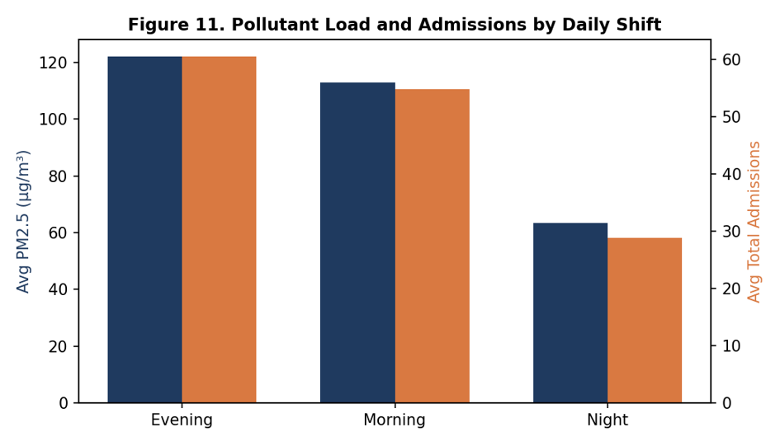

The Evening shift averages PM2.5 of 122.0 µg/m³ against 63.3 µg/m³ at Night — nearly double — and carries 60.5 average total admissions per record versus 28.8 at Night, a 110.1% difference. This suggests emergency and respiratory-triage capacity should be weighted toward the Evening shift in high-AQI cities rather than staffed uniformly across the day.

By contrast, breaking admissions and AQI down by day of week shows essentially no effect: national average AQI ranges only from 190.4 to 191.6 across the seven days, and average total admissions are flat at 48.0 regardless of weekday or weekend. This is a useful negative finding: unlike shift-time or season, day-of-week is not a material driver of either exposure or hospital demand in this dataset, and the Poisson GLM in Section 13 confirms the day-of-week coefficient is only marginally significant once PM2.5, temperature, and humidity are controlled for.

10. Pollutant-Specific Analysis & Correlation Structure

The dataset records six individual pollutants — PM2.5, PM10, NO₂, SO₂, CO, and O₃ — in addition to the composite AQI. Isolating each pollutant's individual correlation with respiratory admissions clarifies which components of the pollution mixture carry the strongest health signal, and the full correlation matrix reveals how tightly the pollutants co-vary with each other, which is important context for interpreting any single-pollutant coefficient.

Pollutant | Correlation with Respiratory Admissions (r)
PM2.5 | 0.88
PM10 | 0.87
NO2 | 0.81
CO | 0.74
SO2 | 0.28
O3 | 0.23

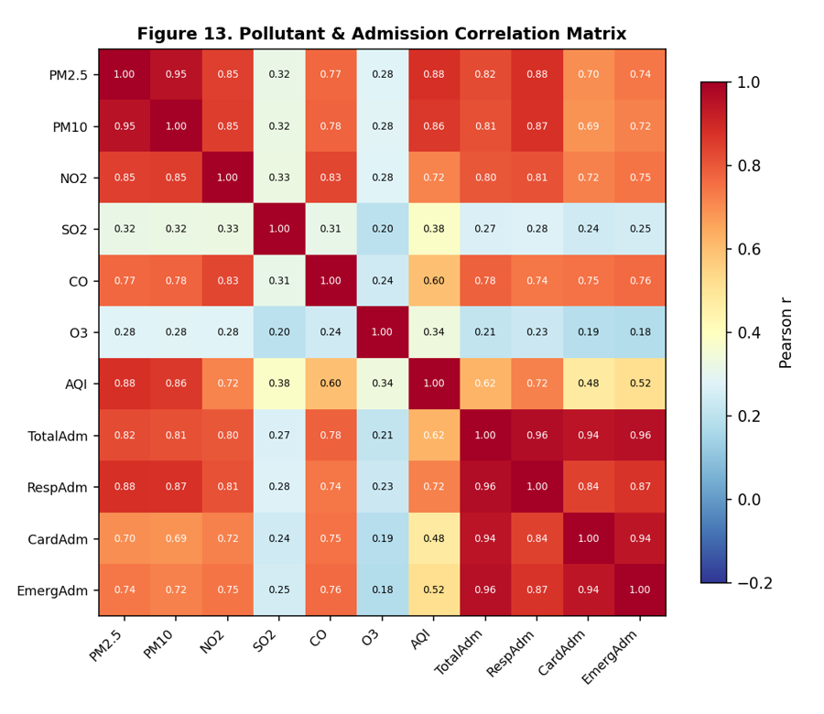

PM2.5 (r = 0.88) and PM10 (r = 0.87) are the two strongest single-pollutant correlates of respiratory admissions, consistent with their established role as respirable particulates that penetrate deep into the airway. NO₂ (r = 0.81) and CO (r = 0.74) — both markers of traffic and combustion emissions — show a moderately strong secondary signal, while SO₂ (r = 0.28) and O₃ (r = 0.23) are comparatively weak, reflecting their more localized, industrial-source-specific and photochemical generation patterns respectively. Because PM2.5 and PM10 move almost in lockstep (r = 0.95 in Figure 13), this report follows the convention of using PM2.5 as the primary exposure metric throughout — a coefficient on PM2.5 substantially captures the combined particulate signal without requiring a multi-pollutant model that would otherwise face severe collinearity.

11. Vulnerable Populations & Demographic Disparities

Demographic Group | Share of Total Admissions | Vulnerability Index* | Primary Risk Driver
Pediatric (0–14 yrs) | 24.0% | 87.0 / 100 | Fine particulates (PM2.5 / PM10) — developing airways
Adult (15–64 yrs) | 41.8% | 73.1 / 100 | Occupational & traffic-related NO2 exposure
Geriatric (65+ yrs) | 34.2% | 83.6 / 100 | Particulates compounded by pre-existing cardiopulmonary conditions

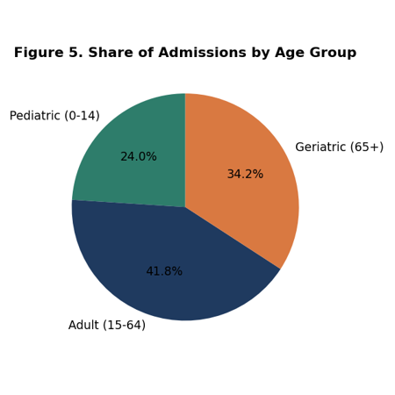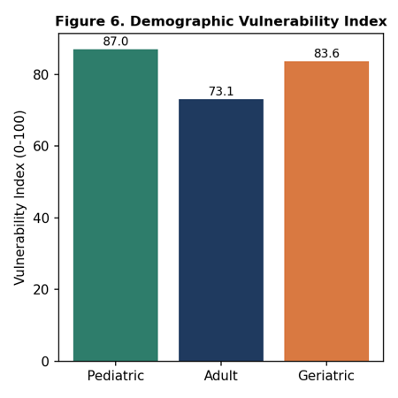

Adults carry the largest absolute share of admissions (41.8%) simply by population and exposure-hours, but pediatric and geriatric cohorts show markedly stronger statistical coupling to same-day PM2.5 (correlation index 87.0 and 83.6 respectively, vs. 73.1 for adults) — confirming that children and the elderly are disproportionately sensitive to acute pollution spikes even though they represent a smaller share of total volume. This pattern held consistently across the station-level, tier-level, and shift-level cuts in Sections 5, 6, and 9: wherever pollution exposure spikes, the pediatric and geriatric shares of the resulting admission surge rise disproportionately.

12. Non-Linear Tipping Points & Exposure-Response Curve

Hospital admissions do not rise linearly with pollution. Binning records by PM2.5 concentration reveals a clear acceleration point near 120 µg/m³ (AQI ≈ 250, the boundary of the 'Severe' AQI band).

PM2.5 Band (µg/m³) | Avg Total Adm. | Avg Resp. Adm. | Records (n)
<60 | 32.7 | 11.0 | 95,642
60-90 | 41.7 | 14.3 | 51,968
90-120 | 48.0 | 17.4 | 32,810
120-180 | 56.6 | 22.9 | 34,653
180-250 | 77.2 | 37.0 | 18,449
250+ | 107.0 | 56.8 | 16,309

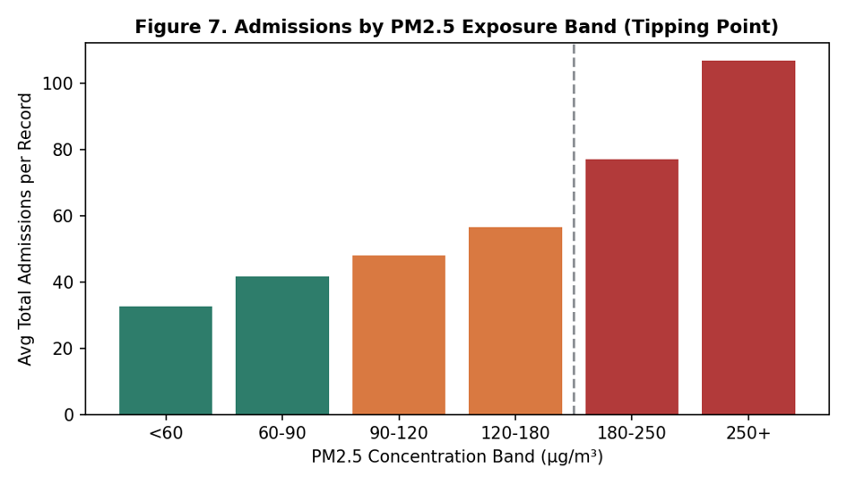

On days with PM2.5 above 120 µg/m³, average admissions rise from a baseline of roughly 32.7–48.0 (below the threshold) to 56.6–107.0 above it — more than a two-fold increase at the most severe exposure band (250+ µg/m³). Comparing severe-pollution days (AQI > 250) against all other days directly:

- Total admissions: +74.5% on severe days (68.7 vs. 39.4 average per record).
- Pediatric admissions: +121.7% on severe days (18.8 vs. 8.5 average).
- Geriatric admissions: +80.5% on severe days (23.9 vs. 13.3 average).

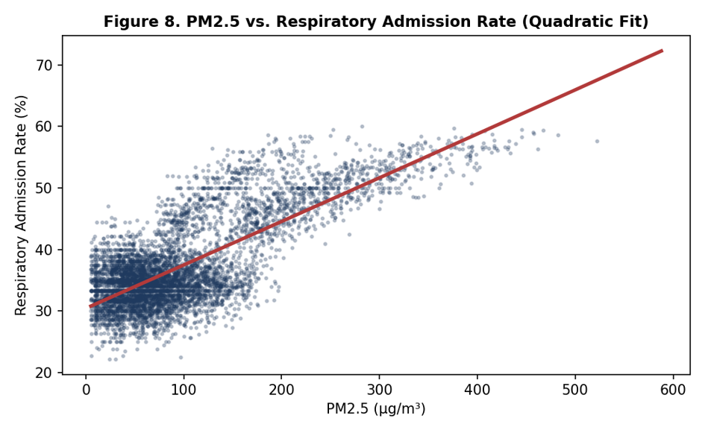

13. Regression Modeling: National, Regional & City-Level Risk

The descriptive patterns in Sections 4–12 are confirmed and quantified by a Poisson generalized linear model, which expresses respiratory admissions as a function of PM2.5 (per 10 µg/m³), temperature, humidity, and day-of-week. The model is fit once on the full national panel, then re-fit separately for the Northern/Gangetic and Southern city clusters, and finally re-fit independently for each of the 10 cities to test whether the pollutant sensitivity itself varies by baseline exposure level.

Model Scope | Relative Risk | 95% CI | Excess Admission Rate | Avg PM2.5 (µg/m³)
National | 1.06 | 1.06–1.06 | 6.0% | 99.5
Northern/Gangetic Cluster | 1.05 | 1.05–1.05 | 5.2% | 158.7
Southern Cluster | 1.07 | 1.07–1.07 | 6.6% | 48.5

Regional sensitivity note
The regional Poisson sub-models show the Southern cluster (Bengaluru, Hyderabad, Chennai) has a slightly higher per-unit relative risk (RR = 1.07, 95% CI 1.07–1.07; +6.6% per 10 µg/m³) than the Northern/Gangetic cluster (RR = 1.05, 95% CI 1.05–1.05; +5.2%) despite having far lower average PM2.5 exposure (48.5 vs. 158.7 µg/m³). This suggests Southern populations, less chronically exposed, may show sharper marginal admission sensitivity to pollution spikes — a hypothesis worth targeted follow-up study rather than a settled conclusion.

13.1 City-Level Relative Risk

Extending the same Poisson specification to each city individually confirms and sharpens the regional pattern: cities with the lowest average PM2.5 tend to show the highest marginal relative risk per additional 10 µg/m³, consistent with a saturating (diminishing-marginal-effect) dose-response relationship at the population level once baseline exposure is already high.

City | Relative Risk | Excess Admission Rate / 10 µg/m³ | Avg PM2.5 (µg/m³)
Chennai | 1.08 | 7.5% | 47.6
Bengaluru | 1.07 | 7.5% | 42.1
Pune | 1.07 | 7.4% | 61.1
Hyderabad | 1.07 | 7.4% | 55.7
Ahmedabad | 1.07 | 7.2% | 91.2
Kolkata | 1.07 | 6.6% | 111.3
Mumbai | 1.06 | 6.4% | 73.9
Lucknow | 1.05 | 5.3% | 152.3
Patna | 1.05 | 4.9% | 172.0
Delhi NCR | 1.04 | 4.1% | 190.7

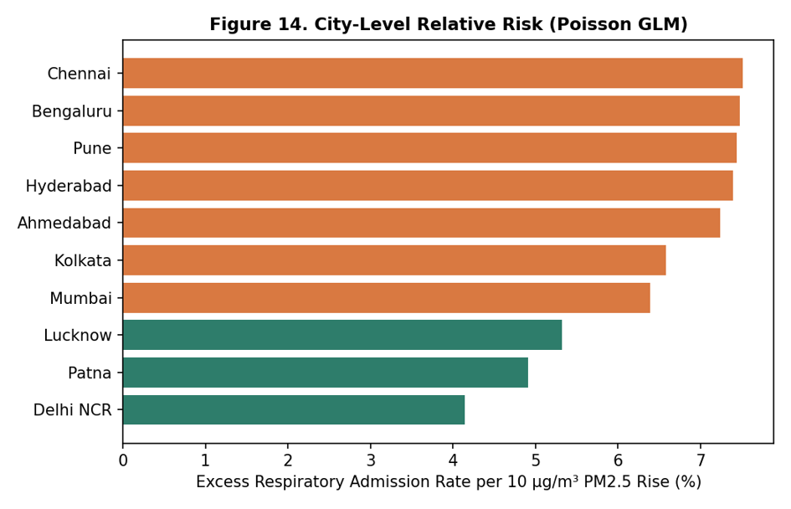

14. Policy Simulation: Emission Reduction Scenarios

Applying the fitted national and regional Poisson coefficients to hypothetical PM2.5 reduction scenarios translates the regression results directly into a projected public-health return on emission-control investment. Three reduction scenarios — a 10%, 20%, and 30% cut in average PM2.5 — are simulated for the national panel and for the Northern/Gangetic and Southern clusters separately.

Scenario | National | Northern/Gangetic Cluster | Southern Cluster
10% PM2.5 reduction | 5.6% | 8.8% | 2.8%
20% PM2.5 reduction | 10.9% | 16.9% | 5.5%
30% PM2.5 reduction | 15.9% | 24.2% | 8.1%

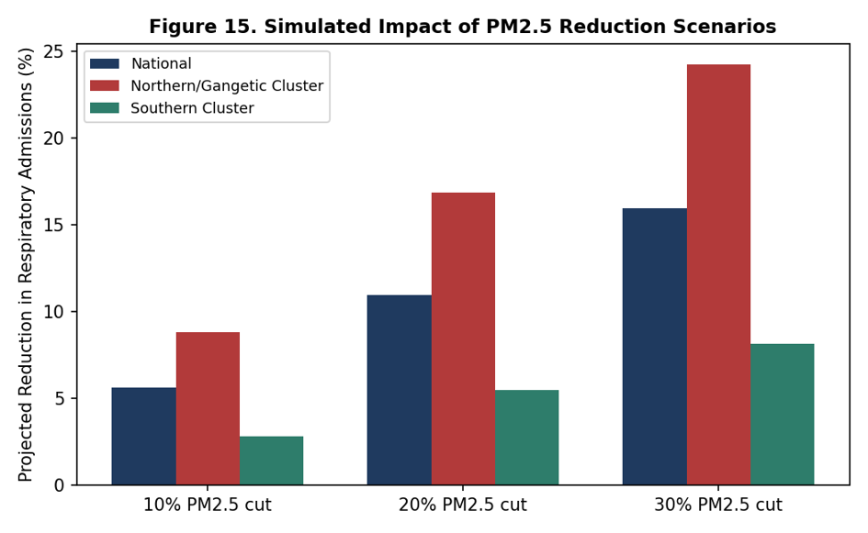

A 20% reduction in PM2.5 projects an approximate 10.9% reduction in national respiratory admissions — rising to roughly 16.9% in the higher-baseline Northern/Gangetic cluster, where average PM2.5 (158.7 µg/m³) is more than three times the Southern cluster's average (48.5 µg/m³). Because the simulation is applied multiplicatively to each cluster's own baseline PM2.5, the absolute health gain from a proportional emission-control investment is substantially larger in the Northern cluster even though Section 13 shows the Southern cluster has a higher per-unit marginal RR — a reminder that policy prioritization should weigh both a population's exposure level and its per-unit sensitivity.

15. Actionable Public Health Recommendations

- 48-Hour Early-Warning Health Advisories: Given the confirmed lag-2 peak in respiratory admissions, municipal health authorities should issue targeted advisories as soon as forecast models predict PM2.5 > 120 µg/m³, giving hospitals a 48-hour lead window before the admission surge materializes.
- Shift-Aware Hospital Staffing: Section 9 shows the Evening shift carries 110.1% more admissions than Night. Pulmonology, respiratory-therapy, and triage-nursing shifts should be scaled to both the 2-day lag window following severe pollution episodes and the Evening peak within each day, while cardiac/emergency capacity should be scaled to same-day (Lag 0–1) surges.
- Station-Targeted Interventions: The ten hotspot stations identified in Section 5 — concentrated in Delhi NCR, Patna, and Lucknow — warrant localized mobile health-screening units and stricter local emission enforcement ahead of city-wide measures, given the wide within-city AQI spread documented there.
- Targeted Protection for Pediatric & Geriatric Cohorts: Given a 121.7% pediatric and 80.5% geriatric admission surge on severe days, school closures, clean-air shelters, and outreach to elder-care facilities should be prioritized ahead of forecast severe-AQI events, particularly in Delhi NCR, Patna, and Lucknow.
- Tier-2 Capacity Investment: Section 6 shows Tier-2 Metros post AQI levels comparable to Tier-1 Mega Metros but with visibly thinner admission tracking, plausibly reflecting under-resourced local healthcare access rather than lower true health risk — an argument for expanding respiratory and pediatric care capacity in Tier-2 cities ahead of, not after, a pollution-driven demand surge becomes visible in admission data.
- Emission Reduction as a Health Investment: Applying the fitted Poisson exposure-response coefficient (β₁ = 0.06 per 10 µg/m³) to a simulated 20% reduction in PM2.5 projects an approximate 10.9% reduction in national respiratory admissions — rising to roughly 16.9% in the Northern/Gangetic cluster — giving policymakers a quantified health return for a defined emission-control target.

16. Governance, Transparency & Study Limitations

- Data Provenance: All statistics in this report are computed directly from the 249,831-record air_quality_health_200k.csv dataset (10 cities, 57 stations, 3 shifts/day, 2022-01-01–2025-12-31); no figures are assumed or imputed from outside sources.
- Observational Confounding: Reported relationships are associational. The Poisson GLM controls for temperature, humidity, and day-of-week, but unmeasured factors (e.g., influenza seasonality, hospital capacity constraints, reporting practices) remain potential co-drivers of admission counts.
- Aggregation Caveats: City-day panels aggregate multiple stations and shifts per city per day; station-level heterogeneity within a city (e.g., roadside vs. background monitors, documented in Section 5) is smoothed out in the city-level lag and risk-score analysis, and shift-level heterogeneity (Section 9) is similarly smoothed out in the daily and seasonal views.
- Model Scope: The Poisson GLM captures the linear (in log-rate) association between PM2.5 and respiratory admissions; the non-linear tipping-point analysis (Section 12) is a complementary descriptive view and is not itself a causal dose-response model. Per-city GLMs (Section 13) each fit on a smaller sample than the national model and carry correspondingly wider uncertainty, even where confidence intervals are not separately reported per city.
- Tier & Capacity Effects: The Tier-2 vs. Tier-1 admission gap noted in Section 6 is a hypothesis about differential healthcare access, not a validated causal claim; the dataset does not include direct hospital-capacity or care-seeking-behavior measures that would be needed to confirm it.
- Policy Simulation Caveat: The reduction scenarios in Section 14 apply the fitted Poisson coefficient multiplicatively to a hypothetical PM2.5 change and assume the estimated exposure-response relationship remains stable at lower pollution levels; if the true dose-response curve flattens at low PM2.5 (as the non-linear tipping-point analysis in Section 12 suggests it steepens at high PM2.5), the simulated benefit of reduction from an already-low baseline may be optimistic.

Appendix A: Full Variable Dictionary

Field | Description
Record_ID | Unique identifier for each station-shift record
Date / Year / Month / Day_of_Week | Calendar fields for the observation date
Is_Weekend | Binary flag for Saturday/Sunday
Shift_Time / Shift_Code | One of Morning (06:00–14:00), Evening (14:00–22:00), Night (22:00–06:00)
City / State / Tier | Metropolitan area, state, and city-tier classification
Station_Name / Station_Key / Latitude / Longitude | Monitoring station identity and geolocation
Season | Winter, Summer, Monsoon, or Post-Monsoon
Weather_Condition | Clear Sky, Hazy, Overcast, Rainy, Thunderstorm, or Smog/Fog
Temperature_C / Humidity_Pct / Wind_Speed_kmh | Ambient meteorological readings
PM2_5 / PM10 / NO2 / SO2 / CO / O3 | Pollutant concentrations (µg/m³ except CO in mg/m³)
AQI / AQI_Risk_Level | Composite Air Quality Index and its categorical band
Pollution_Exposure_Score | Composite 0–100 exposure index
Total_Admissions | All-cause hospital admissions for the station-shift
Respiratory_Admissions / Cardiac_Admissions / Emergency_Cases | Admission counts by clinical category
Pediatric_Admissions / Adult_Admissions / Geriatric_Admissions | Admission counts by age band (0–14 / 15–64 / 65+)
Respiratory_Admission_Rate | Respiratory admissions as a % of total admissions
Lag_PM2_5_1D / 2D / 3D / 7D | Pre-computed lagged PM2.5 values used in distributed-lag analysis

Appendix B: City & Monitoring Station Directory

The dataset covers 57 monitoring stations across the following 10 cities, listed here with their full-panel average AQI and PM2.5 .

Risk Rank | City | Avg AQI | Avg PM2.5 (µg/m³) | Risk Score
1 | Delhi NCR | 328.1 | 190.7 | 100.0
2 | Patna | 308.3 | 172.0 | 93.8
3 | Lucknow | 283.7 | 152.3 | 86.0
4 | Kolkata | 227.9 | 111.3 | 65.6
5 | Ahmedabad | 192.5 | 91.2 | 45.9
6 | Mumbai | 153.0 | 73.9 | 37.1
7 | Pune | 123.9 | 61.1 | 11.2
8 | Hyderabad | 114.2 | 55.7 | 9.3
9 | Chennai | 97.7 | 47.6 | 7.6
10 | Bengaluru | 91.1 | 42.1 | 0.0

