1.What was the problem?

Nowadays, every month or even every week, an accident occurs somewhere due to gas leakage. And due to this, sometimes students and sometimes workers or families are becoming victims of this accident. Some solutions have already been proposed in the literature, yet people are not able to become alert at the right time and they are not able to save themselves. Sometimes circumstances are such that we are not able to even ask for help from anyone. Therefore many example like- “Delhi gas leak: 24 school students rushed to hospital after falling sick**”** and “Gas leak at Ludhiana factory kills 11, few injured**”**. According to “THE ECONOMIC TIMES news**”**.

2.How did you solve it?

In order to solve the aforesaid problem, a smart device is disclosed in the present invention. The main purpose of the device is predict before the any accident chances from gas leakage and safe the people by its alert system. To perform this operation, a gas detector has been used which will detect LPG gas present in the air and send alert siren through buzzer and alert notification will be sent to smart device through wireless communication system.

***Prototype of Model:***

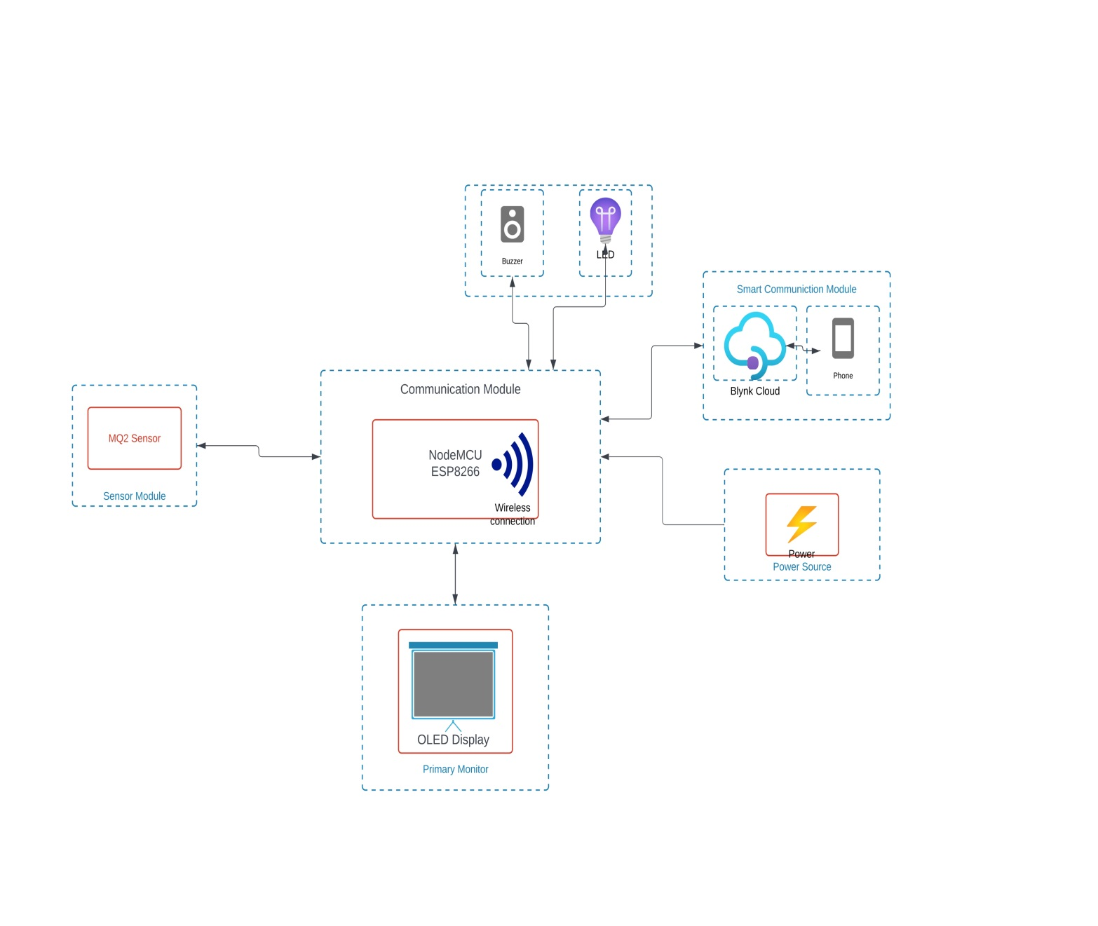

**Figure 1:** Prototype of Smart Smoke Detector

Description: The device generally consists of the following parts:

1. NODE MCU ESP8266:

(i)Sensor Interface: NodeMCU ESP8266 connects to smoke sensors, interpreting data received from them regarding the presence of smoke or fire through its GPIO pins or analog inputs.

(ii)Data Processing and Alert Generation: It processes sensor data, analyzing it based on predefined parameters or algorithms to detect smoke/fire signatures. Upon detection, it triggers an alarm and sends alerts via its Wi-Fi capabilities to connected devices.

(iii)Remote Monitoring and Control: Through Wi-Fi connectivity, it enables remote monitoring of the smoke detector system, allowing users to receive alerts and take necessary actions regardless of their physical location.

1. MQ2 Sensor:

(i)Gas Sensing Capability: The MQ2 sensor is designed to detect various gases like LPG, butane, propane, methane, alcohol, smoke, and other flammable gases, making it suitable for smoke detection in a project.

(ii)Analog Output: This sensor provides an analog output voltage proportional to the concentration of gases detected. It interfaces with microcontrollers, such as Arduino or NodeMCU, through its analog pins to transmit gas concentration data.

(iii)Integration in Smoke Detection: In a smoke detector project, the MQ2 sensor functions by detecting the presence of combustible gases or smoke particles in the air. It translates this detection into analog signals that can be processed by microcontrollers like NodeMCU ESP8266 to trigger alarms or alert systems in case of potential fire hazards.

1. LED: Blink light after smoke detection.
2. Buzzer: Buzzing sound after smoke detecting.
3. Conneting Wires: Connect every component with each other.
4. Display: Show the value of leakage gas.

**Block description:** 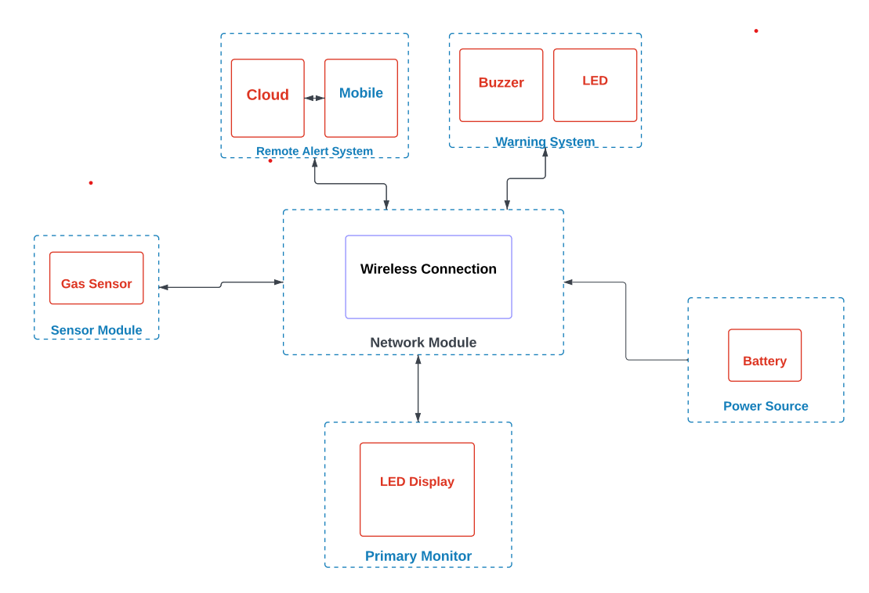

Figure 2 . *Block description of Device Controller* .

* The **power source** module supplies power to the **network module** where the *microcontroller* takes input from the sensor to check whether gas is leaking or not.
* **Warning system** includes display takes data from microcontroller and shows output according to their characteristics.

3. What are the advantages of the solution proposed by you?

* If the gas cylinder leaks due to some reason and due to no one knowing about it, the gas gets wasted. By using this device, you can save gas as well as money.
* There are possibilities of fire due to gas leakage, which can be avoided if we use it.
* There is a display installed on this device through which we can monitor the value of leakage gas and can also monitor it from a remote smart device through WiFi model.
* Its most important role is to receive notification when an accident occurs, through which even if we are not at the accident site, we can take the help of someone else and send relief material to the accident site.
* Its size is very small, so we can carry it easily.
* This is a cost efficient device.so anyone afford it.
* There is no much cost in its maintenance. If a person buys it, he can use it for a long time.
* It consumes very less energy.