

PROJECT REPORT
ON
TradeCraft: Stock Market Learning Platform
IN
Computer Science and Engineering
SUBMITTED IN PARTIAL FULFILLMENT OF THE DEGREE
OF
BE(CSE)

Submitted By:
Name University ID No

Koushik Adak 2211981201

Chitkara University, Himachal Pradesh

Acknowledgement
We express our deepest gratitude to Dr. Nagesh Kumar, our project mentor, for her continuous guidance, insightful feedback, and unwavering support throughout the development of Tradecraft. Her expertise in software architecture and data-driven systems has been instrumental in shaping this project.
We are thankful to the Department of Computer Science and Engineering for providing us with the infrastructure, lab facilities, and academic environment necessary to carry out this work.
Special thanks to our peers and batchmates for their constructive suggestions during peer reviews and usability testing sessions. Their real-world feedback helped refine the user experience significantly.
We also acknowledge the open-source community—React.js, Node.js, MongoDB, Three.js, for providing robust, scalable tools that formed the backbone of our application.
Finally, we extend our heartfelt thanks to our families for their patience, encouragement, and understanding during late-night coding and debugging sessions
Preface
In an era where financial literacy has evolved from a valuable asset to an essential life skill, the ability to understand and navigate the stock market has never been more important. Yet, for many aspiring learners, the world of trading remains intimidating—filled with complex terminology, volatile market movements, and steep learning curves. Traditional education methods often focus heavily on theory, leaving beginners unprepared to apply their knowledge in real-world situations. This disconnect inspired the creation of TradeCraft.
TradeCraft was developed with a clear mission: to make stock market education accessible, engaging, and practical for everyone. Whether you are a novice taking your first steps into the world of investing or an intermediate learner looking to sharpen your strategies, TradeCraft offers a learning experience that adapts to your pace and goals. By combining structured lessons with interactive tutorials, quizzes, and real-time virtual trading simulations, the platform ensures that learners gain not only knowledge but also hands-on experience—without any financial risk.
Education becomes most powerful when it is immersive. With TradeCraft's intuitive interface, gamified elements, and performance tracking tools, users stay motivated, challenged, and connected with a community of fellow learners. Leaderboards, progress metrics, and competitive modules add a sense of excitement, transforming what is often perceived as a difficult subject into an enjoyable journey.
Supported by modern technologies such as React, Flutter, Node.js, and MongoDB, and safeguarded by secure authentication systems like JWT, TradeCraft provides a reliable and seamless learning environment. Every feature is built to align with a single purpose: to empower individuals with the confidence and competence needed to make informed financial decisions.
This platform is more than just a learning tool—it is a bridge between theory and practice, between curiosity and expertise. TradeCraft embodies the belief that everyone, regardless of background, can become a knowledgeable and responsible investor. With this preface, we invite you to step into a transformative learning experience and begin your journey toward financial empowerment.

Contents:
- Introduction to Project
- Feasibility Study
- Requirement Analysis
- Modules Completed
- Detailed Analysis of Individual Modules
- Design
- Coding
- Bibliography and References

Introduction to Project
TradeCraft is an innovative web and mobile-based learning platform developed to make stock market education more accessible, interactive, and practical for beginners as well as intermediate learners. In today’s fast-evolving financial world, understanding the stock market has become an essential skill for individuals aiming to manage their finances effectively or pursue careers in finance and investment. However, traditional learning methods often fail to bridge the gap between theoretical concepts and real-world trading experiences. TradeCraft addresses this gap by offering a dynamic, simulation-based learning environment where users can practice trading strategies in real time without financial risk.
The platform provides a comprehensive collection of structured lessons, interactive tutorials, quizzes, and virtual trading modules that encourage experiential learning. Learners can track their progress, participate in leaderboards, and compare their performance with peers, fostering healthy competition and engagement. Through its intuitive interface and gamified design, TradeCraft transforms complex stock market concepts into easy-to-understand and enjoyable learning experiences.
Technologically, TradeCraft is built using modern and robust tools such as React, Flutter, Node.js, and MongoDB , ensuring a smooth, secure, and scalable platform. It also integrates authentication and data protection features like JWT, providing a reliable and user-friendly system for learners.
Ultimately, TradeCraft aims to promote financial literacy and empower individuals to become confident, informed investors. By blending education with practical simulation, the platform serves as a bridge between academic learning and real-world market application, preparing users to make sound financial decisions in their personal and professional lives.

Feasibility Study

Technical Feasibility
TradeCraft is developed using a modern full-stack architecture. The frontend is built with React.js, Flutter, and Tailwind CSS for a responsive and interactive user experience. The backend is powered by Node.js and Express.js, ensuring smooth and secure communication between client and server. MongoDB Atlas and Firebase are used for cloud-based storage and authentication, providing fast and reliable access to user data. Security measures such as JWT are implemented for safe user login and data protection. All technologies are open-source, efficient, and widely adopted in large-scale educational and trading applications.

Operational Feasibility
The platform is designed to be intuitive and user-friendly, allowing even beginners to easily navigate and use its features. TradeCraft runs directly on web browsers and mobile devices, requiring no installation. Users can access tutorials, quizzes, and virtual trading modules seamlessly from anywhere with an internet connection. The admin panel enables easy management of courses, users, and analytics. Its gamified interface with leaderboards and progress tracking ensures engaging and practical learning for users at all levels.

Economic Feasibility
TradeCraft is highly cost-effective to develop and maintain. All core tools and frameworks — React, Node.js, Flutter, and MongoDB — are free and open-source, minimizing development expenses. Hosting can be done using affordable platforms like Firebase, or Onrender. MongoDB Atlas provides free tiers suitable for academic and prototype use. Additionally, the platform has future monetization potential through premium content, certifications, and partnerships. Hence, TradeCraft is economically feasible and sustainable for academic as well as startup environments.

Requirement Analysis

Software Requirements:
Frontend: React.js, Flutter, Tailwind CSS, React Router
Backend: Node.js, Express.js, MongoDB Atlas, Firebase
Tools/Services: Git & GitHub, Onreder, Postman, VS CodeHardware

Modules Completed
• User Authentication Module (JWT Security)
• Home Page and Navigation Module
• Courses and Tutorial Module
• Quiz and Leaderboard Module
• Virtual Trading Simulation Module
• User Dashboard and Progress Tracking
• About & Contact Us Module
• Admin Management Panel
• Data Storage and Cloud Integration
• AI-Based Personalized Learning (Planned)

Detailed Analysis of Individual Modules
• User Authentication Module
- Allows users to securely register and log in using email or Google account.
- Authentication is handled using JWT (JSON Web Token) for secure sessions.
- User credentials and data are stored safely in MongoDB with encryption for added protection.
• Courses and Tutorial Module
- Provides structured lessons and tutorials on stock market fundamentals and trading concepts.
- Categorized into beginner, intermediate, and advanced levels for step-by-step learning.
- Includes text, images, and short videos for interactive understanding.
• Quiz and Leaderboard Module
- Contains quizzes after each lesson to test user knowledge and track progress.
- Displays scores and ranks on a leaderboard, encouraging healthy competition among learners.
- Helps in assessing learning outcomes and motivating users.
• Virtual Trading Simulation Module
- Simulates a real-time stock trading environment using virtual money.
- Users can buy and sell stocks, track portfolio performance, and learn market behavior practically.
- Reinforces theoretical learning through hands-on practice without financial risk.
• Dashboard and Progress Tracking Module
- Displays user statistics such as course completion, quiz performance, and trading results.
- Provides visual progress charts and insights using Chart.js or similar tools.
- Helps users analyze learning patterns and improve decision-making skills.
• About and Contact Module
- Provides platform and developer information for better user transparency.
- Includes a Contact Us section for queries, feedback, or support requests.
- Ensures effective communication between users and administrators.
• Admin Management Panel
- Allows admins to manage users, courses, and trading simulations.
- Enables monitoring of user activities, leaderboard data, and content updates.
- Ensures smooth backend operations and platform maintenance.
• AI-Based Personalized Learning (Planned)
- Future integration to offer AI-driven adaptive learning and investment suggestions.
- Will analyze user activity, quiz results, and trading behavior to provide tailored feedback.
- Enhances engagement and learning outcomes through smart recommendations.

Design
- Usecase:
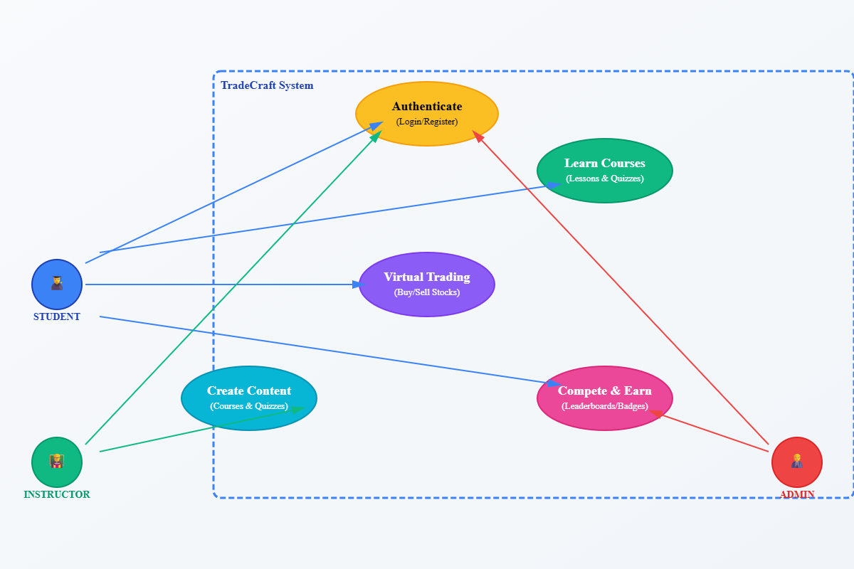

- Flowchart:
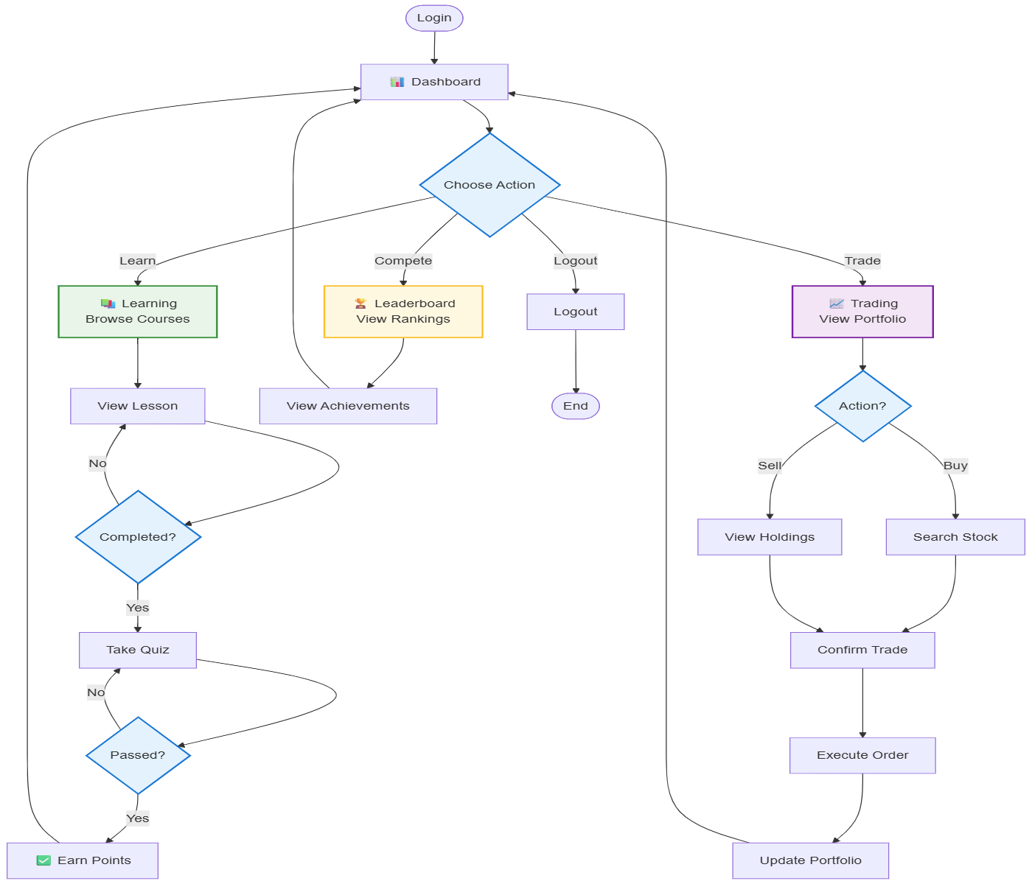

- System Architecture:
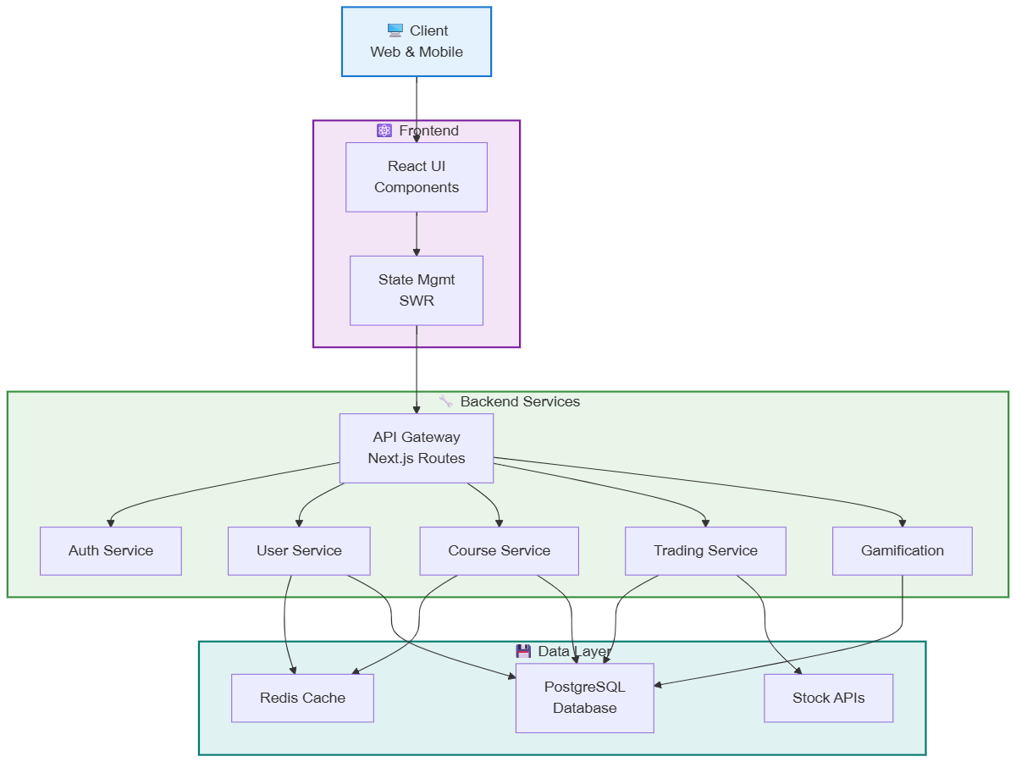

Coding:
- Main.dart:
import 'package:flutter/material.dart';
import 'package:webview_flutter/webview_flutter.dart';

void main() {
runApp(
MaterialApp(
debugShowCheckedModeBanner: false,
home: Scaffold(
body: SafeArea(
child: WebViewWidget(
controller: WebViewController()
..setJavaScriptMode(JavaScriptMode.unrestricted)
..loadRequest(Uri.parse("https://tradecraftapp-q9wj.onrender.com/")),
),
),
),
),
);
}

- Home.jsx
"use client"

import { Suspense } from "react"
import { Link } from "react-router-dom"
import { Canvas } from "@react-three/fiber"
import { OrbitControls, Stars } from "@react-three/drei"
import { motion } from "framer-motion"
import { FaChartLine, FaGraduationCap, FaUsers, FaLightbulb, FaChartBar, FaRobot } from "react-icons/fa"
import CandlestickChart3D from "../components/CandlestickChart3D"
import MarketTicker from "../components/MarketTicker"
import Grid3D from "../components/Grid3D"

// Scene Component
function Scene() {
return (
<Suspense fallback={null}>
<ambientLight intensity={0.5} />
<pointLight position={[10, 10, 10]} intensity={1} />
<Stars radius={100} depth={50} count={5000} factor={4} fade speed={1} />
<Grid3D />
<CandlestickChart3D />
<MarketTicker />
<OrbitControls enableZoom={false} enablePan={false} maxPolarAngle={Math.PI / 2} minPolarAngle={Math.PI / 3} />
</Suspense>
);
}

const courseModules = [
{
title: "Technical Analysis Mastery",
description: "Learn to read charts, identify patterns, and make data-driven decisions",
icon: <FaChartLine className="text-4xl text-emerald-500" />,
duration: "8 weeks"
},
{
title: "Fundamental Analysis",
description: "Understand market fundamentals, economic indicators, and company valuations",
icon: <FaChartBar className="text-4xl text-blue-500" />,
duration: "6 weeks"
},
{
title: "Risk Management",
description: "Master the art of position sizing, stop-loss strategies, and portfolio management",
icon: <FaLightbulb className="text-4xl text-yellow-500" />,
duration: "4 weeks"
},
{
title: "Algorithmic Trading",
description: "Build and backtest automated trading strategies using modern tools",
icon: <FaRobot className="text-4xl text-purple-500" />,
duration: "10 weeks"
}
];

export default function Home() {
return (
<div className="min-h-screen w-full bg-[#0A0F1C] text-white overflow-hidden">
{/* Hero Section with Enhanced 3D Animation */}
<div className="relative h-screen">
<div className="absolute inset-0">
<Canvas camera={{ position: [0, 0, 30], fov: 75 }}>
<Scene />
</Canvas>
</div>

<div className="relative z-10 h-full flex items-center justify-center">
<div className="max-w-4xl mx-auto px-4 sm:px-6 lg:px-8 text-center">
<motion.div
initial={{ opacity: 0, y: 20 }}
animate={{ opacity: 1, y: 0 }}
transition={{ duration: 0.8 }}
>
<h1 className="text-5xl sm:text-7xl font-extrabold mb-6 bg-clip-text text-transparent bg-gradient-to-r from-emerald-400 via-blue-500 to-purple-500">
Master the Art of Trading
</h1>
<p className="text-xl sm:text-2xl text-gray-300 mb-8">
Transform your trading journey with our comprehensive learning platform
</p>
<div className="flex flex-wrap gap-6 justify-center">
<Link
to="/courses"
className="px-8 py-4 bg-emerald-500 hover:bg-emerald-600 rounded-xl font-bold transition-all duration-300 transform hover:scale-105 hover:shadow-lg hover:shadow-emerald-500/20"
>
Start Learning
</Link>
<Link
to="/about"
className="px-8 py-4 bg-transparent border-2 border-emerald-500 hover:bg-emerald-500/10 rounded-xl font-bold transition-all duration-300 transform hover:scale-105"
>
Learn More
</Link>
</div>
</motion.div>
</div>
</div>
</div>

{/* Course Modules Section */}
<div className="py-24 px-4 sm:px-6 lg:px-8 bg-[#0F172A]/80 backdrop-blur-lg">
<div className="max-w-7xl mx-auto">
<motion.div
initial={{ opacity: 0, y: 20 }}
whileInView={{ opacity: 1, y: 0 }}
transition={{ duration: 0.8 }}
className="text-center mb-16"
>
<h2 className="text-4xl font-bold text-emerald-400 mb-4">
Comprehensive Learning Path
</h2>
<p className="text-xl text-gray-400">
Master every aspect of trading through our structured curriculum
</p>
</motion.div>

<div className="grid grid-cols-1 md:grid-cols-2 gap-8">
{courseModules.map((module, index) => (
<motion.div
key={index}
initial={{ opacity: 0, y: 20 }}
whileInView={{ opacity: 1, y: 0 }}
transition={{ duration: 0.5, delay: index * 0.1 }}
className="p-8 rounded-2xl bg-gradient-to-br from-[#1E293B] to-[#0F172A] backdrop-blur-lg border border-gray-800 hover:border-emerald-500/50 transition-all duration-300"
>
<div className="flex items-start gap-4">
<div className="p-3 rounded-lg bg-gray-800/50">
{module.icon}
</div>
<div>
<h3 className="text-xl font-bold text-white mb-2">
{module.title}
</h3>
<p className="text-gray-400 mb-4">
{module.description}
</p>
<span className="text-sm text-emerald-400 font-medium">
Duration: {module.duration}
</span>
</div>
</div>
</motion.div>
))}
</div>
</div>
</div>

{/* Features Section */}
<div className="py-24 px-4 sm:px-6 lg:px-8">
<div className="max-w-7xl mx-auto">
<motion.div
initial={{ opacity: 0 }}
whileInView={{ opacity: 1 }}
transition={{ duration: 1 }}
className="grid grid-cols-1 md:grid-cols-2 lg:grid-cols-3 gap-8"
>
<div className="p-6 rounded-2xl bg-gradient-to-br from-[#1E293B] to-[#0F172A] backdrop-blur-lg border border-gray-800">
<FaChartLine className="text-4xl text-emerald-500 mb-4" />
<h3 className="text-xl font-bold mb-2">Real-Time Trading</h3>
<p className="text-gray-400">Practice with live market data and advanced charting tools</p>
</div>
<div className="p-6 rounded-2xl bg-gradient-to-br from-[#1E293B] to-[#0F172A] backdrop-blur-lg border border-gray-800">
<FaGraduationCap className="text-4xl text-blue-500 mb-4" />
<h3 className="text-xl font-bold mb-2">Expert Mentorship</h3>
<p className="text-gray-400">Learn directly from professional traders with years of experience</p>
</div>
<div className="p-6 rounded-2xl bg-gradient-to-br from-[#1E293B] to-[#0F172A] backdrop-blur-lg border border-gray-800">
<FaUsers className="text-4xl text-purple-500 mb-4" />
<h3 className="text-xl font-bold mb-2">Community Support</h3>
<p className="text-gray-400">Join a vibrant community of traders and share insights</p>
</div>
</motion.div>
</div>
</div>

{/* Call to Action */}
<div className="py-24 px-4 sm:px-6 lg:px-8 bg-gradient-to-b from-[#0F172A] to-[#0A0F1C]">
<div className="max-w-4xl mx-auto text-center">
<motion.div
initial={{ opacity: 0, y: 20 }}
whileInView={{ opacity: 1, y: 0 }}
transition={{ duration: 0.8 }}
>
<h2 className="text-4xl font-bold text-white mb-6">
Ready to Start Your Trading Journey?
</h2>
<p className="text-xl text-gray-400 mb-8">
Join thousands of successful traders who have transformed their trading career with our platform
</p>
<Link
to="/signup"
className="inline-block px-8 py-4 bg-emerald-500 hover:bg-emerald-600 rounded-xl font-bold transition-all duration-300 transform hover:scale-105 hover:shadow-lg hover:shadow-emerald-500/20"
>
Get Started Today
</Link>
</motion.div>
</div>
</div>
</div>
);
}

iii)CandleStickChart3D.tsx
import { useRef, useMemo } from 'react';
import { useFrame } from '@react-three/fiber';
import { Vector3 } from 'three';
import { Text } from '@react-three/drei';

interface Candle {
open: number;
close: number;
high: number;
low: number;
color: string;
}

export default function CandlestickChart3D() {
const groupRef = useRef<THREE.Group>(null);

// Generate sample candlestick data
const candleData = useMemo(() => {
const data: Candle[] = [];
let lastClose = 100;

for (let i = 0; i < 20; i++) {
const change = (Math.random() - 0.5) * 10;
const open = lastClose;
const close = open + change;
const high = Math.max(open, close) + Math.random() * 5;
const low = Math.min(open, close) - Math.random() * 5;

data.push({
open,
close,
high,
low,
color: close > open ? '#00ff88' : '#ff3366'
});

lastClose = close;
}

return data;
}, []);

// Animate the chart
useFrame((state) => {
if (groupRef.current) {
groupRef.current.rotation.y = Math.sin(state.clock.elapsedTime * 0.2) * 0.2;
}
});

return (
<group ref={groupRef} position={[0, 0, 0]}>
{candleData.map((candle, index) => {
const height = Math.abs(candle.close - candle.open);
const wickHeight = candle.high - candle.low;
const position = new Vector3(
index * 2 - 20,
(candle.high + candle.low) / 2 - 100,
0
);

return (
<group key={index} position={position}>
{/* Candlestick body */}
<mesh position={[0, 0, 0]}>
<boxGeometry args={[0.5, height, 0.5]} />
<meshStandardMaterial color={candle.color} />
</mesh>

{/* Candlestick wick */}
<mesh position={[0, 0, 0]}>
<boxGeometry args={[0.1, wickHeight, 0.1]} />
<meshStandardMaterial color={candle.color} />
</mesh>
</group>
);
})}

{/* Price labels */}
<Text
position={[-22, -90, 0]}
color="white"
fontSize={2}
anchorX="left"
>
Price
</Text>

{/* Time labels */}
<Text
position={[0, -110, 0]}
color="white"
fontSize={2}
anchorX="center"
>
Time
</Text>
</group>
);
}
{
"name": "tradecraft-server",
"version": "1.0.0",
"lockfileVersion": 3,
"requires": true,
"packages": {
"": {
"name": "tradecraft-server",
"version": "1.0.0",
"dependencies": {
"@react-oauth/google": "^0.12.2",
"@types/cookie-parser": "^1.4.9",
"@types/stripe": "^8.0.417",
"axios": "^1.9.0",
"bcryptjs": "^3.0.2",
"cookie-parser": "^1.4.7",
"cors": "^2.8.5",
"dotenv": "^16.4.5",
"express": "^4.18.3",
"google-auth-library": "^9.6.3",
"jsonwebtoken": "^9.0.2",
"mongodb": "^6.18.0",
"mongoose": "^8.15.1",
"pdfjs-dist": "^5.2.133",
"stripe": "^18.3.0"
},
"devDependencies": {
"@types/cors": "^2.8.17",
"@types/express": "^4.17.21",
"@types/node": "^20.11.24",
"nodemon": "^3.1.10",
"ts-node": "^10.9.2",
"ts-node-dev": "^2.0.0",
"typescript": "^5.8.2"
}
},
"node_modules/@cspotcode/source-map-support": {
"version": "0.8.1",
"resolved": "https://registry.npmjs.org/@cspotcode/source-map-support/-/source-map-support-0.8.1.tgz",
"integrity": "sha512-IchNf6dN4tHoMFIn/7OE8LWZ19Y6q/67Bmf6vnGREv8RSbBVb9LPJxEcnwrcwX6ixSvaiGoomAUvu4YSxXrVgw==",
"dev": true,
"dependencies": {
"@jridgewell/trace-mapping": "0.3.9"
},
"engines": {
"node": ">=12"
}
},
"node_modules/@jridgewell/resolve-uri": {
"version": "3.1.2",
"resolved": "https://registry.npmjs.org/@jridgewell/resolve-uri/-/resolve-uri-3.1.2.tgz",
"integrity": "sha512-bRISgCIjP20/tbWSPWMEi54QVPRZExkuD9lJL+UIxUKtwVJA8wW1Trb1jMs1RFXo1CBTNZ/5hpC9QvmKWdopKw==",
"dev": true,
"engines": {
"node": ">=6.0.0"
}
},
"node_modules/@jridgewell/sourcemap-codec": {
"version": "1.5.4",
"resolved": "https://registry.npmjs.org/@jridgewell/sourcemap-codec/-/sourcemap-codec-1.5.4.tgz",
"integrity": "sha512-VT2+G1VQs/9oz078bLrYbecdZKs912zQlkelYpuf+SXF+QvZDYJlbx/LSx+meSAwdDFnF8FVXW92AVjjkVmgFw==",
"dev": true
},
"node_modules/@jridgewell/trace-mapping": {
"version": "0.3.9",
"resolved": "https://registry.npmjs.org/@jridgewell/trace-mapping/-/trace-mapping-0.3.9.tgz",
"integrity": "sha512-3Belt6tdc8bPgAtbcmdtNJlirVoTmEb5e2gC94PnkwEW9jI6CAHUeoG85tjWP5WquqfavoMtMwiG4P926ZKKuQ==",
"dev": true,
"dependencies": {
"@jridgewell/resolve-uri": "^3.0.3",
"@jridgewell/sourcemap-codec": "^1.4.10"
}
},
"node_modules/@mongodb-js/saslprep": {
"version": "1.2.2",
"resolved": "https://registry.npmjs.org/@mongodb-js/saslprep/-/saslprep-1.2.2.tgz",
"integrity": "sha512-EB0O3SCSNRUFk66iRCpI+cXzIjdswfCs7F6nOC3RAGJ7xr5YhaicvsRwJ9eyzYvYRlCSDUO/c7g4yNulxKC1WA==",
"license": "MIT",
"dependencies": {
"sparse-bitfield": "^3.0.3"
}
},
"node_modules/@napi-rs/canvas": {
"version": "0.1.74",
"resolved": "https://registry.npmjs.org/@napi-rs/canvas/-/canvas-0.1.74.tgz",
"integrity": "sha512-pOIyzuS+5Bz1vAhD7tdhaw5/936mMJZUn4aVajojUdjYOGSWmfpDYSgt0nQLZPZVN5GLgWgutqXPOi7Jsm3k+Q==",
"optional": true,
"engines": {
"node": ">= 10"
},
"optionalDependencies": {
"@napi-rs/canvas-android-arm64": "0.1.74",
"@napi-rs/canvas-darwin-arm64": "0.1.74",
"@napi-rs/canvas-darwin-x64": "0.1.74",
"@napi-rs/canvas-linux-arm-gnueabihf": "0.1.74",
"@napi-rs/canvas-linux-arm64-gnu": "0.1.74",
"@napi-rs/canvas-linux-arm64-musl": "0.1.74",
"@napi-rs/canvas-linux-riscv64-gnu": "0.1.74",
"@napi-rs/canvas-linux-x64-gnu": "0.1.74",
"@napi-rs/canvas-linux-x64-musl": "0.1.74",
"@napi-rs/canvas-win32-x64-msvc": "0.1.74"
}
},
"node_modules/@napi-rs/canvas-android-arm64": {
"version": "0.1.74",
"resolved": "https://registry.npmjs.org/@napi-rs/canvas-android-arm64/-/canvas-android-arm64-0.1.74.tgz",
"integrity": "sha512-aq5ode+9Z/ZR0H485dI2jdRdttg/hl9Ob+iPCt0nj+QFiirpxDrbUHKeTZWQWEtkWyC7vI5R2dMTbDINBfl9eg==",
"cpu": [
"arm64"
],
"optional": true,
"os": [
"android"
],
"engines": {
"node": ">= 10"
}
},
"node_modules/@napi-rs/canvas-darwin-arm64": {
"version": "0.1.74",
"resolved": "https://registry.npmjs.org/@napi-rs/canvas-darwin-arm64/-/canvas-darwin-arm64-0.1.74.tgz",
"integrity": "sha512-eO5Miz+ef1dEQyUMWDdcbAb1Wr7yMyxD9/CL9d4frQxO4pTTaCiMBUWup8XDPLr/g7XkSkGCZLP47xiXiyXSpQ==",
"cpu": [
"arm64"
],
"optional": true,
"os": [
"darwin"
],
"engines": {
"node": ">= 10"
}
},
"node_modules/@napi-rs/canvas-darwin-x64": {
"version": "0.1.74",
"resolved": "https://registry.npmjs.org/@napi-rs/canvas-darwin-x64/-/canvas-darwin-x64-0.1.74.tgz",
"integrity": "sha512-0EkO0IFkps7C3JpKC7lbM3IL+QDUYeUKagHLDbUry4PeQTghxp6JcgccpmU32ZbpFZgPnm7o0tTJO0J1d8S2rA==",
"cpu": [
"x64"
],
"optional": true,
"os": [
"darwin"
],
"engines": {
"node": ">= 10"
}
},
"node_modules/@napi-rs/canvas-linux-arm-gnueabihf": {
"version": "0.1.74",
"resolved": "https://registry.npmjs.org/@napi-rs/canvas-linux-arm-gnueabihf/-/canvas-linux-arm-gnueabihf-0.1.74.tgz",
"integrity": "sha512-qAVJEN2JqGayEI1kSpJy1Xr6ZmCFV9QhRyV35yWsS7e9X1jm+T4DAlCxI4PlKIlqVSzYMYhKrxchST20XBSzHg==",
"cpu": [
"arm"
],
"optional": true,
"os": [
"linux"
],
"engines": {
"node": ">= 10"
}
},
"node_modules/@napi-rs/canvas-linux-arm64-gnu": {
"version": "0.1.74",
"resolved": "https://registry.npmjs.org/@napi-rs/canvas-linux-arm64-gnu/-/canvas-linux-arm64-gnu-0.1.74.tgz",
"integrity": "sha512-lOnop22qy6MYxI94GGunMMjo6D80I//2W/6pqKUfwXaDQtOfvHsTcVVzDu5cFXUTNrb9ZRfMCeol5YEd+9FJvg==",
"cpu": [
"arm64"
],
"optional": true,
"os": [
"linux"
],
"engines": {
"node": ">= 10"
}
},
"node_modules/@napi-rs/canvas-linux-arm64-musl": {
"version": "0.1.74",
"resolved": "https://registry.npmjs.org/@napi-rs/canvas-linux-arm64-musl/-/canvas-linux-arm64-musl-0.1.74.tgz",
"integrity": "sha512-tfFqLHGtSEabBigOnPUfZviSTGmW2xHv5tYZYPBWmgGiTkoNJ7lEWFUxHjwvV5HXGqLs8ok/O7g1enSpxO6lmQ==",
"cpu": [
"arm64"
],
"optional": true,
"os": [
"linux"
],
"engines": {
"node": ">= 10"
}
},
"node_modules/@napi-rs/canvas-linux-riscv64-gnu": {
"version": "0.1.74",
"resolved": "https://registry.npmjs.org/@napi-rs/canvas-linux-riscv64-gnu/-/canvas-linux-riscv64-gnu-0.1.74.tgz",
"integrity": "sha512-j6H9dHTMtr1y3tu/zGm1ythYIL9vTl4EEv9f6CMx0n3Zn2M+OruUUwh9ylCj4afzSNEK9T8cr6zMnmTPzkpBvQ==",
"cpu": [
"riscv64"
],
"optional": true,
"os": [
"linux"
],
"engines": {
"node": ">= 10"
}
},
"node_modules/@napi-rs/canvas-linux-x64-gnu": {
"version": "0.1.74",
"resolved": "https://registry.npmjs.org/@napi-rs/canvas-linux-x64-gnu/-/canvas-linux-x64-gnu-0.1.74.tgz",
"integrity": "sha512-73DIV4E7Y9CpIJuUXVl9H6+MEQXyRy4VJQoUGA1tOlcKQiStxqhq6UErL4decI28NxjyQXBhtYZKj5q8AJEuOg==",
"cpu": [
"x64"
],
"optional": true,
"os": [
"linux"
],
"engines": {
"node": ">= 10"
}
},
"node_modules/@napi-rs/canvas-linux-x64-musl": {
"version": "0.1.74",
"resolved": "https://registry.npmjs.org/@napi-rs/canvas-linux-x64-musl/-/canvas-linux-x64-musl-0.1.74.tgz",
"integrity": "sha512-FgDMEFdGIJT3I2xejflRJ82/ZgDphyirS43RgtoLaIXI6zihLiZcQ7rczpqeWgAwlJNjR0He2EustsKe1SkUOg==",
"cpu": [
"x64"
],
"optional": true,
"os": [
"linux"
],
"engines": {
"node": ">= 10"
}
},
"node_modules/@napi-rs/canvas-win32-x64-msvc": {
"version": "0.1.74",
"resolved": "https://registry.npmjs.org/@napi-rs/canvas-win32-x64-msvc/-/canvas-win32-x64-msvc-0.1.74.tgz",
"integrity": "sha512-x6bhwlhn0wU7dfiP46mt5Bi6PowSUH4CJ4PTzGj58LRQ1HVasEIJgoMx7MLC48F738eJpzbfg3WR/D8+e9CeTA==",
"cpu": [
"x64"
],
"optional": true,
"os": [
"win32"
],
"engines": {
"node": ">= 10"
}
},
"node_modules/@react-oauth/google": {
"version": "0.12.2",
"resolved": "https://registry.npmjs.org/@react-oauth/google/-/google-0.12.2.tgz",
"integrity": "sha512-d1GVm2uD4E44EJft2RbKtp8Z1fp/gK8Lb6KHgs3pHlM0PxCXGLaq8LLYQYENnN4xPWO1gkL4apBtlPKzpLvZwg==",
"license": "MIT",
"peerDependencies": {
"react": ">=16.8.0",
"react-dom": ">=16.8

import express from 'express';
import mongoose from 'mongoose';
import cors from 'cors';
import dotenv from 'dotenv';
import authRoutes from './routes/auth.js';
import courseRoutes from './routes/courses.js';
import contactRoutes from './routes/contact.js';
import paymentRoutes from './routes/payment.js';

dotenv.config();

const app = express();

// Middleware
app.use(cors());
app.use(express.json());

// Special middleware for Stripe webhook
app.use('/api/payment/webhook', express.raw({ type: 'application/json' }));

// MongoDB Connection with retry logic
const connectDB = async () => {
try {
const mongoURI = process.env.MONGODB_URI;

if (!mongoURI) {
throw new Error('MongoDB URI is not defined in environment variables');
}

console.log('Attempting to connect to MongoDB...');

await mongoose.connect(mongoURI, {
serverSelectionTimeoutMS: 30000, // Timeout after 30 seconds instead of 15
socketTimeoutMS: 45000, // Close sockets after 45 seconds of inactivity
// Add these new options
maxPoolSize: 10,
minPoolSize: 2,
maxIdleTimeMS: 30000,
waitQueueTimeoutMS: 15000,
connectTimeoutMS: 30000,
retryWrites: true,
heartbeatFrequencyMS: 5000,
// Buffer commands until connection is ready
bufferCommands: true
});

// Set mongoose specific options
mongoose.set('autoIndex', true);
mongoose.set('bufferCommands', true);
mongoose.set('bufferTimeoutMS', 20000);

console.log('Successfully connected to MongoDB');
} catch (err) {
console.error('MongoDB connection error:', err);
// Retry connection after 5 seconds
console.log('Retrying connection in 5 seconds...');
setTimeout(connectDB, 5000);
}
};

// Initial database connection
connectDB();

// Handle MongoDB connection events
mongoose.connection.on('disconnected', () => {
console.log('MongoDB disconnected! Attempting to reconnect...');
connectDB();
});

mongoose.connection.on('error', (err) => {
console.error('MongoDB connection error:', err);
connectDB();
});

// Routes
app.use('/api/auth', authRoutes);
app.use('/api/courses', courseRoutes);
app.use('/api/contact', contactRoutes);
app.use('/api/payment', paymentRoutes);

const PORT = process.env.PORT || 5000;
app.listen(PORT, () => {
console.log(`Server running on port ${PORT}`);
});
const jwt = require('jsonwebtoken');

const payload = {
id: 1,
username: 'koushik',
role: 'admin'
};

const secretKey = 'your_secret_key';

// Generate token with NO expiry
const token = jwt.sign(payload, secretKey);

console.log("Lifetime JWT Token:\n", token);

import express from 'express';
import axios from 'axios';

const router = express.Router();

router.post('/', async (req, res) => {
try {
const { name, email, message } = req.body;

// Log the request data for debugging
console.log('Contact form submission:', { name, email, messageLength: message?.length });
console.log('EmailJS Config:', {
serviceId: process.env.EMAILJS_SERVICE_ID,
templateId: process.env.EMAILJS_TEMPLATE_ID,
userId: process.env.EMAILJS_USER_ID
});

if (!name || !email || !message) {
return res.status(400).json({ error: 'All fields are required' });
}

const response = await axios.post(
'https://api.emailjs.com/api/v1.0/email/send',
{
service_id: process.env.EMAILJS_SERVICE_ID,
template_id: process.env.EMAILJS_TEMPLATE_ID,
user_id: process.env.EMAILJS_USER_ID,
accessToken: process.env.EMAILJS_PRIVATE_KEY,
template_params: {
from_name: name,
from_email: email,
message: message,
to_name: 'Admin',
reply_to: email
},
}
);

if (response.status === 200) {
console.log('Email sent successfully');
res.json({ message: 'Message sent successfully' });
} else {
console.error('Unexpected response:', response.status, response.data);
throw new Error('Failed to send message');
}
} catch (error) {
if (axios.isAxiosError(error)) {
console.error('EmailJS error:', {
status: error.response?.status,
data: error.response?.data,
message: error.message
});
res.status(error.response?.status || 500).json({
error: 'Failed to send message',
details: error.response?.data || error.message
});
} else {
console.error('Contact form error:', error);
res.status(500).json({ error: 'Internal server error' });
}
}
});

export default router;

import express from 'express';
import { OAuth2Client } from 'google-auth-library';
import jwt from 'jsonwebtoken';
import User from '../models/User.js';

const router = express.Router();
//const client = new OAuth2Client(process.env.GOOGLE_CLIENT_ID);

// Cookie options
const cookieOptions = {
httpOnly: true, // Prevents client-side access to the cookie
secure: process.env.NODE_ENV === 'production', // Use secure cookies in production
sameSite: 'lax', // Protects against CSRF
maxAge: 7 * 24 * 60 * 60 * 1000 // 7 days
};

// Middleware to verify JWT token from cookie
export const verifyToken = async (req, res, next) => {
try {
const token = req.cookies.token || req.headers.authorization?.split(' ')[1];

if (!token) {
return res.status(401).json({ error: 'Access denied. No token provided.' });
}

const decoded = jwt.verify(token, process.env.JWT_SECRET || '');
req.user = decoded;

// Verify user still exists
const user = await User.findById(decoded.userId);
if (!user) {
res.clearCookie('token');
return res.status(401).json({ error: 'User not found.' });
}

next();
} catch (error) {
res.clearCookie('token');
res.status(401).json({ error: 'Invalid token.' });
}
};

// Middleware to verify admin
const verifyAdmin = async (req, res, next) => {
try {
const user = await User.findById(req.user.userId);
Bibliography
Alexander, C. (2020). Market Risk Analysis: Quantitative Methods in Finance. Wiley.
Bodie, Z., Kane, A., & Marcus, A. J. (2021). Investments (12th ed.). McGraw-Hill Education.
Frailey, D. (2019). Software Engineering: The Professional Practice. MIT Press.
Hull, J. C. (2017). Options, Futures, and Other Derivatives (10th ed.). Pearson.
Investopedia. (n.d.). Stock Market Basics. Retrieved from https://www.investopedia.com
Khan, S., & Solow, D. (2022). Learning Financial Modelling with Excel and Python. O’Reilly Media.
Mayer, R. E. (2014). The Cambridge Handbook of Multimedia Learning. Cambridge University Press.
Nielsen, J. (2012). Usability Engineering. Morgan Kaufmann.
Preece, J., Rogers, Y., & Sharp, H. (2019). Interaction Design: Beyond Human–Computer Interaction (5th ed.). Wiley.
Pressman, R. S., & Maxim, B. R. (2020). Software Engineering: A Practitioner’s Approach (9th ed.). McGraw-Hill Education.
Sharma, M. (2021). Gamification in Education: Strategies for Motivation and Engagement. Springer.
Sommerville, I. (2016). Software Engineering (10th ed.). Pearson.
Statman, M. (2017). Finance for Normal People: How Investors and Markets Behave. Oxford University Press.
Wan, Z., & Lee, J. (2020). Modern Authentication with JSON Web Tokens. Apress.
Wankel, C., & Blessinger, P. (2017). Increasing Student Engagement and Retention Using Mobile Applications. Emerald Publishing.

