methodology

**Block diagram :-**

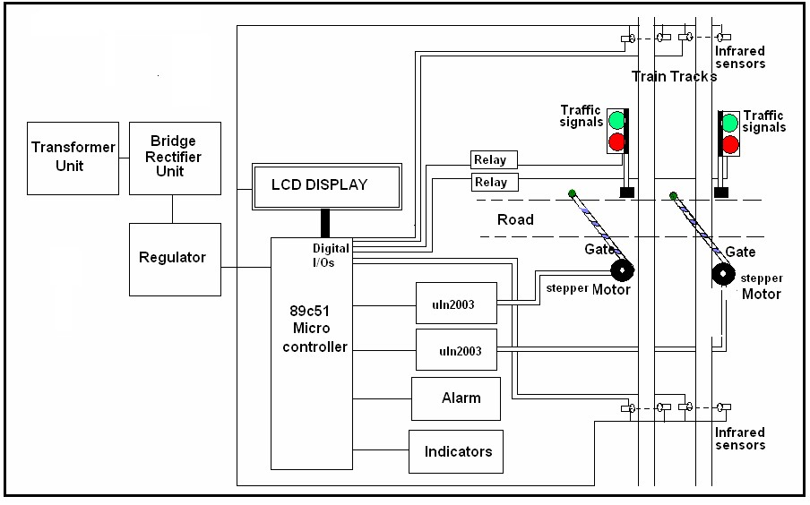

**FIG 2.1.**

**The above figure** shows the general block diagram of unmanned railway gate control, the various blocks of this are:

1. Power supply unit

1. Gate control unit
2. Track changing unit
3. LCD Message display unit

This project uses microcontroller like Arduino or raspberry pi for programming and operation. And ULN2003 driver.

The Block diagram consists of the power supply, which is of single-phase 230V ac. This should be given to step down transformer to reduce the 230V ac voltage to lower value. i.e., to 9V or 18V ac this value depends on the transformer inner winding. The output of the transformer is given to the rectifier circuit. This rectifier converts ac voltage to dc voltage. But the voltage may consist of ripples or harmonics.

To avoid these ripples, the output of the rectifier is connected to filter. The filter thus removes the harmonics. This is the exact dc voltage of the given specification. But the controller operates at 5V dc and the relays and driver operates at 12V dc voltage. So the regulator is required to reduce the voltage. Regulator 7805 produces 5V dc and regulator 7812 produces 12V dc. Both are positive voltages.

The supply from 7805 regulator is used for the purpose of track changing which consists of a stepper motor driven with ULN2003 the current driver chip. The supply of

12v is given to drive the stepper motor for the purpose of gate control. Through uln2003

**2.2 Operation:**

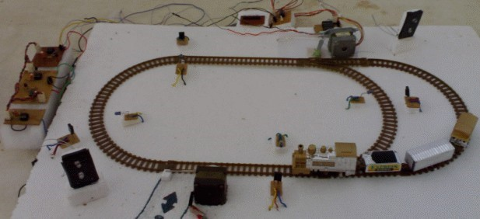

**Fig 2.2.** shows the of view of model project**.**

This project utilizes two powerful IR transmitters and two receivers; one pair of transmitter and receiver is fixed at up side (from where the train comes) at a level higher than a human being in exact alignment and similarly the other pair is fixed at down side of the train direction. Sensor activation time is so adjusted by calculating the time taken at a certain speed to cross at least one compartment of standard minimum size of the Indian railway. We have considered 5 seconds for this project. Sensors are fixed at 1km on both sides of the gate. We call the sensor along the train direction as ‘foreside sensor’ and the other as ‘aft side sensor’. When foreside receiver gets activated, the gate motor is turned on in one direction and the gate is closed and stays closed until the train crosses the gate and reaches aft side sensors. When aft side receiver gets activated motor turns in opposite direction and gate opens and motor stops. Buzzer will immediately sound at the fore side receiver activation and gate will close after 5 seconds, so giving time to drivers to clear gate area in order to avoid trapping between the gates and stop sound after the train has crossed.

The same principle is applied for track switching. Considering a situation wherein an express train and a local train are traveling in opposite directions on the same track; the express train is allowed to travel on the same track and the local train has to switch on to the other track. Two sensors are placed at the either sides of the junction where the track switches. If there’s a train approaching from the other side, then another sensor placed along that direction gets activated and will send an interrupt to the controller. The interrupt service routine switches the track. Indicator lights have been provided to avoid collisions. Here the switching operation is performed using a stepper motor. Assuming that within a certain delay, the train has passed the track is switched back to its original position, allowing the first train to pass without any interruption. This concept of track switching can be applied at 1km distance from the stations.

In this project Atmel 89c51 Micro controller Integrated Chip plays the main role. The program for this project is embedded in this Micro controller Integrated Chip and interfaced to all the peripherals. The timer program is inside the Micro controller IC to maintain all the functions as per the scheduled time. The Liquid crystal Display (LCD) is interfaced to Atmel 89c51 Micro controller to display the message, stepper motors are used for the purpose of gate control and track changing interfaced with current drivers chip ULN2003 it’s a 16 pin ic.

Infrared sensors are used in this for the detection of the train when ever it sends a signal to microcontroller the stepper motor should operate or message will be displayed on LCD. It consists of units called transmitter and receiver circuit.

Infrared sensor circuit consists of IC555 timer C 555 is used to construct an astable multivibrator which has two quasi-stable states. It generates a square wave of frequency 38 kHz and amplitude 5Volts. It is required to switch ‘ON’ the IR LED.

A stepper motor is a widely used device that translates electrical pulses into mechanical movement. They function as their name suggests - they “step” a little bit at a time.

The software is written in C-language and is dumped to the microcontroller to run the project.

Operation of this project can be explained through three units:

1. Gate control unit
2. Track changing unit
3. Announcement unit
4. Two trains opposite on same track case

**2.2.1 Gate control unit:**

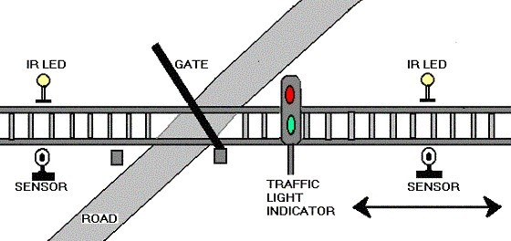

# **FIG: 2.2.1**

Railways being the cheapest mode of transportation are preferred over all the other means .When we go through the daily newspapers we come across many railway accidents occurring at unmanned railway crossings. This is mainly due to the carelessness in manual operations or lack of workers. We, in this project have come up with a solution for the same. Using simple electronic components we have tried to automate the control of railway gates. As a train approaches the railway crossing from either side, the sensors placed at a certain distance from the gate detects the approaching train and accordingly controls the operation of the gate. Also an indicator light has been provided to alert the motorists about the approaching train.

The above figure shows the gate controlling unit block diagram. Its operation can be explained through that.

As the figure shows it consists of two pairs of infrared sensors placed at two sides of gate. They should keep at a distance of 9 cm (2km in usual case) from the gate. and a stepper motor is used for the purpose of the gate closing and opening. Interfaced to the ULN2003.

When train reaches the sensor, it is detected by IR sensors placed 9 cm before the station and led in the sensor will glow because the 555 timer works into quasi state of operation. such that the IR LED should glow till the timer works in quasi state i.e., when train passes away the sensors it again into normal state then it receives 5v at terminals that pin at the 89c51 terminal goes high which enables the power to the stepper motor to rotate in steps which drives gate to close similarly when it reaches the second pair of sensors it senses and send the signal to the microcontroller to enable the current driver to open the gate by rotating the stepper motor in steps to get back in to original position.

**2.2.2 Track changing unit:**

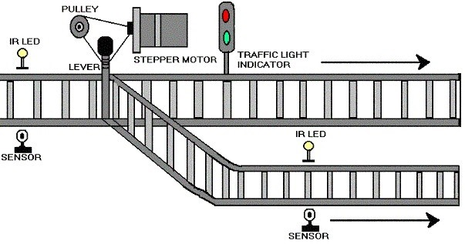

**FIG: 2.2.2**

Using the same principle as that for gate control, we have developed a concept of automatic track switching. Considering a situation wherein an express train and a local train are traveling in opposite directions on the same track; the express train is allowed to travel on the same track and the local train has to switch on to the other track. Indicator lights have been provided to avoid collisions .Here the switching operation is performed using a stepper motor. In practical purposes this can be achieved using electromagnets.

For the ease of description we are considering only two plat forms thus this can be implemented to any number of platforms. When train reaches the platform before a 10cm distance apart a set of sensors are placed to detect the train and two pair of sensors are placed on each of track at platforms. When the train is at the first pair of sensors it sends a signal to microcontroller to know the availability of plat form. Here after checking availability microcontroller operates stepper motor to change the track. The mechanism is arranged as shown in fig. but in this case the track changing is done due to second sensor that used to open the gate.

It consists of 5v driven stepper motor, ULN 2003 current driver chip and pulley for track changing mechanism.

**2.2.3 Announcement unit:**

Usually, announcement made at the station for the information of train arrival and departure. In this model we are using a buzzer for the announcement and LCD for the purpose of display message. LCD is interfaced to 89C51 microcontroller.

The announcement and display message is according to the second sensor which should be used for the purpose of gate opening.

**2.2.3.1 Train arrival detection**::

Detection of train approaching the gate can be sensed by means of sensors R1, R2, R3&R4 placed on either side of the gate. In particular direction of approach, R1 is used to sense the arrival; R3 is used to sense the departure of the train. In the same way R4&R2 senses arrival and departure in the other direction. Train arrival and departure sensing can be achieved by means of relay technique. A confined part of parallel track is supplied with positive voltage and ground. As wheels of the train, is made up of aluminum which is a conducting material, it shorts two parallel tracks. When the wheels of the train moves over it, both tracks are shorted to ground and this acts as a signal to microcontroller (89C51) indicating train arrival. The train detection in the other direction is done in the same way by the sensors R1 & R4. These sensors are placed five kilometers before the gate.

**2.2.3.2 warning for road users:** At that moment the train arrival is sensed on either of the gate, road users are warned about the train approach by RED signal placed to caution the road users passing through the gate .RED signal appears for the road user, once the train cuts the relay sensor placed before the 5Kms before the gate .A buzzer is for train, when there is any obstacle; signal is made RED for train in order to slow done its speed before 5km from gate.

**2.2.3.3 Train departure detection:** Detection of train is also done using relay techniques as explained the head of train arrival detection. Sensor R3&R2 respectively considering direction of train approach do train departure.

A message is displayed on LCD when train reaches the platform. Sensed by IR sensors.

**Future enhancement**: In our technique though it has many merits, but still the power supply of 223V AC POWER is required for functioning of the motor. It can be avoided with the help of a battery charged by a Solar Cell. Since solar energy is an inexhaustible natural source of energy.

**2.2.4 Two trains opposite on same track:**

We know that the rate of accidents increasing day by day, in this because failure of mechanism at track changing two trains coming on same track. This can also happens some times due to human negligence. This can avoided by using the following unmanned detection for two trains coming on same track case.

In our model of project, we are using the gate controlling pair of sensors to execute this method. i.e., when two trains are coming same track at that location the two sensors will operate at a time i.e., two 555 timers of circuit are driven in to quasi stable state and thus corresponding two buzzer will operate at a time and two IR LED will operate and hence signal sends to micro processor to operate the stepper motor at tack changing.

The components that we use in order to execute are stepper motor 5v, ULN2003, AT89C51 AND IR sensors.

**2.2.5 Initial signal display:**

Signals are placed near gate each at a specified distance. Train may be approaching gate at either direction so all four signals are made RED initially to indicate gate is OPENED and vehicles are going through gate. The road user signals are made GREEN so that they freely move through gate. Buzzer is OFF since there is no approach of train and users need not be warned.

HARDWARE COMPONENTS

* MICRO CONTROLLER ()
* IR SENSOR
* STEPPER MOTOR
* LCD DISPLAY
* BUZZER AND LED’S

SOFTWARE REQUIREMENTS

* EMBEDDED C