INTRODUCTION TO IMAGE PROCESSING USING XILINX SYSTEM GENERATOR.

* Load image from “image from file” block .In which we have flexibility to change from one multidimensional signal to seperate color signals i,e. R,G,B.And also set sample time to 1.
* Now invoke “video viewer” to display the loaded image. Video viewer works as sink.
* Here both the blocks are from simulink.

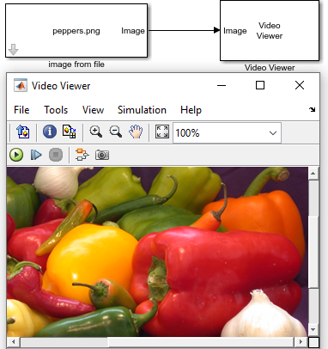
Fig 1

* Now we shall add xilinx “gateway-in & gateway-out” blocks between image
source and sink.Doing so we will get an error.
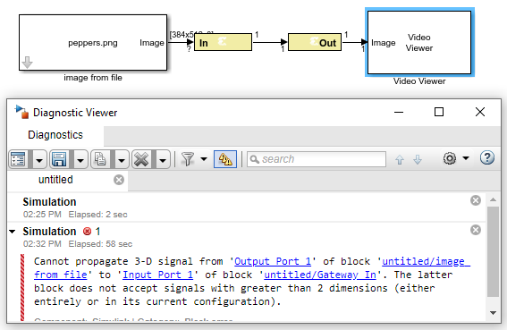
Fig 2
Reason : Gateway in block cannot take 3 dimensional image i,e length*breadth*RGB.
Rectifying error : we need to do preprocessing before we send it to gateway-in block.
* Firstly we need to convert into 2-dimensional image i,e we have to choose any one out of RGB.
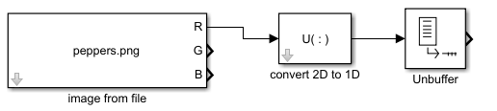

Fig 3
PRE-PROCESSING
* Using “convert 2-D to 1-D” block to convert extracted 2-D data in 1-D form.i,e vectorization of data.
* Now we need to use “unbuffer” block . As FPGA clock frequency is much higher than the sampling frequency . Therefore we need to process our sample at very higher rate. Unbuffer converts a frame (is a vector or a matrice of buffered samples of consecutive times stacked together) to scalar samples and output at a higher rate .

Fig 4 pre-processing sub system

POST-PROCESSING
* Basically it is reverse process of pre-processing.
* “Buffer” block is used to convert scalar samples to a frame output at a lower rate. We have give dimensions of input image as buffer size as parameter.
* Then “Convert 1-D to 2-D” block is used to convert processed 1D signal to 2D .i,e to convert vector to matrice form .Therefore we have to give number of rows and number of columns from input image dimensions. And also select framed based output as it is image.

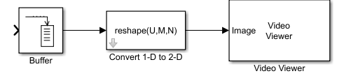
Fig 5 post-processing sub system

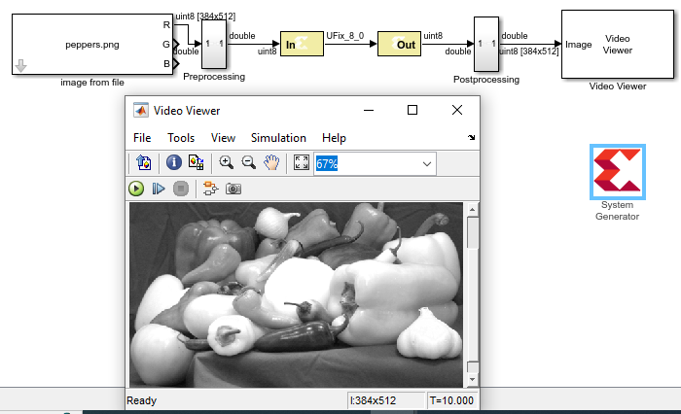
Fig 6 final execution

BLOCKS USED

GATEWAY-IN

* It is interface between simulink blocks and xilinx system generator blocks.
* It converts the simulink data type to system generator data .
* Simulink supports int8,unint8,int16,unint16,int32,unint32,single,double and fixed pointdata type.In all causes the input data is converted to a double internal to gateway and then converted to target data type as specified on the gateway-in block.

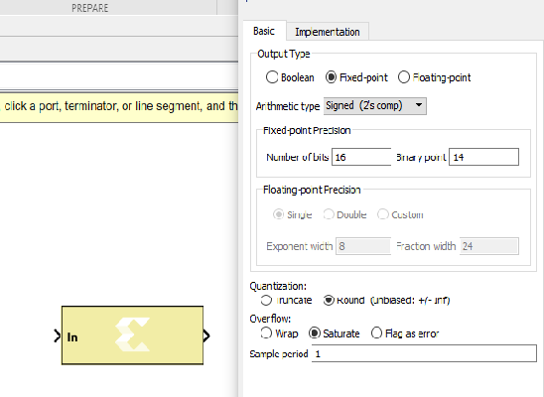
Fig 7 gateway-in

GATEWAY-OUT

* Converts data from a system generator fixed-point or floating point data type into simulink integer,single,double or fixed-point data type.
Block parameters
* Propagate data type to output
* The system generator data type is propagated to an appropriate simulink data accordingly.
* Translate into output port
* This option enables output port during hardware implementation. If this option is unchecked then it prevents the gateway from becoming an actual output port when translated into hardware.

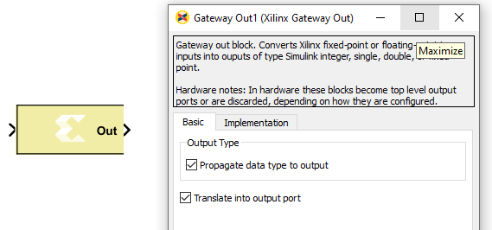
Fig 8 gateway-out

XILINX SYSTEM GENERATOR TOKEN

* Serve as control panel for controlling system and simulation parameters and also used to invoke the code generator for netlisting.
* If simulink model consist even one xilinx block then we must add system generator token to the model.
* This also contains three major tabs they are compilation,clocking,general setting tabs.

Fig 9 xilinx system generator token

