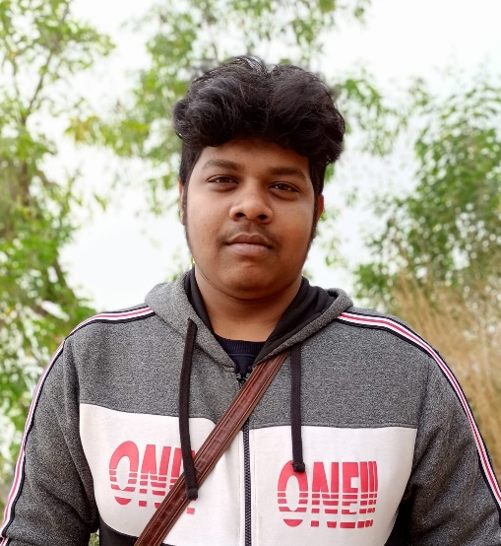

13/23 Edison Road, B-zone, Durgapur, Paschim Bardhaman,

Pin code : 713205

9933454265 & 8250734192

Full Stack Web and Software developer

Koushik Chandra Saha