Health Inspector

**Setup:**

Android Studio:

Open Android Studio > Build > Edit Build Types > Signing >

* + Key Alias: key0
  + Key Password: password
  + Store File: choose release.jks from app folder
  + Store password: password

In bottom left, choose build variants as Release

Run the application

**Libraries Used / Dependencies:**

Firebase Auth UI for social login.

Retrofit, OkHTTP for making network calls

GSON to parse JSON response to java object

Google Maps API for location

**Authentication:**

* Firebase Login UI Auth for social Login (Mobile, Email, Google Login)
* Fetching SHA-1 for release.jks (check certificate.txt) and Substitute that SHA-1 value in firebase console for Authentication
* Firebase SignOut

**Doctor Search with Better Doctors API:**

* Drop down (Spinner) to specify specialization in doctor search query
* Making REST Call with lat,lng, limit=10 and specialization

@GET

<https://api.betterdoctor.com/2016-03-01/doctors?location=37.773%2C-122.413%2C100&user_location=37.773%2C-122.413&skip=0&limit=10&user_key=76a2878a9e8d28dcd556ba0c53461174&specialty_uid=pediatrician>

And parsing it in Home Activity with RecyclerView

**Calculating Meals for given target calories using Spoonacular API:**

* + Taking Calories per day input through EditText
  + Making REST Call with target calories per day

@GET

<https://spoonacular-recipe-food-nutrition-v1.p.mashape.com/recipes/mealplans/generate?timeFrame=day&targetCalories=2000>

+

Pass Keys in header

X-Mashape-Key: 1Dnz7LuzBVmshia88a9IKqmf7n82p1v8KSGjsnP7R2gBashGJA (key)

X-Mashape-Host: spoonacular-recipe-food-nutrition-v1.p.mashape.com (key)

And parsing it in MyDiet Activity with Recycler View and in Nutrients View

**BMI Activity**

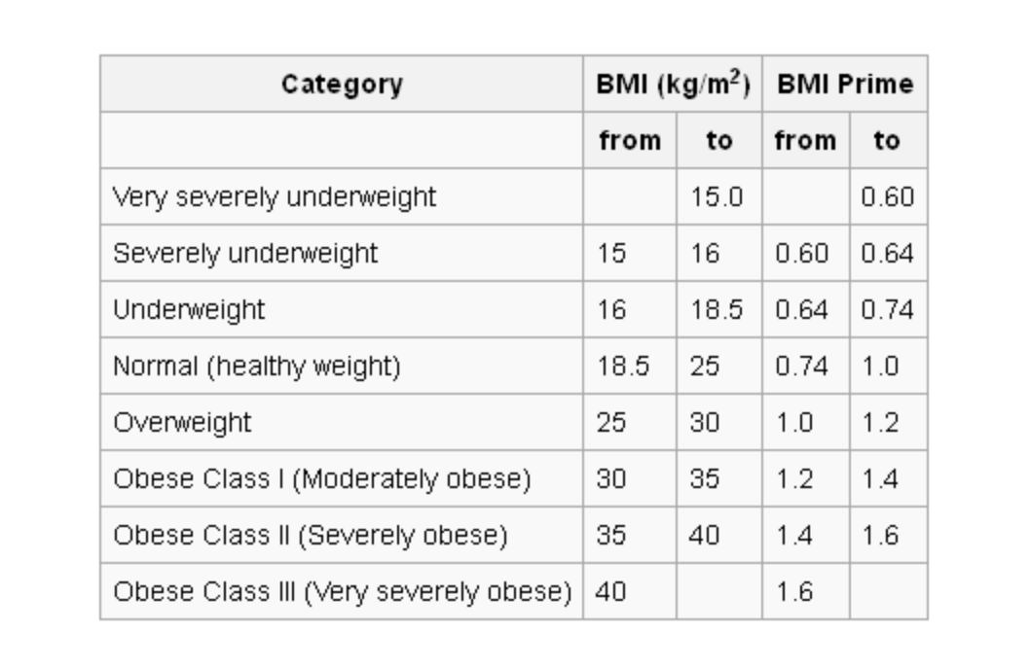

Calculating BMI taking weight and height as inputs and using above table info.