AI-Based Manufacturing Efficiency Classification
Using Sensor, Production, and 6G Network Data
Research Paper — EDA, Insights & Recommendations
Prepared for: Unified Mentor — AI Intern Program

Executive Summary
Smart factories powered by Industrial IoT and 6G connectivity generate large volumes of sensor, production, and network data every second. This project develops a machine learning system that classifies real-time manufacturing efficiency into High, Medium, or Low categories, enabling factory systems to react instantly to efficiency changes rather than relying on delayed, manual dashboard review.
A Random Forest classifier was selected as the best-performing model after comparing Logistic Regression, Random Forest, and XGBoost, achieving an accuracy of 99.98% and a macro F1-score of 99.90% on held-out test data.

1. Background and Context
In smart factories enabled by Industrial IoT and 6G connectivity, efficiency can fluctuate rapidly due to sensor deviations, network instability, and quality/error variations. Traditional dashboards show what happened in the past, but modern factory systems increasingly need to know the current efficiency state of the manufacturing process in real time, so that corrective action can be taken immediately.

2. Problem Statement
Manufacturing teams face several recurring challenges:
- Delayed detection of efficiency degradation
- Manual interpretation of dozens of sensor and network metrics
- Lack of automated, interpretable efficiency assessment
Without AI support, efficiency drops may go unnoticed, corrective actions are delayed, and production losses increase. This project addresses these gaps with an automated, explainable classification system.

3. Dataset Overview
The dataset used for this project (Thales Group Manufacturing dataset) contains 100,000 time-stamped records collected from 50 industrial machines, covering sensor readings, production metrics, 6G network parameters, and a target efficiency label.
Field | Description
Date / Time | Timestamp of the recorded observation
Machine_ID | Unique identifier for each of the 50 machines
Operation_Mode | Active / Idle / Maintenance
Temperature_C, Vibration_Hz | Core sensor readings
Power_Consumption_kW | Electrical power consumed
Network_Latency_ms, Packet_Loss_% | 6G network quality indicators
Quality_Control_Defect_Rate_% | Defective units identified during QC
Production_Speed_units_per_hr | Units produced per hour
Predictive_Maintenance_Score | AI-derived maintenance readiness score
Error_Rate_% | Operational errors during production
Efficiency_Status (target) | High / Medium / Low

4. Exploratory Data Analysis

4.1 Class Distribution
The target variable is imbalanced: the majority of records fall under 'Low' efficiency, followed by 'Medium', with 'High' being the rarest class. This imbalance was addressed during model training using class weighting.
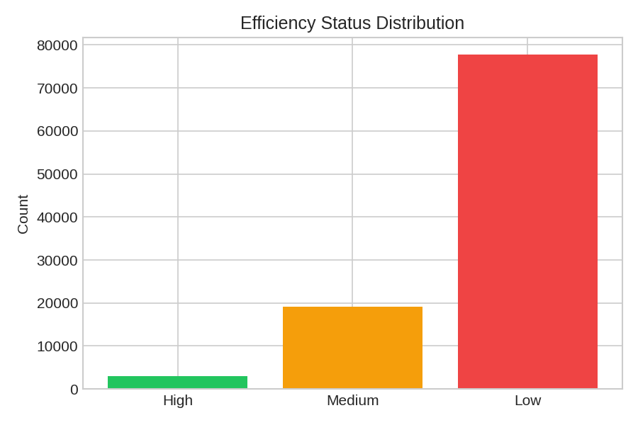
Figure 1: Distribution of Efficiency Status classes

4.2 Correlation Analysis
A correlation heatmap of the numeric sensor, network, and production features reveals the relationships between variables, helping identify which metrics move together and which are largely independent.
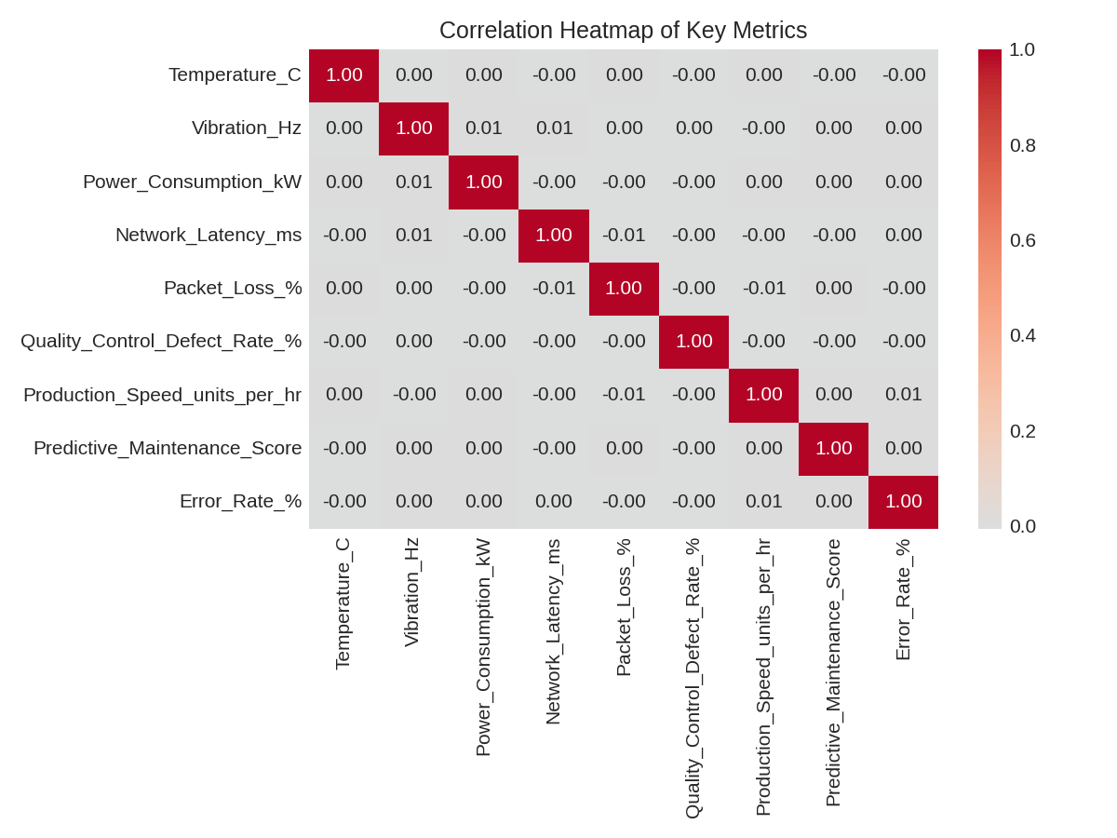
Figure 2: Correlation heatmap of key numeric metrics

4.3 Error Rate by Efficiency Class
Error Rate shows a clear separation across efficiency classes — machines with higher error rates are overwhelmingly classified as Low efficiency, confirming its role as a strong predictive signal.
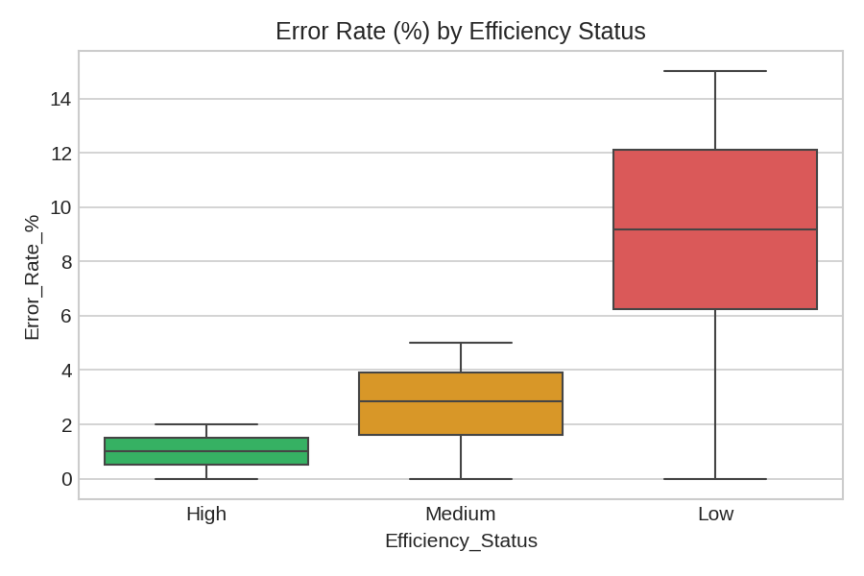
Figure 3: Error Rate (%) distribution across efficiency classes

4.4 Efficiency by Operation Mode
Machines in 'Active' mode show the widest spread across efficiency classes, while 'Idle' and 'Maintenance' modes are more concentrated, reflecting expected operational patterns.
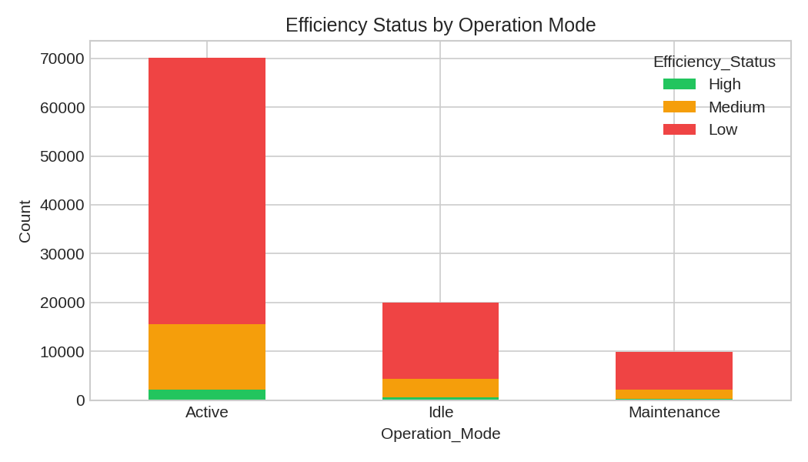
Figure 4: Efficiency status distribution by operation mode

5. Data Science Methodology

5.1 Data Preprocessing
- Combined Date + Time into a single DateTime field and sorted chronologically
- Encoded the categorical Operation_Mode variable
- Scaled numerical features using StandardScaler (for linear models)
- Addressed class imbalance using class-weighted training

5.2 Feature Engineering
- Sensor Stability Indicator — vibration relative to temperature
- Energy Efficiency Ratio — production speed relative to power consumption
- Error-to-Output Ratio — error rate relative to production speed
- Network Reliability Score — composite of latency and packet loss

5.3 Model Development
Three classification models were trained and compared:
Model | Accuracy | F1-score (macro)
Logistic Regression | 88.68% | 82.37%
Random Forest | 99.98% | 99.90%
XGBoost | 99.81% | 99.58%

The Random Forest model was selected as the final production model based on its superior macro F1-score, which is the more reliable metric given the class imbalance in the dataset.

5.4 Feature Importance & Explainability
The top features driving the model's classification decisions are:
Rank | Feature | Importance
1 | Error_Rate_% | 0.3613
2 | Error_to_Output_Ratio | 0.3004
3 | Production_Speed_units_per_hr | 0.2686
4 | Energy_Efficiency_Ratio | 0.0568
5 | Power_Consumption_kW | 0.0062

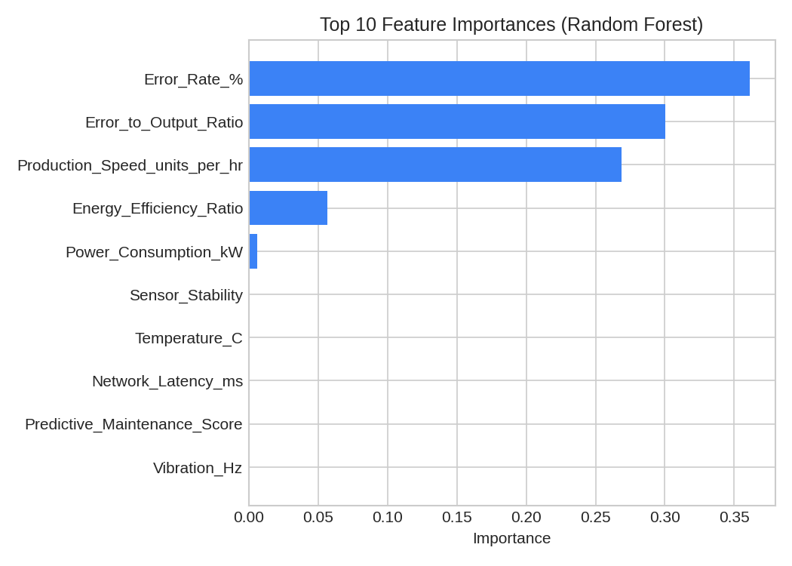
Figure 5: Top 10 feature importances from the Random Forest model
Error Rate, Error-to-Output Ratio, and Production Speed are consistently the strongest drivers of the predicted efficiency class, giving engineers a clear, explainable basis for trusting and acting on model predictions.

6. Key Performance Indicators (KPIs)
KPI | Description
Efficiency Class | High / Medium / Low
Prediction Confidence | Model certainty level for each prediction
Feature Contribution | Key influencing factors behind a prediction
Machine Efficiency Profile | Per-machine classification trends

7. Streamlit Web Application
An interactive Streamlit dashboard was built with four modules, giving users the ability to filter by machine, time window, operation mode, network quality, and defect-rate sensitivity:
- Efficiency Prediction Dashboard — real-time classification with confidence scores and a live prediction tool
- Machine-Level Insights — efficiency trends and historical classification patterns per machine
- Explainability Panel — feature importance charts and class-comparison analysis
- Operational Monitoring View — efficiency by operation mode and network-vs-sensor impact comparison

8. Recommendations
- Prioritize monitoring of Error Rate and Production Speed as early-warning indicators of efficiency degradation
- Deploy the model for real-time scoring so operators receive alerts before efficiency drops materially impact output
- Investigate machines with persistently high defect rates flagged in the Operational Monitoring View for predictive maintenance
- Periodically retrain the model as new operational data accumulates to maintain prediction accuracy

9. Conclusion
This project introduces AI-driven intelligence into smart manufacturing by automatically classifying production efficiency using sensor, quality, and 6G network data. Unlike traditional dashboards that focus on retrospective diagnostic analysis, this system provides real-time predictive classification, enabling manufacturing systems to react instantly to efficiency changes — a critical building block for autonomous, intelligent factories.

