**Task 2:**

**Access the hbase data from hive For the above hbase table create a corresponding hive table and access the data by running queries in hive**

CREATE EXTERNAL TABLE stocks(rowkey string,stock_symbol string, commented string, userid string, displayname string, Active strin

g, comment string)STORED BY 'org.apache.hadoop.hive.hbase.HBaseStorageHandler'WITH SERDEPROPERTIES ('hbase.columns.mapping' = ':key,sam

pledata:stock_symbol,sampledata:commented,sampledata:userid,sampledata:displayname,sampledata:Active,sampledata:comment')TBLPROPERTIES

('hbase.table.name' = 'koushikhbase:stocks');

**What are the comments by user3?**

select comment from stocks where userid = 'user3';

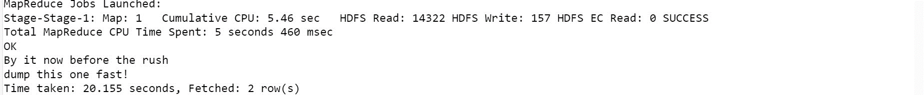

**Which users have inactive comments?**

select userid from stocks where Active = 'False';

