**Step 1: Copy the provided csv files in a directory named AirlinesOntimeAnalysis**

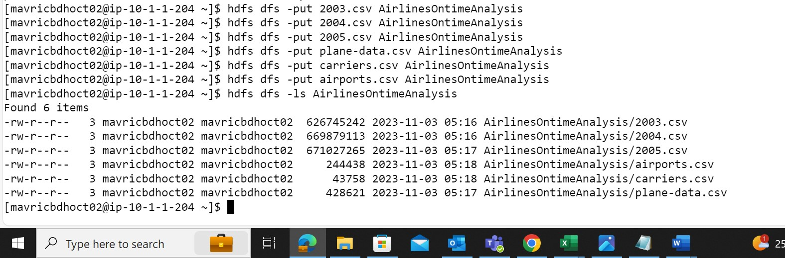

**Step 2: Unzip the contents for the bz2 files.**

**Step 3: Create the directories in hdfs where your data will reside**

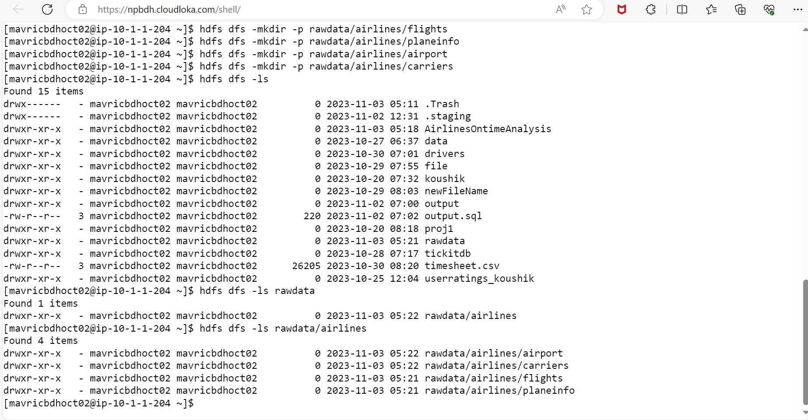

**Step 4: copy the respective files to the above created hdfs structure**

**Airports**

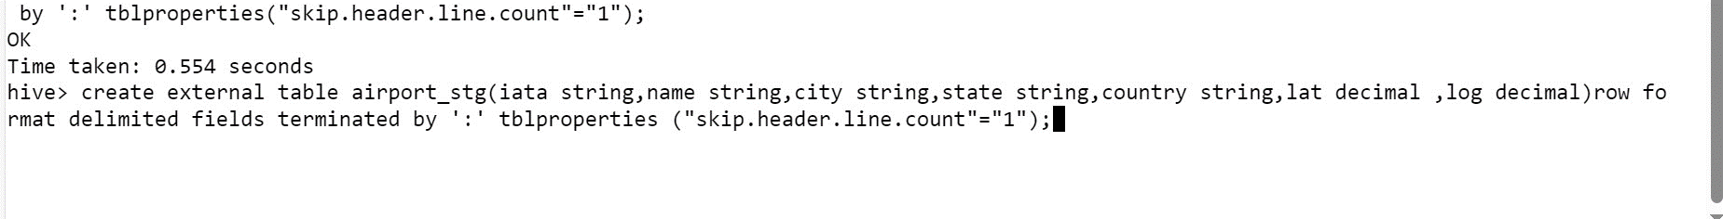

**Carrier**

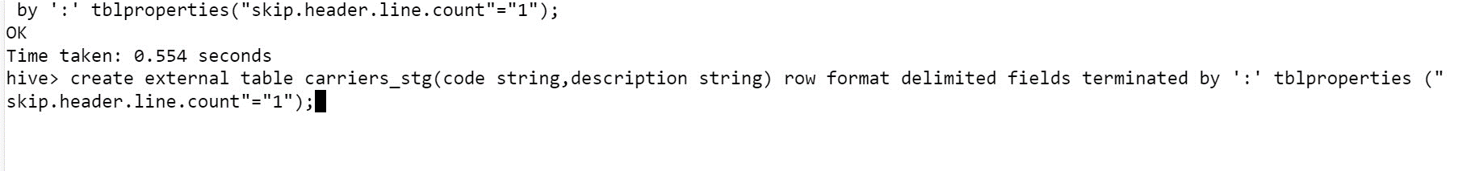

**Plane Info**

**Flights**

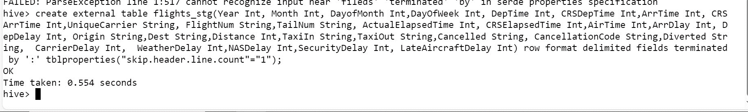

**Loading the data to the tables**

1. Airports

load data inpath 'AirlinesOntimeAnalysis/airports.csv' into table airport_stg;

1. **Carriers**

load data inpath 'AirlinesOntimeAnalysis/carriers.csv' into table carriers_stg;

1. Plane info

load data inpath 'AirlinesOntimeAnalysis/plane-data.csv' into table planeinfo_stg;

1. **Flights**

load data inpath 'AirlinesOntimeAnalysis/2003.csv' into table flights_stg;

load data inpath 'AirlinesOntimeAnalysis/2004.csv' into table flights_stg;

load data inpath 'AirlinesOntimeAnalysis/2005.csv' into table flights_stg;

**What is the average arrival delay and average departure delay in each month of the year 2004?**

**Improving the performance of Hive tables - Parquet format**

create external table flights_pq(Year Int, Month Int, DayofMonth Int,DayOfWeek Int, DepTime Int, CRSDepTime Int,ArrTime Int, CRSA

rrTime Int,UniqueCarrier String, FlightNum String,TailNum String, ActualElapsedTime Int, CRSElapsedTime Int,AirTime Int,ArrDlay Int, De

pDelay Int, Origin String,Dest String,Distance Int,TaxiIn String,TaxiOut String,Cancelled String, CancellationCode String,Diverted Stri

ng, CarrierDelay Int, WeatherDelay Int,NASDelay Int,SecurityDelay Int, LateAircraftDelay Int) row format delimited fields terminated

by ':' stored as parquet location ‘user/mavricbdhoct02/output/airline/pq_flight’ tblproperties("skip.header.line.count"="1");

insert overwrite table flight_pq select * from flight_stg;

select month, avg(arrdelay) as avg_arrdela

y, avg(depdelay) as avg_depdelay from flights_pq where year = 2004 group by month

**Is there a difference between the response times for the queries(2 and 3)**

