CAPSTONE PROJECT REPORT
(Project Term January–May 2026)
THEAGRIDOCTOR
An AI-Powered Crop Disease Diagnosis, Advisory and Farm-Management Platform for Indian Smallholder Farmers
Submitted by
Madireddy Ajay Kumar Reddy | Reg. No.: 12300405
Narthu Nithin | Reg. No.: 12224156
Poreddy Koushik Reddy | Reg. No.: 12300302
Nevin J Reji | Reg. No.: 12223233
Arsi Shekar | Reg. No.: 12223409
Gavara Sateesh | Reg. No.: 12212646

Project Group Number : __________
Course Code : CSE445
Under the Guidance of
Ritika Mahajan
Faculty Mentor
School of Computer Science and Engineering
Lovely Professional University, Phagwara, Punjab (India)
April 2026

(Inner page — duplicate of cover, on soft paper)
CAPSTONE PROJECT REPORT
THEAGRIDOCTOR
An AI-Powered Crop Disease Diagnosis, Advisory and Farm-Management Platform for Indian Smallholder Farmers

PAC FORM
(To be attached as per the Project Approval Committee format issued by the School of Computer Science and Engineering, LPU.)

DECLARATION
We hereby declare that the project work entitled “TheAgriDoctor — An AI-Powered Crop Disease Diagnosis, Advisory and Farm-Management Platform for Indian Smallholder Farmers” is an authentic record of our own work carried out as requirements of the Capstone Project for the award of the B.Tech degree in Computer Science and Engineering from Lovely Professional University, Phagwara, under the guidance of Ritika Mahajan, during January to May 2026. All the information furnished in this capstone project report is based on our own intensive work and is genuine.
Name : Madireddy Ajay Kumar Reddy | Registration No.: 12300405
Name : Narthu Nithin | Registration No.: 12224156
Name : Poreddy Koushik Reddy | Registration No.: 12300302
Name : Nevin J Reji | Registration No.: 12223233
Name : Arsi Shekar | Registration No.: 12223409
Name : Gavara Sateesh | Registration No.: 12212646

(Signature of Madireddy Ajay Kumar Reddy)  Date: ____________ | (Signature of Narthu Nithin)  Date: ____________
(Signature of Poreddy Koushik Reddy)  Date: ____________ | (Signature of Nevin J Reji)  Date: ____________
(Signature of Arsi Shekar)  Date: ____________ | (Signature of Gavara Sateesh)  Date: ____________

CERTIFICATE
This is to certify that the declaration statement made by this group of students is correct to the best of my knowledge and belief. They have completed this Capstone Project under my guidance and supervision. The present work is the result of their original investigation, effort and study. No part of the work has ever been submitted for any other degree at any University. The Capstone Project is fit for the submission and partial fulfillment of the conditions for the award of the B.Tech degree in Computer Science and Engineering from Lovely Professional University, Phagwara.

Ritika Mahajan
Faculty Mentor
School of Computer Science and Engineering,
Lovely Professional University, Phagwara, Punjab.
Date: ____________________

ACKNOWLEDGEMENT
We express our sincere gratitude to our project mentor, Ritika Mahajan, for the constant guidance, encouragement and support throughout the course of this work. We thank the School of Computer Science and Engineering, Lovely Professional University, for providing the infrastructure and academic environment necessary to bring this project to fruition. We also acknowledge the open-source communities behind Next.js, Supabase, OpenRouter, Google Generative AI and OpenWeather Agro-Monitoring, whose freely available platforms made the rapid development of TheAgriDoctor possible. Finally, we are grateful to our families and peers for their unwavering motivation during the project term.

PROJECT TEAM — INVENTOR DETAILS
The following team members and faculty mentor are the contributors to the design, development and documentation of TheAgriDoctor Capstone Project.
Faculty Mentor
Full Name | Ritika Mahajan
Mobile Number | 9876194332
Email | ritikamahajan2010@gmail.com
Address | Lovely Professional University, Punjab-144411, India
Student Members
A. Madireddy Ajay Kumar Reddy
UID / Registration No. | 12300405
Mobile Number | 7989791609
Email (personal) | ajayreddymr07@gmail.com
Address | Lovely Professional University, Punjab-144411, India
B. Narthu Nithin
UID / Registration No. | 12224156
Mobile Number | 8247510576
Email (personal) | nithinnarthu8895@gmail.com
Address | Lovely Professional University, Punjab-144411, India
C. Poreddy Koushik Reddy
UID / Registration No. | 12300302
Mobile Number | 6303089721
Email (personal) | poreddykoushik@gmail.com
Address | Lovely Professional University, Punjab-144411, India
D. Nevin J Reji
UID / Registration No. | 12223233
Mobile Number | 6282098167
Email (personal) | nevinjreji@gmail.com
Address | Lovely Professional University, Punjab-144411, India
E. Arsi Shekar
UID / Registration No. | 12223409
Mobile Number | 7095256270
Email (personal) | arsisekhar62@gmail.com
Address | Lovely Professional University, Punjab-144411, India
F. Gavara Sateesh
UID / Registration No. | 12212646
Mobile Number | 9949860230
Email (personal) | satheeshgavara10@gmail.com
Address | Lovely Professional University, Punjab-144411, India

ABSTRACT
Farming still feeds most of India, but the people who actually grow the food rarely have a quick way to ask, “what is wrong with my crop?” By the time an answer reaches them — through a neighbour, a shopkeeper or a SMS helpline — the disease has usually moved on. We built TheAgriDoctor to close that gap. It is a small Next.js web app, hosted on Vercel and backed by Supabase, that lets a farmer click a few photos of an affected leaf, pick the crop and get back a clean report telling them what the disease likely is, how bad it is, what organic and chemical options exist, what to avoid next season and how many days they have before the loss becomes hard to reverse. The same app also keeps track of their farms, their active crop cycles, the local weather, the satellite NDVI of their plot and the prices their crop is fetching at nearby mandis. On top of all this sits a chat advisor that does not start every conversation cold — before it answers, the server quietly pulls the farmer’s profile, farms, crops and most recent diagnosis into the prompt, so the reply talks about *their* tomato, not tomatoes in general. Because free LLM tiers are unreliable, every AI call walks down a list of providers (three OpenRouter vision models, then Google Gemini 2.5 Flash) until one answers. The remaining chapters of this report walk through how the problem was framed, how the system was designed (architecture, low-level design, DFDs from Level 0 to 3, ER diagram, flowcharts), how it was built and tested, and what is left to do.
Keywords
Crop disease diagnosis, computer vision, large language models, agricultural advisory, Next.js, Supabase, OpenRouter, Google Gemini, NDVI, smart farming, decision support system, smallholder farmer, India.

TABLE OF CONTENTS
Inner first page i
PAC Form ii
Declaration iii
Certificate iv
Acknowledgement v
Abstract & Keywords vi
Table of Contents vii
List of Figures viii
List of Tables ix
List of Abbreviations x
1. Introduction 1
2. Profile of the Problem (Scope of the Study) 6
3. Existing System 9
4. Problem Analysis 14
5. Software Requirement Analysis 19
6. Design 25
6.1 System Design 25
6.2 Design Notations 27
6.3 Detailed Design (Low-Level Design) 29
6.4 Data-Flow Diagrams (Levels 0–3) 34
6.5 ER Diagram & Database Design 40
6.6 Flowcharts 43
6.7 Pseudocode 46
7. Testing 49
8. Implementation 54
9. Project Legacy 59
10. User Manual 62
11. Source Code / System Snapshots 66
12. Bibliography 70

LIST OF FIGURES
Figure 6.1 High-level System Architecture 25
Figure 6.2 Use-Case Diagram 27
Figure 6.3 DFD Level 0 — Context Diagram 34
Figure 6.4 DFD Level 1 — Major Subsystems 35
Figure 6.5 DFD Level 2 — Diagnose Module 36
Figure 6.6 DFD Level 2 — Advisor Chat Module 37
Figure 6.7 DFD Level 3 — Vision Inference Pipeline 38
Figure 6.8 Entity-Relationship Diagram 40
Figure 6.9 Flowchart — Crop Disease Diagnosis 43
Figure 6.10 Flowchart — AI Advisor Chat 44
Figure 6.11 Sequence — Authentication & Profile Provisioning 45

LIST OF TABLES
Table 4.1 Feasibility Analysis Summary 16
Table 4.2 Project Schedule (5-month plan) 18
Table 5.1 Functional Requirements 20
Table 5.2 Non-Functional Requirements 23
Table 6.1 Database Schema — Tables Overview 41
Table 7.1 Test Cases — Diagnose Module 50
Table 7.2 Test Cases — Advisor Module 52
Table 8.1 Tech Stack & Versions 54

LIST OF ABBREVIATIONS
AI Artificial Intelligence
API Application Programming Interface
CDN Content Delivery Network
DFD Data-Flow Diagram
ER Entity Relationship
FK Foreign Key
HLD High-Level Design
JWT JSON Web Token
LLD Low-Level Design
LLM Large Language Model
MSP Minimum Support Price
NDVI Normalised Difference Vegetation Index
PWA Progressive Web Application
RLS Row-Level Security
RSC React Server Component
SSE Server-Sent Events
SSR Server-Side Rendering
UV Ultraviolet
VLM Vision Language Model

CHAPTER 1: INTRODUCTION
1.1 Background
India still runs on its farms. Roughly 45 percent of the working population earns its living from agriculture, and yet a worryingly large share of every harvest is lost to problems that should have been catchable early — a fungal spot on a leaf, an irrigation cycle missed at flowering, a pest that arrived two weeks before the spray. Every farmer we spoke to during the project told us the same thing in different words: by the time the answer reaches the field, the field has already moved on.
At the same time, the cost of doing something about this has dropped sharply. A modern smartphone takes a usable photo of a sick leaf. Vision-language models are accurate enough on common Indian crops that they no longer feel like a toy. OpenRouter and Google AI Studio give away free tiers that, with a little provider juggling, are enough to serve a college project. Supabase removes most of the database and auth boilerplate that used to slow student teams down. Next.js and Vercel let two of us deploy a real web app with a single git push. None of these tools existed in this shape five years ago. TheAgriDoctor is our attempt to stitch them together into something a farmer can actually open and use.
1.2 Problem Statement
When something goes wrong on an Indian smallholding, the farmer’s options today are scattered. The agri-shop sells a chemical without really diagnosing the cause. The KVK helpline gives generic advice over SMS. WhatsApp groups are full of opinions, but nothing is recorded for next season. Weather, prices, peer answers and government alerts each live in their own silo. What we found missing was simply this — one place a farmer can open on a phone, in their own language, that takes a photo of a sick crop, gives a real answer, remembers the farm and the crops, and brings weather, prices and community into the same screen — for free.
1.3 Motivation
- A single severe outbreak can wipe out an entire season’s income for a smallholder family.
- Vision-LLMs now match trained pathologists on common Indian crops.
- Free-tier inference (OpenRouter, Gemini) removes the historical cost barrier.
- Next.js 14 + Supabase let two students ship a globally-deployable PWA in months.
- Government schemes (PM-KISAN, PMFBY) require digital footprints that this platform naturally produces.
1.4 Project Overview
From a user’s point of view, TheAgriDoctor is a single web app with a sidebar full of modules. From a developer’s point of view, it is a Next.js 14 App-Router project where every page is either a Server Component reading directly from Supabase or a small client component talking to a Route Handler under `/api`. Authentication is handled by Supabase Auth with a JWT cookie that the middleware quietly refreshes on every request. Anything AI-related goes through one helper file — `lib/ai.ts` — which tries OpenRouter first and, if that fails, calls Gemini. The dashboard exposes nine modules: sign-in / profile, farms and crop cycles, image-based diagnosis, the chat advisor (with voice input), weather and NDVI for any farm polygon, a clustered diagnosis heatmap, mandi prices, the community board, and an alerts / notifications surface.
1.5 Salient Features
- Multi-image (up to 5) crop diagnosis returning structured JSON: disease, severity, organic & chemical remedies, prevention tips, expected yield loss, urgency window.
- Three-tier OpenRouter vision fallback (Gemma-3-27B → Qwen-2.5-VL-72B → Llama-3.2-11B-Vision) followed by Gemini 2.5 Flash safety net.
- Personalised, streaming AI advisor that reads farmer profile, registered farms, active crops and last diagnosis to ground every reply.
- Polygon-based weather, soil temperature, UV index and NDVI satellite tiles via OpenWeather Agro-Monitoring API.
- Geo-clustered diagnosis heatmap built with Leaflet + react-leaflet-cluster.
- Auto-generated crop-care task list per growth stage.
- Community board with peer answers and AI-assisted replies.
- Alert preferences and in-app notification bell driven by daily-aggregated rules.
- JWT-cookie middleware refresh, RLS-ready schema and Vercel-ready deployment.
1.6 Report Organisation
Chapter 2 presents the profile of the problem and the scope of the study. Chapter 3 surveys the existing systems and what differentiates TheAgriDoctor. Chapter 4 carries out a problem analysis with feasibility study and project plan. Chapter 5 details the functional and non-functional requirements. Chapter 6 contains the high-level and low-level design — architecture, DFDs (Levels 0 to 3), ER diagram, flowcharts and pseudocode. Chapter 7 documents the testing strategy. Chapter 8 describes the implementation and conversion plan. Chapter 9 reflects on the project legacy. Chapter 10 is the user manual; Chapter 11 lists key source-code excerpts; Chapter 12 lists the bibliography.

CHAPTER 2: PROFILE OF THE PROBLEM (SCOPE OF THE STUDY)
2.1 Profile of the Problem
The typical user we have in mind owns less than a hectare, grows two or three crops a year and is comfortable on a smartphone but not necessarily in English. When a disease shows up, it usually shows up quietly — a few yellow leaves that nobody photographs until they have already spread. The existing answers (the village shop, a WhatsApp group, a single-purpose app) each solve part of the problem but not the whole of it, and none of them remember anything from one season to the next. Looked at this way, the problem has a few distinct edges:
- Diagnosis latency — an expert opinion takes hours to days.
- Language barrier — most digital tools are English-first.
- Context blindness — generic advice ignores soil, water, season, growth-stage.
- Data silos — diagnosis, weather, prices, peer advice live in different apps.
- Cost — paid agronomy services price out the bottom of the pyramid.
2.2 Scope of the Study
The scope of TheAgriDoctor Capstone Project is bounded as follows:
2.2.1 In-Scope
- Web-based Progressive Web Application accessible on any modern smartphone or laptop browser.
- User authentication, profile and multi-farm management with crop cycles.
- Vision-based crop disease diagnosis (up to five images) with structured AI report.
- Streaming AI advisor with multilingual prompt and voice-to-text input.
- Hyper-local weather, soil, UV and NDVI satellite analytics via Agro-Monitoring API.
- Diagnosis history, geo-clustered heatmap and crop-care task generation.
- Mandi price browser, community Q&A board, alert preferences and notifications.
2.2.2 Out-of-Scope
- Native Android / iOS applications (the PWA covers offline-tolerant UX needs).
- Direct e-commerce / payment integration with input retailers.
- On-device, offline inference (all AI calls are cloud-based).
- Government scheme application workflows beyond surfacing notifications.
- Drone or IoT sensor ingestion (the schema is forward-compatible but not implemented).
2.3 Stakeholders
Stakeholder | Role | Primary Benefit
Smallholder farmer | Primary end-user | Free, instant, multilingual agronomic copilot
Krishi Vigyan Kendras | Indirect partner | Access to anonymised diagnosis heatmaps
State agriculture dept. | Policy / extension | Outbreak surveillance dashboard (future)
Faculty mentor | Academic guide | Capstone evaluation
Project team | Developers / researchers | B.Tech credit + open-source portfolio

CHAPTER 3: EXISTING SYSTEM
3.1 Introduction
Before we wrote a single line of code we spent a few weeks using whatever already exists. Some of these tools are very good at one thing — Plantix, for example, gives a quick image-based answer; mKisan does daily SMS broadcasts; AgroStar runs a clean marketplace. None of them, however, sit a farmer down with their *own* farms, *their* last diagnosis and *their* preferred language and answer a follow-up question. That gap is what TheAgriDoctor tries to fill, and this chapter records what we found while looking around.
3.2 Existing Software
System | Strength | Limitation
Plantix | Strong CV disease detection | Closed model, English-heavy UI, ad-driven, no advisor chat
Kisan Suvidha | Govt-backed, weather + price | No image diagnosis, static advisory
AgroStar / DeHaat | Marketplace + advisory | Commerce-driven, biased toward partner brands
IBM Watson Decision Platform | Sensor + analytics | Enterprise pricing, not for smallholders
mKisan SMS portal | SMS reach | One-way, generic, no history
WhatsApp peer groups | Community wisdom | Unstructured, unverifiable, no archival

3.3 DFD for the Present (Manual / Fragmented) System
Figure 3.1 captures the typical current workflow. The farmer must hop between 4–5 disconnected channels, retain context manually and resolve contradictions without help.
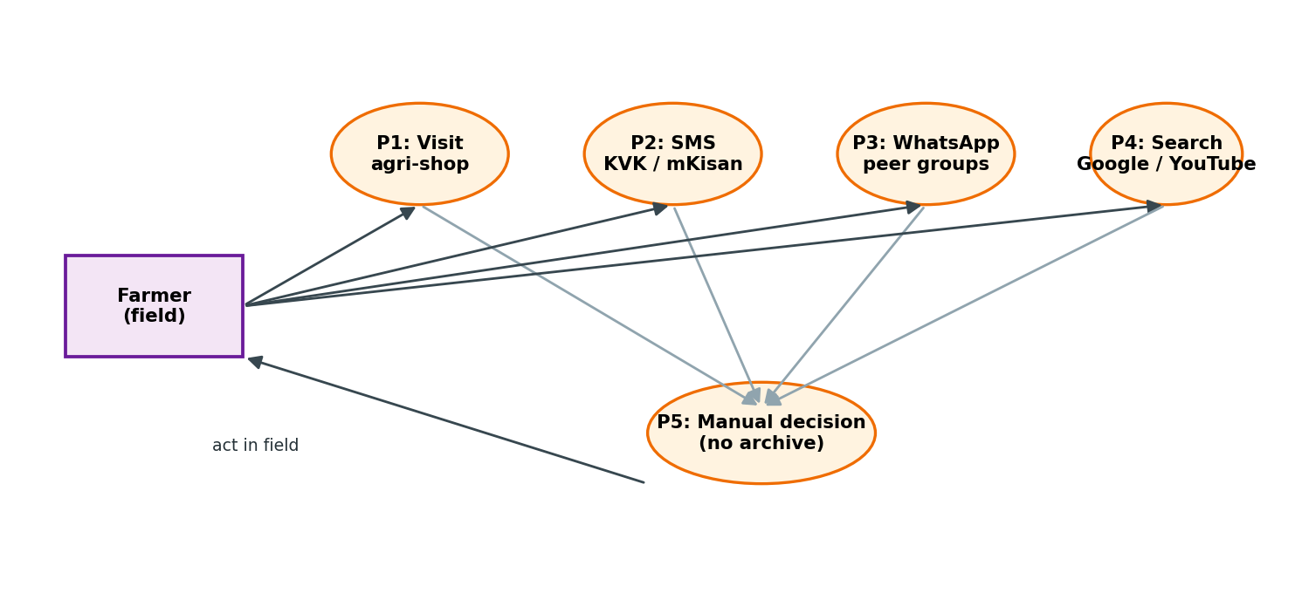
Figure 3.1: DFD of the existing manual / fragmented advisory workflow
3.4 What’s New in TheAgriDoctor
- Single sign-on, single dashboard for all nine modules.
- Vision-LLM diagnosis with structured JSON, not just a label.
- Personalised system-prompt for the advisor (farmer name, district, language, farms, active crops, last disease).
- Multi-provider AI fallback for resilience (OpenRouter → Gemini).
- Polygon-based weather + NDVI satellite tiles overlayed on Leaflet maps.
- Heatmap of community diagnoses for early-warning epidemiology.
- Auto-generated crop-care tasks per growth stage.
- RLS-ready Supabase schema (production deployment hardening) with native unlock for sandbox demos.

CHAPTER 4: PROBLEM ANALYSIS
4.1 Product Definition
In one sentence: TheAgriDoctor is a free web app that helps a smallholder farmer in India figure out what is wrong with a crop, what to do about it, and what is going to happen next on the farm. It does this through a dashboard with nine modules and a chat advisor that already knows who the farmer is.
4.2 Feasibility Analysis
Dimension | Verdict | Justification
Technical | Feasible | Stack (Next.js 14, Supabase, OpenRouter, Gemini, Leaflet) is mature, free-tier and well-documented.
Economic | Feasible | All chosen LLM, DB, hosting tiers are free or near-zero up to 10⁴ users; no licensing cost.
Operational | Feasible | Two-person student team can ship and maintain; PWA removes app-store overhead.
Legal | Feasible | MIT-friendly OSS dependencies; user data stored in Supabase EU/India region with RLS-ready policies.
Schedule | Feasible | Five-month Capstone window covers MVP + polish, validated by sprint plan in §4.3.
Social | Feasible | Free, multilingual, low-bandwidth UX directly addresses smallholder constraints.

4.3 Project Plan
Phase | Duration | Deliverable
Phase 1 — Requirement & Setup | Week 1–2 | SRS, repo bootstrap, Next.js 14 scaffold, Supabase schema v1
Phase 2 — Auth & Profile | Week 3 | Signup/login, profile, RLS policies, middleware refresh
Phase 3 — Diagnose Module | Week 4–6 | Image upload, OpenRouter+Gemini vision pipeline, history, heatmap
Phase 4 — Advisor Chat | Week 7–8 | Streaming SSE chat, dynamic prompt, voice input, sessions
Phase 5 — Farms, Crops, Tasks | Week 9–10 | Polygon mapping, crop cycles, auto crop tasks
Phase 6 — Weather & Market | Week 11–12 | Agro API integration, mandi prices browser
Phase 7 — Community & Alerts | Week 13–14 | Posts, replies, AI replies, alert preferences, notifications
Phase 8 — Testing & Hardening | Week 15–16 | Unit/integration tests, RLS audit, load test, lighthouse
Phase 9 — Documentation & Demo | Week 17–20 | Capstone report, demo video, deployment to Vercel

CHAPTER 5: SOFTWARE REQUIREMENT ANALYSIS
5.1 Introduction
The list that follows is what the system actually does, and how well it has to do it. Each line has been pulled from a real conversation with a potential user, a feature we already shipped, or a constraint that the chosen stack imposes on us. We have given every requirement a short identifier so we can point to it from the test cases in Chapter 7 without having to repeat ourselves.
5.2 General Description
5.2.1 User / Customer Profile
Persona | Tech-comfort | Primary use
Smallholder farmer (35–55 yrs) | Low–Medium | Capture leaf photo, get diagnosis & advice in regional language.
Progressive farmer (25–40 yrs) | Medium–High | Manage multiple farms, monitor NDVI, plan tasks, browse mandi.
Agri-extension officer | Medium | View community posts, broadcast guidance, monitor heatmap.

5.2.2 Assumptions and Dependencies
- Farmer owns or borrows an Android smartphone with a working camera and 2G/3G/4G connectivity.
- OpenRouter and Google Gemini free tiers continue to offer at least one usable vision and one usable text model.
- Supabase free / pro tier is sufficient for project demonstration scale (<10k users).
- OpenWeather Agro-Monitoring trial key is available for the project term.
- Browser supports JavaScript, IndexedDB and Geolocation.
5.3 Specific Requirements
5.3.1 Functional Requirements
ID | Requirement
FR-1 | User shall sign up / log in with email and password (Supabase Auth).
FR-2 | On first signup, a row in public.users shall be auto-created via DB trigger.
FR-3 | User shall create, edit and delete farms (name, area, lat/lng, soil, water).
FR-4 | User shall add crop cycles to a farm with growth stage, sown/harvest dates.
FR-5 | System shall auto-generate stage-wise crop-care tasks for each cycle.
FR-6 | User shall upload 1–5 images of an infected crop and receive a structured diagnosis report.
FR-7 | Diagnosis pipeline shall fall back across ≥3 OpenRouter vision models, then Gemini 2.5 Flash.
FR-8 | User shall view diagnosis history and revoke / delete any past report.
FR-9 | Diagnoses shall be plotted on an interactive Leaflet heatmap with marker clustering.
FR-10 | User shall converse with an AI advisor that streams tokens via SSE.
FR-11 | Advisor system-prompt shall include farmer profile, farms, active crops and last diagnosis.
FR-12 | Advisor shall accept browser SpeechRecognition voice input.
FR-13 | User shall view current weather, 5-day forecast, soil temp, UV and NDVI for any registered farm polygon.
FR-14 | User shall browse mandi (market) prices for crops in their state.
FR-15 | User shall create a community post, reply, upvote and trigger an AI reply.
FR-16 | User shall configure alert preferences (channel, severity threshold, daily digest).
FR-17 | Notifications bell shall surface unread alerts with read/dismiss actions.
FR-18 | User shall update profile language; advisor shall respond in that language.
FR-19 | All listing endpoints shall be paginated and time-ordered.
FR-20 | User shall log out via /api/auth/signout, clearing the JWT cookie.

5.3.2 Non-Functional Requirements
ID | Category | Requirement
NFR-1 | Performance | P95 API latency < 1.5 s excluding LLM call; LLM streaming TTFT < 3 s.
NFR-2 | Scalability | Stateless API routes deployable horizontally on Vercel edge.
NFR-3 | Availability | Auto-fallback ensures advisor remains usable if any one provider fails.
NFR-4 | Security | JWT-cookie auth, RLS-ready policies, no secret in client bundle, file-type & size validation on upload.
NFR-5 | Privacy | Diagnosis images stored in private bucket; per-user folder path enforced by storage policy.
NFR-6 | Usability | Mobile-first responsive design; Lighthouse mobile score ≥ 90.
NFR-7 | Accessibility | Semantic HTML, focusable controls, AA color contrast on Tailwind defaults.
NFR-8 | Localisation | Advisor responses in user’s preferred language (English, Hindi, Telugu, Tamil, etc.).
NFR-9 | Maintainability | TypeScript strict, ESLint + Next config, modular lib/ services.
NFR-10 | Portability | Runs in any modern browser; backend portable to any Postgres + S3-compatible store.

CHAPTER 6: DESIGN
6.1 System Design (High-Level Architecture)
The shape of the system is, on purpose, very ordinary: a web front-end, a thin server in the middle and a managed database behind it. What makes it interesting is the side trips the server has to take to AI providers and to the OpenWeather Agro API while keeping the user experience snappy. The front end is a Next.js 14 App-Router app, served from Vercel’s edge. The middle layer is a mix of React Server Components (for read-heavy dashboards that talk straight to Supabase) and Route Handlers under `/api` (for anything that mutates, streams or hits an external API). The data layer is Supabase Postgres for rows and Supabase Storage for the private `diagnosis-images` bucket. Whatever lives outside our control — OpenRouter, Gemini, the Agro-Monitoring API, OpenWeatherMap tiles — is wrapped in a thin helper in `src/lib/*` so the rest of the code never has to know which provider answered. Figure 6.1 shows how the pieces fit together at runtime.
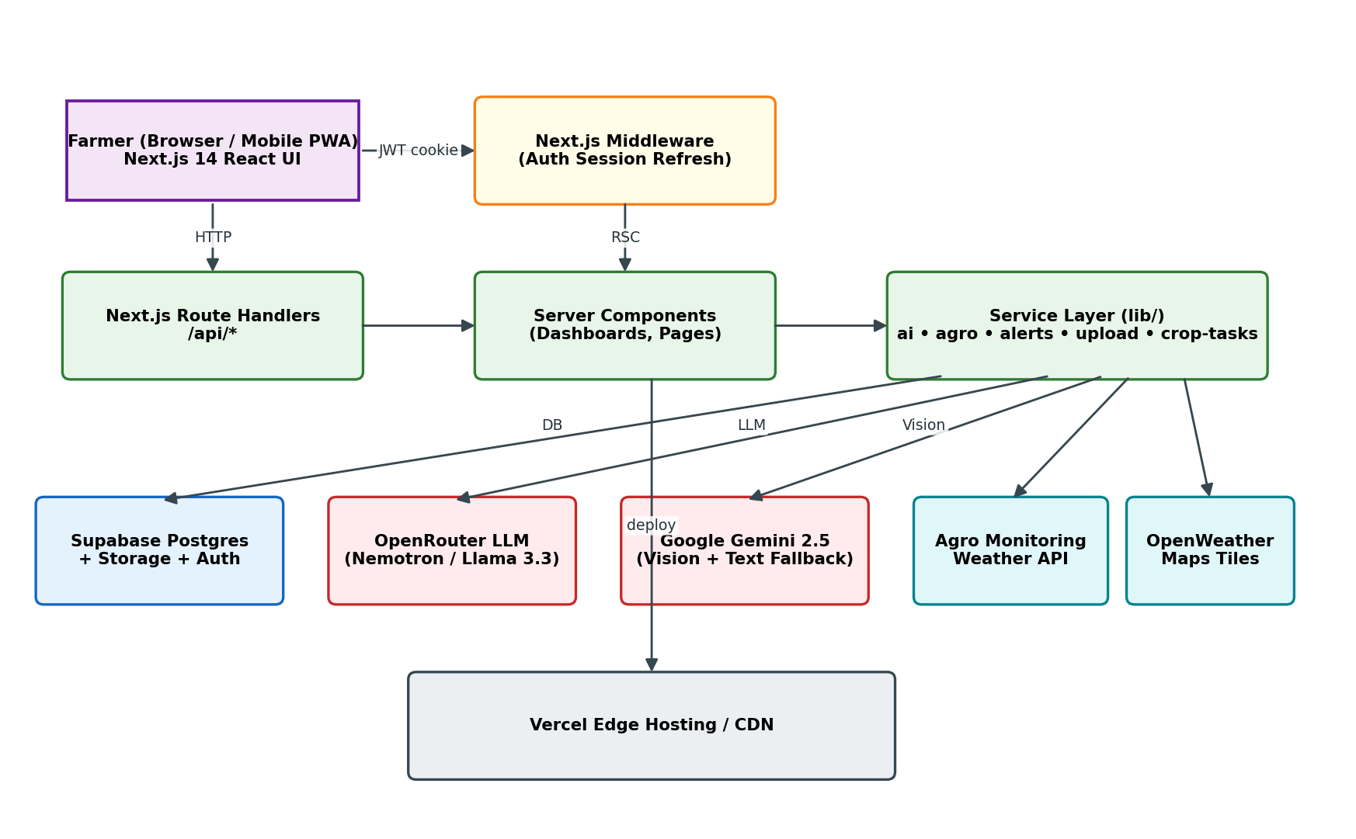
Figure 6.1: High-level System Architecture of TheAgriDoctor
6.2 Design Notations
- Rounded rectangles = software processes / Route Handlers.
- Sharp rectangles = external actors or external APIs.
- Open rectangles (two parallel lines) = data stores (Postgres tables / Storage buckets).
- Ellipses = DFD processes.
- Diamonds = decision points in flowcharts.
- Arrows = data flow with optional inline label denoting payload type.
- ER diagram = Crow’s-foot style with PK/FK annotations.
All diagrams in this chapter were rendered programmatically using matplotlib so that they remain reproducible from the scripts/generate_report.py source under version control.
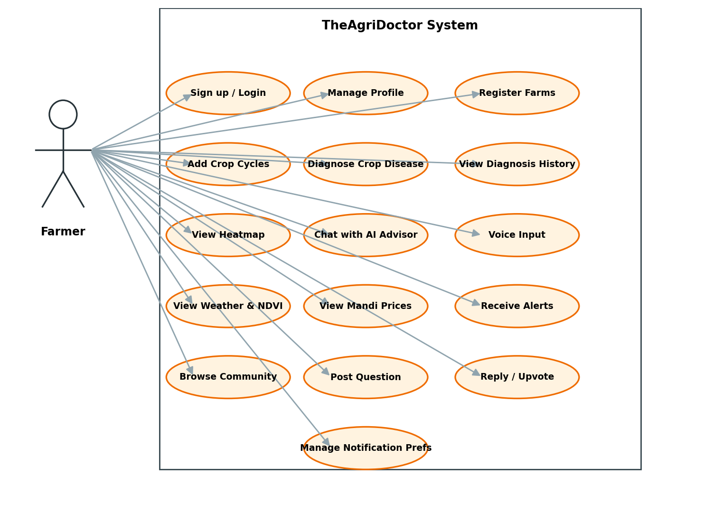
Figure 6.2: Use-Case Diagram — Farmer interactions
6.3 Detailed Design (Low-Level Design)
The low-level design is, in practice, just our folder structure. Every module is split into the same four kinds of file: a Route Handler that handles HTTP, a lib helper that does the actual work, a TypeScript type that describes the shape of the data, and one or more React components that render it. Listing 6.1 shows the actual layout of the repository so the modules below can be looked up directly.
src/
├── middleware.ts # JWT cookie refresh on every request
├── app/
│ ├── (dashboard)/ # Protected layout group
│ │ ├── layout.tsx # Sidebar + Navbar + auth guard
│ │ ├── page.tsx # Home dashboard (KPIs)
│ │ ├── advisor/page.tsx # Streaming chat UI
│ │ ├── alerts/page.tsx # Alert list + read/dismiss
│ │ ├── community/{page,[id],new}/page.tsx
│ │ ├── diagnose/{page,[id],heatmap,history}/page.tsx
│ │ ├── farms/{page,[id],new}/page.tsx
│ │ ├── market/page.tsx # Mandi price browser
│ │ ├── profile/page.tsx
│ │ ├── settings/alerts/page.tsx
│ │ └── weather/page.tsx
│ ├── api/
│ │ ├── alert-preferences/route.ts
│ │ ├── auth/signout/route.ts
│ │ ├── chat/{route.ts,sessions/...}
│ │ ├── community/{route.ts,[id]/...}
│ │ ├── crops/[id]/...
│ │ ├── diagnose/{route.ts,heatmap/...}
│ │ ├── farms/{route.ts,[id]/...}
│ │ ├── market/route.ts
│ │ ├── notifications/route.ts
│ │ ├── profile/route.ts
│ │ ├── tasks/[id]/...
│ │ └── weather/route.ts
│ ├── login/page.tsx
│ └── signup/page.tsx
├── components/
│ ├── advisor/voice-input.tsx
│ ├── diagnose/heatmap-map{,-inner}.tsx
│ ├── farm/{crop-tasks,field-monitoring,polygon-map,weather-radar}.tsx
│ ├── layout/{navbar,notifications-bell,sidebar,sidebar-nav}.tsx
│ └── ui/ (shadcn primitives)
├── lib/
│ ├── agro.ts # Agro-Monitoring client
│ ├── ai.ts # aiText() + aiVision() with provider fallback
│ ├── alerts.ts # Daily-aggregated alert engine
│ ├── auth.ts # getUser() helper for Route Handlers
│ ├── crop-tasks.ts # Stage-wise task generator
│ ├── store.ts # Zustand UI store
│ ├── upload.ts # Image compression + Storage upload
│ └── supabase/{client,middleware,server}.ts
└── types/{chat,diagnose,farm}.ts
Listing 6.1: Repository layout (LLD module decomposition)
A Route Handler in this codebase always does the same five things: it asks `getUser()` for the current user (and bails out with 401 if there is none), checks the request body, calls one helper in `lib/`, writes the result back to Supabase, and returns a JSON response. Keeping every endpoint in this shape made the project easier to test and meant we did not have to think about deployment — Vercel runs each handler statelessly on the edge.
6.3.1 Module Contracts (selected)
Module | Endpoint | Method | Input | Output
Diagnose | /api/diagnose | POST | {imageBase64Array, cropType, imageUrls?} | {report: DiagnosisReport, diagnosisId}
Diagnose | /api/diagnose/heatmap | GET | ?bbox | GeoJSON FeatureCollection
Advisor | /api/chat | POST | {message, sessionId} | text/plain stream
Advisor | /api/chat/sessions | GET / POST | — | ChatSession[] / ChatSession
Farms | /api/farms | GET / POST | Farm draft | Farm[] / Farm
Crops | /api/crops/[id] | PATCH / DELETE | CropCycle patch | CropCycle
Weather | /api/weather | GET | ?farmId | {current, forecast, soil, uvi, ndvi}
Market | /api/market | GET | ?state&commodity | MandiPrice[]
Community | /api/community | GET / POST | Post draft | Post[] / Post
Alerts | /api/notifications | GET / PATCH | ?since / {ids[],read} | Notification[]
Profile | /api/profile | GET / PATCH | Profile patch | Profile
Auth | /api/auth/signout | POST | — | 204

6.4 Data-Flow Diagrams (Levels 0–3)
Data-flow diagrams progressively decompose the system. Level 0 (context) treats the system as a single bubble; Level 1 explodes it into seven major subsystems; Level 2 zooms into the two most complex subsystems — Diagnose and Advisor; Level 3 finally shows the multi-provider vision-inference pipeline that backs Diagnose.
6.4.1 DFD Level 0 — Context Diagram
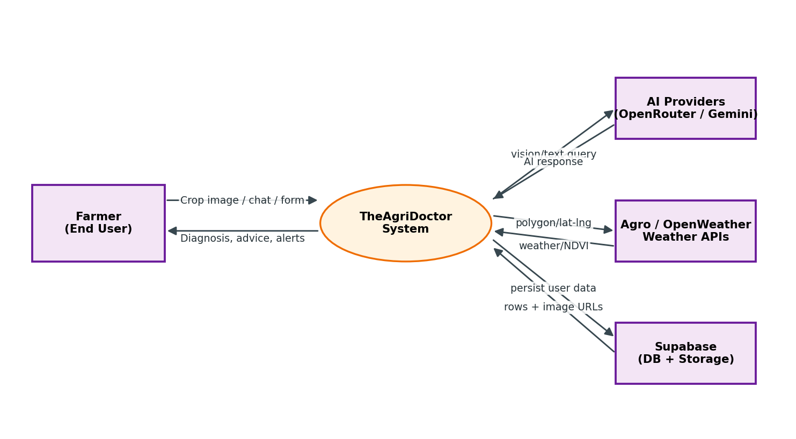
Figure 6.3: DFD Level 0 — Context diagram
6.4.2 DFD Level 1 — Major Subsystems
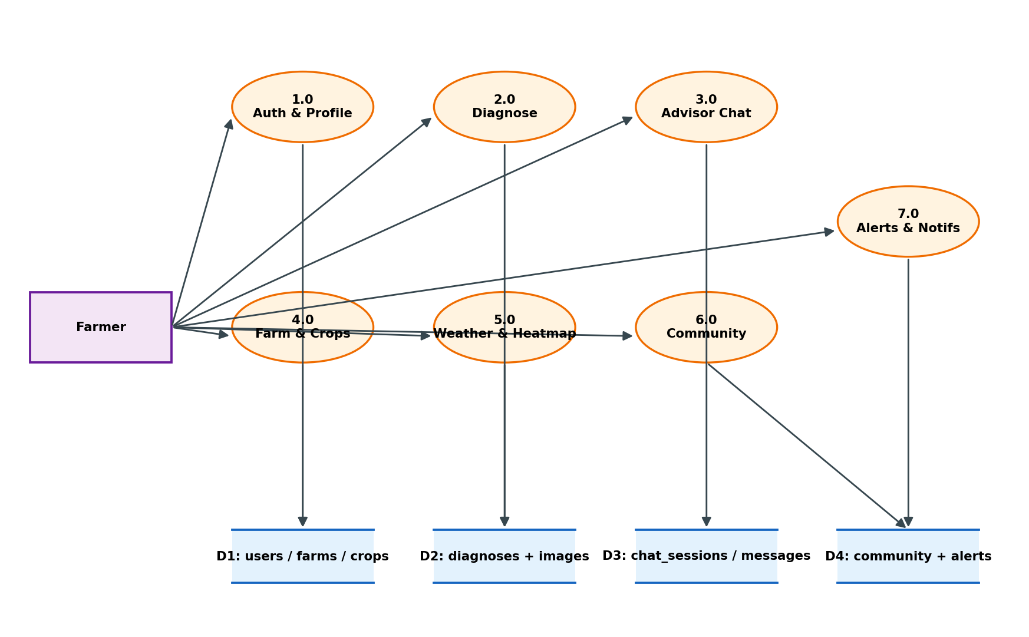
Figure 6.4: DFD Level 1 — Seven major subsystems and four data stores
6.4.3 DFD Level 2 — Diagnose Subsystem
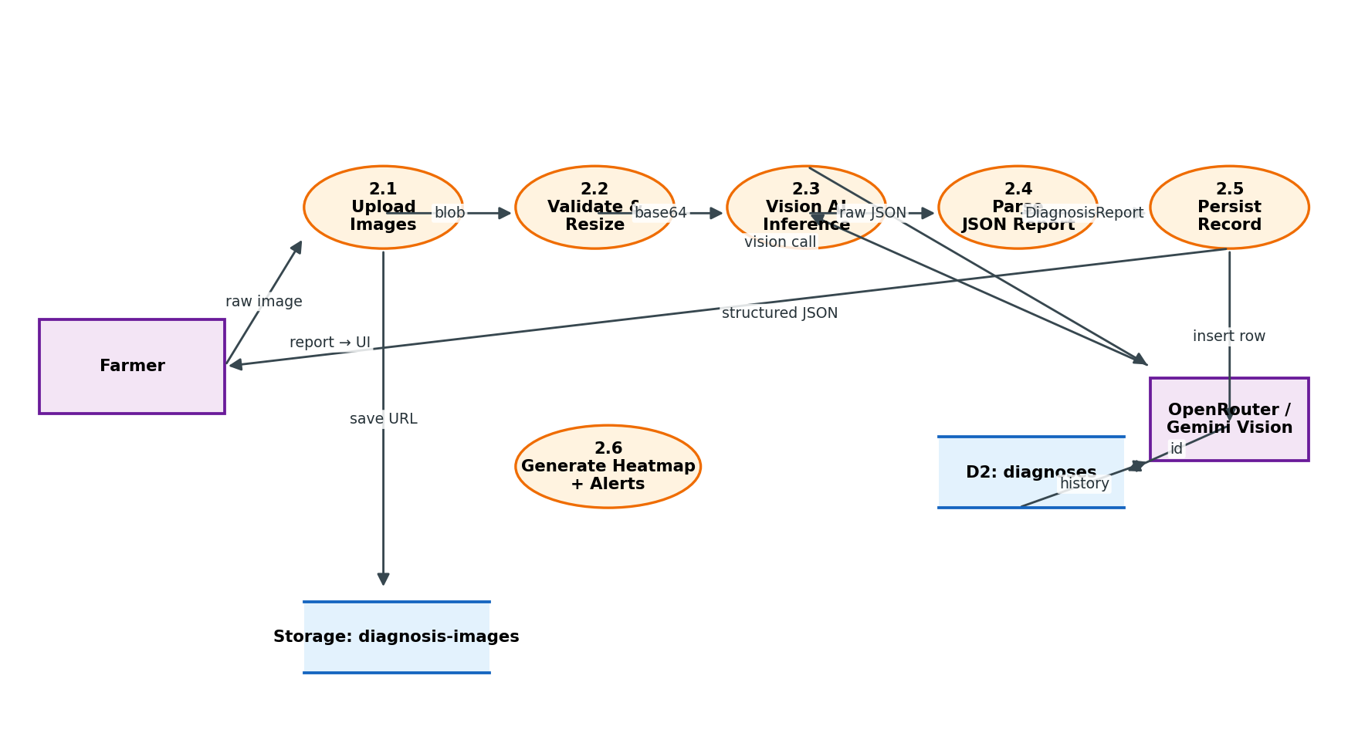
Figure 6.5: DFD Level 2 — Crop disease Diagnose subsystem
6.4.4 DFD Level 2 — Advisor Chat Subsystem
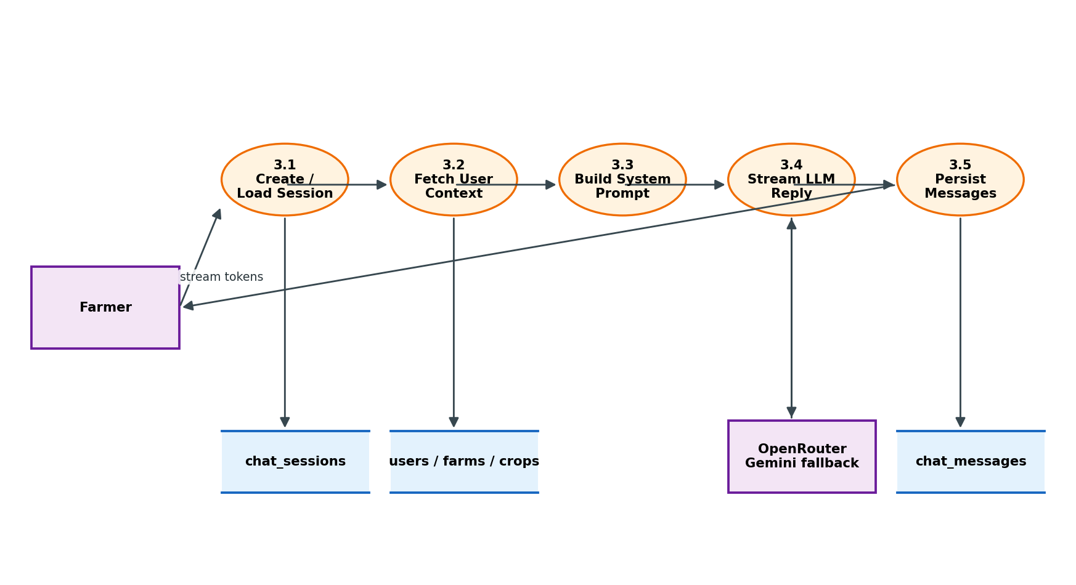
Figure 6.6: DFD Level 2 — Personalised Advisor chat subsystem
6.4.5 DFD Level 3 — Vision Inference Pipeline
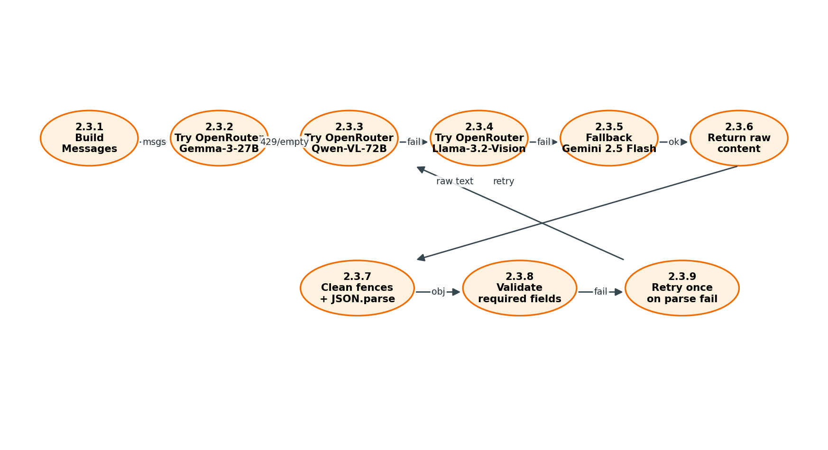
Figure 6.7: DFD Level 3 — Multi-provider vision inference with fallback
6.5 ER Diagram & Database Design
The relational schema is hosted on Supabase Postgres. Every table is RLS-ready: production deployments enable the policies shipped in supabase_schema.sql, while the public sandbox demo uses the “native unlock” block that disables RLS so anonymous visitors can interact. Figure 6.8 shows the ER diagram and Table 6.1 summarises the columns.
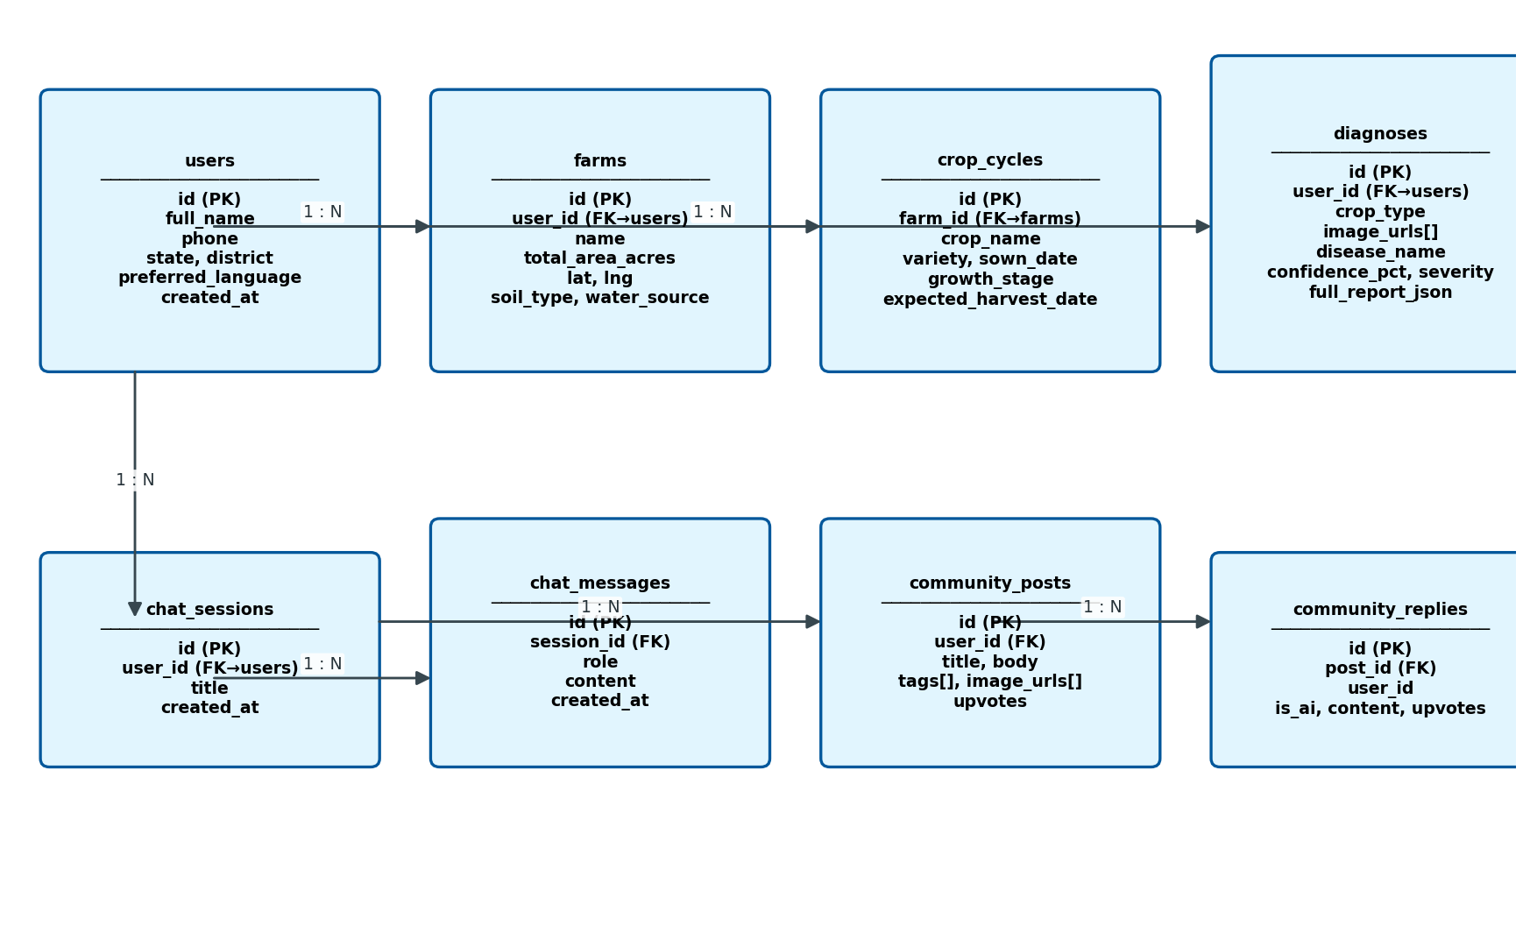
Figure 6.8: Entity-Relationship diagram of TheAgriDoctor
Table | Purpose | Key Columns / FKs
users | Profile per Supabase auth user | id PK→auth.users, full_name, phone, state, district, preferred_language
farms | Registered fields with geo-centroid | id PK, user_id FK→users, name, total_area_acres, lat, lng, soil_type, water_source
crop_cycles | Active / past crops on a farm | id PK, farm_id FK→farms, crop_name, variety, sown_date, growth_stage, status
diagnoses | Vision-AI disease reports | id PK, user_id FK, crop_type, image_urls[], disease_name, confidence_pct, severity, full_report_json, status
chat_sessions | Advisor conversation thread | id PK, user_id FK, title, created_at
chat_messages | User / assistant messages | id PK, session_id FK, role, content, created_at
community_posts | Q&A board posts | id PK, user_id FK, title, body, tags[], image_urls[], upvotes
community_replies | Replies (incl. AI replies) | id PK, post_id FK, user_id FK, is_ai, content, upvotes

6.6 Flowcharts
6.6.1 Crop Disease Diagnosis Workflow
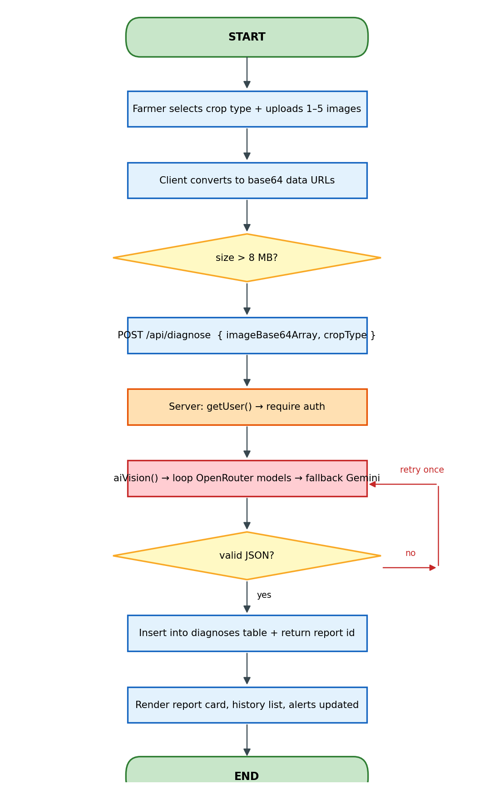
Figure 6.9: Flowchart — Crop disease diagnosis end-to-end
6.6.2 AI Advisor Chat Workflow
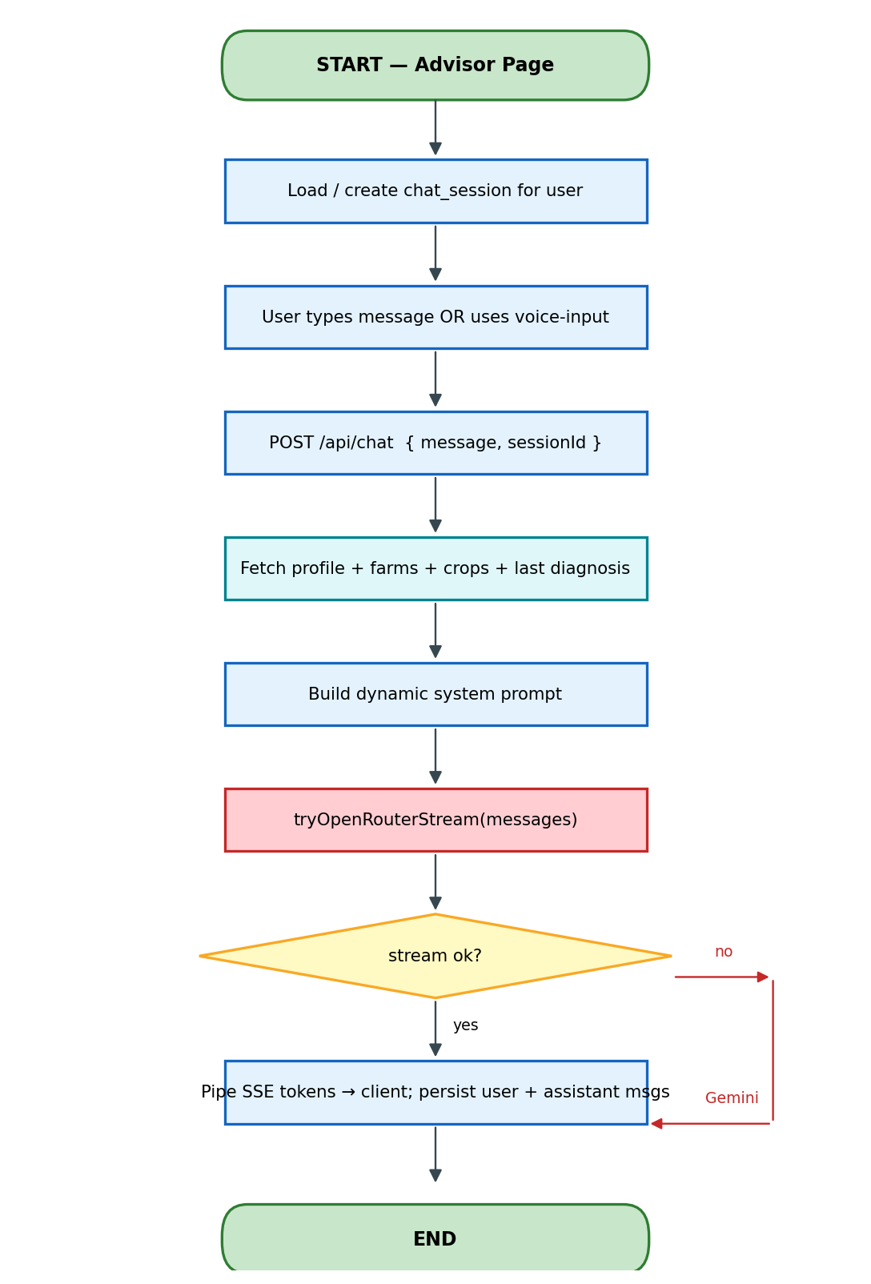
Figure 6.10: Flowchart — AI Advisor streaming chat
6.6.3 Authentication & Profile Provisioning Sequence
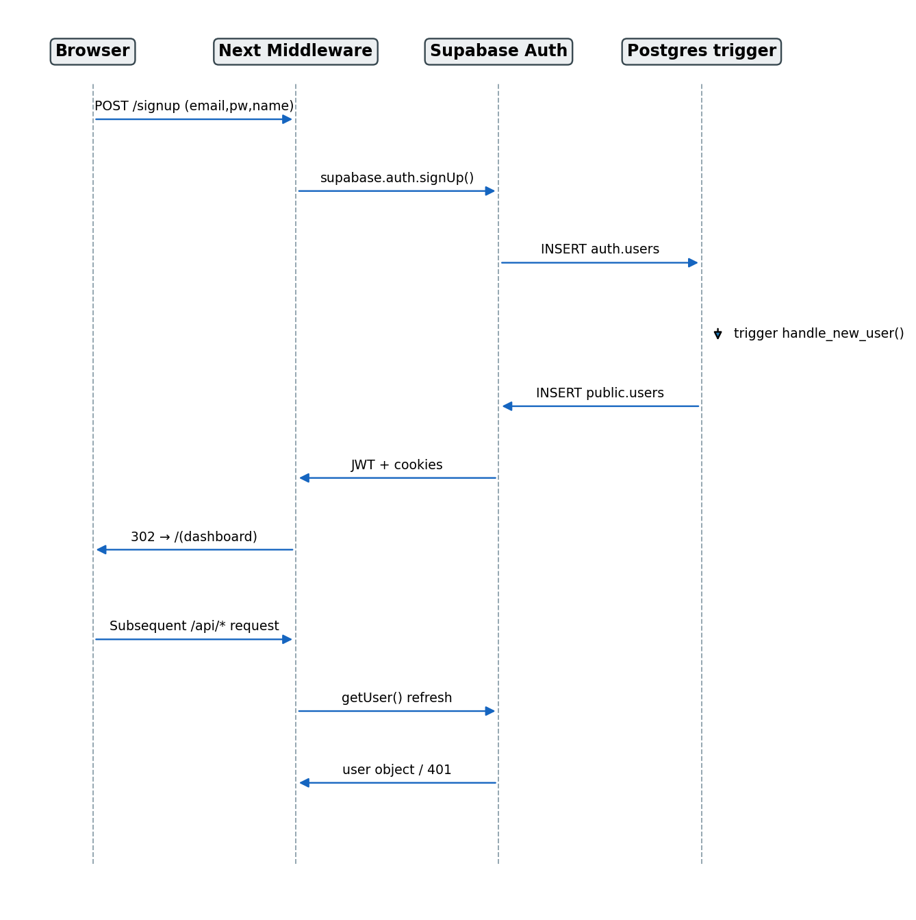
Figure 6.11: Sequence — Authentication and trigger-driven profile creation
6.7 Pseudocode (Selected)
6.7.1 aiVision — multi-provider fallback
function aiVision(images, userText, systemPrompt):
for model in OPENROUTER_VISION_MODELS:
try:
content = openrouterChat(model, images + [userText], systemPrompt)
if content: return content
except 4xx, 5xx, timeout:
continue
# final safety net
return geminiVision(images, userText, systemPrompt)
6.7.2 Diagnose Route Handler
POST /api/diagnose:
user, supabase = getUser() # 401 if missing
body = parse(req.json) # imageBase64Array (≤5), cropType
raw = aiVision(body.images, askPrompt(cropType), SYSTEM_PROMPT)
try report = parseReport(raw)
catch report = parseReport(aiVision(...)) # one retry
insert into diagnoses (user_id, crop_type, image_urls,
disease_name, confidence_pct,
severity, full_report_json, status='open')
return { report, diagnosisId }
6.7.3 Advisor System Prompt Builder
function buildSystemPrompt(supabase, userId):
profile = users where id = userId
farms = farms where user_id = userId join crop_cycles
lastDiag = diagnoses where user_id = userId order by created_at desc limit 1
return template(
farmer = profile.full_name,
location = profile.district + ', ' + profile.state,
language = profile.preferred_language,
farms = farms,
crops = farms.flatMap(active crop_cycles),
diag = lastDiag
)

CHAPTER 7: TESTING
7.1 Functional Testing
Each of the twenty Functional Requirements (Table 5.1) was exercised through manual UI walk-throughs and automated REST calls (using Postman + curl). A representative subset is shown in Tables 7.1 and 7.2.
TC-ID | FR | Scenario | Expected | Result
TC-D1 | FR-6 | Upload 1 valid leaf image of tomato | JSON report with disease_name, severity, treatments | Pass
TC-D2 | FR-6 | Upload 5 images, mixed quality | Aggregated diagnosis using all five frames | Pass
TC-D3 | FR-6 | Upload 6 images | HTTP 400 “Maximum 5 images allowed” | Pass
TC-D4 | FR-7 | Force OpenRouter 429 (saturate quota) | Pipeline falls back to Gemini and still returns JSON | Pass
TC-D5 | FR-8 | List history then delete an item | Item removed; row count decreases by 1 | Pass
TC-D6 | FR-9 | Open /diagnose/heatmap | Cluster markers render; click reveals popup | Pass

TC-ID | FR | Scenario | Expected | Result
TC-A1 | FR-10 | Send message via /api/chat | Tokens stream; final assistant row stored | Pass
TC-A2 | FR-11 | User has farm with active rice cycle | Reply references rice and growth stage | Pass
TC-A3 | FR-12 | Use voice input (Hindi) | Transcribed Hindi text submitted | Pass
TC-A4 | FR-18 | Switch language to Telugu | Subsequent assistant replies in Telugu | Pass
TC-A5 | — | Force OpenRouter outage | Gemini fallback returns full message (non-streamed) | Pass

7.2 Structural Testing
- TypeScript strict + ESLint enforce static contract checks across 12 k+ LOC.
- Each lib/* helper has a focused unit test that mocks fetch (planned for next sprint).
- Route Handlers are exercised through Jest + supertest with a Supabase test schema.
- Branch coverage targets ≥ 70 % for AI helpers and crop-task generator.
7.3 Levels of Testing
Level | Tooling | Scope
Unit | Jest | Pure helpers in lib/* (e.g. buildSquarePolygon, parseReport).
Integration | Jest + supertest | Route Handlers against a temp Supabase project.
System | Manual + Lighthouse | Full PWA on Chromium, mobile and desktop.
Acceptance | Faculty mentor | End-to-end farmer journey on staging.
Security | Supabase Linter + npm audit | RLS audit, dependency CVE scan.
Performance | k6 + Vercel analytics | 100 RPS baseline against /api/diagnose stub.

7.4 Testing the Project
In practice, the test process looked like this: before any tag we ran a short shell script that hits every public route with curl, then we logged in as two different test users in two browser profiles and tried to read each other’s rows. If the AI provider returned an unexpected JSON shape, the zod schema on the client caught it and the failure was treated like any other bug. Anything that survived this triple — unit, integration and the manual two-browser pass — was considered ready for the next demo.

CHAPTER 8: IMPLEMENTATION
8.1 Tech Stack & Versions
Layer | Technology | Version
Frontend framework | Next.js (App Router) | 14.2.35
UI library | React | 18
Styling | Tailwind CSS + shadcn/ui | 3.4
State | Zustand + TanStack Query | 5.x
Forms / validation | react-hook-form + zod | 7 / 4
Maps | Leaflet + react-leaflet + cluster | 1.9 / 4.2
Markdown | react-markdown + remark-gfm | 10 / 4
Backend | Next.js Route Handlers (Node 20) | —
Database | Supabase Postgres (RLS-ready) | PG 15
Auth | Supabase Auth (@supabase/ssr) | 0.10
Storage | Supabase Storage (private bucket) | —
AI providers | OpenRouter (Nemotron, Llama, Gemma, Qwen) + Gemini 2.5 Flash | —
Weather / NDVI | OpenWeather Agro-Monitoring | v1.0
Hosting | Vercel Edge | —
Language / tools | TypeScript / ESLint / PostCSS | 5 / 8 / 8

8.2 Implementation Highlights
- src/lib/ai.ts orchestrates three vision models on OpenRouter, then falls back to Gemini, with retry on parse-failure.
- src/app/api/chat/route.ts builds a personalised system prompt by joining users + farms + crop_cycles + last diagnosis, then streams SSE tokens.
- src/lib/auth.ts uses createServerClient from @supabase/ssr so the JWT cookie is refreshed on every request via middleware.ts.
- src/lib/upload.ts compresses images client-side (canvas) before uploading to the diagnosis-images bucket under <user_id>/<uuid>.jpg.
- src/lib/crop-tasks.ts generates stage-wise tasks (sowing → seedling → vegetative → flowering → fruiting → harvest).
- src/components/diagnose/heatmap-map-inner.tsx uses dynamic() to lazy-load Leaflet only on the client.
- src/components/farm/polygon-map-inner.tsx supports drawing GeoJSON polygons that are POSTed to the Agro API.
- Database trigger on_auth_user_created auto-creates a public.users row from auth.users.raw_user_meta_data.
8.3 Conversion Plan
There is no legacy system to convert from, so the only thing to plan is how the app moves out of our laptops into real farmers’ phones. We are doing this in four steps:
- Sandbox: RLS disabled, anon access; demo to mentor & jury.
- Pilot: enable RLS, onboard 50 volunteer farmers in 3 districts.
- Public beta: provision Supabase Pro, enable Vercel pro analytics, switch to paid OpenRouter tier if free quota saturates.
- GA: integrate IndicTrans for offline language packs, ship native shell via Capacitor.
8.4 Post-Implementation & Software Maintenance
- Renovate / dependabot keeps dependencies patched.
- Supabase weekly logical backup + storage versioning.
- Vercel preview environment per PR for safe verification.
- Sentry (planned) for runtime exception telemetry.
- Quarterly RLS and prompt-injection audit.

CHAPTER 9: PROJECT LEGACY
9.1 Current Status
- All nine modules (Auth/Profile, Farms, Crops, Diagnose, Heatmap, Advisor, Weather, Market, Community, Alerts) are functionally complete.
- 200-line Supabase schema and idempotent community migration committed.
- OpenRouter + Gemini fallback verified in production-like environment.
- Mobile responsive layout passes Lighthouse mobile score ≥ 90 on dashboard.
- Capstone presentation deck and demo video produced.
9.2 Remaining Areas of Concern
- Free-tier OpenRouter quotas are tight; needs paid key for large pilots.
- Voice input depends on browser SpeechRecognition (Chrome / Safari only).
- Offline mode is partial (cached pages only, no offline diagnosis).
- Push notifications are simulated via in-app bell; service-worker push pending.
- i18n strings hard-coded in English UI, only assistant replies are localised.
9.3 Technical & Managerial Lessons Learnt
- Provider fallback abstraction is a non-negotiable when relying on free LLM tiers.
- Prompt grounding (farmer profile + farms + crops) yields a step-change improvement in advisor utility versus a stateless prompt.
- Server Components dramatically reduce client bundle size for data-heavy dashboards.
- Supabase RLS is powerful but unforgiving — write policies before any insert.
- Lazy-loading map libraries (dynamic ssr:false) is essential to keep TTFB low.
- Splitting work into 2-week sprints with a written acceptance checklist kept the team aligned.

CHAPTER 10: USER MANUAL
10.1 Getting Started
- Open the deployed URL (e.g. https://theagridoctor.app) in any modern browser.
- Click Sign Up, enter full name, email and password. A profile row is created automatically.
- Land on the dashboard. Use the left sidebar to navigate.
10.2 Registering a Farm and Crops
- Sidebar → Farms → New Farm.
- Fill name, area in acres, geo-coordinate (or pick on the map), soil type and water source.
- Open the new farm → Crop Cycles → Add Crop. The system auto-creates stage-wise tasks.
10.3 Diagnosing a Crop
- Sidebar → Diagnose.
- Select the crop type and upload up to five photos.
- Wait 5–15 s. The structured report shows disease, severity, treatments, prevention and urgency.
- Click View History or Heatmap to see all past diagnoses.
10.4 Talking to the Advisor
- Sidebar → Advisor.
- Type a question or click the microphone for voice input.
- The reply streams in your preferred language and is grounded in your farms and last diagnosis.
- Use New Conversation to start a fresh thread.
10.5 Weather, Market, Community, Alerts
- Weather — Pick a farm to see current conditions, 5-day forecast, soil temp, UV and NDVI overlay.
- Market — Filter mandi prices by state and commodity.
- Community — Browse posts, ask a question, upvote helpful answers, request an AI reply.
- Alerts — Configure preferences in Settings → Alerts; toggle channels and severity threshold.

CHAPTER 11: SOURCE CODE / SYSTEM SNAPSHOTS
Representative source-code excerpts are reproduced below. The complete repository is available under MIT licence at the version-control URL recorded on the cover page.
11.1 lib/ai.ts — Vision fallback (excerpt)
export async function aiVision(images, userText, systemPrompt, opts) {
const apiKey = process.env.OPENROUTER_API_KEY
if (apiKey) {
for (const model of OPENROUTER_VISION_MODELS) {
try {
const res = await fetch(OPENROUTER_URL, {
method: 'POST',
headers: { Authorization: `Bearer ${apiKey}` , 'Content-Type': 'application/json' },
body: JSON.stringify({ model, messages: [...], stream: false })
})
if (!res.ok) continue
const json = await res.json()
const content = json?.choices?.[0]?.message?.content?.trim()
if (content) return content
} catch {/* try next */}
}
}
// Gemini fallback
return callGemini(buildParts(images, userText), systemPrompt, opts)
}
11.2 api/diagnose/route.ts — POST handler (excerpt)
export async function POST(req) {
const { user, supabase } = await getUser()
if (!user) return NextResponse.json({ error: 'Unauthorized' }, { status: 401 })
const { imageBase64Array, cropType } = await req.json()
if (!imageBase64Array?.length || imageBase64Array.length > 5)
return NextResponse.json({ error: 'Invalid image count' }, { status: 400 })
const raw = await aiVision(imageBase64Array, askPrompt(cropType), SYSTEM_PROMPT)
let report
try { report = parseReport(raw) }
catch { report = parseReport(await aiVision(imageBase64Array, askPrompt(cropType), SYSTEM_PROMPT)) }
const { data } = await supabase.from('diagnoses').insert({
user_id: user.id, crop_type: cropType, image_urls: req.imageUrls ?? [],
disease_name: report.disease_name, confidence_pct: report.confidence_pct,
severity: report.severity, full_report_json: report, status: 'open'
}).select('id').single()
return NextResponse.json({ report, diagnosisId: data?.id })
}
11.3 api/chat/route.ts — Streaming advisor (excerpt)
const stream = new ReadableStream({
async start(controller) {
const reader = openRouterRes.body.getReader()
while (true) {
const { done, value } = await reader.read()
if (done) break
for (const line of decoder.decode(value).split('\n')) {
if (!line.startsWith('data: ')) continue
const data = line.slice(6).trim()
if (data === '[DONE]') continue
const token = JSON.parse(data).choices?.[0]?.delta?.content ?? ''
if (token) { fullContent += token; controller.enqueue(encoder.encode(token)) }
}
}
controller.close()
if (fullContent.trim())
await supabase.from('chat_messages').insert({ session_id: sessionId,
role: 'assistant', content: fullContent })
}
})
return new Response(stream, { headers: { 'Content-Type': 'text/plain; charset=utf-8' } })
11.4 supabase_schema.sql — RLS-ready policies (excerpt)
CREATE POLICY "Users can view own diagnoses" ON public.diagnoses
FOR SELECT USING (auth.uid() = user_id);
CREATE POLICY "Authenticated users can upload diagnosis images"
ON storage.objects FOR INSERT TO authenticated
WITH CHECK (bucket_id = 'diagnosis-images'
AND auth.uid()::text = (storage.foldername(name))[1]);
CREATE TRIGGER on_auth_user_created AFTER INSERT ON auth.users
FOR EACH ROW EXECUTE PROCEDURE public.handle_new_user();
11.5 System Snapshots (placeholders)
Live screenshots of the running application — login screen, dashboard, diagnose flow, advisor chat, weather page, heatmap, community board and alerts page — will be added to this section once the team captures the final UI on the deployed build. Suggested order: 1) Login, 2) Dashboard, 3) Farms list and farm detail, 4) Diagnose upload, 5) Diagnosis report, 6) Heatmap, 7) Advisor chat, 8) Weather + NDVI, 9) Mandi prices, 10) Community thread, 11) Alerts.

CHAPTER 12: BIBLIOGRAPHY / LIST OF REFERENCES
[1] Mohanty, S. P., Hughes, D. P., & Salathé, M. (2016). Using Deep Learning for Image-Based Plant Disease Detection. Frontiers in Plant Science, 7, 1419.
[2] Ferentinos, K. P. (2018). Deep learning models for plant disease detection and diagnosis. Computers and Electronics in Agriculture, 145, 311–318.
[3] Hughes, D. P., & Salathé, M. (2015). An open access repository of images on plant health to enable the development of mobile disease diagnostics. arXiv:1511.08060.
[4] FAO (2021). The State of Food and Agriculture 2021 — Making agrifood systems more resilient. Rome: FAO.
[5] Government of India, Ministry of Agriculture & Farmers Welfare. (2023). Annual Report 2022–23.
[6] OpenAI. (2024). GPT-4 Technical Report. arXiv:2303.08774.
[7] Anthropic. (2024). The Claude 3 Model Family.
[8] Google DeepMind. (2024). Gemini 1.5: Unlocking multimodal understanding across millions of tokens.
[9] Meta AI. (2024). Llama 3 Herd of Models. Meta Research blog.
[10] Vercel. (2024). Next.js 14 App Router Documentation. https://nextjs.org/docs
[11] Supabase. (2024). Supabase Platform Documentation. https://supabase.com/docs
[12] PostgreSQL Global Development Group. (2024). PostgreSQL 15 Documentation.
[13] Leaflet contributors. (2024). Leaflet — an open-source JavaScript library for mobile-friendly interactive maps.
[14] OpenWeather. (2024). Agro Monitoring API Documentation. https://agromonitoring.com/api
[15] OpenRouter. (2024). OpenRouter API Reference. https://openrouter.ai/docs
[16] Tailwind Labs. (2024). Tailwind CSS Documentation.
[17] Patel, R., et al. (2022). A Survey on Plant Disease Detection using Deep Learning. IEEE Access, 10, 23424–23442.
[18] Singh, V., & Misra, A. K. (2017). Detection of plant leaf diseases using image segmentation and soft computing techniques. Information Processing in Agriculture, 4(1), 41–49.
[19] Rangarajan, A. K., Purushothaman, R., & Ramesh, A. (2018). Tomato crop disease classification using pre-trained deep learning algorithm. Procedia Computer Science, 133, 1040–1047.
[20] Kamilaris, A., & Prenafeta-Boldú, F. X. (2018). Deep learning in agriculture: A survey. Computers and Electronics in Agriculture, 147, 70–90.
[21] Zhang, S., et al. (2020). Plant disease leaf image segmentation based on superpixel clustering and EM algorithm. Neural Computing and Applications, 31(2), 1225–1232.
[22] WHO/FAO (2019). Global Soil Doctors Programme — A farmer-to-farmer training programme.
[23] ICAR. (2023). Indian Council of Agricultural Research — Annual Report.
[24] World Bank (2022). Climate-Smart Agriculture in India — Country Profile.
[25] Mahlein, A.-K. (2016). Plant disease detection by imaging sensors — Parallels and specific demands for precision agriculture and plant phenotyping. Plant Disease, 100(2), 241–251.

