

Event Finder App

**Event Search iOS App**

# Objectives

* + Become familiar with Swift language, Xcode and iOS App development.
  + Practice the Model-View-Controller design pattern.
  + Build a good-looking IOS app.
  + Learn to use Google Maps APIs and iOS SDK
  + Manage and use third-party libraries by CocoaPods

# High Level Design

This is a mobile app version of Previous Project (NodeJS, Angular, TicketMaster API). In this I’ve developed an iOS Mobile application, which allows users to search for event information, ticketing information, save events as favorites, and post on Twitter.

The main scene of this app is like that in Figure 1. All the implementation details and requirements will be explained in the following sections.

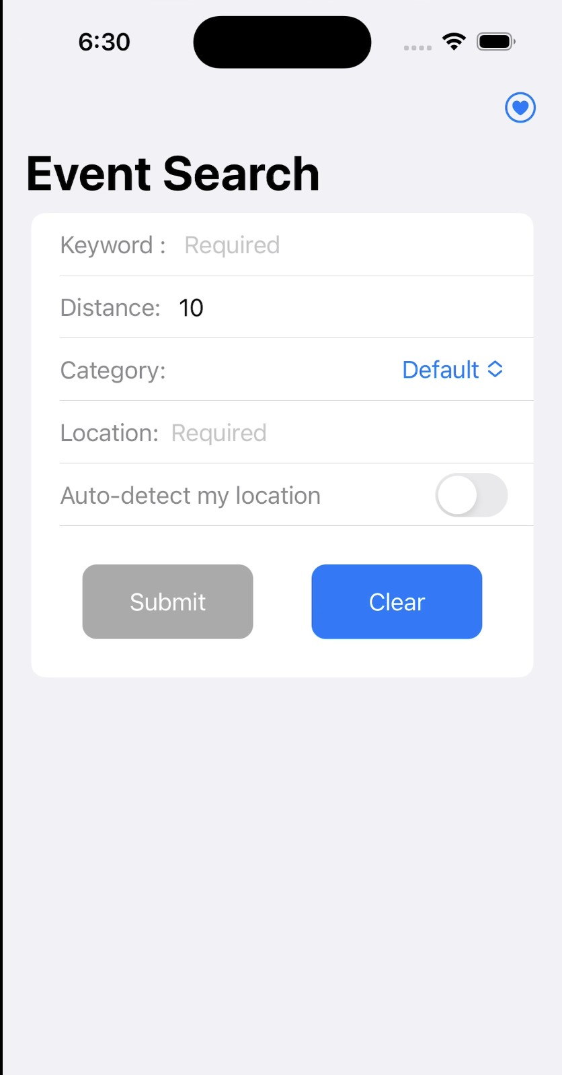

### Figure 1. The Event Search App