K L (DEEMED TO BE) UNIVERSITY
DEPARTMENT OF CS&IT

PROJECT REPORT
ON
LOAN APPROVAL PREDICTION USING ENSEMBLE LEARNING
(RANDOM FOREST, XGBOOST AND LIGHTGBM)
Project report submitted in partial fulfilment of the requirements for the course
MACHINE LEARNING
BACHELOR OF TECHNOLOGY
Academic Year: 2026–2027

Submitted by
S. Koushik (2520090113)
Ch. Ganesh (2520090112)

Under the esteemed guidance of
Dr. Y. Lakshmi Prasanna
Assistant Professor, Department of CS&IT

Bachupally Campus, Hyderabad – 500090, Telangana, India

K L (DEEMED TO BE) UNIVERSITY
DEPARTMENT OF CS&IT
DECLARATION
We hereby declare that the project report entitled “Loan Approval Prediction Using Ensemble Learning (Random Forest, XGBoost and LightGBM)” is submitted in partial fulfilment of the requirements for the Machine Learning course in the Bachelor of Technology programme at K L (Deemed to be) University.
The report is based on the project abstract, dataset, and the two supplied experiment notebooks covering data understanding and exploratory data analysis. Any model training, hyperparameter tuning, and comparative performance evaluation described as proposed work has not been represented as completed experimental work.

S. Koushik – 2520090113
Ch. Ganesh – 2520090112

K L (DEEMED TO BE) UNIVERSITY
DEPARTMENT OF CS&IT
CERTIFICATE
This is to certify that the project report entitled “Loan Approval Prediction Using Ensemble Learning (Random Forest, XGBoost and LightGBM)” has been prepared by S. Koushik (2520090113) and Ch. Ganesh (2520090112) in partial fulfilment of the requirements for the Machine Learning course in the Bachelor of Technology programme during the academic year 2026–2027.

Signature of the Guide

Signature of the Head of Department | Signature of the Course Instructor

ACKNOWLEDGEMENT
We express our sincere gratitude to our project guide, Dr. Y. Lakshmi Prasanna, Assistant Professor, Department of CS&IT, for her guidance and support in preparing this Machine Learning project.
We thank the Department of CS&IT, K L (Deemed to be) University, for providing the academic environment and resources required to study machine learning methods and data analysis.
We also acknowledge the support of our faculty, classmates, friends, and families throughout the preparation of the project. The supplied dataset and experiment notebooks formed the basis of the data understanding and exploratory analysis documented in this report.
S. Koushik – 2520090113
Ch. Ganesh – 2520090112

TABLE OF CONTENTS
S. No. | Contents | Page
1 | 1. Abstract | 6
2 | 2. Introduction | 7
3 | 3. Literature Survey | 8
4 | 4. Problem Statement and Objectives | 9
5 | 5. Hardware and Software Requirements | 10
6 | 6. Methodology and Implementation | 11
7 | 7. Results and Discussion | 14
8 | 8. Conclusion and Future Scope | 18
9 | 9. References | 19
Note: Page numbers are indicative and may shift slightly depending on the word processor and printer settings.

1. ABSTRACT
Loan approval is an important decision in banking and financial services because it affects both customer access to credit and the financial risk of lending institutions. Manual assessment can take time and may produce inconsistent decisions when applications contain many different attributes. This project proposes a machine-learning-based Loan Approval Prediction System using three ensemble learning algorithms: Random Forest (RF), Extreme Gradient Boosting (XGBoost), and Light Gradient Boosting Machine (LightGBM).
The supplied dataset contains 20,000 loan applications and 39 columns, including applicant demographics, employment information, income, existing liabilities, savings, credit history, loan details, collateral information, and the target variable Loan_Status. The provided experiments focus on data understanding and exploratory data analysis (EDA): inspecting data types, missing values, duplicate rows, target-class distribution, numerical distributions, category-wise approval rates, correlations, and possible outliers.
The proposed complete pipeline includes data cleaning, missing-value treatment, categorical encoding, feature preparation, train-test splitting, model training, hyperparameter tuning, and evaluation using accuracy, precision, recall, F1-score, and ROC-AUC. The current supplied notebooks do not contain completed training or comparative model metrics; therefore, no model accuracy or winning algorithm is claimed in this report. The project establishes the data-analysis foundation for a later fair and reproducible model comparison.
Team: S. Koushik (2520090113) and Ch. Ganesh (2520090112).

2. INTRODUCTION

2.1 Background
Loan applications must be assessed using several pieces of information, such as income, job stability, outstanding loans, repayment history, credit score, loan amount, tenure, and collateral. A decision process based only on manual review may be slow when the number of applications is large. Machine learning can help identify patterns in historical application data and provide a consistent prediction for review by a lending professional.

2.2 Project Overview
The project studies a binary classification task. The input consists of applicant and loan-related attributes, while Loan_Status is the target label with two classes: Approved and Rejected. Random Forest, XGBoost, and LightGBM are selected as candidate ensemble models because they can learn non-linear relationships and interactions among structured tabular features.

2.3 Motivation
- Reduce repetitive manual screening and support faster initial assessment.
- Use a consistent data-driven process to compare applications.
- Compare multiple ensemble methods rather than assuming one model is best.
- Use evaluation measures beyond accuracy to understand false approvals and false rejections.
- Keep the final decision subject to human review, fairness checks, and applicable lending rules.

2.4 Scope
The supplied files support dataset inspection and EDA. The full model-development stage is described as the intended methodology. Model deployment, live bank integration, and real-world lending decisions are outside the demonstrated scope of the supplied experiments.

3. LITERATURE SURVEY

3.1 Random Forest
Random Forest is a bagging-based ensemble that trains multiple decision trees on bootstrapped samples and combines their predictions. For classification, aggregation across trees can improve stability compared with relying on a single tree. It can model interactions among numeric and categorical features after appropriate preprocessing.

3.2 XGBoost
XGBoost is a gradient-boosting framework that builds trees sequentially, with each new tree improving the objective by addressing errors from the current ensemble. Regularization and training controls can help manage model complexity. It is widely used for structured/tabular prediction tasks.

3.3 LightGBM
LightGBM is a gradient-boosting framework designed for efficient tree-based learning. It uses histogram-based learning and growth strategies intended to improve training speed and memory use on suitable datasets. Its performance depends on parameter choices and the nature of the data.

3.4 Why Compare These Models?
The algorithms represent complementary ensemble approaches: Random Forest aggregates independently trained trees, while XGBoost and LightGBM build boosted tree ensembles. A fair comparison on the same split and with consistent preprocessing can show which model best balances predictive quality, generalisation, and computational cost for this dataset. The supplied notebooks do not yet report such a comparison.

3.5 EDA as a Prerequisite
Exploratory analysis is needed before fitting models. Missing values, different feature scales, imbalanced target classes, redundant identifiers, and unusual numerical values can affect model development and interpretation. The experiment notebooks examine these aspects before model training.

4. PROBLEM STATEMENT AND OBJECTIVES

4.1 Problem Statement
To develop a machine-learning system that predicts whether a loan application is likely to be approved or rejected using applicant, financial, employment, credit, and loan-related attributes, and to compare Random Forest, XGBoost, and LightGBM using suitable classification metrics.

4.2 Problem Description
The dataset contains mixed numerical and categorical attributes and missing values in several columns. Before learning patterns, the data must be checked and prepared. The target classes are not equally represented, so evaluation should not rely on accuracy alone. The application identifier must also be excluded from predictive inputs because it is an identifier rather than an applicant characteristic.

4.3 Objectives
- Inspect the structure, columns, data types, descriptive statistics, and quality of the supplied dataset.
- Measure missing values and duplicate records and identify columns that require preprocessing.
- Explore Loan_Status class distribution and study patterns in numerical and categorical attributes.
- Prepare a leakage-aware preprocessing pipeline for numerical and categorical features.
- Train Random Forest, XGBoost, and LightGBM on a consistent training split.
- Compare models using accuracy, precision, recall, F1-score, and ROC-AUC.
- Select a model only after validation and document limitations and future improvements.

4.4 Expected Outcome
The expected outcome is a reproducible comparison workflow and a prediction pipeline that can support initial loan application assessment. Actual predictive performance must be established by running the model-training and evaluation stage; it cannot be inferred from EDA alone.

5. HARDWARE AND SOFTWARE REQUIREMENTS

5.1 Hardware Requirements
Component | Recommended requirement
Processor | Modern dual-core processor or better
RAM | 8 GB recommended for comfortable data analysis; 4 GB may be sufficient for basic inspection
Storage | At least 1 GB free space for dataset, notebooks, libraries, and outputs
Display | Standard monitor or laptop display
Internet | Required to install packages or use Google Colab; not required for local runs once dependencies are installed

5.2 Software Requirements
Software / Library | Purpose
Python 3.10 or later | Main programming language
Jupyter Notebook / Google Colab / VS Code | Notebook execution and development
Pandas | Data loading, inspection, and tabular preprocessing
NumPy | Numerical operations
Matplotlib and Seaborn | Charts and exploratory visualisation
Scikit-learn | Preprocessing utilities, data splitting, metrics, and Random Forest
XGBoost | Gradient-boosting classifier
LightGBM | Gradient-boosting classifier
The supplied notebooks import Pandas, NumPy, Matplotlib, and Seaborn for EDA. The ensemble libraries and model-evaluation stage are required for the planned model comparison.

6. METHODOLOGY AND IMPLEMENTATION

6.1 Dataset Description
The file ML DATASET.csv contains 20,000 rows and 39 columns. There are 38 input/identifier columns and one target column, Loan_Status. The notebook identifies 25 numerical attributes and 10 categorical attributes for analysis; Application_ID is an identifier. The target has two classes: Approved and Rejected.
Dataset property | Observed value
Rows / applications | 20,000
Total columns | 39
Target variable | Loan_Status
Target classes | Approved, Rejected
Duplicate rows | 0
Data types | 17 int64, 10 float64, 12 object columns

6.2 Important Attributes
Attribute group | Examples
Applicant profile | Age, Gender, Marital_Status, Education, Dependents, Residence_Type, City_Tier
Employment and income | Employment_Type, Years_at_Current_Job, Total_Work_Experience, Monthly_Income, Annual_Income, Other_Income
Existing financial obligations | Existing_Loans, Existing_Loan_Amount, Monthly_EMI, Debt_to_Income
Savings and credit profile | Savings, Investments, Bank_Balance, Credit_Score, Loan_Defaults, Missed_Payments
Loan and collateral | Loan_Purpose, Loan_Amount, Loan_Tenure, Interest_Rate, Collateral, Property_Value, Collateral_Value, Loan_to_Value
Target | Loan_Status

6.3 Data Understanding (Experiment 1)
Experiment 1 loads the supplied CSV and examines the first five records, shape, column names, data types, dataset information, descriptive statistics, missing-value counts and percentages, duplicate rows, and target distribution. This establishes the quality and structure of the dataset before modelling.

6.4 Exploratory Data Analysis (Experiment 2)
Experiment 2 extends inspection by examining distributions of important numerical variables, approval rates across selected categorical attributes, numerical correlations, and potential outliers using boxplots. It also creates an Approved_Flag for EDA only, mapping Approved to 1 and Rejected to 0. This derived flag is not a replacement for the original target.

6.5 Preprocessing Plan
- Remove Application_ID from predictive features because it is a unique identifier and does not describe applicant creditworthiness.
- Split data into training and test sets with stratification on Loan_Status so that the class proportions are represented in both sets.
- Impute numerical missing values using a statistic such as the median, fitted only on the training data.
- Impute categorical missing values using the most frequent category or an explicit “Unknown” category.
- Encode categorical variables consistently. Any scaling should be applied only if required by the selected model or pipeline.
- Check suspicious ranges, extreme values, and possible data leakage. Do not remove observations solely because a boxplot marks them as outliers.

6.6 Model Development Plan
Model | Approach | Key considerations
Random Forest | Bagging / aggregation of decision trees | Number of trees, tree depth, minimum leaf size, class weighting
XGBoost | Gradient-boosted decision trees | Learning rate, estimators, tree depth, subsampling, regularisation
LightGBM | Efficient gradient-boosted decision trees | Learning rate, leaves/depth, estimators, feature and bagging fractions
Each model should be trained using the same split and preprocessing rules. Hyperparameter tuning should use cross-validation on the training data only. The held-out test set should be used once for the final comparison.

6.7 Evaluation Metrics
- Accuracy: fraction of all predictions that are correct.
- Precision: among predicted approvals, the fraction that are actually approved; the exact positive class must be stated.
- Recall: among actual positive-class examples, the fraction correctly identified.
- F1-score: harmonic mean of precision and recall.
- ROC-AUC: evaluates ranking separation across classification thresholds when probabilities are available.
For lending applications, false approvals and false rejections can have different consequences. The project should therefore document the chosen positive class and use a confusion matrix and class-specific metrics in addition to overall accuracy.

7. RESULTS AND DISCUSSION

7.1 Dataset Structure and Quality
The dataset contains 20,000 loan applications and 39 columns. No fully duplicated rows were found in the supplied CSV. The target variable is present for all 20,000 records in the inspected data. There are missing values in nine columns, which must be handled before training.
Column | Missing values | Approx. percentage
Property_Value | 7529 | 37.65%
Loan_to_Value | 7476 | 37.38%
Collateral_Value | 7395 | 36.98%
Other_Income | 413 | 2.07%
Investments | 409 | 2.05%
Bank_Balance | 193 | 0.97%
Tax_Return_Filed | 175 | 0.88%
Credit_Score | 118 | 0.59%
Interest_Rate | 118 | 0.59%
Property_Value, Loan_to_Value, and Collateral_Value have the highest missingness, with roughly 37–38% of their records missing. Their missingness may be related to whether collateral is provided, so the pattern should be investigated before choosing an imputation strategy.
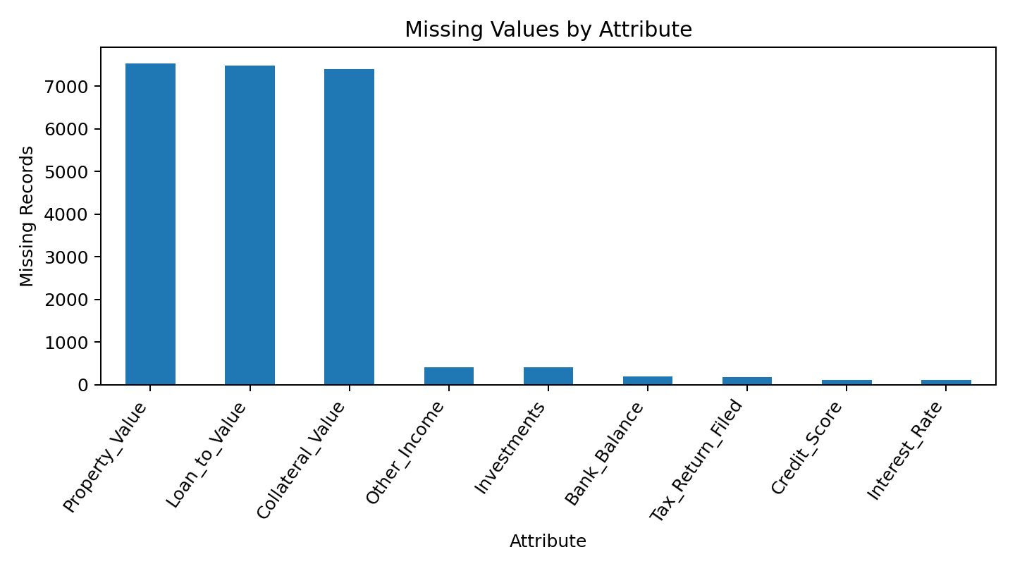
Figure 7.1: Missing-value counts by attribute.

7.2 Loan Status Distribution
The dataset contains 12,856 Approved applications (64.28%) and 7,144 Rejected applications (35.72%). The classes are not evenly distributed: approvals represent approximately 64.28% of records and rejections 35.72%. Stratified splitting and class-specific evaluation are recommended.
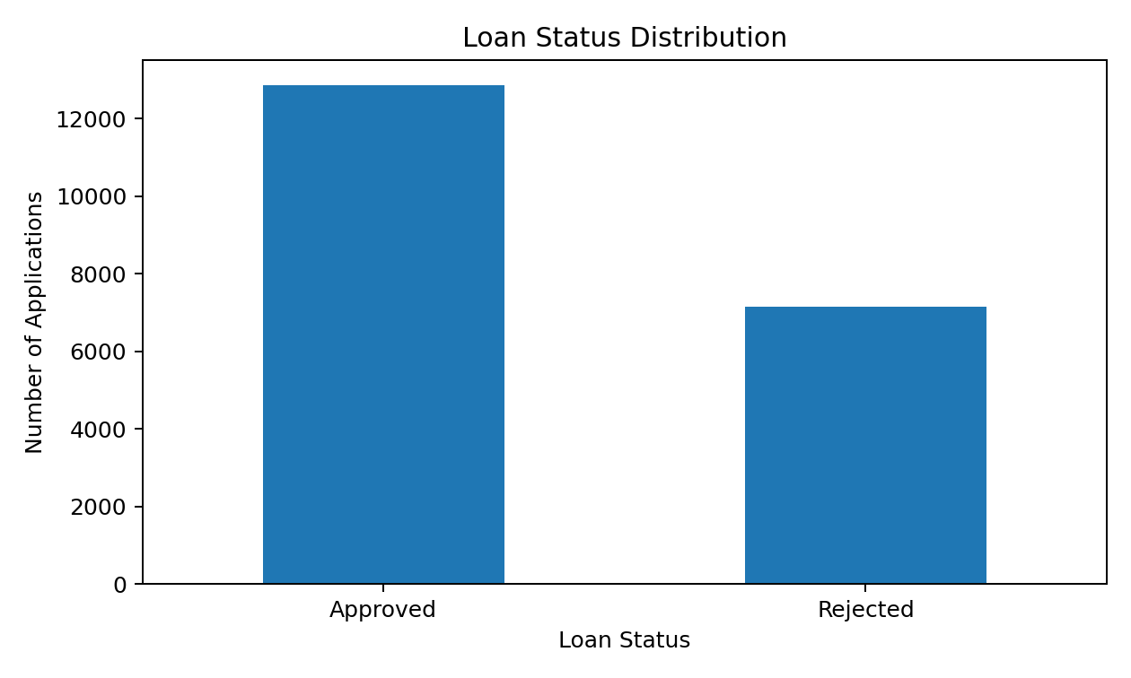
Figure 7.2: Counts for the Loan_Status target classes.

7.3 Numerical Distributions
The EDA notebook plots the distributions of Age, Monthly_Income, Loan_Amount, Credit_Score, Debt_to_Income, and Interest_Rate. These plots help identify skew, spread, and unusual values. Descriptive statistics show that values vary substantially in scale, so preprocessing should be applied through a reproducible pipeline rather than manually transforming the full dataset before splitting.
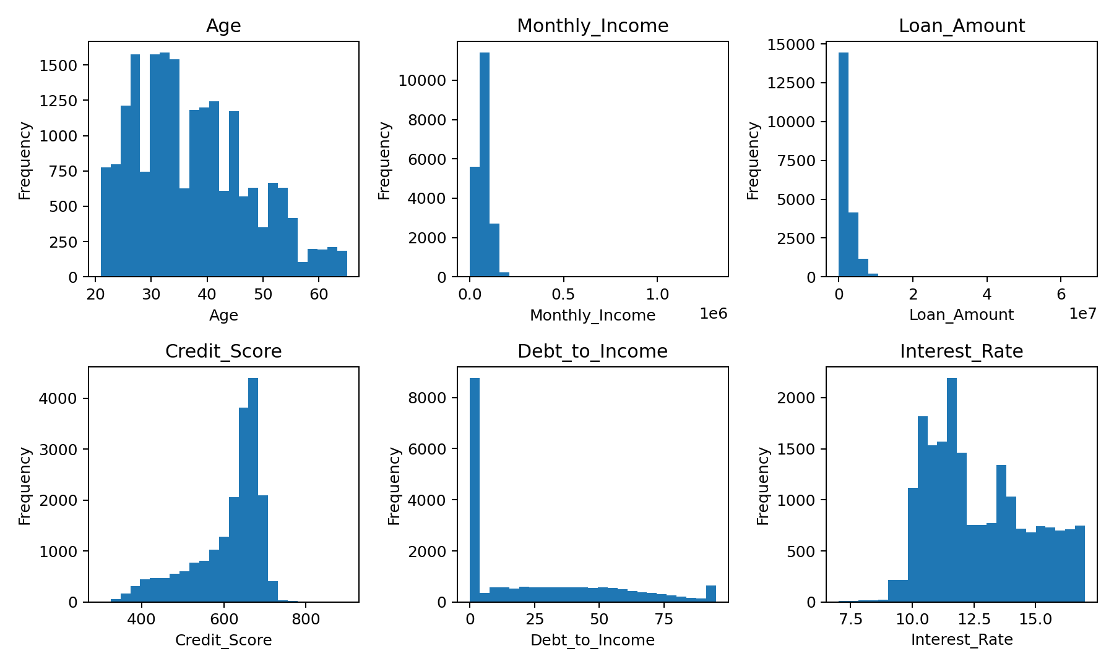
Figure 7.3: Distributions of selected numerical features.

7.4 Approval Rate by Employment Type
The supplied EDA notebook groups records by Employment_Type and computes the proportion labelled Approved for each category. This comparison is useful for understanding how target labels vary across employment categories, but the observed differences are descriptive associations, not proof that employment type causes approval outcomes. The chart below is computed directly from the supplied CSV.
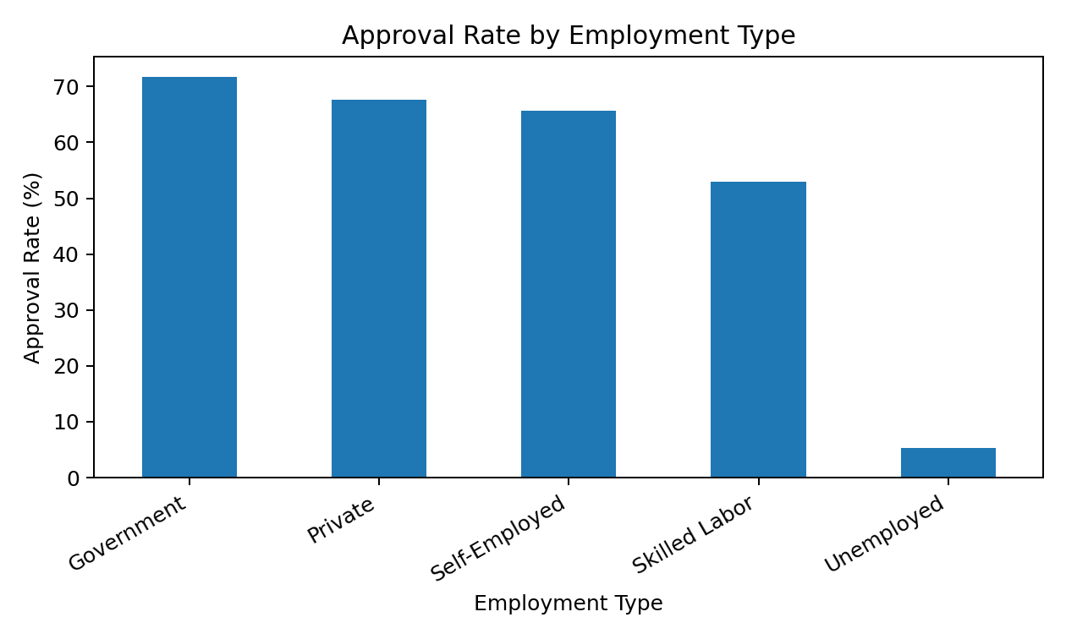
Figure 7.4: Approval rate by employment type in the supplied dataset.

7.5 Correlation and Outlier Analysis
The notebook creates a correlation heatmap for numerical columns and boxplots for selected features. Correlation can identify pairs of numerical variables that move together, while boxplots highlight observations far from the central distribution. Neither method alone establishes causality or proves that a value is invalid. The original experiment notebook includes these plots as part of the EDA workflow.

7.6 Model Results Status
The provided files contain two EDA notebooks and a project abstract. They do not contain completed Random Forest, XGBoost, or LightGBM training outputs, a train/test evaluation table, a confusion matrix, or ROC-AUC values. Consequently, comparative model results cannot be reported honestly yet. The next experimental step is to implement the preprocessing pipeline, train all three models, and record their metrics on the same held-out test set.
Evaluation item | Status in supplied files
Dataset inspection and summary | Included in Experiment 1
Missing values and duplicate check | Included in Experiment 1 and Experiment 2
Target distribution and EDA charts | Included in Experiment 1 and Experiment 2
Random Forest training and metrics | Not shown in supplied notebooks
XGBoost training and metrics | Not shown in supplied notebooks
LightGBM training and metrics | Not shown in supplied notebooks
Best-model selection | Pending model evaluation

8. CONCLUSION AND FUTURE SCOPE

8.1 Conclusion
This project addresses loan approval prediction using an ensemble-learning approach and identifies Random Forest, XGBoost, and LightGBM as the candidate models. The supplied experiments establish the foundation for model development by examining a dataset of 20,000 applications across 39 columns, confirming that there are no duplicate rows, measuring missing values, and exploring the target distribution and selected feature relationships.
The EDA shows that Loan_Status contains 64.28% Approved and 35.72% Rejected records. Missingness is particularly high in Property_Value, Loan_to_Value, and Collateral_Value. These findings make data preprocessing and careful evaluation essential. Because the supplied notebooks stop at data understanding and EDA, model accuracy and the best-performing algorithm remain undetermined.

8.2 Future Scope
- Complete preprocessing with train-only imputation and categorical encoding.
- Train Random Forest, XGBoost, and LightGBM with reproducible seeds and stratified data splitting.
- Use cross-validation and hyperparameter tuning to reduce overfitting.
- Report accuracy, precision, recall, F1-score, ROC-AUC, and confusion matrices for all models.
- Inspect feature importance and use explainability methods to make predictions easier to review.
- Evaluate fairness across relevant demographic groups and check for proxy variables or historical bias.
- Calibrate predicted probabilities and select decision thresholds based on documented lending objectives.
- Build a simple interface for entering applicant details and displaying a prediction with a clear warning that it is decision support, not an automatic final lending decision.
- Document dataset provenance, privacy controls, model drift monitoring, and retraining requirements before real-world use.

9. REFERENCES
- Project source files supplied for this report: ML Abstract.pdf, ML DATASET.csv, Experiment1_ML_Corrected.ipynb, and experiment2_ML_Corrected.ipynb.
- Breiman, L. “Random Forests.” Machine Learning, 45, 5–32 (2001). https://doi.org/10.1023/A:1010933404324
- Chen, T. and Guestrin, C. “XGBoost: A Scalable Tree Boosting System.” Proceedings of the 22nd ACM SIGKDD International Conference on Knowledge Discovery and Data Mining (2016). https://doi.org/10.1145/2939672.2939785
- Ke, G. et al. “LightGBM: A Highly Efficient Gradient Boosting Decision Tree.” Advances in Neural Information Processing Systems 30 (2017). https://papers.nips.cc/paper/2017/hash/6449f44a1025abf4
- Scikit-learn documentation, RandomForestClassifier and model evaluation. https://scikit-learn.org/stable/
- XGBoost documentation. https://xgboost.readthedocs.io/
- LightGBM documentation. https://lightgbm.readthedocs.io/
- Pandas documentation. https://pandas.pydata.org/docs/
- Matplotlib documentation. https://matplotlib.org/stable/
- Seaborn documentation. https://seaborn.pydata.org/

