PRACTICAL 7
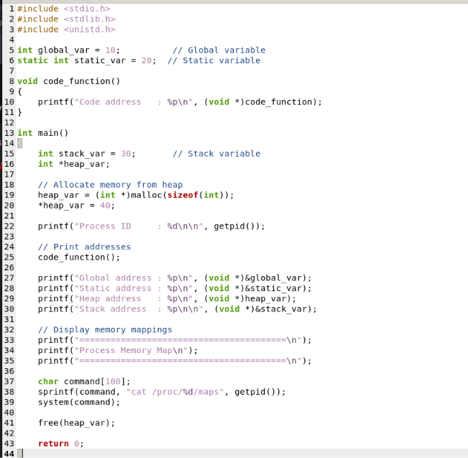
#include <stdio.h> #include <stdlib.h> #include <unistd.h>

int global_var = 10; // Global variable static int static_var = 20; // Static variable

void code_function()

{
printf("Code address : %p\n", (void *)code_function);
}

int main()
{
int stack_var = 30; // Stack variable int *heap_var;

// Allocate memory from heap heap_var = (int *)malloc(sizeof(int));
*heap_var = 40;

printf("Process ID : %d\n\n", getpid());

// Print addresses code_function();

printf("Global address : %p\n", (void *)Cglobal_var); printf("Static address : %p\n", (void *)Cstatic_var); printf("Heap address : %p\n", (void *)heap_var); printf("Stack address : %p\n\n", (void *)Cstack_var);

// Display memory mappings printf("========================================\n");
printf("Process Memory Map\n");

printf("========================================\n");

char command[100];
sprintf(command, "cat /proc/%d/maps", getpid()); system(command);

free(heap_var);

return 0;



