RDP server Connect:

New user added under the Public IP

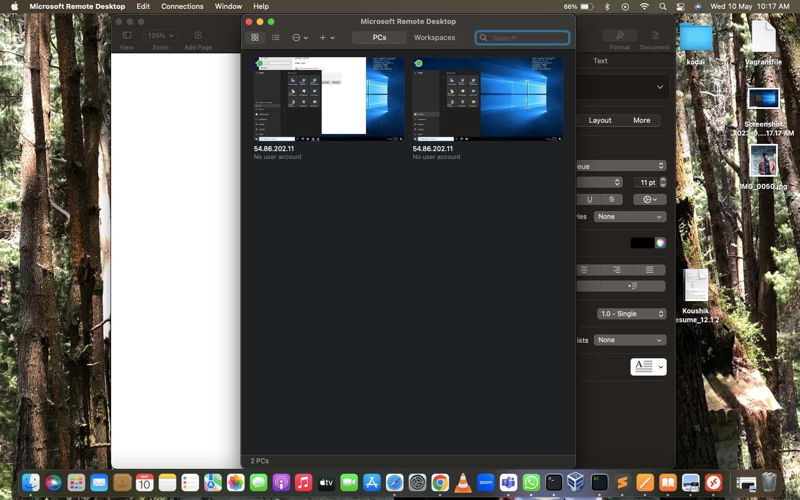

Logged in as newly created user:

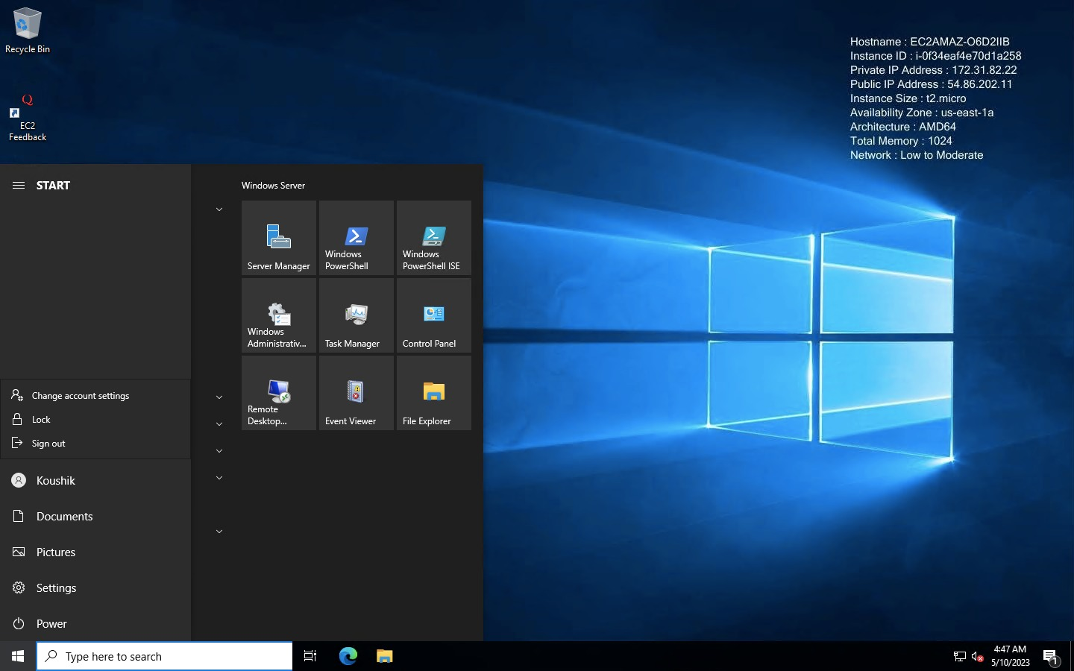

# 2/2 Status Checks:

**System check**

This checks for proper hardware configuration of the instance at host level. It should be noted that you can not check these. These are aws managed. The best you can do is just stop and start the Instance in case system checks fail. It simply deallocates the previous VM and a new VM on different hardware is provisioned. If you want to retain public IP and other related stuff, you can configure Auto Recovery of instance from cloudwatch console.

**Instance Check:**

This check is done to check software(os) level configuration of the instance. This can be looked into by you. If this check fails then you will need to check either user data/ launch configuration or AMI/OS configuration.