class PalindromeCheck
{
//My Method to check
public static boolean isPal(String s)
{ // if length is 0 or 1 then String is palindrome
if(s.length() == 0 || s.length() == 1)
return true;
if(s.charAt(0) == s.charAt(s.length()-1))
/* check for first and last char of String:
* if they are same then do the same thing for a substring
* with first and last char removed. and carry on this
* until you string completes or condition fails
* Function calling itself: Recursion
*/
return isPal(s.substring(1, s.length()-1));

/* If program control reaches to this statement it means
* the String is not palindrome hence return false.
*/
return false;
}

public static void main(String[]args)
{
//For capturing user input
Scanner scanner = new Scanner(System.in);
System.out.println("Enter the String for check:");
String string = scanner.nextLine();
/* If function returns true then the string is
* palindrome else not
*/
if(isPal(string))
System.out.println(string + " is a palindrome");
else
System.out.println(string + " is not a palindrome");
}
}
public class Factorial {

// return n!
// precondition: n >= 0 and n <= 20
public static long factorial(long n) {
if (n < 0) throw new RuntimeException("Underflow error in factorial");
else if (n > 20) throw new RuntimeException("Overflow error in factorial");
else if (n == 0) return 1;
else return n * factorial(n-1);
}

public static void main(String[] args) {
long n = Long.parseLong(args[0]);
StdOut.println(factorial(n));
}

}

class CheckEvenOdd
{
public static void main(String args[])
{
int num;
System.out.println("Enter an Integer number:");

//The input provided by user is stored in num
Scanner input = new Scanner(System.in);
num = input.nextInt();

/* If number is divisible by 2 then it's an even number
* else odd number*/
if ( num % 2 == 0 )
System.out.println("Entered number is even");
else
System.out.println("Entered number is odd");
}
}
class PrimeNumbers
{
public static void main (String[] args)
{
int i =0;
int num =0;
//Empty String
String primeNumbers = "";

for (i = 1; i <= 100; i++)
{
int counter=0;
for(num =i; num>=1; num--)
{
if(i%num==0)
{
counter = counter + 1;
}
}
if (counter ==2)
{
//Appended the Prime number to the String
primeNumbers = primeNumbers + i + " ";
}
}
System.out.println("Prime numbers from 1 to 100 are :");
System.out.println(primeNumbers);
}
}

class PrimeCheck
{
public static void main(String args[])
{
int temp;
boolean isPrime=true;
Scanner scan= new Scanner(System.in);
System.out.println("Enter any number:");
//capture the input in an integer
int num=scan.nextInt();
scan.close();
for(int i=2;i<=num/2;i++)
{
temp=num%i;
if(temp==0)
{
isPrime=false;
break;
}
}
//If isPrime is true then the number is prime else not
if(isPrime)
System.out.println(num + " is a Prime Number");
else
System.out.println(num + " is not a Prime Number");
}
}
class ReverseNumberWhile
{
public static void main(String args[])
{
int num=0;
int reversenum =0;
System.out.println("Input your number and press enter: ");
//This statement will capture the user input
Scanner in = new Scanner(System.in);
//Captured input would be stored in number num
num = in.nextInt();
//While Loop: Logic to find out the reverse number
while( num != 0 )
{
reversenum = reversenum * 10;
reversenum = reversenum + num%10;
num = num/10;
}

System.out.println("Reverse of input number is: "+reversenum);
}
}

How does arraylist grows dynamically?
private void grow(int minCapacity) {
// overflow-conscious code
int oldCapacity = elementData.length;
int newCapacity = oldCapacity + (oldCapacity >> 1);
if (newCapacity - minCapacity < 0)
newCapacity = minCapacity;
if (newCapacity - MAX_ARRAY_SIZE > 0)
newCapacity = hugeCapacity(minCapacity);
// minCapacity is usually close to size, so this is a win:
elementData = Arrays.copyOf(elementData, newCapacity);
}
In Java8
int newCapacity = oldCapacity + (oldCapacity >> 1);
In java 7
int newCapacity = (oldCapacity * 3/2) + 1.

How HashSet work internally?

public boolean add(E e) {
return map.put(e, PRESENT)==null;
}

What is Covariant return type?
It is possible of to have different return type for a override method in child class ,but child class return type should be sub type of parent's return type.
class Parent {
Parent get() {
System.out.println("Parent");
return this;
}
}
public class Child extends Parent {
Child get() {
System.out.println("SubClass");
return this;
}
public static void main(String[] args) {
Parent Child = new Child();
Child.get();
}
}

Different access specifier in java
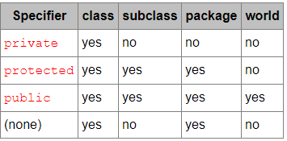
How internally works HashMap in Java?
Hashmap uses the technique of hashing principle.
Hashing: Hashing is the process of converting an object into integer form using the method hashCode();
Bucket: A bucket is one element of hashmap array.It is used to store nodes.Two or more nodes can have same bucket.Linked List structure is used to connect the nodes.
Capacity=number of buckets*load factor
index = hashCode(key) & (n-1).

A bucket contains a element:
int hash;
K key;
V value;
Node<K,V> next;

Java8 update in hashmap:
When the number of items in hash bucket grows beyond certain threshold(TREEIFY_THRESHOLD=8),content of bucket switches from using a linked list of entry objects to a balance tree.

How to create immuatable class in java?

1.Declare the class as final so it can't be extended.
2.Make all the fields private so that direct access is not allowed.
3.Dont provide setter method for variables
4.Make all the mutable fields final so that its value can be assigned only once
5.Initialize all the fields via a consturctor performing deep copy
6.Performing cloning objects in the getter method to return copy rather than returning actual objects.

Example:::

public final class ImmutableClass
{
private final int id;
private final String name;

public int getId()
{
return id;

}
public String getName()
{
return name;
}

public ImmutableClass(int id;String name)
{
this.id=id;
this.name=name;

}

}

What is Synchronization in java?

If our code is running in a multi-threaded environment,we need to synchronization for objects,which are shared among multiple threads,to avoid any corruption of state or any kind of unexpected behavior.
- Synchronization in java will only be needed if shared object is mutable.
- If object is read-only or immutable object we dont need synchronization.
- If all threads is reading value then we dont require synchronization
- JVM gurantees that Java Synchronized code will only be executed by one thread at a time.
- Synchronized code always reads data from main memory ,dont cache locally and it flushes write operation to main memory.
- Java threads acquires object level lock when it enters instance synchronized method and acquires a class level lock when it enters into static synchronized java method.

Synchronization limitation:
If we have more than one JVM and need to synchronize access to a shared file system or database,the java synchronized is not sufficient.
A synchronized method in java is very slow and can degrade performance.
LOCK:
A lock is a kind of data which is logically part of an objects header in heap memory. Each object in JVM has its lock that any program can use to co-ordinate multi-threaded access to the object. If any thread want to access instance variable of that object,then thread must own the objects lock(set some flag in lock memory area).All other threads attempt to access the objects variable have to wait until the owning thread release the object lock.
Once a thread own a lock,it can request the same lock again multiple times but then has to release the lock the same number of times before it is made available to other threads. If a thread request a lock three times then that thread will continue until it has release it three times.
Lock is aquired by a thread ,when it explicitly ask fot it.this is done by synchronization or with wait and notify.

MONITOR:
Monitor is a synchronization construct that allows thread to have both mutual exclusion , to ability to make threads wait for certain condition to be true.
Locks help threads to work independently on shared data without interfering with one another wait sets help threads to cooperate with each other to work with a common goal,all waiting threads will be moved to wait-sets and will get notified once lock is released .The wait-set helps in building monitors with additional help of lock.

Synchronization is built around an internal entity known as the intrinsic lock or monitor lock.
Every object in java is associated with a monitor which a thread can lock or unlock.

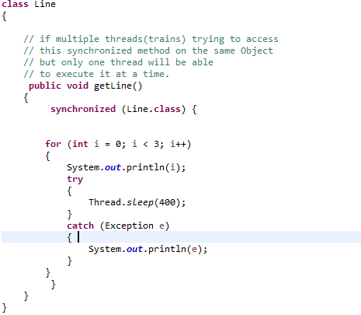

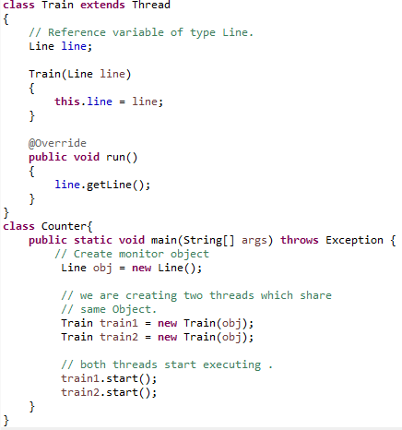

What is double checked locking in Singleton?
public class DraconianSingleton {
private static DraconianSingleton instance;
public static synchronized DraconianSingleton getInstance() {
if (instance == null) {
instance = new DraconianSingleton();
}
return instance;
}

// private constructor and other methods ...
}
Despite this class being thread-safe,we can see that there's clear performance drawback,each time we want to get the instance of our singleton ,we need to acquire a potentially unnecessary lock.
To fix that ,we would instead start by verifying if we need to create the object in the first place and only in that case we would acquire the lock.
This will synchronize only if instance is null to avoid performance issue.
public class DclSingleton {
private static volatile DclSingleton instance;
public static DclSingleton getInstance() {
if (instance == null) {
synchronized (DclSingleton .class) {
if (instance == null) {
instance = new DclSingleton();
}
}
}
return instance;
}

// private constructor and other methods...
}
What is volatile in java?
The volatile keyword does not cache the value of the variable and always read the variable from the main memory.The volatile keyword can not be used in classes or methods.
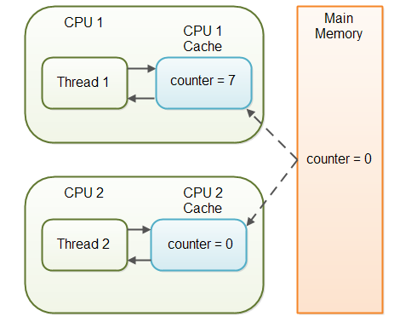
With non-volatile keyword the threads not seeing the latest value of a variable because it hast not yet been written back to main memory by another thread,is called visibility problem.The update os one thread not visible to other thread.

What is the difference between abstraction and encapsulation?

Encapsulation:
Wrapping code and data together into a single unit .class is an example of encapsulation, because it wraps the method and property.
Abstraction:
Hiding internal details and showing functionality only. Abstraction focus on what the object does instead of how it does. It provides generalized view of classes.

Int number =5;
String aNum=number.toString();

.toString()--->Abstraction
how this mechanism number variable converted to string and initialize into aNum is encapsulation.

Why String is immutable in java?

String is immutable for several reasons, here is a summary:
Security: parameters are typically represented as String in network connections, database connection urls, usernames/passwords etc. If it were mutable, these parameters could be easily changed.
Thread-Safe: These immutable string objects are thread-safe as well. Since these objects cannot be changed or modified, they can be shared between threads which eliminates the need for synchronization.
Caching: Since a string object is immutable, its hashcode is cached at the time of creation so that it can be used multiple times without calculation. This immutability feature makes it an appropriate choice for a candidate key for HashMaps.
Class loading: String is used as arguments for class loading. If mutable, it could result in wrong class being loaded (because mutable objects change their state).
Memory management: String pool is a specific storage area for string objects. If a string object is created and that string already exists, then, instead of creating a new object on the heap, the reference of the same object is returned. If string is mutable, then changing one reference will change the value for all the string objects.
Reference
String a=
kousik
kousik

String b=
kousik

What is the difference between StringBuffer and StringBuilder?

StringBuffer is synchronized
StringBuilder is non-sysnchronized

what are Fail-Safe iterator ?

ConcurrentHashMap
CopyOnWriteArrayList

What is reflection in java?

Java Reflection is a of examining or modifying the run time behavior of a class at run time.
Java Reflection is the process of analyzing and modifying all the capabilities of a class at runtime.Reflection API in Java is used to manipulate class and its members which include fields, methods, constructor, etc. at runtime .
One advantage of reflection API in Java is, it can manipulate private members of the class too.
1-method
Class c = Class.forName("Simple");
Simple s=(Simple)c.newInstance();
2-method
Simple s=new Simple();
Class c = s.getClass();
3-method
Class c= Simple.class;

What is the difference between new and newInstance()?

Class.forName("class name").newInstance() is useful if you need to instantiate classes dynamically, because you don't have to hard code the class name to create an object.
A scenario where we load classes dynamically from remote source,we know their names but cant import at compile time.
The new operator creates a new object of a type that's known statically (at compile-time).We use new if you know at compile-time what the type of the object is that you want to create.

Dynamic method dispatch ?

Dynamic method dispatch is a mechanism by which call to an overridden method is resolved at run time. When a overridden method is called by reference ,java determine which which version of that method to execute based on the type of object it refers to.
Type of object it refers determine which version of overridden method will be called.
Parent P=new Parent();
Child c=new Child();
p=c;

Difference between polymorphism and inheritence?

Ineheritence
- refers to using the structure and behaviour of superclass in a subclass.
- Refers when a class derives from an existing class.
- It is applied to classes

Polymorphism
- refers to changing the behaviour of super class in subclass.
- Refers how the program decides which method it should use depending on type of reference or type of object.
- We can perform a task in multiple forms or ways.It is applied to methods or functions .It allows the object to decide which form of function to implement at compile-time or run-time.
Difference between static binding/early binding and dynamic/late binding?

Static Binding:
The binding which can be resolved at compile-time by the compiler is know as static or early binding.
Binding of all private,static and final methods is done in compile-time.
Compiler knows that all such method will not be overridden and will always be accessed by object of local class. Hence compiler doesn't have any difficulty to determine object of class.

Dynamic binding:

In Dynamic binding compiler doesn't decide which method to be called.

During compilation the compiler has no idea to which method to be called since compiler goes only by reference variable not by the type of object,therefore the binding would be delayed to runtime.

Static binding uses type information for binding and dynamic binding uses object to resolve binding.

Convert json string to object?
ObjectMapper mapper = new ObjectMapper();
String json = "[{\"name\":\"mkyong\", \"age\":37}, {\"name\":\"fong\", \"age\":38}]";

// 1. convert JSON array to Array objects
Person[] pp1 = mapper.readValue(json, Person[].class);

// 2. convert JSON array to List of objects
List<Person> ppl2 = Arrays.asList(mapper.readValue(json, Person[].class));

What is daemon thread?
Daemon thread is low priority thread that runs in background to perform tasks such as garbage collection
- They can not prevent the JVM from exiting when all the user threads finish their execution.
- JVM terminates itself when all user threads finish their execution.
- If JVM finds running daemon thread .it terminates the thread after that shutdown itself.JVM does not care whether daemon thread is running or not.
- Its life cycle depend on user thread.

What is functional interface?

A functional interface is an interface that contains only one abstract method.
Example of functional interface :
Runnable,Comparable,ActionListener etc.

What is yield(),sleep(),join(),notify()?
Yield():It indicates that the thread is not doing anything important and if any other threads need to be run,they can.Otherwise,the current thread will continue to run.

Sleep():causes the thread to definitely stop execution for a given amount of time,if no other threads needs to be run,the CPU will be Idle.

Join():wait the current thread until another thread completed its excecution.

Notify():This method gives the notification for only one thread which is waiting for a particular object.

Different methods in Object Class

protected Object clone() throws CloneNotSupportedException
public boolean equals(Object obj)
protected void finalize() throws Throwable
public final Class getClass()
public int hashCode()
public String toString()

