Document No: | Teva Service Desk Agentic AI
System: | Teva Service Desk Agentic AI

Document History:
Version | Date Initiated | Author | Reasons for Change
1.0 | 13-Dec-2025 |  | Initial version
2.0
3.0

Table of Contents
1. Introduction 3
1.1 Purpose 3
1.2 Readers Guide 3
1.3 Documentation Conventions 3
2. Enterprise Architecture Context 3
2.1 Business Architecture Details 3
2.2 Application Architecture Context 4
2.2.1 Details 4
2.3 Data Architecture Context 4
2.3.1 Details 4
2.4 Technology Architecture Context 5
2.4.1 Overview 5
2.4.2 Details 5
3. Principles and Requirements 5
3.1 Architecture Principles 5
3.2 Architecture-Significant Requirements 7
3.2.1 Functional Requirements 7
3.2.2 Non-functional Requirements 9
4. Architecture Alternatives 10
5. Architecture Elaborations 10
5.1 User Flow 10
5.1.1 Human Actors 10
5.1.2 External Systems 11
5.1.3 Architecture Vision 11
5.1.4 Application Architecture 11
5.1.5 Application Components 12
5.2 Infrastructure Architecture 12
5.2.1 Technology/Infrastructure Component: 13
5.2.2 Development 14
5.2.3 Deployment Model 16
5.3 Cross-cutting Architecture Perspectives 17
5.3.1 Security Architecture Perspective 17
5.3.2 Performance & Scalability Architecture Perspective 18
5.3.3 Availability & Reliability Architecture Perspective 18
5.3.4 Extensibility Architecture Perspective 18
6. Architecture Decisions 18
7. References 18

Introduction

Purpose
This document is the Architecture & Development Handbook for Teva Service Desk Agentic AI POC. It describes and documents the Architecture of Teva Service Desk Agentic AI POC.

IntelliFix Assist (Intelligent Service Desk Resolution Assistant) - An intelligent MS Teams chatbot platform which is built to support business users to fix outlook related issues with the help of AI agents and provide end to end IT issue resolution and autonomous handling of routine IT support requests.
Agent Details:
- Classifier Agent - Classifies user problems (e.g., Outlook not opening, sync issues).
- Ticketing Agent - Creates and updates ServiceNow tickets automatically.
- Diagnostic Agent - Collects process status, network checks, event logs, and Outlook profile health and suggests potential fixes based on findings.
- Troubleshooting Agent - Run fix script to repair Outlook, clears cache, and applies fixes

Readers Guide
The Architecture & Development Handbook guides readers to understand the development and solution architecture of the platform.

- The Platform URL is: URL

System classification summary:
Confidentiality | Integrity | Availability | Data Privacy
Strictly Confidential | Standard | Low | PI-Risk (M)

Documentation Conventions
This document uses notations and models according to the Architecture & Development Handbook process description. IntelliFix Assist will likely go through multiple releases, and this document will continue to evolve per release to document the most up to date status as well as how it changes from one release to another.

Enterprise Architecture Context

Business Architecture Details
This table outlines Business Capabilities and Processes in scope.
Business Capability / Process | In Scope | Purpose
Automated L1 Outlook support through AI-driven assistant in Microsoft Teams, delivering intelligent issue classification, secure diagnostics, and self-service remediation—integrated with ServiceNow for real-time ticketing and seamless escalation to L2 when required  Scenarios In Scope:  - cannot open Microsoft Outlook. Outlook launching issues etc. (KB0010265)  - Rebuilding Outlook Profile (KB0010863)  - Outlook Credential prompt (KB0027560)  - Clearing stored passwords from Credential Manager (KB0016605)  - Disable Work Offline in Outlook (KB0016493) | Yes | Reduce MTTR for common Outlook L1 incidents and improve user satisfaction by automating end‑to‑end intake, diagnosis, remediation, and ticketing—freeing IT staff to focus on higher‑value L2/L3 work while maintaining enterprise‑grade security, safety, and traceability

Application Architecture Context

Details
This table outlines applications in scope.
Application | Description | Purpose | Foreseen changes
IntelliFix Assist | IntelliFixAssist (Intelligent Service Desk Resolution Assistant) is intelligent MS Teams chatbot platform which is built to support business users to fix any outlook related issues with the help of AI agents and autonomous handling of routine IT support requests. It Significant reduction in L1 Outlook issue resolution time (from 9.5 mins to near real-time) | IntelliFix Assist is an MS Teams based intelligent chatbot developed to provide end-to-end issue resolution of outlook related issues | IntelliFix Assist will be implemented as a new platform in the submission landscape. The major changes are mentioned in the deck below:

Data Architecture Context

Details
This table outlines Data and components in scope.

Business Object | Description | Purpose | Foreseen changes
Service Desk KB Articles | Details of issue with resolutions steps in ServiceNow knowledge base article | Leverage ServiceNow Knowledge Base articles containing Outlook issue descriptions and resolution steps to power AI-driven classification, diagnostics, and automated remediation workflows—ensuring accurate, context-aware responses and reducing resolution time for L1 incidents. | - Integration with ServiceNow for all the KB articles and data factory implementation with Azure  - RAG Implementation for Intelligent Search & grounding  - Implementation of new Data AI Agent for new knowledge generation  - AI Agent Memory implementation to refer old chats & discussions

Technology Architecture Context

Overview
The purpose of IntelliFixAssist AI is to help the business user with the issue resolution that they are facing in software like Outlook etc.

Details
IntelliFixAssist - runs on Azure through Azure DevOps CI/CD pipeline hosted and managed through standard Azure services.
The front-end is hosted on Kore AI and MS Teams chatbot, and backend components are hosted on separate App Services.

Principles and Requirements
Version | Phases
 | Scope & Seek | Analysis & Conceptual Design | Detailed Design & Development | Testing & Acceptance
1.0 | x | x | x | x

Architecture Principles
The following architecture principles are being followed as guidelines while designing the application and system components, data representation.
Category | Technology
Name | Cloud-based solutions
Statement | Cloud-based architecture for IT solutions instead of On-premises. Prioritize cloud solutions and services in the following order of preference: SaaS, PaaS, Custom solution on IaaS as a last option.
Rationale | • Cloud services enable being asset light and provide flexible scaling without large upfront investments  • Faster application development, testing, and deployment for agility and scale  • Prioritize innovation by offloading infrastructure management to the cloud providers  • Cloud service providers frequently update their offerings to optimize performance, security and compliance
Implications | In assessing new solutions, evaluate in the following order:  • Choose/prefer fully managed application Software as a Service (SaaS) over deploying & managing application software on Platform as a Service (PaaS) or a combination of PaaS or IaaS  • If suitable SaaS or PaaS solutions are unavailable, utilize cloud containerization services or IaaS for application deployment instead of on-premises
Priority | 5

Category | Technology
Name | Reuse before buying or building
Statement | Prioritize reuse and extension of existing technologies and prefer buying software solutions over custom development.
Rationale | Prioritize reuse, extending existing applications and platforms to achieve:  • Cost-efficiency  • Reduced duplication, fragmentation  • Accelerated development  • Lower training requirements, Leverage expertise
Implications | Ensure technology acquisition adhere to enterprise standards, guidelines  • Leverage enterprise platforms e.g. ServiceNow, Azure, Kore AI, Data Platforms  • Extend/Upgrade existing systems when feasible  • Prefer off the shelf software, when reuse is not possible  • Develop new custom applications, platforms as a last option
Priority | 5

Category | Security
Name | Secure by Design
Statement | Ensure enterprise systems are designed, prioritizing cybersecurity as a fundamental aspect of the architecture
Rationale | Addressing security requirements early in the design process has following benefits:  • Minimizes rework and reduces costs associated with retrofitting security measures.  • Reduces vulnerabilities.  • Minimizes the risk of breaches.  • Ensures systems are secure from the outset.  • Facilitates compliance with data protection and privacy regulations.
Implications | • Ensure compliance with policies and standards in designing solutions for minimizing system vulnerabilities  • Classify data and applications based on sensitivity for tailored security measures  • Assessing and monitoring the security posture of third-party vendors & partners to ensure they meet the organization's security requirements.
Priority | 5

Category | Technology
Name | Foster Innovation
Statement | Factor innovative technologies such as AI/GenAI to build new solutions and modernize existing solutions
Rationale | Innovative technologies have potential to transform end-to-end processes and operations and have an impact on  • Better customer, user engagement, experience and productivity  • Better resources utilization & productivity gains  • Strengthening Research and development capabilities  • Regulatory compliance and data privacy  • Better Supply chain and inventory management.  • Data driven decision-making and risk mitigation
Implications | • Evaluate tools and platforms on their use of innovative technologies ensuring they are advanced and future ready  • Continuously monitor emerging technology trends to shape and strategically integrate them into technology roadmaps  • Co-Innovate by fostering collaboration and creativity by involving diverse stakeholders in the innovation process
Priority | 5

Category | Application
Name | Standardized Tooling, Utilizing Automation and DevSecOps
Statement | - Utilize tools consistently that meet the requirements  - Utilize tools consistently that align with enterprise standards where possible  - Utilize DevOps tools and approaches to enable automation and reduce management effort.  - Define and create resources using cloud templates and IaC (Infrastructure as Code).  - Ensure the platform is fully secured following industry guidelines (e.g. Encryption, authorization, data retention policies)
Rationale | By driving for consistency and automation we can accelerate the delivery of the platforms and delivery of the analytics outputs that the end users produce. Crucially linking this all together using the DevSecOps approaches will ensure we deliver in a secure and compliant manner.
Implications | This will reduce the ongoing complexity and management overhead of the platform and the use of case deliveries on that platform.
Priority | 5

Architecture-Significant Requirements
This section describes the main requirements to drive the solution architecture. The documentation of any other requirements is not in scope of the Architecture & Development Handbook.
Each of the individual requirements that have architectural significance are listed below.

Functional Requirements

Use Case Overview
This table outlines Use Cases in scope.
Use Case | Brief Description | Source
Users have a MS Teams Chatbot | When the user accesses the chatbot, it should initiate the discussion in a humane manner and be ready to accept Outlook-related queries. | URS
Ability to enter the application and access functionalities | Allow users to authenticate with AD or SSO before interacting with the chatbot. | URS
User initiates Outlook issue query | User opens MS Teams and types a query such as:  • My Outlook is not opening  • Emails are not loading. | URS
Chatbot engagement & orchestration | Kore AI captures the query, and take all user inputs and performs NLU (Natural Language Understanding) | URS/HLD
ServiceNow ticket creation | Based on the classification, the Orchestrator Agent triggers the ServiceNow Connector to automatically create a new L1 incident ticket with relevant details (issue type, user info, initial diagnosis).  The ticket number is shared with the user. | URS/HLD
Issue classification | Classifier agents take all user inputs and queries to determine the type of Outlook issue. | URS/HLD
Initial diagnostics & user consent | Frontend instructs the Diagnostic Agent to gather preliminary data, such as:  • Outlook process status  • Network connectivity check  • Event logs related to Outlook | URS/HLD
Detailed diagnosis & permission for fix | The Diagnostic Agent runs more in-depth diagnostics (e.g., Outlook profile check).  It identifies potential fixes and presents them to the user via the chatbot, asking for explicit permission to approve or install fixes. | URS/HLD
Troubleshooting & resolution | Upon user approval, the Orchestrator Agent triggers the Troubleshooting Agent. The Troubleshooting Agent executes the approved fix, e.g.:  • Repair Outlook profile  • Disable specific add-in  • Re-index Outlook data  • Password reset | URS/HLD
Confirmation & resolution tracking | The agent confirms the resolution with the user. If resolved, the ServiceNow ticket is updated to 'Resolved.'  If not resolved, the agent escalates to a human L2 agent, providing all diagnostic logs and actions taken.  The ServiceNow ticket status is updated accordingly. | URS/HLD

Use Case Details

Use Case to Chat with Intelli Assist
Name | User end to end interaction & issue resolution with Agentic bot
Brief Description | Users interact with the chatbot with outlook issues
Actor Descriptions | Business user
Preconditions | - Users must be able to access the application.  - User must be logged into his/her Teva account
Basic Flow of Events | - User goes to the application URL – Chabot URL  - User interacts with the Agentic AI chatbot  - Users complete the interaction with all the AI agents for end-to-end issue resolution
Alternative Flows | None
Post-conditions | None
Extension Points | None
Special Requirements | None
Supporting Information | None

Non-functional Requirements
The below section describes the detailed non-functional requirement of IntelliFix Assist. This section will be revisited and updated in the next version of the architecture handbook.
NFR | Brief Description
Access Control and Management | Ensure:  - That the application has appropriate authentication mechanisms  - Authentication credentials are not hard-coded and allow rotation  - Privileged Accounts are controlled and periodically reviewed  - Adequate Application Access Control  - Solution must support user role-based access to system/ individual trials
Backup Management | - Implemented Appropriate Runbook Backup with Azure Storage
Logging and Monitoring | - All the system activities are monitored (login activity, administrator access, etc.)  - Logs are captured in Azure EventHub
Security | - Systems are implemented securely for external threats  - Address network security monitoring with Azure Network, Private Endpoint, VNET & Subnet. Adequate End-point VPN controls are implemented.  - Adequate end-point security  - All the components are securely connected, and communication between services and components are implemented through Managed Identity & interfaces. Strong authentication (AD & O Auth) is also implemented.  SSDLC Process followed for POC:
System Development & Operation | - Teva Coding Standards and Policies are followed.  - Formalized testing is carried out and documented.  Coding Standard Process followed for POC:  SOP to be followed in future for Dev:
Usability (UX) | - The system is implemented with easy navigation.  - Application is intuitive and easy to use
Scalability | - The platform is built with technologies which are close to production technologies and as per the future requirement of the organization.  - Application infrastructure has been designed with global user access, scalability, and minimum user base. The system should be capable of increasing configurations like memory and storage.

Architecture Alternatives
The IntelliFix Assist system was conceptualized and developed in-house to meet the functional requirements stated in above section. Hence, no similar solutions were explored, and no alternatives were evaluated for IntelliFix Assist.

Architecture Elaborations

User Flow
The following user flow diagram shows the use case for IntelliFix Assist Application.
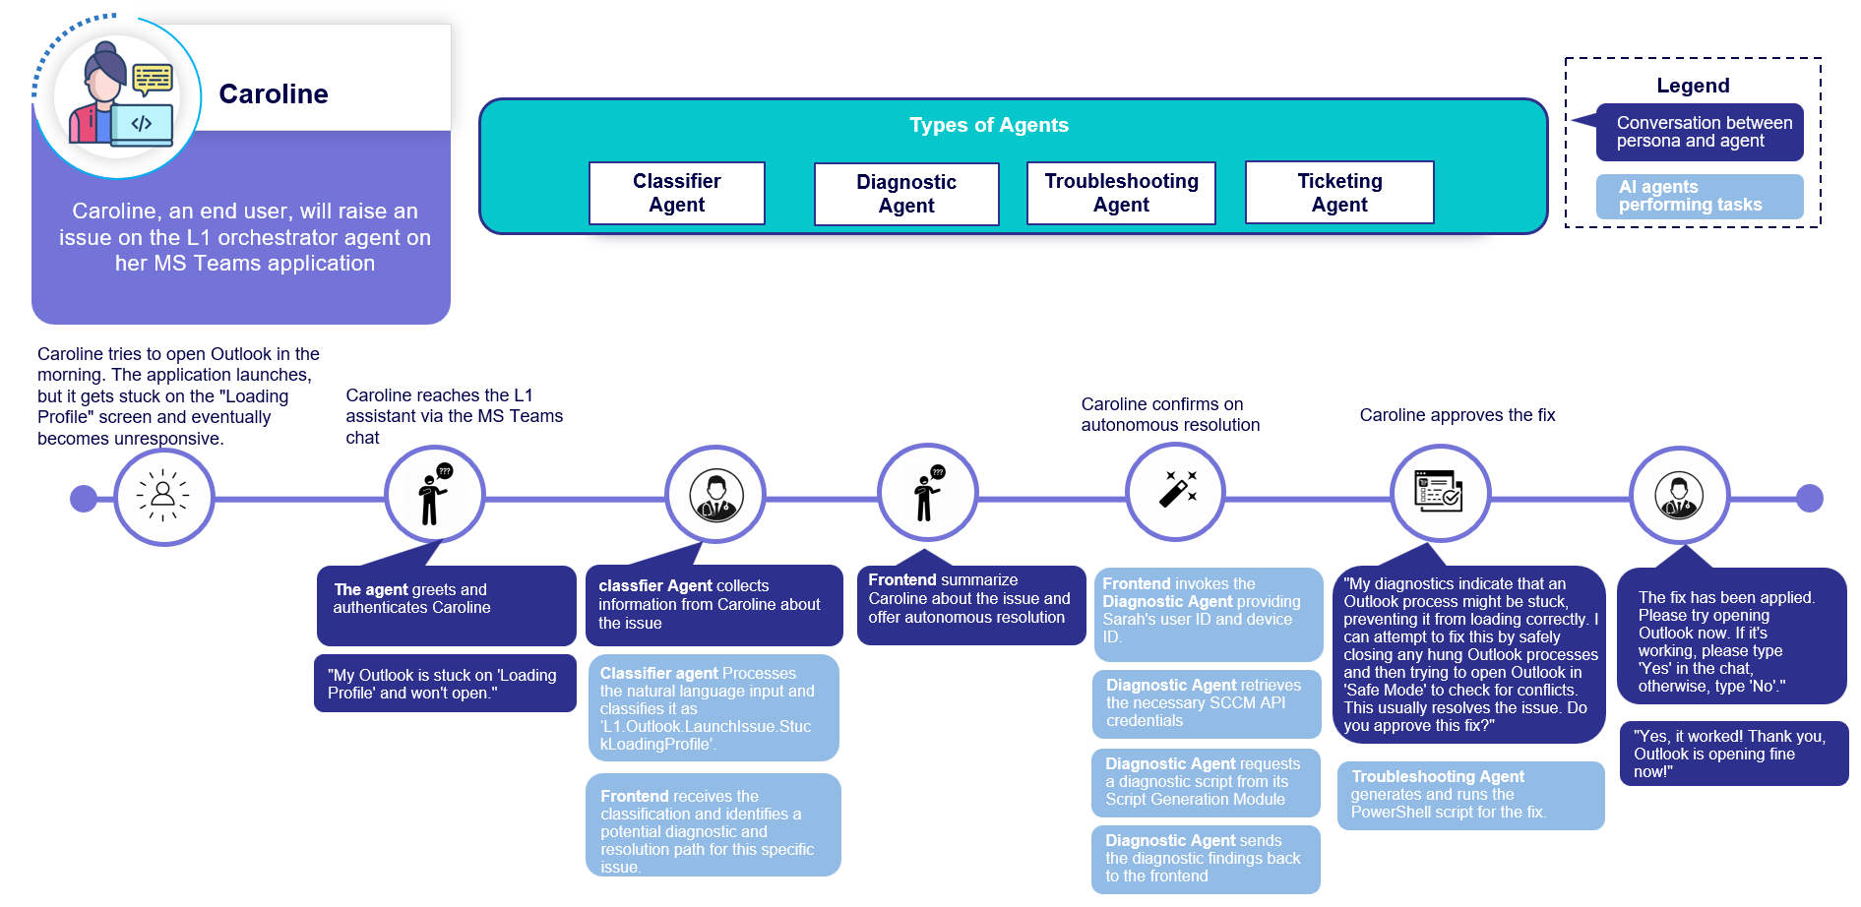

Human Actors
The following table describes Actors, please refer System Context Diagram in more detail.
Actor Name | Actor Description | Number of users | Authentication Mechanism
Business User (Teva Global) | Business User starts the interaction with the agentic platform and enter his/her queries/issues and aims to get to a diagnosis and troubleshooting of the outlook issue using the GenAI/Agentic AI capabilities of IntelliFix Assist platform | >20 | (AD & Oauth2)

- Systems do not have Admin roles or system management roles. All users within the Teva network can access IntelliFix Assist.
- The Users onboarding and offboarding to AD group will follow Teva recommended User Management Process
- All the users are authenticated using AD & OAuth.
- The primary users of the application are Business User (Teva Global).
- External User Access: Only Teva employees would be accessing the application.
- There are no default system accounts.

External Systems
The Application doesn’t interact with any external systems. The APIs which interact uses HTTPS as protocol and authentication/authorization by credentials and verified certificate (Stored in secure vault)

Architecture Vision
This current release is considered MVP (Proof of Concept) and future release will be updated after identifying the external data sources and their integration patterns.

Application Architecture

The following diagram depicts the application architecture.
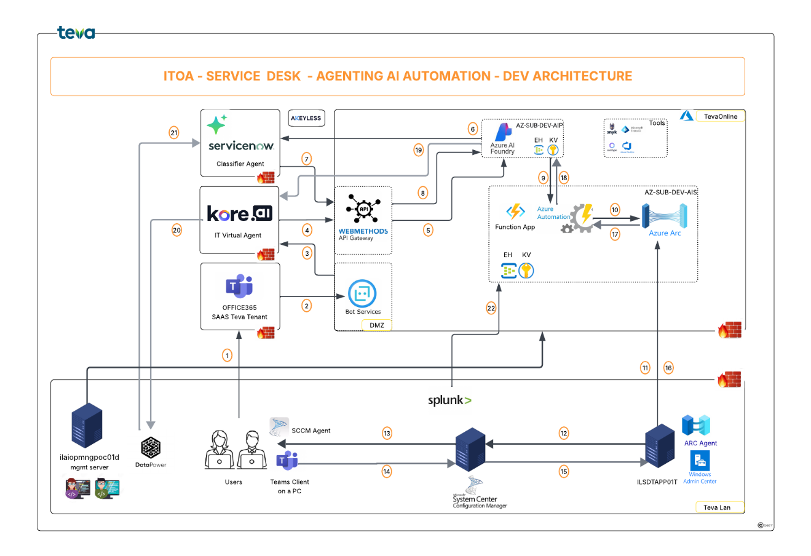

Application Components
Software Component | Description / Main Responsibilities / Technology
Frontend Application | KoreAI frontend hosted on cloud Service.
API Gateway | WebMethods component is hosted on Azure tenant.  WebMethods Endpoint & details for POC:
Azure Cloud Services | Agents are developed with Azure AI Foundry Service. Details are provided in 5.2
Backend Services, Deployment & APIs | All the agents are hosted on Azure Functions as unique endpoints. Details are provided in 5.2
AD Authentication | The application is SSO integrated with Teva Azure AD and internal users access through Teva global ids

Infrastructure Architecture
The architecture and required infrastructure were reviewed by Architecture, Security & Data & AI Team and provided required Infrastructure for the POC
Name:

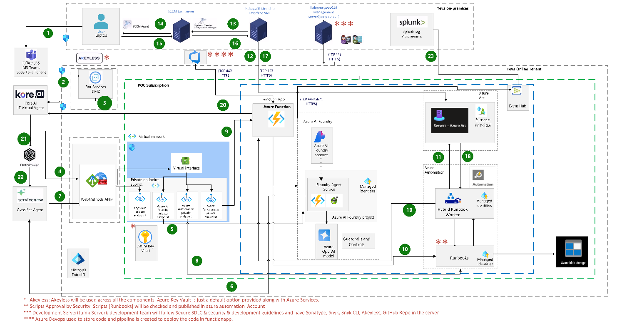

Technology/Infrastructure Component:
The Platform components are deployed on a Teva-managed Azure infrastructure.
Tool | Description | Purpose
Active Directory | The Azure Active Directory (Azure AD) enterprise identity service provides single sign-on and multi-factor authentication to help protect your users from 99.9 percent cybersecurity attacks. | Identity Management
Azure Function App | Azure service for maintain the business logic code of the application in forms of functions which are executed by the triggers | Business Logic &  Application Hosting
Azure Foundry | Azure Foundry Service offers AI models that you can use as per your specific needs for a variety of use cases. | Agents’ creation
Azure DevOps | Azure service which incorporates several products: Artifacts, Source Version Control and Pipelines | Code Repository, Source Version Control, CI / CD
Azure Automation | Azure Automation delivers a cloud-based automation service that supports consistent management across your Azure and non-Azure environments | Runbook creation, Execution using hybrid worker group
Azure Arc | Azure Arc simplifies governance and management by delivering a consistent multi cloud and on-premises management platform. | Onboard On prem SCCM to cloud
Azure EventHub | Azure Event Hubs is a native data-streaming service in the cloud that can stream millions of events per second, with low latency, from any source to any destination. | To store running events
Azure Storage | Azure Blob Storage is Microsoft's object storage solution for the cloud. Blob Storage is optimized for storing massive amounts of unstructured data. Unstructured data is data that doesn't adhere to a particular data model or definition, such as text or binary data. | Store the scripts

Development
All application code for intellifix assistant is developed within a secure development server that is isolated from public networks. This server is accessible only to authorized developers.
During development, the least privileges for azure services were given. Access level for each service along with their respective RITM is mentioned in the table below.

Service | RITM Raised | Access Level | Group Name
Azure Subscription | RITM03749293 | Reader | Cloud_AZ_SUB_POC_AIS_Reader
Azure AI Foundry | RITM03753503 | Azure AI User | Cloud_AZ_SUB_POC_AIS_C_Azure_AI_User
Azure Functions | RITM03764353 | Website Contributor | Cloud_AZ_FA_azfun-wmrcc-ais-swce-poc_C_Website_Contributor
Event Hub & Key Vault | RITM03764707 | Key Vault: Key Vault Secrets User  Event Hubs: Azure Event Hubs Data Sender & Azure Event Hubs Data Receiver | Key Vault: Cloud_AZ_SUB_POC_AIS_KeyVault_Secrets_User  Event Hub: Cloud_AZ_SUB_POC_AIS_Azure_Event_Hubs_Data_Receiver  Cloud_AZ_SUB_POC_AIS_Azure_Event_Hubs_Data_Sender
Azure Arc | RITM03767940 | Reader [Machine was onboarded by admin] | Cloud_AZ_SUB_POC_AIS_Reader
Azure Automation | RITM03767970 | Automation Contributor | Cloud_AZ_SUB_POC_AIS_C_Automation_Contributor
Azure Blob Storage | RITM03822922 | Storage Blob Data Contributor | Cloud_AZ_SUB_POC_AIS_Storage_Blob_Data_Contributor

Version Control and Code Management
Source code was maintained using Azure DevOps Repositories, ensuring full version history and traceability, Controlled access through role-based permissions, branching strategy to separate development, testing and production-ready code.
Each code is tracked with commit ID, author information, timestamp, and change description. This provides complete auditability and rollback capability.
Once development and validation are completed on a secure dev server, code was transferred to Azure DevOps using secure git operations and the final code can be accessed from below link ITOA-Agentic-AI-PROJECT - Repos.

Agent’s development and deployment
Agents are developed in Azure AI Foundry, leveraging a multi-agent architecture to perform automatic diagnostics and troubleshooting in a controlled and secure manner.
There are multiple agents, and each agent has clearly defined responsibility, and agents interact through well-defined inputs and outputs. This modular design improves scalability, maintainability, and security.
The Diagnostic Agent is responsible for analyzing the reported issue and generating a context-specific diagnostic script. This agent works out automation flow.
The Diagnostic Selector Agent acts as a decision-making agent that evaluates the described issue runtime and selects the most appropriate diagnostic script based on issue type.
The Troubleshoot Agent is responsible for analyzing the issue based on ServiceNow articles and generating a context-specific troubleshoot script. This agent works out automation flow.
The Troubleshoot Selector Agent acts as a decision-making agent that evaluates the diagnostic output runtime and selects the most appropriate troubleshooting script based on issue type.
To make the environment secure, these agents are not directly exposed to the public environment. Agents can be accessed from private network using the details below: -

Endpoint: - https://aifoundry-rjteh-ais-swce-poc.services.ai.azure.com/api/projects/aifp-uqqnf-ais-swce-poc
Model Name: - gpt-5-mini,
Deployment: - ITOA-Service_Desk-Agentic_AI_POC-gpt-5-mini,
API Version: - 2024-12-01-preview

Environment Access:
Private endpoint access needs to open firewall and below spreadsheet contains the details of all the secure changes created to make environment accessible from dev server and azure function app.

Endpoints
These are function end points which are used by Kore AI to access the backend. Four function endpoints are created to perform diagnostics and troubleshooting. This approach was implemented to tackle time taken by Apis to return the response.
Diagnostic Agent: - This Api understands the user input [access azure ai foundry agent] and selects a script to perform diagnosis, once the script is picked Parameters like machine name and username are added and a new script is generated in azure automation account. These parameters come from Kore AI as input. After the creation of the script, script is published and executed on SCCM via hybrid worker group agent installed in the machine [This service runs with privileged role i.e. admin role]. SCCM then executes the script in user machine under system context, and output from SCCM is read by automation account. This process takes 2 – 5 minutes. Below is the private link for the Api and can be accessed from a secure network.
- https://azfun-wmrcc-ais-swce-poc.azurewebsites.net/api/diagnostic_agent?code=7XnnqF6QsIAQcmItYe5DbCDSX-mGprHxgSNRhtGOVsu9AzFuspgaig==

Diagnostic Agent Response: This Api is called in a loop that checks if the actions by diagnostic agent Api are running, queued, failed or completed. It uses the session id of the previous agent and uses it to get the response. Once completed, it reads the SCCM output and then the agent converts the output to the user's readable form and displays it to the user. Below is the private link for the Api and can be accessed from a secure network.
- https://azfun-wmrcc-ais-swce-poc.azurewebsites.net/api/diagnosticagent_Response?code=7XnnqF6QsIAQcmItYe5DbCDSX-mGprHxgSNRhtGOVsu9AzFuspgaig==&session_id=dcx-7de84290-9375-525d-8f9f-db0e0b8cb791

Troubleshooting Agent: This Api is like the diagnostic agent Api where only addition is in the input which comes from diagnostic agent, and it selects the script to provide remedy to the user's issue. The agent can be accessed by using
- https://azfun-wmrcc-ais-swce-poc.azurewebsites.net/api/troubleshoot_function?code=7XnnqF6QsIAQcmItYe5DbCDSX-mGprHxgSNRhtGOVsu9AzFuspgaig==

Troubleshooting Agent Response: This Api is called in a loop that checks if the actions by troubleshooting agent Api are running, queued, failed or completed. It uses the session id of the previous agent and uses it to get the response. Once completed, it informs the user about the completion.
- https://azfun-wmrcc-ais-swce-poc.azurewebsites.net/api/troubleshoot_response?code=7XnnqF6QsIAQcmItYe5DbCDSX-mGprHxgSNRhtGOVsu9AzFuspgaig==&session_id=dcx-7de84290-9375-525d-8f9f-db0e0b8cb791

Development Server
All application code for intellifix assistant is developed within a secure development server that is isolated from public networks. This server is accessible only to authorized developers. Server is “ILMANAGE26.TEVA.CORP”. All the azure services are accessible from this server only.

Interface VM
This interface VM [“ilsdtapp01t.test.lab”] is used to access the SCCM configuration manager.

Deployment Model
IntelliFix Assist has a single environment for the POC. The code deployment is happening with CI/CD Pipeline using Azure DevOps to the cloud environment.
The illustration below provides an overview of the DevOps – Repositories, Pipeline setup.
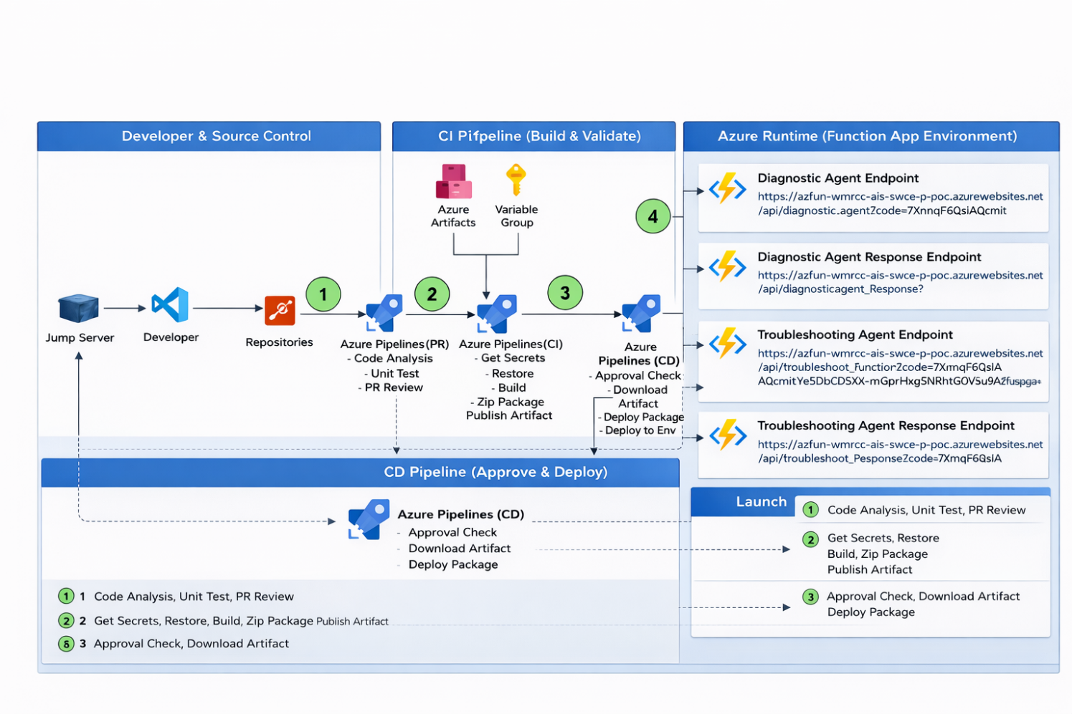

- Developer raises a pull request from feature branch to respective main branch of backend or frontend in Azure Repos
- Code is reviewed and merged with respective main branch of backend or frontend in Azure Repos
- CI/CD Pipeline is triggered with the main branch respective to environment in Azure CI/CD pipeline.
- Build pipeline prepares the build by following the steps in the pipeline using Azure agent i.e. Azure pipeline for DEV and custom self-hosted agent for QA and PROD
- The release pipeline will deploy the build to the respective Azure entities, i.e. the Azure function app for backend.
- Once the CI/CD pipeline is successfully completed, the deployment is validated in the Azure function app.
- After deployment is successful, QA tester will test the application manually respective to the deployed features or the changes.

Cross-cutting Architecture Perspectives

Security Architecture Perspective
We will be following the same approach on and security measures.

      - Addressed Security Requirements

Security Requirement | Brief Description | Approach to Address Security Requirements
Access Control and Management | - That the application has appropriate authentication mechanisms  - Authentication credentials are not hard-coded and allow rotation.  - Privileged Accounts are controlled and periodically reviewed.  - Adequate Application Access Control  - Define access controls to the various environments as part of the Architecture definition and description and ensure adherence / implementation to the descriptions.  - Solution supports user role-based access to system/ individual trials | .  - Users are authenticated against AD with their Teva global id.  - No hard-coded passwords in code. Keys are stored in Azure Key Vault.  - SSL/TLS encryption helps to secure data in IntelliAssist platform when the Information flows over different systems (UI and Backend API Calls).  - System does not have Admin roles or system management roles. All users within Teva intra-network with active Teva global id can access IntelliAssist.  - Users/System, can call All APIs with a valid token generated by AZURE AD.  - No System accounts in scope for the current release.  - No role-based access defined in the application
Encryption Management | - Ensure cryptography used for Blob storage compliant with Teva standards and defined as part of the design phase.  - System must be encryption enabled for data | - Enabled encryption AES-256 to the data stored in Azure Blob Storage  - The access to blob storage uses Managed Identity.
Network Security | - Platform is secured from external threats  - Put a formal architectural process in place.  - address network security monitoring  - consider threats detection within the network.  - Ensure that formal processes are in place and relevant Adequate End-point VPN design controls are implemented.  - Adequate end-point security  - The system must ensure the secure connection to the system or connection via interfaces. Strong authentication must be ensured. Strong authentication must be in place for system and interface access. | - IntelliAssist is deployed into Azure Platform.  - Only valid Teva users can access the System with valid IDs.  - Used the Azure platform’s predefined templates to create required Infrastructure/ Network  - Secured from external threats.  - Approved VPN/ firewall controls  - Secure connection with HTTPS
System Development & Operation | - Ensure Coding Standards and Policies are documented and followed.  - Formalize the testing / migration procedures and ensure tests are carried out and documented. | - SAST enabled in all environments and all Critical and High Impacted findings were addressed.
Logging and Monitoring | - All the system activities are monitored (login activity, administrator access etc.)  - Logs are captured in Azure EventHub

Performance & Scalability Architecture Perspective
IntelliFix Assist is deployed into Azure services where the app services are using standard tier chosen based on high availability and fast processing. In addition, the other system resources (Like automation account) can be increased manually, as needed.

Availability & Reliability Architecture Perspective
IntelliFix Assist Platform is deployed on Azure Functions which have specifications matching the application runtime requirement. The system is fully available and highly resilient for architectural components using Azure services.

Extensibility Architecture Perspective
The application will have releases based on a plan aligned with business. Application has a capability to extend the system's functionality without impacting the customer's tenant. Extensions can be made through the addition of new functionality or through modification of existing functionality. The principle provides enhancements without impairing existing system functions.
For any Teva specific integration requirements, IntelliFix Assist has the capability to extend the functionality through API integration. The UI/internal systems, as a customer, can consume those API services to fulfil the business requirements with the implementation of inbound and outbound integrations.

Architecture Decisions
IntelliFix Assist is deployed in Azure platform which includes additional services such as Function App with Durable Functions. This includes a qualified deployment model.

References
Secure Change requests:

Components Details:

