MACHINE LEARNING

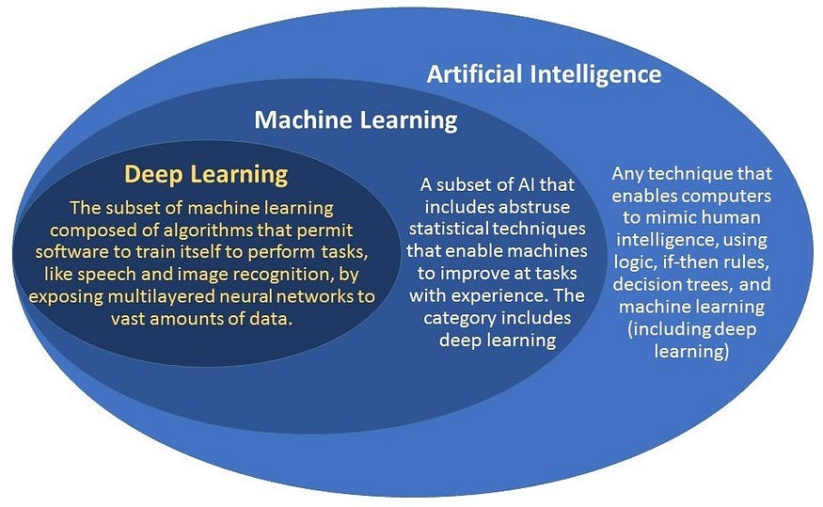

Machine learning (ML) is a field of study in artificial intelligence concerned with the development and study of statistical algorithms that can learn from data and generalize to unseen data, and thus perform tasks without being explicitly programmed.^{[1]} Advances in the field of deep learning have allowed neural networks, a class of statistical algorithms, to surpass many previous machine learning approaches in performance.
Statistics and mathematical optimisation methods compose the foundations of machine learning. Data mining is a related field of study, focusing on exploratory data analysis (EDA) through unsupervised learning

Machine learning approaches are traditionally divided into three broad categories, which correspond to learning paradigms, depending on the nature of the "signal" or "feedback" available to the learning system:
- Supervised learning: The computer is presented with example inputs and their desired outputs, given by a "teacher", and the goal is to learn a general rule that maps inputs to outputs.
- Unsupervised learning: No labels are given to the learning algorithm, leaving it on its own to find structure in its input. Unsupervised learning can be a goal in itself (discovering hidden patterns in data) or a means towards an end (feature learning).
- Reinforcement learning: A computer program interacts with a dynamic environment in which it must perform a certain goal (such as driving a vehicle or playing a game against an opponent). As it navigates its problem space, the program is provided rewards as feedback, which it tries to maximize, thus resulting in the program learning from experience
Supervised learning:
Supervised learning algorithms build a mathematical model of a set of data that contains both the inputs and the desired outputs.^{[46]} The data, known as training data, consists of a set of training examples. Each training example has one or more inputs and the desired output, also known as a supervisory signal. In the mathematical model, each training example is represented by an array or vector, sometimes called a feature vector, and the training data is represented by a matrix. Through iterative optimisation of an objective function, supervised learning algorithms learn a function that can be used to predict the output associated with new inputs.^{[47]} An optimal function allows the algorithm to correctly determine the output for inputs that were not a part of the training data. An algorithm that improves the accuracy of its outputs or predictions over time is said to have learned to perform that task.

Types of supervised-learning algorithms include active learning, classification and regression.^{[48]} Classification algorithms are used when the outputs are restricted to a limited set of values, while regression algorithms are used when the outputs can take any numerical value within a range. For example, in a classification algorithm that filters emails, the input is an incoming email, and the output is the folder in which to file the email. In contrast, regression is used for tasks such as predicting a person's height based on factors like age and genetics or forecasting future temperatures based on historical data.^{[49]}
Similarity learning is an area of supervised machine learning closely related to regression and classification, but the goal is to learn from examples using a similarity function that measures how similar or related two objects are. It has applications in ranking, recommendation systems, visual identity tracking, face verification, and speaker verification.
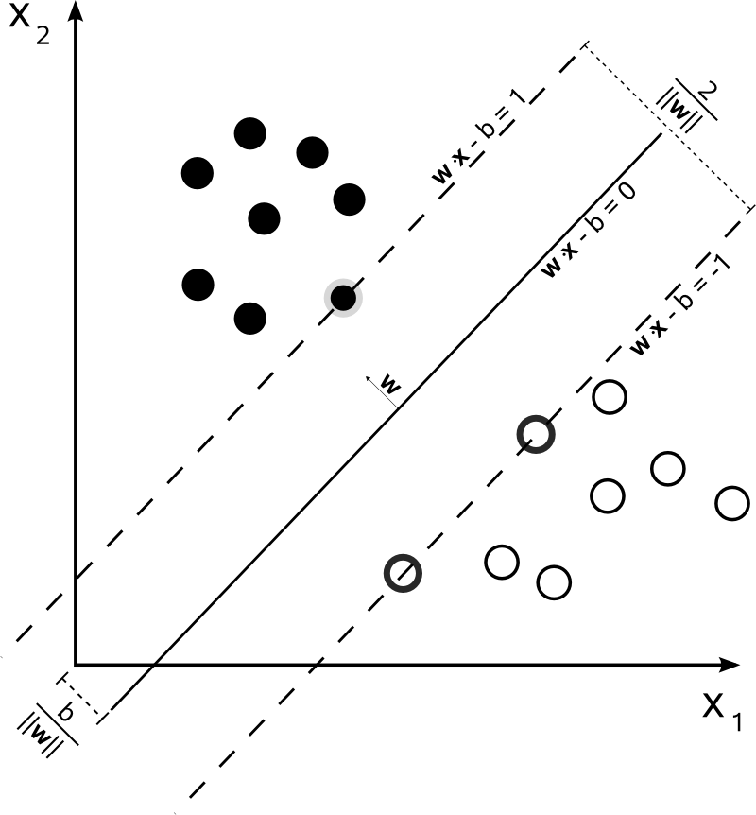
Unsupervised learning:
Unsupervised learning algorithms find structures in data that has not been labelled, classified or categorised. Instead of responding to feedback, unsupervised learning algorithms identify commonalities in the data and react based on the presence or absence of such commonalities in each new piece of data. Central applications of unsupervised machine learning include clustering, dimensionality reduction,^{[4]} and density estimation.^{[50]}
Cluster analysis is the assignment of a set of observations into subsets (called clusters) so that observations within the same cluster are similar according to one or more predesignated criteria, while observations drawn from different clusters are dissimilar. Different clustering techniques make different assumptions on the structure of the data, often defined by some similarity metric and evaluated, for example, by internal compactness, or the similarity between members of the same cluster, and separation, the difference between clusters. Other methods are based on estimated density and graph connectivity.
A special type of unsupervised learning called self-supervised learning involves training a model by generating the supervisory signal from the data itself.
Dimensionality reduction
Dimensionality reduction is a process of reducing the number of random variables under consideration by obtaining a set of principal variables.^{[53]} In other words, it is a process of reducing the dimension of the feature set, also called the "number of features". Most of the dimensionality reduction techniques can be considered as either feature elimination or extraction. One of the popular methods of dimensionality reduction is principal component analysis (PCA). PCA involves changing higher-dimensional data (e.g., 3D) to a smaller space (e.g., 2D). The manifold hypothesis proposes that high-dimensional data sets lie along low-dimensional manifolds, and many dimensionality reduction techniques make this assumption, leading to the areas of manifold learning and manifold regularisation.
Semi-supervised learning
Semi-supervised learning falls between unsupervised learning (without any labelled training data) and supervised learning (with completely labelled training data). Some of the training examples are missing training labels, yet many machine-learning researchers have found that unlabelled data, when used in conjunction with a small amount of labelled data, can produce a considerable improvement in learning accuracy.
In weakly supervised learning, the training labels are noisy, limited, or imprecise; however, these labels are often cheaper to obtain, resulting in larger effective training sets.

Reinforcement learning:
Reinforcement learning is an area of machine learning concerned with how software agents ought to take actions in an environment to maximise some notion of cumulative reward. Due to its generality, the field is studied in many other disciplines, such as game theory, control theory, operations research, information theory, simulation-based optimisation, multi-agent systems, swarm intelligence, statistics and genetic algorithms. In reinforcement learning, the environment is typically represented as a Markov decision process (MDP). Many reinforcement learning algorithms use dynamic programming techniques.^{[55]} Reinforcement learning algorithms do not assume knowledge of an exact mathematical model of the MDP and are used when exact models are infeasible. Reinforcement learning algorithms are used in autonomous vehicles or in learning to play a game against a human opponent.
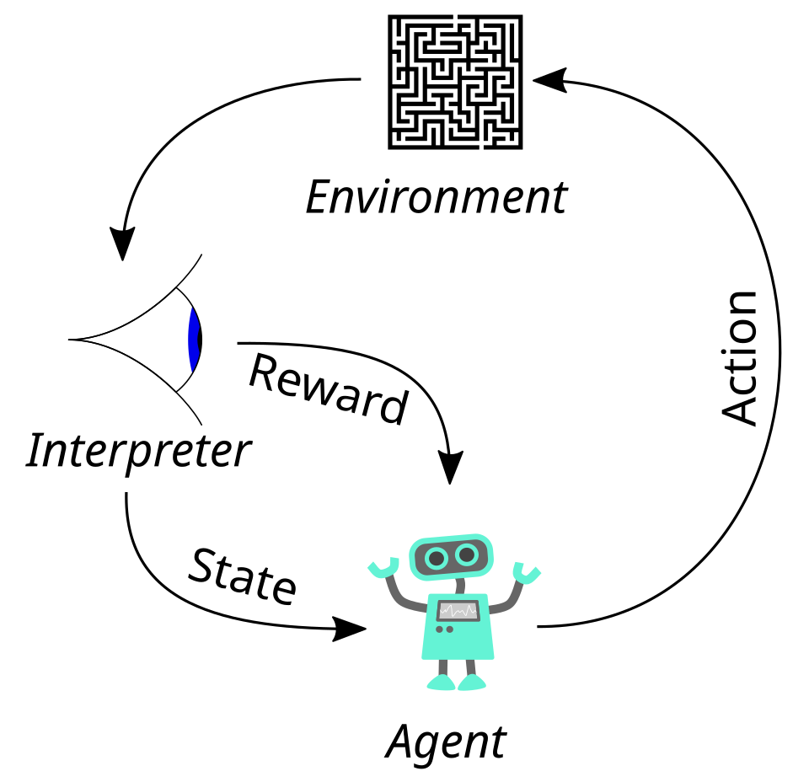
Feature learning:
Several learning algorithms aim at discovering better representations of the inputs provided during training.^{[61]} Classic examples include principal component analysis and cluster analysis. Feature learning algorithms, also called representation learning algorithms, often attempt to preserve the information in their input but also transform it in a way that makes it useful, often as a pre-processing step before performing classification or predictions. This technique allows reconstruction of the inputs coming from the unknown data-generating distribution, while not being necessarily faithful to configurations that are implausible under that distribution. This replaces manual feature engineering, and allows a machine to both learn the features and use them to perform a specific task.
Feature learning can be either supervised or unsupervised. In supervised feature learning, features are learned using labelled input data. Examples include artificial neural networks, multilayer perceptrons, and supervised dictionary learning. In unsupervised feature learning, features are learned with unlabelled input data. Examples include dictionary learning, independent component analysis, autoencoders, matrix factorisation^{[62]} and various forms of clustering.^{[63][64][65]}
Manifold learning algorithms attempt to do so under the constraint that the learned representation is low-dimensional. Sparse coding algorithms attempt to do so under the constraint that the learned representation is sparse, meaning that the mathematical model has many zeros. Multilinear subspace learning algorithms aim to learn low-dimensional representations directly from tensor representations for multidimensional data, without reshaping them into higher-dimensional vectors.^{[66]} Deep learning algorithms discover multiple levels of representation, or a hierarchy of features, with higher-level, more abstract features defined in terms of (or generating) lower-level features. It has been argued that an intelligent machine learns a representation that disentangles the underlying factors of variation that explain the observed data.^{[67]}
Feature learning is motivated by the fact that machine learning tasks such as classification often require input that is mathematically and computationally convenient to process. However, real-world data such as images, video, and sensory data have not yielded attempts to algorithmically define specific features. An alternative is to discover such features or representations through examination, without relying on explicit algorithms.

Regression analysis:
Regression analysis encompasses a large variety of statistical methods to estimate the relationship between input variables and their associated features. Its most common form is linear regression, where a single line is drawn to best fit the given data according to a mathematical criterion such as ordinary least squares. The latter is often extended by regularisation methods to mitigate overfitting and bias, as in ridge regression. When dealing with non-linear problems, go-to models include polynomial regression (for example, used for trendline fitting in Microsoft Excel^{[90]}), logistic regression (often used in statistical classification) or even kernel regression, which introduces non-linearity by taking advantage of the kernel trick to implicitly map input variables to higher-dimensional space.
Multivariate linear regression extends the concept of linear regression to handle multiple dependent variables simultaneously. This approach estimates the relationships between a set of input variables and several output variables by fitting a multidimensional linear model. It is particularly useful in scenarios where outputs are interdependent or share underlying patterns, such as predicting multiple economic indicators or reconstructing images,^{[91]} which are inherently multi-dimensional.
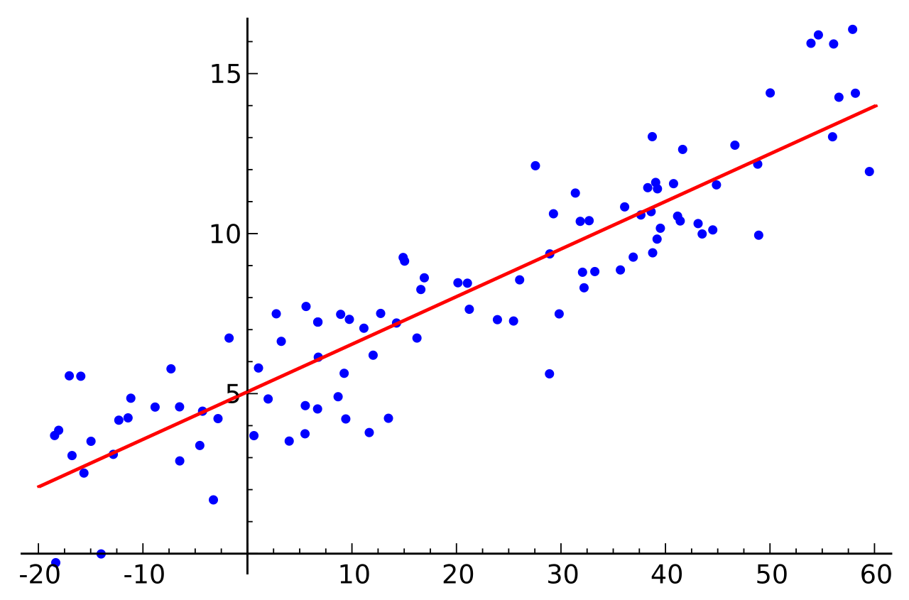

Applications:
There are many applications for machine learning, including:
- Agriculture
- Anatomy
- Adaptive website
- Affective computing
- Astronomy
- Automated decision-making
- Banking
- Behaviorism
- Bioinformatics
- Brain–machine interfaces
- Cheminformatics
- Citizen Science
- Climate Science
- Computer networks
- Computer vision
- Credit-card fraud detection
- Data quality
- DNA sequence classification
- Economics
- Financial data analysis^{[102]}
- General game playing
- Handwriting recognition
- Healthcare
- Information retrieval
- Insurance
- Internet fraud detection
- Investment management^{[103]}
- Knowledge graph embedding
- Linguistics
- Machine learning control
- Machine perception
- Machine translation
- Material Engineering
- Marketing
- Medical diagnosis
- Natural language processing
- Natural language understanding
- Online advertising
- Optimisation
- Recommender systems
- Robot locomotion
- Search engines
- Sentiment analysis
- Sequence mining
- Software engineering
- Speech recognition
- Structural health monitoring
- Syntactic pattern recognition
- Telecommunications
- Theorem proving
- Time-series forecasting
- Tomographic reconstruction^{[104]}
- User behaviour analytics
In 2006, the media-services provider Netflix held the first "Netflix Prize" competition to find a program to better predict user preferences and improve the accuracy of its existing Cinematch movie recommendation algorithm by at least 10%. A joint team made up of researchers from AT&T Labs-Research in collaboration with the teams Big Chaos and Pragmatic Theory built an ensemble model to win the Grand Prize in 2009 for $1 million.^{[105]} Shortly after the prize was awarded, Netflix realised that viewers' ratings were not the best indicators of their viewing patterns ("everything is a recommendation") and they changed their recommendation engine accordingly.^{[106]} In 2010, an article in The Wall Street Journal noted the use of machine learning by Rebellion Research to predict the 2008 financial crisis.^{[107]} In 2012, co-founder of Sun Microsystems, Vinod Khosla, predicted that 80% of medical doctors jobs would be lost in the next two decades to automated machine learning medical diagnostic software.^{[108]} In 2014, it was reported that a machine learning algorithm had been applied in the field of art history to study fine art paintings and that it may have revealed previously unrecognised influences among artists.^{[109]} In 2019 Springer Nature published the first research book created using machine learning.^{[110]} In 2020, machine learning technology was used to help make diagnoses and aid researchers in developing a cure for COVID-19.^{[111]} Machine learning was recently applied to predict the pro-environmental behaviour of travellers.^{[112]} Recently, machine learning technology was also applied to optimise smartphone's performance and thermal behaviour based on the user's interaction with the phone.^{[113][114][115]} When applied correctly, machine learning algorithms (MLAs) can utilise a wide range of company characteristics to predict stock returns without overfitting. By employing effective feature engineering and combining forecasts, MLAs can generate results that far surpass those obtained from basic linear techniques like OLS.^{[116]}
Recent advancements in machine learning have extended into the field of quantum chemistry, where novel algorithms now enable the prediction of solvent effects on chemical reactions, thereby offering new tools for chemists to tailor experimental conditions for optimal outcomes.^{[117]}
Machine Learning is becoming a useful tool to investigate and predict evacuation decision-making in large-scale and small-scale disasters. Different solutions have been tested to predict if and when householders decide to evacuate during wildfires and hurricanes.^{[118][119][120]} Other applications have been focusing on pre evacuation decisions in building fires.^{[121][122]}
Limitations:
Although machine learning has been transformative in some fields, machine-learning programs often fail to deliver expected results.^{[123][124][125]} Reasons for this are numerous: lack of (suitable) data, lack of access to the data, data bias, privacy problems, badly chosen tasks and algorithms, wrong tools and people, lack of resources, and evaluation problems.
The "black box theory" poses another yet significant challenge. Black box refers to a situation where the algorithm or the process of producing an output is entirely opaque, meaning that even the coders of the algorithm cannot audit the pattern that the machine extracted from the data. The House of Lords Select Committee, which claimed that such an "intelligence system" that could have a "substantial impact on an individual's life" would not be considered acceptable unless it provided "a full and satisfactory explanation for the decisions" it makes.
In 2018, a self-driving car from Uber failed to detect a pedestrian, who was killed after a collision.^{[128]} Attempts to use machine learning in healthcare with the IBM Watson system failed to deliver even after years of time and billions of dollars invested. Microsoft's Bing Chat chatbot has been reported to produce hostile and offensive response against its users.
Machine learning has been used as a strategy to update the evidence related to a systematic review and increased reviewer burden related to the growth of biomedical literature. While it has improved with training sets, it has not yet developed sufficiently to reduce the workload burden without limiting the necessary sensitivity for the findings research itself.

HONDA CITY
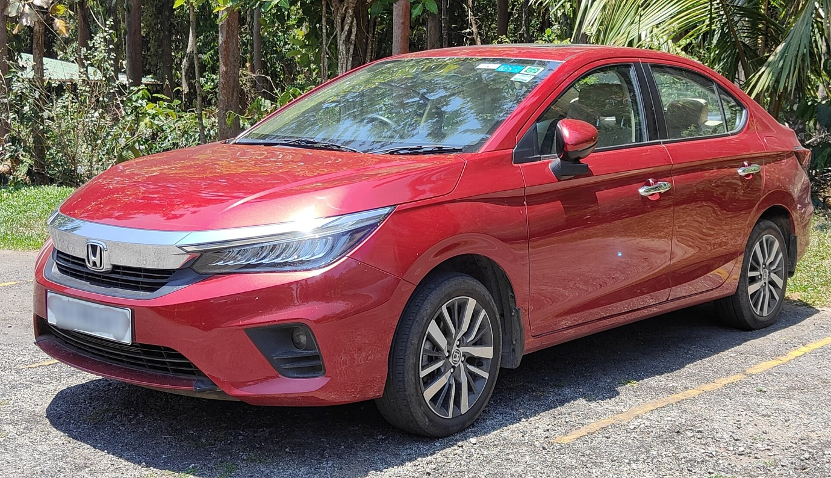

The Honda City (Japanese: ホンダ・シティ, Hepburn: Honda Shiti) is a subcompact car which has been produced by the Japanese manufacturer Honda since 1981.
The City was originally a three-door hatchback for the Japanese, European, and Australasian markets. The three-door City was retired in 1995 after the second-generation and replaced by the Logo. The nameplate was revived in 1996 for use on a series of subcompact four-door sedans aimed primarily at developing markets,^{[a]} first mainly sold in Asia but later also in Latin America and Australia. Since then, it has been a subcompact sedan built on Honda's Global Small Car platform, which is shared with the Fit/Jazz (a 5-door hatchback), the Airwave/Partner, and the first-generation Mobilio — all of which share the location of the fuel tank under the front seats rather than rear seats. The seventh-generation model launched in 2019 features a significant size growth, offering an exterior dimension on par with the ninth-generation Civic sedan. This generation also marks the introduction of the five-door hatchback model starting from 2020.

Asia & Middle East
Year | Thailand^{[147]} |  | Indonesia^{[148]} |  | Philippines |  | Malaysia^{[149]} | Vietnam | India^{[150]} | Pakistan | Turkey
 | Sedan | Hatch | Sedan | Hatch | Sedan | Hatch
1996 |  |  | 953 | —
1997 |  |  | 1,956
1998 | 5,998 |  | 233 |  |  |  |  |  | 8,249 | 5,647
1999 | 9,394 |  | 219 |  |  |  |  |  | 8,963
2000 | 11,950 |  | 4,635 |  |  |  | 1,869 |  | 10,555
2001 | 15,415 |  | 2,957 |  |  |  | 731 |  | 9,224
2002 | 17,333 |  | 1,606 |  |  |  | 709 |  | 11,842
2003 | 27,341 |  | 7,680 |  |  |  | 8,141 |  | 14,367
2004 | 14,498 |  | 8,330 |  |  |  | 9,783 |  | 30,834
2005 | 15,389 |  | 7,475 |  |  |  | 11,440 |  | 35,163
2006 | 18,889 |  | 5,865 |  |  |  | 11,609 |  | 42,570
2007 |  |  | 6,002 |  |  |  | 9,713
2008 |  |  | 4,330 |  |  |  | 9,747
2009 | 35,155 |  | 2,526 |  |  |  | 19,726 |  | 46,810
2010 | 49,030 |  | 3,581 |  |  |  | 19,949
2011 | 32,091 |  | 1,636 |  |  |  | 10,997 |  | 35,931
2012 | 74,656 |  | 2,128 |  |  |  | 13,196 |  | 32,404
2013 | 73,045 |  | 2,974 |  |  |  | 17,584 |  | 21,530
2014 | 44,444 |  | 1,983 |  | 8,212 |  | 36,684 | 2,944^{[151]} | 77,346
2015 | 33,165 |  | 1,818 |  | 7,905 |  | 38,119 | 3,186^{[152]} | 82,922
2016 | 26,463 |  | 1,213 |  | 8,722 |  | 29,531 | 5,780^{[153]} | 57,619
2017 | 34,955 |  | 1,024 |  | 9,630 |  | 30,854 | 12,001^{[154]} | 62,573
2018 | 34,358 |  | 720 |  | 5,683 |  | 35,698 | 14,618^{[155]} | 42,045
2019 | 32,023 |  | 450 |  | 5,717^{[156]} |  | 31,374 | 12,211^{[157]} | 28,696^{[158]} | 15,987
2020 | 35,807^{[159]} |  | 169 |  | 3,094^{[160]} |  | 20,742 | 5,589^{[161]} | 21,826^{[162]} | 10,586
2021 | 25,171^{[163]} | 16,932^{[163]} | 70 | 9,642^{[164]} | 3,957^{[165]} | 392 | 18,977 | 9,745^{[166]} | 34,133^{[167]} | 15,300 | 2,835
2022 | 23,447^{[168][169]} | 21,467^{[170][171]} | 630 | 6,197 |  |  | 45,369 | 14,696^{[172]} | 35,209^{[173]} |  | 9,445^{[174]}
2023 | 19,797^{[175][176]} | 19,587^{[177][178]} | 300 | 2,880 | 3,363^{[179]} | 760^{[179]} | 33,567 | 9,894^{[180]} | 20,216 |  | 9,015
2024 | 15,448^{[181]} | 17,984^{[182]} | 31 | 394 |  |  | 29,246 | 10,500^{[183]} | 11,526
2025 | 12,066^{[184]} | 16,690^{[185]} | 0 | 454 |  |  | 27,107 | 10,899 | 8,109

India
The City sedan was unveiled and launched officially as Honda City 5th Generation in India on 16 July 2020. It was sold alongside the old model which continued to be produced there.^{[100]} The Indian-market City is offered in three trim levels – V, VX and ZX – with a choice of petrol and diesel 1.5-litre four-cylinder engines. The petrol engine uptrimd i-VTEC unit with DOHC (previously SOHC), with the other being an i-DTEC turbo-diesel. Both engines are paired with a 6-speed manual transmission as standard, with the CVT option only available for the petrol version.
All trim levels are fitted with ESC, rear ISOFIX anchorages, neck restraints and three-point seatbelts for all five passengers, dual front airbags, front torso-protecting side airbags, traction control and hill start assistance as standard, the VX and ZX trim levels are equipped with head-protecting curtain airbags, and the ZX trim is fitted with a blind spot monitor.
For the first time, the top-spec City is equipped with Honda's LaneWatch camera system. Other notable features include 8.0-inch touchscreen audio system with Alexa remote capability and support for Android Auto and Apple CarPlay, 7.0-inch digital instrument cluster display, and sunroof.^{[101]}
Honda Cars India announced the market launch of the City e:HEV in April 2022. This powertrain is expected to be available on the ZX trim. In addition, this trim is the first Honda model in India to offer Honda Sensing which includes safety assist technologies.^{[102]}
The first-facelifted City was launched on 2 March 2023 in both petrol and e:HEV engines.^{[103]} The petrol engine is available in four trim levels: SV, V, VX and ZX, while the e:HEV engine is available in two trim levels: V and ZX.^{[104]} The City also gets Honda Sensing which includes safety assist technologies in both and Wireless Charging, while the i-DTEC turbo-diesel engine was discontinued from the lineup due to poor sales.^{[105]} The car sold less than half of the figure for FY23 in FY24.This was attributed to rising consumer preference for SUVs.^{[106]}
The second-facelifted City was launched, alongside the ZR-V on 22 May 2026.
Safety
Global NCAP
Global NCAP 1.0 test results
(India)
Honda City (4th Gen) – 2 Airbags
(H1 2022, similar to Latin NCAP 2013)^{[65]}
Test | Score | Stars
Adult occupant protection | 12.03/17.00
Child occupant protection | 38.27/49.00

India
The sixth-generation City was unveiled in India on 25 November 2013 and is available with a choice of two engines; a new 1.5-litre Earth Dreams i-DTEC turbodiesel and a refined version of the 1.5-litre i-VTEC petrol. The new 1.5-litre turbo-diesel engine, which also powers the Honda Amaze.^{[43]}
Honda launched the sixth-generation City in India on 7 January 2014.^{[44]} The sixth-generation City is available in five trim levels – E, S, SV, V and VX for both petrol and diesel. The petrol automatic is available in SV and VX trim levels.^{[45]} While the City has always been a popular offering of Honda in India, its sales doubled after it was launched with a diesel engine.
In March 2015, the City became the fastest selling compact sedan to reach the 100,000 mark in just 15 months and is locally assembled with roughly 90% local parts.^{[46][47]}
From April 2015, the City is available with an additional trim levels: VX (O). It is positioned above the VX.^{[48][49]}
In 2017, with the facelift, Honda launched a new top-of-the-line ZX trim in India which comes with 6 airbags, rear parking camera and Honda's digipad infotainment system. The facelifted City also comes with full LED headlamps and tail lamps and also a sunroof. Over 10,000 orders were received in less than a month after the facelifted 2017 City was released in mid-February 2017.^{[50]} The City became India's best selling compact sedan for the first half of 2017.

Third generation
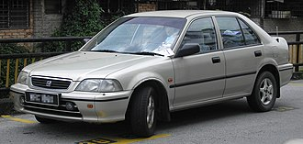
Honda City (pre-facelift, Malaysia)
Overview
Model code | - 3A2  - 3A3  - SX8
Production | 1996–2002
Assembly | - Thailand: Ayutthaya  - Indonesia: North Jakarta  - Philippines: Santa Rosa, Laguna  - Taiwan: Hsinchu (Sanyang Motor)  - India: Greater Noida (HSCI)  - Pakistan: Lahore (HACP)  - Malaysia: Johor Bahru (Kah Motor Co.)
Body and chassis
Body style | 4-door sedan
Layout | Front-engine, front-wheel drive
Platform | 3A2/3A3
Related | Honda Civic (fourth generation)
Powertrain
Engine | Petrol:  1.3 L D13B I4  1.5 L D15B I4  1.5 L D15B VTEC I4
Transmission | 5-speed manual  4-speed automatic
Dimensions
Wheelbase | 2,500 mm (98.4 in)
Length | 4,225 mm (166.3 in)
Width | 1,690 mm (66.5 in)
Height | 1,395 mm (54.9 in)
Curb weight | 940–985 kg (2,072–2,172 lb)

Fourth generation
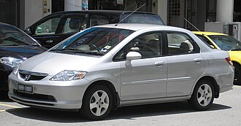
Honda City (pre-facelift, Malaysia)
Overview
Model code | - GD6  - GD7  - GD8  - GD9  - GE1  - GE4
Also called | Honda Fit Aria (Japan)  Honda Fit Saloon (China, 2003–2006)  Everus S1 (China)
Production | 2002–2008  2011–2014 (Everus S1)
Assembly | - China: Guangzhou (Guangqi Honda, JDM and Far East models only)  - India: Greater Noida (HSCI, South Asia models only)  - Malaysia: Alor Gajah, Malacca (Oceanica models only)  - Pakistan: Lahore (HACP, West Asia and Middle East models only)  - Philippines: Santa Rosa, Laguna (East Asia models only)  - Thailand: Ayutthaya  - Turkey: Şekerpınar, Çayırova, Kocaeli (Honda Türkiye, Europe and Turkey domestic market models only)
Body and chassis
Body style | 4-door sedan
Layout | Front-engine, front-wheel drive (GD6/GD8)  Front-engine, all-wheel-drive (GD7/GD9)
Related | Honda Fit/Jazz (first generation)  Honda Airwave
Powertrain
Engine | - Petrol:  - 1.3 L L13A i-DSI I4  - 1.5 L L15A2 i-DSI I4  - 1.5 L L15A1 VTEC I4  - 2.0 L K20A I4 (Type-S)
Transmission | - 5-speed manual  - CVT (7-speed Multimatic)
Dimensions
Wheelbase | 2,450 mm (96.5 in)
Length | 4,390 mm (172.8 in)
Width | 1,690 mm (66.5 in)
Height | 1,485 mm (58.5 in)
Curb weight | 1,190 kg (2,624 lb)
Chronology
Predecessor | Honda Domani (Japan)  Honda Integra SJ (1996–2001) / Isuzu Vertex (Thailand)
Successor | Honda Insight (second generation) (Japan)

Fifth generation
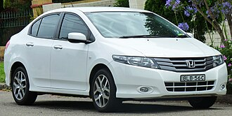
Overview
Model code | - GM2  - GM3
Also called | Honda Ballade (South Africa)
Production | 2008–2013  2011–2014 (Argentina)  2009–2021 (Pakistan)
Assembly | - Thailand: Ayutthaya  - Malaysia: Alor Gajah, Malacca  - Philippines: Santa Rosa, Laguna  - China: Guangzhou (Guangqi Honda, JDM and Far East models only)  - India: Greater Noida (HSCI/HCIL, South Asia models only)  - Pakistan: Lahore (HACP, West Asia and Middle East models only)  - Turkey: Çayırova, Kocaeli (Honda Türkiye, Europe and Turkey models only)  - Brazil: Sumaré, São Paulo (Central America models only)  - Argentina: Campana, Buenos Aires (South America models only)
Body and chassis
Body style | 4-door sedan
Layout | Front-engine, front-wheel-drive
Related | Honda Fit/Jazz (second generation)  Honda Freed (first generation)  Honda Insight (second generation)
Powertrain
Engine | - Petrol:  - 1.3 L L13Z1 I4  - 1.5 L L15A7 I4  - 1.8 L R18A I4  - Petrol/CNG:  - 1.5 L L15A I4  - Diesel:  - 1.5 L N15 I4 turbo
Transmission | 5-speed manual  5-speed automatic
Dimensions
Wheelbase | 2,550 mm (100.4 in)
Length | 4,420 mm (174.0 in)
Width | 1,695 mm (66.7 in)
Height | 1,470 mm (57.9 in)
Curb weight | 1,095–1,155 kg (2,414–2,546 lb)

Sixth generation
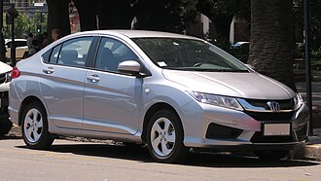
2016 Honda City LX (pre-facelift, Chile)
Overview
Model code | - GM4  - GM5  - GM6  - GM8  - GM9
Also called | Honda Grace (Japan)  Honda Ballade (South Africa)  Honda Greiz (China)  Honda Gienia (China, liftback variant)
Production | November 2013 – 2023  2014 – August 2020 (Japan)  2015–2019 (China)  2021–present (Pakistan)^{[34]}
Assembly | - Japan: Yorii, Saitama  - Thailand: Ayutthaya  - Malaysia: Alor Gajah, Malacca  - Philippines: Santa Rosa, Laguna  - Vietnam: Vĩnh Phúc  - China: Guangzhou (Guangqi Honda) (City, domestic); Guangzhou (CHAC) (City, export); Wuhan (Dongfeng Honda) (Greiz/Gienia)  - Taiwan: Pingtung  - India: Greater Noida (HCIL)  - Pakistan: Lahore (HACP)  - Brazil: Sumaré, São Paulo
Designer | Jun Goto and Toshinobu Minami (pre-facelift)^{[35]}
Body and chassis
Body style | 4-door sedan  5-door liftback (Gienia)
Layout | Front-engine, front-wheel-drive  Front-engine, all-wheel-drive (Grace, Japan only)
Related | Honda Fit/Jazz (third generation)  Honda HR-V (second generation)  Honda Freed (second generation)  Honda WR-V (first generation)  Honda Crider (first generation)
Powertrain
Engine | - Petrol:  - 1.2 L L12B I4 (Pakistan)  - 1.5 L L15Z1 I4  - 1.5 L L15Z1 FFV I4 (Thailand)  - Petrol hybrid:  - 1.5 L LEB-H1 I4  - Petrol/CNG:  - 1.5 L L15A I4  - Diesel:  - 1.5 L N15A I4 turbo
Electric motor | 29.5 PS (22 kW; 29 hp) Honda H1 Electric Motor Sport Hybrid i-DCD
Transmission | 5-speed manual  6-speed manual  7-speed DCT  CVT
Hybrid drivetrain | Honda's Intelligent-Dual Clutch Drive (i-DCD) (City / Grace Hybrid)
Dimensions
Wheelbase | 2,600 mm (102.4 in)
Length | 4,442 mm (174.9 in)  4,495 mm (177.0 in) (Greiz)  4,517 mm (177.8 in) (Gienia)
Width | 1,694 mm (66.7 in)  1,705 mm (67.1 in) (Greiz and Gienia)
Height | 1,477 mm (58.1 in)  1,489 mm (58.6 in) (Gienia)
Curb weight | 1,029–1,165 kg (2,269–2,568 lb)  1,109–1,178 kg (2,445–2,597 lb) (Gienia)
Chronology
Predecessor | Honda Insight (second generation) (Japan)
Successor | Honda Fit e:HEV (Japan)  Honda Insight (third generation) (Japan)

Seventh generation
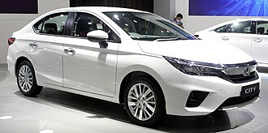
2022 Honda City (pre-facelift)
Overview
Model code | - GN1  - GN2  - GN3  - GN5  - GN6  - GN7
Also called | Honda Ballade (South Africa, sedan, until 2025)^{[70]}
Production | 2019–present
Assembly | - Thailand: Ayutthaya; Prachinburi  - India: Tapukara (HCIL)  - Malaysia: Alor Gajah, Malacca  - Vietnam: Vĩnh Phúc (Honda Ô tô Vĩnh Phúc)  - Indonesia: Karawang, West Java (HPM, until 2025)^{[71]}  - Brazil: Sumaré, São Paulo
Designer | Norihito Ōnuma^{[72]}  Taishi Ogawa (hatchback)^{[73]}
Body and chassis
Body style | - 4-door sedan  - 5-door hatchback^{[74]}
Layout | Front-engine, front-wheel-drive
Platform | Honda Global Small Car^{[75]}
Related | - Honda Elevate/WR-V  - Honda Fit/Jazz/Life (fourth generation)  - Honda HR-V/Vezel (third generation)
Powertrain
Engine | - Petrol:  - 1.0 L P10A6 I3 turbo (Thailand)  - 1.5 L L15Z1C I4  - 1.5 L L15ZF I4  - Petrol hybrid:  - 1.5 L LEB8 Atkinson cycle i-MMD I4  - 1.5 L LEB-H5 Atkinson cycle i-MMD I4  - Diesel:  - 1.5 L N15 I4 turbo (India)
Electric motor | 79 kW (107 PS; 106 hp) AC PMSM
Transmission | - 6-speed manual  - CVT  - eCVT (hybrid)
Hybrid drivetrain | Sport Hybrid i-MMD (City e:HEV)
Dimensions
Wheelbase | 2,589–2,600 mm (101.9–102.4 in)
Length | - 4,553 mm (179.3 in) (sedan)  - 4,345 mm (171.1 in) (hatchback)
Width | 1,748 mm (68.8 in)
Height | 1,467–1,489 mm (57.8–58.6 in)^{[76]}
Curb weight | 1,065–1,217 kg (2,348–2,683 lb)
Chronology
Predecessor | Honda Fit/Jazz (third generation) (hatchback, Southeast Asia and South America)^{[77][78]}

Chassis code | Model | Engine | Power |  | Torque | Transmissions
Petrol engines
GN1 (sedan)  GN7 (hatchback) | 1.0 L VTEC Turbo P10A6 | 988 cc turbocharged I3 | 122 PS (90 kW; 120 hp) @ 5,500 rpm |  | 173 N⋅m (128 lb⋅ft) @ 2,000–4,500 rpm | CVT
GN2 (sedan)  GN5 (hatchback) | 1.5 L i-VTEC DOHC L15ZD/L15ZE/L15ZF | 1,498 cc I4 | 121 PS (89 kW; 119 hp) @ 6,600 rpm |  | 145 N⋅m (107 lb⋅ft) @ 4,300 rpm | 6-speed manual  CVT
GN3 (sedan)  GN6 (hatchback) | 1.5 L e:HEV LEB-H5 / LEB8 | 1,497 cc Atkinson cycle hybrid I4 | Engine power | 98 PS (72 kW; 97 hp) @ 5,600–6,400 rpm | 127 N⋅m (94 lb⋅ft) @ 4,500–5,000 rpm | eCVT
 |  |  | Electric motor | 109 PS (80 kW; 108 hp) @ 4,000–8,000 rpm | 253 N⋅m (187 lb⋅ft) @ 0–3,000 rpm
Diesel engine
GN4 | 1.5 L i-DTEC N15 | 1,498 cc turbocharged I4 | 99 PS (73 kW; 98 hp) @ 3,600 rpm |  | 200 N⋅m (150 lb⋅ft) @ 1,750 rpm | 6-speed manual

BENGAL TIGER
The Bengal tiger is a population of the Panthera tigris tigris subspecies. It ranks among the largest of wild cats. It is distributed from India, southern Nepal, Bangladesh, Bhutan to Southwestern China. Its historical range extended to the Indus Basin until the early 19th century, and it is thought to have been present in the Indian subcontinent since the Late Pleistocene about 12,000 to 16,500 years ago. It is threatened by poaching, habitat loss and habitat fragmentation.
As of 2022, the Bengal tiger population was estimated at 3,167–3,682 individuals in India, 316–355 individuals in Nepal, 131 individuals in Bhutan and around 125 individuals in Bangladesh. It is the national animal of India and Bangladesh.
Bengal tiger
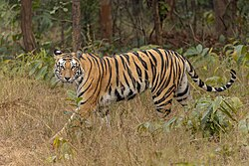
Bengal tiger in Sanjay National Park
Scientific classification
Kingdom: | Animalia
Phylum: | Chordata
Class: | Mammalia
Infraclass: | Placentalia
Order: | Carnivora
Family: | Felidae
Genus: | Panthera
Species: | P. tigris
Subspecies: | P. t. tigris
Population: | Bengal tiger
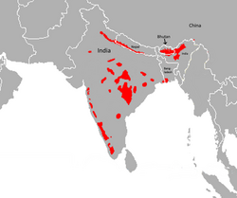
Range of Bengal tiger in red

Characteristics
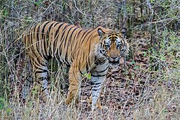
A tiger in Bandhavgarh National Park, Madhya Pradesh
The Bengal tiger's coat is yellow to light orange, with stripes ranging from dark brown to black; the belly and the interior parts of the limbs are white, and the tail is orange with black rings. The white tiger is a recessive mutant, which is reported in the wild from time to time in Assam, Bengal, Bihar and especially in the former State of Rewa. However, it is not an occurrence of albinism. In fact, only one fully authenticated case of a true albino tiger is known, and there are no confirmed cases of black tigers, except for a possible specimen examined in Chittagong in 1846. Fourteen Bengal tiger skins in the collection of the Natural History Museum, London have 21–29 stripes.^{[3]} Another recessive mutant is the golden tiger that has a pale golden fur with red-brown stripes.^{[10]} The mutants are very rare in nature.^{[11]}
The greatest skull length of a tiger is 351 mm (13.8 in) in males and 293 mm (11.5 in) in females.^{[12]} It has exceptionally stout teeth. Its canines are 7.5 to 10 cm (3.0 to 3.9 in) long and thus the longest among all cats.
Body weight and size
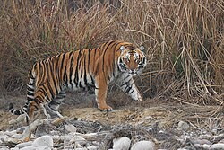
A male tiger in Jim Corbett National Park, Uttarakhand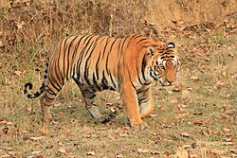
A tiger in Kanha National Park, Madhya Pradesh
The Bengal tiger ranks among the biggest wild cats alive. Males and female Bengal tigers in Panna Tiger Reserve reach a head-to-body length of 183–211 cm (72–83 in) and 164–193 cm (65–76 in) respectively, including a tail about 85–110 cm (33–43 in) long. Total length ranges from 283 to 311 cm (111 to 122 in) for male tigers and 255–285 cm (100–112 in) for female tigers. They typically range from 90–110 cm (35–43 in) in shoulder height.
Subadult males weigh between 130 and 170 kg (290 and 370 lb) and reach 200–260 kg (440–570 lb) when adult; subadult females weigh 80–100 kg (180–220 lb) and reach between 110 and 180 kg (240 and 400 lb) when adult. In central India, 42 adult male Bengal tigers weighed on average 190 kg (420 lb) with a range of 167–234 kg (368–516 lb); their total length was 282 cm (111 in) with a range of 267–312 cm (105–123 in), and their average shoulder height was 99 cm (39 in); 39 adult female Bengal tigers weighed an average of 132 kg (291 lb) with a maximum of 156 kg (344 lb) and an average total length of 254 cm (100 in) ranging from 239 to 277 cm (94 to 109 in). Several scientists indicated that adult male Bengal tigers in the Terai consistently attain more than 227 kg (500 lb) of body weight. Seven adult males captured in Chitwan National Park in the early 1970s had an average weight of 235 kg (518 lb) ranging from 200 to 261 kg (441 to 575 lb), and that of the females averaged 140 kg (310 lb) ranging from 116 to 164 kg (256 to 362 lb).^{[19]} Two male tigers captured in Chitwan National Park in the 1980s exceeded weights of 270 kg (600 lb) and are the largest free ranging tigers reported to date.^{[20]}
The smallest recorded weights for Bengal tigers are from the Bangladesh Sundarbans, where adult females weigh 75–80 kg (165–176 lb).^{[21]} Three tigresses from the Bangladesh Sundarbans had a mean weight of 76.7 kg (169 lb). The oldest female weighed 75 kg (165 lb) and was in a relatively poor condition at the time of capture. Their skulls and body weights were distinct from those of tigers in other habitats, indicating that they may have adapted to the unique conditions of the mangrove habitat. Their small sizes are probably due to a combination of intense intraspecific competition and small size of prey available to tigers in the Sundarbans, compared to the larger deer and other prey available to tigers in other parts.^{[22]}
The very large "Leeds Tiger" on display at Leeds City Museum, shot in 1860 near Mussoorie, had a body length of 371 cm (12 ft 2 in) at death. Two tigers shot in Kumaon District and near Oude at the end of the 19th century allegedly measured more than 370 cm (12 ft). But at the time, sportsmen had not yet adopted a standard system of measurement; some measured 'between the pegs' while others measured 'over the curves'.^{[23]} The greatest length of a tiger skull measured 41.3 cm (16.25 in) "over the bone"; this one was shot in the vicinity of Nagina in northern India.^{[24]}
In the beginning of the 20th century, a male tiger was shot in central India with a head and body length of 221 cm (87 in) between pegs, a chest girth of 150 cm (59 in), a shoulder height of 109 cm (43 in) and a tail length of 81 cm (32 in), which was perhaps bitten off by a rival male. This specimen could not be weighed, but it was estimated to weigh about 272 kg (600 lb).^{[18]} A male weighing 259 kg (570 lb) was shot in northern India in the 1930s.^{[24]} A male tiger shot in Nepal weighed 320 kg (710 lb) and measured 328 cm (10 ft 9 in) 'over the curves'.^{[25]} The heaviest wild tiger was possibly a male killed in 1967 in the foothills of the Himalayas that measured 323 cm (127 in) between pegs and 338 cm (133 in) over curves; it weighed 388.7 kg (857 lb) after eating a buffalo calf. Without eating the calf, it would have likely weighed about 324.3 kg (715 lb).^{[26]} In the Central Provinces of India, a male tiger shot weighed 317 kg (699 lb) and measured 3.02 m (9 ft 11 in).^{[27]}
The Bengal tiger rivals the Siberian tiger in average weight.

Ecology and behaviour
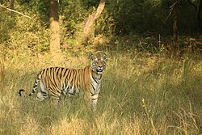

A tigress in Bandhavgarh National Park
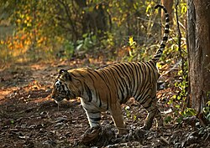
A tiger marking territory in Tadoba National Park
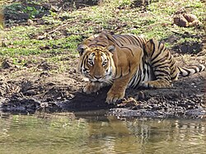
A tiger drinking from a pond in Mudumalai National Park
The basic social unit of the tiger is composed of a female and her offspring. Adult animals congregate only temporarily when special conditions permit, such as plentiful supplies of food. Otherwise, they lead solitary lives, hunting individually for the forest and grassland animals upon which they prey. Resident adults of either sex maintain home ranges, confining their movements to definite habitats within which they satisfy their needs and those of their cubs, which include prey, water and shelter. In this site, they also maintain contact with other tigers, especially those of the opposite sex. Those sharing the same ground are well aware of each other's movements and activities.^{[9]} In Chitwan National Park, radio-collared subadult tigers started dispersing from their natal areas earliest at the age of 19 months. Of the 14 subadults studied, the four females stayed closer to their mother's home range than the 10 males. The latter dispersed between 9.5 and 65.7 km (5.9 and 40.8 mi). None of them crossed open cultivated areas that were more than 10 km (6.2 mi) wide, but moved through prime alluvial and forested habitat.
In the Panna Tiger Reserve, an adult radio-collared male tiger moved 1.7 to 10.5 km (1.1 to 6.5 mi) between locations on successive days in winter, and 1 to 13.9 km (0.62 to 8.64 mi) in summer. His home range was about 200 km² (77 sq mi) in summer and 110 km² (42 sq mi) in winter. Included in his home range were the much smaller home ranges of two females, a tigress with cubs and a subadult tigress. They occupied home ranges of 16 to 31 km² (6.2 to 12.0 sq mi).
The home ranges occupied by adult male residents tend to be mutually exclusive, even though one of these residents may tolerate a transient or sub-adult male at least for a time. A male tiger keeps a large territory in order to include the home ranges of several females within its bounds, so that he may maintain mating rights with them. Spacing among females is less complete. Typically there is partial overlap with neighbouring female residents. They tend to have core areas, which are more exclusive, at least for most of the time. Home ranges of both males and females are not stable. The shift or alteration of a home range by one animal is correlated with a shift of another. Shifts from less suitable habitat to better ones are made by animals that are already resident. New animals become residents only as vacancies occur when a former resident moves out or dies. There are more places for resident females than for resident males.
During seven years of camera trapping, tracking, and observational data in Chitwan National Park, six to nine breeding tigers, two to sixteen non-breeding tigers, and six to twenty young tigers of less than one year of age were detected in the study area of 100 km² (39 sq mi). One of the resident females left her territory to one of her female offspring and took over an adjoining area by displacing another female; and a displaced female managed to re-establish herself in a neighbouring territory made vacant by the death of the resident. Of 11 resident females, 7 were still alive at the end of the study period, two disappeared after losing their territories to rivals, and two died. The initial loss of two resident males and subsequent take over of their home ranges by new males caused social instability for two years. Of four resident males, one was still alive and three were displaced by rivals. Five litters of cubs were killed by infanticide, two litters died because they were too young to fend for themselves when their mothers died. One juvenile tiger was presumed dead after being photographed with severe injuries from a deer snare. The remaining young lived long enough to reach dispersal age, two of them becoming residents in the study area.
Hunting and diet
The Bengal tiger is a carnivore and prefers hunting large ungulates such as gaur, sambar, chital, barasingha, water buffalo, nilgai, serow and takin. Medium-sized prey includes wild boar, Indian hog deer, Indian muntjac and northern plains gray langur. Small prey such as porcupine, hare and peafowl form a small part of its diet. Because of the encroachment of humans into tiger habitat, it also preys on domestic livestock.
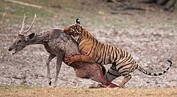
A tiger attacking a Sambar deer in Ranthambore National Park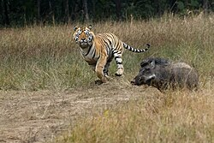
Tiger chasing a wild boar in Tadoba Andhari Tiger Reserve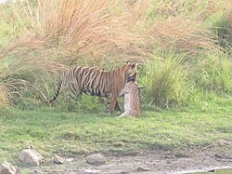
Tiger with kill in Ranthambore National Park
Bengal tigers occasionally hunt and kill predators such as Indian leopard, mugger crocodile, Asian black bear, sloth bear, and dhole. They generally do not attack adult Indian elephant and Indian rhinoceros, but such extraordinarily rare events have been recorded. In Kaziranga National Park, tigers killed 20 rhinoceros in 2007. In 2011 and 2014, two instances of Bengal tigers killing adult elephants were recorded; in Jim Corbett National Park on a 20-year-old elephant cow, and another on a 28-year-old sick elephant in Kaziranga National Park; the latter was eaten by several tigers at once. A king cobra (Ophiophagus hannah), an Indian cobra (Naja naja), Asian water monitor, rhesus macaque, fish, crabs, and very rarely fishing cats and turtles were found in the stomachs and scat of tigers in the Sundarbans. One in Chitwan National Park has been reported to have hunted three gharials.
Results of scat analyses indicate that the Bengal tigers in Nagarahole National Park preferred prey weighing more than 176 kg (388 lb) and that on average tiger prey weighed 91.5 kg (202 lb). The prey species included chital, sambar, wild pig and gaur. Gaur remains were found in 44.8% of all tiger scat samples, sambar remains in 28.6%, wild pig remains in 14.3% and chital remains in 10.4% of all scat samples. In Bandipur National Park, gaur and sambar together also constituted 73% of tiger diet.
In most cases, Bengal tigers approach their victim from the side or behind from as close a distance as possible and grasp the prey's throat to kill it. Then they drag the carcass into cover, occasionally over several hundred metres, to consume it. The nature of the tiger's hunting method and prey availability results in a "feast or famine" feeding style: they often consume 18–40 kg (40–88 lb) of meat at one time. In one study, tigresses from Nepal made about 40–50 kills a year and ate a minimum of 5–6.3 kg (11–14 lb) of meat a day. Two males made about 40–50 kills in a year and ate 6.3–7.8 kg (14–17 lb) of meat a day at the least.
If injured, old or weak, or when its regular prey species become scarce, Bengal tigers often attack humans and become man-eaters.

PYTHON PROGRAMMING LANGUAGE

Python

Paradigm | Multi-paradigm: object-oriented,^{[1]} procedural (imperative), functional, structured, reflective
Designed by | Guido van Rossum
Developer | Python Software Foundation
First appeared | 20 February 1991; 35 years ago^{[2]}
Stable release | 3.14.5^{[3]} / 10 May 2026; 23 days ago
Typing discipline | Duck, dynamic, strong;^{[4]} optional type annotations^{[a]}
Memory management | Garbage-collected
OS | Cross-platform^{[b]}
License | Python Software Foundation License
Filename extensions | .py,^{[11]} .pyc,^{[12]} .pyd,^{[13]} .pyi,^{[14]} .pyw,^{[15]} .pyz^{[16]}
Website | python.org
Major implementations
CPython, PyPy, MicroPython, CircuitPython, IronPython, Jython, Stackless Python
Dialects
Cython, RPython, Starlark^{[17]}
Influenced by
ABC,^{[18]} Ada,^{[19][failed verification]} ALGOL 68,^{[20]} APL,^{[21]} C,^{[22]} C++,^{[23]} CLU,^{[24]} Dylan,^{[25]} Haskell,^{[26][21]} Icon,^{[27]} Lisp,^{[28]} Modula-3,^{[20][23]} Perl,^{[29]} Standard ML^{[21]}
Influenced
Apache Groovy, Boo, Cobra, CoffeeScript,^{[30]} D, F#, GDScript, Go, JavaScript,^{[31][32]} Julia,^{[33]} Mojo,^{[34]} Nim, Ruby,^{[35]} Swift,^{[36]} V^{[37]}

Python is a high-level, general-purpose programming language that emphasizes code readability, simplicity, and ease-of-writing with the use of significant indentation,^{[38]} "plain English" naming, an extensive ("batteries-included") standard library, and garbage collection. Python supports multiple programming paradigms but with an emphasis on object-oriented programming and dynamic typing.
Guido van Rossum began working on Python in the late 1980s as a successor to the ABC programming language. Python 3.0, released in 2008, was a major revision and not completely backward-compatible with earlier versions. Beginning with Python 3.5,^{[39]} capabilities and keywords for typing were added to the language, allowing optional static typing.^{[40]} As of 2026, the Python Software Foundation supports Python 3.10, 3.11, 3.12, 3.13, and 3.14, following the project's annual release cycle and five-year support policy. Python 3.15 is currently in the alpha development phase, and the stable release is expected to launch in October 2026.^{[41]} Earlier versions in the 3.x series have reached end-of-life and no longer receive security updates.
Python has gained extensive use in the machine learning community.^{[42][43][44][45]} It is widely taught as an introductory programming language.^{[46]} Since 2003, Python has consistently ranked among the top ten most popular programming languages in the TIOBE Programming Community Index, which ranks programming languages based on searches across 24 platforms.

History
Main article: History of Python

The designer of Python, Guido van Rossum, at PyCon US 2024
Python was conceived in the late 1980s^{[11]} by Guido van Rossum at Centrum Wiskunde & Informatica (CWI) in the Netherlands.^{[48]} It was designed as a successor to the ABC programming language, which was inspired by SETL,^{[49]} capable of exception handling and interfacing with the Amoeba operating system.^{[18]} Python implementation began in December 1989.^{[48]} Van Rossum first released it in 1991 as Python 0.9.0.^{[48]} Van Rossum assumed sole responsibility for the project, as the lead developer, until 12 July 2018, when he announced his "permanent vacation" from responsibilities as Python's "benevolent dictator for life" (BDFL); this title was bestowed on him by the Python community to reflect his long-term commitment as the project's chief decision-maker.^{[50]} (He has since come out of retirement and is self-titled "BDFL-emeritus".) In January 2019, active Python core developers elected a five-member Steering Council to lead the project.^{[51][52]}
The name Python derives from the British comedy series Monty Python's Flying Circus.^{[53]} (See § Naming.)
Python 2.0 was released on 16 October 2000, featuring many new features such as list comprehensions, cycle-detecting garbage collection, reference counting, and Unicode support.^{[54]} Python 2.7's end-of-life was initially set for 2015, and then postponed to 2020 out of concern that a large body of existing code could not easily be forward-ported to Python 3.^{[55][56]} It no longer receives security patches or updates.^{[57][58]} While Python 2.7 and older versions are officially unsupported, a different unofficial Python implementation, PyPy, continues to support Python 2, i.e., "2.7.18+" (plus 3.11), with the plus signifying (at least some) "backported security updates".^{[59]}
Python 3.0 was released on 3 December 2008, and was a major revision and not completely backward-compatible with earlier versions, with some new semantics and changed syntax. Python 2.7.18, released in 2020, was the last release of Python 2.^{[60]} Several releases in the Python 3.x series have added new syntax to the language, and made a few (considered very minor) backward-incompatible changes.
As of May 2026, Python 3.14.5 is the latest stable release. All older 3.x versions had a security update down to Python 3.9.24 then again with 3.9.25, the final version in 3.9 series. Python 3.10 is, since November 2025, the oldest supported branch.^{[61]} Python 3.15 has an alpha released, and Android has an official downloadable executable available for Python 3.14. Releases receive two years of full support followed by three years of security support.

Syntax and semantics
Main article: Python syntax and semantics
Python is meant to be an easily readable language. Its formatting is visually uncluttered and often uses English keywords where other languages use punctuation. Unlike many other languages, it does not use curly brackets to delimit blocks, and semicolons after statements are allowed but rarely used. It has fewer syntactic exceptions and special cases than C or Pascal.^{[88]}
Indentation
Further information: Python syntax and semantics § Indentation
Python uses whitespace indentation, rather than curly brackets or keywords, to delimit blocks. An increase in indentation comes after certain statements; a decrease in indentation signifies the end of the current block.^{[89]} Thus, the program's visual structure accurately represents its semantic structure.^{[90]} This feature is sometimes termed the off-side rule. Some other languages use indentation this way; but in most, indentation has no semantic meaning. The recommended indent size is four spaces.^{[91]}
Statements and control flow
Python's statements include the following:
- The assignment statement, using a single equals sign =
- The if statement, which conditionally executes a block of code, along with else and elif (a contraction of else if)
- The for statement, which iterates over an iterable object, capturing each element to a variable for use by the attached block; the variable is not deleted when the loop finishes
- The while statement, which executes a block of code as long as boolean condition is true
- The try statement, which allows exceptions raised in its attached code block to be caught and handled by except clauses (or new syntax except* in Python 3.11 for exception groups);^{[92]} the try statement also ensures that clean-up code in a finally block is always run regardless of how the block exits
- The raise statement, used to raise a specified exception or re-raise a caught exception
- The class statement, which executes a block of code and attaches its local namespace to a class, for use in object-oriented programming
- The def statement, which defines a function or method
- The with statement, which encloses a code block within a context manager, allowing resource-acquisition-is-initialization (RAII)-like behavior and replacing a common try/finally idiom^{[93]} Examples of a context include acquiring a lock before some code is run, and then releasing the lock; or opening and then closing a file
- The break statement, which exits a loop
- The continue statement, which skips the rest of the current iteration and continues with the next
- The del statement, which removes a variable—deleting the reference from the name to the value, and producing an error if the variable is referred to before it is redefined^{[c]}
- The pass statement, serving as a NOP (i.e., no operation), which is syntactically needed to create an empty code block
- The assert statement, used in debugging to check for conditions that should apply
- The yield statement, which returns a value from a generator function (and also an operator); used to implement coroutines
- The return statement, used to return a value from a function
- The import and from statements, used to import modules whose functions or variables can be used in the current program. Python 3.15 adds a new functionality to lazily import with a new keyword: "The lazy keyword works with both import and from ... import statements."^{[94]}
- The match and case statements, analogous to a switch statement construct, which compares an expression against one or more cases as a control-flow measure
The assignment statement (=) binds a name as a reference to a separate, dynamically allocated object. Variables may subsequently be rebound at any time to any object. In Python, a variable name is a generic reference holder without a fixed data type; however, it always refers to some object with a type. This is called dynamic typing—in contrast to statically-typed languages, where each variable may contain only a value of a certain type.
Python does not support tail call optimization or first-class continuations; according to Van Rossum, the language never will.^{[95][96]} However, better support for coroutine-like functionality is provided by extending Python's generators.^{[97]} Before 2.5, generators were lazy iterators; data was passed unidirectionally out of the generator. From Python 2.5 on, it is possible to pass data back into a generator function; and from version 3.3, data can be passed through multiple stack levels.^{[98]}
Expressions
Python's expressions include the following:
- The +, -, and * operators for mathematical addition, subtraction, and multiplication are similar to other languages, but the behavior of division differs. There are two types of division in Python: floor division (or integer division) //, and floating-point division /.^{[99]} Python uses the ** operator for exponentiation.
- Python uses the + operator for string concatenation. The language uses the * operator for duplicating a string a specified number of times.
- The @ infix operator is intended to be used by libraries such as NumPy for matrix multiplication.^{[100][101]}
- The syntax :=, called the "walrus operator", was introduced in Python 3.8. This operator assigns values to variables as part of a larger expression.^{[102]}
- In Python, == compares two objects by value. Python's is operator may be used to compare object identities (i.e., comparison by reference), and comparisons may be chained—for example, a <= b <= c.
- Python uses and, or, and not as Boolean operators.
- Python has a type of expression called a list comprehension, and a more general expression called a generator expression.^{[69]}
- Anonymous functions are implemented using lambda expressions; however, there may be only one expression in each body.
- Conditional expressions are written as x if c else y.^{[103]} (This is different in operand order from the c ? x : y operator common to many other languages.)
- Python makes a distinction between lists and tuples. Lists are written as [1, 2, 3], are mutable, and cannot be used as the keys of dictionaries (since dictionary keys must be immutable in Python). Tuples, written as (1, 2, 3), are immutable and thus can be used as the keys of dictionaries, provided that all of the tuple's elements are immutable. The + operator can be used to concatenate two tuples, which does not directly modify their contents, but produces a new tuple containing the elements of both. For example, given the variable t initially equal to (1, 2, 3), executing t = t + (4, 5) first evaluates t + (4, 5), which yields (1, 2, 3, 4, 5); this result is then assigned back to t—thereby effectively "modifying the contents" of t while conforming to the immutable nature of tuple objects. Parentheses are optional for tuples in unambiguous contexts.^{[104]}
- Python features sequence unpacking where multiple expressions, each evaluating to something assignable (e.g., a variable or a writable property) are associated just as in forming tuple literal; as a whole, the results are then put on the left-hand side of the equal sign in an assignment statement. This statement expects an iterable object on the right-hand side of the equal sign to produce the same number of values as the writable expressions on the left-hand side; while iterating, the statement assigns each of the values produced on the right to the corresponding expression on the left.^{[105]}
- Python has a "string format" operator % that functions analogously to printf format strings in the C language—e.g. "spam=%s eggs=%d" % ("blah", 2) evaluates to "spam=blah eggs=2". In Python 2.6+ and 3+, this operator was supplemented by the format() method of the str class, e.g., "spam={0} eggs={1}".format("blah", 2). Python 3.6 added "f-strings": spam = "blah"; eggs = 2; f'spam={spam} eggs={eggs}'.^{[106]}
- Strings in Python can be concatenated by "adding" them (using the same operator as for adding integers and floats); e.g., "spam" + "eggs" returns "spameggs". If strings contain numbers, they are concatenated as strings rather than as integers, e.g. "2" + "2" returns "22".
- Python supports string literals in several ways:
  - Delimited by single or double quotation marks; single and double quotation marks have equivalent functionality (unlike in Unix shells, Perl, and Perl-influenced languages). Both marks use the backslash (\) as an escape character. String interpolation became available in Python 3.6 as "formatted string literals".^{[106]}
  - Triple-quoted, i.e., starting and ending with three single or double quotation marks; this may span multiple lines and function like here documents in shells, Perl, and Ruby.
  - Raw string varieties, denoted by prefixing the string literal with r. Escape sequences are not interpreted; hence raw strings are useful where literal backslashes are common, such as in regular expressions and Windows-style paths. (Compare "@-quoting" in C#.)
- Python has array index and array slicing expressions in lists, which are written as a[key], a[start:stop] or a[start:stop:step]. Indexes are zero-based, and negative indexes are relative to the end. Slices take elements from the start index up to, but not including, the stop index. The (optional) third slice parameter, called step or stride, allows elements to be skipped or reversed. Slice indexes may be omitted—for example, a[:] returns a copy of the entire list. Each element of a slice is a shallow copy.
In Python, a distinction between expressions and statements is rigidly enforced, in contrast to languages such as Common Lisp, Scheme, or Ruby. This distinction leads to duplicating some functionality, for example:
- List comprehensions vs. for-loops
- Conditional expressions vs. if blocks
- The eval() vs. exec() built-in functions (in Python 2, exec is a statement); the former function is for expressions, while the latter is for statements
A statement cannot be part of an expression; because of this restriction, expressions such as list and dict comprehensions (and lambda expressions) cannot contain statements. As a particular case, an assignment statement such as a = 1 cannot be part of the conditional expression of a conditional statement.
Typing
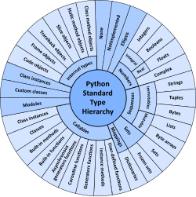
The standard type hierarchy in Python 3
Python uses duck typing, and it has typed objects but untyped variable names. Type constraints are not checked at definition time; rather, operations on an object may fail at usage time, indicating that the object is not of an appropriate type. Despite being dynamically typed, Python is strongly typed, forbidding operations that are poorly defined (e.g., adding a number and a string) rather than quietly attempting to interpret them.
Python allows programmers to define their own types using classes, most often for object-oriented programming. New instances of classes are constructed by calling the class, for example, SpamClass() or EggsClass()); the classes are instances of the metaclass type (which is an instance of itself), thereby allowing metaprogramming and reflection.
Before version 3.0, Python had two kinds of classes, both using the same syntax: old-style and new-style.^{[107]} Current Python versions support the semantics of only the new style.
Python supports optional type annotations.^{[5][108]} These annotations are not enforced by the language, but may be used by external tools such as mypy to catch errors. Python includes a module typing including several type names for type annotations.^{[109][110]} Also, mypy supports a Python compiler called mypyc, which leverages type annotations for optimization.^{[111]}
Summary of Python 3's built-in types
Type | Mutability | Description | Syntax examples
bool | immutable | Boolean value | True  False
bytearray | mutable | Sequence of bytes | bytearray(b'Some ASCII')  bytearray(b"Some ASCII")  bytearray([119, 105, 107, 105])
bytes | immutable | Sequence of bytes | b'Some ASCII'  b"Some ASCII"  bytes([119, 105, 107, 105])
complex | immutable | Complex number with real and imaginary parts | 3+2.7j  3 + 2.7j  5j
dict | mutable | Associative array (or dictionary) of key and value pairs; can contain mixed types (keys and values); keys must be a hashable type | {'key1': 1.0, 3: False}  {}
types.EllipsisType | immutable | An ellipsis placeholder to be used as an index in NumPy arrays | ...  Ellipsis
float | immutable | Double-precision floating-point number. The precision is machine-dependent, but in practice it is generally implemented as a 64-bit IEEE 754 number with 53 bits of precision.^{[112]} | 1.33333
frozenset | immutable | Unordered set, contains no duplicates; can contain mixed types, if hashable | frozenset({4.0, 'string', True})  frozenset()
int | immutable | Integer of unlimited magnitude^{[113]} | 42
list | mutable | List, can contain mixed types | [4.0, 'string', True]  []
types.NoneType | immutable | An object representing the absence of a value, often called null in other languages | None
types.NotImplementedType | immutable | A placeholder that can be returned from overloaded operators to indicate unsupported operand types. | NotImplemented
range | immutable | An immutable sequence of numbers, commonly used for iterating a specific number of times in for loops^{[114]} | range(−1, 10)  range(10, −5, −2)
set | mutable | Unordered set, contains no duplicates; can contain mixed types, if hashable | {4.0, 'string', True}  set()
str | immutable | A character string: sequence of Unicode codepoints | 'Wikipedia'  "Wikipedia"  """Spanning  multiple  lines"""
tuple | immutable | Tuple, can contain mixed types | (4.0, 'string', True)  ('single element',)  ()
Arithmetic operations
Python includes conventional symbols for arithmetic operators (+, -, *, /), the floor-division operator //, and the modulo operator %. (With the modulo operator, a remainder can be negative, e.g., 4 % -3 == -2.) Python also offers the ** symbol for exponentiation, e.g. 5**3 == 125 and 9**0.5 == 3.0, as well as the matrix-multiplication operator @.^{[115]} These operators work as in traditional mathematics; with the same precedence rules, the infix operators + and - can also be unary, to represent positive and negative numbers respectively.
Division between integers produces floating-point results. The behavior of division has changed significantly over time:^{[116]}
- The current version of Python (i.e., since 3.0) changed the / operator to always represent floating-point division, e.g., 5/2 == 2.5.
- The floor division // operator was introduced, meaning that 7//3 == 2, -7//3 == -3, 7.5//3 == 2.0, and -7.5//3 == -3.0. For Python 2.7, adding the from __future__ import division statement allows a module in Python 2.7 to use Python 3.x rules for division (see above).
In Python terms, the / operator represents true division (or simply division), while the // operator represents floor division. Before version 3.0, the / operator represents classic division.^{[116]}
Rounding towards negative infinity, though a different method than in most languages, adds consistency to Python. For instance, this rounding implies that the equation (a + b)//b == a//b + 1 is always true. Also, the rounding implies that the equation b*(a//b) + a%b == a is valid for both positive and negative values of a. As expected, the result of a%b lies in the half-open interval [0, b), where b is a positive integer; however, maintaining the validity of the equation requires that the result must lie in the interval (b, 0] when b is negative.^{[117]}
Python provides a round function for rounding a float to the nearest integer. For tie-breaking, Python 3 uses the round to even method: round(1.5) and round(2.5) both produce 2.^{[118]} Python versions before 3 used the round-away-from-zero method: round(0.5) is 1.0, and round(-0.5) is −1.0.^{[119]}
Python allows Boolean expressions that contain multiple equality relations to be consistent with general usage in mathematics. For example, the expression a < b < c tests whether a is less than b and b is less than c.^{[120]} C-derived languages interpret this expression differently: in C, the expression would first evaluate a < b, resulting in 0 or 1, and that result would then be compared with c.^{[121]}
Python uses arbitrary-precision arithmetic for all integer operations. The Decimal type/class in the decimal module provides decimal floating-point numbers to a pre-defined arbitrary precision with several rounding modes.^{[122]} The Fraction class in the fractions module provides arbitrary precision for rational numbers.^{[123]}
Due to Python's extensive mathematics library and the third-party library NumPy, the language is frequently used for scientific scripting in tasks such as numerical data processing and manipulation.^{[124][125]}
Function syntax
Functions are created in Python by using the def keyword. A function is defined similarly to how it is called, by first providing the function name and then the required parameters. Here is an example of a function that prints its inputs:
def printer(input1, input2 = "already there"):
print(input1)
print(input2)

printer("hello")

# Example output:
# hello
# already there
To assign a default value to a function parameter in case no actual value is provided at run time, variable-definition syntax can be used inside the function header.
Code examples
"Hello, World!" program:
print('Hello, World!')
Program to calculate the factorial of a non-negative integer:
text = input('Type a number, and its factorial will be printed: ')
n = int(text)

if n < 0:
raise ValueError('You must enter a non-negative integer')

factorial = 1
for i in range(2, n + 1):
factorial *= i

print(factorial)
Libraries
Python's large standard library^{[126]} is commonly cited as one of its greatest strengths. For Internet-facing applications, many standard formats and protocols such as MIME and HTTP are supported. The language includes modules for creating graphical user interfaces, connecting to relational databases, generating pseudorandom numbers, arithmetic with arbitrary-precision decimals,^{[122]} manipulating regular expressions, and unit testing.
Some parts of the standard library are covered by specifications—for example, the Web Server Gateway Interface (WSGI) implementation wsgiref follows PEP 333^{[127]}—but most parts are specified by their code, internal documentation, and test suites. However, because most of the standard library is cross-platform Python code, only a few modules must be altered or rewritten for variant implementations.
As of 13 March 2025, the Python Package Index (PyPI), the official repository for third-party Python software, contains over 614,339^{[128]} packages.
Development environments
See also: Comparison of integrated development environments § Python
Most^{[which?]} Python implementations (including CPython) include a read–eval–print loop (REPL); this permits the environment to function as a command line interpreter, with which users enter statements sequentially and receive results immediately.^{[129]}
Also, CPython is bundled with an integrated development environment (IDE) called IDLE,^{[130]} which is oriented toward beginners.^{[citation needed][by whom?]}
Other shells, including IDLE and IPython, add additional capabilities such as improved auto-completion, session-state retention, and syntax highlighting.^{[130][131]}
Standard desktop IDEs include PyCharm, Spyder, and Visual Studio Code;^{[132]} there are web browser-based IDEs, such as the following environments:
- Jupyter Notebooks, an open-source interactive computing platform;^{[133]}
- PythonAnywhere, a browser-based IDE and hosting environment; and
- Canopy, a commercial IDE from Enthought that emphasizes scientific computing.^{[134][135]}
Implementations
See also: List of Python software § Python implementations
Reference implementation
CPython is the reference implementation of Python. This implementation is written in C, meeting the C11 standard^{[136]} since version 3.11. Older versions use the C89 standard with several select C99 features, but third-party extensions are not limited to older C versions—e.g., they can be implemented using C11 or C++.^{[137][138]} CPython compiles Python programs into an intermediate bytecode,^{[139]} which is then executed by a virtual machine.^{[140]} CPython is distributed with a large standard library written in a combination of C and native Python.
CPython is available for many platforms, including Windows and most modern Unix-like systems, including macOS (and Apple M1 Macs, since Python 3.9.1, using an experimental installer). Starting with Python 3.9, the Python installer intentionally fails to install on Windows 7 and 8;^{[141][142]} Windows XP was supported until Python 3.5, with unofficial support for VMS.^{[143]} Platform portability was one of Python's earliest priorities.^{[144]} During development of Python 1 and 2, even OS/2 and Solaris were supported;^{[8]} since that time, support has been dropped for many platforms.
All current Python versions (since 3.7) support only operating systems that feature multithreading, by now supporting not nearly as many operating systems (dropping many outdated) than in the past.
Limitations of the reference implementation
- The energy usage of Python with CPython for typically written code is much worse than C by a factor of 75.88.^{[145]}
- The throughput of Python with CPython for typically written code is worse than C by a factor of 71.9.^{[145]}
- The average memory usage of CPython for typically written code is worse than C by a factor of 2.4.

