**CA 1**

**Software Testing using Selenium**

**727721EUIT116**

**PRIYADHARSHINI B**

1.

package cia1;

import org.openqa.selenium.By;

import org.openqa.selenium.WebDriver;

import org.openqa.selenium.WebElement;

import org.openqa.selenium.chrome.ChromeDriver;

import org.openqa.selenium.chrome.ChromeOptions;

import io.github.bonigarcia.wdm.WebDriverManager;

public class Question1 {

public static void main(String[] args)

{

WebDriverManager.chromedriver().setup();

WebDriver driver;

ChromeOptions co = new ChromeOptions();

co.addArguments("--remote-allow-origins=*");

driver = new ChromeDriver(co);

driver.navigate().to("https://www.amazon.in/American-Tourister-AMT-SCH-02/dp/B07CJCGM1M/ref=lp_2454169031_1_3?th=1");

WebElement addtocart = driver.findElement(By.id("add-to-cart-button"));

addtocart.click();

WebElement check = driver.findElement(By.xpath("//*[@class=\"a-button-input\"]"));

check.click();

driver.navigate().to("https://www.amazon.in/gp/cart/view.html/ref=dp_atch_dss_cart?");

WebElement del = driver.findElement(By.xpath("//*[@class=\"a-color-link\"]"));

del.click();

}

}

OUTPUT: 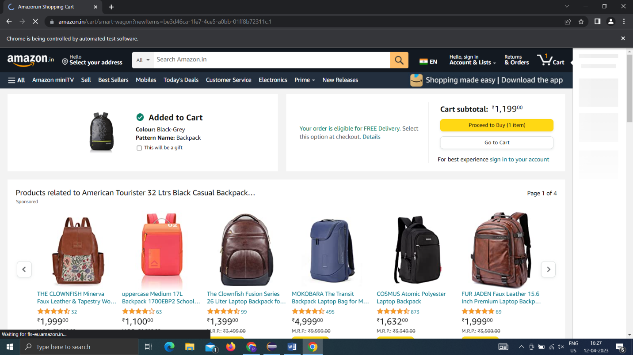

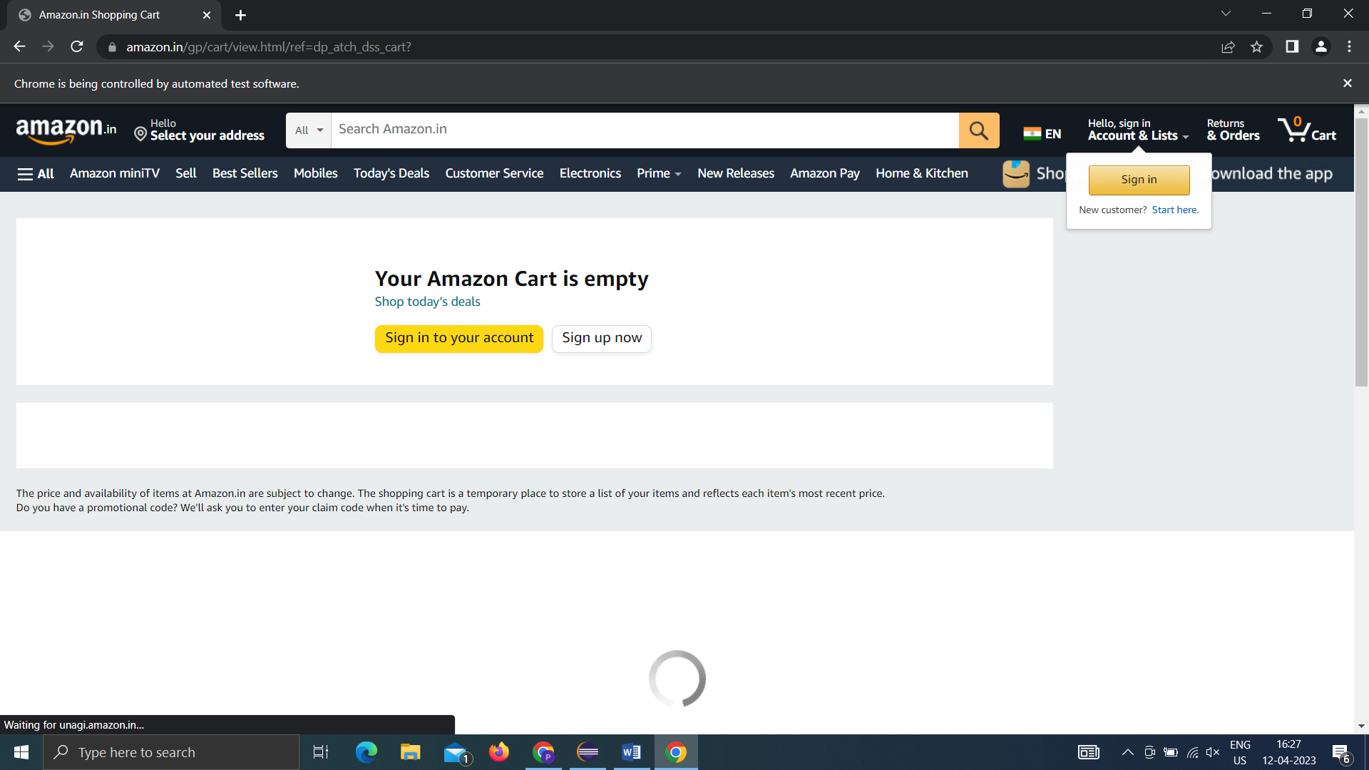

2.

package cia1;

import org.openqa.selenium.WebElement;

import java.util.List;

import org.openqa.selenium.By;

import org.openqa.selenium.WebDriver;

import org.openqa.selenium.chrome.ChromeDriver;

import org.openqa.selenium.chrome.ChromeOptions;

import io.github.bonigarcia.wdm.WebDriverManager;

public class product {

public static void main(String args[])

{

WebDriverManager.chromedriver().setup();

WebDriver driver;

ChromeOptions co=new ChromeOptions();

co.addArguments("--remote-allow-origin=*");

driver=new ChromeDriver(co);

driver.get("https://www.amazon.in/");

driver.manage().window().maximize();

WebElement phone= driver.findElement(By.id("twotabsearchtextbox"));

phone.sendKeys("phone");

WebElement search= driver.findElement(By.id("nav-search-submit-button"));

search.click();

List<WebElement> li = driver.findElements(By.xpath("//*[@class=\"a-size-medium a-color-base a-text-normal\"]"));

for(WebElement l:li)

System.out.print(l.getText()+" ");

}

}

OUTPUT:

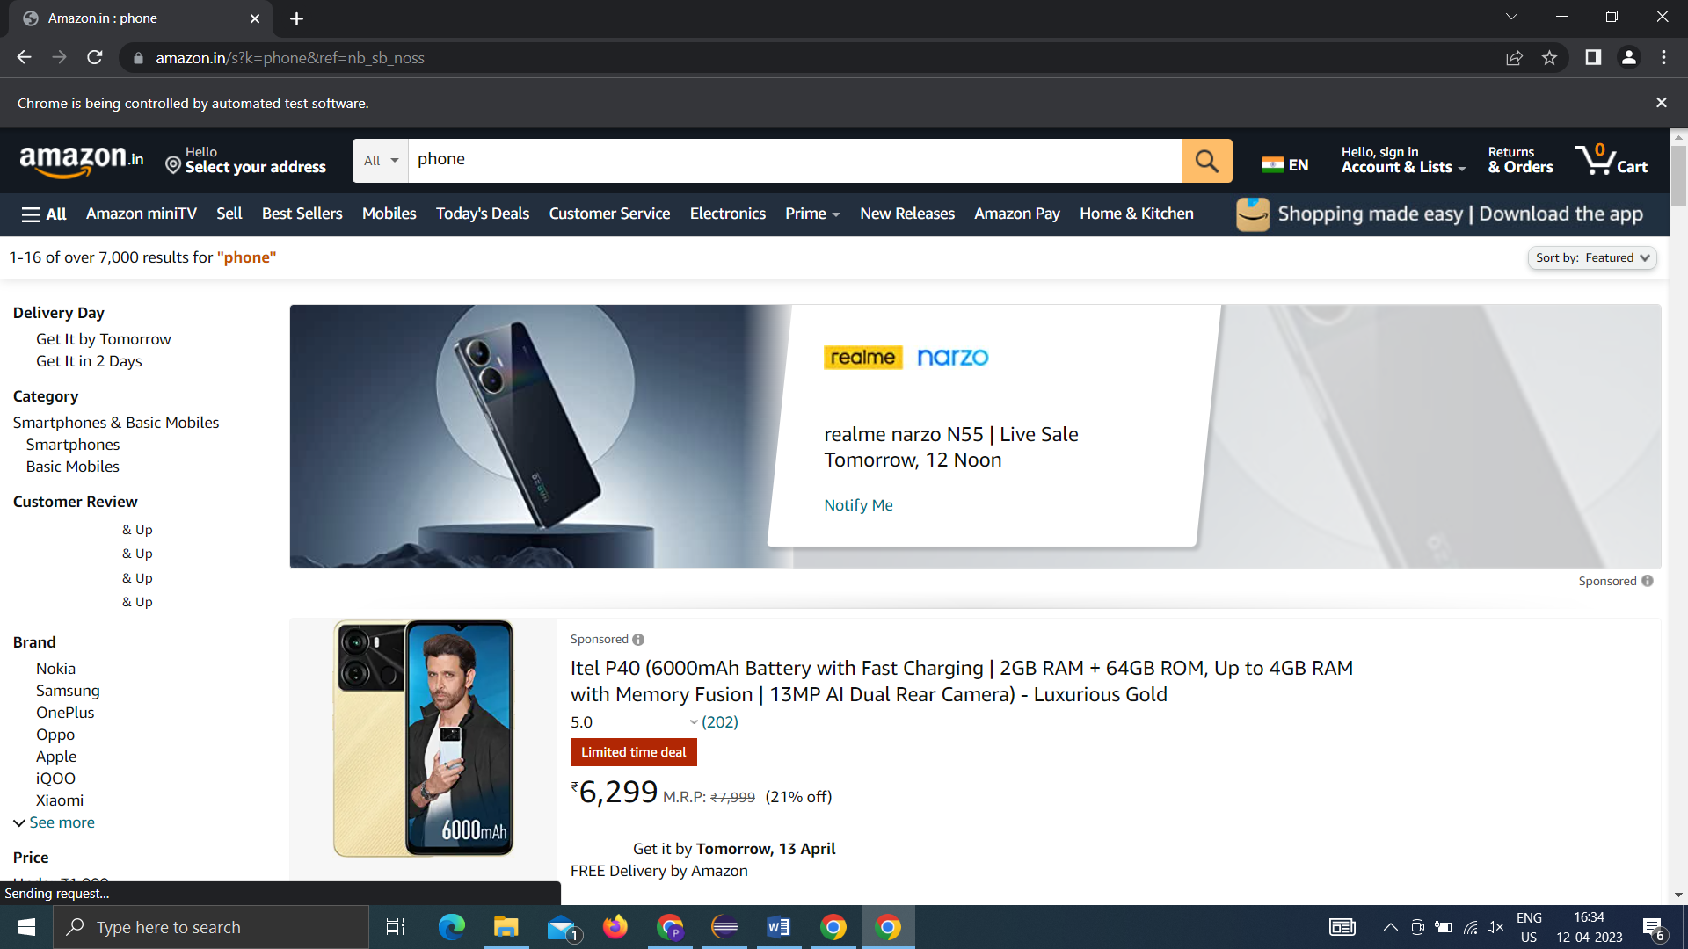

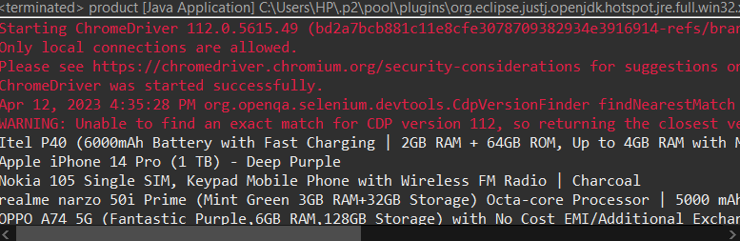

3.

package com.selenium.test.NewTest2.SelTest;

import java.util.List;

import org.openqa.selenium.By;

import org.openqa.selenium.JavascriptExecutor;

import org.openqa.selenium.Keys;

import org.openqa.selenium.WebDriver;

import org.openqa.selenium.WebElement;

import org.openqa.selenium.chrome.ChromeDriver;

import org.openqa.selenium.chrome.ChromeOptions;

import org.openqa.selenium.support.ui.Select;

import io.github.bonigarcia.wdm.WebDriverManager;

/**

* Hello world!

*

*/

public class App

{

public static void main( String[] args ) throws InterruptedException

{

WebDriverManager.chromedriver().setup();

ChromeOptions co = new ChromeOptions();

co.addArguments("--remote-allow-origins=*");

WebDriver driver=new ChromeDriver(co);

driver.get("https://www.amazon.in/ref=nav_logo");

driver.manage().window().maximize();

String title=driver.getTitle();

System.out.println(title);

if(title.equals("Online Shopping site in India: Shop Online for Mobiles, Books, Watches, Shoes and More - Amazon.in")) {

System.out.println("Verified title of the page");

}else {

System.out.println("Title not matched");

}

driver.findElement(By.id("nav-link-accountList")).click();

driver.findElement(By.id("ap_email")).sendKeys("priya28@gmail.com");

driver.findElement(By.id("ap_email")).sendKeys(Keys.ENTER);

driver.findElement(By.id("ap_password")).sendKeys("Fevi2802*");

driver.findElement(By.id("ap_password")).sendKeys(Keys.ENTER);

Thread.sleep(2000);

String name=driver.findElement(By.id("nav-link-accountList-nav-line-1")).getText();

if(name.equals("Hello, priya")) {

System.out.println("Successfully, signed in");

}else {

System.out.println("Sign in failed");

}

System.out.println("Testing Ended");

driver.quit();

}

}