Department of Electrical and Computer Engineering
North South University



CSE445 Report

Used Car Prediction Using a Machine Learning Model With LIME

Kousique Ahmmed 2021752042
Md Hasanul Haque Rumman 2021753042
Syed Mozahidul Islam 2111672642
Yeastic Hassan Zihan 202132804
Rafat Istiak Alam Rashik 2013999042

Faculty:
Riasat Khan
Assistant Professor
ECE Department

Summer, 2024

Individual Contribution Table
Section | Contributing Member Name
IEEE/LaTEX formatting | Mozahidul
Grammarly check | Kousique & Yeastic | Grammarly Score: 99%
Abstract | Mozahidul
Keywords | Mozahidul
Introduction Motivation | Mozahidul
Paper Review 1 | Kousique
Paper Review 2 | Rumman
Paper Review 3 | Mozahidul
Paper Review 4 | Yeastic
Paper Review 5 | Rafat
Introduction Second-Last Paragraph (describe your work) | Rumman  Yeastic-FlowChart
Proposed System (Dataset and Preprocessing) | Dataset-Rumman  Preprocess-kousique
Proposed System (Model description) | Decision tree | Rafat
 | Random Forest | Rumman
 | KNN | Yeastic
 | Linear Regression | Mozahidul
 | XGBOOST | Kousique
 | Stacking/Blending | Kousique
Results and Discussion | Yeastic & Rafat
Figure and Table Title Formatting | Yeastic & Mozahidul
Conclusions | Rafat
Equations formatting | Yeastic
References Formatting in IEEE format | Yeastic

Used Car Price Prediction Using ML with LIME
Syed Mozahidul Islam
Electrical and Computer Engineering
North South University
Dhaka, Bangladesh
syed.islam02@northsouth.edu

Rafat Istiak Alam Rashik
Electrical and Computer Engineering
North South University
Dhaka, Bangladesh
rafat.rashik@northsouth.edu
Kousique Ahmmed
Electrical and Computer Engineering
North South University
Dhaka, Bangladesh
kousaque.ahmed@northsouth.edu

Yeastic Hassan Zihan
Electrical and Computer Engineering
North South University
Dhaka, Bangladesh
yeastic.zihan@northsouth.edu
Md Hasanul Haque Rumman
Electrical and Computer Engineering
North South University
Dhaka, Bangladesh
hasanul.haque01@northsouth.edu

Abstract— The used car market has become an integral component of the automotive industry, providing consumers with affordable vehicles while allowing sellers to monetize pre-owned vehicles. However, correctly forecasting the price of a used car is difficult due to various factors such as age, mileage, fuel type, and condition. This study uses a variety of machine learning models, including Linear Regression, Decision Trees, Random Forest, K-nearest neighbors (KNN), XGBoost, and Stacking, to estimate used automobile pricing. A dataset of over 6,016 samples underwent extensive data pre-processing and hyperparameter adjustment. XGBoost outperformed other models with an RMSE score of 0.240, indicating accurate and dependable predictions.
Keywords— Machine Learning, Price Prediction, XGBoost, Data Pre-processing, Used Car Market, Regression Models

Introduction
The used car market plays a significant role in the automotive industry, providing affordable vehicle options to buyers and a platform for sellers to monetize pre-owned vehicles. However, it is not easy to determine the price of a used car, as there are several factors on which its price depends: brand and model, manufacturing year, mileage, fuel type, Transmission, and car condition. Traditional valuation methods include manual evaluation or static pricing guides, which are often inaccurate, time-consuming, and inconsistent. The used car market is expected to grow at a CAGR of 7.6% from 2021 to 2030, and thus, fair pricing systems become important. There is thus an urgent need for an effective data-driven solution to ensure that price estimation is transparent and correct. Machine learning-based systems offer potential alternatives to overcoming such issues, as they make objective and reliable pricing forecasts based on past information.
Wang et al. [1] show which model provides the best results through different models. There are four types of models applied to a dataset, and among them, the "EXTRA TREES REGRESSOR" model performs best (R^2=0.9807%). Moreover, its accuracy rate is slightly better than that of other models. They compare their results with the average absolute error and multi-dimensional evaluation model. This model demonstrates with mathematical calculations how better performance can be achieved by the same pre-processed dataset.
Kamil et al. [2] solved the approximate value of the used car through ML's RANDOM FOREST REGRESSOR ALGORITHMS model. This model is used here because the RANDOM FOREST model performs very well on large data sets. Here we also see that the values of RMSE (validate=0.5561, test=0.5663) and MAE (validate=0.4520, test=0.4757) perform very well in this model. This velocity makes it easy to understand that the model does not overfit. This model can expect the optimal solution by pre-processing the data set well.
Balcıoğlu and Sezen [3] proposed a model for car price prediction utilizing multiple machine-learning techniques. The study initially explored single-classifier approaches such as Random Forest (RF), Support Vector Machine (SVM), and Artificial Neural Networks (ANN). Among these, the SVM model achieved the highest accuracy (92.38%) with the lowest error rate. However, recognizing the limitations of single classifiers, the authors introduced an ensemble method combining RF, SVM, and ANN. This ensemble approach significantly improved predictive accuracy while addressing the trade-offs between computational demands and model performance. The model incorporated a comprehensive dataset with diverse vehicle attributes and emphasized meticulous data pre-processing to enhance prediction reliability.
Kemidi et al. [4] analyzed the performance of Machine Learning (ML) algorithms, including Lasso Regression, Ridge Regression, Linear Regression, and Random Forest Regression, for forecasting used vehicle prices. They developed a web-based application named "The Car Price Predictor" that utilizes a supervised dataset and applies supervised ML algorithms. Their study found that linear Regression achieved higher accuracy than previous models.
Hanker and his teammates used different Machine Learning (ML) Models to predict the prices of second-hand cars. The team focused on the details of a car, such as mileage, the type of fuel to use in a car, the engine's power, the brand, the model, and the year of production. They Collected data from Avito, Avito is a well-known Moroccan e-commerce site; they tested different models like MLR, KNNR, RFR, GBR, and ANN and found that the GBR (Gradient Boosting Regressor) model worked best. This model achieved the highest accuracy (0.80) with the lowest error rate. The study shows how machine learning can help to set the price of used cars by providing a reliable estimate of resale values. [5]
In this work, as shown in Fig. 1 we have done in sequence. First, we recognized the problem through our research. Then, we analyzed the related issues to determine the price of used cars and analyzed the results. We have developed a used car price prediction system with multiple machine-learning models. This work's dataset contains attributes like car age, mileage, fuel type, seller type, etc. Multiple ML algorithms, such as Linear Regression, Decision Trees, XGBoost, KNN, Stacking, and Random Forest, were applied in the study. Their performances were compared using R-squared, mean absolute error, and root mean squared error. Among them, XGBoost has the best accuracy and was the final model for deploying this system. This system would also create a platform that makes it easy to interact with buyers and sellers to estimate car prices transparently and correctly.
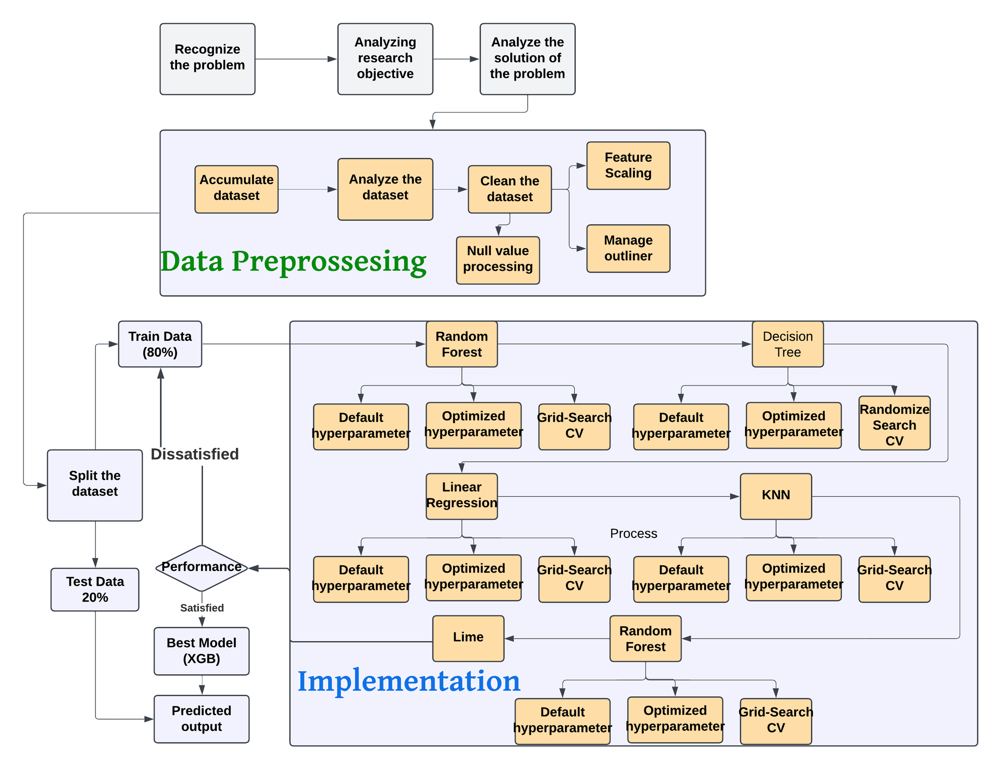
Fig. 1 DEMONSTRATES THE WORKING SEQUENCES OF THE PROPOSED USED CAR PRICE DETECTION SYSTEM
The rest of the paper is organized as follows: Section II describes the proposed system, which includes methodologies, system design, and flowcharts. Section III presents experimental results and evaluates the performance of different models. Finally, Section IV concludes the paper and discusses possible future improvements that could be made for better prediction accuracy and usability.

Proposed System

Dataset
In Table I. the dataset is mainly based on used car price prediction. The dataset is taken from GitHub. The dataset has 7,252 samples and 13 features directly related to used car price prediction. The features are name, location, year, kilometers, Fuel_tupe, Transmission, Owner_Type, Mileage, Engine, Power, seat, New price, and Price. All these features together basically determine the price of a used car. How many kilometers has the car driven? What is the fuel type, the engine power of the car, the number of seats in the car, and what was the price of the new car? These types of features help determine the price of a used car. The features Kilometers_Driven and Year have numerical values, while the features Fuel_Type and Transmission have categorical values. Each sample provides important information that helps determine the value of a used car. [7]
TABLE I. VARIOUS FEATURES OF THE EMPLOYED DATASET
Name | Location | Year | Kilometers Driven | Fuel Type | Transmission | Owner Type | Mileage | Engine | Power | Seats | New Price | Price
Ford EcoSport 1.5 Petrol Trend | Kolkata | 2016 | 21460 | Petrol | Manual | First | 17.0 kmpl | 1497 CC | 121.36 bhp | 5.0 | 9.47  Lakh | 6.00
Maruti Wagon R VXI 1.2 | Kochi | 2015 | 49818 | Petrol | Manual | First | 21.5 kmpl | 1197 CC | 81.80 bhp | 5.0 | 5.44  Lakh | 4.11
Ford Endeavour 4x2 XLT | Hyderabad | 2007 | 130000 | Diesel | Manual | First | 13.1 kmpl | 2499 CC | 141 bhp | 7.0 | NaN | 6.00
Mercedes-Benz E-Class E250 CDI Avantgarde | Coimbatore | 2016 | 39753 | Diesel | Automatic | First | 13.0 kmpl | 2143 CC | 201.1 bhp | 5.0 | NaN | 35.28
Hyundai Xcent 1.2 Kappa AT SX Option | Kochi | 2018 | 45560 | Petrol | Automatic | First | 16.9 kmpl | 1197 CC | 82 bhp | 5.0 | NaN | 6.34
Toyota Innova Crysta 2.8 ZX AT | Coimbatore | 2019 | 40674 | Diesel | Automatic | First | 11.36 kmpl | 2755 CC | 171.5 bhp | 7.0 | 28.05 Lakh | 24.82
Mercedes-Benz E-Class E250 CDI Avantgarde | Bangalore | 2014 | 37382 | Diesel | Automatic | First | 13.0 kmpl | 2143 CC | 201.1 bhp | 5.0 | NaN | 32.00

Dataset Pre-processing
First, we see many types of problems when we review our data set. One of these problems is mixing discrete and continuous values. In addition, many prices are missing in other features such as new prices. In addition, there are multi-type values ​​in one feature. As a result, if the entire data set is not modified, we cannot expect our optimal solution from here.
For this reason, we first reviewed the data set and identified our problems. We checked the values ​​in each feature and later checked whether there were multiple values ​​in a feature. Later, we separated the descriptive and contentious values.
Below are our steps step by step:
First, we identified the number of int, float, and object in our data set. Later, we identified how many values ​​were missing in our total data set. Here we see new price-86.130, price-17.014, seats-0.731, engine- .634, power-.634 mileage-.028 percent of value missing.
Then, we tried to solve each feature by identifying the problems with each feature part by part. Furthermore, we solved them in such a way that they are optimized to bring the best output to our model.
First of all, we completely deleted the s.no feature. Because the serial number is not a suitable value for our model. Later, we checked from the name column. Here, we see that there are many unique values. We completely removed this column because the car's name must be different. Later, we identified the exact age of the car through the year column. Moreover, created a new column based on this value. The name of the new column is Car_Age. Later, we identified and saw how old the cars in our total data set were. Moreover, who has separated them into groups for our convenience?
Later, in the mileage column, we see two types of values ​​here simultaneously. One is a float value, and the other is a string value. So here, for our convenience, two separate new columns have been created: mielage_no and mielage_unit.
In mielage_unit, we see two values ​​(kmpl, km/kg). Again, there are two parts to this (cng/lpg). Now, we checked and sorted out how many values ​​there are. Here, there are a total of 74 values, which is much less than the total data set. So, we removed these values ​​from this column.
Here, in the engine, we see two types of values. So, here, we have removed the string value by keeping only the number value. We have also organized the data column in a new way.
We see this kind of problem in the case of power columns, too. So, we have kept the number values ​​from here and removed the string values. Later, for further validation, we have seen if any other value exists in power.
In the new_price column, we see different types of values ​​. For example, some are in lakhs, and some cars are priced in crores. Moreover, since most cars are priced in lakhs, we have separated our crore values ​​from here and converted them to lakhs.
Later, we checked if there were any duplicate rows in our total data set. Here, we see 17 duplicate rows, so we removed them from the data set. We have also given our final data type check.
This time, we worked with missing values. Because there were many missing values ​​in our data. Again, we fixed these missing values ​​by taking each feature. We calculated a percentage of how many values ​​were missing in our data set, and accordingly, we started our missing value treatment.
First, in the mileage column, we see some zero-mileage cars; from here, we identify the total number of zero-mileage cars. A total of 84 cars has zero mileage. So, these values ​​were converted from zero to NaN. Because keeping the zero value does not give an optimal solution in this case. Since the value of the New Price column is missing more than 60 percent, we dropped this column.
Furthermore, along with this, we dropped the price column. Our ultimate goal is to make price predictions, so we removed this column. Later, in the power column, we see many missing values. So, in this case, we have identified the mean value of the value we have and replaced the missing value with the mean value, and in the case of power, too, we have done the same thing.
In the case of mileage, we also see some missing data here. In this case, we have applied a different method. That is, we have replaced the values ​​of the cars whose mileage value is missing with the mean value of the cars of that brand one by one. That is, we have replaced only the missing values ​​of Toyota with the mean value of the Toyota car. The reason for doing this here is that mileage depends on the user and how many kilos he will drive. Later, we checked the value of the Seat_no column and saw that the value of 12 cars was missing. So, since there is less value here, we have manually checked and selected the car model from the internet and replaced the seat number.
If you look at the engine column, you can see that here, too; since the missing value is low, we have replaced the null value with information from the relevant cars. Lastly, we checked the mileage unit, and there is no null value here. So we reviewed our entire data set again, and from here, we checked whether there is any null value in the entire data set. And the overall data set is okay.
Later, we plotted our feature data in different ways to see what our values ​​were like and whether any outliers existed. Here, we drew a scatter plot with and without hue, a KDE plot with and without HUE, a Histogram with and without HUE, and a box plot of all features, and from here, we identified whether there are any outliers.
In addition, we drew a swarm plot, strip, violin plot, and, lastly, feature scaling and completed one hot-end coding.
Below are some examples of graphs:
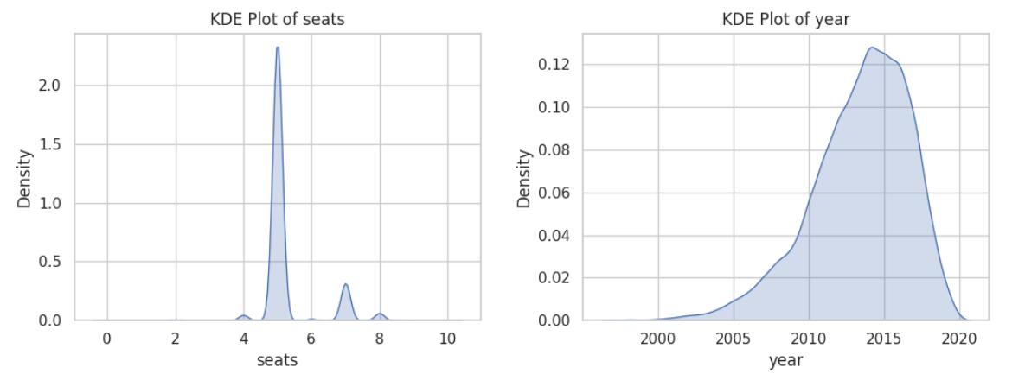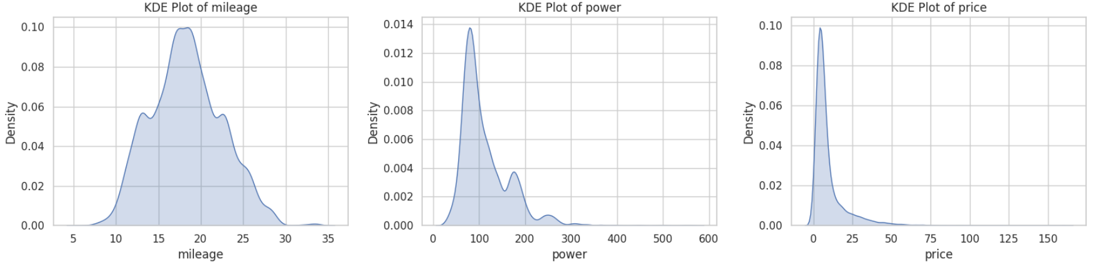
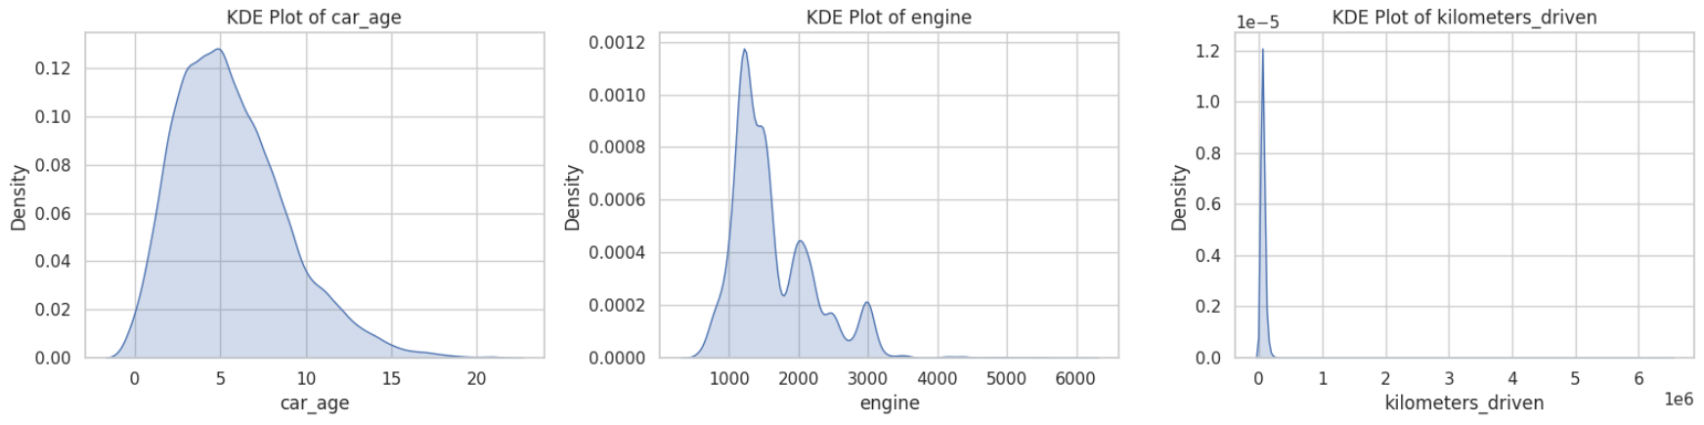
Fig. 2 KDE PLOT FOR FEATURES
In Fig.2 we plotted our feature data in different ways to see what our values were like a KDE plot with and without HUE

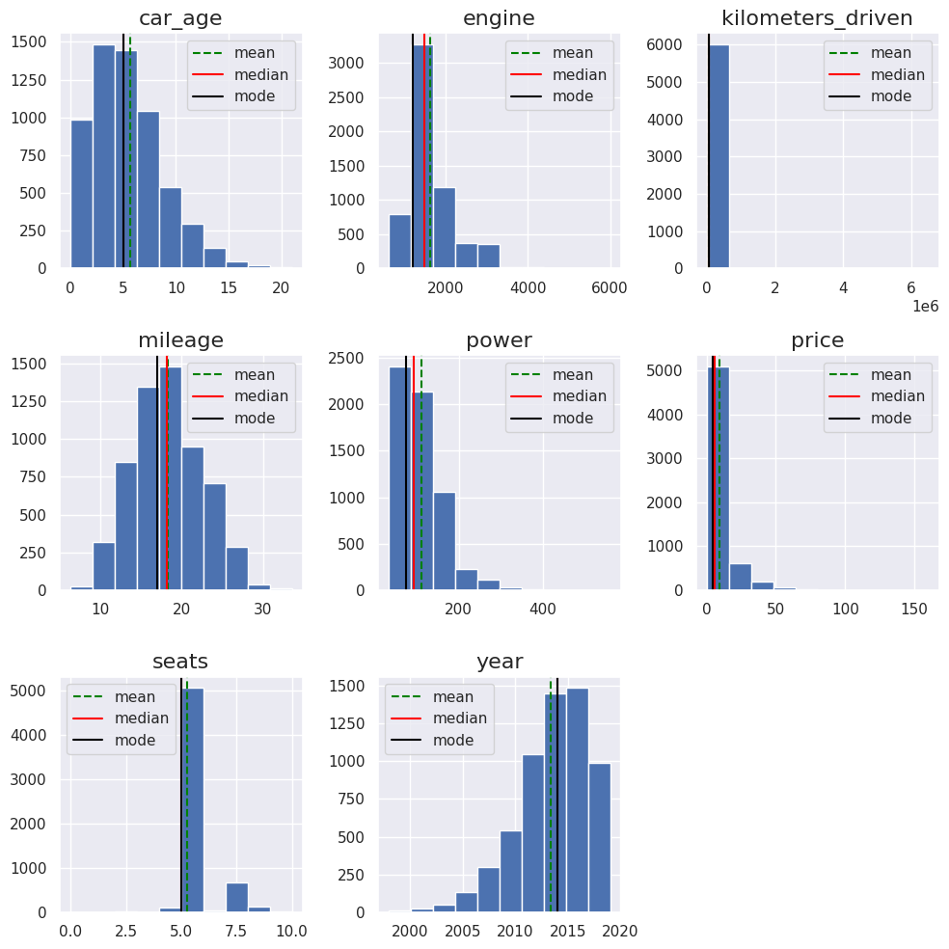
Fig. 3 HISTOGRAM OF FEATURES
In Fig.3 we plotted our feature data in different ways to see what our values ​​were like a Histogram with and without HUE
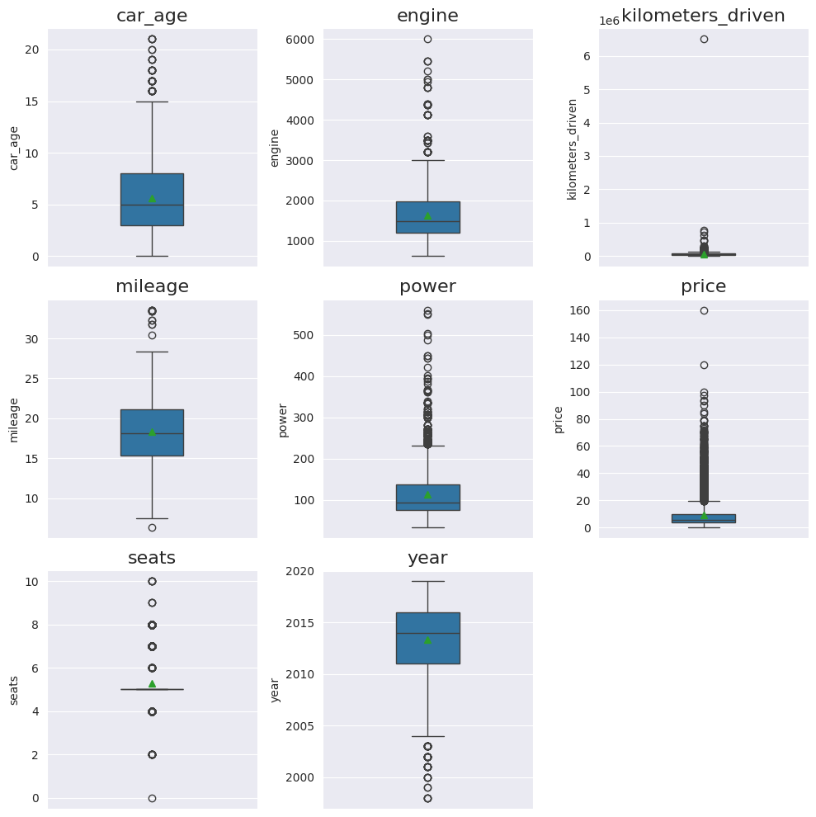
Fig. 4 CHECK THE OUTLIER OF THE DATASET
In Fig. 4 we plotted our feature data in different ways to see what our values ​​were like and whether any outliers existed. So, this is a box plot of all features, and from here, we identified whether there are any outliers.
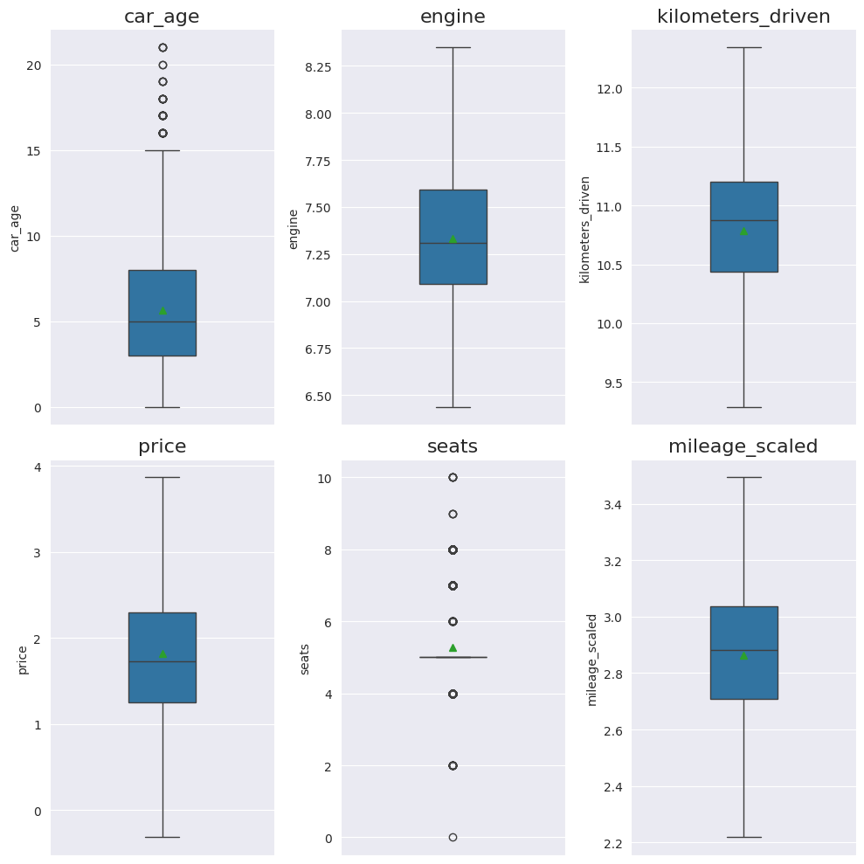
Fig. 5 AFTER TREATMENT OF OUTLIER
In Fig. 5 we plotted our feature data in different ways to see what our values ​​were like and whether any outliers existed. So, this is a box plot of all features, and from here, we remove the outlier and we solve the issue and plot all the graph to see the problem is really solved.

Machine Learning Models

Linear Regression: Linear Regression is a statistical method used to model the relationship between a dependent variable and one or more independent variables. It assumes a linear relationship between the variables, with the dependent variable predicted using the weighted sum of the independent variables. Using a technique known as least squares, the model minimizes the difference between observed and predicted values. This simplicity makes linear Regression helpful in analyzing and interpreting data correlations, but it may struggle with complex, non-linear patterns.

Decision tree: A Decision tree for a regression dataset is a model that carefully breaks down the data into some short groups to predict numbers. With the goal of low prediction mistakes, the data is split according to the values of variables such as kilometers_driven, fuel_type, Transmission, and owner_type. In every stage, it frequently analyses every possible approach to splitting data and picks the optimal one by reducing the average error to the mean squared error. This process continues until there are very few data points to split the tree or the tree further is too deep. At the end of the tree, the final group is called LEAF NODES, and every LEAF shows the average value of the targeted data of this group. This model begins at the top of the tree and goes from there and splits according to the feature values until it reaches a LEAF NODE in order to make predictions for fresh data. This model can handle complex data and show which features are most important. However, they can give too specific results or change a lot if the data changes slightly. Also, the predictions are not smooth due to the assigned set numbers to each category. To solve these problems, methods like Random Forests or Gradient Boosting combine many trees to give better results. Decision trees help predict numbers, especially when we need a simple and straightforward model.

Random forest: Random Forest uses bootstrap sampling. It creates many decision trees so that the output prediction is reasonable. First, the dataset is divided into two parts: train and test. Second, it creates a random subset. Then, it creates many independent decision trees from there. Then, it combines the predictions of the decision trees and creates the final result through the average value.
    - KNN model: The KNN model uses the distance between the training samples and the data to make predictions. This distance will be measured using a Manhattan or Euclidean distance matrix. The Euclidean Distance: The cartesian distance between two locations in the plane or hyperplane is all that this is. The length of the straight line connecting the two sites under investigation is another way to depict the Euclidean distance. We may determine the net displacement between an object's two states with the aid of this metric.
distance (x, X_{i}) = $\sqrt{\sum_{j=1}^{d}{}{\left(x_{j}-x_{ij}\right)}^{2}}$ (1)
The Manhattan Distance: Manhattan When we are interested in an object's total distance traveled rather than its displacement, we typically employ the distance metric. The absolute difference between the point coordinates in n dimensions is added together to determine this measure.
$d(x, y) = \sum_{i=1}^{n}{}\left|x_{i}-y_{i}\right| \#\left(2\right)$
Regression, multi-classification, and classification datasets can all be used to train this model. Because this model merely saves the data and does not alter it during training, it is a lazy approach.
    - XGBoost: XGBOOST is one of the ensembles learning systems where the Regression problem is solved with the help of decision trees. Here, the previous mistakes are corrected at each step, and the process proceeds step by step. First, the initial value is extracted and its mean value is identified. Here, the gradient calculation is based on the prediction and actual value. Later, the decision tree is trained with this value. And this value is later scaled by a new learning rate. This process continues until the permanence is updated. XGBOOST is effective for L1/L2 value regularization, missing data handling, and parallel processing. And it performs very well in Regression.
    - Stacking: Stacking is one of the ensemble's learning techniques where the model with the best performance is identified as the meta-model. This model is trained on the output of the base models. Here, we have tested the base model on the data set. The base models are Linear Regression, Random Forest, Decision Tree, and KNN. And here, the meta-model is XGBOOST. Here, the meta-model is trained depending on the character of the output of the base model. The meta-model combines the output of the base model and gives an optimal solution. Usually, this model provides an optimal solution by reducing bias and variance.

d. Equations Formatting:
- Mean Square Error (MSE):
The mean square error, or MSE, is the only figure that indicates how good a regression line is. Because a smaller MSE number indicates a reduced quantity of errors, a smaller value indicates a better match.
$MSE=\frac{1}{N}\sum_{i=1}^{N}{}{\left(y_{i}-\hat{y}\right)}^{2} \#\left(3\right)$

- Root Mean Square Error (RMSE):
The quadratic scoring rule known as Root Mean Square Error (RMSE) calculates the average error magnitude. It is calculated as the square root of the average squared discrepancy between the actual observation and the prediction.
$RMSE=\sqrt{MSE}=\sqrt{\frac{1}{N}\sum_{i=1}^{N}{}{\left(y_{i}-\hat{y}\right)}^{2}} \#\left(4\right)$

- Mean Absolute Error (MAE):
The average absolute difference between the dataset's actual and anticipated values is represented by the Mean Absolute Error (MAE). It stands for the dataset's average residual.
$MAE=\frac{1}{N}\sum_{i=1}^{N}{}\left|y_{i}-\hat{y}\right| \#\left(5\right)$
- R-Squared Error (R2):
This figure indicates the percentage of the dependent variable's variance that can be accounted for by the independent variable.
$R^{2}=1-\frac{∑{\left(y_{i}-\hat{y}\right)}^{2}}{∑{\left(y_{i}-\hat{y}\right)}^{2}} \#\left(6\right)$
Here,
N = the number of data points (or samples) in the test set. We have N = 1204 samples.
Yi = the actual value (true value) for the ith data point. Here i = 1.
y = the predicted value of the model for the ith data point. Here i = 1.
yi-y = the absolute error (the absolute difference between the actual and predicted values).
∑ = Indicates summation (the process of adding terms together)

Results and Discussion
We first prepared each model in our dataset using the default hyperparameters. Then, we fine-tuned the hyperparameters to calculate the four measurements—Mean Absolute Error (MAE), Mean Squared Error (MSE), Root Mean Squared Error (RMSE), and R-squared (R2) Score.
Table II. HYPERPARAMETER OPTIMIZATION RESULTS FOR VARIOUS MACHINE LEARNING MODELS
Model | Hyperparameter Value Range | Optimized value
Random forest | 'n_estimators': np.range(200, 3001, 200), 'max_depth': [None, 10, 15, 20, 30, 50, 100, 200], 'min_samples_split': [2, 5, 10, 15, 20], 'min_samples_leaf': [1, 2, 4, 6, 8, 10], 'max_features': ['auto,' 'sqrt,' 'log2', 0.5, 0.75], 'bootstrap': [True, False], 'oob_score': [True] | 'oob_score': True, 'n_estimators': 800, 'min_samples_split': 5, 'min_samples_leaf': 1, 'max_features': 0.75, 'max_depth': 200, 'bootstrap': True
Decision Tree | 'criterion': ['squared_error,' 'friedman_mse,' 'absolute_error,' 'Poisson'], 'max_depth': [None, 10, 20, 30, 50, 100], 'min_samples_split': [2, 5, 10, 20], 'min_samples_leaf': [1, 2, 5, 10], 'max_features': [None, 'sqrt,' 'log2'] | 'min_samples_split': 20, 'min_samples_leaf': 5, 'max_features': None, 'max_depth': 100, 'criterion': 'friedman_mse'
Linear Regression | 'alpha': np.logspace(-4, 4, 50) | 'alpha': 1.2067926406393288
KNN | 'n_neighbors': [3, 5, 7, 9, 11], 'weights': ['uniform', 'distance'] | 'n_neighbors': 5, 'weights': 'distance'
XGBOOST | 'n_estimators': np.range(100, 1001, 100), 'learning_rate': [0.0001, 0.001, 0.01, 0.1, 0.5], 'max_depth': [3, 5, 7, 10, 15, 20], 'subsample': [0.6, 0.7, 0.8, 0.9, 1.0], 'colsample_bytree': [0.5, 0.7, 0.8, 0.9, 1.0], 'gamma': [0, 0.1, 0.2, 0.3, 0.5] | 'colsample_bytree': 0.9, 'gamma': 0, 'learning_rate': 0.1, 'max_depth': 5, 'n_estimators': 700, 'subsample': 0.9
As in the above Table II. We give all of the hyperparameter ranges and optimal hyperparameters that we utilized to train each model are displayed in the table. Every model has its own set of hyperparameters, and the ranges of those parameters vary. As a result in XGBOOST we can take gamma values 0, 0.1, 0.2, 0.3, 0.4, 0.5. They all are hyperparameters but for this dataset the optimized value of gamma is 0. Same as for max_depth 3, 5, 7, 10, 15, 20 and optimize value for the dataset's depth is 5. We take all the optimized hyperparameters to get the better results from the dataset by the model. From this we got the best model XGboost with the optimized hyperparameter which values are: 'colsample_bytree': 0.9, 'gamma': 0, 'learning_rate': 0.1, 'max_depth': 5, 'n_estimators': 700, 'subsample': 0.9. Besides these table II describes all the hyperparameter value ranges and optimized values.
Table III. PERFORMANCE METRICS OF MACHINE LEARNING MODELS WITH DEFAULT HYPERPARAMETERS
Model Name | Mean Absolute Error (MAE) | Mean Squared Error (MSE) | Root Mean Squared Error (RMSE) | R-squared (R2) Score
Random Forest | 0.188 | 0.068 | 0.262 | 0.906
Decision Tree | 0.243 | 0.121 | 0.348 | 0.833
Linear Regression | 0.262 | 0.117 | 0.343 | 0.841
KNN | 0.225 | 0.095 | 0.309 | 0.870
XGBOOST | 0.173 | 0.057 | 0.240 | 0.921
Stacking | 0.223 | 0.090 | 0.301 | 0.877

This Table III. lists the four less-performed errors with default parameter values for six models. According to the scores, XGBoost stands out with the lowest errors, and it also got a higher R² score (0.921), which means that almost every car price was accurate by a factor of more than 92%. The Random Forest model's performance is excellent (R² = 0.906), but error values are slightly higher on some XGBoost. While they perform well (R² = 0.87 and 0.877), KNN and Stacking are slightly less accurate than Random Forest. Linear Regression does not give great results, and with a low R² (0.841!) value, the performance is moderate; we have high error for Each package. The worst is the Decision Tree with over errors and R² 0,833. Then we can say XGBoost > Random Forest>KNN>Stacking>Linear Regression> Decision Tree.
Table IV. PERFORMANCE METRICS OF MACHINE LEARNING MODELS WITH OPTIMIZED HYPERPARAMETERS
Model Name | Mean Absolute Error (MAE) | Mean Squared Error (MSE) | Root Mean Squared Error (RMSE) | R-squared (R2) Score
Random Forest | 0.186 | 0.066 | - | 0.909
Decision Tree | 0.221 | 0.095 | 0.308 | 0.871
Linear Regression | 0.262 | 0.117 | 0.342 | 0.841
KNN | 0.217 | 0.090 | 0.300 | 0.878
XGBOOST | 0.170 | 0.056 | 0.240 | 0.924
Stacking | 0.186 | 0.068 | 0.260 | 0.908

In Table IV. We calculated the same four metrics with tuned hyperparameters for every model. We got the best performer, XGBoost, with the lowest MAE (0. 170), MSE (0. 056), RMSE (0. 240), and highest R² (0. 924), arguing the just overall accuracy. Then Random Forest, with an R² score of 0. 909, is slenderly more abject than XGBoost. KNN and Stacking execute similarly, with R² accounting for 0. 878 and 0. 908, respectively, and moderate errors. Linear Regression evinces the weakest public presentation with the high MAE and R². Determination Tree stimulates the highest computer error economic value among the models XGBoost leads, followed by Random Forest and Stacking, while Conclusion Tree and Linear Regression lag behind.

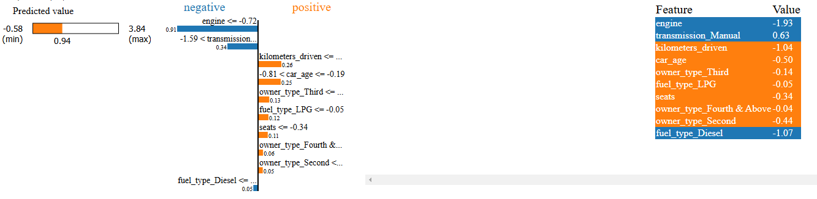
Fig. 6 Machine Learning Model Prediction Interpretation by LIME Explainable AI Library

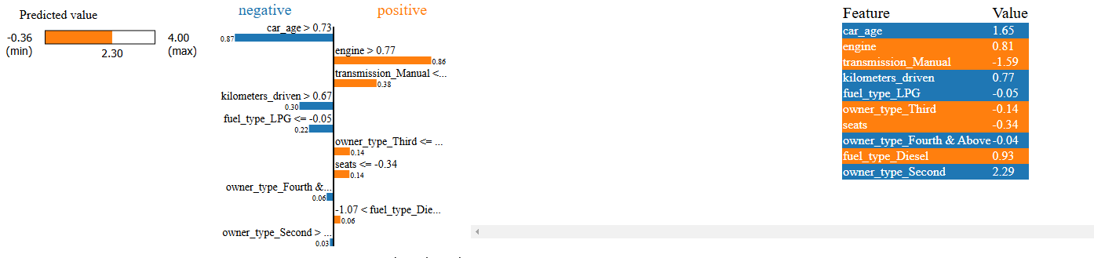
Fig. 7 Machine Learning Model Prediction Interpretation by LIME Explainable AI Library
These two graphs Fig. 6 & Fig. 7 are the picture of a figure that demonstrates Machine learning model prediction interpretation by the LIME explainable AI library. This figure is divided into three parts. The left side shows the predicted Value (Min to max), the right part shows the feature list and the exact values, and the middle section highlights the key features. The blue part shows the negative value, and the orange shows the positive.

Conclusions
The work developed a machine learning system that can predict used car prices accurately and simply. K-nearest neighbors (KNN), XGBoost, Random Forest, Decision Tree, Linear Regression, and Stacking are the six models we used. Performance metrics such as Mean Absolute Error (MAE), Mean Squared Error (MSE), Root Mean Squared Error (RMSE), and R-squared (R²) Score are used to evaluate the models. With the lowest error (MAE=0.170) and the highest accuracy (R2=0.924) following tweaking, the findings demonstrated that XGBoost was the best model. Random Forest and Stacking also performed well, showing the superiority of ensemble approaches. The models got even more accurate when their settings were optimized using essential data like age, mileage, and fuel type. That data helps buyers and sellers determine the best price for used cars. This approach is easy to use, reliable, and trusted for accurate price estimation. In the future, we can improve the system. It will also be simpler for users to access this system if we develop a website or app for Android and iOS. This work shows how machine learning can help solve real-world problems like used car pricing.
  - Future Work
In the future, we can improve the system and add new features like market trends and real-time data, updating the dataset for greater accuracy. Real-time predictions using APIs and exploring advanced models like deep learning can increase performance. The system can also be adapted for global markets and it will also be simpler for users to access this system if we develop a website or app for Android and iOS. This project shows how machine learning can help solve real-world problems like used car pricing.

References
- F. Wang, X. Zhang, and Q. Wang, "Prediction of Used Car Price Based on Supervised Learning Algorithm," International Conference on Networking, Communications and Information Technology, 2021.
- A. F. Kinadi, R. Andreswari, E. Sutoyo, R. Nugraha and A. A. B. Kamil, "Used Car Price Prediction in Surabaya Using Random Forest Regressor Algorithms," International Conference Advancement in Data Science, E-learning and Information Systems, 2022.
- Y. S. Balcıoğlu and B. Sezen, "Car Price Prediction Using Machine Learning Techniques," International Artemis Congress on Health and Sport Sciences, 2024.
- D. V. c. L. R. M. B. K. a. C. M. Kemidi, "Analysis of Used Vehicle Value Prediction using Machine Learning," 5th International Conference on Image Processing and Capsule Networks (ICIPCN), pp. 154-158, 2024.
- M. Hankar, M. Birjali, and A. Beni-Hssane, "Used Car Price Prediction Using Machine Learning: A Case Study," IEEE International Symposium on Signal, Image, Video and Communications, 2022
- D. R. Das Adhikary, "Prediction of Used Car Prices Using Machine Learning," Springer Nature Singapore, vol. 271, pp. 131--140, 2022.
- S. Dhanasar, "Used-Car-Price-Prediction," Github, 02 11 2023. [Online]. Available: https://github.com/seandhan/ Used-Car-Price Prediction/blob/main/data/used_cars_data.csv. [Accessed 12 11 2024]

