M. Sai Koushik

**M. Sai Koushik**

**NEC0820082**

**NEC-NTTF-BANGALORE**

**OPERATIONS MANAGEMENT**



**OPERATIONS MANAGEMENT**

**ASSIGNMENT BRIEF: -**

Dave has been running Three Rings call center for over 40 years. It was set up by Dave and his wife Mary and is considered the most successful call center in the region. Their levels of customer service have made them number 1 in the region at 4.5 stars out of 5 and customers remain loyal to the company for that reason. Staff must undergo regular training courses in customer service and team building. The average waiting time for a customer on hold is half what it is everywhere else because of the level of staff efficiency. At Three Rings the waiting time has been 2 minutes compared to the average 4 minutes. The company has grown in the last 40 years increasing the number of staff members from just 10 in 1977 to 2000 in 2017. The company tries to stay true to its roots and is reluctant to modernize the software and technology in the office.

Recently there has been a decline however in sales made by call Centre operators on behalf of clients and they are at the lowest they have been for over 20 years. The HR department has recently changed managers and since the change, fewer staff have been enrolled on the regular training courses Three Rings puts on for the staff. The level of staff recruitment has dropped significantly and staff numbers are dropping as no one is replacing staff who are retiring or leaving. The lack of staff creates strain in busy periods – when sales should be soaring, they are dropping. Due to the recent staffing issues, the average wait time for a customer on hold has increased to

* 1. minutes. It is no surprise to the staff – November and December are their busiest periods and always have been – yet no one seems to have been planning for this.

There is also an issue with dated software which will crash frequently and cause delays in service; the computers and phones are also dated and are difficult to use. Any data relating to the call center is stored directly on these computers for access

**THE VISION, MISSION, AND VALUE STATEMENTS: -**

**Vision:**

To be a consistently top-rated call center with customer satisfaction at 100% through accessible, friendly and fast service.

**Mission:**

To lead by example as the top call center for customer service and sales from a company of friendly and motivated staff all contributing to a dynamic team environment.

**Values:**

One team, simple, fast, and friendly.

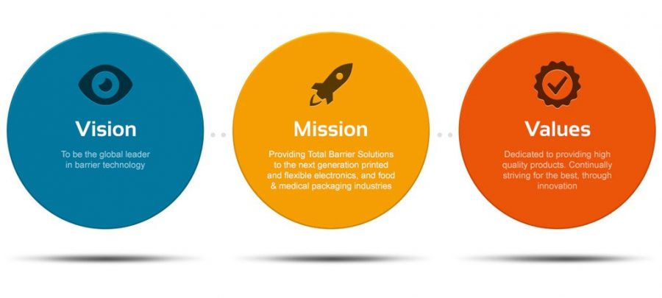

Every year the sales team have a meeting with other heads of department to decide on sales strategy and targets for the year. The most recent objectives Dave has set for the sales staff has been to increase the customer service rating from 4.5 stars to 5 through kind and helpful service. He has also said he wants the average waiting time for a customer on hold to be reduced from 3.5 minutes to 1.5 minutes. They aim for a sales figure for 2017 of £110,000.

**Below is a table showing data collected of sales targets against actual sales in the past 9 years from the sales team: -**

|  |  |  |  |  |  |  |  |  |  |
| --- | --- | --- | --- | --- | --- | --- | --- | --- | --- |
| Year | 2009 | 2010 | 2011 | 2012 | 2013 | 2014 | 2015 | 2016 | 2017 |
| Target Sales  (£,000s) | 70 | 75 | 80 | 82 | 85 | 88 | 90 | 105 | 110 |
| Actual Sales (£,000s) | 72 | 77 | 81 | 84 | 87 | 89 | 94 | 107 |  |

The current factors used to measure the performance of the call center operators are:

* **How long each customer is waiting on hold.**
* **How long each phone call lasts.**
* **How many hours the staff work a month.**
* **How many sales an operator makes.**
* **What days of the week the staff like to work.**

The staff are unhappy with their feedback on how they are achieving these KPIs and are finding it unfair as they are trying their hardest. Below is a table showing the monthly figures for customer satisfaction rating as a percentage by month in 2015 and 2016

|  |  |  |  |  |  |  |  |  |  |  |  |  |  |
| --- | --- | --- | --- | --- | --- | --- | --- | --- | --- | --- | --- | --- | --- |
| **Year** | **Customer Satisfaction Rating**  **(%)** | | | |  | | | | | | | | |
| **Jan** | **Feb** | **March** | **April** | **May** | **June** | **July** | **August** | **Sept** | **Oct** | **Nov** | **Dec** |
| 2015 | 85 | 79 | 92 | 76 | 95 | 99 | 78 | 88 | 79 | 94 | 68 | 45 |
| 2016 | 91 | 92 | 89 | 86 | 93 | 98 | 91 | 89 | 86 | 95 | 70 | 51 |

As Operations Manager, you have been tasked by Dave to review the operational management of the Three Rings Call Centre and produce a report for him. He wants to understand how well the operation is aligning with the overall objectives, what problems are occurring and how they can be resolved. Dave sees that things are starting to slip but he does not understand why.

Produce a report for Dave which covers an assessment of the factors A-G below. Include a list of recommendations that should be put into action to resolve any issues/problems you have highlighted.



**TASK AND ASSIGNMENTS: -**

* + 1. Identify the key links that should be in place between Operations Management and the Sales team – and comment on how operations management should relate to the targets set for the sales team.
    2. Comment on the Mission, Vision and Values of the Call Centre, and whether you believe that measures and KPIs in place for the call center directly contribute to the achievement of the mission and vision.
    3. Identify and assess the KPIs in place and measured for the sales team – are the relationship of targets set appropriate to the measures in place. Suggest additional or alternative measures that could be used.
    4. Comment on staffing levels and performance in the contact center. Explain how workforce planning should be put in place to resolve any issues and how it should be used going forward.
    5. Review the methods of storing data and managing technology in the call center, highlighting any risks and identifying solutions/improvements.
    6. Analyze the customer satisfaction ratings that have been collected for 2015 and 2016 using an appropriate data analysis tool that helps show trends. Identify and use a data analysis tool to use and describe how to create this so that you can look at any trends. What is the data showing you and what recommendations would you now make to address anything you think is significant?
    7. Summarize your findings and prepare an action plan of recommendations for Dave with solutions to the operational problems. Explain to Dave the importance of operations management, commenting on how effective operations management should prevent problems in the future.

**TASK 1: -**

Identify the key links that should be in place between Operations Management and the sales team – and comment on how operations management should relate to the targets set for the sales team

**KEY LINKS OPERATION MANAGEMENT AND SALES TEAM:-**

* Sales team share the customers demand to Operation management.
* Operation management produce what sales demand – quality, quantity, and cost.
* Share data about defect analysis to Operation management.
* Conditions under which defects occurred.
* Get customer feedback and share to the operation management.
* Share the expectations of the customers in the terms of functionality and quality of products to Operation Management
* Share logistic and delivery time of products to Operation management.
* Operation team keep growth with business through sales team, by expanding relationship with customers.
* By expanding customer base in terms of new geographical area and demography.



**HOW OPERATIONS MANAGEMENT SHOULD RELATE TO THE TARGETS SET FOR THE SALES TEAM: -**

* Improve customer satisfaction and service through sales team training.
* Workforce and Resource planning.
* Improve Quality of information and communication.
* Enhancement of technology.
* Seamless integration.
* Reduce customer Churn.
* Lower customer acquisition costs.



**TASK 2: -**

Comment on the mission, vision, and values of the call centers and whether you believe that measures and KPI’s in place for the call center directly contributes to the achievement of the mission and vision.

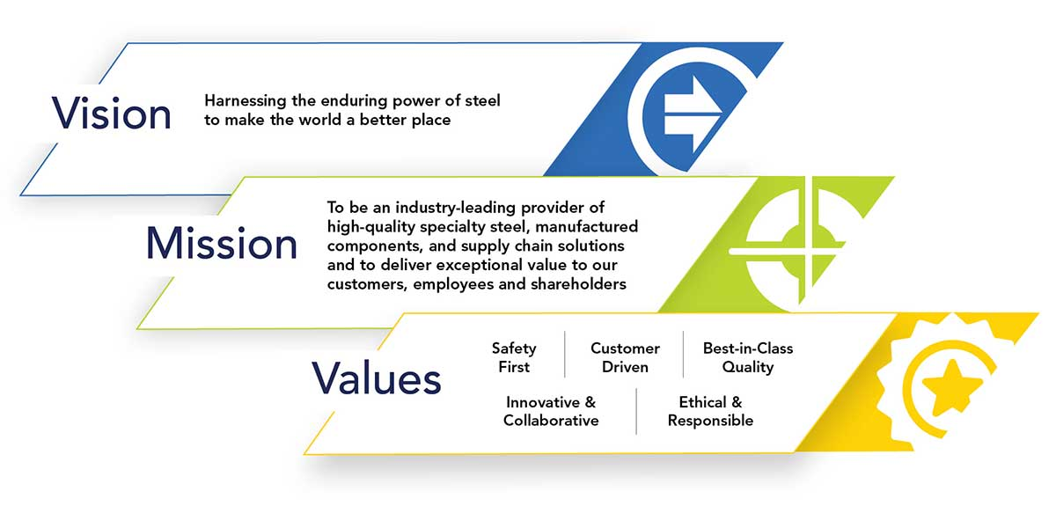

### Mission:

To lead by example as the top call center for customer service and sales from a company of friendly and motivated staff all contributing to a dynamic team environment.

BASED ON MISSION STATEMENT: -

* + A MISSION statement defines the company’s business, its objectives, and its approach to reach those objectives.
  + Dave’s call center mission clearly defines the company process and its objectives and it’s approach with dynamic team environment.

### Vision:

To be a consistently top-rated call center with customer satisfaction at 100% through accessible, friendly and fast service.

BASED ON VISION STATEMENT: -

* + A VISION statement describes the desired future position of the company.
  + Dave’s call center vision also clearly defines the company future like - 100% customer satisfaction, Aspiration and possible.

### Value:

One team, simple, fast, and friendly.

BASED ON VALUE STATEMENT: -

* Based on value statement value of the company is provide the customer solution and faster and friendlier

**KPI SHOULD INCLUDE: -**

* Identify the training needs – desired and existing skill level of employees
* Reduce customer waiting time
* Collection data on why sales have failed
* Repeated calls by Customer to close the transaction
* Analyze about employee happiness
* Number of revisits of a customer. This will help in identifying important customer

### KPI REFLECTING ON VISION DATA LIKE:

* Number 1 in region, 4.5 star out of 5, Customer remain loyal, Success of the vision of company.

### KPI REFLECTING ON MISSION DATA LIKE:

* Regular training customer service and team building part of mission of company.

### KPI REFLECTING ON VALUE DATA LIKE:

* Waiting time 50% of others due to staff efficiency.
* Value of company how fast customer service is.

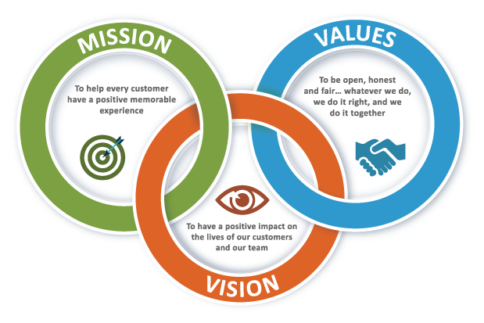

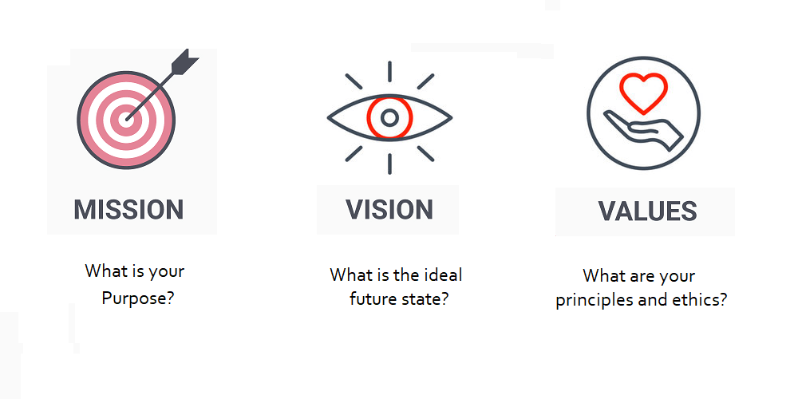

**TASK 3: -**

Identify and access the KPI’s in place and measured for the sales team – are the relationship of targets set appropriate to the measures in place. Suggest additional or alternative measures that could be used.

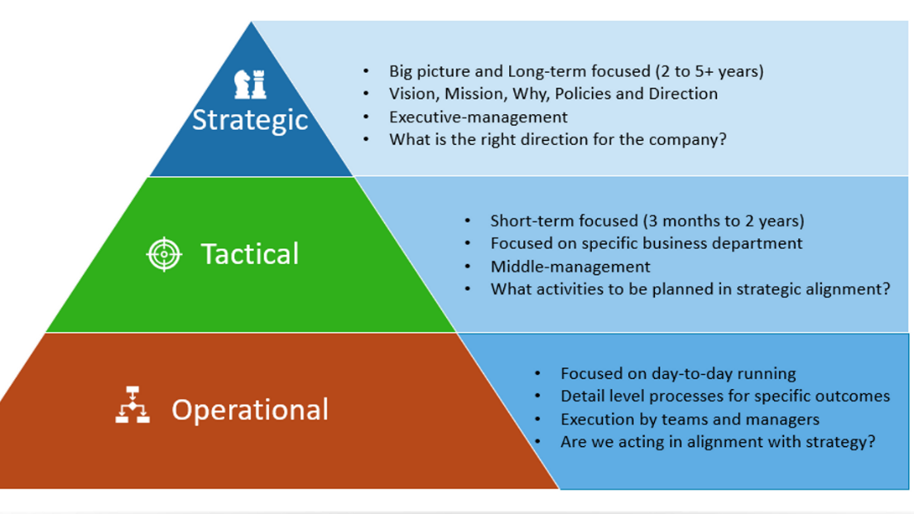

# 

**KPI FOR SALES TEAM: -**

* SALES GROWTH
* SALES TARGET
* CUSTOMER ACQUISITION COST
* AVERAGE REVENUE PER UNIT(ARPU)
* CUSTOMER LIFETIME VALUE(CLV)
* CUSTOMER CHURN RATE
* AVERAGE SALES CYCLE LENGTH
* LEAD-TO-OPPORTUNITY RATIO
* OPPORTUNITY-TO-WIN RATIO
* LEAD CONVERSION RATIO
* NUMBER OF SALES OPPURTUNITIES
* SALES OPPURTUNITY SCORE
* AVERAGE PURCHASE VALUE
* REVENUE PER SALES REP
* PROFIT MARGIN PER SALES REP
* UPSELL & CROSS-SELL RATES

**ADDITIONAL KPI: -**

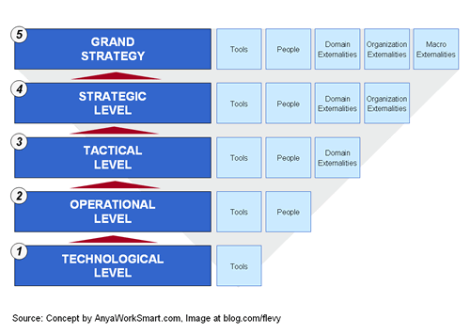

* Percentage of calls blocked
* Business Drivers
* Workforce Management
* Quality Assurance Metrics
* Sales per Agent
* Revenue per successful call
* Call arrival rate
* Call setup success rate
* Longest Call Hold
* Average Call Length
* Average age of Query
* ACW – After Call Work Time
* FRT – First Call Resolution

**TASK 4: -**

Comment on staffing levels and performance in the contact centre. Explain how workforce planning should be put in place to resolve any issues and how it should be used going forward

|  |  |  |  |  |  |  |  |  |  |  |  |  |
| --- | --- | --- | --- | --- | --- | --- | --- | --- | --- | --- | --- | --- |
| **Year** | **Customer Satisfaction**  **Rating (%)** | | | |  | | | | | | | |
| **Jan** | **Feb** | **March** | **April** | **May** | **June** | **July** | **August** | **Sept** | **Oct** | **Nov** | **Dec** |
| 2015 | 85 | 79 | 92 | 76 | 95 | 99 | 78 | 88 | 79 | 94 | 68 | 45 |
| 2016 | 91 | 92 | 89 | 86 | 93 | 98 | 91 | 89 | 86 | 95 | 70 | 51 |

* November and December months in 2015 & 2016 customer satisfaction rate is start falling.
* Customer waiting time increased up to 3.5 mins.
* Staffs strength decreased and fewer staffs enrolled without proper training.
* In call center only old computers, software’s, and technology’s available
* Calculate the average calls per day in call center (H number of calls per day).
* Calculate the average time per call in call center (M number of calls per day).
* M x H and get the total business hours.
* Waiting time – Maximum 1.5m, number of staff require will be given by

**= ((M-3)*H)/60 + H/20 ROUNDER UPTO NEXT INTEGER**

|  |  |  |  |  |
| --- | --- | --- | --- | --- |
| **Time** | **Minute per call** | **Calls per hour** | **((M-3)*H)/60 + H/20** | **Staff required`** |
| 9 to 10 | 4 | 100 | 5.0 | 5 |
| 10 to 11 | 4 | 110 | 5.5 | 6 |
| 11 to 12 | 3 | 80 | 4.0 | 4 |
| 12 to 1 | 3 | 150 | 10.0 | 10 |
| 1 to 2 | 4 | 120 | 8.0 | 8 |
| 2 to 3 | 3 | 100 | 5.0 | 5 |

**LIMITATION: -**

* Maximum number of states = system capacity (how many simultaneous calls it can handle).
* Work schedule and optimization of employee hours (based on no.of calls per our).
* Use data of previous 3years to arrive at predicted number of customers.
* Same method to plan for strategic work force planning.
* Employees off duty put through regular training and enhancement of knowledge.

**STAFFS TRAINING TO: -**

* Data on why sales failed.
* Number of repeated calls by customer to close a transaction.
* Number of revisits of a customer.
* How many sales an operator makes.

**HOW WORKLOAD WOULD CHANGE IF THE FOLLOWING EVENTS OCCURED: -**

* Advertising campaign increases the calls.
* Many untrained agents start work at the same time.
* A new multimedia channel becomes available to customers.
* A key product line is offered at a discount

**WORK FORCE PLANNING: -**

* Arrange the training to the staff.
* Appoint more suitable staffs on call center.
* Prepare some new technologies and equipment’s and make familiarization to employees.
* Make work schedule to employees based on no of calls per day.

**TASK 5: -**

Review the methods of storing data and managing technology in the call center, highlighting any risks and identifying solutions / improvements.

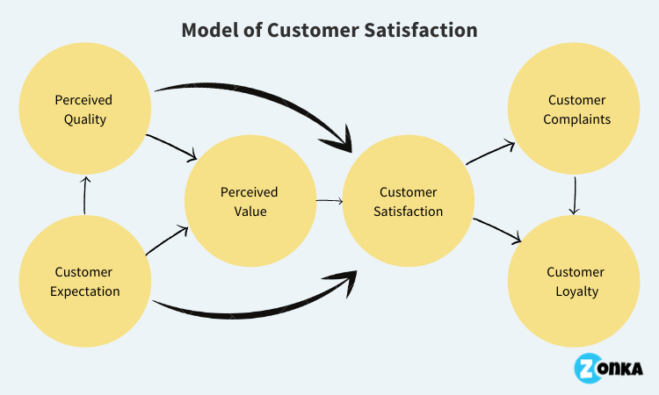

**SOLOTION: -**

* Identify the issue.
* Understand everyone’s interests.
* List the possible solution (option).
* Evaluate the options.
* Select an option or options.
* Document the agreement.
* Agree on contingencies, monitoring, and evaluation.

**MATERIAL: -**

* Remove the old system from center and add new system.
* Erase all old software and update to new software’s.

**MACHINES: -**

* In Dave’s call center all computers and phones.
* Replace all the thing to new and adaptable form updated software

**PEOPLES: -**

* Staff try to focus on customer satisfaction.
* Try to attend the call early.

**ENVIRONMENT: -**

* Environmental issues are not avoidable problems.
* Make strong wire connection to avoid this thigs.

**METHOD: -**

* Make work schedule.
* And work force on employees.
* Make proper training to staffs

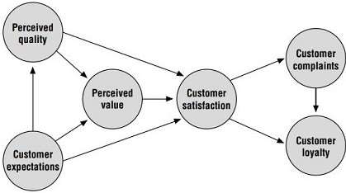

**TASK 6: -**

Analyze the customer satisfaction ratings that have been collected for 2015 and 2016 using an appropriate data analysis tool that helps show trends. Identify and use a data analysis tool to use and describe how to create this so that you can look at any trends. What is the data showing you and what recommendations would you now make to address anything you think is significant?

|  |  |  |  |  |  |  |  |  |  |  |  |  |  |
| --- | --- | --- | --- | --- | --- | --- | --- | --- | --- | --- | --- | --- | --- |
| **Year** | **Customer Satisfaction Rating(%)** | | | | | | | | | | | | |
| **Jan** | **Feb** | **March** | **April** | **May** | **June** | **July** | **August** | **Sept** | **Oct** | **Nov** | **Dec** |
| 2015 | 85 | 79 | 92 | 76 | 95 | 99 | 78 | 88 | 79 | 94 | 68 | 45 |
| 2016 | 91 | 92 | 89 | 86 | 93 | 98 | 91 | 89 | 86 | 95 | 70 | 51 |

**Line Diagram of customer satisfaction rating in 2015&2016:**

* In based online diagram November and December of the 2015 and 2016 customer rating will be reduced.
* Because of staffing issue.
* Customer waiting time increased.
* Dated software, computers, and phones.
* Make training to staffs.
* Choose another some perfect staffs for staffing.
* Monitor the training.
* Try to reduce customer waiting time.



**TASK 7: -**

Summarize your findings and prepare an action plan of recommendations for Dave solutions to the operational problems. Explain to Dave the importance of operations management, commenting on how effective operations management should prevent problems in the future.

* Dave has been running Three Rings call center for over 40 years.
* Their levels of customer service have made them number 1 in the region at 4.5 stars out of 5 and customers remain loyal to the company for that reason.
* The average waiting time for a customer on hold is half what it is everywhere else because of the level of staff efficiency.
* At Three Rings the waiting time has been 2 minutes compared to the average 4 minutes.
* The company has grown in the last 40 years increasing the number of staff members from just 10 in 1977 to 2000 in 2017.
* The company tries to stay true to its roots and is reluctant to modernize the software and technology in the office.
* Recently there has been a decline however in sales made by call center operators on behalf of clients and they are at the lowest they have been for over 20 years.
* The HR department has recently changed managers and since the change, fewer staff have been enrolled on the regular training courses.
* The lack of staff creates strain in busy periods – when sales should be soaring, they are actually dropping.
* Due to the recent staffing issues, the average wait time for a customer on hold has increased to 3.5 minutes.

### DAVES CALL CENTRE VISION, MISSION, AND VALUES: -

**Vision:**

To be a consistently top-rated call center with customer satisfaction at 100% through accessible, friendly and fast service.

**Mission:**

To lead by example as the top call center for customer service and sales from a company of friendly and motivated staff all contributing in a dynamic team environment

.

**Values:**

One team, simple, fast, and friendly

**Below is a table showing data collected of sales targets against actual sales in the past 9 years from the sales team**.

|  |  |  |  |  |  |  |  |  |  |
| --- | --- | --- | --- | --- | --- | --- | --- | --- | --- |
| Year | 2009 | 2010 | 2011 | 2012 | 2013 | 2014 | 2015 | 2016 | 2017 |
| Target Sales (£,000s) | 80 | 85 | 90 | 92 | 95 | 98 | 100 | 105 | 110 |
| Actual Sales (£,000s) | 82 | 87 | 91 | 94 | 97 | 99 | 104 | 107 |  |

**Below is a table showing the monthly figures for customer satisfaction rating as a percentage by month in 2015 and 2016.**

|  |  |  |  |  |  |  |  |  |  |  |  |  |  |
| --- | --- | --- | --- | --- | --- | --- | --- | --- | --- | --- | --- | --- | --- |
| **Year** | **Customer Satisfaction Rating**  **(%)** | | | |  | | | | | | | | |
| **Jan** | **Feb** | **March** | **April** | **May** | **June** | **July** | **August** | **Sept** | **Oct** | **Nov** | **Dec** |
| 2015 | 85 | 79 | 92 | 76 | 95 | 99 | 78 | 88 | 79 | 94 | 68 | 45 |
| 2016 | 91 | 92 | 89 | 86 | 93 | 98 | 91 | 89 | 86 | 95 | 70 | 51 |

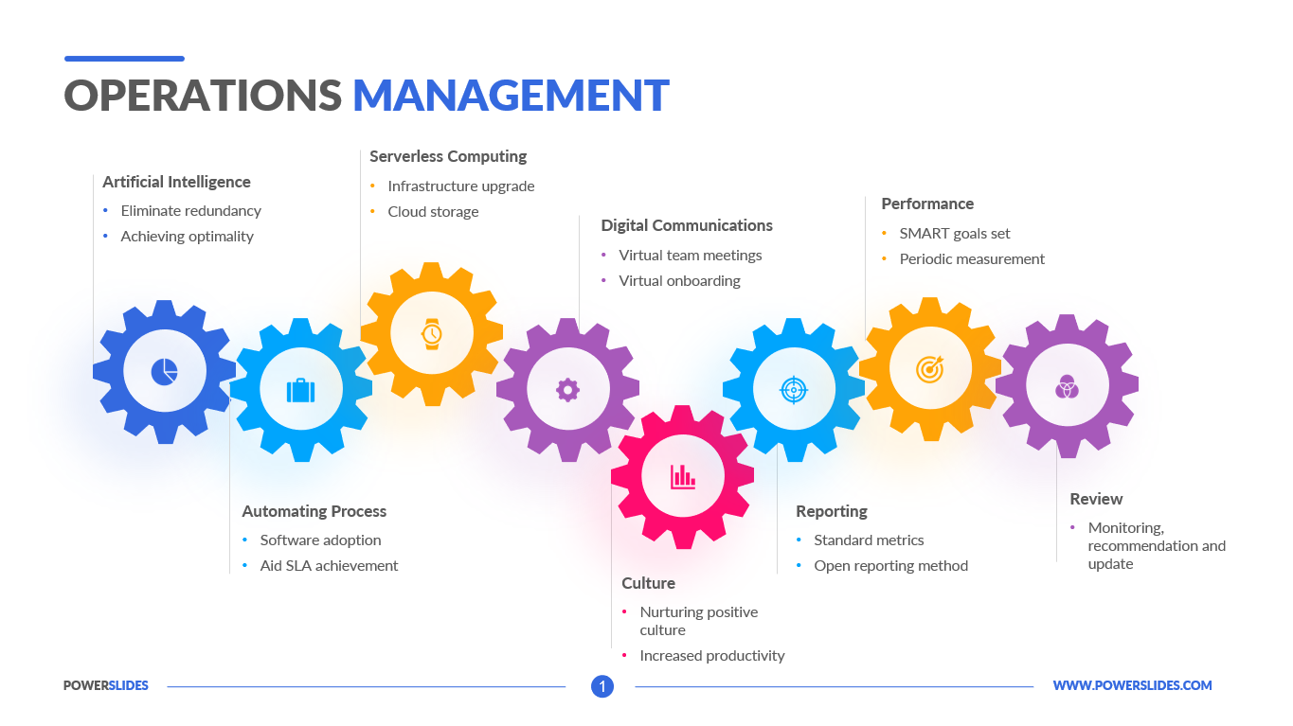

**RECTIFY ABOVE PROBLEM TO CALL CENTER CAN REACH THEIR OLD NUMBER ONE POSITION**

**SOLOTION TO REDUCE ABOVE PROBLEMS: -**

* Identify the issue.
* Understand everyone’s interests.
* List the possible solution (option).
* Evaluate the options.
* Select an option or options.
* Document the agreement.
* Agree on contingencies, monitoring, and evaluation.
* Remove the old system from center and add new system.
* Erase all old software and update to new software’s.
* In Dave’s call center all computers and phones.
* Replace all the thing to new and adaptable form updated software
* Staff try to focus on customer satisfaction.
* Try to attend the call early.
* Environmental issues are not avoidable problems.
* Make strong wire connection to avoid this thigs.
* Make work schedule.
* And work force on employees.
* Make proper training to staffs.

**IMPLEMENT THE ABOVE SOLUTION TO**

**CALL CENTER REACH THE NO.1 POSITION**

